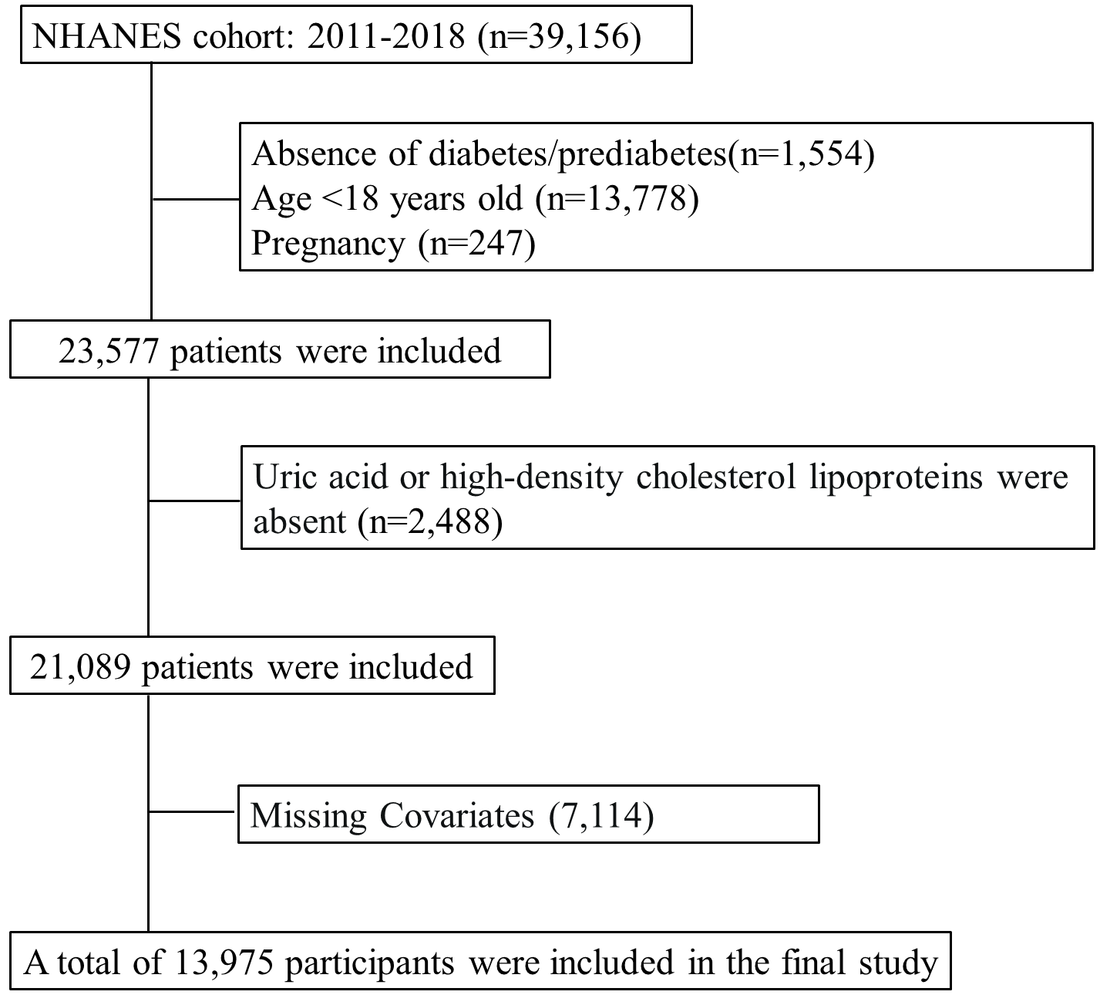
Fig. S1 The Flowchart of participant selection from National Health and Nutrition Examination Survey (NHANES) 2011–2018
Abbreviation: UHR, serum uric acid high-density lipoprotein cholesterol ratio; NHANES, The National Health and Nutrition Examination Survey.

Presented below are the complete set of figures derived from the weighted analysis of the NHANES survey.
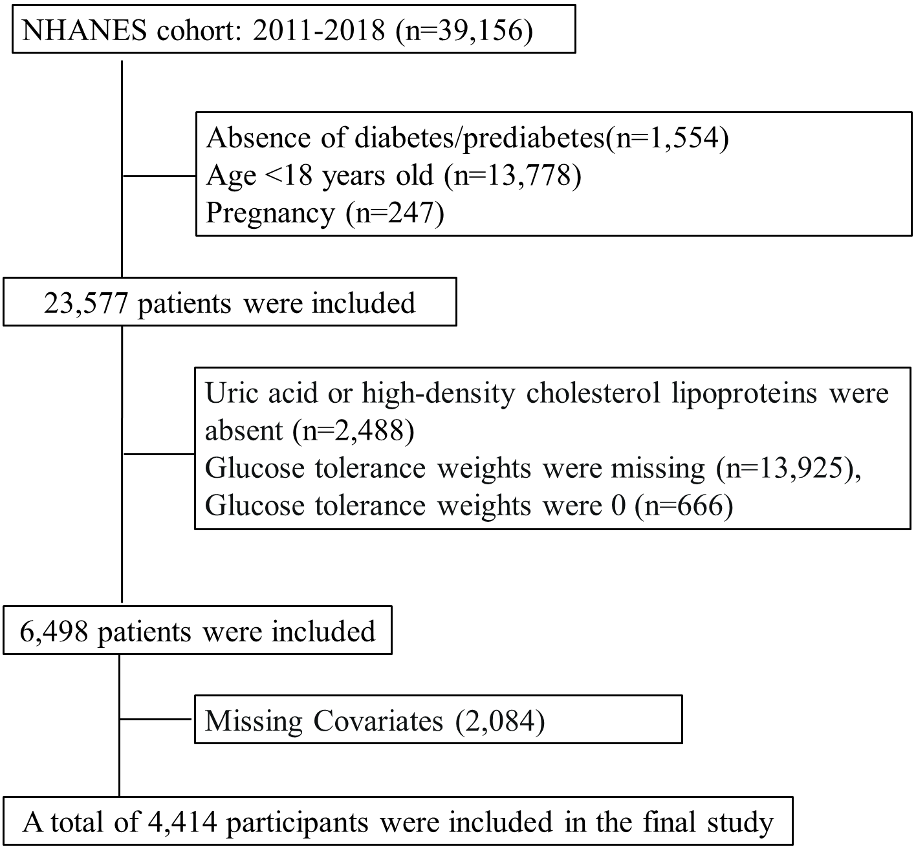
Fig. S2 The Flowchart of participant selection from National Health and Nutrition Examination Survey (NHANES) 2011–2018 (weighted)
Abbreviation: UHR, serum uric acid high-density lipoprotein cholesterol ratio; NHANES, The National Health and Nutrition Examination Survey.
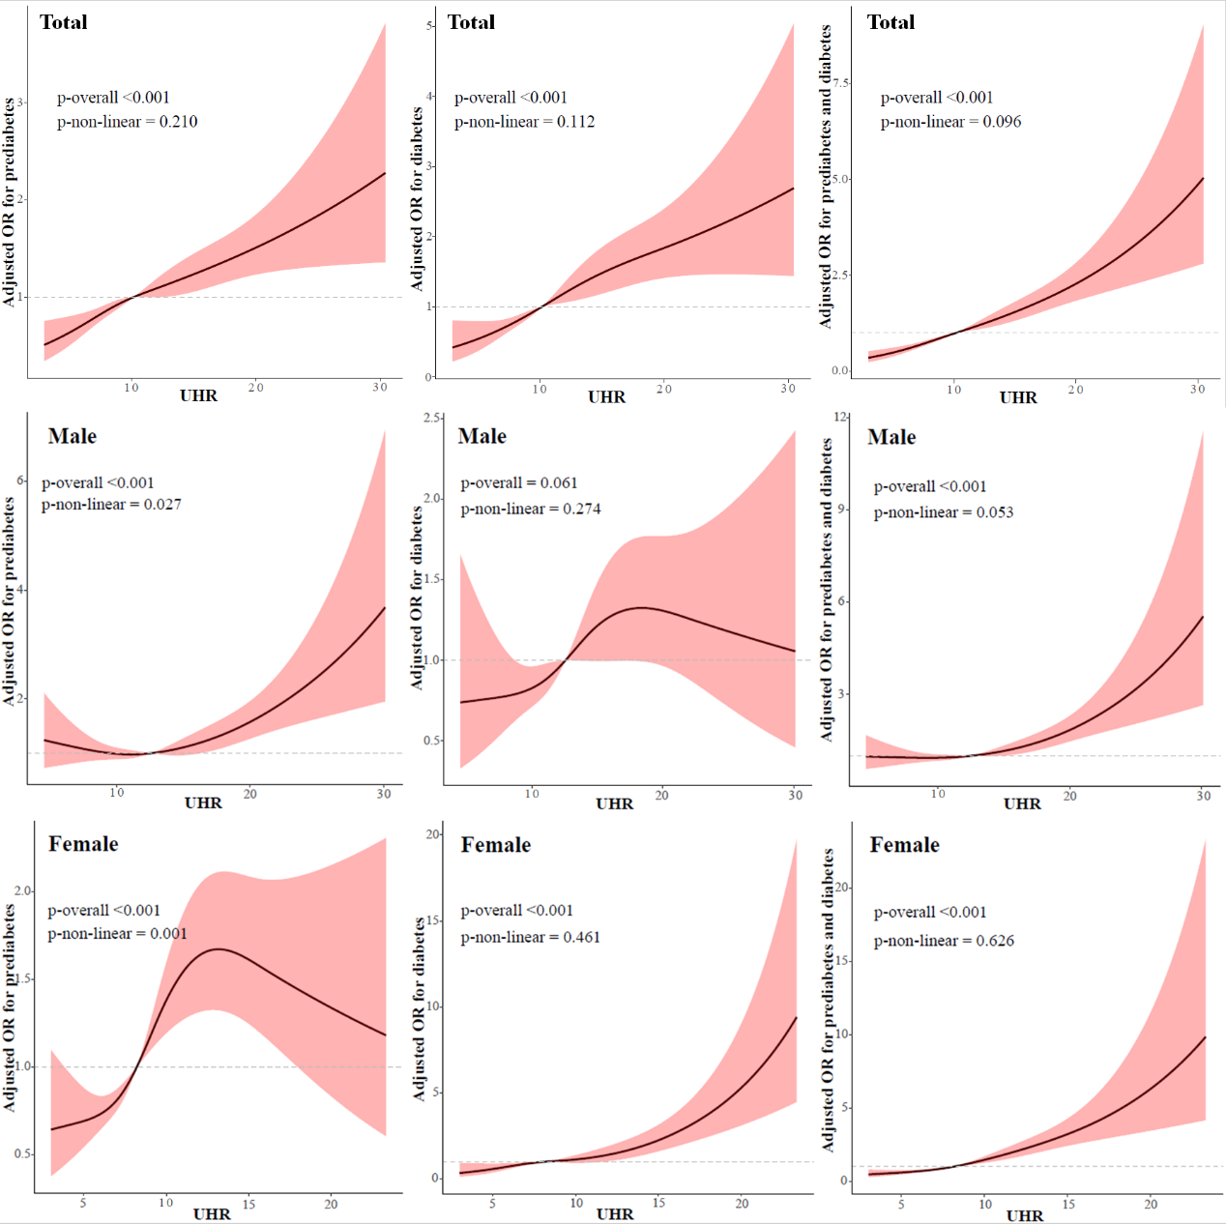
Fig. S3 Restricted cubic spline analysis of UHR with theprevalence of prediabetes/diabetes in model 2 (weighted). (1st line) all participants, (2nd line) male, (3rd line) female, (1st column) Prediabetes, (2nd column) Diabetes, (3rd column) Prediabetes and diabetes. The Dark and light red lines represent the estimated values and corresponding 95% confidence interval, respectively. The adjustment factors included age, gender, race, marriage, education level, PIR, HBP, PAL, BMI, TC, serum creatinine, smoking, drinking, family history of diabetes, dietary calories, and cancer. Abbreviation: UHR, serum uric acid high-density lipoprotein cholesterol ratio; PIR, household income to poverty ratio; TC, total cholesterol; BMI, body mass index; PAL, physical activity levels; HBP, hypertension.

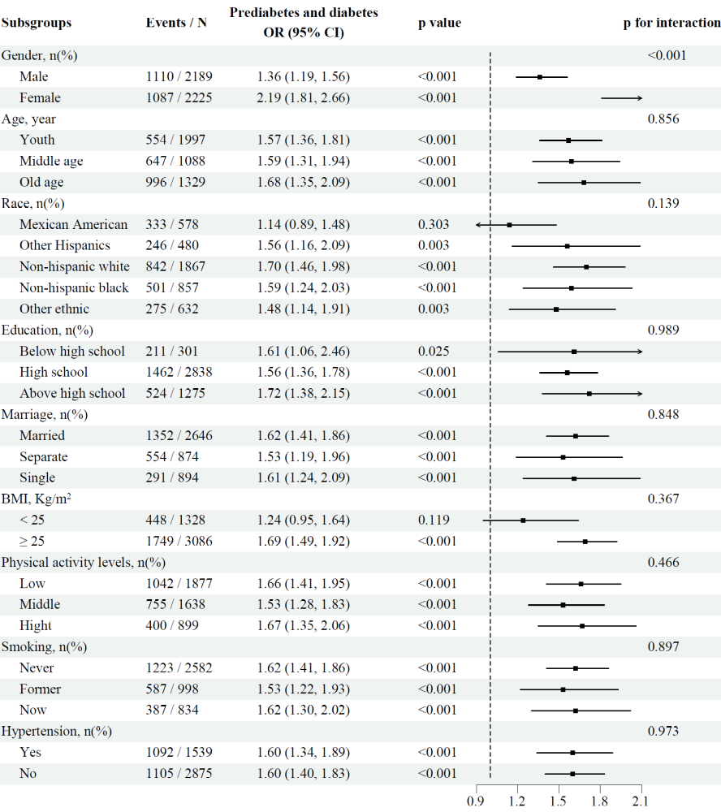
Fig. S4 Forest plot for subgroup analysis of the effect of UHR on prediabetes and diabetes in model 2 (weighted). Each subgroup analysis was adjusted for age, gender, race, marriage, education level, PIR, HBP, PAL, BMI, TC, serum creatinine, smoking, drinking, family history of diabetes, dietary calories, and cancer. Abbreviation: UHR, serum uric acid high-density lipoprotein cholesterol ratio; PIR, household income to poverty ratio; TC, total cholesterol; BMI, body mass index; PAL, physical activity levels; SMK, smoking.
Table S1 Baseline characteristics of participants according to the UHR quartiles (weighted).
Variables | Overall | UHR |  |  |  | P value
Variables | Overall | Q1(<7.6) | Q2(7.6-10.2) | Q3(10.2-13.7) | Q4(≥0.137) | P value
Participants | 518510673.4 | 137732453.7 | 124784573.5 | 128158405.3 | 127835240.9
Male, n(%) | 251171872.2 (48.4) | 20289577.6 (14.7) | 47910890.1 (38.4) | 79561629.4 (62.1) | 103409775.2 (80.9) | <0.001
Age, year | 46.0 [32.0, 60.0] | 49.0 [33.0, 62.0] | 46.0 [31.0, 59.0] | 44.0 [31.0, 59.0] | 44.3 [32.0, 59.0] | 0.062
Race, n(%) |  |  |  |  |  | 0.055
Mexican American | 39985899.3 (7.7) | 9694389.2 (7.0) | 10220162.5 (8.2) | 9787302.4 (7.6) | 10284045.2 (8.0)
Other Hispanics | 30112334.7 (5.8) | 7441183.2 (5.4) | 6694274.1 (5.4) | 7893938.9 (6.2) | 8082938.5 (6.3)
Non-hispanic white | 353019350.9 (68.1) | 94217820.5 (68.4) | 81158952.6 (65.0) | 87604845.5 (68.4) | 90037732.3 (70.4)
Non-hispanic black | 56249865.3 (10.8) | 15882226.3 (11.5) | 15795673.3 (12.7) | 14030733.5 (10.9) | 10541232.2 (8.2)
Other ethnic | 39143223.2 (7.5) | 10496834.5 (7.6) | 10915511.0 (8.7) | 8841585.0 (6.9) | 8889292.7 (7.0)
Education, n(%)ª |  |  |  |  |  | <0.001
Below high school | 19865707.6 (3.8) | 4650408.3 (3.4) | 4970877.9 (4.0) | 5402700.4 (4.2) | 4841721.0 (3.8)
High school | 322828302.3 (62.3) | 76139799.2 (55.3) | 76700775.1 (61.5) | 84599388.2 (66.0) | 85388339.8 (66.8)
Above high school | 175816663.5 (33.9) | 56942246.2 (41.3) | 43112920.6 (34.5) | 38156316.6 (29.8) | 37605180.1 (29.4)
Marital status, n(%) |  |  |  |  |  | 0.001
Married | 330583662.6 (63.8) | 90331529.6 (65.6) | 70553298.4 (56.5) | 83751129.5 (65.3) | 85947705.1 (67.2)
Separate | 86221883.2 (16.6) | 22067773.0 (16.0) | 25737734.8 (20.6) | 18956024.7 (14.8) | 19460350.7 (15.2)
Single | 101705127.7 (19.6) | 25333151.1 (18.4) | 28493540.3 (22.8) | 25451251.1 (19.9) | 22427185.2 (17.5)
PIR, n(%) |  |  |  |  |  | 0.002
Poor | 112641424.6 (21.7) | 27661064.2 (20.1) | 28647993.0 (23.0) | 29314289.0 (22.9) | 27018078.5 (21.1)
Middle | 160373715.3 (30.9) | 35255274.1 (25.6) | 40539365.1 (32.5) | 41762779.6 (32.6) | 42816296.4 (33.5)
Rich | 245495533.5 (47.3) | 74816115.4 (54.3) | 55597215.4 (44.6) | 57081336.7 (44.5) | 58000866.0 (45.4)
Dietary calories, Kcal | 2104.7 (795.1) | 1930.0 (654.1) | 2036.1 (751.5) | 2205.6 (862.3) | 2258.9 (858.3) | <0.001
SBP, mmHg | 121.4 (16.2) | 118.0 (16.7) | 121.2 (15.5) | 122.5 (15.7) | 124.3 (16.3) | <0.001
DBP, mmHg | 69.5 (11.7) | 67.5 (10.9) | 69.0 (11.3) | 70.2 (11.9) | 71.2 (12.3) | <0.001
BMI, Kg/m² | 29.0 (6.9) | 25.6 (5.3) | 28.3 (6.5) | 29.9 (6.8) | 32.4 (7.2) | 0.034
Family history of diabetes, n(%) | 196291974.9 (37.9) | 48172055.6 (35.0) | 43300196.4 (34.7) | 50016995.5 (39.0) | 54802727.4 (42.9) | 0.044
TCHOL, mmol/L | 4.9 (1.0) | 5.1 (1.0) | 4.9 (1.0) | 4.8 (1.1) | 4.9 (1.1) | <0.001
HDL-C, mmol/L | 1.4 (0.4) | 1.9 (0.4) | 1.5 (0.3) | 1.3 (0.2) | 1.0 (0.2) | <0.001
UA, µmol/L | 323.8 (81.6) | 246.8 (49.8) | 303.3 (53.4) | 341.6 (50.8) | 409.0 (68.1) | <0.001
Serum creatinine, µmol/L | 74.3 [62.8, 87.5] | 65.4 [58.3, 74.4] | 70.7 [60.1, 83.1] | 76.9 [67.2, 89.3] | 84.8 [73.4, 96.4] | <0.001
Hypertension, n(%) | 165094009.6 (31.8) | 34547100.4 (25.1) | 33796591.6 (27.1) | 46180983.9 (36.0) | 50569333.6 (39.6) | <0.001
HF, n(%) | 10817079.1 (2.1) | 934076.4 (0.7) | 1844681.4 (1.5) | 3193635.2 (2.5) | 4844686.1 (3.8) | <0.001
CHD, n(%) | 15113376.1 (2.9) | 3550194.4 (2.6) | 3449324.5 (2.8) | 3578572.9 (2.8) | 4535284.3 (3.5) | 0.718
Stroke, n(%) | 11498156.0 (2.2) | 2940568.7 (2.1) | 2456859.6 (2.0) | 2317920.6 (1.8) | 3782807.2 (3.0) | 0.335
Canser, n(%) | 57450795.0 (11.1) | 17923627.4 (13.0) | 12275608.7 (9.8) | 12473196.1 (9.7) | 14778362.8 (11.6) | 0.175
PAL, n(%) |  |  |  |  |  | <0.001
Low | 207382789.2 (40.0) | 60710340.6 (44.1) | 51381667.0 (41.2) | 49203911.2 (38.4) | 46086870.5 (36.1)
Medium | 196546111.5 (37.9) | 55080183.2 (40.0) | 48268845.2 (38.7) | 50080563.2 (39.1) | 43116519.8 (33.7)
High | 114581772.7 (22.1) | 21941929.9 (15.9) | 25134061.3 (20.1) | 28873930.9 (22.5) | 38631850.6 (30.2)
Drinking alcohol, n(%) |  |  |  |  |  | <0.001
Never | 62537955.1 (12.1) | 19007433.9 (13.8) | 17262318.8 (13.8) | 12302180.1 (9.6) | 13966022.3 (10.9)
Former | 59333601.8 (11.4) | 15243744.1 (11.1) | 15011662.6 (12.0) | 16272032.3 (12.7) | 12806162.9 (10.0)
Mild | 309458835.2 (59.7) | 90944799.4 (66.0) | 75241049.3 (60.3) | 71619595.5 (55.9) | 71653391.0 (56.1)
Moderate | 48217788.1 (9.3) | 7877627.4 (5.7) | 10959862.4 (8.8) | 14954574.5 (11.7) | 14425723.7 (11.3)
Heavy | 38962493.3 (7.5) | 4658848.9 (3.4) | 6309680.5 (5.1) | 13010022.9 (10.2) | 14983941.0 (11.7)
Smoking, n(%) |  |  |  |  |  | <0.001
Never | 302247625.0 (58.3) | 86682192.3 (62.9) | 78642697.3 (63.0) | 70219307.0 (54.8) | 66703428.4 (52.2)
Former | 121548721.2 (23.4) | 29451090.2 (21.4) | 23756177.0 (19.0) | 33602830.9 (26.2) | 34738623.0 (27.2)
Current | 94714327.3 (18.3) | 21599171.2 (15.7) | 22385699.2 (17.9) | 24336267.4 (19.0) | 26393189.5 (20.6)
Prediabetes, n(%) | 147596881.7 (28.5) | 32393726.5 (23.5) | 34885672.3 (28.0) | 38348221.5 (29.9) | 41969261.4 (32.8) | 0.004
Diabetes, n(%) | 72812057.4 (14.0) | 10655656.8 (7.7) | 15317794.0 (12.3) | 20113205.6 (15.7) | 26725401.1 (20.9) | <0.001
Prediabetes and diabetes, n(%) | 220408939.1 (42.5) | 43049383.3 (31.3) | 50203466.3 (40.2) | 58461427.1 (45.6) | 68694662.5 (53.7) | <0.001
Abbreviation: ª For the 6–19 age group, "Less Than 9th Grade" was classified as below high school, "9-11th Grade","High School Grad/GED or Equivalent" as high school graduation or equivalent, and "Some College or AA degree", "College Graduate or above" as above high school level. UHR, serum uric acid high-density lipoprotein cholesterol ratio; PIR, household income to poverty ratio; TC, total cholesterol; HDL-C, high-density lipoprotein cholesterol; BMI, body mass index; PAL, physical activity levels; SBP, systolic blood pressure; DBP, diastolic blood pressure; SUA, serum uric acid; HF, heart failure; CHD, coronary heart disease.

Table S2 Association of UHR levels with risk of prediabetes and diabetes among all participants (weighted).
Outcome | Events / N | OR (95%CI), p-value
Outcome | Events / N | Crude | Model 1 | Model 2
Prediabetes
Per 1 SD increment | 1314 / 4414 | 1.10 (1.03-1.17), 0.003 | 1.12 (1.04-1.20), 0.003 | 1.13 (1.04-1.23), 0.003
Quartiles
Q1(< 7.6) | 303 / 1104 | Ref. | Ref. | Ref.
Q2(7.6-10.2) | 335 / 1098 | 1.16 (0.97-1.40), 0.113 | 1.18 (0.98-1.43), 0.088 | 1.17 (0.96-1.42), 0.127
Q3(10.2-13.7) | 347 / 1108 | 1.21 (1.00-1.45), 0.046 | 1.21 (0.99-1.47), 0.061 | 1.19 (0.96-1.46), 0.109
Q4(≥13.7) | 356 / 1104 | 1.26 (1.05-1.51), 0.014 | 1.30 (1.05-1.60), 0.014 | 1.28 (1.02-1.61), 0.035
p for trend |  | 0.014 | 0.018 | 0.045
Diabetes
Per 1 SD increment | 856 / 4414 | 1.39 (1.30-1.49), <0.001 | 1.60 (1.47-1.75), <0.001 | 1.36 (1.23-1.50), <0.001
Quartiles
Q1(< 7.6) | 127 / 1104 | Ref. | Ref. | Ref.
Q2(7.6-10.2) | 191 / 1098 | 1.62 (1.27-2.06), <0.001 | 1.90 (1.46-2.46), <0.001 | 1.58 (1.20-2.08), 0.001
Q3(10.2-13.7) | 245 / 1108 | 2.18 (1.73-2.76), <0.001 | 2.75 (2.12-3.56), <0.001 | 1.98 (1.50-2.62), <0.001
Q4(≥13.7) | 293 / 1104 | 2.78 (2.21-3.49), <0.001 | 4.27 (3.26-5.59), <0.001 | 2.78 (2.07-3.74), <0.001
p for trend |  | <0.001 | <0.001 | <0.001
Prediabetes and diabetes
Per 1 SD increment | 2197 / 4414 | 1.37 (1.29-1.46), <0.001 | 1.67 (1.53-1.81), <0.001 | 1.45 (1.33-1.58), <0.001
Quartiles
Q1(< 7.6) | 430 / 1104 | Ref. | Ref. | Ref.
Q2(7.6-10.2) | 335 / 1098 | 1.44 (1.22-1.71), <0.001 | 1.75 (1.44-2.14), <0.001 | 1.53 (1.25-1.88), <0.001
Q3(10.2-13.7) | 592 / 1108 | 1.80 (1.52-2.13), <0.001 | 2.41 (1.96-2.97), <0.001 | 1.84 (1.48-2.30), <0.001
Q4(≥13.7) | 649 / 1104 | 2.24 (1.89-2.65), <0.001 | 3.69 (2.95-4.61), <0.001 | 2.56 (2.01-3.25), <0.001
p for trend |  | <0.001 | <0.001 | <0.001
Crude: unajusted model
Model 1: adjusted for age, gender, race, marriage and education level
Model 2: adjusted for age, gender, race, marriage, education level, PIR, HBP, PAL, BMI, TC, serum creatinine, smoking, drinking, family history of diabetes, dietary calories, and cancer.
Abbreviation: UHR, serum uric acid high-density lipoprotein cholesterol ratio; PIR, household income to poverty ratio; HBP, hypertension; PAL, physical activity levels; BMI, body mass index; TC, total cholesterol..

Table S3 Association of UHR levels with risk of prediabetes/diabetes among different sex participants (weighted).
Outcome | Events / N | Prediabetes and diabetes OR (95%CI), p-value
Outcome | Events / N | Crude | Model 1 | Model 2
Male
Per 1 SD increment | 1110 / 2189 | 1.21 (1.11-1.32), <0.001 | 1.39 (1.26-1.54), <0.001 | 1.24 (1.11-1.38), <0.001
Quartiles
Q1(< 9.8) | 264 / 547 | Ref. | Ref. | Ref.
Q2(9.8-12.6) | 254 / 546 | 0.93 (0.74-1.18), 0.564 | 1.13 (0.86-1.48), 0.375 | 0.93 (0.70-1.23), 0.603
Q3(12.6-15.9) | 271 / 548 | 1.05 (0.83-1.33), 0.694 | 1.33 (1.01-1.74), 0.039 | 1.01 (0.76-1.35), 0.928
Q4(≥15.9) | 321 / 548 | 1.52 (1.19-1.92), <0.001 | 2.20 (1.67-2.90), <0.001 | 1.56 (1.16-2.11), 0.004
p for trend |  | <0.001 | <0.001 | 0.002
Female
Per 1 SD increment | 1087 / 2225 | 1.79 (1.62-1.98), <0.001 | 1.93 (1.72-2.16), <0.001 | 1.71 (1.52-1.94), <0.001
Quartiles
Q1(< 6.3) | 186 / 555 | Ref. | Ref. | Ref.
Q2(6.3-8.2) | 239 / 556 | 1.50 (1.17-1.91), 0.001 | 1.50 (1.13-1.99), 0.005 | 1.35 (1.00-1.80), 0.047
Q3(8.2-10.7) | 289 / 557 | 2.14 (1.68-2.73), <0.001 | 2.32 (1.76-3.07), <0.001 | 1.89 (1.41-2.54), <0.001
Q4(≥10.7) | 373 / 557 | 4.02 (3.13-5.16), <0.001 | 4.51 (3.37-6.03), <0.001 | 3.24 (2.36-4.45), <0.001
p for trend |  | <0.001 | <0.001 | <0.001
Crude: unajusted model
Model 1: adjusted for age, race, marriage and education level
Model 2: adjusted for age, race, marriage, education level, PIR, HBP, PAL, BMI, TC, serum creatinine, smoking, drinking, family history of diabetes, dietary calories, and cancer.
Abbreviation: UHR, serum uric acid high-density lipoprotein cholesterol ratio; PIR, household income to poverty ratio; HBP, hypertension; PAL, physical activity levels; BMI, body mass index; TC, total cholesterol.

