Supplementary materials
Supplementary Table 1. CONSORT 2010 Checklist of Information to Include When Reporting a Randomized Trial
Item No. | Checklist Item | Reported Location in Manuscript
1a | Identification as a randomized trial in the title | Title includes "randomized clinical trial"
1b | Structured summary of trial design, methods, results, and conclusions | Structured abstract provided
2a | Scientific background and explanation of rationale | Introduction, paragraphs 1–2
2b | Specific objectives or hypotheses | End of Introduction
3a | Description of trial design, including allocation ratio | Methods – Study Design
3b | Important changes to methods after trial commencement | None
4a | Eligibility criteria for participants | Methods – Study Population
4b | Settings and locations where the data were collected | Methods – Study Population (Loghman Hakim Hospital)
5 | Interventions for each group with sufficient details to allow replication | Methods – Intervention
6a | Completely defined pre-specified primary and secondary outcome measures | Methods – Outcomes and Follow-Up
6b | Any changes to trial outcomes after the trial commenced | None
7a | How sample size was determined | Methods – Sample Size Calculation
7b | Explanation of any interim analyses and stopping guidelines | Not applicable
8a | Method used to generate the random allocation sequence | Methods – Randomization and Blinding
8b | Type of randomization; details of any restriction | Simple randomization using computer-generated numbers
9 | Mechanism used to implement the random allocation sequence | Sequentially numbered opaque sealed envelopes
10 | Who generated the allocation sequence, enrolled participants, and assigned interventions | Statistician generated sequence; staff enrolled and assigned participants
11a | Blinding (who was blinded and how) | Single-blinded; participants blinded, outcome assessors not
11b | Description of similarity of interventions | Identical packaging used
12a | Statistical methods used to compare groups | Methods – Statistical Analysis
12b | Methods for additional analyses, such as subgroup and adjusted analyses | None
13a | Participant flow (a diagram is strongly recommended) | Results – Figure 1 (CONSORT diagram)
13b | Losses and exclusions after randomization, with reasons | Results – Participant Flow Description
14a | Dates defining recruitment and follow-up periods | Methods – Study Population (Oct 10, 2024 – May 15, 2025)
14b | Why the trial ended or was stopped | Not applicable
15 | Baseline demographic and clinical characteristics for each group | Results – Table 1
16 | Number of participants included in each analysis | Results – Analysis sections and CONSORT diagram
17a | Outcomes and estimation for each group | Results – Tables 2, 3, 4, and 5
17b | Presentation of both absolute and relative effect sizes for binary outcomes | Not applicable
18 | Results of any other analyses performed | Correlation analysis reported in Results
19 | All important harms or unintended effects in each group | Results – Adverse Events
20 | Trial limitations, addressing sources of potential bias | Discussion – Limitation’s paragraph
21 | Generalisability of the trial findings | Discussion – Strengths and Limitations
22 | Interpretation consistent with results, balancing benefits and harms | Discussion and Conclusion
23 | Registration number and name of trial registry | Trial Registration: IRCT20210811052150N1
24 | Where the full trial protocol can be accessed | Available from the corresponding author upon request
25 | Sources of funding and other support | Funding – No external funding
26 | Role of funders | Not applicable

Sample Size Determination and Power Analysis
The primary aim of the sample size calculation was to ensure sufficient power to detect a moderate treatment effect between two independent groups on key liver markers (such as ALT and FIB-4). A two-sided test with α = 0.05 was planned within a randomized controlled trial with two arms and equal allocation (1:1). The expected effect was expressed as a standardized mean difference (Cohen’s d (1)).
Assumptions
- Two independent groups with approximately equal variance.
- Approximate normality of outcomes or adequate sample size for central limit theorem.
- Two-sided hypothesis test with α = 0.05.
- Target power of 80% to detect d = 0.50 (a moderate effect).
- Equal allocation at baseline with allowance for 10% attrition.
Formula for Two-Group Comparison (Cohen’s d): For an independent samples t-test with standardized mean difference d (2):
$$n_{per group}= \frac{2×{(Z_{1-\frac{α}{2}}+Z_{1-β})}^{2}}{d^{2}}$$
Where $Z_{1-\frac{α}{2}}$ = 1.96 for alpha = 0.05 and $Z_{1-β}$ = 0.84 for 80% power.
After substitution → n = 63 participants per group
Allowing for ~10% attrition, the target enrollment was ≥70 per group (≥140 total). This was also consistent with the empirical sample size used in the RCT by Chehrehgosha et al. (2021), which enrolled ~70 patients per arm and observed clinically meaningful improvements in liver steatosis and fibrosis with empagliflozin. Our calculation was conducted independently but aligned with these prior findings.
Actual Enrollment and Realized Power
A total of 143 participants were enrolled: 72 in the intervention arm and 71 in the control arm. After attrition, the final analyzed sample sizes were 69 in the intervention group and 50 in the control group.
Using the noncentral t approximation:
$$δ=\frac{d}{\sqrt{\frac{1}{n_{1}}+\frac{1}{n_{2}}}}$$
where $δ$ is the non-centrality parameter.
• For d=0.50: power ≈ 0.77 (77%).
• For d=0.52: power ≈ 0.80 (80%).
• For d=0.60: power ≈ 0.90 (90%).
Thus, the achieved power was slightly below 80% for a moderate effect of d = 0.50 but adequate (≥80%) for effect sizes of d ≥ 0.52.
Sensitivity Analyses
Required sample size for varying effect sizes (α = 0.05, 80% power)
Effect size (d) | Required n per group
0.40 | 99
0.50 | 63
0.60 | 44

Achieved power with n₁ = 69 and n₂ = 50
Effect size (d) | Achieved power
0.40 | 0.58
0.50 | 0.77
0.52 | 0.80
0.60 | 0.90

This confirms that the study maintained adequate power to detect moderate-to-large effects, though the differential attrition reduced precision for exactly d = 0.50.
The trial by Chehrehgosha et al. (2021) (3) included ~70 patients per arm and demonstrated meaningful improvements in liver outcomes with empagliflozin. We used their study as supportive empirical evidence for our target sample size. However, our a priori calculation was conducted independently and confirmed that ≥63 participants per group (≥70 allowing for attrition) was sufficient.
Because the final analyzed sample size provided ~77% power for d = 0.50, we report effect sizes (Hedges’ g) with 95% confidence intervals alongside p-values. This improves interpretability and accounts for the slight reduction in power due to attrition imbalance

Supplementary Table 2. Changes in Liver Enzymes and Fibrosis Markers Between Baseline and 6-Month Follow-Up
Pair | Baseline * | 6-Month | Correlation | Mean Difference (SD) | 95% CI | t | p-value
GGT (IU/L) | 52.87 (22.34) | 37.15 (13.74) | 0.63 | 15.71 (17.34) | 12.57, 18.86 | 9.89 | < 0.001
AST (IU/L) | 44.97 (13.25) | 32.91 (10.84) | 0.48 | 12.07 (12.46) | 9.81, 14.33 | 10.57 | < 0.001
ALT (IU/L) | 61.33 (39.57) | 35.51 (11.66) | 0.18 | 25.82 (39.24) | 18.69, 32.94 | 7.18 | < 0.001
ALP (IU/L) | 191.56 (56.99) | 188.87 (55.09) | 0.90 | 2.69 (25.31) | -1.90, 7.29 | 1.16 | 0.248
Total Bilirubin (mg/dL) | 0.87 (0.31) | 0.87 (0.27) | 0.84 | -0.01 (0.17) | -0.04, 0.03 | -0.32 | 0.747
Direct Bilirubin (mg/dL) | 0.26 (0.20) | 0.23 (0.17) | 0.82 | 0.03 (0.12) | 0.01, 0.05 | 2.73 | 0.007
FIB-4 Index | 1.31 (0.51) | 1.21 (0.44) | 0.82 | 0.10 (0.29) | 0.05, 0.16 | 3.81 | < 0.001
NFS Score | –0.996 (1.28) | –0.93 (1.08) | 0.87 | –0.07 (0.64) | –0.19, 0.05 | –1.19 | 0.237

* Values are presented as mean (standard deviation, SD). Mean differences are derived from paired-sample t-tests, with corresponding 95% confidence intervals (CI), correlation coefficients, and p-values shown. p-values <0.05 were considered statistically significant. Abbreviations: GGT, γ-glutamyl transferase; AST, aspartate aminotransferase; ALT, alanine aminotransferase; ALP, alkaline phosphatase; FIB-4, Fibrosis-4 index; NFS, NAFLD fibrosis score.

Supplementary Figure 1. Forest plot of adjusted mean differences (95% CI) between experimental and control groups at 6 months.

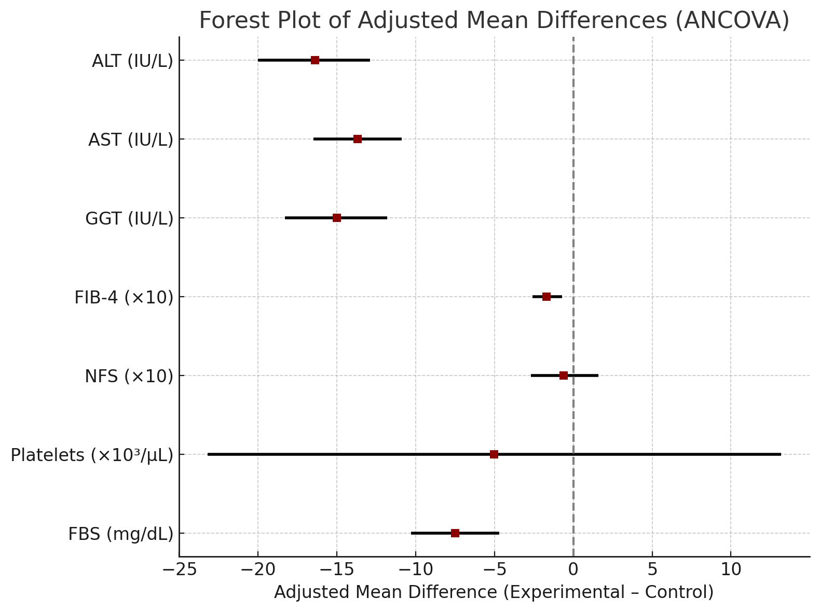

*Values were obtained using ANCOVA adjusted for baseline levels and age. Negative values indicate lower outcomes in the experimental group compared with the control group. Liver enzymes (ALT, AST, and GGT) and fasting blood sugar (FBS) showed significant reductions with empagliflozin compared to control. The FIB-4 index was also significantly lower in the intervention group, suggesting improved fibrosis. The NAFLD fibrosis score (NFS) showed no significant between-group difference. Platelet counts were comparable between groups. For visualization purposes, both FIB-4 and NFS values were multiplied by 10 to enhance visibility of effect sizes on the plot.
Supplementary Table 3. Mixed-effects model results for changes in liver and metabolic outcomes at 6 months in patients with type 2 diabetes and NAFLD.
Outcome | Model | Baseline Mean (Exp) | Baseline Mean (Ctrl) | 6-mo Mean (Exp) | 6-mo Mean (Ctrl) | Adjusted Mean Difference at 6 mo (95% CI) | p-value (Group×Time)
ALT (IU/L) | Mixed model (age-adjusted) | 71.9 | 48.5 | 29.4 | 43.9 | –14.5 (–21.5 to –7.6) | <0.001
AST (IU/L) | Mixed model (age-adjusted) | 46.1 | 43.4 | 27.7 | 40.0 | –12.3 (–15.6 to –9.0) * | <0.001
GGT (IU/L) | Mixed model (age-adjusted) | 60.3 | 43.6 | 34.0 | 41.5 | –7.5 (–11.0 to –4.0) * | <0.001
FBS (mg/dL) | Mixed model (age-adjusted) | 124.6 | 112.9 | 104.5 | 107.6 | –3.1 (–7.8 to +1.6) | <0.001
FIB-4 | Mixed model (age-adjusted) | 1.26 | 1.37 | 1.13 | 1.32 | –0.20 (–0.43 to +0.02) | 0.098
NFS | Mixed model (age-adjusted) | –1.21 | –0.70 | –1.09 | –0.70 | –0.38 (–0.91 to 0.15) | 0.261
Platelet count (×10³/µL) | Mixed model (age-adjusted) | 248.4 | 227.4 | 234.2 | 228.1 | +6.2 (–7.5 to +19.9) | 0.154

* Estimated marginal means (EMMs) with standard errors (SE) and 95% confidence intervals (CIs) are presented for each group (empagliflozin vs. control) at baseline and 6 months. Models were fitted using linear mixed-effects regression with restricted maximum likelihood (REML) estimation, including fixed effects for group (empagliflozin vs. control), time (baseline vs. 6 months), age, and the group × time interaction. Repeated measures were modeled with a compound symmetry covariance structure at the participant level. Reported p-values for group × time interaction test whether the change over time differed significantly between groups. Negative adjusted mean differences indicate greater reductions in the empagliflozin group compared with controls.

Supplementary Table 4. Subgroup analysis of empagliflozin dosage effects on liver and metabolic outcomes at 6 months (ANCOVA adjusted for baseline values and age)
Outcome | 10 mg adj. mean (95% CI) | 25 mg adj. mean (95% CI) | Adjusted mean difference (95% CI) | p-value
ALT (IU/L) | 31.0 (28.3 – 33.8) | 27.0 (21.8 – 32.3) | 3.98 (–2.04 to 9.99) | 0.192
AST (IU/L) | 29.0 (27.1 – 31.0) | 25.9 (22.1 – 29.6) | 3.19 (–1.03 to 7.41) | 0.136
GGT (IU/L) | 35.0 (32.5 – 37.4) | 30.6 (25.9 – 35.3) | 4.42 (–0.91 to 9.75) | 0.102
FIB-4 | 1.05 (0.99 – 1.11) | 1.08 (0.97 – 1.19) | –0.03 (–0.16 to 0.09) | 0.616
NFS | –1.29 (–1.45 to –1.13) | –0.87 (–1.17 to –0.57) | –0.42 (–0.77 to –0.08) | 0.017
PLT (/µL) | 244,504 (230,239 – 258,768) | 202,119 (174,752 – 229,487) | 42,385 (11,318 – 73,451) | 0.008
FBS (mg/dL) | 105.7 (103.6 – 107.7) | 99.9 (96.0 – 103.8) | 5.77 (1.29 – 10.24) | 0.012

* Supplementary Table 4 presents the subgroup analysis comparing 10 mg and 25 mg empagliflozin doses at 6 months, adjusted for baseline values and age. Outcomes included liver enzymes (ALT, AST, GGT), non-invasive fibrosis markers (FIB-4 and NFS), platelet counts, and fasting blood sugar (FBS). Estimated marginal means (95% CI) and adjusted mean differences with Bonferroni-corrected p-values are reported. Significant differences were observed in NFS, platelet counts, and FBS, while other outcomes showed no significant dose-related variation.

References
1. Cohen J. Statistical power analysis for the behavioral sciences: routledge; 2013.
2. Chow S-C, Shao J, Wang H, Lokhnygina Y. Sample size calculations in clinical research: chapman and hall/CRC; 2017.
3. Chehrehgosha H, Sohrabi MR, Ismail-Beigi F, Malek M, Reza Babaei M, Zamani F, et al. Empagliflozin Improves Liver Steatosis and Fibrosis in Patients with Non-Alcoholic Fatty Liver Disease and Type 2 Diabetes: A Randomized, Double-Blind, Placebo-Controlled Clinical Trial. Diabetes Therapy. 2021;12(3):843-61.

