Supplementary materials

Table S1. Location of genotype-specific primer bands in conventional AMHR2 knockout mice
Prime | Genotype | Location
F1/R1 | AMHR2^{-/-} | 686 bp
F2/R2 | WT | 446 bp

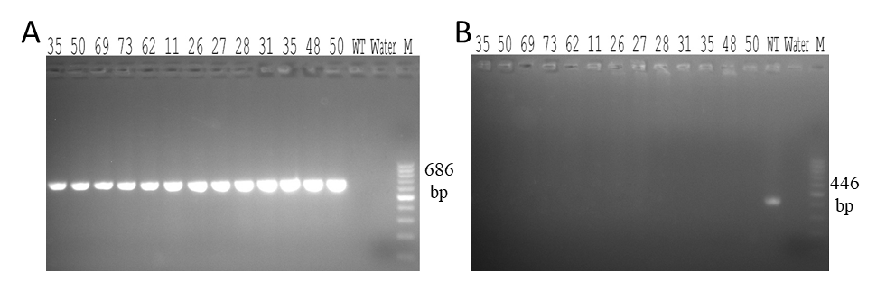
Figure S1. Genotype identification of conventional AMHR2 knockout mice. (A) AMHR2^{-/-} genotype identification result. (B) WT genotype identification result.

Table S2. Location of genotype-specific primer bands in conditional AMHR2 Knockout mice
Prime | Genotype | Location
F1/R1 | AMHR2^{flox/flox} | 202 bp
F1/R1 | WT | 134 bp
ObRb-Cre | ObRb^{Cre+} | 225 bp
Cyp19a1-IRES-Cre | Cyp19a1^{IRES/Cre+} | 337 bp

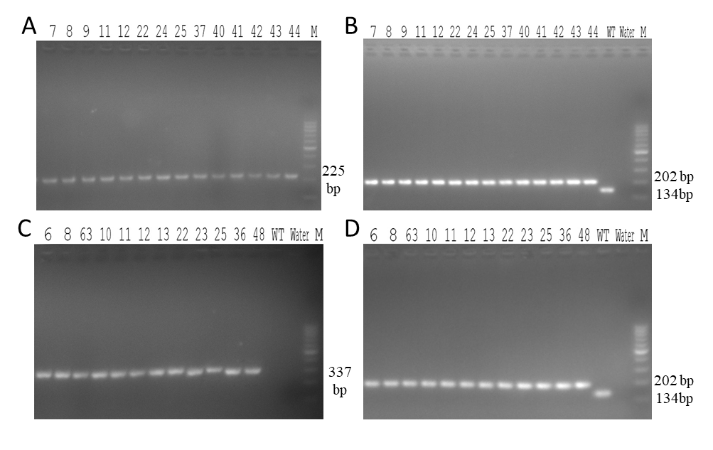
Figure S2. Genotype identification of conditional AMHR2 knockout mice. (A) ObRb^{Cre+} genotype identification result. (C) Cyp19a1^{IRES/Cre+} genotype identification result. (B, D) AMHR2^{flox/flox} and WT genotype identification result.

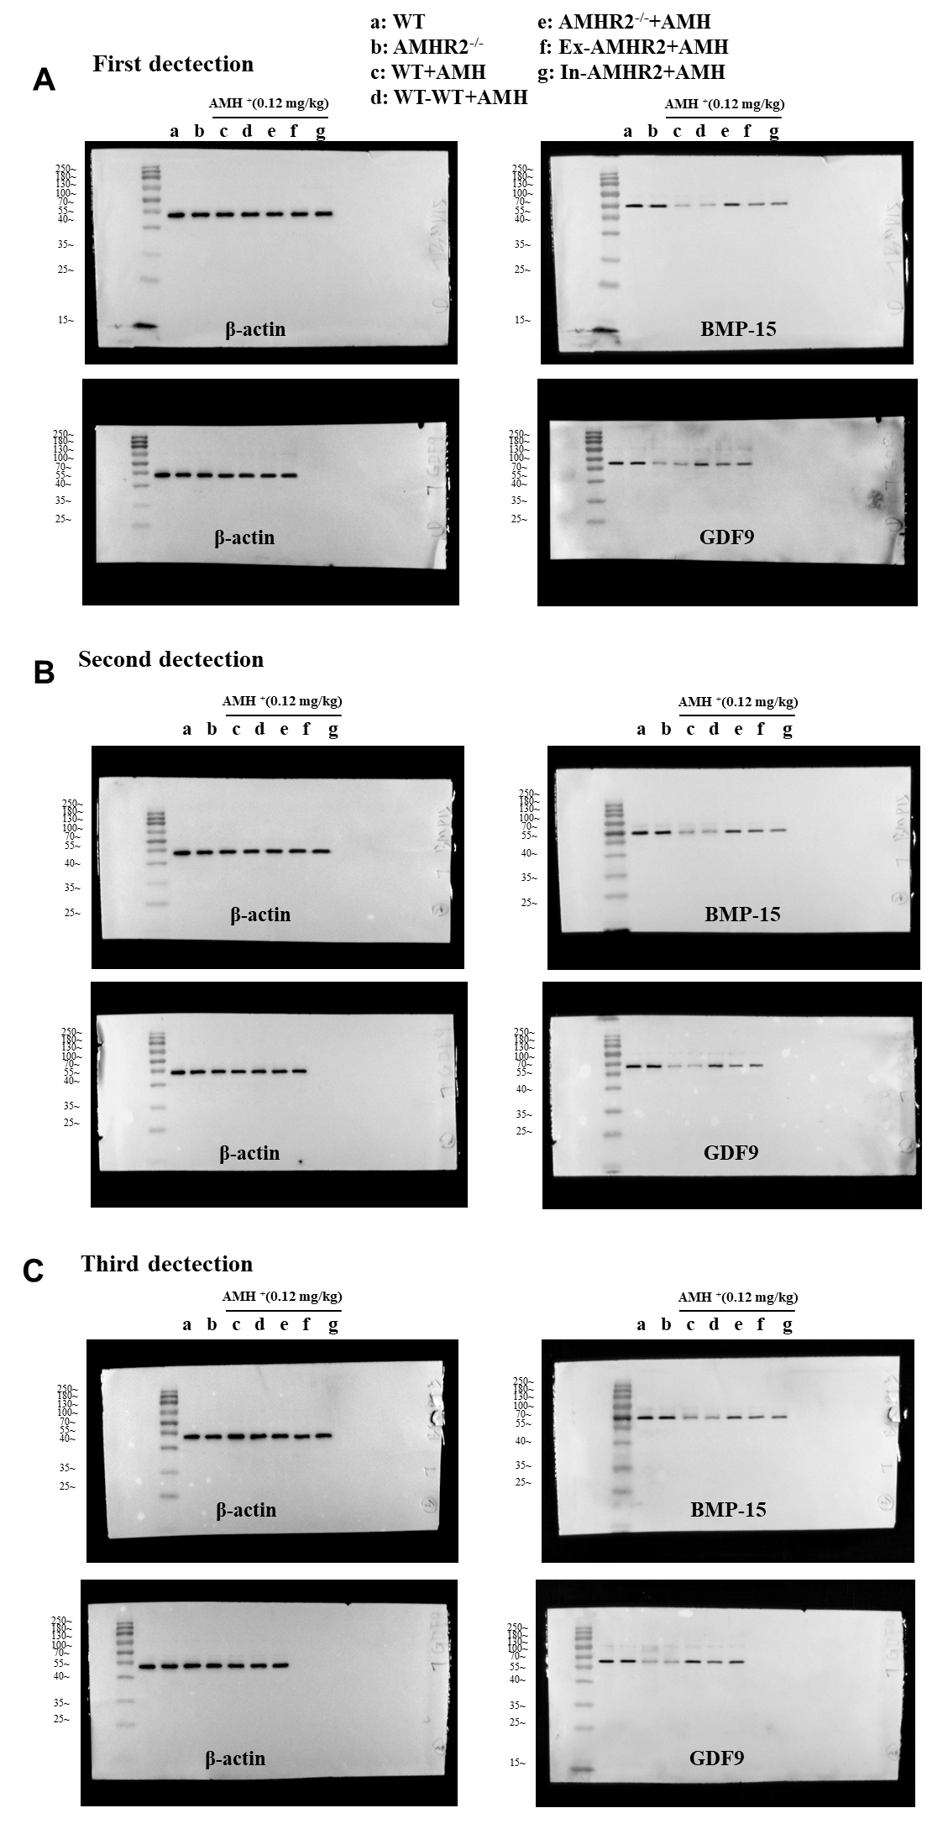
Figure S3. The uncropped three western blot detection images in Figure 2B of the manuscript.

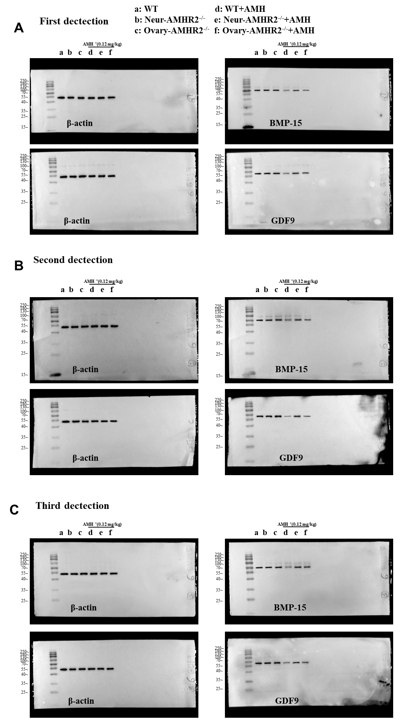
Figure S4. The uncropped three western blot detection images in Figure 2B of the manuscript.

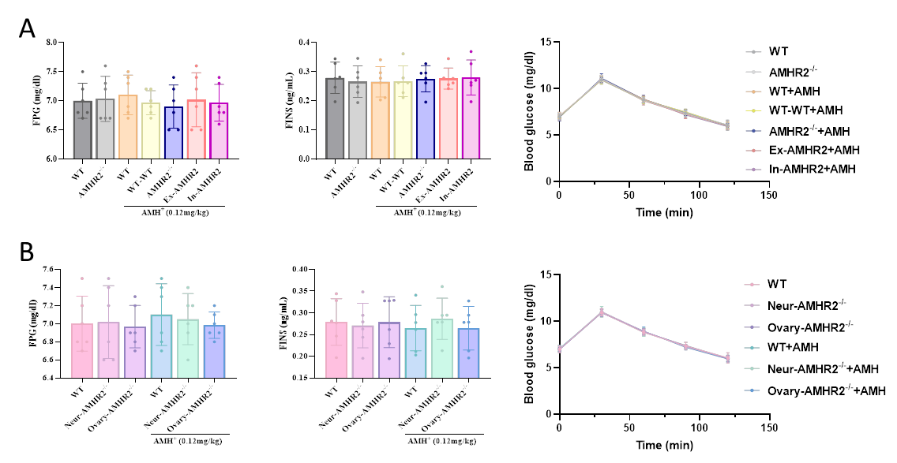
Figure S5 Assessment results of glucose metabolic homeostasis in mice from each group. (A) Results of fasting plsama glucose (FPG), fasting insulin (FINS), and intraperitoneal glucose tolerance test (IPGTT) in mice from each group in the reciprocal ovarian transplantation experiment (n = 6). (B) Results of fasting plsama glucose (FPG), fasting insulin (FINS), and intraperitoneal glucose tolerance test (IPGTT) in mice from each group in tissue-specific knockout experiments. (n = 6).

