Supplemental Materials

1. Supplemental Figures
Fig. S1 Research flowchart
Fig. S2 ROC curves comparing the discriminative ability of TITR, TIR, and HbA1c for albuminuria.
Fig. S3 ROC curves comparing the discriminative ability of TITR, TIR, and HbA1c for diabetic kidney disease.
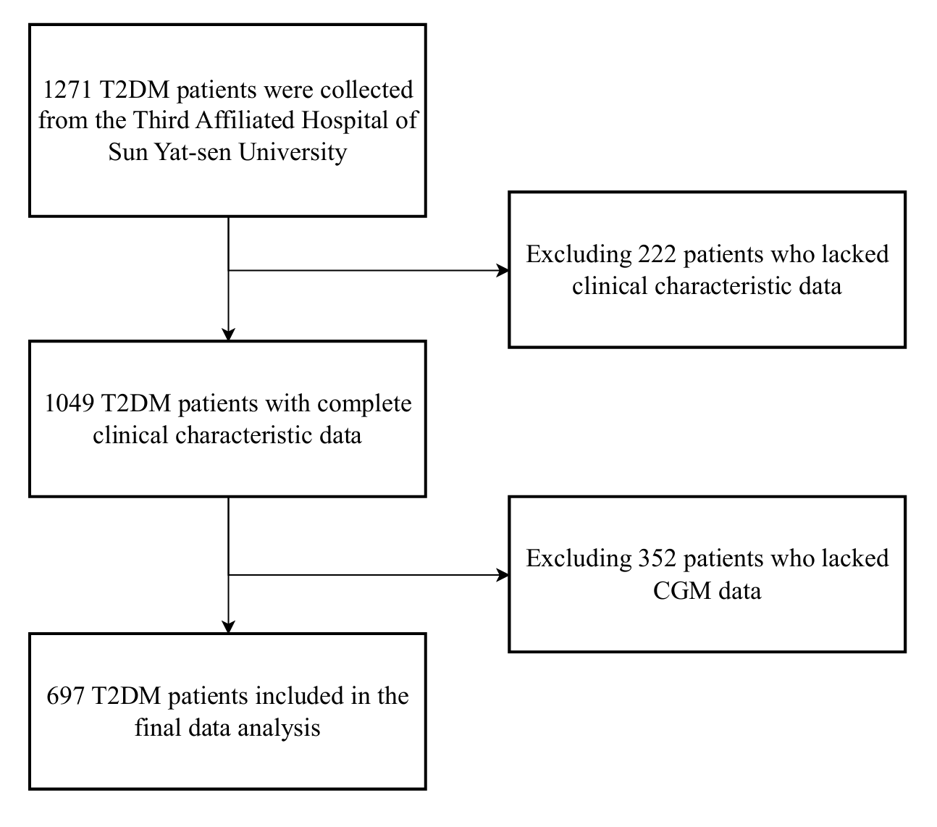
Fig. S1 Research flowchart

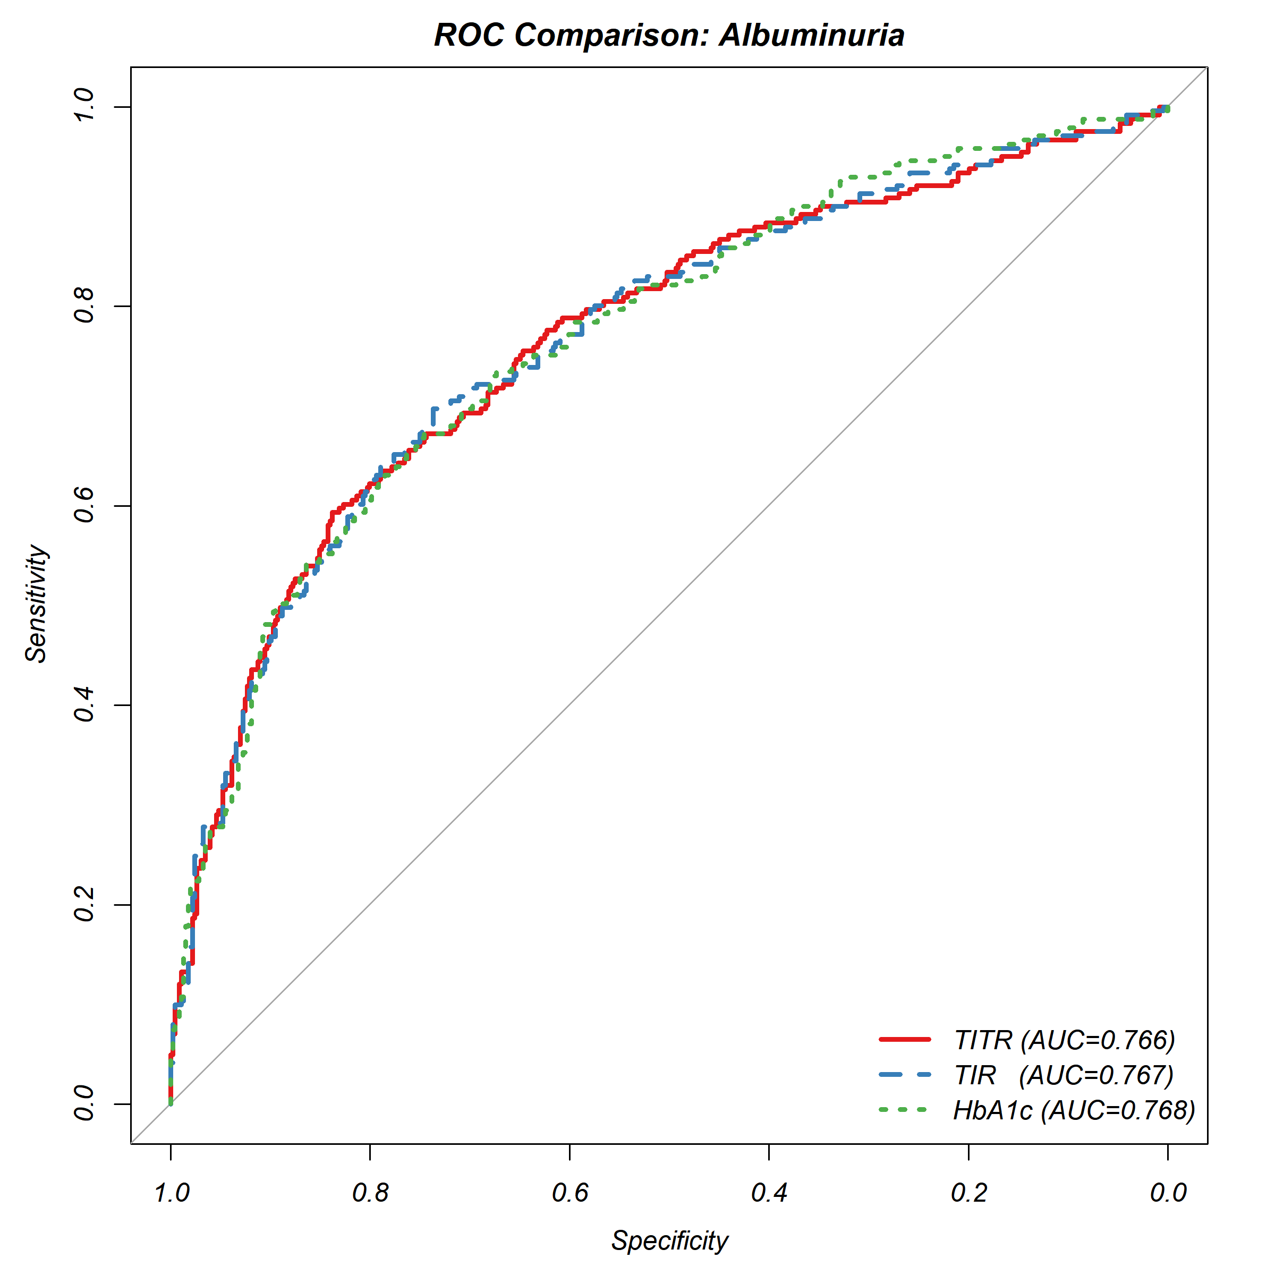
Fig. S2 ROC curves comparing the discriminative ability of TITR, TIR, and HbA1c for albuminuria.
Abbreviations: ROC, receiver operating characteristic; TITR, time in tight range; TIR, time in range; HbA1c, glycated hemoglobin.
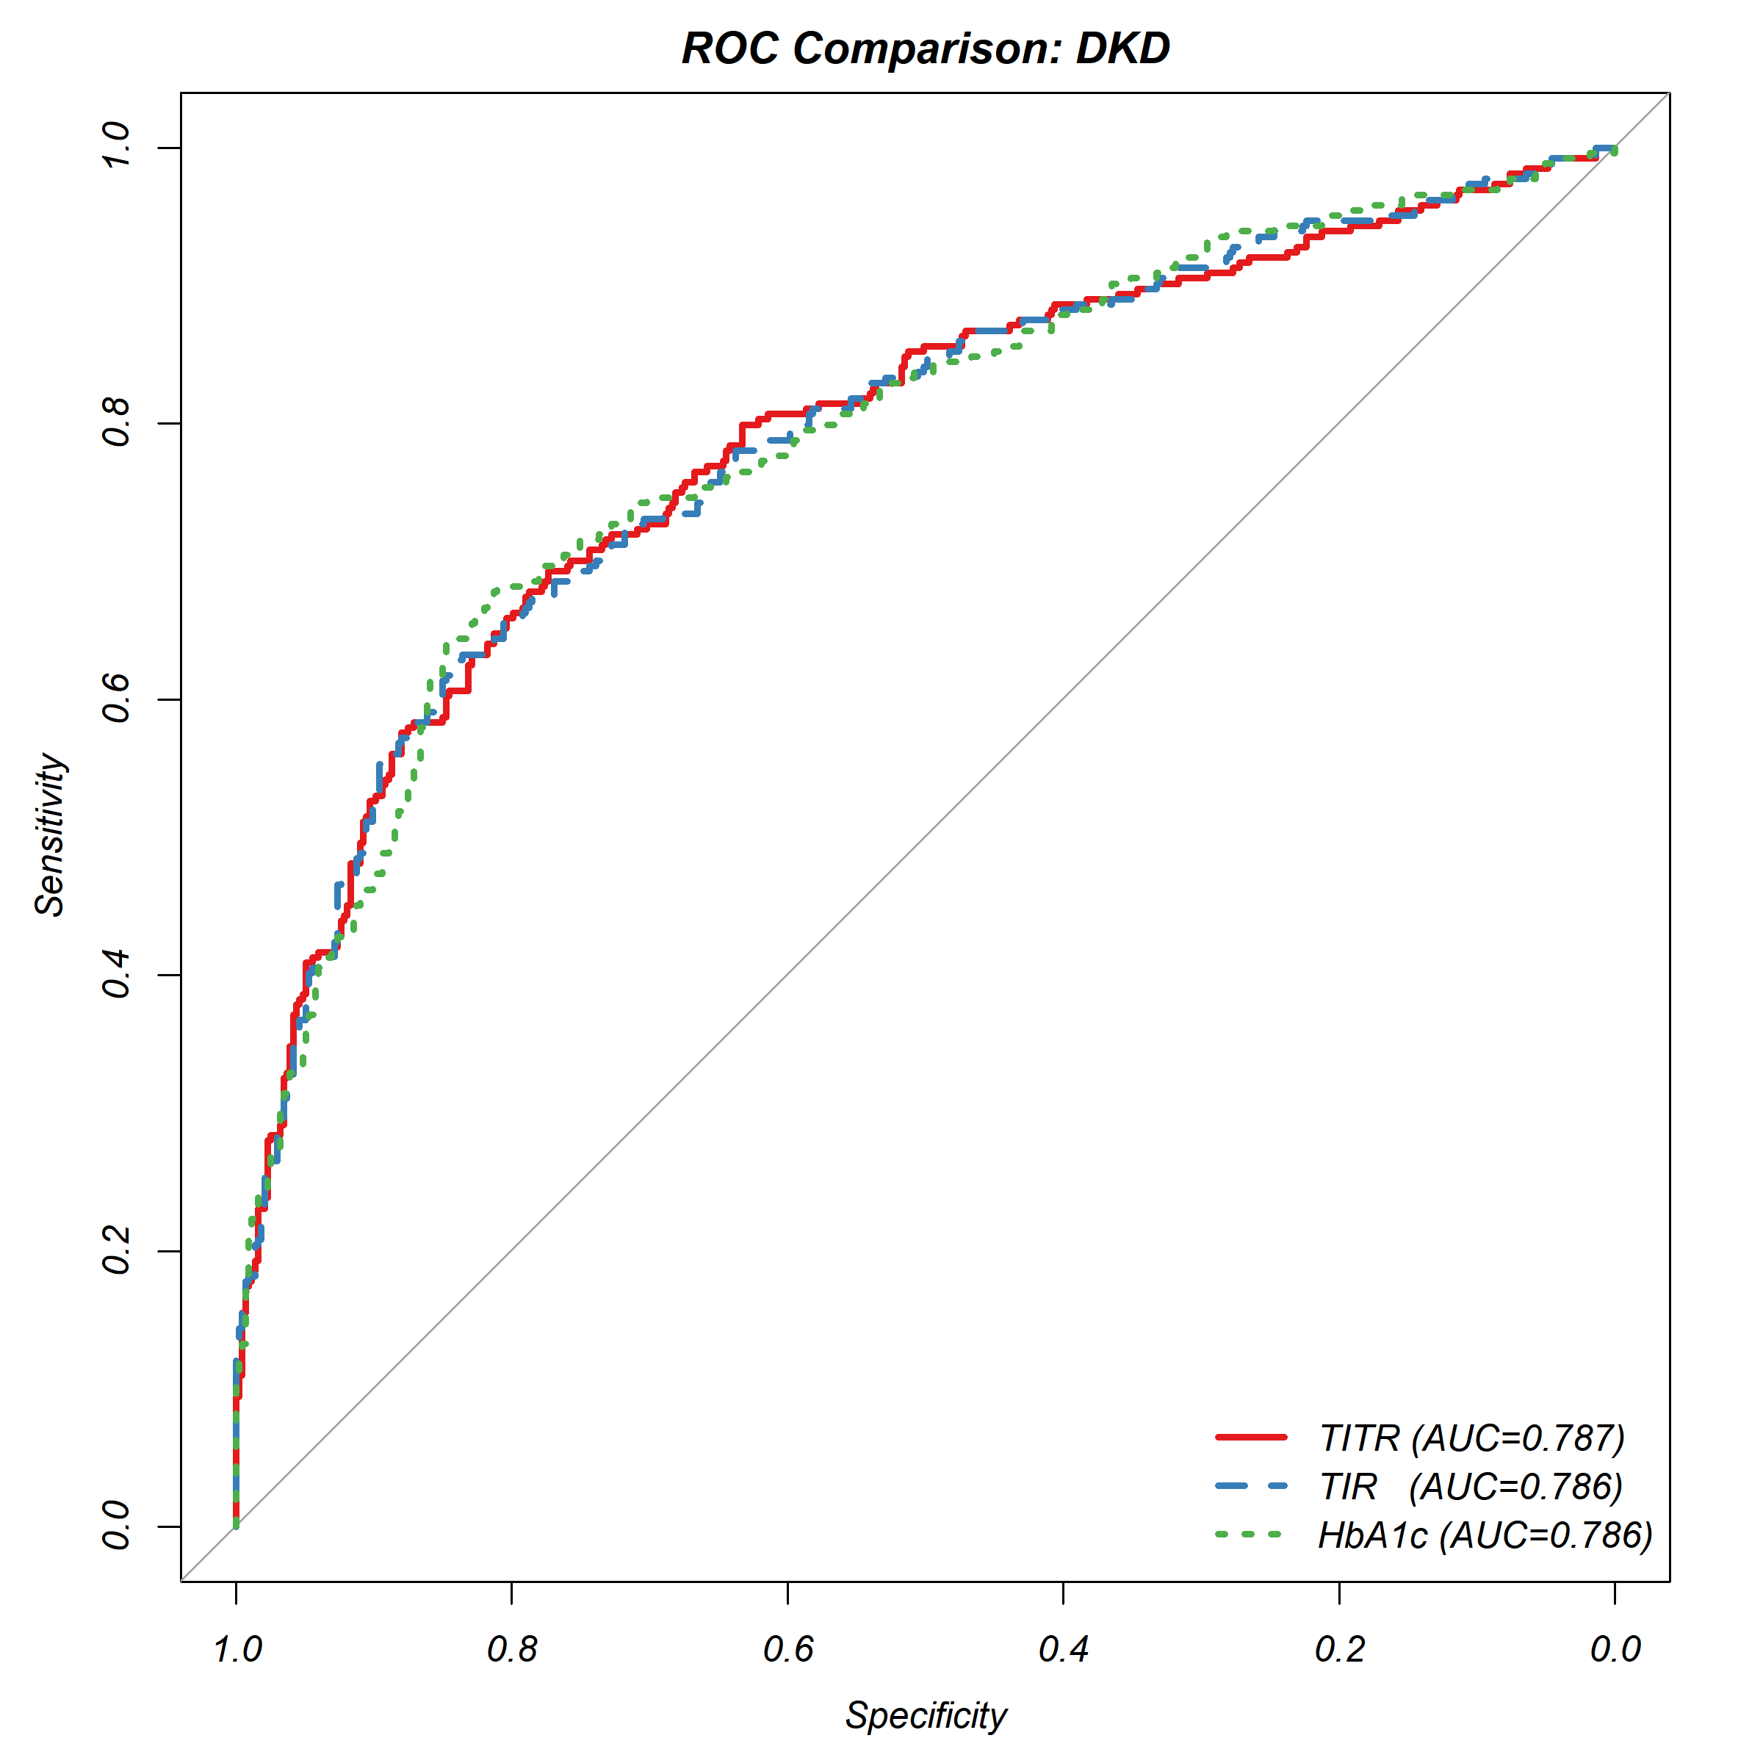
Fig. S3 ROC curves comparing the discriminative ability of TITR, TIR, and HbA1c for diabetic kidney disease.
Abbreviations: ROC, receiver operating characteristic; TITR, time in tight range; TIR, time in range; HbA1c, glycated hemoglobin.

2. Supplemental Tables: Variance Inflation Factors (VIFs) for Variables in Each Multivariate Model.

Table S1: Variance Inflation Factors for TITR and albuminuria, Model 2 (continuous)
Variable | VIF
TITR | 1.006661
Age | 1.110482
Sex | 1.184900
Educational levels | 1.230229

Table S2: Variance Inflation Factors for TITR and albuminuria, Model 3 (continuous)
Variable | VIF
TITR | 1.064098
Age | 1.571753
Sex | 1.345159
Diabetic duration | 1.705799
SBP | 1.072404
Educational levels | 1.279862
LDL-C | 1.199873
Lp(a) | 1.111766
HGB | 1.334789
ALT | 1.041160
Diabetic retinopathy | 1.084760
Diabetic foot | 1.030935
Stroke | 1.044851
No medication | 1.626005
Sulfonylureas&Meglitinides | 1.312511
ACEI/ARB | 1.060865
Insulin | 1.433208
Table S3: Variance Inflation Factors for TITR and albuminuria, Model 4 (continuous)
Variable | VIF
TITR | 1.196889
Age | 1.902200
Sex | 1.416923
Diabetic duration | 1.783662
SBP | 1.079772
Educational levels | 1.307049
LDL-C | 1.284160
Lp(a) | 1.146477
UA | 1.214067
HGB | 1.378132
ALT | 1.055199
HOMA2-%B | 1.356053
HOMA2-IR | 1.193375
Diabetic retinopathy | 1.091161
Diabetic peripheral vascular disease | 1.251349
Diabetic foot | 1.039182
Cardiovascular disease | 1.139785
Stroke | 1.061064
No medication | 1.884030
Sulfonylureas&Meglitinides | 1.360633
a-glucosidaseinhibitor | 1.138997
SGLT2-i | 1.238340
GLP1-RA | 1.084940
ACEI/ARB | 1.110080
Insulin | 1.454335

Table S4: Variance Inflation Factors for TITR and albuminuria, Model 2 (categorical)
Variable | GVIF | Df | GVIF^(1/(2*Df))
TITR.quantile | 1.012084 | 2 | 1.003008
Age | 1.113952 | 1 | 1.055439
Sex | 1.188290 | 1 | 1.090087
Educational levels | 1.233058 | 1 | 1.110431

Table S5: Variance Inflation Factors for TITR and albuminuria, Model 3 (categorical)
Variable | GVIF | Df | GVIF^(1/(2*Df))
TITR.quantile | 1.110726 | 2 | 1.026601
Age | 1.578192 | 1 | 1.256261
Sex | 1.347859 | 1 | 1.160973
Diabetic duration | 1.699232 | 1 | 1.303546
SBP | 1.082107 | 1 | 1.040244
Educational levels | 1.279056 | 1 | 1.130954
LDL-C | 1.199655 | 1 | 1.095288
Lp(a) | 1.116764 | 1 | 1.056770
HGB | 1.334708 | 1 | 1.155296
ALT | 1.041319 | 1 | 1.020451
Diabetic retinopathy | 1.087717 | 1 | 1.042937
Diabetic foot | 1.044193 | 1 | 1.021858
Stroke | 1.052395 | 1 | 1.025863
No medication | 1.620999 | 1 | 1.273185
Sulfonylureas&Meglitinides | 1.300072 | 1 | 1.140207
ACEI/ARB | 1.063311 | 1 | 1.031170
Insulin | 1.433977 | 1 | 1.197488

Table S6: Variance Inflation Factors for TITR and albuminuria, Model 4 (categorical)
Variable | GVIF | Df | GVIF^(1/(2*Df))
TITR.quantile | 1.267748 | 2 | 1.061105
Age | 1.913600 | 1 | 1.383329
Sex | 1.415291 | 1 | 1.189660
Diabetic duration | 1.778497 | 1 | 1.333603
SBP | 1.092714 | 1 | 1.045330
Educational levels | 1.306275 | 1 | 1.142924
LDL-C | 1.289029 | 1 | 1.135354
Lp(a) | 1.151209 | 1 | 1.072944
UA | 1.218896 | 1 | 1.104036
HGB | 1.377580 | 1 | 1.173704
ALT | 1.056368 | 1 | 1.027798
HOMA2-%B | 1.338974 | 1 | 1.157140
HOMA2-IR | 1.194165 | 1 | 1.092779
Diabetic retinopathy | 1.094850 | 1 | 1.046351
Diabetic peripheral vascular disease | 1.253708 | 1 | 1.119691
Diabetic foot | 1.052152 | 1 | 1.025745
Cardiovascular disease | 1.143548 | 1 | 1.069368
Stroke | 1.067304 | 1 | 1.033104
No medication | 1.877201 | 1 | 1.370110
Sulfonylureas&Meglitinides | 1.345189 | 1 | 1.159823
a-glucosidaseinhibitor | 1.141157 | 1 | 1.068249
SGLT2-i | 1.243043 | 1 | 1.114918
GLP1-RA | 1.101780 | 1 | 1.049657
ACEI/ARB | 1.114771 | 1 | 1.055827
Insulin | 1.457942 | 1 | 1.207453

Table S7: Variance Inflation Factors for TIR and albuminuria, Model 2 (continuous)
Variable | VIF
TIR | 1.005724
Age | 1.108363
Sex | 1.185690
Educational levels | 1.233371

Table S8: Variance Inflation Factors for TIR and albuminuria, Model 3 (continuous)
Variable | VIF
TIR | 1.060635
Age | 1.566408
Sex | 1.345129
Diabetic duration | 1.704399
SBP | 1.074789
Educational levels | 1.284059
LDL-C | 1.196009
Lp(a) | 1.111378
HGB | 1.334159
ALT | 1.040207
Diabetic retinopathy | 1.083935
Diabetic foot | 1.031011
Stroke | 1.043515
No medication | 1.646316
Sulfonylureas&Meglitinides | 1.313132
ACEI/ARB | 1.059938
Insulin | 1.433114

Table S9: Variance Inflation Factors for TIR and albuminuria, Model 4 (continuous)
Variable | VIF
TIR | 1.173961
Age | 1.890300
Sex | 1.417980
Diabetic duration | 1.787866
SBP | 1.081910
Educational levels | 1.311816
LDL-C | 1.283579
Lp(a) | 1.146642
UA | 1.228182
HGB | 1.376599
ALT | 1.054110
HOMA2-%B | 1.305642
HOMA2-IR | 1.190139
Diabetic retinopathy | 1.090217
Diabetic peripheral vascular disease | 1.247867
Diabetic foot | 1.041665
Cardiovascular disease | 1.138267
Stroke | 1.060595
No medication | 1.900496
Sulfonylureas&Meglitinides | 1.357472
a-glucosidaseinhibitor | 1.137214
SGLT2-i | 1.245205
GLP1-RA | 1.085044
ACEI/ARB | 1.112331
Insulin | 1.453986

Table S10: Variance Inflation Factors for TIR and albuminuria, Model 2 (categorical)
Variable | GVIF | Df | GVIF^(1/(2*Df))
TIR.quantile | 1.012508 | 2 | 1.003112
Age | 1.107368 | 1 | 1.052316
Sex | 1.184961 | 1 | 1.088559
Educational levels | 1.236866 | 1 | 1.112145

Table S11: Variance Inflation Factors for TIR and albuminuria, Model 3 (categorical)
Variable | GVIF | Df | GVIF^(1/(2*Df))
TIR.quantile | 1.119477 | 2 | 1.028617
Age | 1.560715 | 1 | 1.249286
Sex | 1.339890 | 1 | 1.157536
Diabetic duration | 1.698256 | 1 | 1.303172
SBP | 1.082551 | 1 | 1.040457
Educational levels | 1.286629 | 1 | 1.134297
LDL-C | 1.199711 | 1 | 1.095313
Lp(a) | 1.121929 | 1 | 1.059211
HGB | 1.334067 | 1 | 1.155018
ALT | 1.040249 | 1 | 1.019926
Diabetic retinopathy | 1.083892 | 1 | 1.041101
Diabetic foot | 1.031377 | 1 | 1.015568
Stroke | 1.054566 | 1 | 1.026921
No medication | 1.656703 | 1 | 1.287130
Sulfonylureas&Meglitinides | 1.324181 | 1 | 1.150730
ACEI/ARB | 1.063071 | 1 | 1.031053
Insulin | 1.429271 | 1 | 1.195521

Table S12: Variance Inflation Factors for TIR and albuminuria, Model 4 (categorical)
Variable | GVIF | Df | GVIF^(1/(2*Df))
TIR.quantile | 1.266879 | 2 | 1.060923
Age | 1.879701 | 1 | 1.371022
Sex | 1.407355 | 1 | 1.186320
Diabetic duration | 1.783085 | 1 | 1.335322
SBP | 1.093193 | 1 | 1.045559
Educational levels | 1.311870 | 1 | 1.145369
LDL-C | 1.287193 | 1 | 1.134545
Lp(a) | 1.154721 | 1 | 1.074579
UA | 1.227897 | 1 | 1.108105
HGB | 1.376341 | 1 | 1.173176
ALT | 1.054282 | 1 | 1.026783
HOMA2-%B | 1.311835 | 1 | 1.145354
HOMA2-IR | 1.198651 | 1 | 1.094829
Diabetic retinopathy | 1.089916 | 1 | 1.043991
Diabetic peripheral vascular disease | 1.254714 | 1 | 1.120140
Diabetic foot | 1.041156 | 1 | 1.020370
Cardiovascular disease | 1.138458 | 1 | 1.066985
Stroke | 1.072394 | 1 | 1.035565
No medication | 1.916688 | 1 | 1.384445
Sulfonylureas&Meglitinides | 1.367306 | 1 | 1.169319
a-glucosidaseinhibitor | 1.137443 | 1 | 1.066510
SGLT2-i | 1.247045 | 1 | 1.116712
GLP1-RA | 1.089660 | 1 | 1.043868
ACEI/ARB | 1.111569 | 1 | 1.054310
Insulin | 1.452147 | 1 | 1.205051

Table S13: Variance Inflation Factors for HbA1c and albuminuria, Model 2 (continuous)
Variable | VIF
HbA1c | 1.039094
Age | 1.145106
Sex | 1.184222
Educational levels | 1.228358

Table S14: Variance Inflation Factors for HbA1c and albuminuria, Model 3 (continuous)
Variable | VIF
HbA1c | 1.223472
Age | 1.565847
Sex | 1.341031
Diabetic duration | 1.691712
SBP | 1.069641
Educational levels | 1.275591
LDL-C | 1.257117
Lp(a) | 1.110164
HGB | 1.329268
ALT | 1.041659
Diabetic retinopathy | 1.085817
Diabetic foot | 1.037018
Stroke | 1.044239
No medication | 1.682374
Sulfonylureas&Meglitinides | 1.302146
ACEI/ARB | 1.068889
Insulin | 1.410691

Table S15: Variance Inflation Factors for HbA1c and albuminuria, Model 4 (continuous)
Variable | VIF
HbA1c | 1.492227
Age | 1.905546
Sex | 1.414456
Diabetic duration | 1.778639
SBP | 1.078741
Educational levels | 1.300074
LDL-C | 1.318103
Lp(a) | 1.146518
UA | 1.206381
HGB | 1.367349
ALT | 1.056724
HOMA2-%B | 1.419120
HOMA2-IR | 1.189981
Diabetic retinopathy | 1.094697
Diabetic peripheral vascular disease | 1.264691
Diabetic foot | 1.043724
Cardiovascular disease | 1.136698
Stroke | 1.064818
No medication | 1.921234
Sulfonylureas&Meglitinides | 1.346110
a-glucosidaseinhibitor | 1.132561
SGLT2-i | 1.251266
GLP1-RA | 1.079893
ACEI/ARB | 1.116268
Insulin | 1.439635

Table S16: Variance Inflation Factors for HbA1c and albuminuria, Model 2 (categorical)
Variable | GVIF | Df | GVIF^(1/(2*Df))
HbA1c.quantile | 1.063724 | 2 | 1.015564
Age | 1.164520 | 1 | 1.079129
Sex | 1.184255 | 1 | 1.088235
Educational levels | 1.233956 | 1 | 1.110836

Table S17: Variance Inflation Factors for HbA1c and albuminuria, Model 3 (categorical)
Variable | GVIF | Df | GVIF^(1/(2*Df))
HbA1c.quantile | 1.274270 | 2 | 1.062467
Age | 1.585138 | 1 | 1.259023
Sex | 1.341983 | 1 | 1.158440
Diabetic duration | 1.703279 | 1 | 1.305097
SBP | 1.068262 | 1 | 1.033567
Educational levels | 1.291359 | 1 | 1.136380
LDL-C | 1.239003 | 1 | 1.113105
Lp(a) | 1.114307 | 1 | 1.055607
HGB | 1.335294 | 1 | 1.155549
ALT | 1.040512 | 1 | 1.020055
Diabetic retinopathy | 1.095645 | 1 | 1.046731
Diabetic foot | 1.042925 | 1 | 1.021237
Stroke | 1.046880 | 1 | 1.023171
No medication | 1.659302 | 1 | 1.288139
Sulfonylureas&Meglitinides | 1.305614 | 1 | 1.142635
ACEI/ARB | 1.076476 | 1 | 1.037534
Insulin | 1.421442 | 1 | 1.192242

Table S18: Variance Inflation Factors for HbA1c and albuminuria, Model 4 (categorical)
Variable | GVIF | Df | GVIF^(1/(2*Df))
HbA1c.quantile | 1.600997 | 2 | 1.124858
Age | 1.922810 | 1 | 1.386654
Sex | 1.414144 | 1 | 1.189178
Diabetic duration | 1.792742 | 1 | 1.338933
SBP | 1.077821 | 1 | 1.038182
Educational levels | 1.314087 | 1 | 1.146336
LDL-C | 1.305207 | 1 | 1.142457
Lp(a) | 1.148657 | 1 | 1.071754
UA | 1.206768 | 1 | 1.098530
HGB | 1.373426 | 1 | 1.171933
ALT | 1.054261 | 1 | 1.026772
HOMA2-%B | 1.419833 | 1 | 1.191568
HOMA2-IR | 1.209595 | 1 | 1.099816
Diabetic retinopathy | 1.104453 | 1 | 1.050930
Diabetic peripheral vascular disease | 1.260381 | 1 | 1.122667
Diabetic foot | 1.049365 | 1 | 1.024385
Cardiovascular disease | 1.136173 | 1 | 1.065914
Stroke | 1.068418 | 1 | 1.033643
No medication | 1.904789 | 1 | 1.380141
Sulfonylureas&Meglitinides | 1.352889 | 1 | 1.163138
a-glucosidaseinhibitor | 1.134573 | 1 | 1.065163
SGLT2-i | 1.259157 | 1 | 1.122121
GLP1-RA | 1.081032 | 1 | 1.039727
ACEI/ARB | 1.123787 | 1 | 1.060088
Insulin | 1.451681 | 1 | 1.204857

Table S19: Variance Inflation Factors for TITR and DKD, Model 2 (continuous)
Variable | VIF
TITR | 1.006298
Age | 1.103060
Sex | 1.189311
Educational levels | 1.224182

Table S20: Variance Inflation Factors for TITR and DKD, Model 3 (continuous)
Variable | VIF
TITR | 1.199016
Age | 1.819371
Diabetic duration | 1.739350
SBP | 1.053871
Educational levels | 1.205807
LDL-C | 1.180083
UA | 1.197920
HGB | 1.193014
ALT | 1.035982
HOMA2-%B | 1.303235
HOMA2-IR | 1.152081
Diabetic retinopathy | 1.090807
Diabetic peripheral vascular disease | 1.233675
Diabetic foot | 1.027961
Cardiovascular disease | 1.112713
No medication | 1.734078
Sulfonylureas&Meglitinides | 1.313473
a-glucosidaseinhibitor | 1.126885
ACEI/ARB | 1.072503
Insulin | 1.437295

Table S21: Variance Inflation Factors for TITR and DKD, Model 4 (continuous)
Variable | VIF
TITR | 1.199485
Age | 1.854579
Sex | 1.431305
Diabetic duration | 1.751972
SBP | 1.079074
Educational levels | 1.303648
LDL-C | 1.270148
Lp(a) | 1.141373
UA | 1.249203
HGB | 1.379114
ALT | 1.058099
HOMA2-%B | 1.317190
HOMA2-IR | 1.179580
Diabetic retinopathy | 1.088239
Diabetic peripheral vascular disease | 1.250733
Diabetic foot | 1.030983
Cardiovascular disease | 1.129272
Stroke | 1.063366
No medication | 1.922734
Sulfonylureas&Meglitinides | 1.358276
a-glucosidaseinhibitor | 1.140528
SGLT2-i | 1.257731
GLP1-RA | 1.092388
ACEI/ARB | 1.100318
Insulin | 1.450885

Table S22: Variance Inflation Factors for TITR and DKD, Model 2 (categorical)
Variable | GVIF | Df | GVIF^(1/(2*Df))
TITR.quantile | 1.013396 | 2 | 1.003332
Age | 1.106921 | 1 | 1.052103
Sex | 1.192878 | 1 | 1.092190
Educational levels | 1.226592 | 1 | 1.107516

Table S23: Variance Inflation Factors for TITR and DKD, Model 3 (categorical)
Variable | GVIF | Df | GVIF^(1/(2*Df))
TITR.quantile | 1.229932 | 2 | 1.053102
Age | 1.835003 | 1 | 1.354623
Diabetic duration | 1.733992 | 1 | 1.316811
SBP | 1.069122 | 1 | 1.033983
Educational levels | 1.204334 | 1 | 1.097421
LDL-C | 1.184593 | 1 | 1.088390
UA | 1.205195 | 1 | 1.097814
HGB | 1.195711 | 1 | 1.093486
ALT | 1.038363 | 1 | 1.019001
HOMA2-%B | 1.290158 | 1 | 1.135851
HOMA2-IR | 1.155414 | 1 | 1.074902
Diabetic retinopathy | 1.095746 | 1 | 1.046779
Diabetic peripheral vascular disease | 1.236549 | 1 | 1.112002
Diabetic foot | 1.039054 | 1 | 1.019340
Cardiovascular disease | 1.116017 | 1 | 1.056417
No medication | 1.724833 | 1 | 1.313329
Sulfonylureas&Meglitinides | 1.299495 | 1 | 1.139954
a-glucosidaseinhibitor | 1.128876 | 1 | 1.062486
ACEI/ARB | 1.075032 | 1 | 1.036837
Insulin | 1.439553 | 1 | 1.199814

Table S24: Variance Inflation Factors for TITR and DKD, Model 4 (categorical)
Variable | GVIF | Df | GVIF^(1/(2*Df))
TITR.quantile | 1.269988 | 2 | 1.061573
Age | 1.867131 | 1 | 1.366430
Sex | 1.430960 | 1 | 1.196227
Diabetic duration | 1.747256 | 1 | 1.321838
SBP | 1.095331 | 1 | 1.046581
Educational levels | 1.302439 | 1 | 1.141245
LDL-C | 1.273002 | 1 | 1.128274
Lp(a) | 1.144161 | 1 | 1.069655
UA | 1.252450 | 1 | 1.119129
HGB | 1.381711 | 1 | 1.175462
ALT | 1.058171 | 1 | 1.028674
HOMA2-%B | 1.306011 | 1 | 1.142808
HOMA2-IR | 1.183084 | 1 | 1.087697
Diabetic retinopathy | 1.093833 | 1 | 1.045865
Diabetic peripheral vascular disease | 1.253339 | 1 | 1.119526
Diabetic foot | 1.042604 | 1 | 1.021080
Cardiovascular disease | 1.133743 | 1 | 1.064773
Stroke | 1.067674 | 1 | 1.033283
No medication | 1.914277 | 1 | 1.383574
Sulfonylureas&Meglitinides | 1.345828 | 1 | 1.160098
a-glucosidaseinhibitor | 1.142551 | 1 | 1.068902
SGLT2-i | 1.261551 | 1 | 1.123188
GLP1-RA | 1.107250 | 1 | 1.052260
ACEI/ARB | 1.104540 | 1 | 1.050971
Insulin | 1.454331 | 1 | 1.205956

Table S25: Variance Inflation Factors for TIR and DKD, Model 2 (continuous)
Variable | VIF
TIR | 1.006283
Age | 1.101498
Sex | 1.189921
Educational levels | 1.227424

Table S26: Variance Inflation Factors for TIR and DKD, Model 3 (continuous)
Variable | VIF
TIR | 1.168739
Age | 1.807522
Diabetic duration | 1.737988
SBP | 1.054849
Educational levels | 1.207971
LDL-C | 1.178638
UA | 1.212340
HGB | 1.191607
ALT | 1.036098
HOMA2-%B | 1.249983
HOMA2-IR | 1.149587
Diabetic retinopathy | 1.088571
Diabetic peripheral vascular disease | 1.228499
Diabetic foot | 1.028685
Cardiovascular disease | 1.111576
No medication | 1.759385
Sulfonylureas&Meglitinides | 1.314805
a-glucosidaseinhibitor | 1.125577
ACEI/ARB | 1.073562
Insulin | 1.430461

Table S27: Variance Inflation Factors for TIR and DKD, Model 4 (continuous)
Variable | VIF
TIR | 1.176472
Age | 1.840004
Sex | 1.432193
Diabetic duration | 1.755211
SBP | 1.080054
Educational levels | 1.307687
LDL-C | 1.269349
Lp(a) | 1.141060
UA | 1.265277
HGB | 1.374854
ALT | 1.055622
HOMA2-%B | 1.265064
HOMA2-IR | 1.175955
Diabetic retinopathy | 1.086870
Diabetic peripheral vascular disease | 1.245623
Diabetic foot | 1.031198
Cardiovascular disease | 1.128132
Stroke | 1.062309
No medication | 1.933528
Sulfonylureas&Meglitinides | 1.355408
a-glucosidaseinhibitor | 1.138146
SGLT2-i | 1.263420
GLP1-RA | 1.092717
ACEI/ARB | 1.101939
Insulin | 1.445261

Table S28: Variance Inflation Factors for TIR and DKD, Model 2 (categorical)
Variable | GVIF | Df | GVIF^(1/(2*Df))
TIR.quantile | 1.014387 | 2 | 1.003577
Age | 1.100346 | 1 | 1.048974
Sex | 1.188566 | 1 | 1.090214
Educational levels | 1.230930 | 1 | 1.109473

Table S29: Variance Inflation Factors for TIR and DKD, Model 3 (categorical)
Variable | GVIF | Df | GVIF^(1/(2*Df))
TIR.quantile | 1.239127 | 2 | 1.055064
Age | 1.801190 | 1 | 1.342084
Diabetic duration | 1.733017 | 1 | 1.316441
SBP | 1.065997 | 1 | 1.032471
Educational levels | 1.213092 | 1 | 1.101404
LDL-C | 1.179998 | 1 | 1.086277
UA | 1.216207 | 1 | 1.102818
HGB | 1.196128 | 1 | 1.093677
ALT | 1.037591 | 1 | 1.018622
HOMA2-%B | 1.259883 | 1 | 1.122445
HOMA2-IR | 1.157283 | 1 | 1.075771
Diabetic retinopathy | 1.088397 | 1 | 1.043263
Diabetic peripheral vascular disease | 1.235204 | 1 | 1.111397
Diabetic foot | 1.028201 | 1 | 1.014003
Cardiovascular disease | 1.115440 | 1 | 1.056144
No medication | 1.776730 | 1 | 1.332940
Sulfonylureas&Meglitinides | 1.324928 | 1 | 1.151055
a-glucosidaseinhibitor | 1.126081 | 1 | 1.061169
ACEI/ARB | 1.073368 | 1 | 1.036035
Insulin | 1.432524 | 1 | 1.196881

Table S30: Variance Inflation Factors for TIR and DKD, Model 4 (categorical)
Variable | GVIF | Df | GVIF^(1/(2*Df))
TIR.quantile | 1.272495 | 2 | 1.062097
Age | 1.834284 | 1 | 1.354357
Sex | 1.421098 | 1 | 1.192098
Diabetic duration | 1.751753 | 1 | 1.323538
SBP | 1.095688 | 1 | 1.046751
Educational levels | 1.307382 | 1 | 1.143408
LDL-C | 1.271522 | 1 | 1.127618
Lp(a) | 1.147523 | 1 | 1.071225
UA | 1.267496 | 1 | 1.125831
HGB | 1.375902 | 1 | 1.172988
ALT | 1.055858 | 1 | 1.027550
HOMA2-%B | 1.274131 | 1 | 1.128774
HOMA2-IR | 1.186522 | 1 | 1.089276
Diabetic retinopathy | 1.085745 | 1 | 1.041991
Diabetic peripheral vascular disease | 1.253369 | 1 | 1.119540
Diabetic foot | 1.030832 | 1 | 1.015299
Cardiovascular disease | 1.131474 | 1 | 1.063708
Stroke | 1.071737 | 1 | 1.035247
No medication | 1.952144 | 1 | 1.397192
Sulfonylureas&Meglitinides | 1.364075 | 1 | 1.167936
a-glucosidaseinhibitor | 1.138931 | 1 | 1.067207
SGLT2-i | 1.266501 | 1 | 1.125389
GLP1-RA | 1.096679 | 1 | 1.047225
ACEI/ARB | 1.101860 | 1 | 1.049695
Insulin | 1.444647 | 1 | 1.201935

Table S31: Variance Inflation Factors for HbA1c and DKD, Model 2 (continuous)
Variable | VIF
HbA1c | 1.038312
Age | 1.137267
Sex | 1.187947
Educational levels | 1.221629

Table S32: Variance Inflation Factors for HbA1c and DKD, Model 3 (continuous)
Variable | VIF
HbA1c | 1.474122
Age | 1.830229
Diabetic duration | 1.735400
SBP | 1.054617
Educational levels | 1.195707
LDL-C | 1.203947
UA | 1.186511
HGB | 1.190932
ALT | 1.038562
HOMA2-%B | 1.378277
HOMA2-IR | 1.147933
Diabetic retinopathy | 1.093867
Diabetic peripheral vascular disease | 1.244459
Diabetic foot | 1.028749
Cardiovascular disease | 1.110748
No medication | 1.783852
Sulfonylureas&Meglitinides | 1.308030
a-glucosidaseinhibitor | 1.122453
ACEI/ARB | 1.081325
Insulin | 1.421327

Table S33: Variance Inflation Factors for HbA1c and DKD, Model 4 (continuous)
Variable | VIF
HbA1c | 1.490929
Age | 1.861511
Sex | 1.428464
Diabetic duration | 1.756452
SBP | 1.076165
Educational levels | 1.294546
LDL-C | 1.295447
Lp(a) | 1.139892
UA | 1.236762
HGB | 1.368777
ALT | 1.057720
HOMA2-%B | 1.396033
HOMA2-IR | 1.178685
Diabetic retinopathy | 1.092083
Diabetic peripheral vascular disease | 1.263219
Diabetic foot | 1.032636
Cardiovascular disease | 1.126614
Stroke | 1.067124
No medication | 1.946184
Sulfonylureas&Meglitinides | 1.347493
a-glucosidaseinhibitor | 1.132780
SGLT2-i | 1.266207
GLP1-RA | 1.085569
ACEI/ARB | 1.109133
Insulin | 1.438676

Table S34: Variance Inflation Factors for HbA1c and DKD, Model 2 (categorical)
Variable | GVIF | Df | GVIF^(1/(2*Df))
HbA1c.quantile | 1.061740 | 2 | 1.015090
Age | 1.154259 | 1 | 1.074365
Sex | 1.187497 | 1 | 1.089723
Educational levels | 1.227625 | 1 | 1.107982

Table S35: Variance Inflation Factors for HbA1c and DKD, Model 3 (categorical)
Variable | GVIF | Df | GVIF^(1/(2*Df))
HbA1c.quantile | 1.554425 | 2 | 1.116587
Age | 1.842113 | 1 | 1.357245
Diabetic duration | 1.750345 | 1 | 1.323006
SBP | 1.052265 | 1 | 1.025800
Educational levels | 1.211724 | 1 | 1.100783
LDL-C | 1.194013 | 1 | 1.092709
UA | 1.187573 | 1 | 1.089758
HGB | 1.195652 | 1 | 1.093459
ALT | 1.036451 | 1 | 1.018063
HOMA2-%B | 1.377547 | 1 | 1.173690
HOMA2-IR | 1.173598 | 1 | 1.083327
Diabetic retinopathy | 1.101516 | 1 | 1.049531
Diabetic peripheral vascular disease | 1.236339 | 1 | 1.111908
Diabetic foot | 1.033332 | 1 | 1.016529
Cardiovascular disease | 1.111275 | 1 | 1.054170
No medication | 1.759942 | 1 | 1.326628
Sulfonylureas&Meglitinides | 1.312169 | 1 | 1.145499
a-glucosidaseinhibitor | 1.124790 | 1 | 1.060561
ACEI/ARB | 1.090677 | 1 | 1.044355
Insulin | 1.432998 | 1 | 1.197079

Table S36: Variance Inflation Factors for HbA1c and DKD, Model 4 (categorical)
Variable | GVIF | Df | GVIF^(1/(2*Df))
HbA1c.quantile | 1.596797 | 2 | 1.124119
Age | 1.877713 | 1 | 1.370297
Sex | 1.431915 | 1 | 1.196626
Diabetic duration | 1.771640 | 1 | 1.331030
SBP | 1.074339 | 1 | 1.036503
Educational levels | 1.308624 | 1 | 1.143951
LDL-C | 1.285869 | 1 | 1.133962
Lp(a) | 1.142444 | 1 | 1.068852
UA | 1.237258 | 1 | 1.112321
HGB | 1.376461 | 1 | 1.173227
ALT | 1.055164 | 1 | 1.027212
HOMA2-%B | 1.396979 | 1 | 1.181939
HOMA2-IR | 1.202302 | 1 | 1.096495
Diabetic retinopathy | 1.099610 | 1 | 1.048623
Diabetic peripheral vascular disease | 1.257324 | 1 | 1.121305
Diabetic foot | 1.036901 | 1 | 1.018283
Cardiovascular disease | 1.127204 | 1 | 1.061699
Stroke | 1.071184 | 1 | 1.034980
No medication | 1.929742 | 1 | 1.389152
Sulfonylureas&Meglitinides | 1.351810 | 1 | 1.162674
a-glucosidaseinhibitor | 1.135272 | 1 | 1.065492
SGLT2-i | 1.275136 | 1 | 1.129219
GLP1-RA | 1.087551 | 1 | 1.042857
ACEI/ARB | 1.115392 | 1 | 1.056121
Insulin | 1.448908 | 1 | 1.203706

