Supplementary Table 1. The literature search strategy for the databases.
Databases | Search Strategy | Finding
Web of science | ((TS=(Alpha Ketoglutarate Dependent Dioxygenase FTO OR FTO, Alpha-Ketoglutarate-Dependent Dioxygenase OR Alpha-Ketoglutarate-Dependent Dioxygenase OR Alpha Ketoglutarate Dependent Dioxygenase OR Dioxygenase, Alpha-Ketoglutarate-Dependent OR Fat Mass and Obesity Associated (FTO) Protein OR Fat Mass and Obesity Associated Protein OR AlkB Homolog 9 Protein)) AND TS=(Obesity OR Obesity, Abdominal OR Obesity, Morbid OR Body Weight OR Body Size OR Overweight)) AND TS=(Adult OR Frail Elderly OR Middle Aged OR Young Adult OR Aged + OR Adults, Young OR Adult, Young OR Young Adults) | 2500
PubMed | ((Alpha Ketoglutarate Dependent Dioxygenase FTO[Title/Abstract] OR FTO, Alpha-Ketoglutarate-Dependent Dioxygenase[Title/Abstract] OR Alpha-Ketoglutarate-Dependent Dioxygenase[Title/Abstract] OR Alpha Ketoglutarate Dependent Dioxygenase[Title/Abstract] OR Dioxygenase, Alpha-Ketoglutarate-Dependent[Title/Abstract] OR Fat Mass[Title/Abstract] AND Obesity Associated (FTO) Protein[Title/Abstract] OR Fat Mass[Title/Abstract] AND Obesity Associated Protein[Title/Abstract] OR AlkB Homolog 9 Protein[Title/Abstract]) AND (Obesity[Title/Abstract] OR Obesity, Abdominal[Title/Abstract] OR Obesity, Morbid[Title/Abstract] OR Body Weight[Title/Abstract] OR Body Size[Title/Abstract] OR Overweight[Title/Abstract])) AND (Adult[Title/Abstract] OR Frail Elderly[Title/Abstract] OR Middle Aged[Title/Abstract] OR Young Adult[Title/Abstract] OR Aged +[Title/Abstract] OR Adults, Young[Title/Abstract] OR Adult, Young[Title/Abstract] OR Young Adults[Title/Abstract]) | 20
Scopus | ( TITLE-ABS-KEY ( "Alpha Ketoglutarate Dependent Dioxygenase FTO" OR "FTO, Alpha-Ketoglutarate-Dependent Dioxygenase" OR "Alpha-Ketoglutarate-Dependent Dioxygenase" OR "Alpha Ketoglutarate Dependent Dioxygenase" OR "Dioxygenase, Alpha-Ketoglutarate-Dependent" OR "Fat Mass and Obesity Associated (FTO) Protein" OR "Fat Mass and Obesity Associated Protein" OR "AlkB Homolog 9 Protein" ) AND TITLE-ABS-KEY ( "Obesity" OR "Obesity, Abdominal" OR "Obesity, Morbid" OR "Body Weight" OR "Body Size" OR "Overweight" ) AND TITLE-ABS-KEY ( "Adult" OR "Frail Elderly" OR "Middle Aged" OR "Young Adult" OR "Aged +" OR "Adults, Young" OR "Adult, Young" OR "Young Adults" ) ) | 622

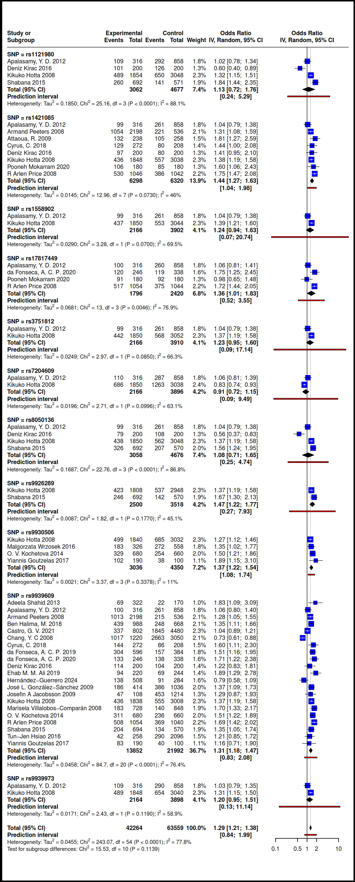
Supplementary Figure 1. The forest plot in adult obese individual in the Allelic model.
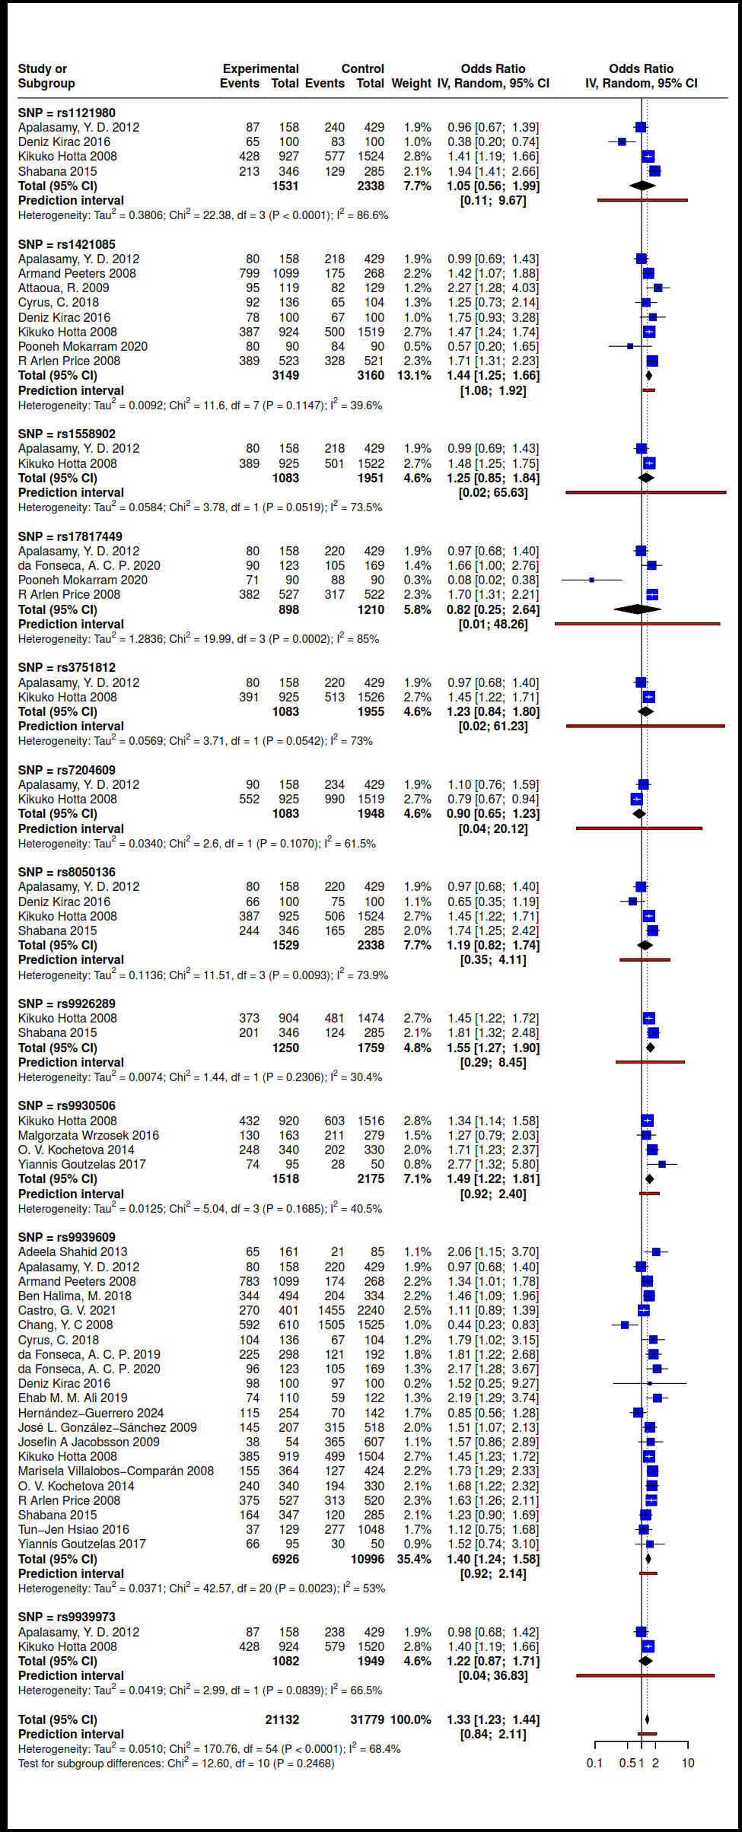
Supplementary Figure 2. The forest plot in adult obese individual in the Dominant model.
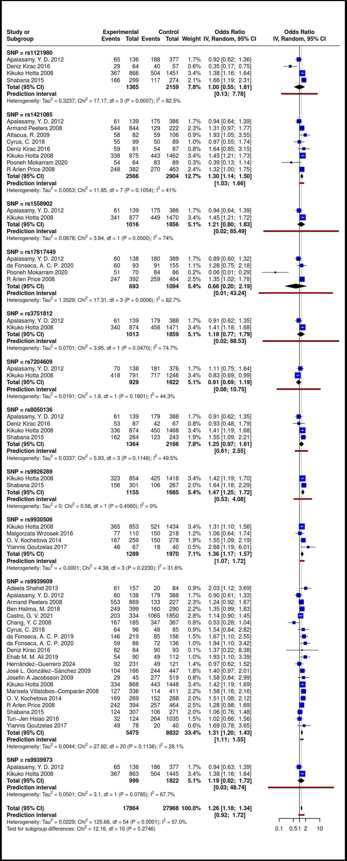
Supplementary Figure 3. The forest plot in adult obese individual in the Co-Dominant model (Heterozygous).
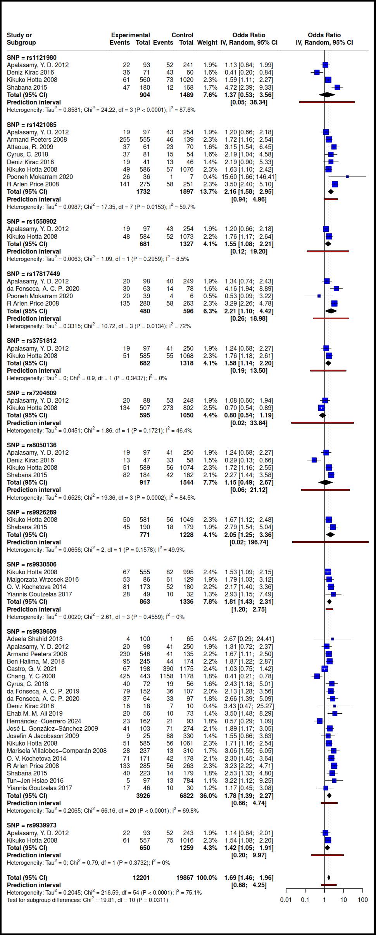
Supplementary Figure 4. The forest plot in adult obese individual in the Co-Dominant model (Homozygous).
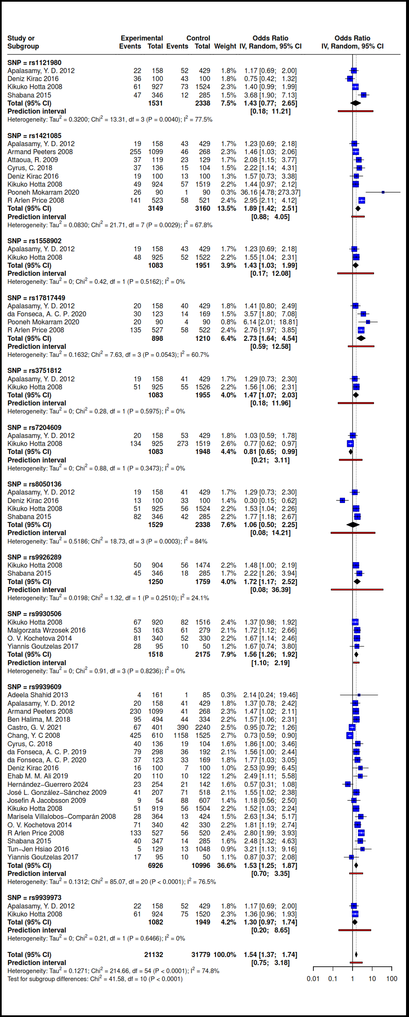
Supplementary Figure 5. The forest plot in adult obese individual in the Recessive model.
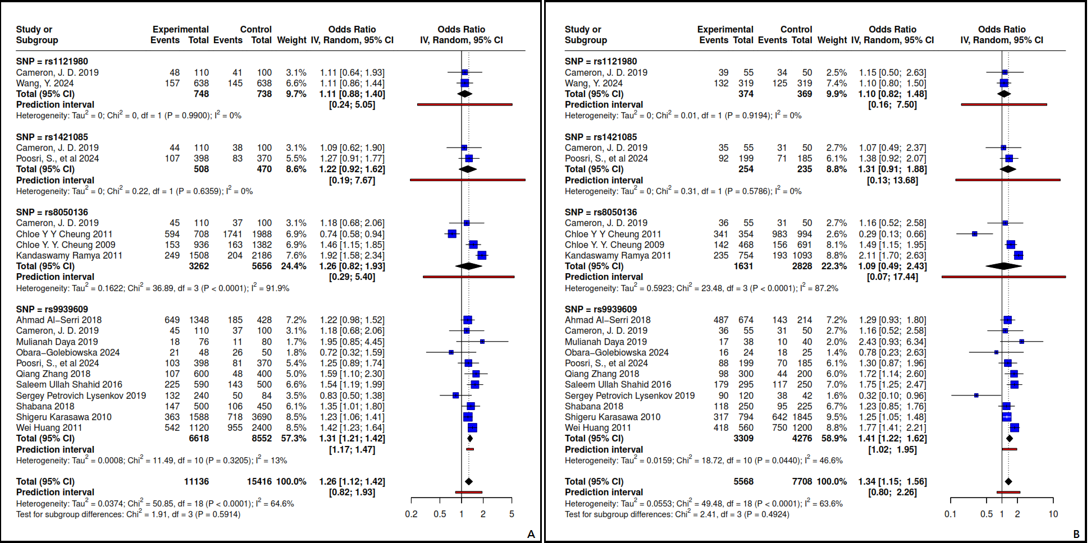
Supplementary Figure 6. The forest plot of FTO gene polymorphisms in adult Overweight and Obesity. A) Allelic, B) Dominant.

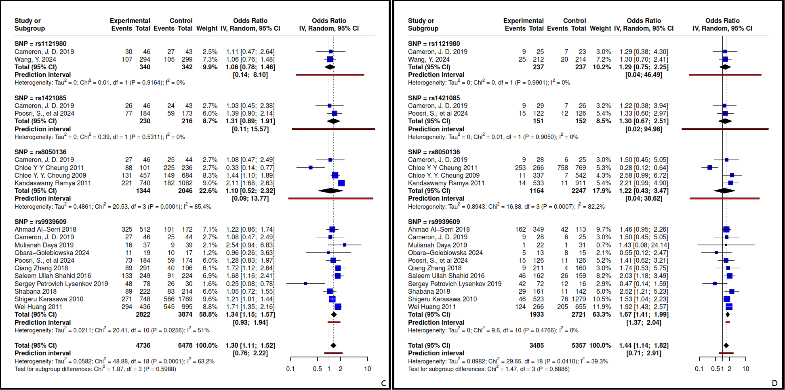
Supplementary Figure 7. The forest plot of FTO gene polymorphisms in adult Overweight and Obesity. C) Heterozygous, D) Homozygous.

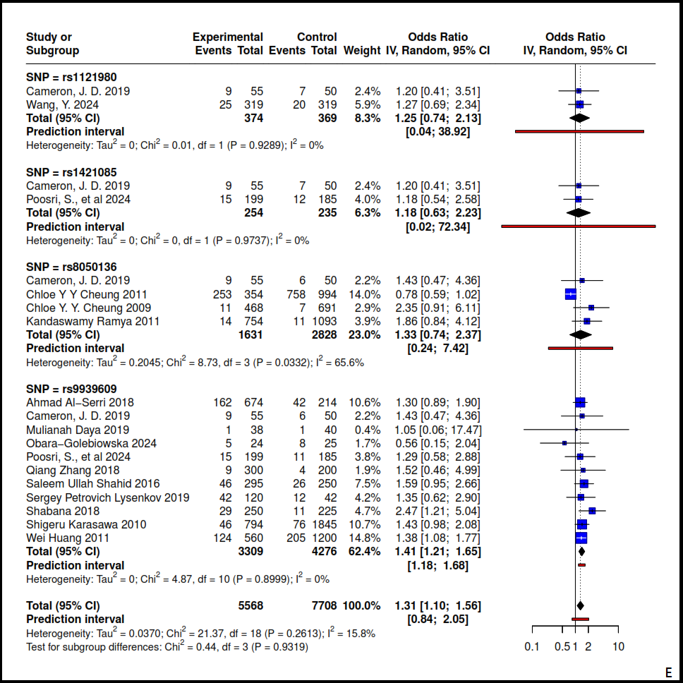
Supplementary Figure 8. The forest plot of FTO gene polymorphisms in adult Overweight and Obesity.
E) Recessive.
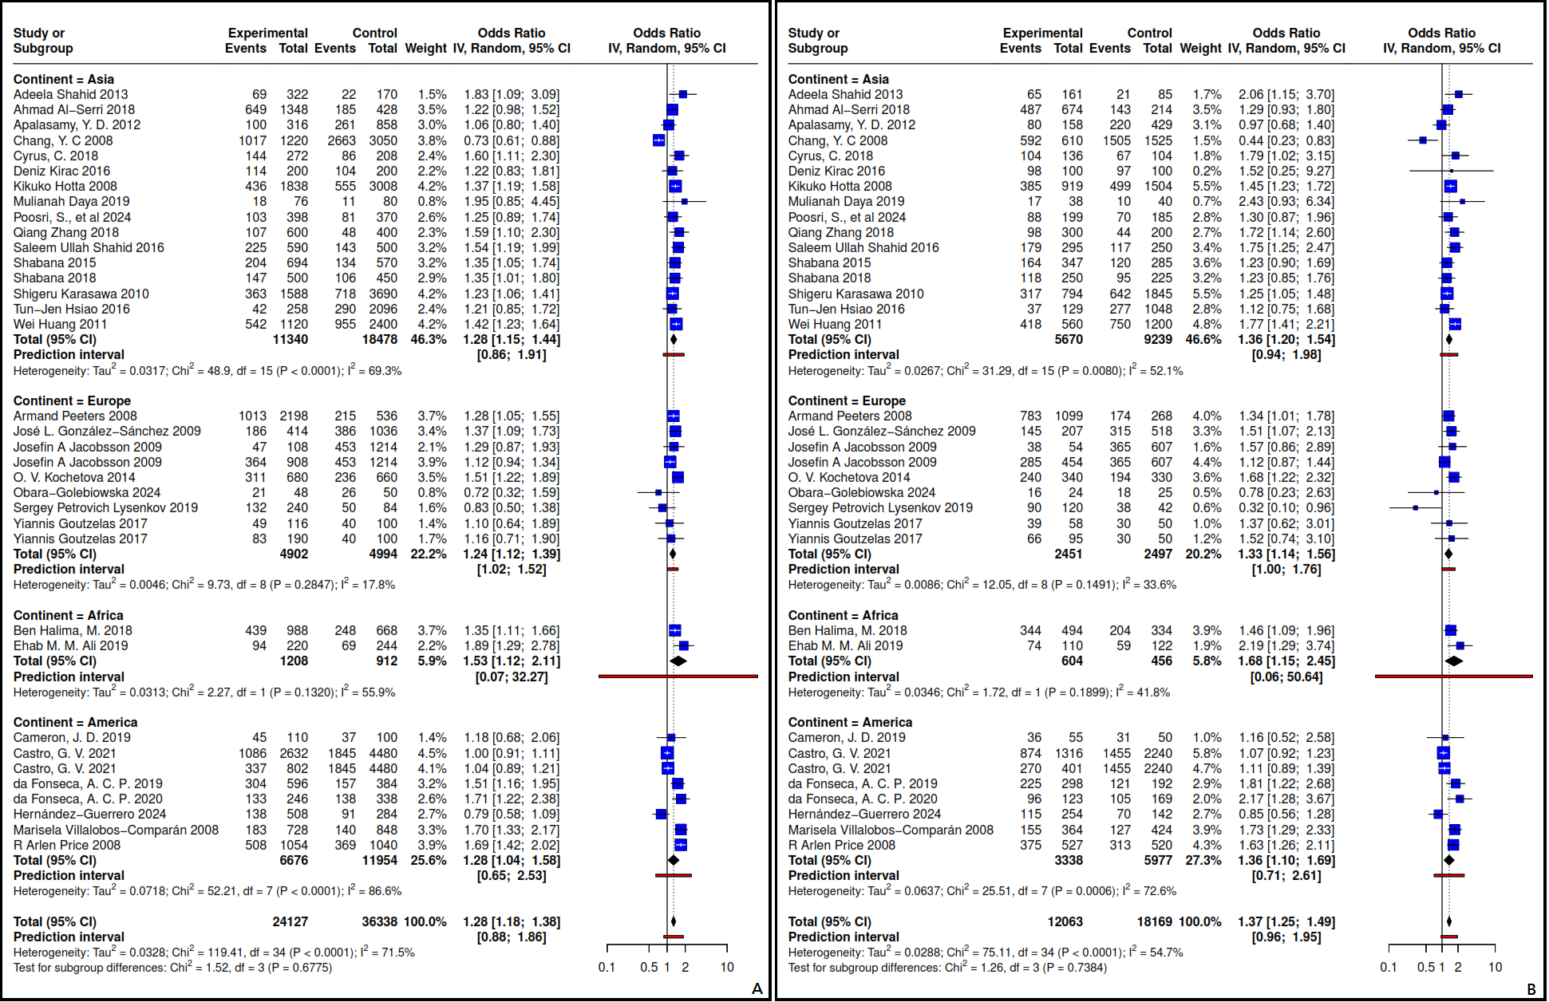
Supplementary Figure 9. The forest plot of rs9939609 in adult Overweight/Obesity in the geographic region. A) Allelic, B) Dominant.

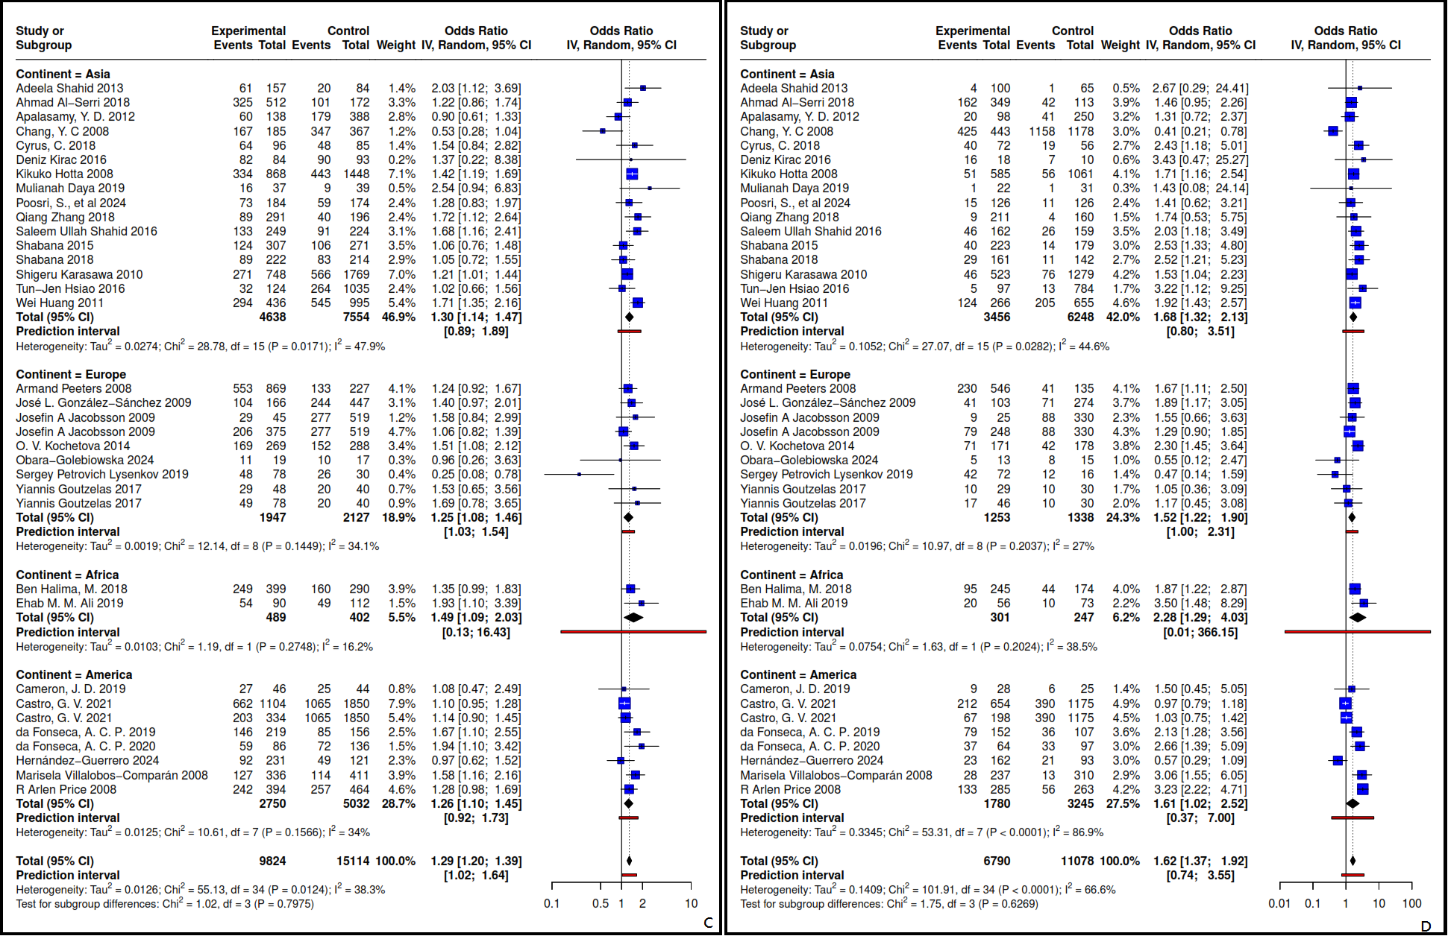
Supplementary Figure 10. The forest plot of rs9939609 in adult Overweight/Obesity in the geographic region. C) Heterozygous, D) Homozygous.

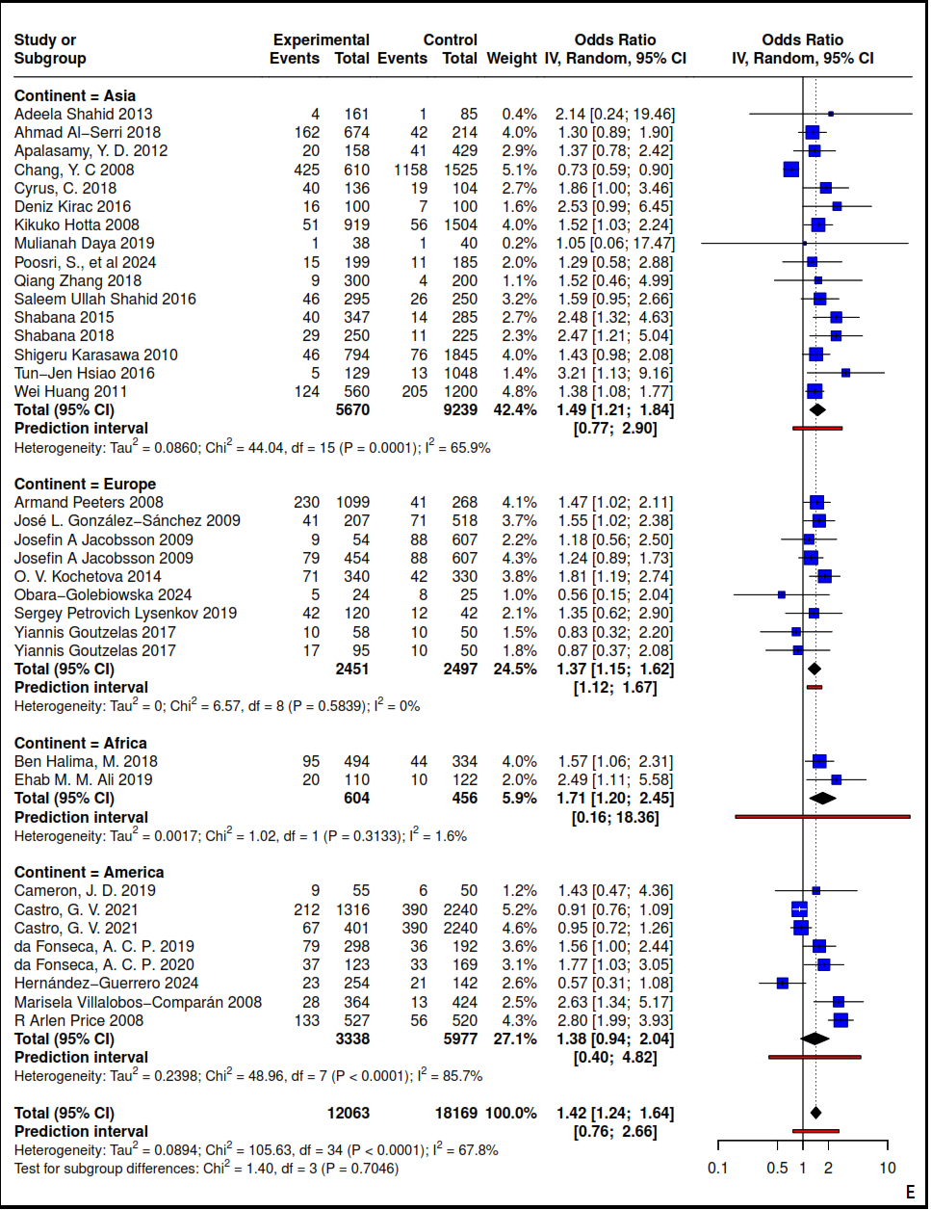
Supplementary Figure 11. The forest plot of rs9939609 in adult Overweight/Obesity in the geographic region. E) Recessive.

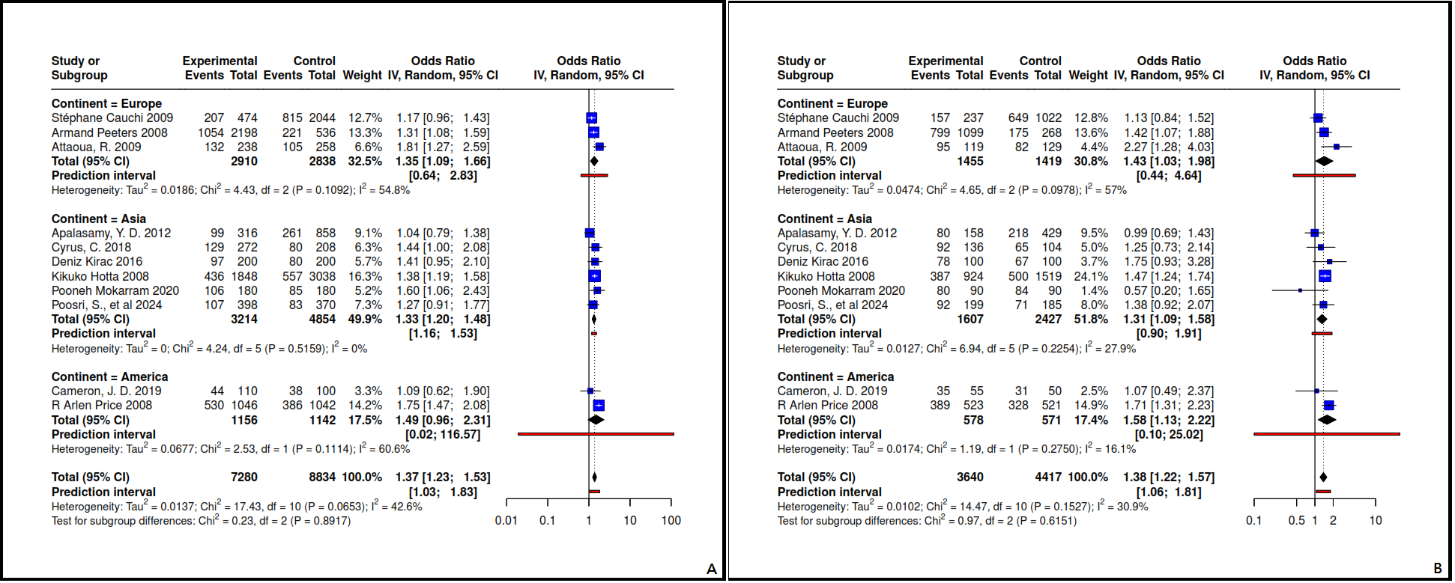
Supplementary Figure 12. The forest plot of rs1421085 in adult Overweight/Obesity in the geographic region. A) Allelic, B) Dominant.

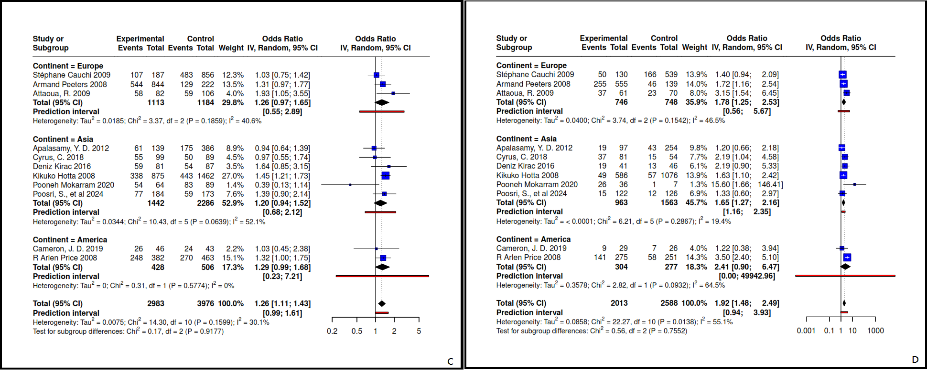
Supplementary Figure 13. The forest plot of rs1421085 in adult Overweight/Obesity in the geographic region. C) Heterozygous, D) Homozygous.

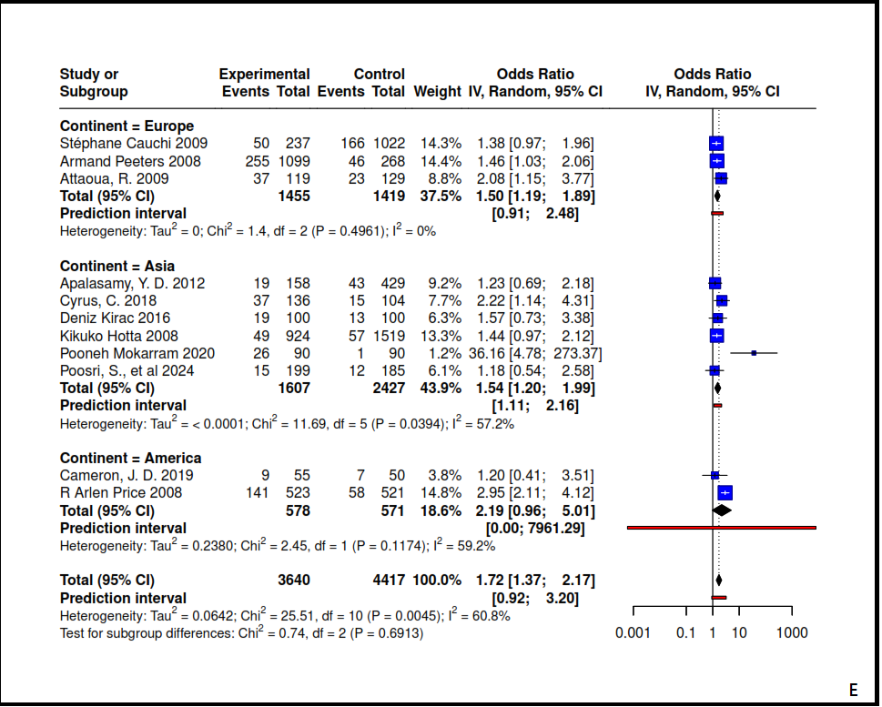
Supplementary Figure 14. The forest plot of rs1421085 in adult Overweight/Obesity in the geographic region. E) Recessive.
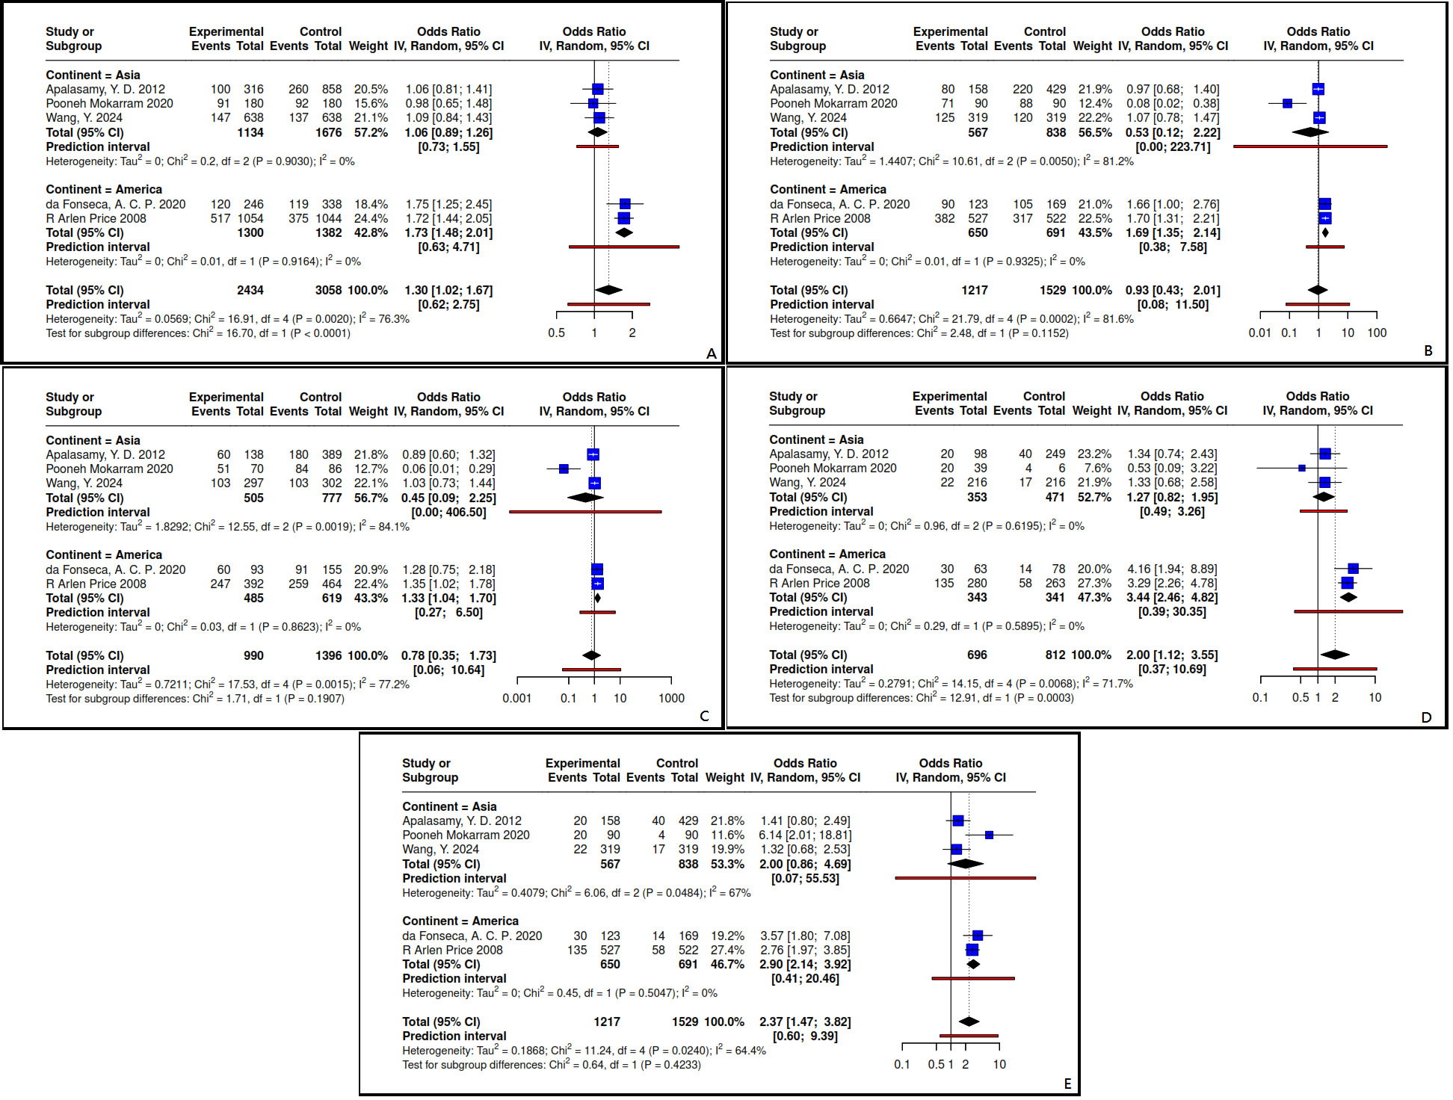
Supplementary Figure 15. The forest plot of rs17817449 in adult Overweight/Obesity in the geographic region. A) Allelic, B) Dominant, C) Heterozygous, D) Homozygous, E) Recessive.

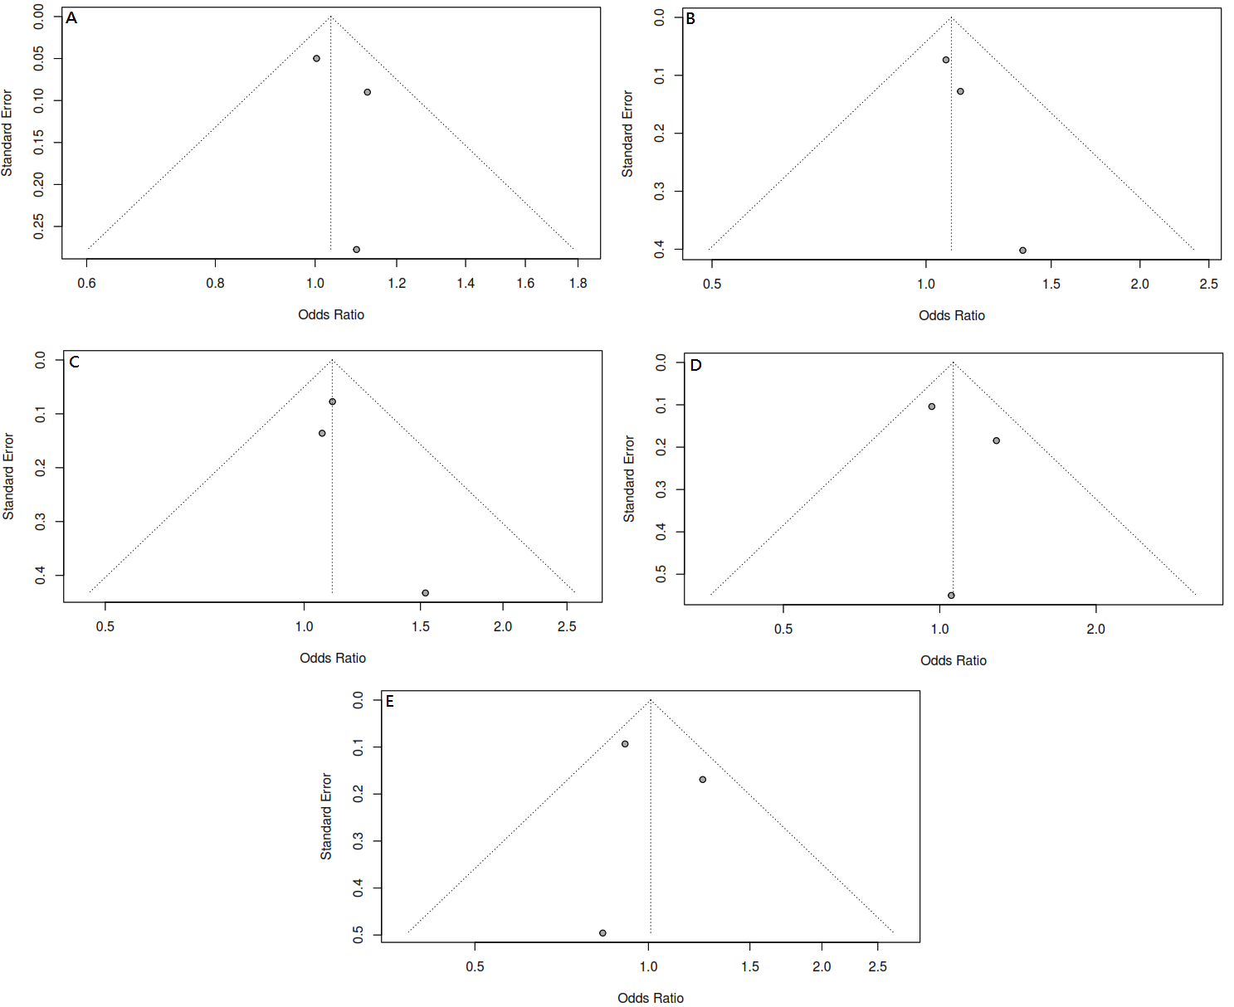
Supplementary Figure 16. Investigation of Funnel plots in the overweight subgroup. A) Allelic, B) Dominant, C) Heterozygous, D) Homozygous, E) Recessive.

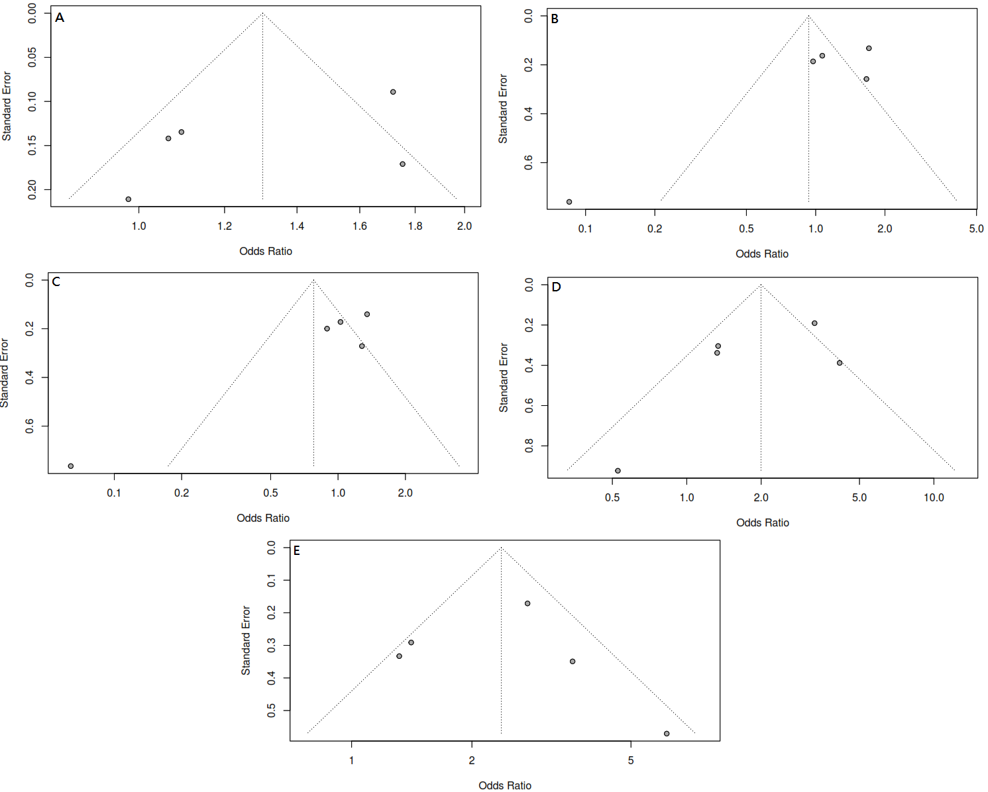
Supplementary Figure 17. Investigation of funnel plots relating to the rs17817449 in a geographic region. A) Allelic, B) Dominant, C) Heterozygous, D) Homozygous, E) Recessive.

