Table S1 Stepwise regression analysis
 | B | Std.Error | Beta | t | P | VIF | R² | adjustedR² | F
Constant | 7.961 | 0.190 |  | 41.825 | 0.000 |  | 0.682 | 0.677 | F=5.511,  P=0.020
FPG | 0.113 | 0.006 | 0.742 | 17.857 | 0.000 | 1.116 | 0.682 | 0.677 | F=5.511,  P=0.020
eGDR | -0.070 | 0.017 | -0.175 | -4.229 | 0.000 | 1.109 | 0.682 | 0.677 | F=5.511,  P=0.020
Dailyinsulin | 0.408 | 0.174 | 0.093 | 2.348 | 0.020 | 1.007 | 0.682 | 0.677 | F=5.511,  P=0.020
Dependent variable: TyG; Durbin-Watson value: 1.317

Table S2 Comparison of Logistic Regression Analysis Models
 | OR (95%CI) | P | LR chi-square | P | AIC | BIC
TyG | 1.832 (1.217-2.758) | 0.004 | 228.130 | 0.001 | 242.130 | 265.560
TG | 0.952 (0.583-1.555) | 0.845 | 236.907 | 0.026 | 250.907 | 274.337
HbA1c | 0.724 (0.612-0.855) | 0.000 | 219.692 | 0.000 | 233.692 | 257.121

Table S3 ROC curve comparison (DeLong test)
 |  | AUC Difference | Std. Error | 95% CI | Z | P
TyG | HbA1c | 0.0955 | 0.0622 | -0.026 ~ 0.218 | 1.5349 | 0.1248
TyG | eGDR | 0.1275 | 0.0535 | 0.023 ~ 0.232 | 2.3832 | 0.0172
TyG | TyG+HbA1c | 0.0229 | 0.0278 | -0.031 ~ 0.077 | 0.8264 | 0.4086
TyG | TyG+eGDR | 0.0036 | 0.0066 | -0.009 ~ 0.016 | 0.5490 | 0.5830

Figure S1 Multicollinearity assessment of eGDR, daily insulin dose, HbA1c and FPG
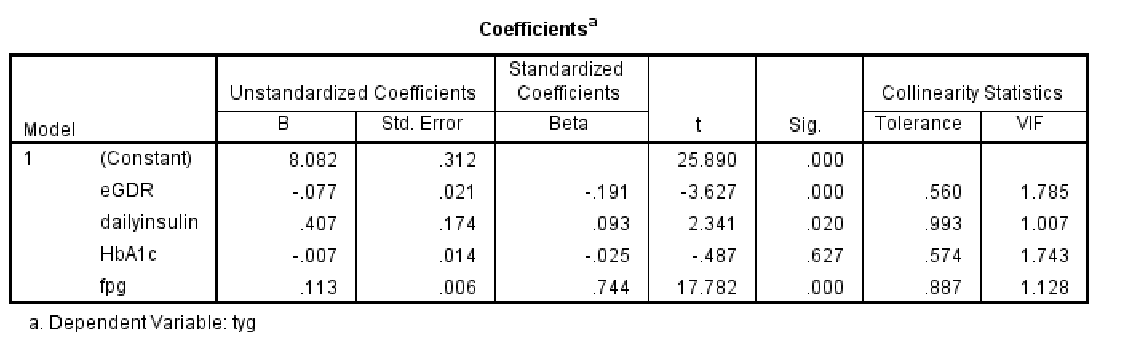

Figure S2 Correlation matrix of TyG, statin medication, eGDR, daily insulin dose, HbA1c and FPG
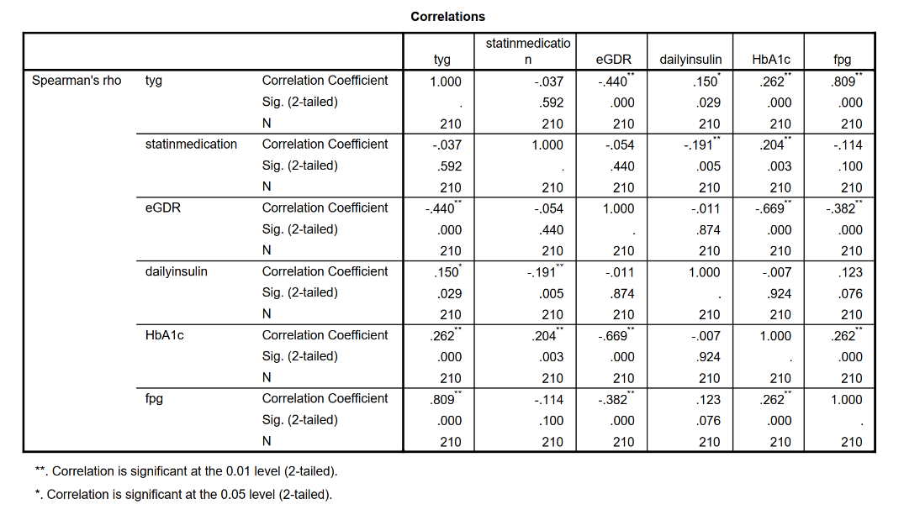

Abbreviation: TyG index, triglyceride-glucose index; FPG, fasting plasma glucose; eGDR, estimated glucose disposal rate; HbA1c, glycated hemoglobin; OR, odds ratio; 95% CI, 95% confidence interval; LR, likelihood ratio; AIC, Akaike information criterion; BIC, Bayesian Information Criterion; VIF, variance inflation factor; ROC, receiver operating characteristic curve; AUC, area under the curve

