Supplementary Table S1: Robustness of Mediation Analysis Across HDL-C Levels
HDL-C Groups | N | Total Effect | Mediation Effect | Proportion mediated | P value
 |  | β (95% CI) | β (95% CI) | (%)
Overall | 1658 | 0.1288 (0.05-0.21) | 0.0281(0.01-0.04) | 21.51 | <0.001
Lowest Tertile | 553 | 0.1403 (0.03-0.25) | 0.0256(0.01-0.05) | 18.3 | 0.034
Middle Tertile | 550 | 0.1331(0.04-0.22) | 0.0283(0.01-0.04) | 21.8 | 0.012
Highest Tertile | 555 | 0.1204 (0.03-0.21) | 0.0277(0.01-0.05) | 23.1 | 0.018
Note: All analyses were performed using Model 3 (fully adjusted model) with 1000 bootstrap resamples. Total effect represents the overall association between HDL-C and DR; Direct effect represents the association between HDL-C and DR after accounting for BRI mediation; Indirect effect represents the mediation effect through BRI; Mediation effect % = (Indirect effect / Total effect) × 100%

Supplementary Table S2 Missingness summary for medication-category indicators (after recoding based on skip logic).
Variable | Miss.freq | Miss.percentage (%)
Antihypertensive medications | 203 | 12.2437
Lipid-lowering agents | 497 | 29.9759
Antidiabetic drugs | 694 | 41.8577

Supplementary Table S3 Association between HDL-C and DR
 | Model1 |  |  | Model2 |  |  | Model3
 | OR (95%CI) | P value |  | OR (95%CI) | P value |  | OR (95%CI) | P value
HDL-C | 1.81 (1.27 ~ 2.57) | 0.003 |  | 2.35 (1.63 ~ 3.40) | <0.001 |  | 2.22 (1.41 ~ 3.51) | 0.009
HDL-C(Tertile)
T1 | 1.00 (Reference) | 1 |  | 1.00 (Reference) |  |  | 1.00 (Reference)
T2 | 1.10 (0.84 ~ 1.45) | 0.480 |  | 1.22 (0.93 ~ 1.60) | 0.160 |  | 1.16 (0.87 ~ 1.54) | 0.346
T3 | 1.86 (1.35 ~ 2.55) | <0.001 |  | 2.45 (1.76 ~ 3.41) | <0.001 |  | 2.30 (1.50 ~ 3.52) | 0.006
P for trend | <0.001 |  |  | <0.001 |  |  | <0.001
OR: Odds Ratio, CI: Confidence Interval.
Model1: no covariates were adjusted.
Model2: gender, age, and race were adjusted.
Model3: gender, age, race, smoking status, Alcohol use, overweight, Hypertension history, Hyperlipidemia, duration of diabetes, Glu, HbA1c, BUN, Cr, TC, CRP, Antihypertensive medications,Lipid-lowering agents, Antidiabetic drugs were adjusted.

Supplementary Table S4 Subgroup analysis of the association between HDL-C and DR
Subgroup | Model 3  OR (95%CI) | P value | P for interaction
Gender |  |  | 0.773
Male | 2.53 (1.36 ~ 4.71) | 0.017
Female | 2.28 (1.30 ~ 3.98) | 0.018
Overweight |  |  | 0.188
No | 3.67 (1.69 ~ 7.97) | 0.009
Yes | 1.79 (1.06 ~ 3.02) | 0.056
Race |  |  | 0.455
Mexican American | 0.9 (0.43~1.92) | 0.793
Other Hispanic | 3.32 (0.64~17.23) | 0.153
Non-Hispanic White | 2.32 (1.42~3.79) | 0.001
Non-Hispanic Black | 1.59 (0.89~2.86) | 0.12
Other Race | 25.69 (0.19~3557.33) | 0.197
Smoking status |  |  | 0.147
Never | 2.62 (1.28 ~ 5.35) | 0.025
Former | 1.45 (0.71 ~ 2.97) | 0.328
Now | 3.59 (1.67 ~ 7.73) | 0.011
Alcohol use |  |  | 0.765
No | 2.33 (1.10 ~ 4.96) | 0.055
Yes | 2.31 (1.30 ~ 4.10) | 0.019
Hypertension history |  |  | 0.771
No | 2.53 (1.07 ~ 5.96) | 0.060
Yes | 2.17 (1.35 ~ 3.50) | 0.011
Hyperlipidemia |  |  | 0.431
No | 5.43 (1.65 ~ 17.86) | 0.027
Yes | 2.11 (1.28 ~ 3.48) | 0.017
Age group |  |  | 0.942
＜60 | 2.33 (1.23 ~ 4.44) | 0.033
≥60 | 2.11 (1.16 ~ 3.86) | 0.041
Model3 adjusts for: gender, age, race, smoking status, Alcohol use, overweight, Hypertension history, Hyperlipidemia, duration of diabetes, Glu, HbA1c, BUN, Cr, TC, CRP, Antihypertensive medications,Lipid-lowering agents, Antidiabetic drugs. Stratification variables were not included in the adjustment process of the corresponding stratification analysis.

Supplementary Table S5 Association between BRI and DR; HDL-C and BRI
 | Model1 |  |  | Model2 |  |  | Model3
 | Value (95%CI) | P value |  | Value (95%CI) | P value |  | Value (95%CI) | P value
BRI and DR | OR 0.84 (0.80 ~ 0.88) | <0.001 |  | OR 0.84 (0.80 ~ 0.89) | <0.001 |  | OR 0.84 (0.78 ~ 0.91) | 0.003
HDL-C and BRI | β -1.54(-1.88~ -1.21) | <0.001 |  | β -1.94 (-2.23 ~ -1.64) | <0.001 |  | β -1.14 (-1.41 ~ -0.88) | <0.001
Model1: no covariates were adjusted.
Model2: gender, age, and race were adjusted.
Model3: gender, age, race, smoking status, Alcohol use, overweight, Hypertension history, Hyperlipidemia, duration of diabetes, Glu, HbA1c, BUN, Cr, TC, CRP, Antihypertensive medications,Lipid-lowering agents, Antidiabetic drugs were adjusted.

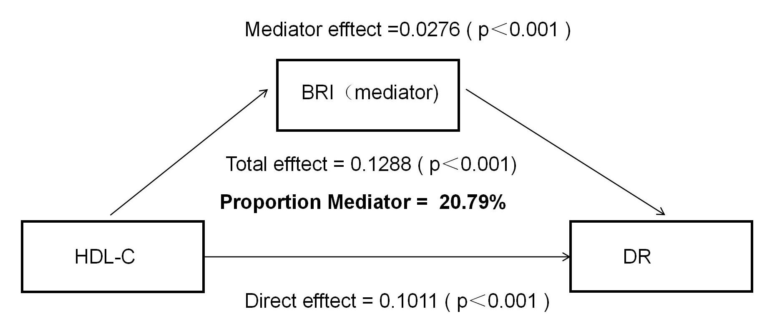

Fig S1. Medication-adjusted mediation effect of body roundness index (BRI) on the association between high-density lipoprotein cholesterol (HDL-C) and diabetic retinopathy (DR).

