Supp Text 1 Obesity subtypes and OMOP Concept codes
Obesity: 433736; Morbid obesity: 434005; Localized adiposity: 438731; Extreme obesity with alveolar hypoventilation: 4100857; Drug-induced obesity: 4097996; Simple obesity: 4217557

Supp Text 2 Comorbidities for determining overweight
prediabetes, diabetes, hypertension, metabolic syndrome, obstructive sleep apnea, polycystic ovary syndrome, insulin resistance, hyperlipidemia, fatty liver, non-alcoholic steatohepatitis, coronary artery disease, cerebrovascular accident, stroke, peripheral vascular disease, congestive heart failure, colon/breast/renal/endometrial/liver cancer, osteoarthritis, or with HbA1c >= 5.7 and < 6.5

Supp Text 3 ICD-9 and ICD-10 diagnosis codes for determining obesity phenotype in COSMOS database
ICD-9: (‘278’, ‘278.0’, ‘278.00’, ‘278.01’, ‘278.02’, ‘278.03’, ‘278.1’, ‘278.2’, ‘278.3’, ‘278.4’, ‘278.8’)
ICD-10: (‘E66’, ‘E66.0’, ‘E66.01’, ‘E66.09’, ‘E66.1’, ‘E66.2’, ‘E66.3’, ‘E66.8’, ‘E66.9’)

Supp Text 4 ICD-9 and ICD-10 procedure codes for determining obesity-related surgery in COSMOS database
ICD-9 procedure codes ( ‘42.62’, ‘43’, ‘43.5’, ‘43.7’, ‘43.8’, ‘43.81’, ‘43.82’, ‘43.89’, ‘43.9’, ‘43.91’, ‘43.99’, ‘44.3’, ‘44.31’, ‘44.32’, ‘44.39’, ‘44.9’, ‘44.95’, ‘44.96’)
ICD-10 procedure codes ('0D11076', '0D110J6', '0D110K6', '0D110Z6', '0D11476', '0D114J6', '0D114K6', '0D114Z6', '0D11876', '0D118J6', '0D118K6', '0D118Z6', '0D12076', '0D120J6', '0D120K6', '0D120Z6', '0D12476', '0D124J6', '0D124K6', '0D124Z6', '0D12876', '0D128J6', '0D128K6', '0D128Z6', '0D13076', '0D130J6', '0D130K6', '0D130Z6', '0D13476', '0D134J6', '0D134K6', '0D134Z6', '0D13876', '0D138J6', '0D138K6', '0D138Z6', '0D15076', '0D150J6', '0D150K6', '0D150Z6', '0D15476', '0D154J6', '0D154K6', '0D154Z6', '0D15876', '0D158J6', '0D158K6', '0D158Z6', '0D16074', '0D16079', '0D1607B', '0D1607L', '0D160J4', '0D160J9', '0D160JB', '0D160JL', '0D160K4', '0D160K9', '0D160KB', '0D160KL', '0D160Z4', '0D160Z9', '0D160ZB', '0D160ZL', '0D163J4', '0D16474', '0D16479', '0D1647B', '0D1647L', '0D164J4', '0D164J9', '0D164JB', '0D164JL', '0D164K4', '0D164K9', '0D164KB', '0D164KL', '0D164Z4', '0D164Z9', '0D164ZB', '0D164ZL', '0D16874', '0D168J4', '0D168K4', '0D168Z4', '0DB40ZX', '0DB40ZZ', '0DB43ZX', '0DB43ZZ', '0DB44ZX', '0DB44ZZ', '0DB47ZX', '0DB47ZZ', '0DB48ZX', '0DB48ZZ', '0DB60Z3', '0DB60ZX', '0DB60ZZ', '0DB63Z3', '0DB63ZX', '0DB63ZZ', '0DB64Z3', '0DB64ZX', '0DB64ZZ', '0DB67Z3', '0DB67ZX', '0DB67ZZ', '0DB68Z3', '0DB68ZX', '0DB68ZZ', '0DB74ZX', '0DB74ZZ', '0DT40ZZ', '0DT44ZZ', '0DT47ZZ', '0DT48ZZ', '0DT60ZZ', '0DT64ZZ', '0DT67ZZ', '0DT68ZZ', '0DT74ZZ', '0F140D4', '0F140Z4', '0F144D4', '0F144Z4', '0F150D4', '0F150Z4', '0F154D4', '0F154Z4', '0F160D4', '0F160Z4', '0F164D4', '0F164Z4', '0F170D4', '0F170Z4', '0F174D4', '0F174Z4', '0F180D4', '0F180Z4', '0F184D4', '0F184Z4', '0F190D4', '0F190Z4', '0F194D4', '0F194Z4', '0F1D0D4', '0F1D0Z4', '0F1D4D4', '0F1D4Z4').

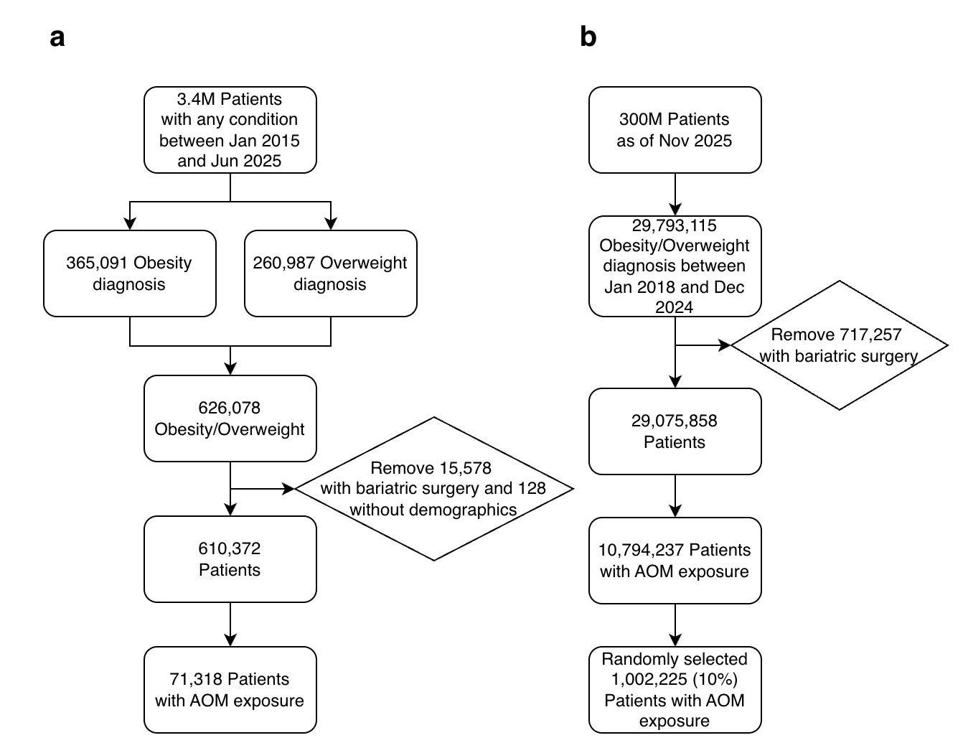
Supp Figure 1 Sample processing flow for a) UT-Physician cohort, b) COSMOS cohort.

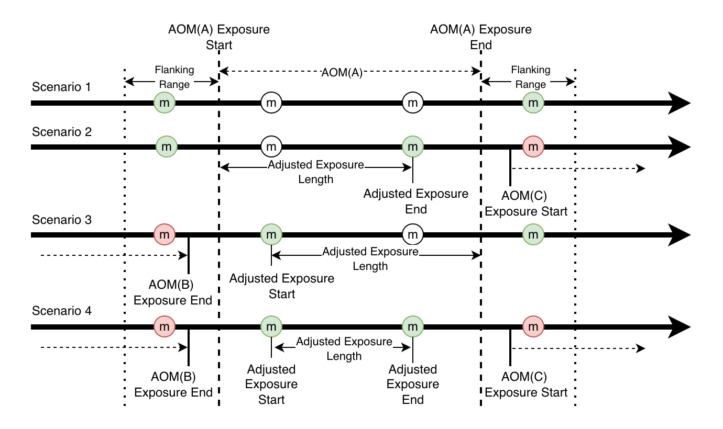
Supp Figure 2 Example timelines illustrate four scenarios of how body weight measurements are obtained relative to AOM exposure. Each circle represents a weight measurement (“m”). Green circles denote measurements that are eligible for evaluating weight loss outcomes, while red circles indicate measurements that are excluded due to overlap with another AOM exposure. Flanking ranges are dynamically determined based on the exposure length.

a b
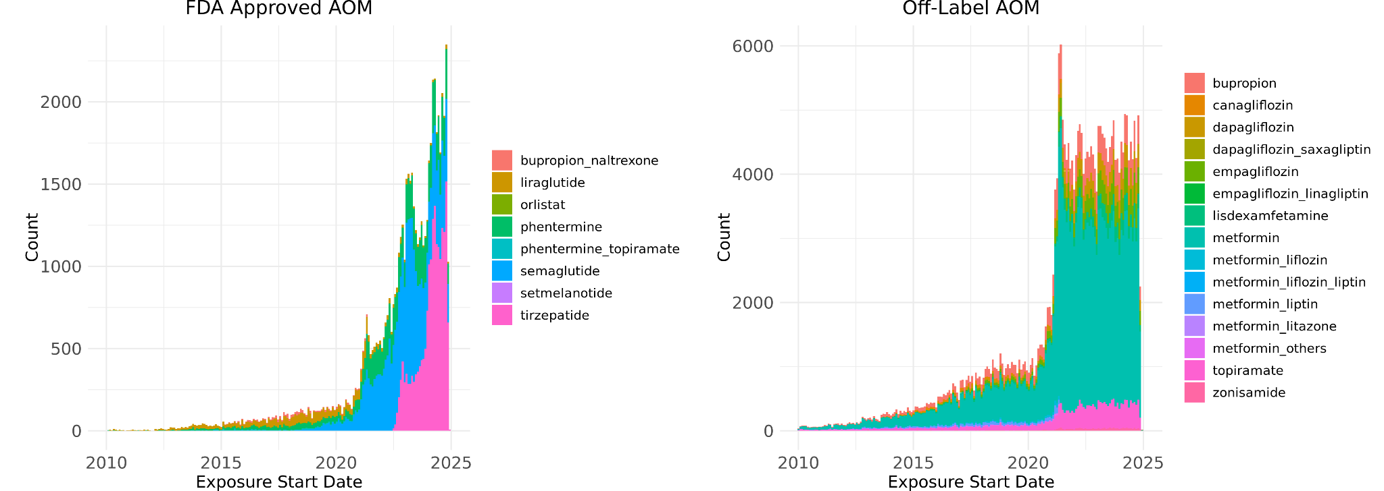
c d
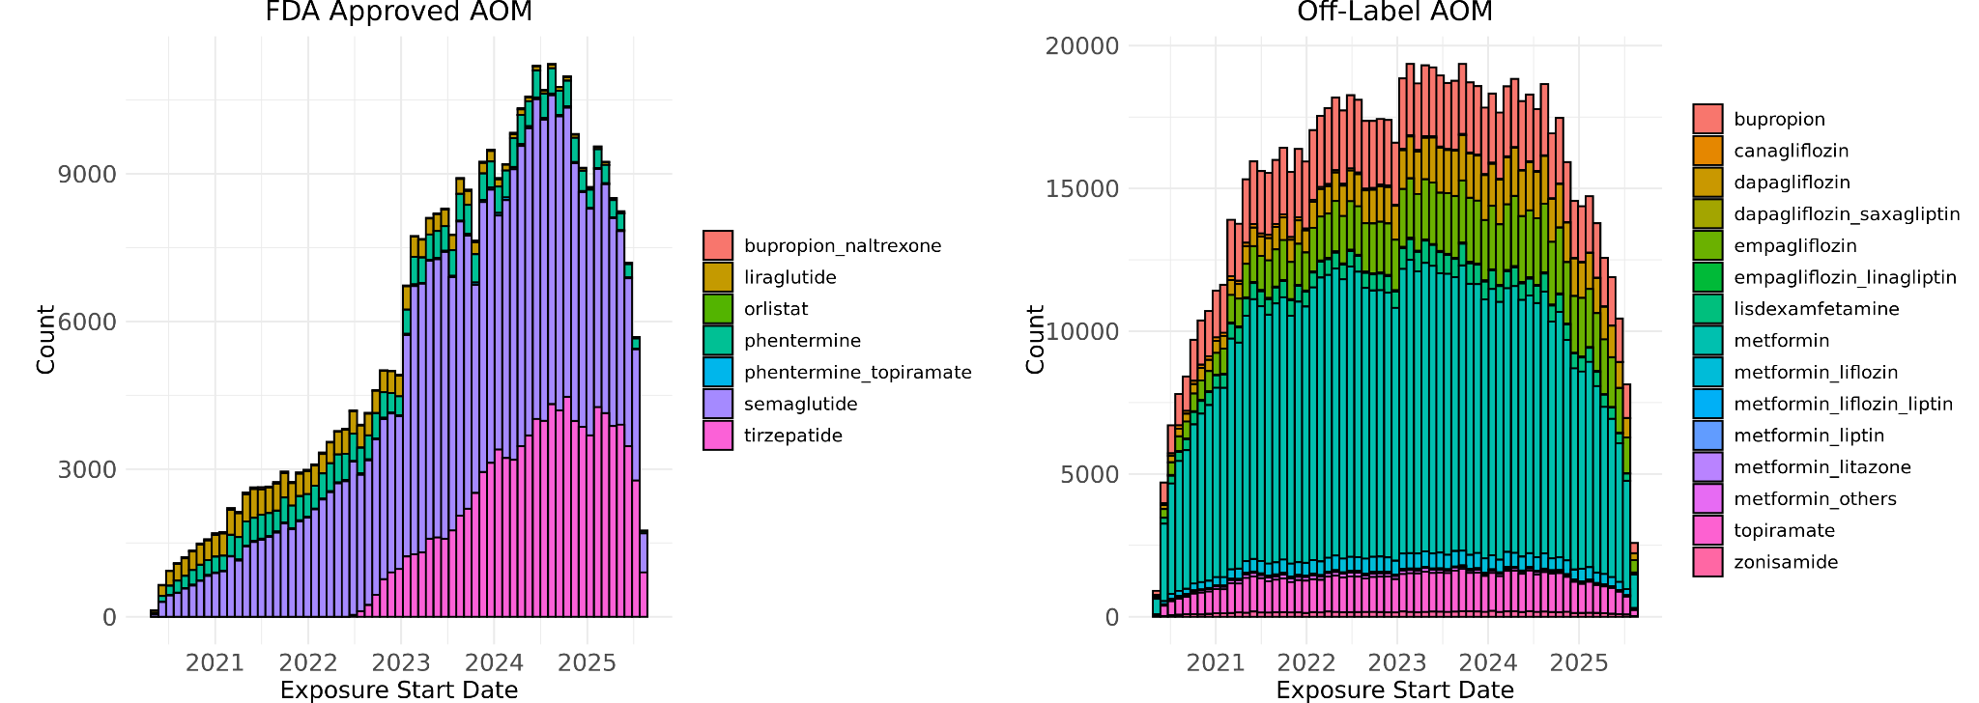

e f
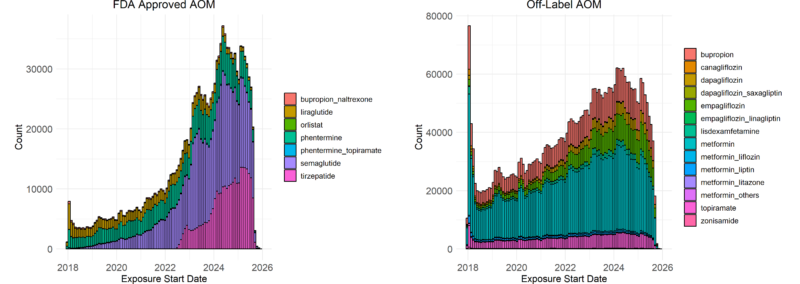
Supp Figure 3 Stacked histograms of prescription records for a) F-AOMs and b) O-AOMs from 2010 to 2025, dispensing records for c) F-AOMs and d) O-AOMs from May 2020 to September 2025 in the UT-Physician cohort, and dispensing records for e) F-AOMs and f) O-AOMs from January 2018 to December 2024 in the COSMOS cohort

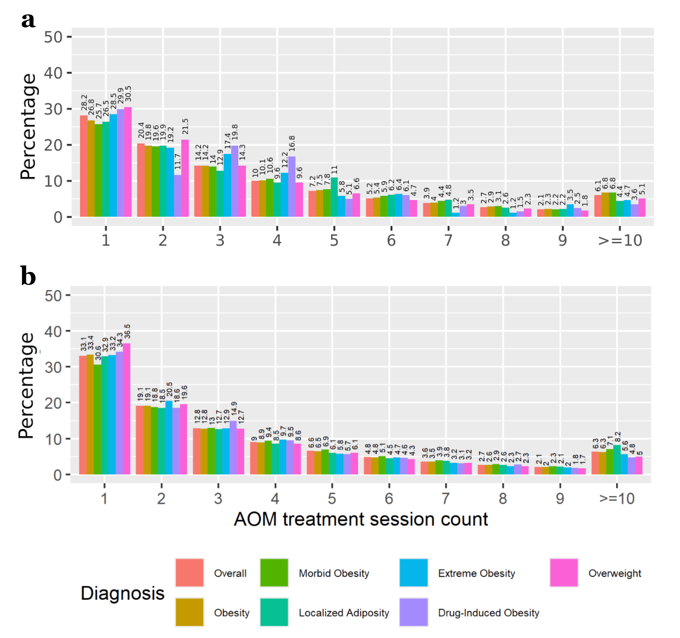

Supp Figure 4 Distribution of treatment session counts in individuals with different diagnoses in the a) UT-Physician and b) COSMOS cohort.

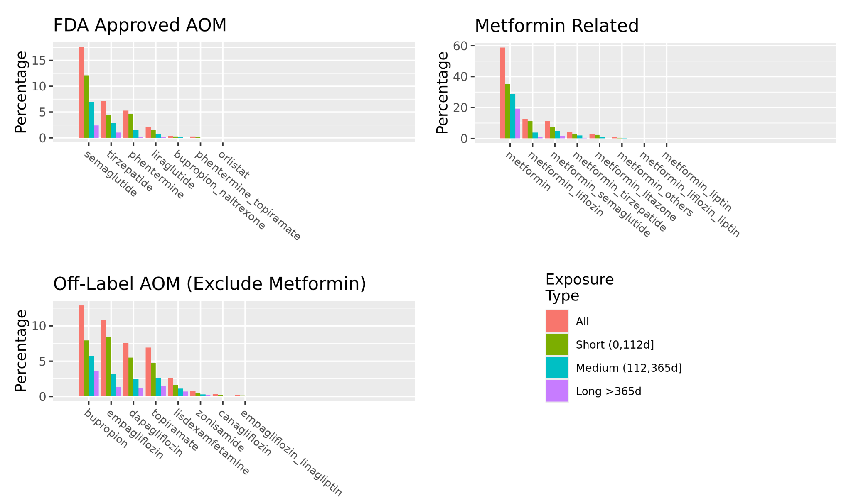
Supp Figure 5 Prevalence of AOMs and various treatment session lengths among individuals with AOM exposure. Data shown for the UT-Physician cohort.

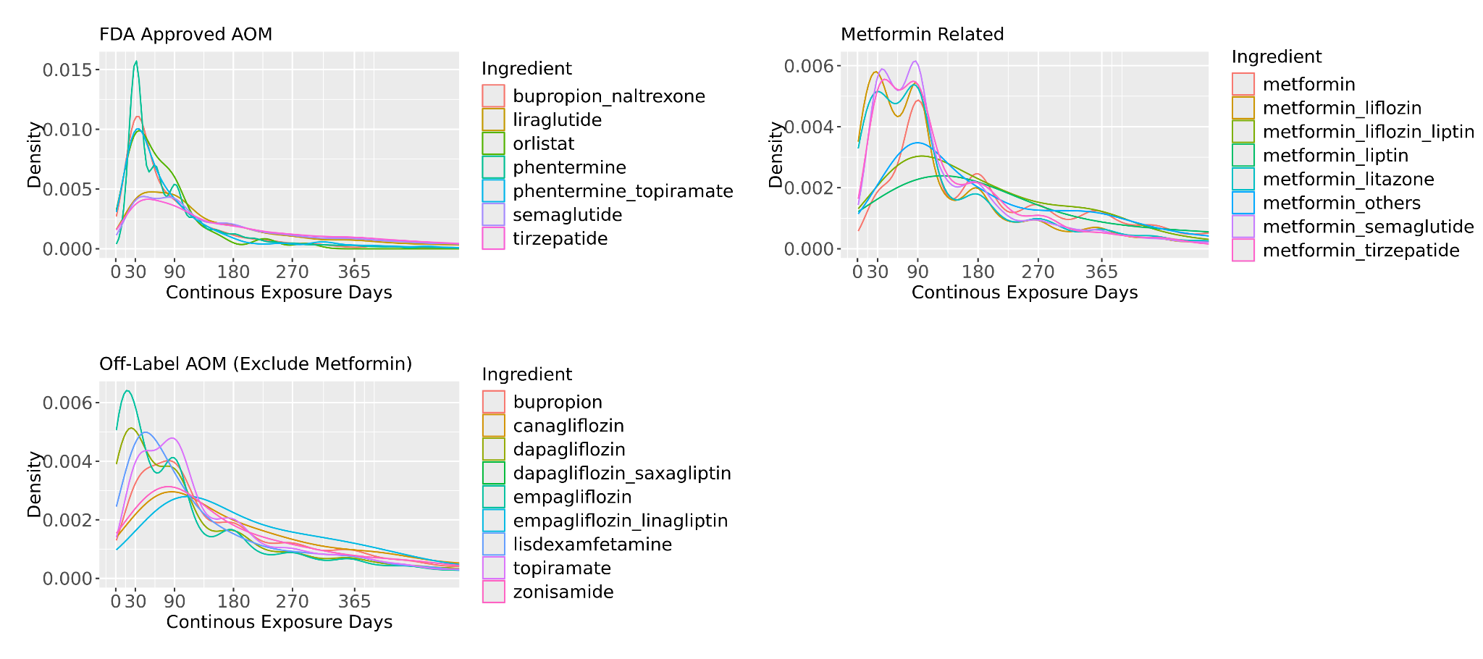

Supp Figure 6 Distribution of individual AOM treatment session length after ignoring interruption from different AOM ingredient(s). Data shown for the UT-Physician cohort.

a
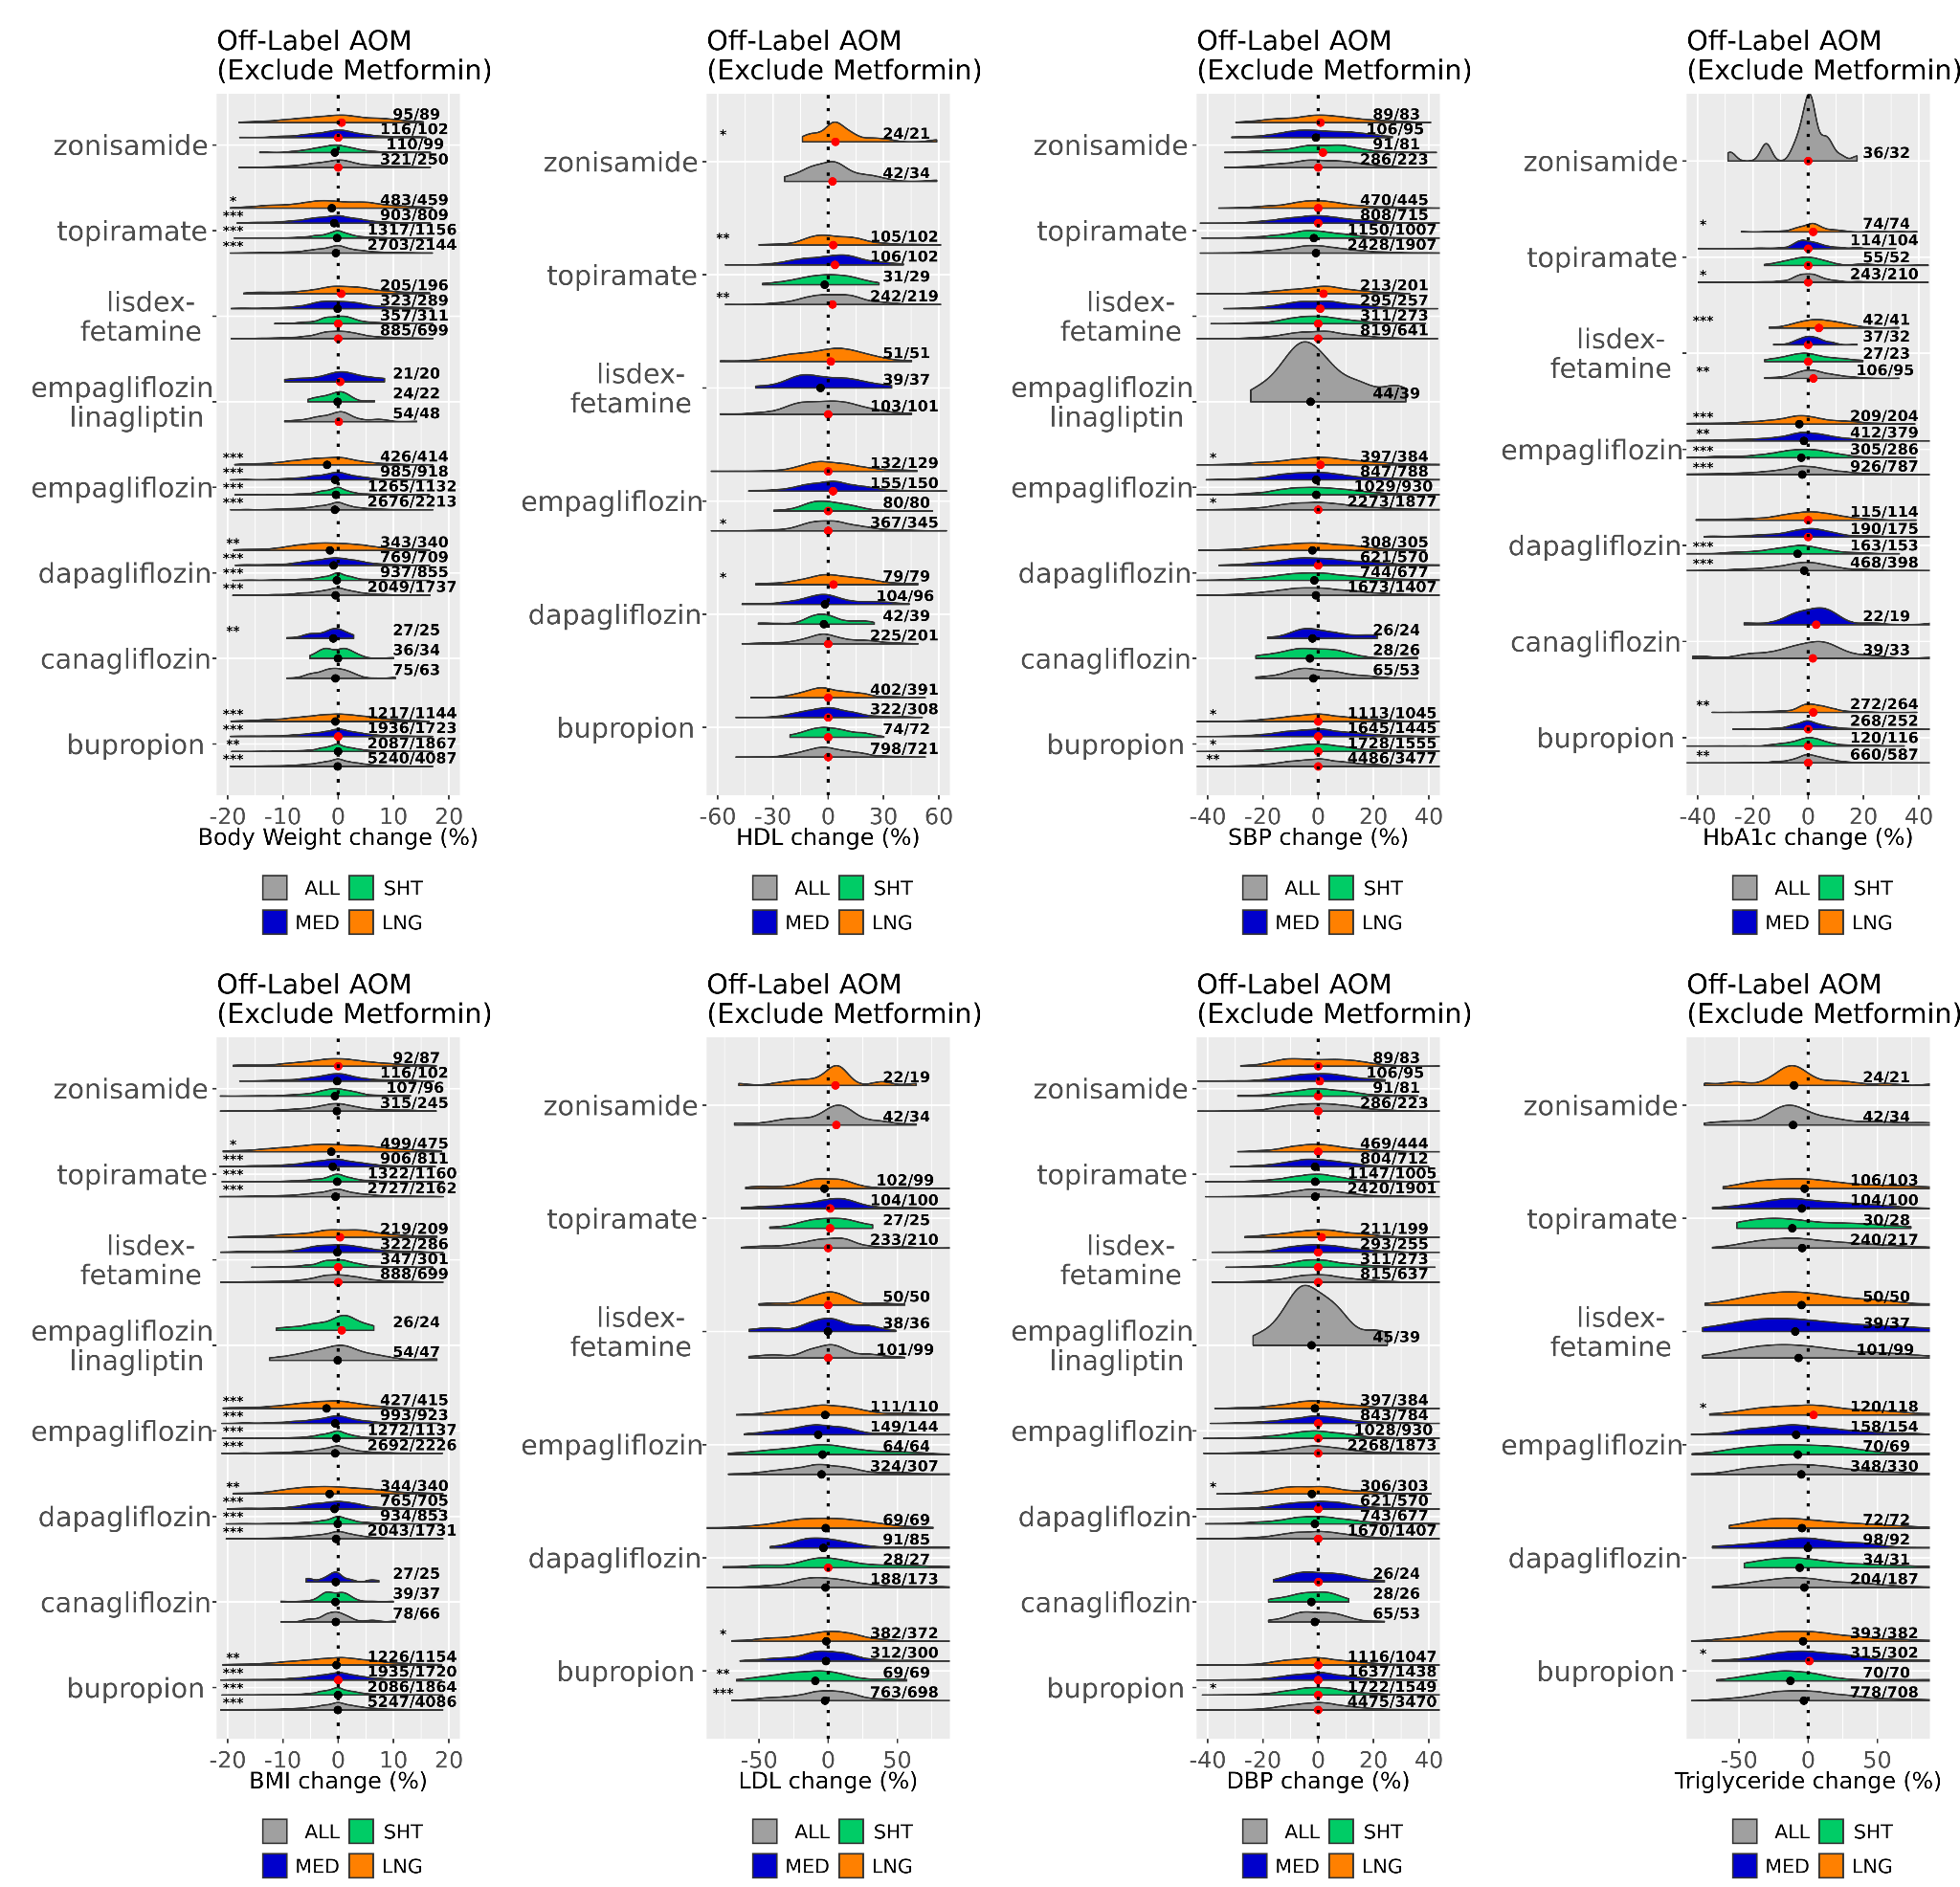

b
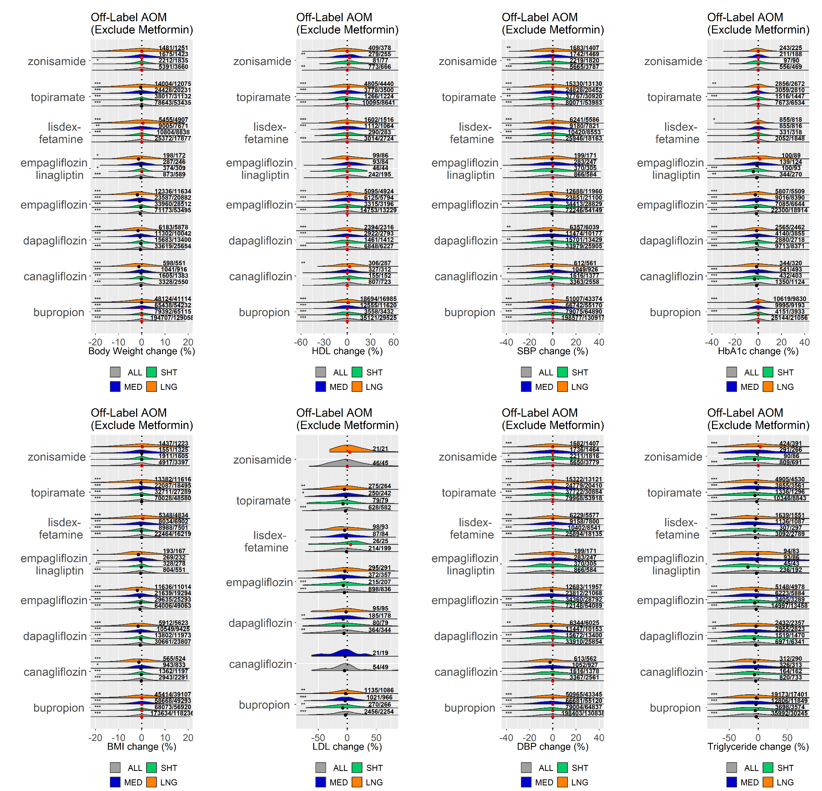
Supp Figure 7 Distribution of percentage changes in obesity related metabolic metrics after various lengths (SHT: Short-term; MED: Medium-term; LNG: Long-term) of O-AOM (exclude metformin) exposure for a) UT-Physician cohort, and b) COSMOS cohort. Result displayed for each drug and category with a minimum of 20 observations. Black and red dots depict median values <0 and ≥0, respectively. Numbers on the right of each distribution shown as (number of observed records/number of unique individuals). The asterisks on the left denote significance (p$≤$0.05 (*), p$≤$0.01 (**), and p$≤$0.001(***)) of two-tailed z-test against the null hypothesis of mean value 0.

a
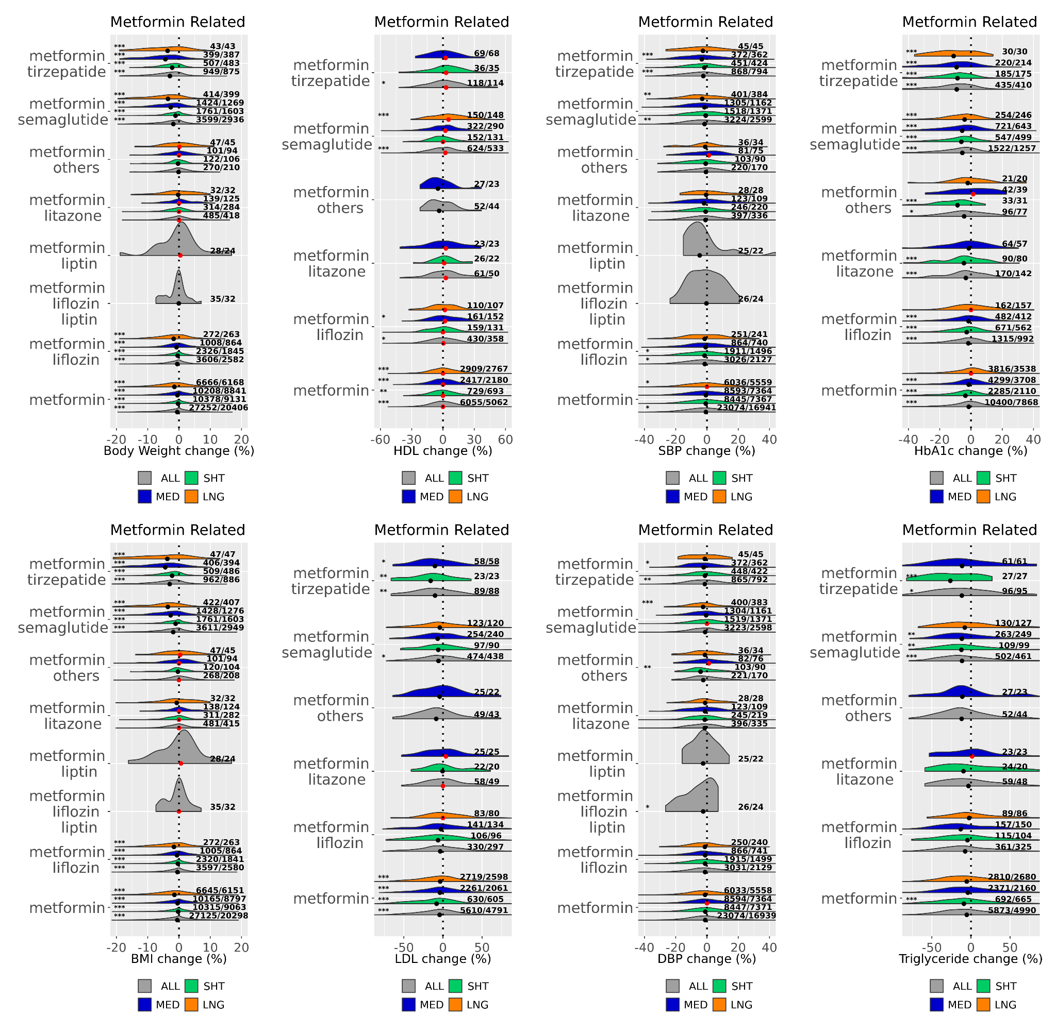

b
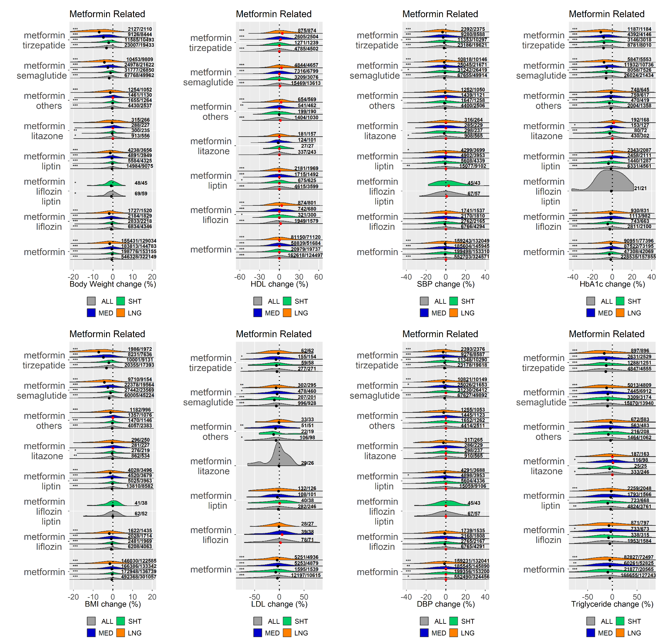
Supp Figure 8 Distribution of percentage changes in obesity related metabolic metrics after various lengths (SHT: Short-term; MED: Medium-term; LNG: Long-term) of exposure to metformin related AOMs for a) UT-Physician cohort, and b) COSMOS cohort. Result displayed for each drug and category with a minimum of 20 observations. Black and red dots depict median values <0 and ≥0, respectively. Numbers on the right of each distribution shown as (number of observed records/number of unique individuals). The asterisks on the left denote significance (p$≤$0.05 (*), p$≤$0.01 (**), and p$≤$0.001(***)) of two-tailed z-test against the null hypothesis of mean value 0.

a b
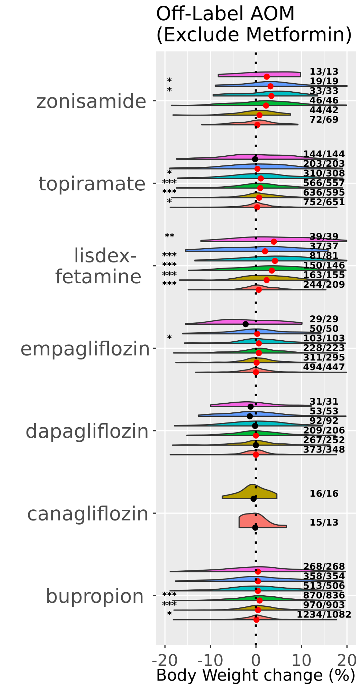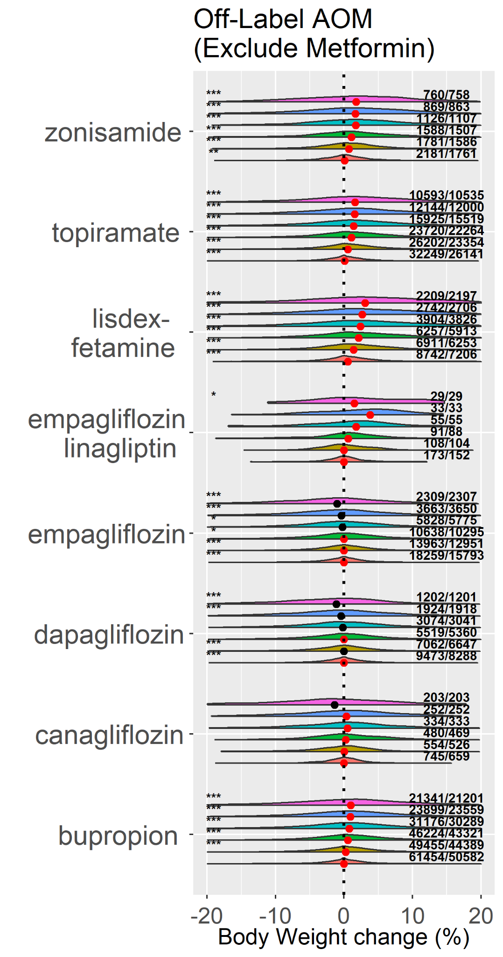
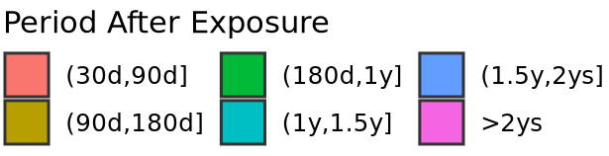
Supp Figure 9 Body weight changes after discontinuing O-AOMs (exclude metformin), using body weight at the end of exposure as reference weight. a) UT Physician cohort. b) COSMOS cohort.

a b
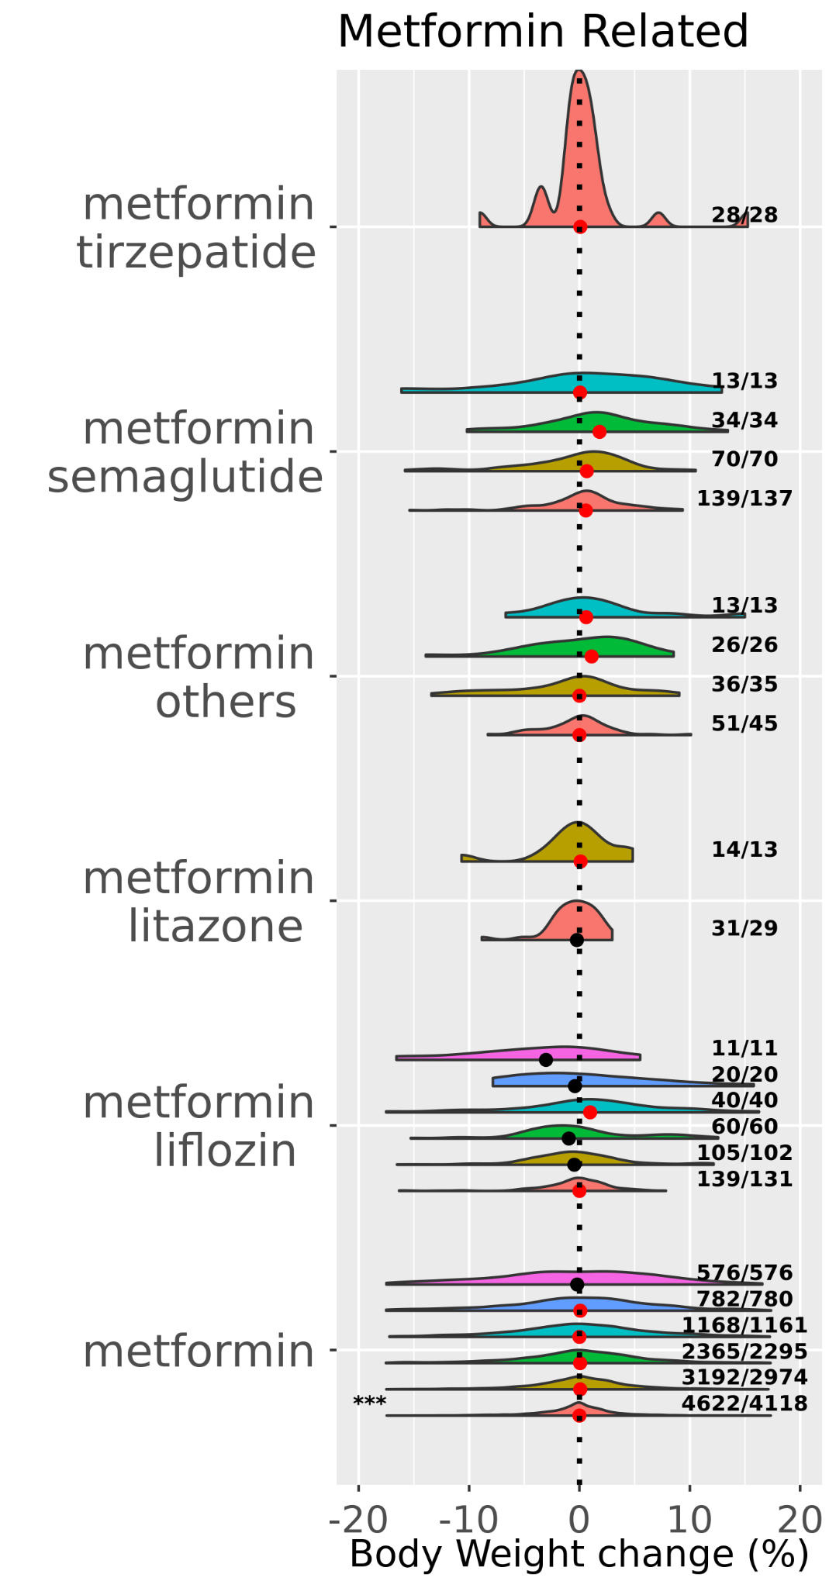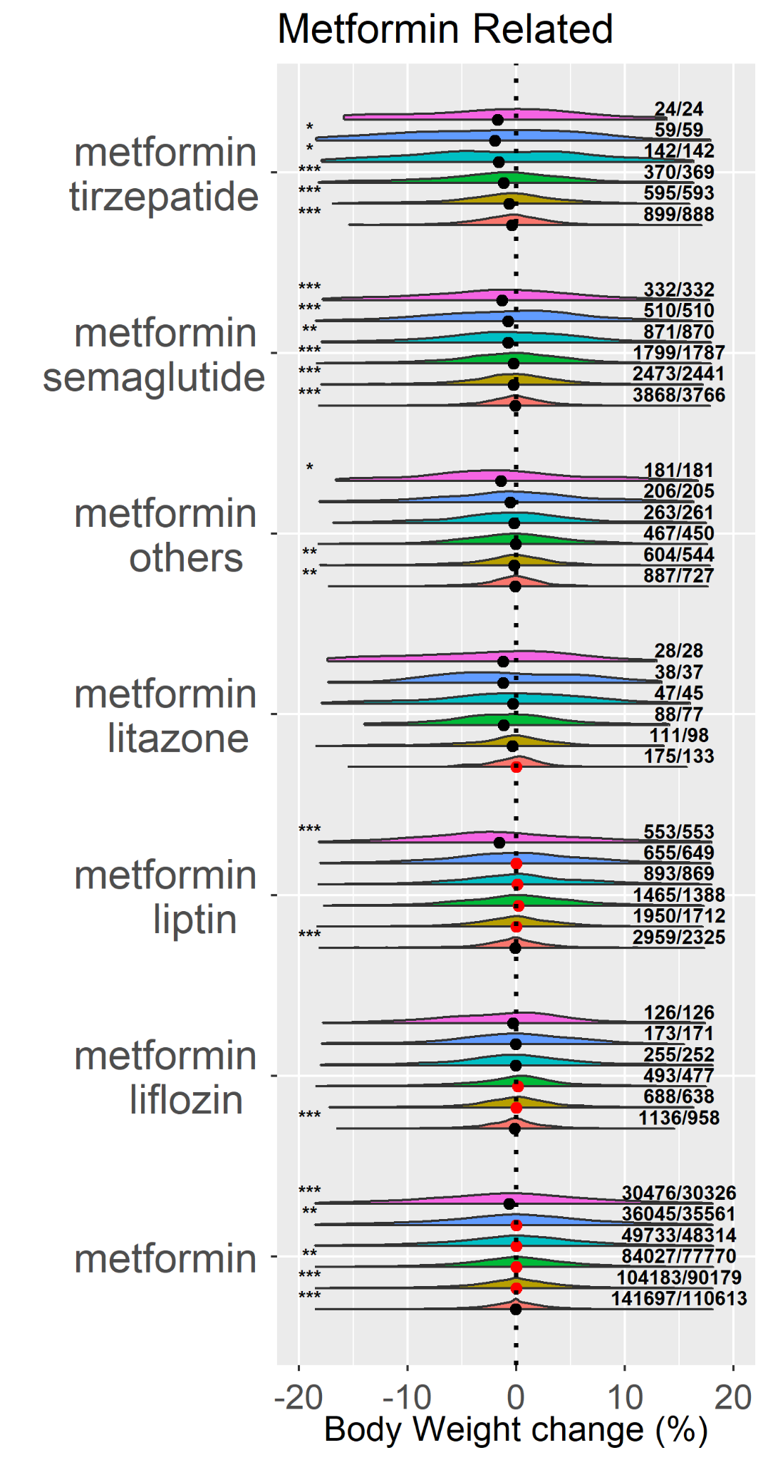
Supp Figure 10 Body weight changes after discontinuing metformin related AOMs, using body weight at the end of exposure as reference weight. a) UT Physician cohort. b) COSMOS cohort.

