Additional file 1
Supplementary Figure S1 and Supplementary Tables S1-S4
Supplementary Figure S1 Model-specific variance inflation factors for QCT-derived parameters in the fully adjusted logistic regression models.
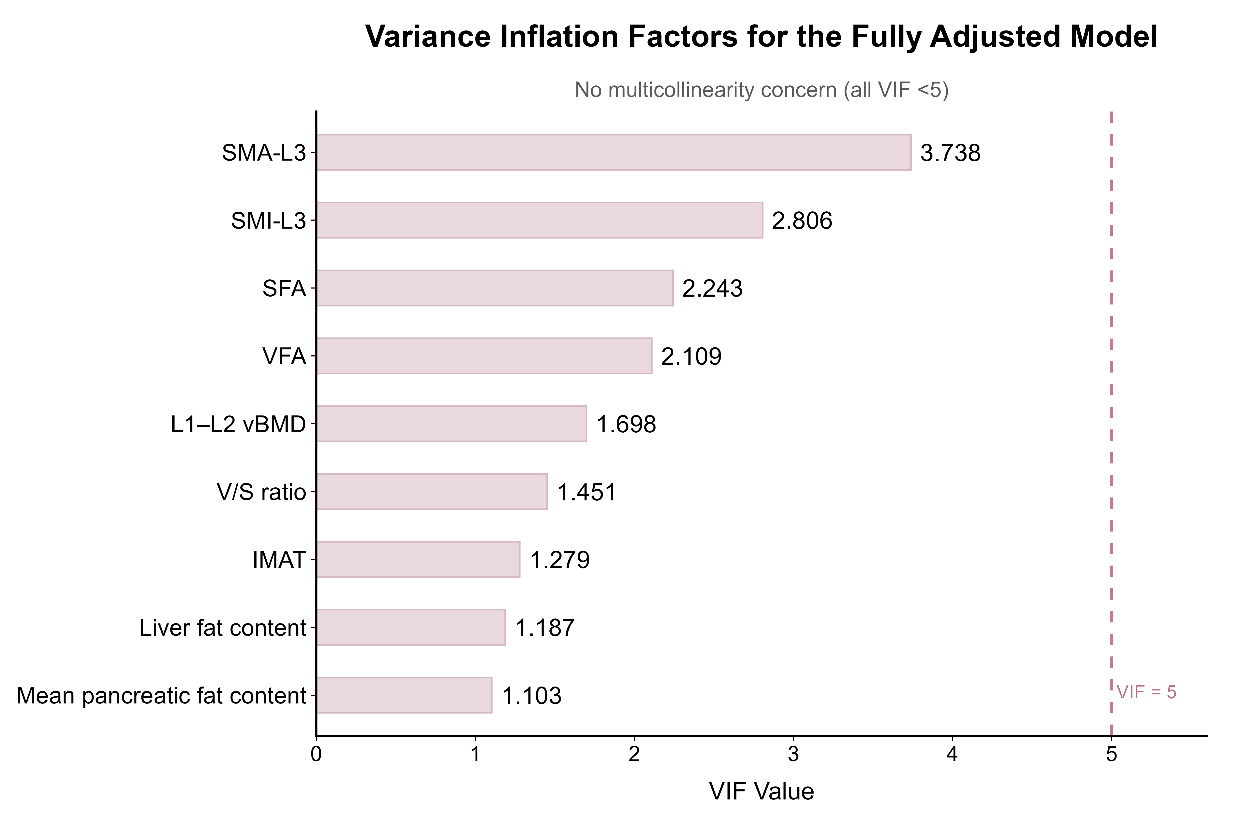
Each QCT-derived parameter was entered separately into a fully adjusted model together with the prespecified covariates. The dashed vertical line indicates the VIF threshold of 5. All VIF values were <5.
Supplementary Table S1 Model-specific variance inflation factors in fully adjusted models

QCT-derived parameter | Tolerance for QCT-derived parameter | VIF for QCT-derived parameter
VFA | 0.474 | 2.109
SFA | 0.446 | 2.243
V/S ratio | 0.689 | 1.451
IMAT | 0.782 | 1.279
SMA-L3 | 0.268 | 3.738
SMI-L3 | 0.356 | 2.806
Liver fat content | 0.843 | 1.187
Mean pancreatic fat content | 0.907 | 1.103
L1–L2 vBMD | 0.589 | 1.698
Note: Values represent model-specific collinearity diagnostics. Each QCT-derived parameter was entered separately into a fully adjusted logistic regression model together with age, sex, BMI, and diabetes duration. Tolerance and VIF values shown in the table refer to the QCT-derived parameter in each corresponding model. A VIF value <5 was considered to indicate no substantial multicollinearity.
Abbreviations: QCT, quantitative computed tomography; VIF, variance inflation factor; BMI, body mass index; VFA, visceral fat area; SFA, subcutaneous fat area; V/S ratio, visceral-to-subcutaneous fat area ratio; IMAT, intermuscular adipose tissue; SMA-L3, skeletal muscle area at the third lumbar vertebra; SMI-L3, skeletal muscle index at the third lumbar vertebra; vBMD, volumetric bone mineral density.
Supplementary Table S2. Antidiabetic medication use according to HOMA-IR tertiles in the final analyzed cohort

 |  | HOMA-IR
 | Total | Low  (≤1.89) | Middle  (1.90–3.95) | High  (>3.95)
Medication category | N = 245 | n = 82 | n = 81 | n = 82 | P value
Metformin | 176 (71.8) | 59 (72.0) | 58 (71.6) | 59 (72.0) | 0.998
Basal insulin therapy | 124 (50.6) | 53 (64.6) | 36 (44.4) | 35 (42.7) | 0.008
α-glucosidase inhibitor | 132 (53.9) | 59 (72.0) | 43 (53.1) | 30 (36.6) | <0.001
DPP-4 inhibitor | 55 (22.4) | 17 (20.7) | 20 (24.7) | 18 (22.0) | 0.825
GLP-1 receptor agonist | 0 (0.0) | 0 (0.0) | 0 (0.0) | 0 (0.0) | —
SGLT2 inhibitor | 0 (0.0) | 0 (0.0) | 0 (0.0) | 0 (0.0) | —
Thiazolidinedione | 0 (0.0) | 0 (0.0) | 0 (0.0) | 0 (0.0) | —
Glinide | 1 (0.4) | 1 (1.2) | 0 (0.0) | 0 (0.0) | —
Sulfonylurea | 0 (0.0) | 0 (0.0) | 0 (0.0) | 0 (0.0) | —
Note: Data are presented as n (%). Percentages were calculated within each HOMA-IR tertile. Medication use was recorded from the electronic medical records at the time of QCT examination. Medication categories were not mutually exclusive. P values were calculated using the chi-square test or Fisher’s exact test, as appropriate. P values were not shown for medication classes with no users or extremely sparse events.
Abbreviations: DPP-4, dipeptidyl peptidase-4; GLP-1, glucagon-like peptide-1; HOMA-IR, homeostasis model assessment of insulin resistance; QCT, quantitative computed tomography; SGLT2, sodium-glucose cotransporter 2.
Supplementary Table S3. Sensitivity analysis excluding patients receiving basal insulin therapy

QCT parameter | Fully adjusted sensitivity model OR (95% CI) | P value
Adipose distribution
VFA, cm² | 2.039 (1.148–3.619) | 0.015
SFA, cm² | 1.131 (0.638–2.004) | 0.673
V/S ratio | 1.556 (0.930–2.603) | 0.092
Skeletal muscle-related parameters
IMAT, cm² | 0.907 (0.591–1.391) | 0.653
SMA-L3, cm² | 1.387 (0.625–3.077) | 0.422
SMI-L3, cm²/m² | 1.720 (0.855–3.460) | 0.128
Ectopic fat deposition
Liver fat content, % | 1.891 (1.155–3.096) | 0.011
Mean pancreatic fat content, % | 0.775 (0.515–1.167) | 0.222
Bone mineral density
L1–L2 vBMD, mg/cm³ | 1.178 (0.693–2.003) | 0.545
Note: Data are presented as odds ratios (ORs) with 95% confidence intervals (CIs). Patients receiving basal insulin therapy were excluded from this sensitivity analysis. The analytic sample included 121 patients. High HOMA-IR was defined using the same cohort-derived threshold as in the primary analysis (>3.95). Each standardized QCT-derived parameter was entered separately into a fully adjusted multivariable logistic regression model adjusted for age, sex, BMI, and diabetes duration. ORs indicate the change in odds of high HOMA-IR per 1-standard-deviation increase in each QCT-derived parameter.
Abbreviations: BMI, body mass index; CI, confidence interval; HOMA-IR, homeostasis model assessment of insulin resistance; IMAT, intermuscular adipose tissue; OR, odds ratio; QCT, quantitative computed tomography; SFA, subcutaneous fat area; SMA-L3, skeletal muscle area at the third lumbar vertebra; SMI-L3, skeletal muscle index at the third lumbar vertebra; VFA, visceral fat area; V/S ratio, visceral-to-subcutaneous fat area ratio; vBMD, volumetric bone mineral density.
Supplementary Table S4. Associations between QCT-derived parameters and log-transformed HOMA-IR
QCT parameter | Regression coefficient B (95% CI) | P value
Adipose distribution
VFA, cm² | 0.274 (0.110–0.439) | 0.001
SFA, cm² | 0.121 (-0.064–0.307) | 0.196
V/S ratio | 0.130 (-0.027–0.286) | 0.103
Skeletal muscle-related parameters
IMAT, cm² | -0.095 (-0.233–0.043) | 0.174
SMA-L3, cm² | 0.174 (-0.075–0.422) | 0.169
SMI-L3, cm²/m² | 0.185 (-0.029–0.399) | 0.089
Ectopic fat deposition
Liver fat content, % | 0.167 (0.035–0.299) | 0.014
Mean pancreatic fat content, % | -0.050 (-0.180–0.079) | 0.444
Bone mineral density
L1–L2 vBMD, mg/cm³ | 0.034 (-0.134–0.201) | 0.693
Note: Data are presented as regression coefficients (B) with 95% confidence intervals (CIs). HOMA-IR was log-transformed and analyzed as a continuous outcome. Each standardized QCT-derived parameter was entered separately into a multivariable linear regression model adjusted for age, sex, BMI, and diabetes duration. Regression coefficients indicate the change in log-transformed HOMA-IR per 1-standard-deviation increase in each QCT-derived parameter.
Abbreviations: B, regression coefficient; BMI, body mass index; CI, confidence interval; HOMA-IR, homeostasis model assessment of insulin resistance; IMAT, intermuscular adipose tissue; QCT, quantitative computed tomography; SFA, subcutaneous fat area; SMA-L3, skeletal muscle area at the third lumbar vertebra; SMI-L3, skeletal muscle index at the third lumbar vertebra; VFA, visceral fat area; V/S ratio, visceral-to-subcutaneous fat area ratio; vBMD, volumetric bone mineral density.

