Additional file 2: Supplementary figures and robustness analyses

Description
This file contains the risk-of-bias summary plot, stage-group-specific REML leave-one-out sensitivity analyses, and CKM stage 4 funnel plots for eligible outcomes.

Supplementary Figure S1. Summary of risk-of-bias judgments for selected efficacy results
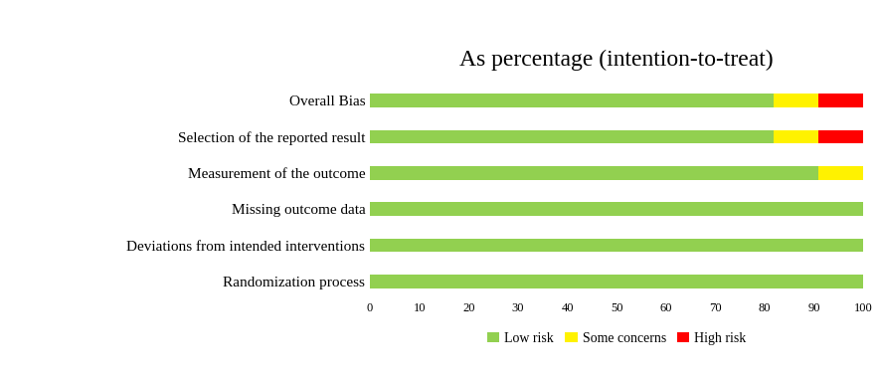
Legend. The bars show the percentage of the 11 assessed results judged as low risk of bias, some concerns, or high risk of bias across the five Cochrane Risk of Bias 2 domains and for the overall judgment. Assessments targeted the effect of assignment to intervention (the intention-to-treat effect). RoB 2, Cochrane Risk of Bias 2.

Supplementary Figure S2A. Composite heart failure endpoint
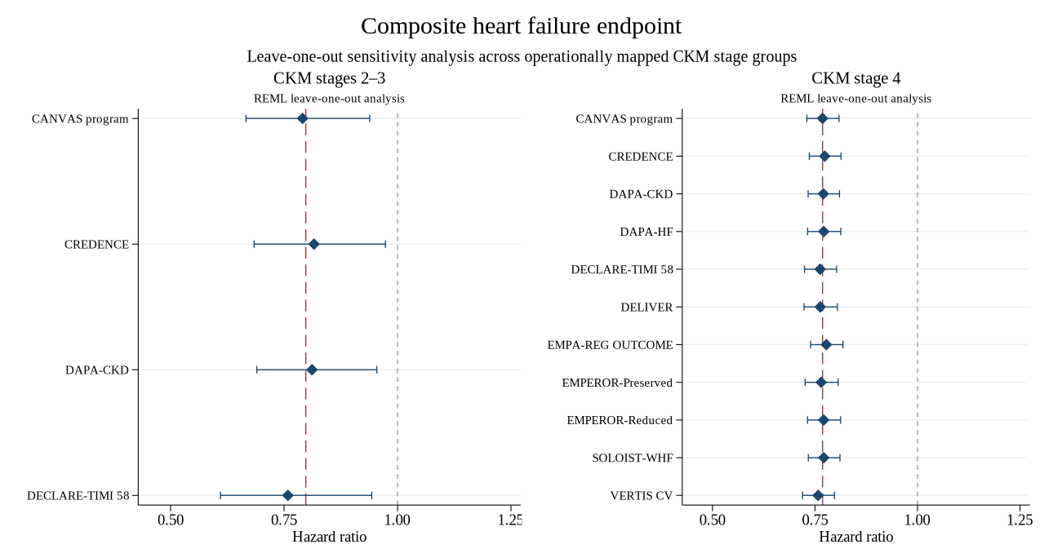

Supplementary Figure S2B. Major adverse cardiovascular events
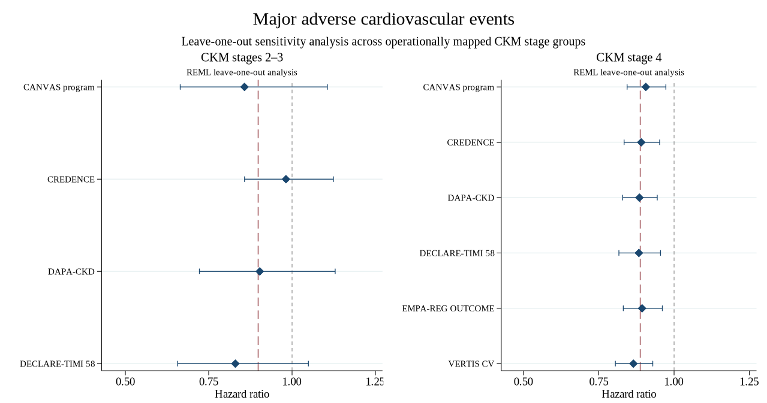

Supplementary Figure S2C. Hospitalization for heart failure
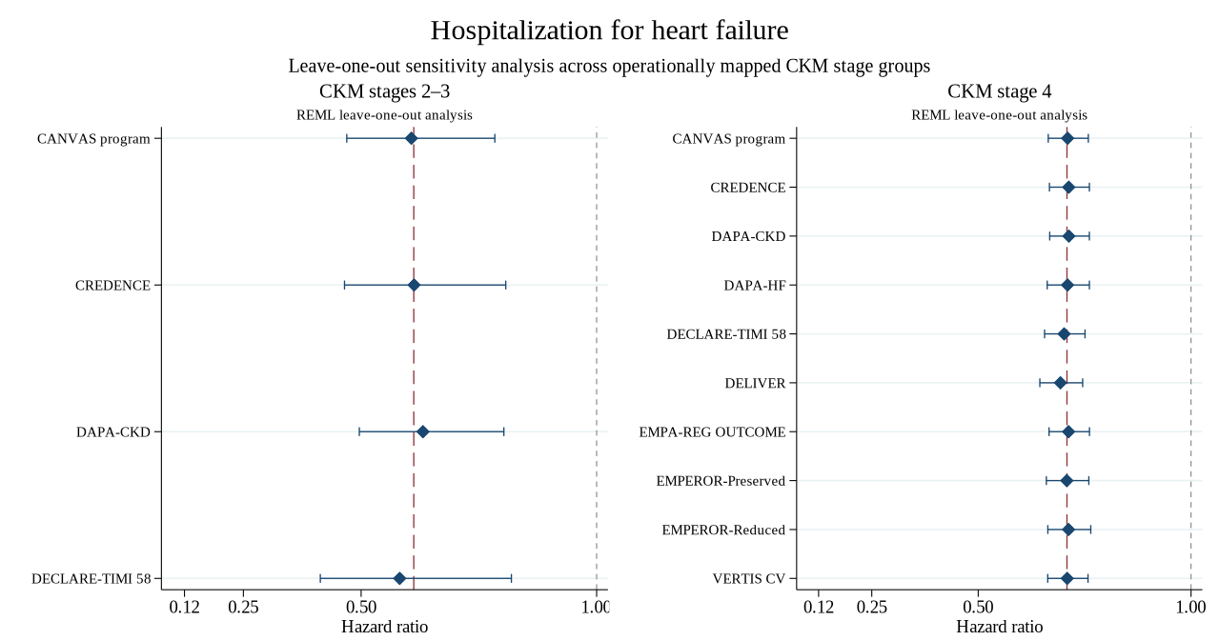

Supplementary Figure S2D. Trial-defined kidney composite outcomes
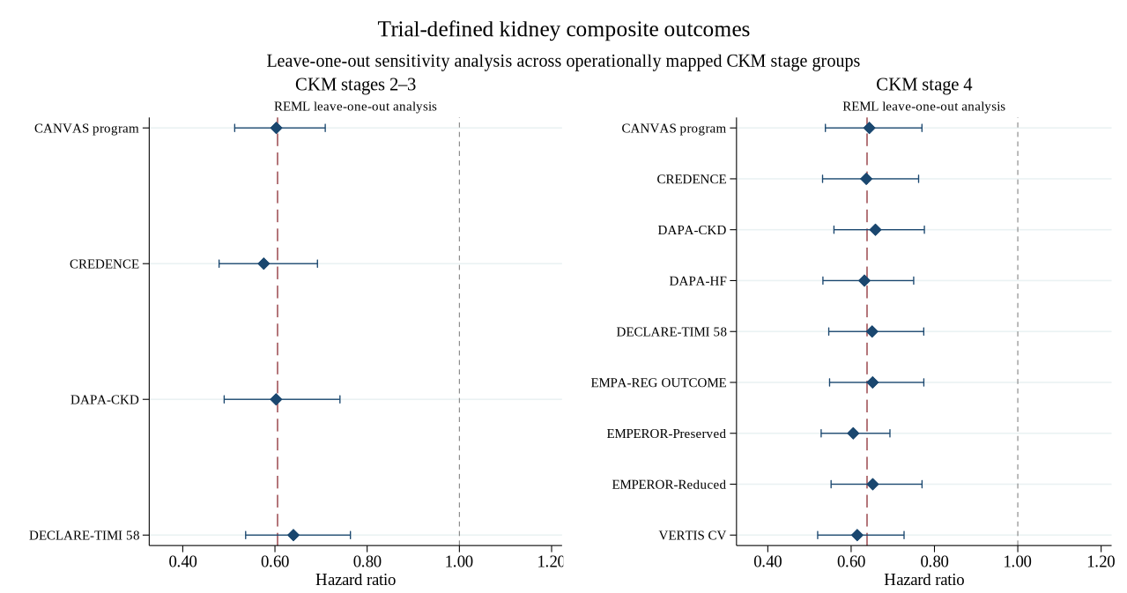

Supplementary Figure S2E. All-cause mortality
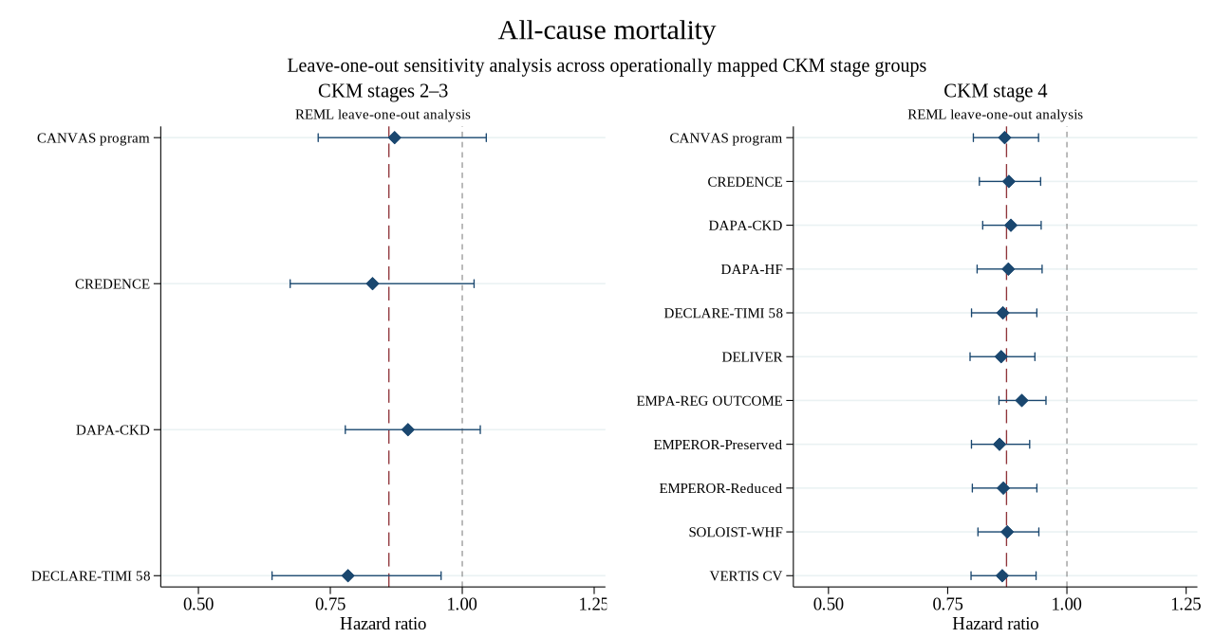

Supplementary Figure S2F. Cardiovascular death
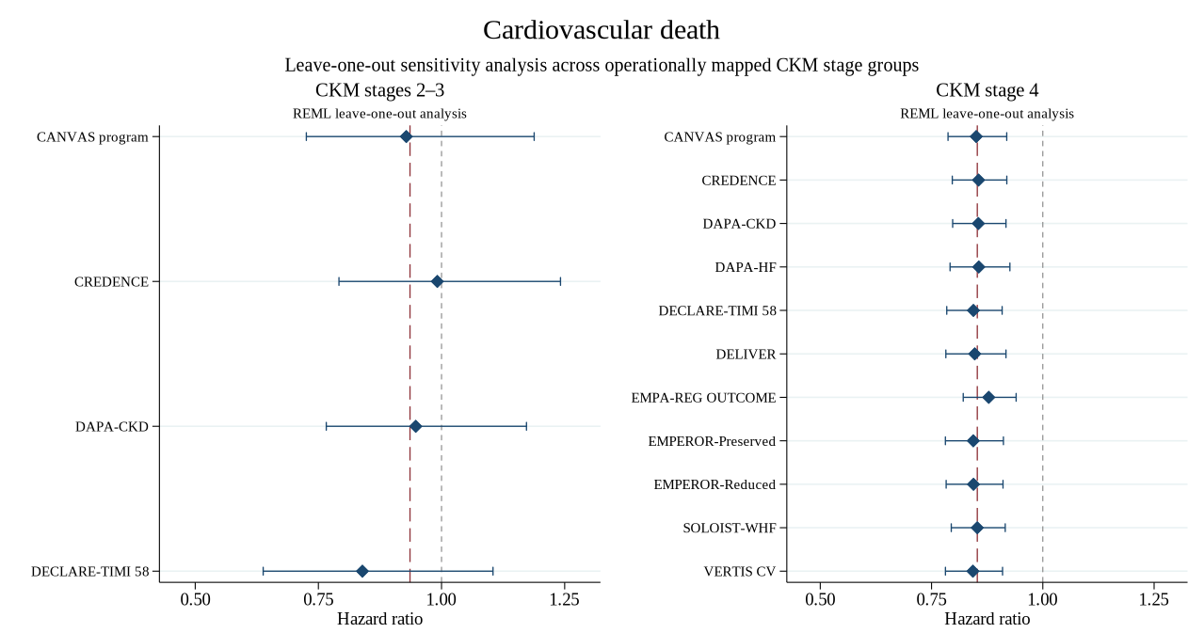
Legend. Leave-one-out analyses were conducted separately within CKM stages 2–3 and CKM stage 4. Diamonds represent REML random-effects pooled HRs after sequential omission of the named contributing estimate; horizontal lines represent 95% CIs. Dashed reference lines indicate the primary stage-group-specific pooled HR, and the vertical line at HR = 1 indicates the null effect. CKM groups were operationally mapped and do not represent formal patient-level staging. CI, confidence interval; CKM, cardiovascular-kidney-metabolic; HR, hazard ratio; REML, restricted maximum likelihood.

Supplementary Figure S3A. Composite heart failure endpoint
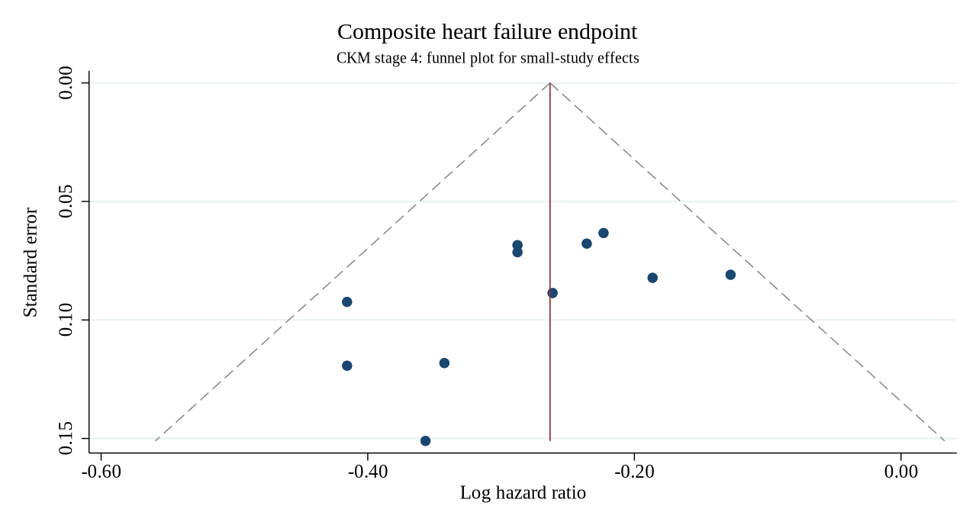

Supplementary Figure S3B. Hospitalization for heart failure
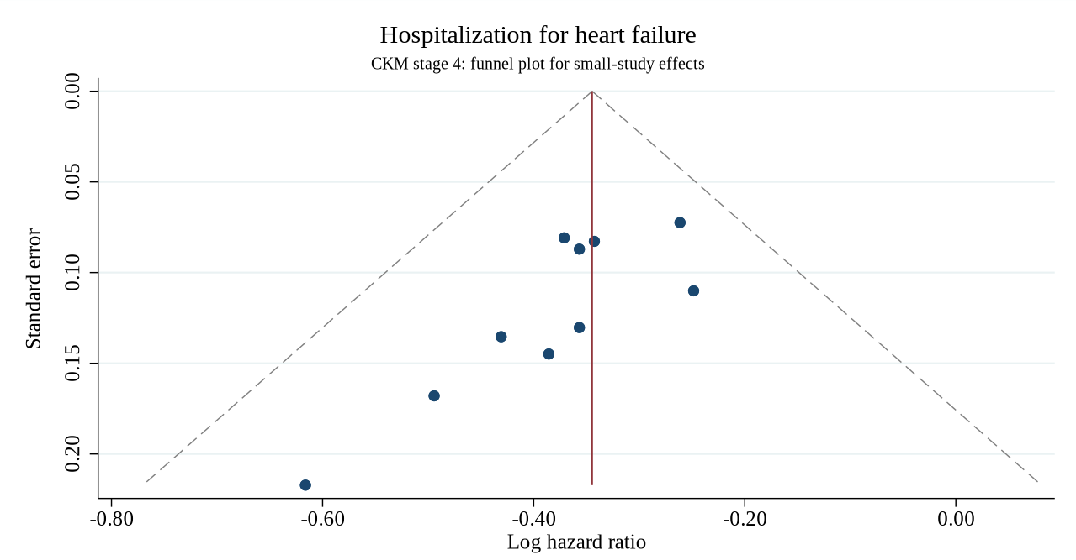

Supplementary Figure S3C. All-cause mortality
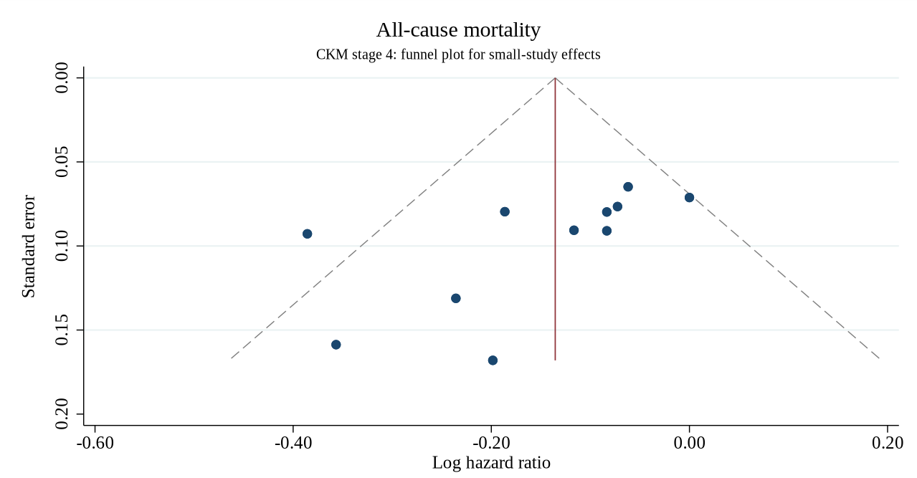

Supplementary Figure S3D. Cardiovascular death
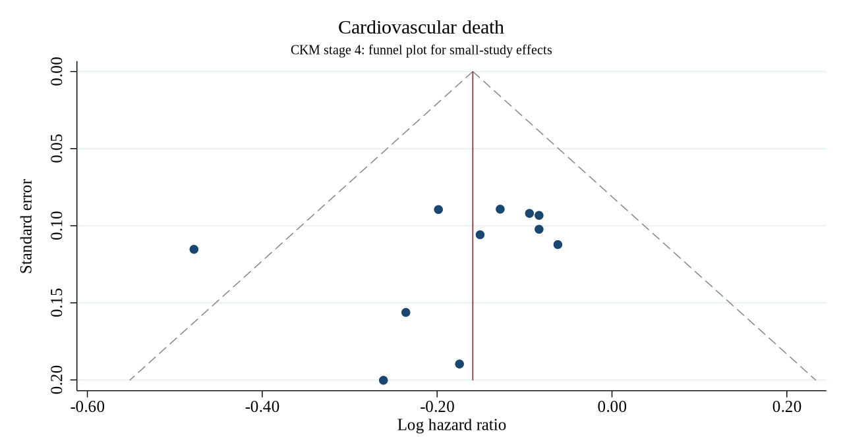
Legend. Funnel plots were presented only for stage-group-specific syntheses including at least 10 independent trial estimates. The horizontal axis shows the log hazard ratio and the vertical axis its standard error. The vertical reference line represents the corresponding REML random-effects pooled log hazard ratio; diagonal dashed lines indicate pseudo 95% confidence limits. Funnel plots were interpreted as exploratory and in conjunction with Egger regression results in Supplementary Table S9. A statistically detectable asymmetry signal was not considered direct evidence of publication bias. CKM, cardiovascular-kidney-metabolic; REML, restricted maximum likelihood.

