Supplementary Materials
Differential Pathway Profiles of Uric Acid and the Non-High-Density Lipoprotein Cholesterol to High-Density Lipoprotein Cholesterol Ratio (NHHR) in Predicting Incident Type 2 Diabetes: A Prospective Cohort Study
Weiqiang Qin^{1†}; Bo Liu^{1†}; Xiaoling Yi³, Juan Lei¹, Lan Mai²

Supplementary Figure S1
Decision curve analysis.

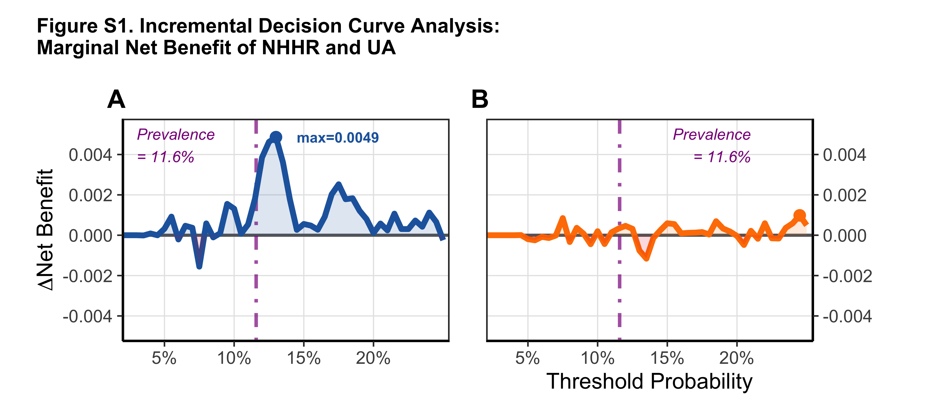
Figure S1. Decision curve analysis. (A) Standard decision curve: net benefit across different threshold probabilities. (B) Delta net benefit (ΔNB): incremental net benefit of adding NHHR or uric acid to the base model. NHHR showed a marginal net benefit around the 11.6% prevalence threshold (ΔNB = 0.0049), while uric acid showed near-zero net benefit across all thresholds.

Supplementary Table S1
Baseline characteristics by uric acid × NHHR combined groups.
Data source: China Health and Retirement Longitudinal Study (CHARLS) wave 1. Analysis sample: N=8,140 (excluding baseline diabetes). Classification: Uric acid (UA ≥ 6.0 mg/dL, Youden cutoff) × NHHR (NHHR ≥ 3.62, Youden cutoff).
Characteristic | G1 Low UA / Low NHHR (n=5,588) | G2 Low UA / High NHHR (n=1,721) | G3 High UA / Low NHHR (n=520) | G4 High UA / High NHHR (n=311) | P-value
T2DM events, n (%) | 530 (9.5%) | 260 (15.1%) | 57 (11.0%) | 59 (19.0%) | <0.001
Demographics
Age (years) | 58.3 ± 9.1 | 58.3 ± 8.7 | 61.3 ± 9.7 | 59.2 ± 9.4 | <0.001
Male, n (%) | 2,455 (43.9%) | 693 (40.3%) | 426 (81.9%) | 237 (76.2%) | <0.001
Anthropometrics
BMI (kg/m²) | 22.7 ± 3.6 | 24.9 ± 3.6 | 23.1 ± 3.9 | 25.1 ± 3.6 | <0.001
Waist circumference (cm) | 81.8 ± 12.0 | 88.3 ± 11.9 | 84.3 ± 11.8 | 90.1 ± 12.4 | <0.001
Blood pressure
Systolic BP (mmHg) | 126.8 ± 21.0 | 131.3 ± 21.5 | 132.5 ± 20.3 | 133.9 ± 19.9 | <0.001
Hypertension history, n (%) | 1,151 (20.8%) | 528 (31.0%) | 164 (31.8%) | 109 (35.6%) | <0.001
Antihypertensive use, n (%) | 751 (13.6%) | 384 (22.5%) | 115 (22.3%) | 87 (28.5%) | <0.001
Glucose
FPG (mg/dL) | 98.8 ± 11.9 | 102.7 ± 11.3 | 100.8 ± 12.3 | 105.4 ± 10.9 | <0.001
HbA1c (%) | 5.1 ± 0.4 | 5.1 ± 0.4 | 5.1 ± 0.4 | 5.2 ± 0.5 | <0.001
Uric acid & lipids
Uric acid (μmol/L) | 244 ± 54 | 262 ± 54 | 404 ± 48 | 410 ± 48 | <0.001
NHHR | 2.4 ± 0.7 | 4.6 ± 1.1 | 2.4 ± 0.7 | 5.0 ± 1.3 | <0.001
TC (mg/dL) | 185.1 ± 33.5 | 211.6 ± 38.8 | 187.4 ± 34.9 | 219.3 ± 41.0 | <0.001
TG (mg/dL) | 98.3 ± 45.7 | 184.2 ± 97.7 | 110.3 ± 57.9 | 214.3 ± 109.8 | <0.001
HDL-C (mg/dL) | 56.9 ± 13.9 | 38.2 ± 7.8 | 56.6 ± 14.8 | 37.3 ± 7.6 | <0.001
LDL-C (mg/dL) | 111.0 ± 28.7 | 134.2 ± 39.7 | 110.4 ± 32.0 | 136.4 ± 42.0 | <0.001
Kidney function & inflammation
eGFR (mL/min) | 112.1 ± 27.6 | 107.7 ± 27.0 | 89.5 ± 21.2 | 86.8 ± 21.5 | <0.001
CRP (mg/L) | 2.3 ± 6.6 | 2.7 ± 6.7 | 2.9 ± 6.2 | 2.7 ± 3.2 | <0.001
Lifestyle
Smoking, n (%) | 457 (11.6%) | 179 (13.7%) | 77 (28.3%) | 57 (29.7%) | <0.001
Drinking, n (%) | 2,106 (37.8%) | 567 (33.1%) | 330 (63.8%) | 168 (54.4%) | <0.001
Medications
Lipid-lowering meds, n (%) | 146 (2.7%) | 104 (6.2%) | 13 (2.6%) | 23 (7.7%) | <0.001
BMI ≥ 24, n (%) | 1,542 (32.2%) | 835 (56.9%) | 148 (34.1%) | 151 (58.8%) | <0.001
Continuous variables: mean ± SD; categorical variables: n (%). Group definitions: G1 = Low UA + Low NHHR (reference); G2 = Low UA + High NHHR; G3 = High UA + Low NHHR; G4 = High UA + High NHHR. High UA: UA ≥ 6.0 mg/dL (≈357 μmol/L); High NHHR: NHHR ≥ 3.62 (Youden-derived optimal cutoff). Continuous variables: Kruskal-Wallis test; categorical variables: χ² test.

Supplementary Table S2
Pearson correlation coefficients (r) between NHHR, uric acid, and metabolic risk factors. Analysis conducted in the full cohort without baseline diabetes (N=8,121).
 | Age | BMI | Waist | SBP | TC | TG | HDL-C | LDL-C | FPG | eGFR | Log CRP
NHHR | -0.024* | +0.315*** | +0.276*** | +0.106*** | +0.412*** | +0.657*** | -0.719*** | +0.398*** | +0.188*** | -0.102*** | +0.165***
Uric acid | +0.117*** | +0.088*** | +0.130*** | +0.118*** | +0.078*** | +0.159*** | -0.108*** | +0.041*** | +0.086*** | -0.401*** | +0.165***
Pearson correlation. SBP, systolic blood pressure; TC, total cholesterol; TG, triglycerides; HDL-C, high-density lipoprotein cholesterol; LDL-C, low-density lipoprotein cholesterol; FPG, fasting plasma glucose; eGFR, estimated glomerular filtration rate; CRP, C-reactive protein. P values: *** P<0.001, ** P<0.01, * P<0.05.

Supplementary Table S3
Eight sensitivity analyses evaluating the robustness of the primary findings.
Sensitivity analysis | N | Events | HR | 95% CI | P-value
S1: Fully adjusted model (Model 4) | 6,762 | 783 | 1.104 | 1.050–1.161 | <0.001
S2: Excluding CRP > 10 mg/L | 6,523 | 743 | 1.127 | 1.069–1.188 | <0.001
S3: Uniform UA cutoff (≥416 μmol/L) | 6,762 | 783 | 1.107 | 1.053–1.164 | <0.001
S4: Additional waist circumference adjustment | — | — | — | — | —
S5: Excluding eGFR < 60 mL/min/1.73m² | 6,671 | 774 | 1.104 | 1.049–1.161 | <0.001
S6: Logistic regression (no dyslipidemia adjustment) | 6,884 | 801 | 1.139 | 1.076–1.205 | <0.001
S7: Self-reported diabetes only | 6,762 | 491 | 1.147 | 1.079–1.218 | <0.001
S8: UA and NHHR within clinically plausible ranges | 6,750 | 781 | 1.122 | 1.063–1.184 | <0.001
E-value (based on S1) | — | — | E=1.44 | E(CI)=1.28 | —
S4 (additional waist circumference adjustment) failed to converge due to missing data and is not reported. All sensitivity analyses support the primary conclusion: the NHHR–T2DM association was robust across all analyses (HR range: 1.104–1.147, all P<0.05).

Supplementary Table S4
Comparison of baseline characteristics between included (complete-case analysis, n=6,762) and excluded (missing covariates, n=1,388) participants.
Purpose: To assess differences in baseline characteristics between participants included in the fully adjusted model (n=6,762) and those excluded due to missing covariate data (n=1,388), in order to evaluate whether the missing data mechanism approximates random.
Conclusion: No significant differences were observed in key metabolic indicators (UA, NHHR, CRP, eGFR) between the two groups, suggesting that the missing data mechanism approximates random and the primary findings are unlikely to be substantially biased by missing data.
Continuous variables (mean ± SD)
Variable | Included (n=6,762) | Excluded (n=1,388) | P-value
Age (years) | 58.7 ± 9.1 | 57.6 ± 9.3 | 0.000
BMI (kg/m²) | 23.9 ± 3.2 | NA | —
Waist circumference (cm) | 83.7 ± 12.2 (n=6,758) | 82.8 ± 14.8 (n=253) | 0.360
Systolic BP (mmHg) | 128.2 ± 21.2 (n=6,719) | 131.2 ± 21.1 (n=273) | 0.023
eGFR (mL/min/1.73m²) | 108.5 ± 27.6 | 110.1 ± 28.7 | 0.063
CRP (mg/L) | 2.4 ± 6.6 | 2.5 ± 5.9 | 0.750
HbA1c (%) | 5.1 ± 0.4 (n=6,726) | 5.1 ± 0.4 (n=1,365) | 0.951
FPG (mg/dL) | 100.0 ± 11.9 | 100.0 ± 12.3 | 0.922
UA (μmol/L) | 262 ± 73 | 267 ± 77 | 0.194
NHHR | 2.9 ± 1.3 | 3.0 ± 1.4 | 0.113
Categorical variables (n, %)
Variable | Included (n=6,762) | Excluded (n=1,388) | P-value
Female | 3,628 (53.6%) | 705 (51.2%) | 0.115
Ever smoking | 557 (8.2%) | 214 (15.5%) | <0.001
Ever drinking | 2,635 (38.9%) | 540 (40.2%) | 0.388
Hypertension | 1,595 (23.5%) | 363 (27.8%) | 0.001
Dyslipidemia | 527 (7.8%) | 110 (9.3%) | 0.082
Hyperuricemia | 319 (4.7%) | 77 (5.6%) | 0.187
High NHHR | 3,375 (49.8%) | 694 (50.8%) | 0.547
Baseline prediabetes | 3,537 (52.2%) | 737 (53.5%) | 0.395
Education level
Education level | Included (n=6,762) | Excluded (n=1,388)
Below primary school | 6,155 (90.9%) | 1,206 (87.6%)
Middle school | 556 (8.2%) | 141 (10.2%)
High school | 62 (0.9%) | 30 (2.2%)
P-value |  |  | <0.001
Note: Continuous variables: t-test; categorical variables: χ² test. BMI was not available in the excluded group (BMI missing was the primary reason for exclusion). UA converted from mg/dL (×59.48). No significant differences in UA or NHHR between groups, suggesting the missing data mechanism approximates random.
Included group: complete-case sample for fully adjusted Model 4 (n=6,762). Excluded group: participants excluded due to missing covariate data (primarily BMI, n=1,388).

