Supplemental Material

Supplemental Methods
_____________________________________________________________________________________
Table S1. PRISMA Checklist 2020
Section and Topic | Item # | Checklist item | Location where item is reported
TITLE
Title | 1 | Identify the report as a systematic review. | Page 1
ABSTRACT
Abstract | 2 | See the PRISMA 2020 for Abstracts checklist. | Page 2
INTRODUCTION
Rationale | 3 | Describe the rationale for the review in the context of existing knowledge. | Page 3
Objectives | 4 | Provide an explicit statement of the objective(s) or question(s) the review addresses. | Page 4
METHODS
Eligibility criteria | 5 | Specify the inclusion and exclusion criteria for the review and how studies were grouped for the syntheses. | Page 4, 5
Information sources | 6 | Specify all databases, registers, websites, organisations, reference lists and other sources searched or consulted to identify studies. Specify the date when each source was last searched or consulted. | Page 4, 6
Search strategy | 7 | Present the full search strategies for all databases, registers and websites, including any filters and limits used. | Page 4.+ Supplemental material Table S2
Selection process | 8 | Specify the methods used to decide whether a study met the inclusion criteria of the review, including how many reviewers screened each record and each report retrieved, whether they worked independently, and if applicable, details of automation tools used in the process. | Page 4, 5
Data collection process | 9 | Specify the methods used to collect data from reports, including how many reviewers collected data from each report, whether they worked independently, any processes for obtaining or confirming data from study investigators, and if applicable, details of automation tools used in the process. | Page 4, 5
Data items | 10a | List and define all outcomes for which data were sought. Specify whether all results that were compatible with each outcome domain in each study were sought (e.g. for all measures, time points, analyses), and if not, the methods used to decide which results to collect. | Page 4, 5
Data items | 10b | List and define all other variables for which data were sought (e.g. participant and intervention characteristics, funding sources). Describe any assumptions made about any missing or unclear information. | Page 4, 5
Study risk of bias assessment | 11 | Specify the methods used to assess risk of bias in the included studies, including details of the tool(s) used, how many reviewers assessed each study and whether they worked independently, and if applicable, details of automation tools used in the process. | Page 5
Effect measures | 12 | Specify for each outcome the effect measure(s) (e.g. risk ratio, mean difference) used in the synthesis or presentation of results. | Page 6
Synthesis methods | 13a | Describe the processes used to decide which studies were eligible for each synthesis (e.g. tabulating the study intervention characteristics and comparing against the planned groups for each synthesis (item #5)). | Page 6
Synthesis methods | 13b | Describe any methods required to prepare the data for presentation or synthesis, such as handling of missing summary statistics, or data conversions. | Page 6
Synthesis methods | 13c | Describe any methods used to tabulate or visually display results of individual studies and syntheses. | Page 6
Synthesis methods | 13d | Describe any methods used to synthesize results and provide a rationale for the choice(s). If meta-analysis was performed, describe the model(s), method(s) to identify the presence and extent of statistical heterogeneity, and software package(s) used. | Page 6
Synthesis methods | 13e | Describe any methods used to explore possible causes of heterogeneity among study results (e.g. subgroup analysis, meta-regression). | Page 6
Synthesis methods | 13f | Describe any sensitivity analyses conducted to assess robustness of the synthesized results.
Reporting bias assessment | 14 | Describe any methods used to assess risk of bias due to missing results in a synthesis (arising from reporting biases). | Page 6
Certainty assessment | 15 | Describe any methods used to assess certainty (or confidence) in the body of evidence for an outcome. | Page 6
RESULTS
Study selection | 16a | Describe the results of the search and selection process, from the number of records identified in the search to the number of studies included in the review, ideally using a flow diagram. | Page 6
Study selection | 16b | Cite studies that might appear to meet the inclusion criteria, but which were excluded, and explain why they were excluded. | Page 6
Study characteristics | 17 | Cite each included study and present its characteristics. | Table 1
Risk of bias in studies | 18 | Present assessments of risk of bias for each included study. | Page 6
Results of individual studies | 19 | For all outcomes, present, for each study: (a) summary statistics for each group (where appropriate) and (b) an effect estimate and its precision (e.g. confidence/credible interval), ideally using structured tables or plots. | Page 8 and supplementary material
Results of syntheses | 20a | For each synthesis, briefly summarise the characteristics and risk of bias among contributing studies. | Supp. Table S3
Results of syntheses | 20b | Present results of all statistical syntheses conducted. If meta-analysis was done, present for each the summary estimate and its precision (e.g. confidence/credible interval) and measures of statistical heterogeneity. If comparing groups, describe the direction of the effect. | Result part
Results of syntheses | 20c | Present results of all investigations of possible causes of heterogeneity among study results. | Subgroup analysis explained in each part
Results of syntheses | 20d | Present results of all sensitivity analyses conducted to assess the robustness of the synthesized results.
Reporting biases | 21 | Present assessments of risk of bias due to missing results (arising from reporting biases) for each synthesis assessed.
Certainty of evidence | 22 | Present assessments of certainty (or confidence) in the body of evidence for each outcome assessed. | Result part
DISCUSSION
Discussion | 23a | Provide a general interpretation of the results in the context of other evidence. | Page 8, 11
Discussion | 23b | Discuss any limitations of the evidence included in the review. | Page 10, 11
Discussion | 23c | Discuss any limitations of the review processes used. | Page 10, 11
Discussion | 23d | Discuss implications of the results for practice, policy, and future research. | Page 8-11
OTHER INFORMATION
Registration and protocol | 24a | Provide registration information for the review, including register name and registration number, or state that the review was not registered. | Page 4
Registration and protocol | 24b | Indicate where the review protocol can be accessed, or state that a protocol was not prepared. | Page 4
Registration and protocol | 24c | Describe and explain any amendments to information provided at registration or in the protocol. | Page 4
Support | 25 | Describe sources of financial or non-financial support for the review, and the role of the funders or sponsors in the review. | Page 12
Competing interests | 26 | Declare any competing interests of review authors. | Page 12
Availability of data, code and other materials | 27 | Report which of the following are publicly available and where they can be found: template data collection forms; data extracted from included studies; data used for all analyses; analytic code; any other materials used in the review. | Page 12

Table S2. Search strategy and results
Database | Query | Results (No.)
PubMed | ((Diabetic [Title/Abstract]) OR (Ketoacidosis[Title/Abstract]) OR (Ketoacidoses[Title/Abstract]) OR (Acidosis[Title/Abstract]) OR (Acidoses[Title/Abstract]) OR (DKA[Title/Abstract])) AND ((ICU[Title/Abstract]) OR (Intensive Care[Title/Abstract])) AND ((Child[Title/Abstract]) OR (Children[Title/Abstract]) OR (Pediatric[Title/Abstract]) OR (Pediatrics[Title/Abstract])) | 664
Web of Science (WOS) | (ALL=(Diabetic OR Ketoacidosis OR ketoacidosis OR acidosis OR Acidosis OR DKA)) AND (ALL=(ICU OR Intensive Care)) AND (ALL=(Child OR Children OR Pediatrics OR Pediatric)) | 1273
Scopus | (TITLE-ABS-KEY (Diabetic OR Ketoacidosis OR Ketoacidoses OR Acidoses OR Acidosis OR DKA)) AND (TITLE-ABS-KEY (ICU OR Intensive Care)) AND (TITLE-ABS-KEY (Child OR Pediatrics OR Children OR Pediatric)) | 2917
Embase | ('diabetic ketoacidosis':ti,ab,kw) AND ('child':ti,ab,kw OR 'pediatric':ti,ab,kw OR 'pediatrics':ti,ab,kw) AND ('intensive care unit':ti,ab,kw OR 'intensive care':ti,ab,kw) | 342

Quality Assessment
Table S3. Risk of Bias according to modified National Institute of Health (NIH) quality assessment tool for observational cohort and cross-sectional studies.

1st author, year | Domain 1 | Domain 2 | Domain 3 | Domain 4 | Domain 5 | Domain 6 | Domain 7 | Domain 8 | Domain 9 | Domain 10 | Domain 11 | Domain 12 | Domain 13 | Domain 14 | Total score | Overal appresial
Monroe, 1997 | Yes | Yes | Yes | Yes | Yes | No | Yes | No | Yes | No | Yes | NR | NR | Yes | 9 | Fair
Jahagirdar, 2007 | Yes | Yes | Yes | Yes | Yes | No | Yes | Yes | Yes | No | Yes | NR | Yes | Yes | 11 | Good
Kanwal, 2012 | Yes | Yes | Yes | Yes | Yes | No | Yes | Yes | Yes | No | Yes | NR | Yes | Yes | 11 | Good
Rochmah, 2015 | Yes | Yes | Yes | Yes | Yes | No | Yes | Yes | Yes | No | Yes | NR | Yes | Yes | 11 | Good
Varshney, 2015 | Yes | Yes | Yes | Yes | Yes | No | Yes | No | Yes | No | Yes | NR | NR | Yes | 9 | Fair
Velasco, 2017 | Yes | Yes | Yes | Yes | Yes | No | Yes | Yes | Yes | No | Yes | NR | Yes | Yes | 11 | Good
Abbas, 2018 | Yes | Yes | Yes | Yes | Yes | No | Yes | Yes | Yes | No | Yes | NR | Yes | Yes | 11 | Good
Baalaaji, 2018 | Yes | Yes | Yes | Yes | Yes | No | Yes | Yes | Yes | No | Yes | NR | Yes | Yes | 11 | Good
Del Pozo, 2018 | Yes | Yes | Yes | Yes | Yes | No | Yes | No | Yes | No | Yes | NR | Yes | Yes | 9 | Fair
Burcul, 2019 | Yes | Yes | Yes | Yes | Yes | No | NR | Yes | Yes | No | Yes | NR | Yes | Yes | 9 | Fair
Weissbach, 2019 | Yes | Yes | Yes | Yes | Yes | No | Yes | Yes | Yes | No | Yes | NR | Yes | Yes | 11 | Good
Agarwal, 2020 | Yes | Yes | Yes | Yes | Yes | No | Yes | Yes | Yes | No | Yes | NR | Yes | Yes | 11 | Good
Broberg, 2020 | Yes | Yes | Yes | Yes | Yes | No | Yes | Yes | Yes | No | Yes | NR | Yes | Yes | 11 | Good
Cully, 2020 | Yes | Yes | Yes | Yes | Yes | No | Yes | Yes | Yes | No | Yes | NR | Yes | Yes | 11 | Good
Kangin, 2020 | Yes | Yes | Yes | Yes | Yes | No | Yes | Yes | Yes | No | No | NR | Yes | Yes | 10 | Good
Unal, 2020 | Yes | Yes | Yes | Yes | Yes | No | Yes | Yes | Yes | No | Yes | NR | Yes | Yes | 11 | Good
Babbitt, 2021 | Yes | Yes | Yes | Yes | Yes | No | Yes | Yes | Yes | No | Yes | NR | Yes | Yes | 11 | Good
Baloch, 2021 | Yes | Yes | Yes | Yes | Yes | No | Yes | Yes | Yes | No | Yes | NR | Yes | Yes | 11 | Good
Yang, 2021 | Yes | Yes | Yes | Yes | Yes | No | Yes | Yes | Yes | No | No | NR | Yes | Yes | 10 | Good
Ahmed, 2022 | Yes | Yes | Yes | Yes | Yes | No | Yes | Yes | Yes | No | No | NR | Yes | Yes | 10 | Good
Fathi, 2022 | Yes | Yes | Yes | Yes | Yes | No | Yes | Yes | Yes | No | No | NR | Yes | Yes | 10 | Good
Lah Tomulić, 2022 | Yes | Yes | Yes | Yes | Yes | No | Yes | Yes | Yes | No | Yes | NR | Yes | Yes | 11 | Good
Maurice, 2022 | Yes | Yes | Yes | Yes | Yes | No | Yes | Yes | Yes | No | No | NR | Yes | Yes | 10 | Good
Ozcan, 2022 | Yes | Yes | Yes | Yes | Yes | No | Yes | Yes | Yes | No | Yes | NR | Yes | Yes | 11 | Good
Sehgal, 2022 | Yes | Yes | Yes | Yes | Yes | No | Yes | Yes | Yes | No | No | NR | Yes | Yes | 10 | Good
Varol, 2022 | Yes | Yes | Yes | Yes | Yes | No | Yes | Yes | Yes | No | Yes | NR | Yes | Yes | 11 | Good
Albuali, 2023 | Yes | Yes | Yes | Yes | Yes | No | Yes | Yes | Yes | No | Yes | NR | Yes | Yes | 11 | Good
Kahveci, 2024 | Yes | Yes | Yes | Yes | Yes | No | Yes | Yes | Yes | No | Yes | NR | Yes | Yes | 11 | Good
Kausar, 2023 | Yes | Yes | Yes | Yes | Yes | No | Yes | Yes | Yes | No | Yes | NR | Yes | Yes | 11 | Good
Lazar, 2023 | Yes | Yes | Yes | Yes | Yes | No | Yes | Yes | Yes | No | No | NR | Yes | Yes | 10 | Good
Welter, 2023 | Yes | Yes | Yes | Yes | Yes | No | Yes | Yes | Yes | No | Yes | NR | Yes | Yes | 11 | Good
Yazici, 2023 | Yes | Yes | Yes | Yes | Yes | No | Yes | Yes | Yes | No | Yes | NR | Yes | Yes | 11 | Good
Ahmed Houssein, 2024 | Yes | Yes | Yes | Yes | Yes | No | Yes | Yes | Yes | No | Yes | NR | Yes | Yes | 11 | Good
Aşık, 2024 | Yes | Yes | Yes | Yes | Yes | No | Yes | Yes | Yes | No | Yes | NR | Yes | Yes | 11 | Good
Baker, 2024 | Yes | Yes | Yes | Yes | Yes | No | Yes | Yes | Yes | No | Yes | NR | Yes | Yes | 11 | Good
Cormack, 2024 | Yes | Yes | Yes | Yes | Yes | No | Yes | Yes | Yes | No | Yes | NR | Yes | Yes | 11 | Good
Perak, 2024 | Yes | Yes | Yes | Yes | Yes | No | Yes | Yes | Yes | No | Yes | NR | Yes | Yes | 11 | Good
Saffari, 2024 | Yes | Yes | Yes | Yes | Yes | No | Yes | Yes | Yes | No | Yes | NR | Yes | Yes | 11 | Good
Likhitha, 2025 | Yes | Yes | Yes | Yes | Yes | No | Yes | Yes | Yes | No | Yes | NR | Yes | Yes | 11 | Good
Liu, 2025 | Yes | Yes | Yes | Yes | Yes | No | Yes | Yes | Yes | No | Yes | NR | Yes | No | 10 | Good
Sailaja , 2025 | Yes | Yes | Yes | Yes | Yes | No | Yes | Yes | Yes | No | Yes | NR | Yes | Yes | 11 | Good

Figure S1. Meta-analysis of the prevalence of severe DKA at initial assessments (a) Forest plot, (b) Leave-one-out sensitivity analysis, (c) Funnel plot.
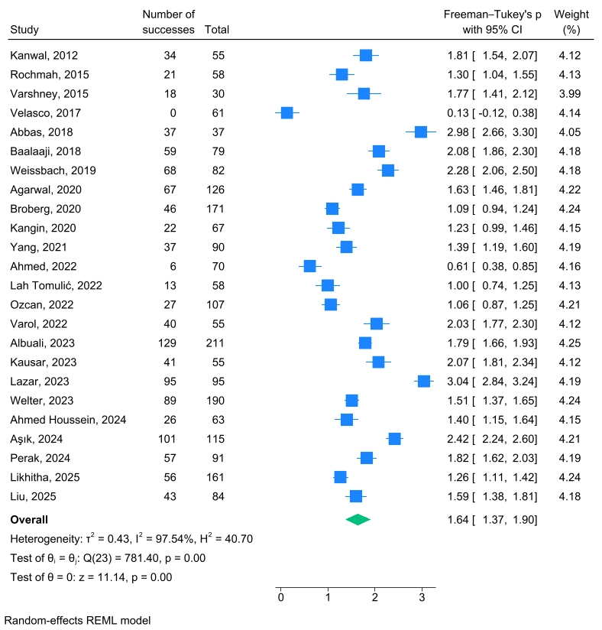
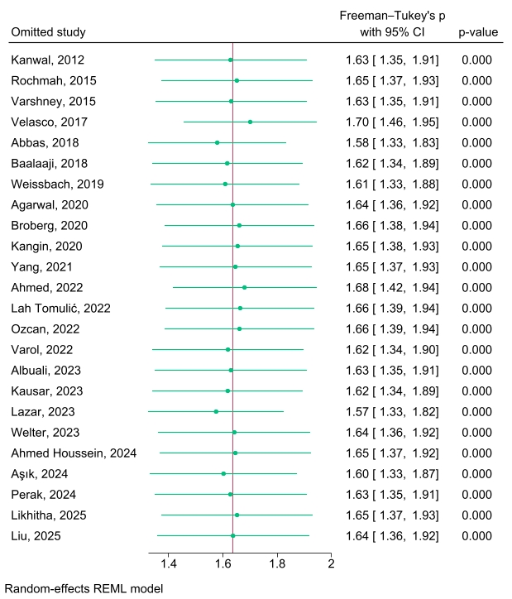
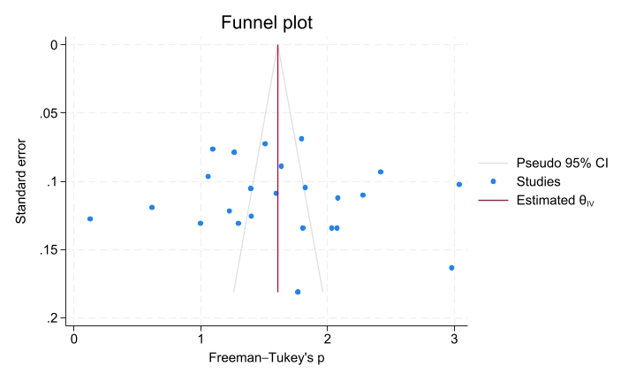

Figure S2. Meta-analysis of the prevalence of recurrent DKA at initial assessments (a) Forest plot, (b) Leave-one-out sensitivity analysis, (c) Funnel plot.
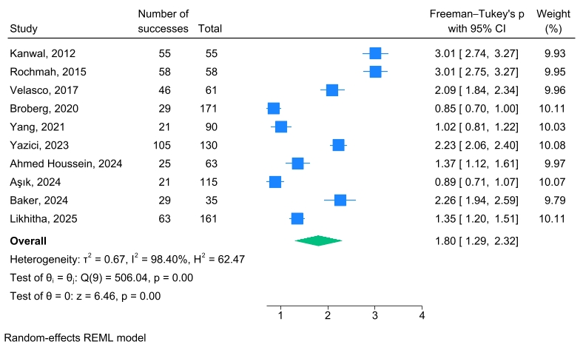
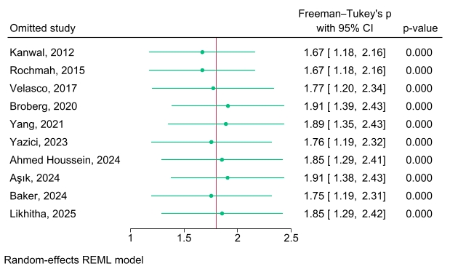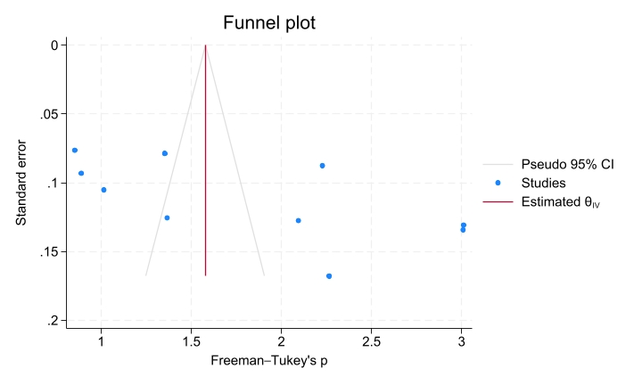
Figure S3. Meta-analysis of the prevalence of vomiting at initial assessments (a) Forest plot, (b) Leave-one-out sensitivity analysis, (c) Funnel plot.
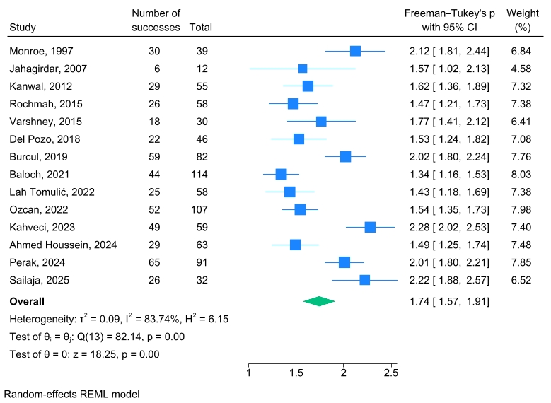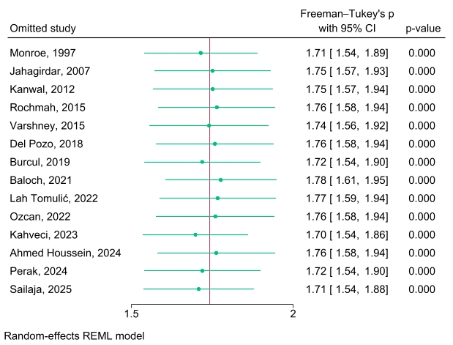
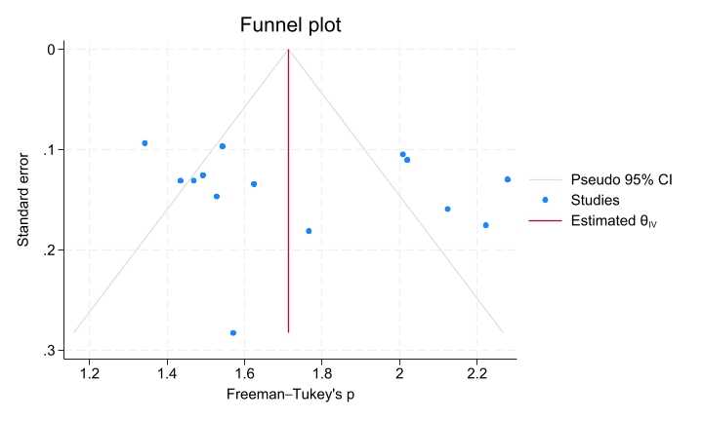

Figure S4. Meta-analysis of the prevalence of polydipsia at initial assessments (a) Forest plot, (b) Leave-one-out sensitivity analysis, (c) Funnel plot.
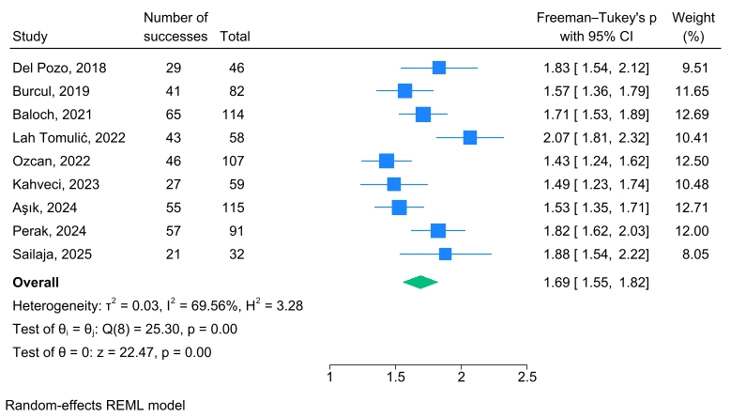

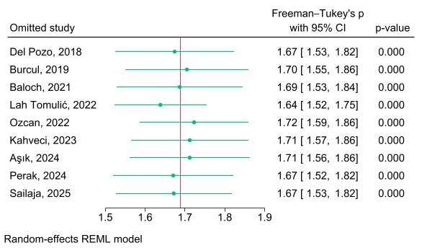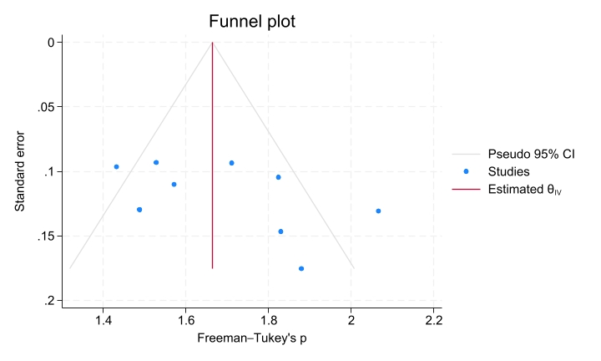
Figure S5. Meta-analysis of the prevalence of polyuria at initial assessments (a) Forest plot, (b) Leave-one-out sensitivity analysis, (c) Funnel plot.
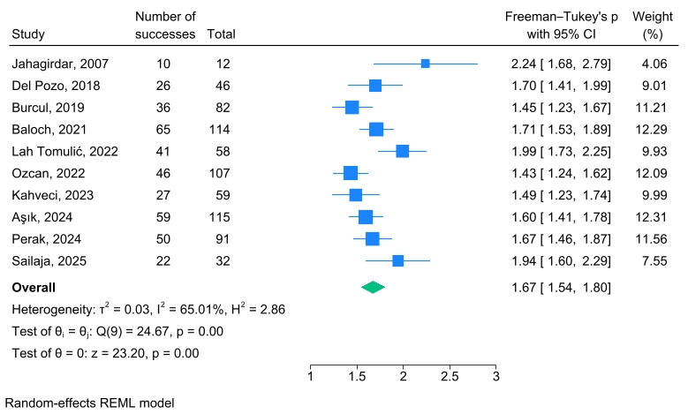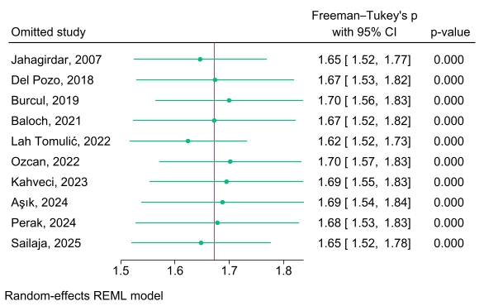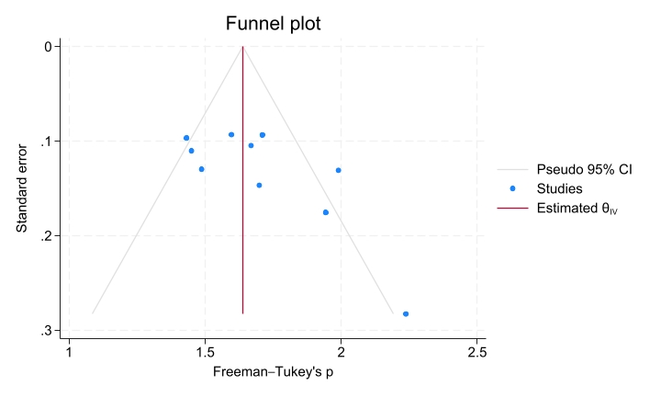
Figure S6. Meta-analysis of the prevalence of polydipsia and polyuria at initial assessments (a) Forest plot, (b) Leave-one-out sensitivity analysis, (c) Funnel plot.
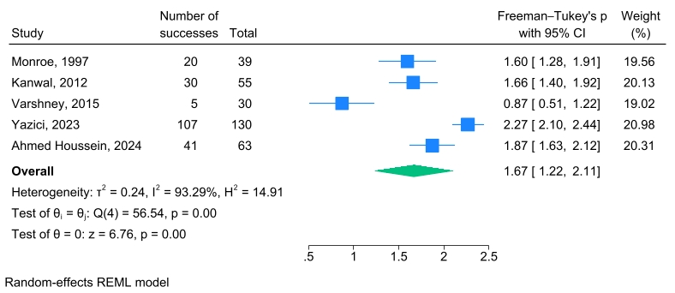
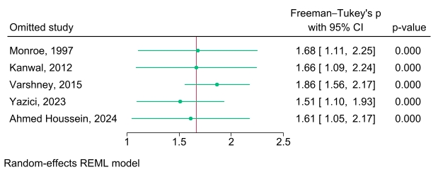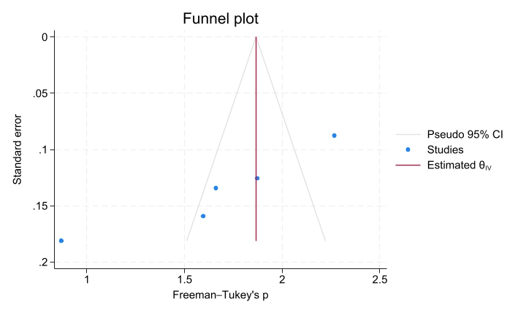
Figure S7. Meta-analysis of the prevalence of weight loss at initial assessments (a) Forest plot, (b) Leave-one-out sensitivity analysis, (c) Funnel plot. 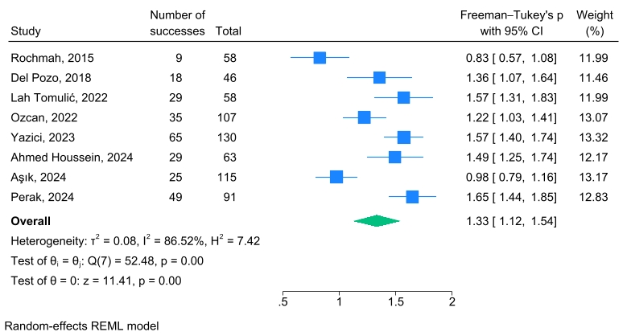
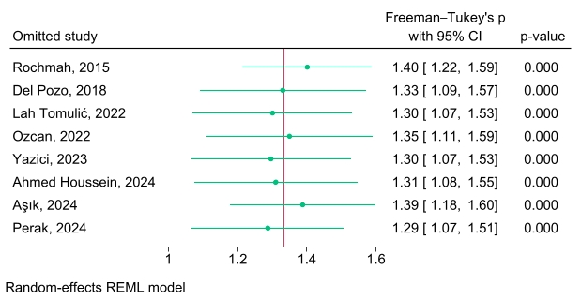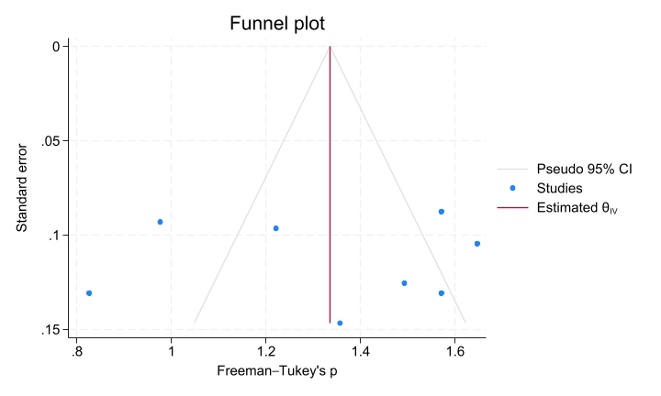
Figure S8. Meta-analysis of the prevalence of tachypnea at initial assessments (a) Forest plot, (b) Leave-one-out sensitivity analysis, (c) Funnel plot.
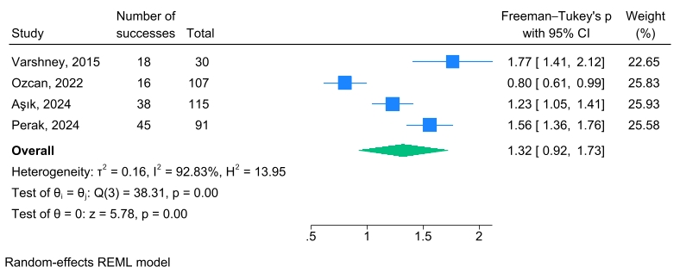
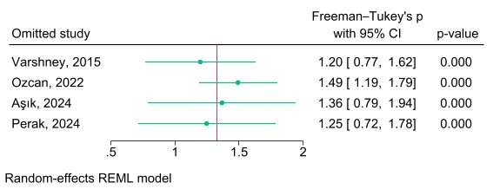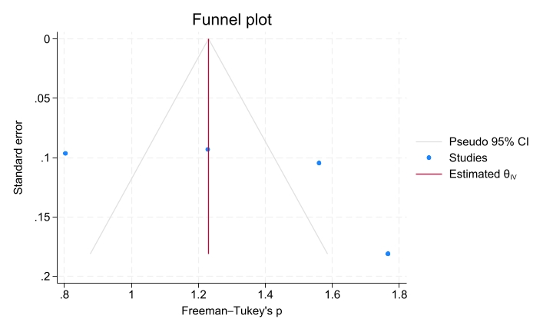
Figure S9. Meta-analysis of the prevalence of loss of consciousness at initial assessments (a) Forest plot, (b) Leave-one-out sensitivity analysis, (c) Funnel plot.
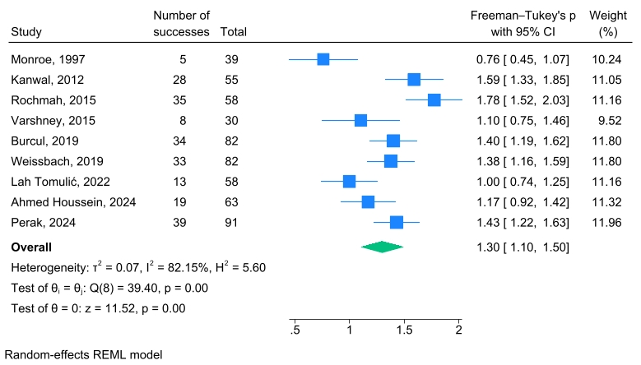
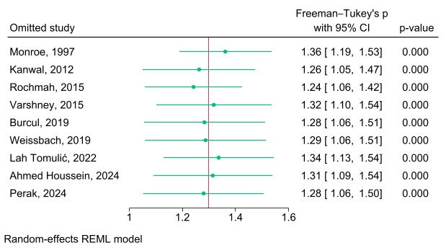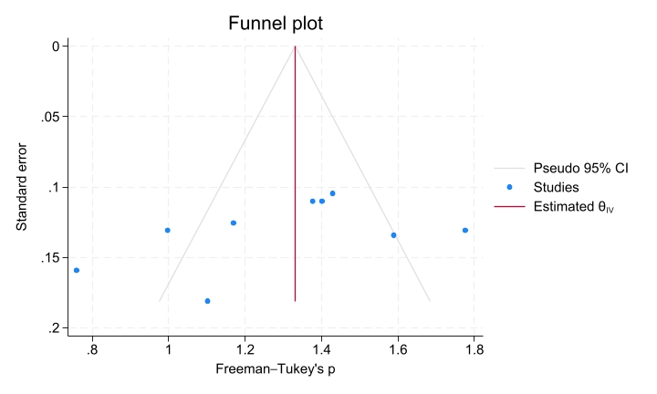
Figure S10. Meta-analysis of the prevalence of fever at initial assessments (a) Forest plot, (b) Leave-one-out sensitivity analysis, (c) Funnel plot.
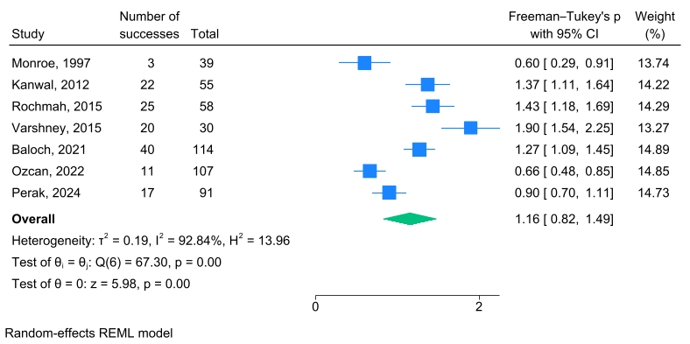
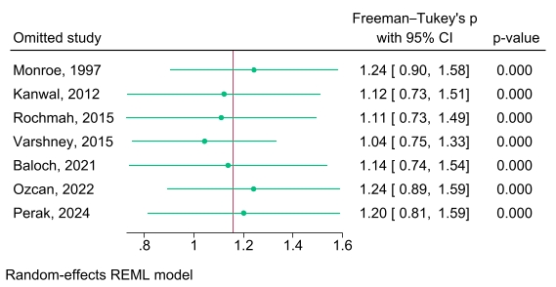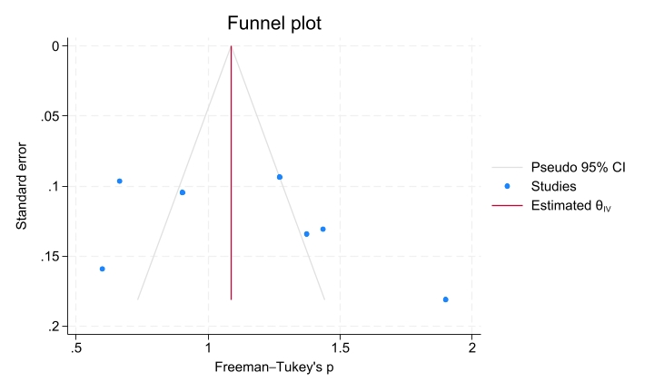
Figure S11. Meta-analysis of the prevalence of abdominal pain presentation at initial assessments (a) Forest plot, (b) Leave-one-out sensitivity analysis, (c) Funnel plot. 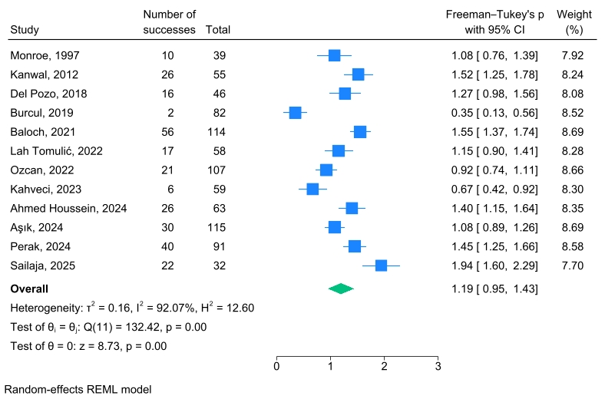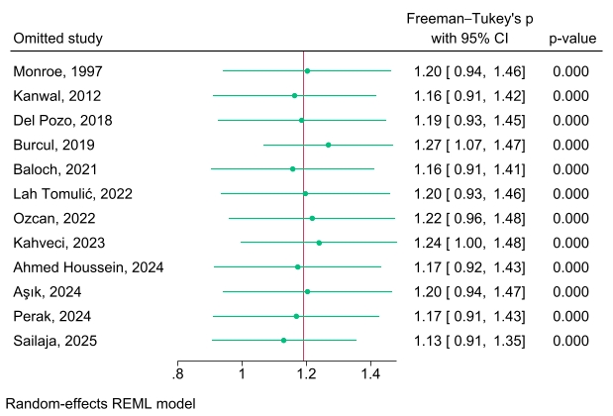
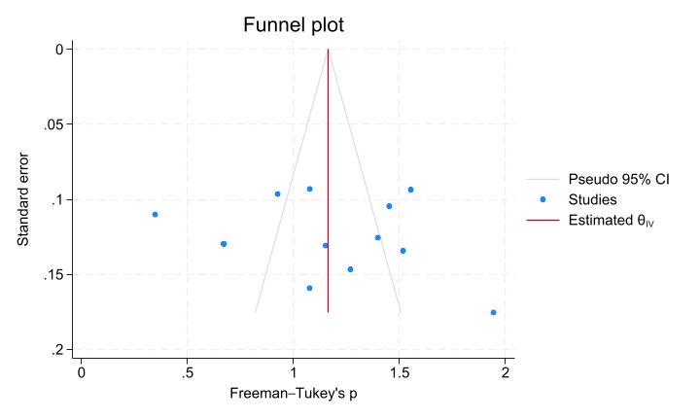

Figure S12. Meta-analysis of the prevalence of enuresis at initial assessments (a) Forest plot, (b) Leave-one-out sensitivity analysis, (c) Funnel plot.
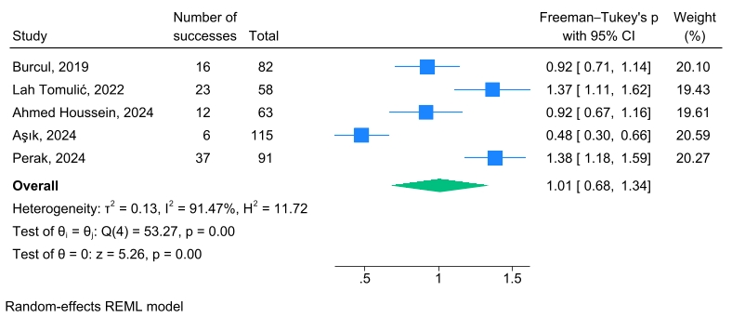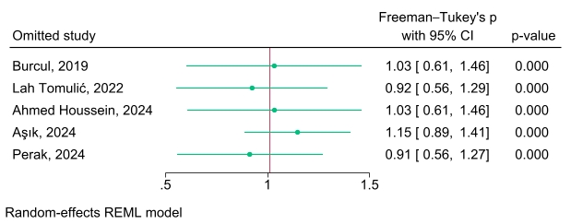
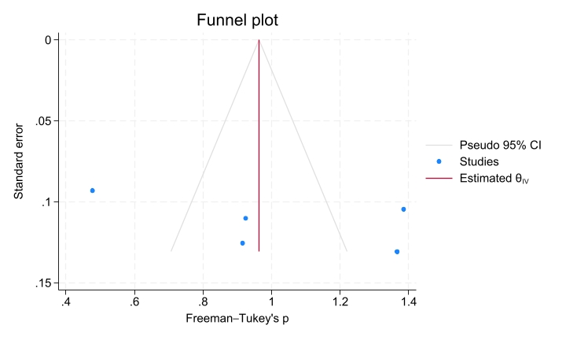
Figure S13. Meta-analysis of the prevalence of shock at initial assessments (a) Forest plot, (b) Leave-one-out sensitivity analysis, (c) Funnel plot.
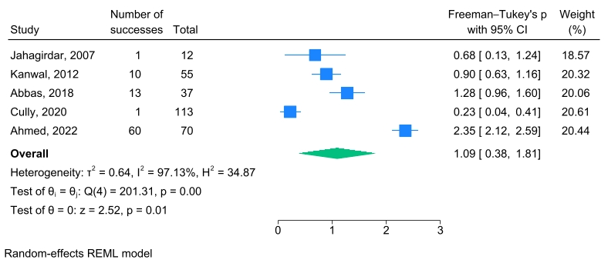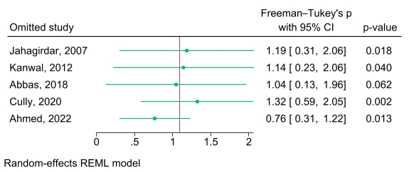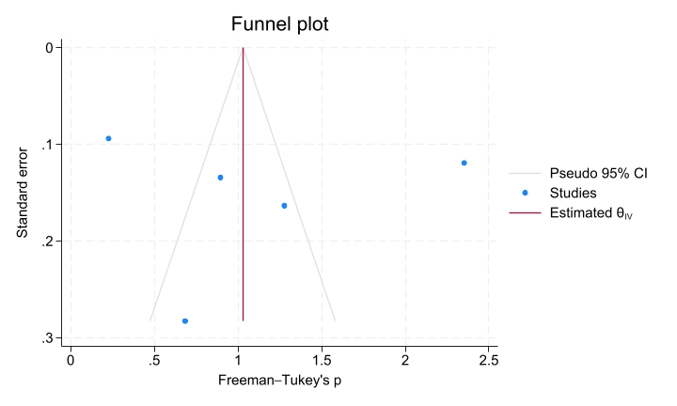
Figure S14. Meta-analysis of the prevalence of nausea at initial assessments (a) Forest plot, (b) Leave-one-out sensitivity analysis, (c) Funnel plot.
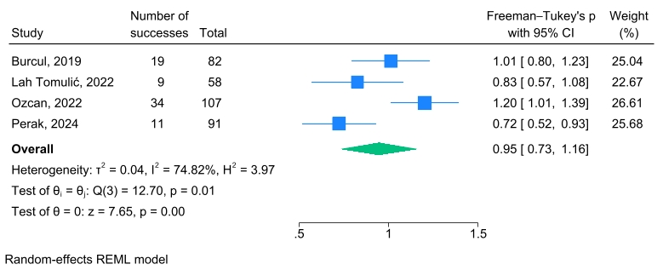
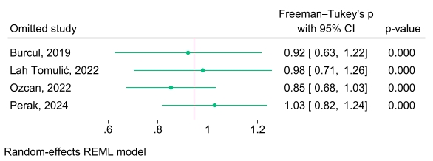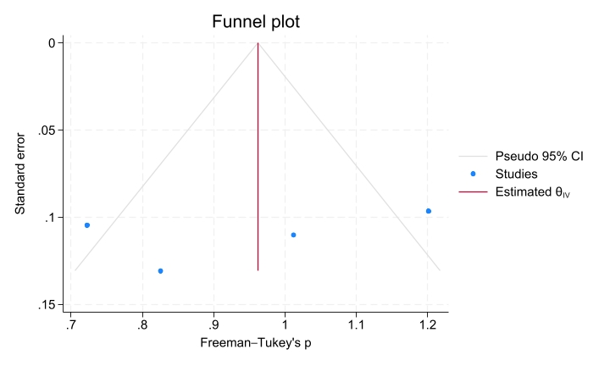
Figure S15. Meta-analysis of the mortality rate (a) Forest plot, (b) Leave-one-out sensitivity analysis, (c) Funnel plot.
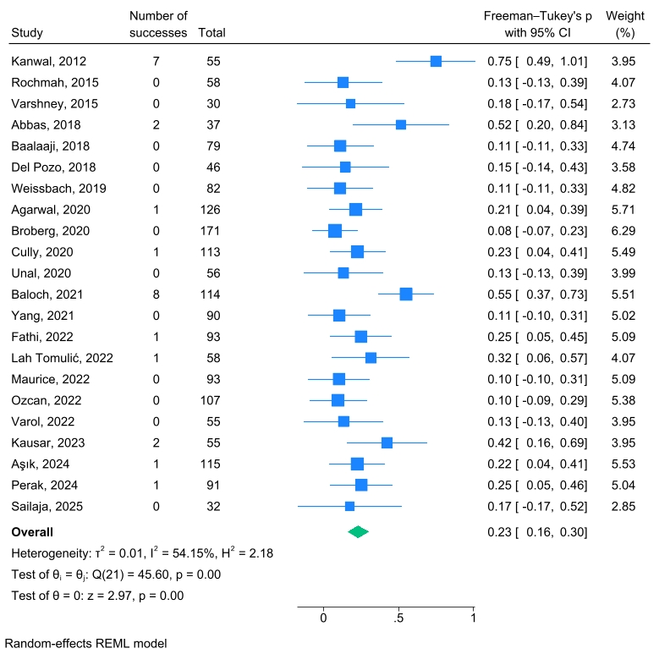
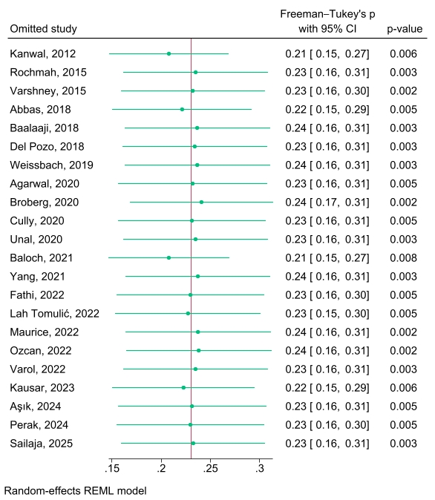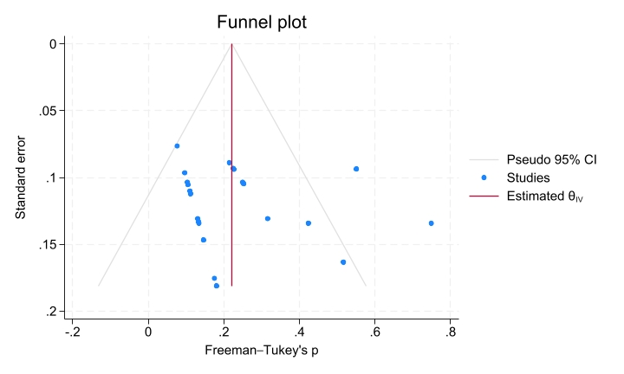
Figure S16. Meta-analysis of the prevalence of invasive mechanical ventilation requirement (a) Forest plot, (b) Leave-one-out sensitivity analysis, (c) Funnel plot.
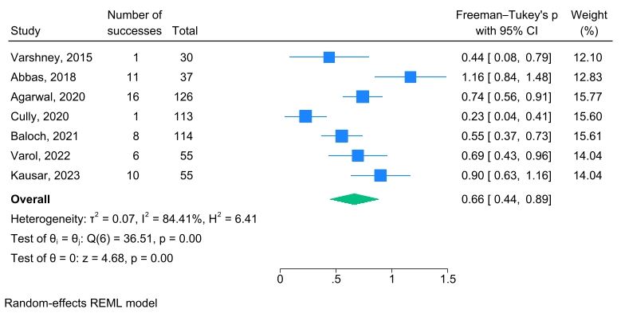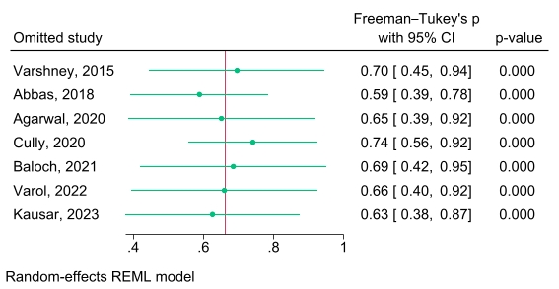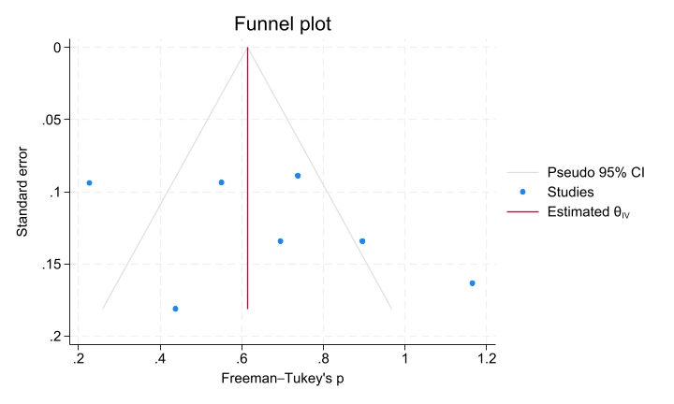
Figure S17. Meta-analysis of the prevalence of inotrope support requirement (a) Forest plot, (b) Leave-one-out sensitivity analysis, (c) Funnel plot.
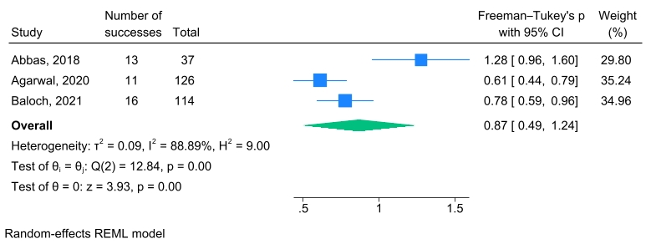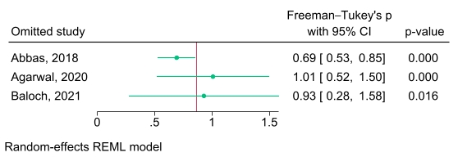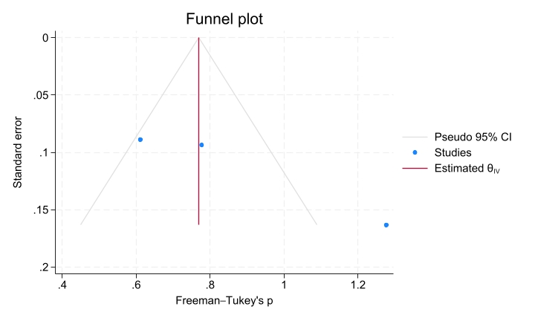
Figure S18. Meta-analysis of the prevalence of renal replacement therapy requirement (a) Forest plot, (b) Leave-one-out sensitivity analysis, (c) Funnel plot.
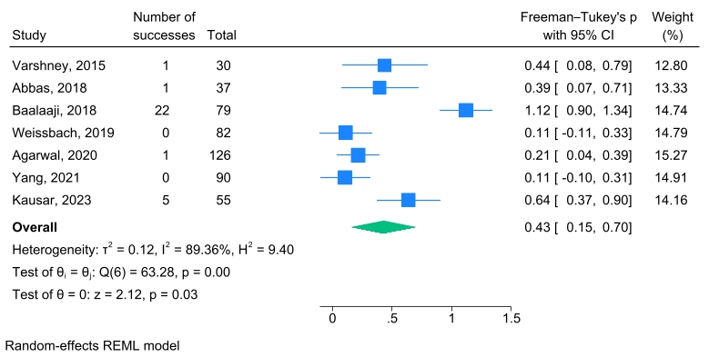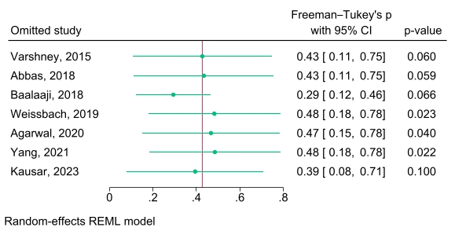
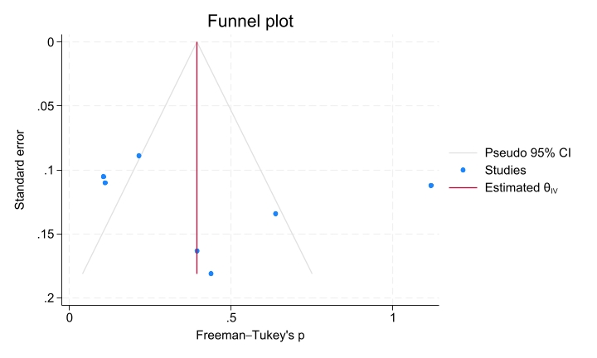
Figure S19. Meta-analysis of the prevalence of acute kidney injury complication (a) Forest plot, (b) Leave-one-out sensitivity analysis, (c) Funnel plot.
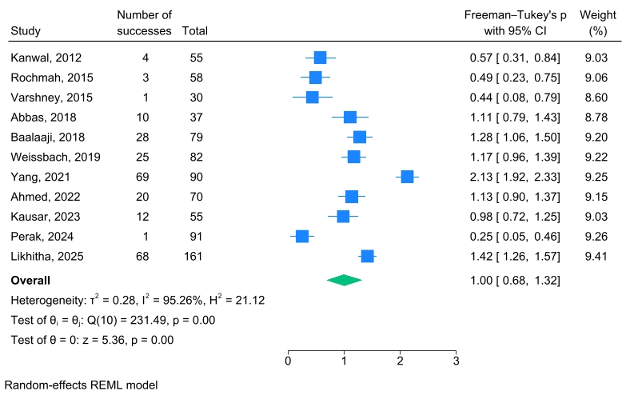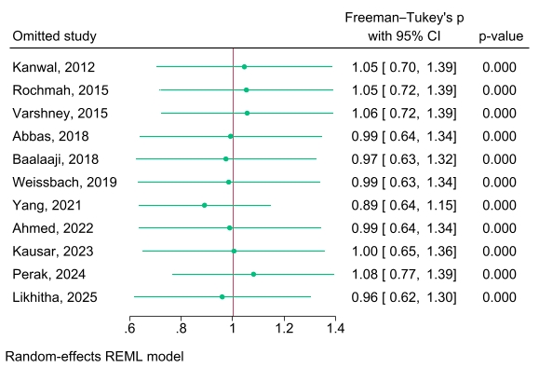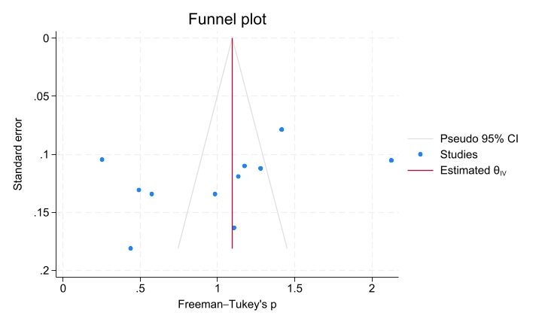
Figure S20. Meta-analysis of the prevalence of hypokalemia complication (a) Forest plot, (b) Leave-one-out sensitivity analysis, (c) Funnel plot.
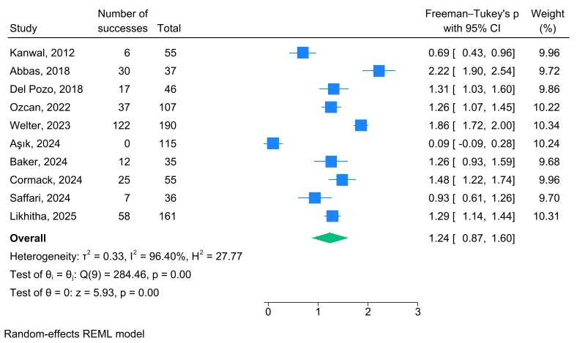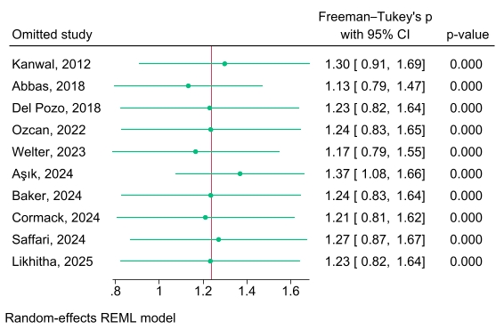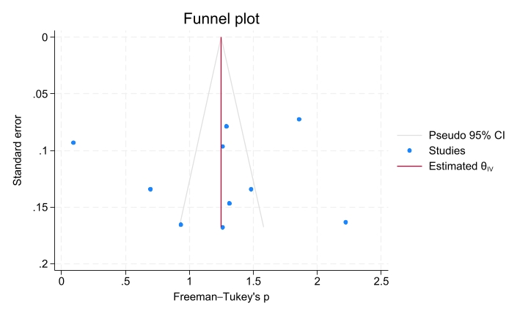
Figure S21. Meta-analysis of the prevalence of hyperkalemia complication (a) Forest plot, (b) Leave-one-out sensitivity analysis, (c) Funnel plot.
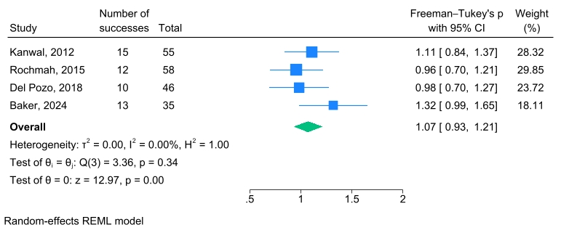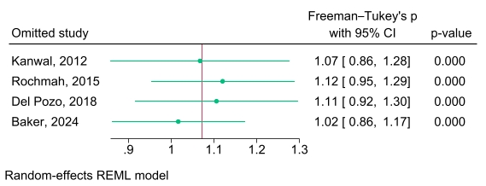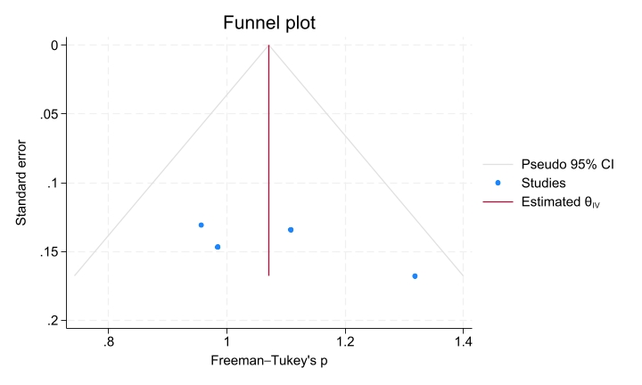
Figure S22. Meta-analysis of the prevalence of hypoglycemia complication (a) Forest plot, (b) Leave-one-out sensitivity analysis, (c) Funnel plot.
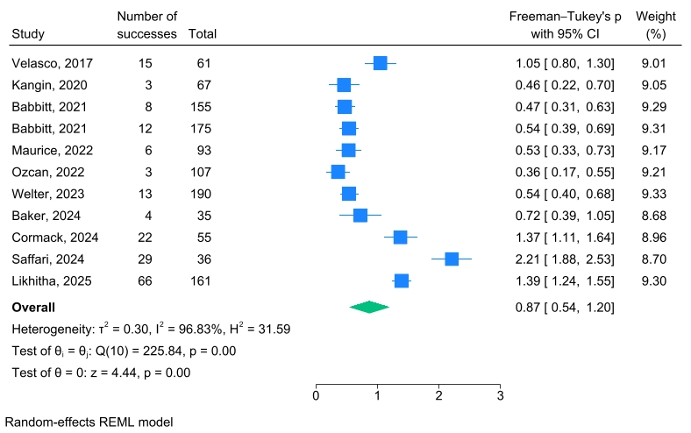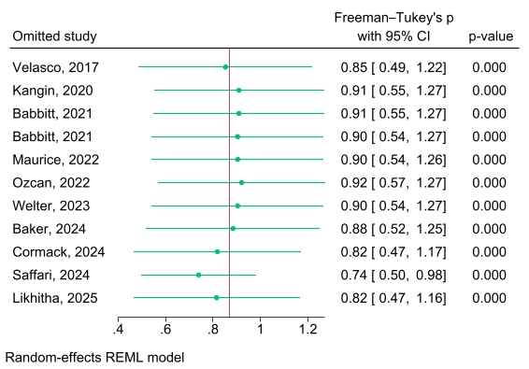
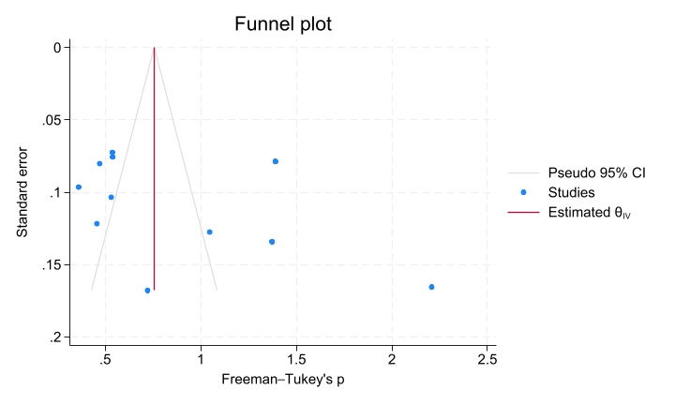

Figure S23. Meta-analysis of the prevalence of cerebral edema complication (a) Forest plot, (b) Leave-one-out sensitivity analysis, (c) Funnel plot.
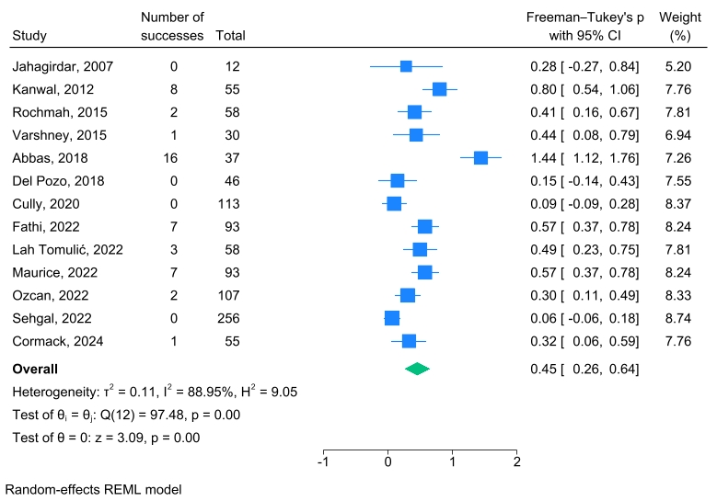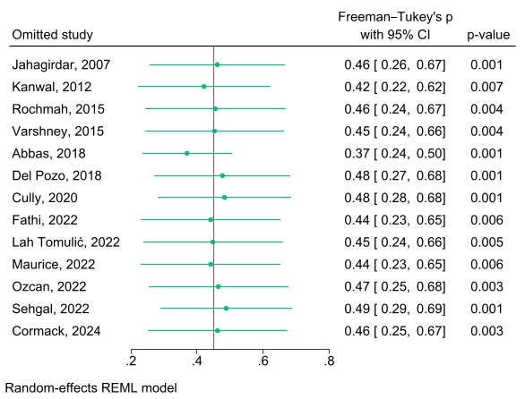
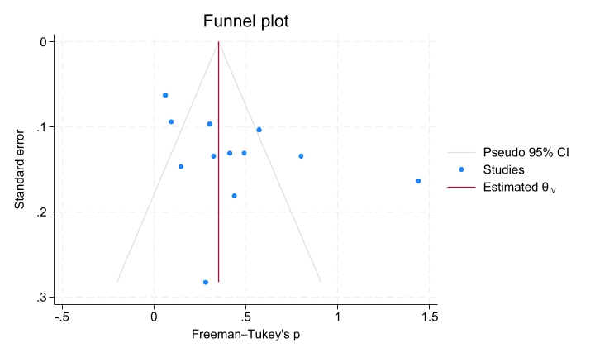

Figure S24. Meta-analysis of the prevalence of arrhythmia complication (a) Forest plot, (b) Leave-one-out sensitivity analysis, (c) Funnel plot.
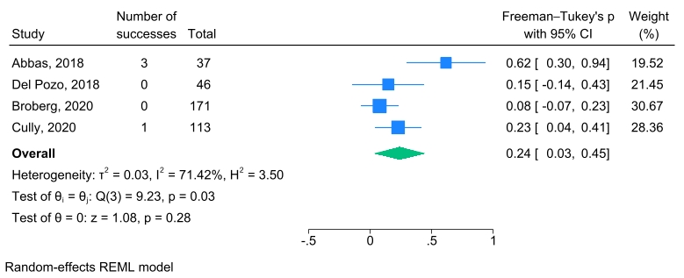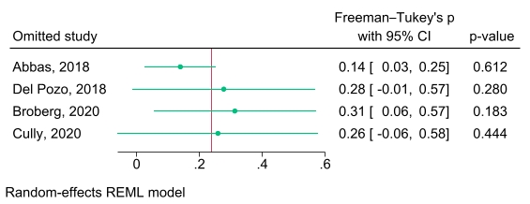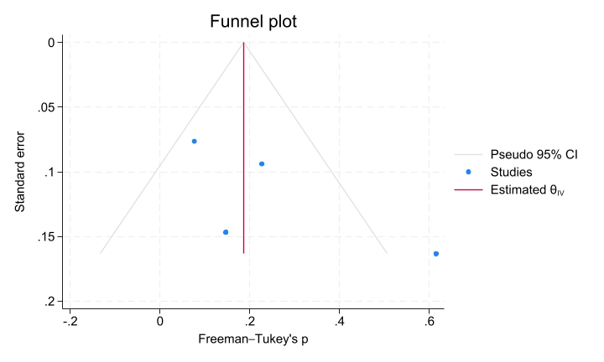
Figure S25. Meta-analysis of insulin requirement (a) Forest plot, (b) Leave-one-out sensitivity analysis, (c) Funnel plot.
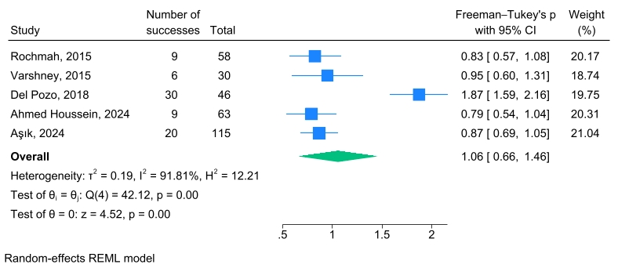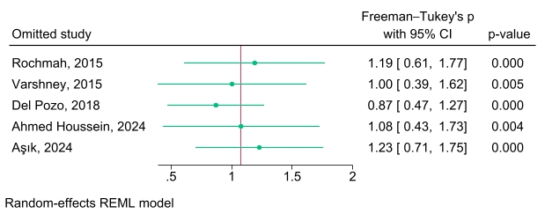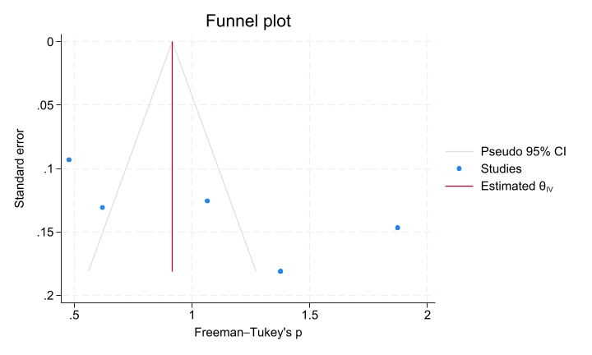
Figure S26. Meta-analysis of length of stay at PICU (a) Forest plot, (b) Leave-one-out sensitivity analysis, (c) Funnel plot.
Figure S27. Subgroup analysis of serum bicarbonate level at admission time (a) Forest plot, (b) Leave-one-out sensitivity analysis, (c) Funnel plot.
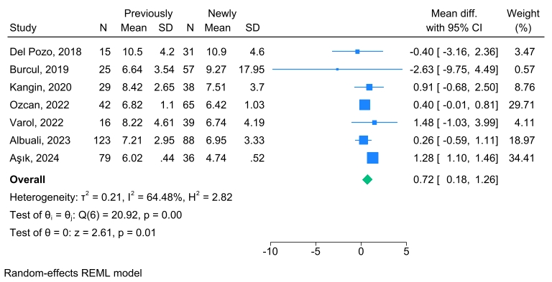
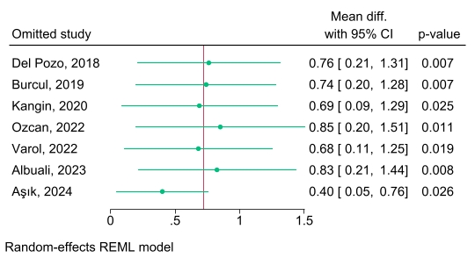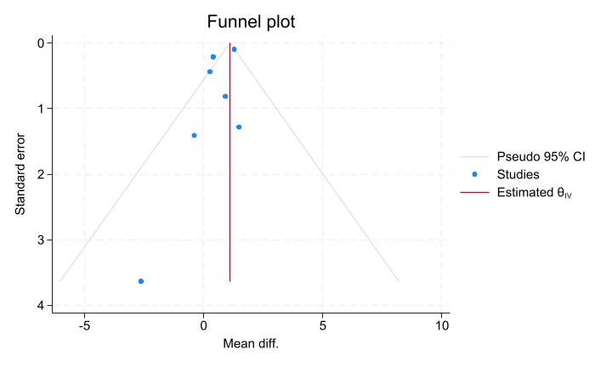
Figure S28. Subgroup analysis of blood ketone level at admission time (a) Forest plot, (b) Leave-one-out sensitivity analysis, (c) Funnel plot.
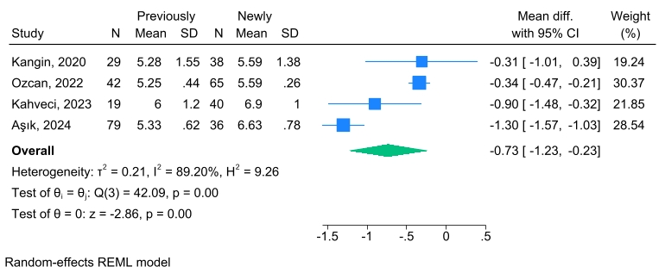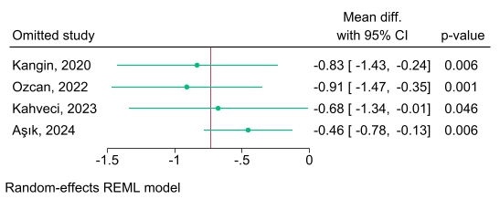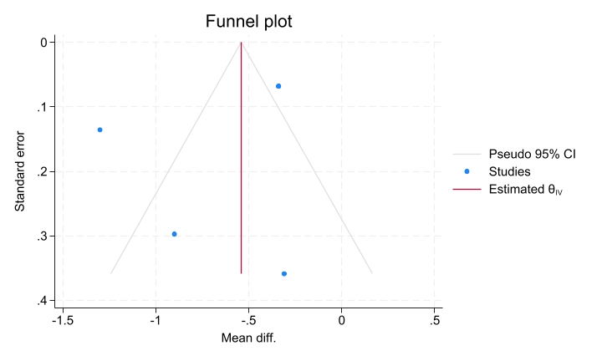
Figure S29. Subgroup analysis of serum blood urea nitrogen (BUN) level at admission time (a) Forest plot, (b) Leave-one-out sensitivity analysis, (c) Funnel plot.
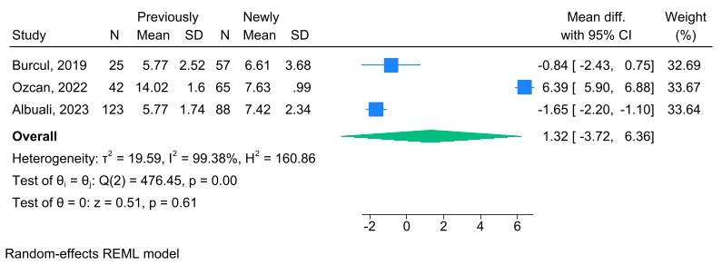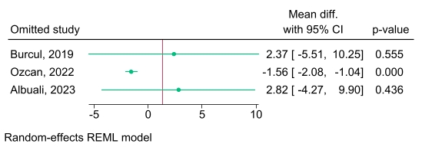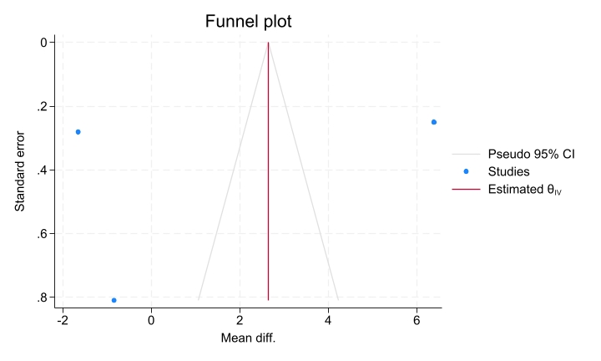
Figure S30. Subgroup analysis of serum chloride (Cl) level at admission time (a) Forest plot, (b) Leave-one-out sensitivity analysis, (c) Funnel plot.
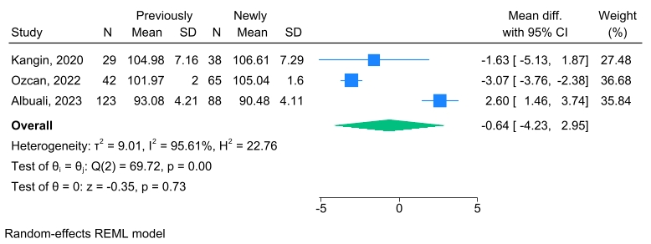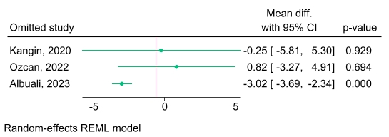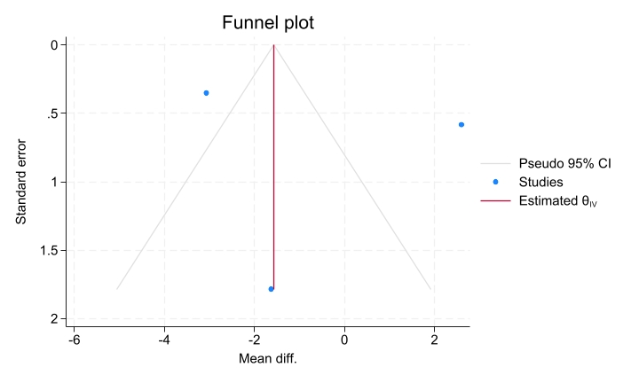
Figure S31. Subgroup analysis of serum creatinine (Cr) level at admission time (a) Forest plot, (b) Leave-one-out sensitivity analysis, (c) Funnel plot.
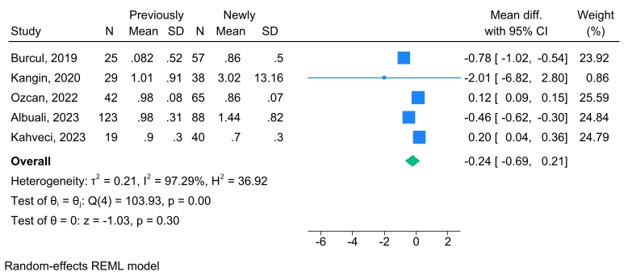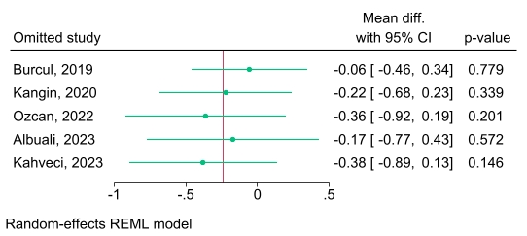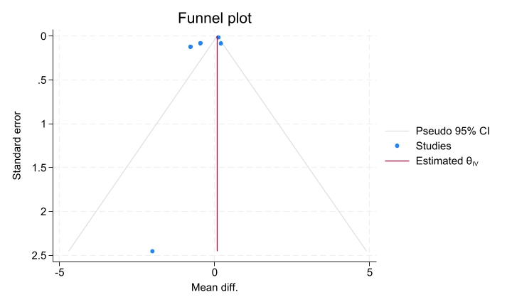
Figure S32. Subgroup analysis of serum lactate level at admission time (a) Forest plot, (b) Leave-one-out sensitivity analysis, (c) Funnel plot.
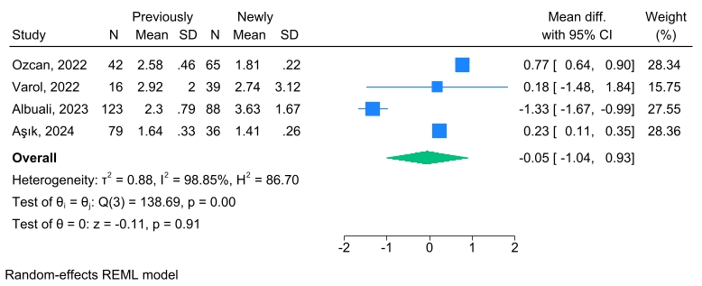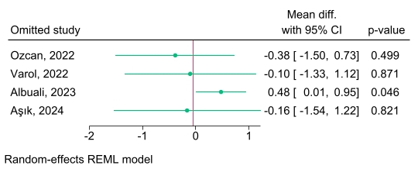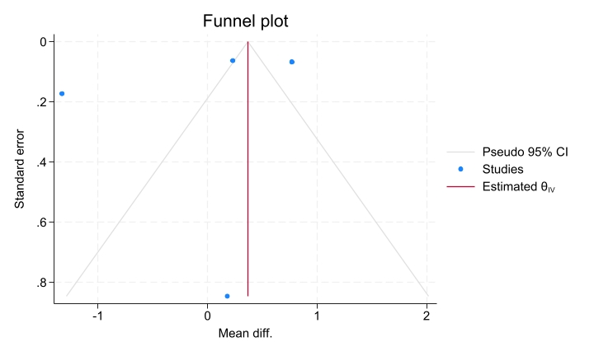
Figure S33. Subgroup analysis of serum sodium (Na) level at admission time (a) Forest plot, (b) Leave-one-out sensitivity analysis, (c) Funnel plot.
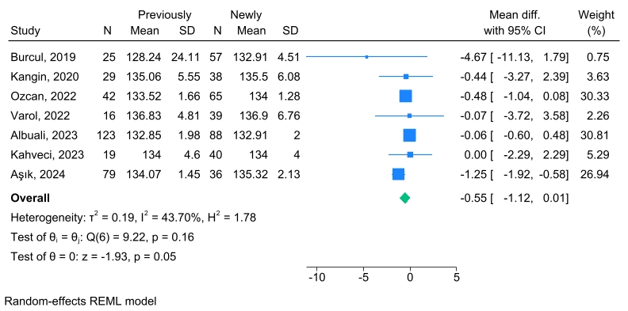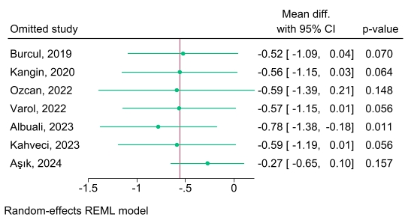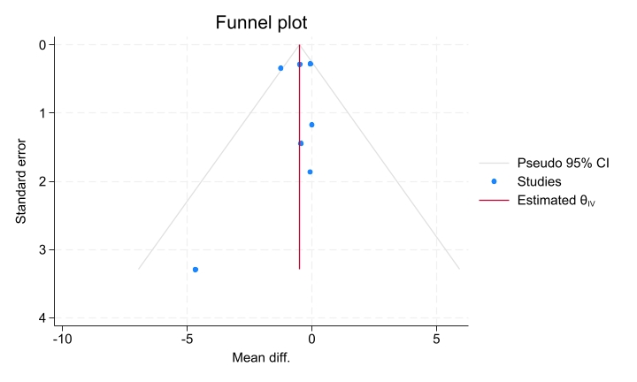
Figure S34. Subgroup analysis of serum potassium (K) level at admission time (a) Forest plot, (b) Leave-one-out sensitivity analysis, (c) Funnel plot.
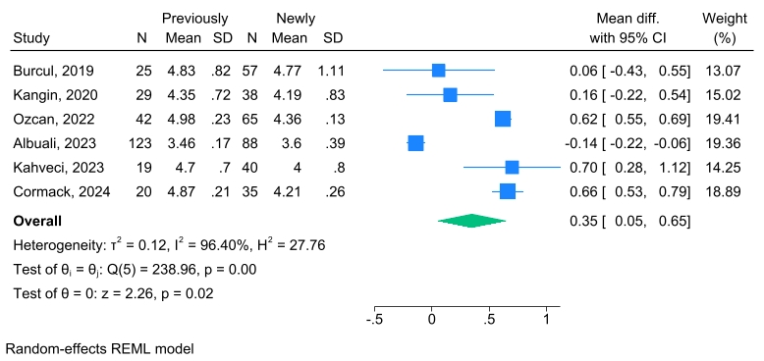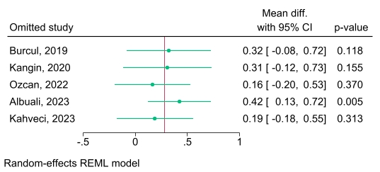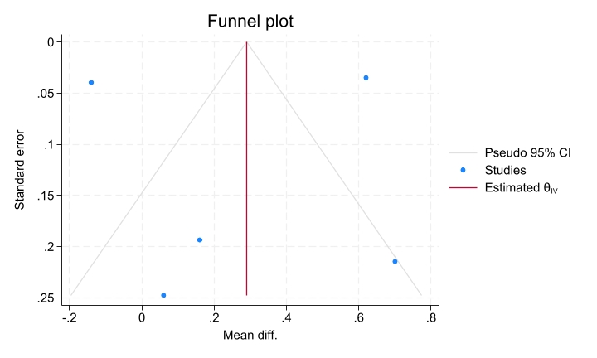
Figure S35. Subgroup analysis of serum phosphorus level at admission time (a) Forest plot, (b) Leave-one-out sensitivity analysis, (c) Funnel plot.
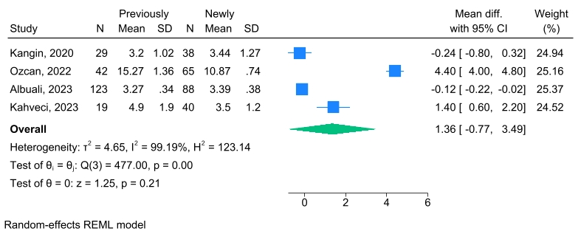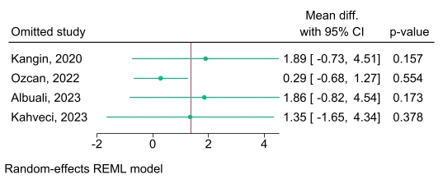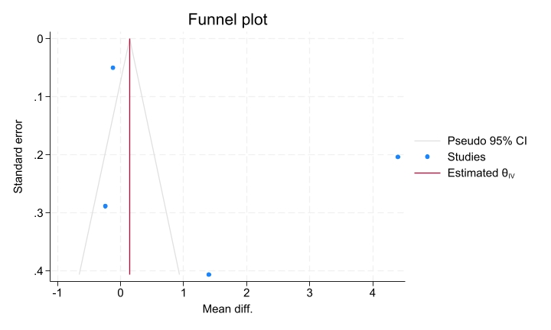
Figure S36. Subgroup analysis of serum PCO2 level at admission time (a) Forest plot, (b) Leave-one-out sensitivity analysis, (c) Funnel plot.
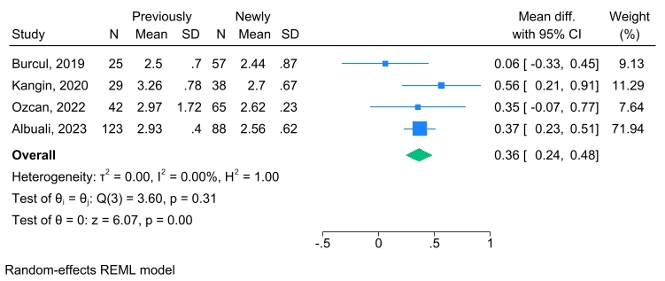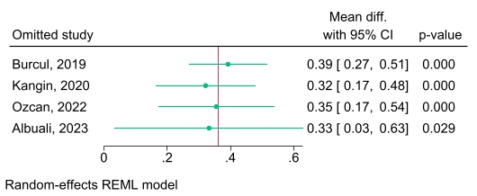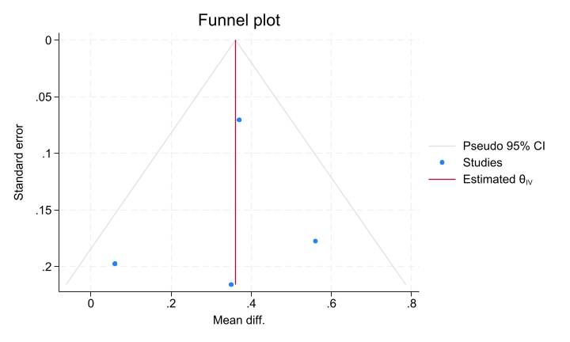
Figure S37. Subgroup analysis of serum pH level at admission time (a) Forest plot, (b) Leave-one-out sensitivity analysis, (c) Funnel plot.
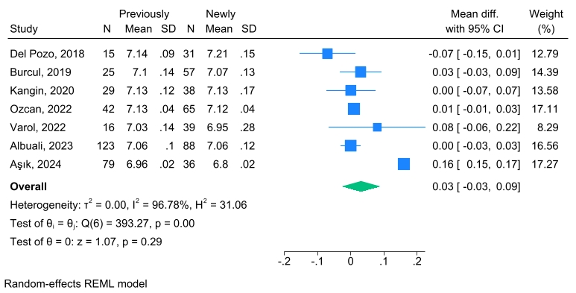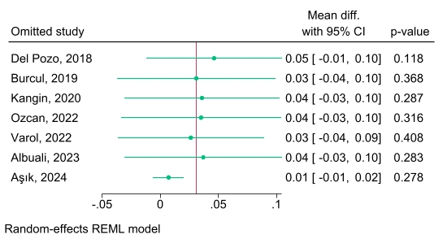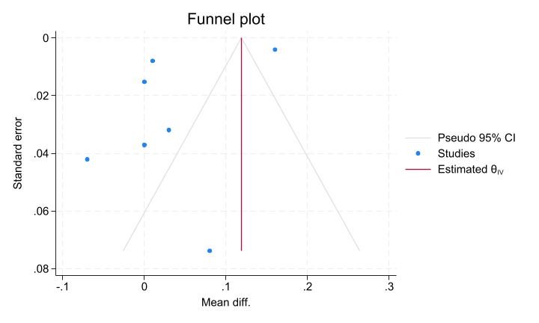
Figure S38. Subgroup analysis of serum glucose level at admission time (a) Forest plot, (b) Leave-one-out sensitivity analysis, (c) Funnel plot.
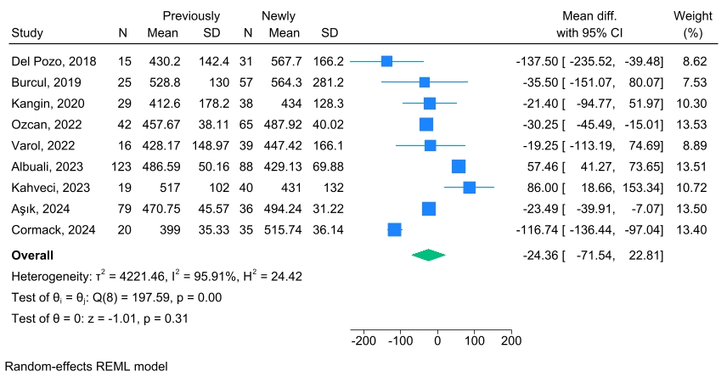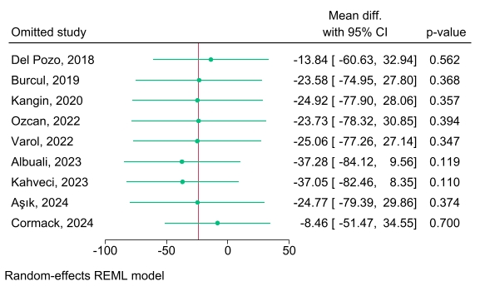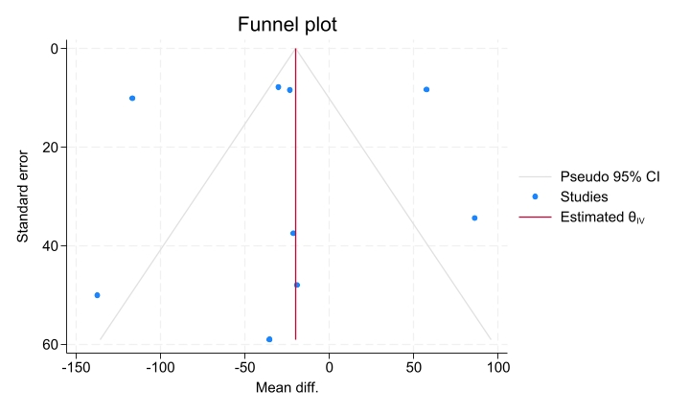
Figure S39. Subgroup analysis of serum HbA1C level at admission time (a) Forest plot, (b) Leave-one-out sensitivity analysis, (c) Funnel plot.
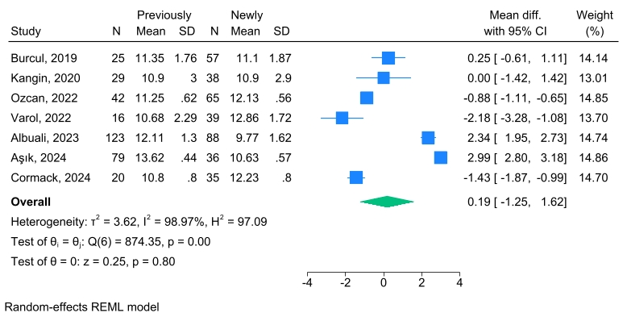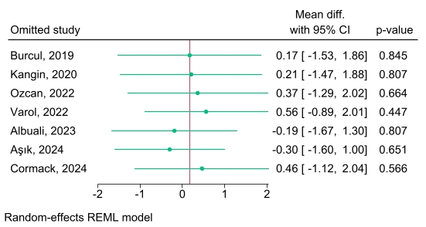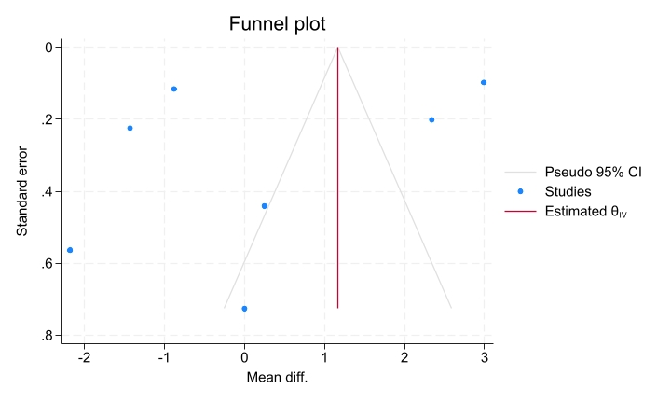
Figure S40. Subgroup analysis of length of PICU stay (a) Forest plot, (b) Leave-one-out sensitivity analysis, (c) Funnel plot.
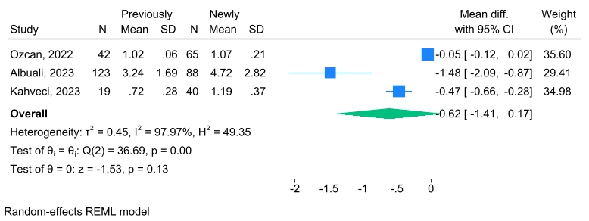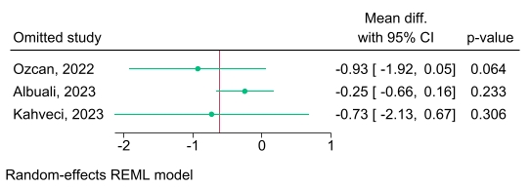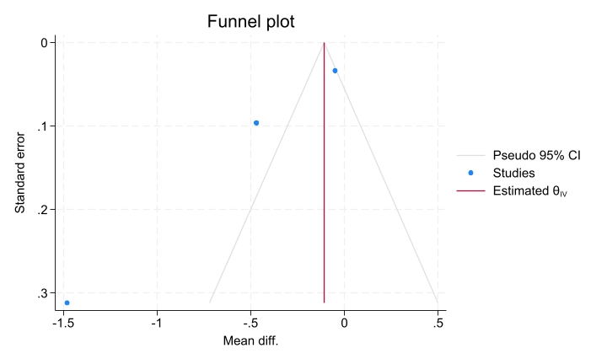
Figure S41. Subgroup analysis of GCS level (a) Forest plot, (b) Leave-one-out sensitivity analysis, (c) Funnel plot.
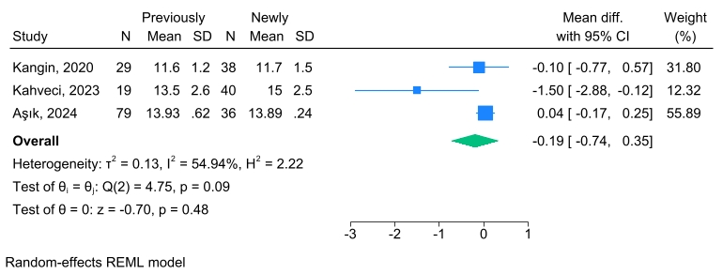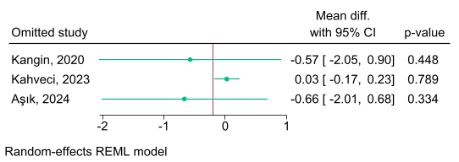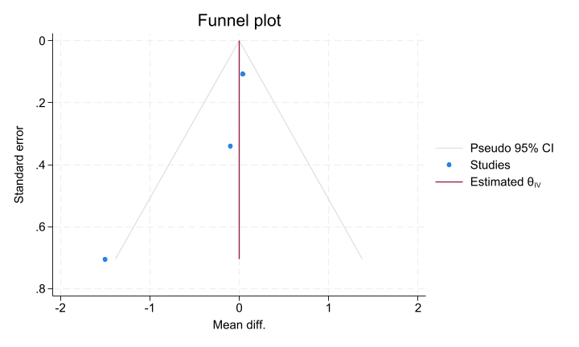
Figure S42. Subgroup analysis of duration of insulin infusion (a) Forest plot, (b) Leave-one-out sensitivity analysis, (c) Funnel plot.
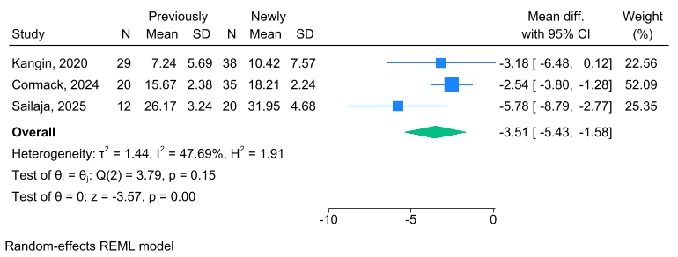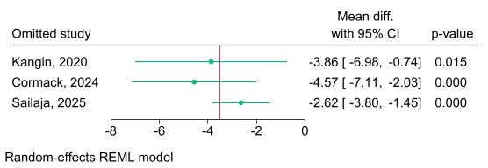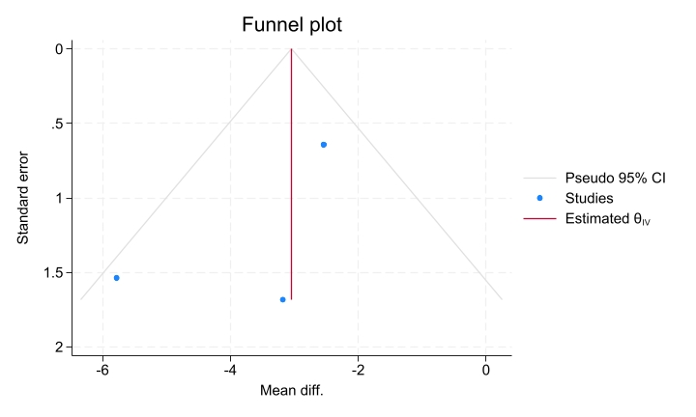
Figure S43. Subgroup analysis of patients with abdominal pain presentation (a) Forest plot, (b) Leave-one-out sensitivity analysis, (c) Funnel plot.
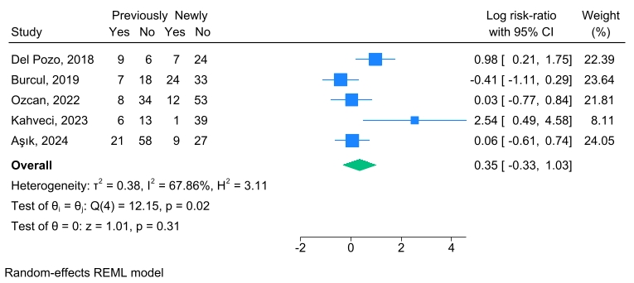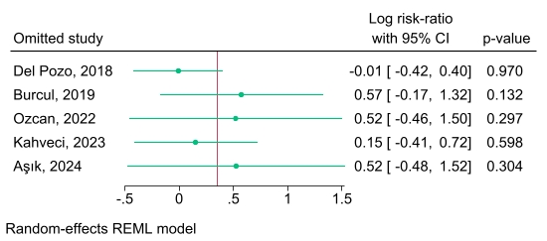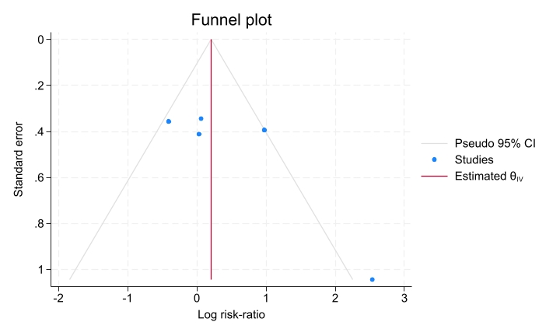
Figure S44. Subgroup analysis of patients with polydipsia presentation (a) Forest plot, (b) Leave-one-out sensitivity analysis, (c) Funnel plot.
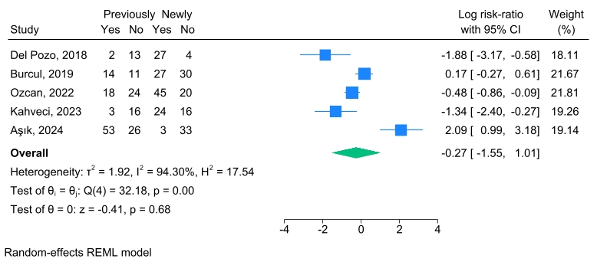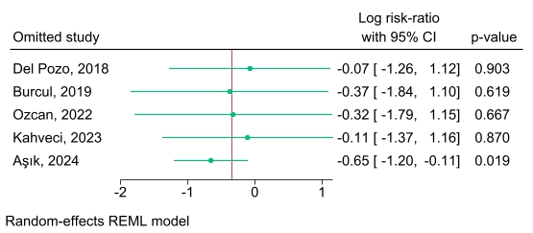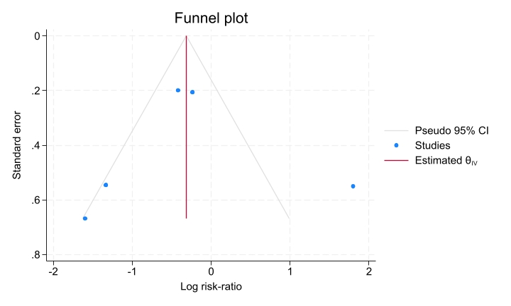
Figure S45. Subgroup analysis of patients with polyuria presentation (a) Forest plot, (b) Leave-one-out sensitivity analysis, (c) Funnel plot.
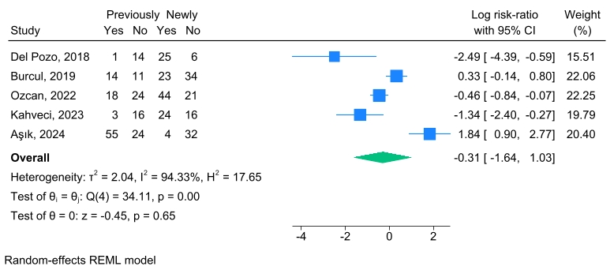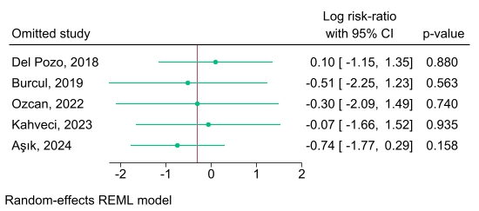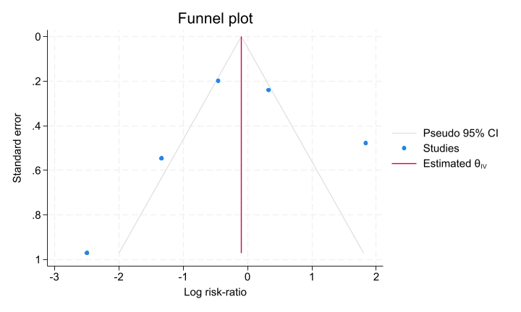
Figure S46. Subgroup analysis of patients with vomiting presentation (a) Forest plot, (b) Leave-one-out sensitivity analysis, (c) Funnel plot.
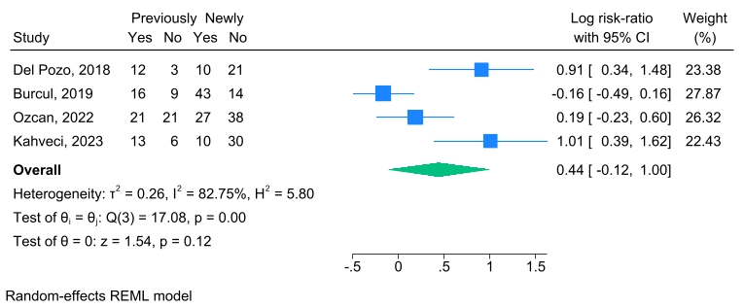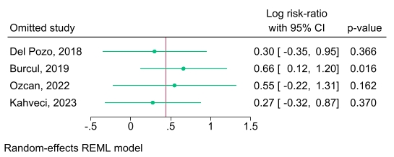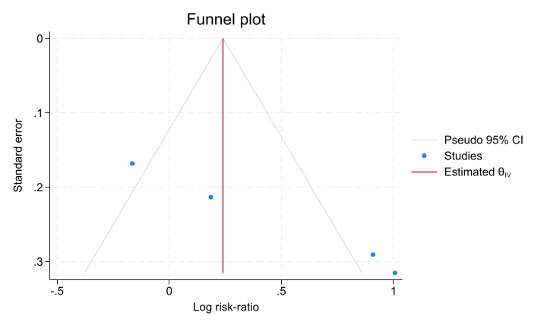
Figure S47 Subgroup analysis of patients with weight loss presentation (a) Forest plot, (b) Leave-one-out sensitivity analysis, (c) Funnel plot.
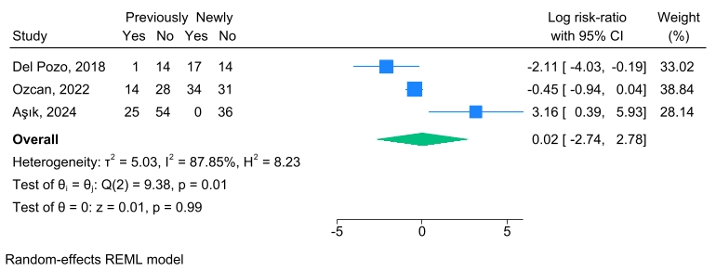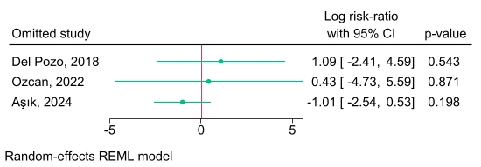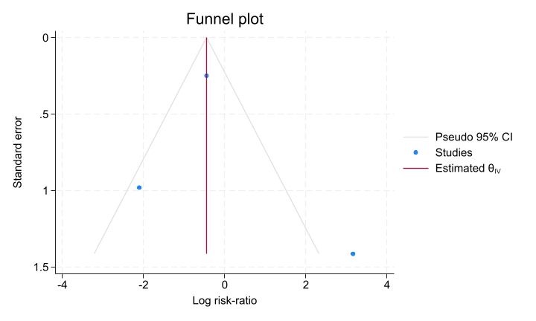
Figure S48. Subgroup analysis of severe DKA (a) Forest plot, (b) Leave-one-out sensitivity analysis, (c) Funnel plot.
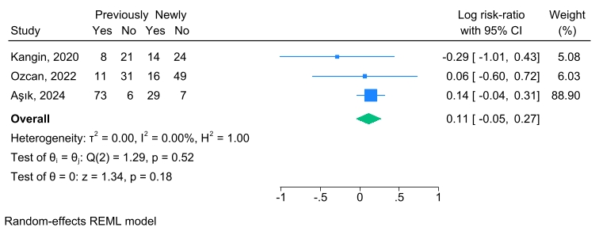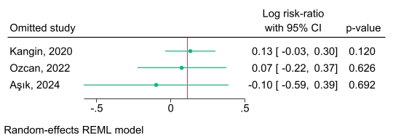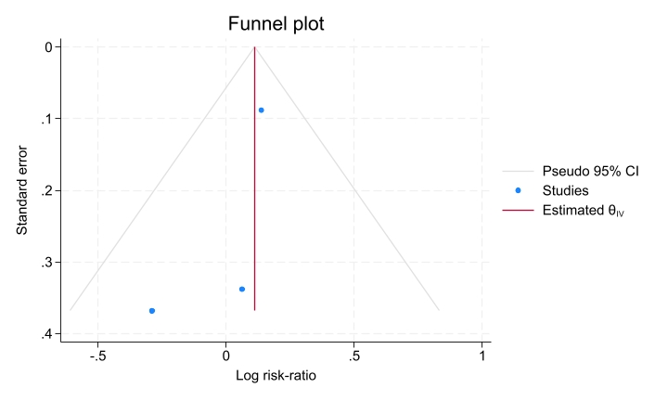
Figure S49. Subgroup analysis of brain edema (a) Forest plot, (b) Leave-one-out sensitivity analysis, (c) Funnel plot.
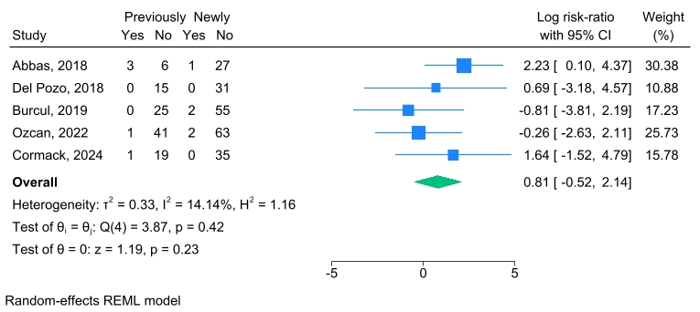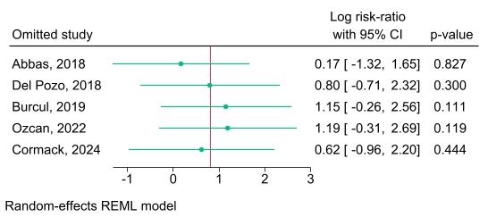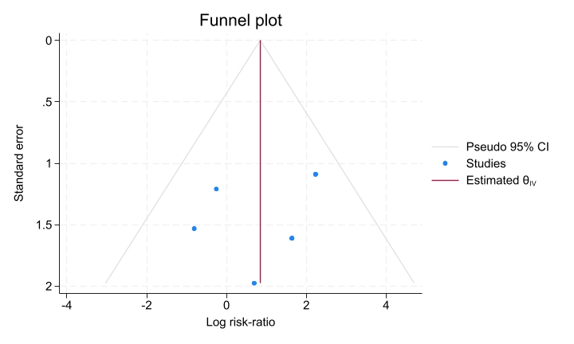
Figure S50. Subgroup analysis of hypokalemia (a) Forest plot, (b) Leave-one-out sensitivity analysis, (c) Funnel plot.
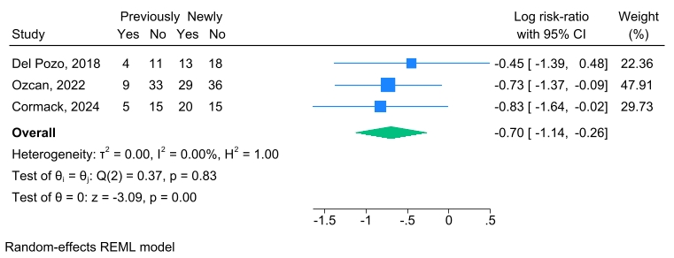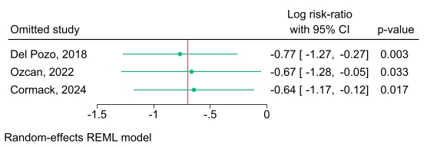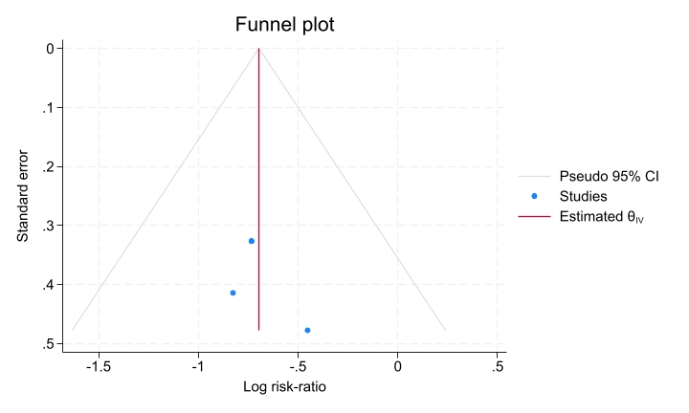
Figure S51. Bubble plot of meta-regression analysis evaluating serum glucose level as a covariate in abdominal pain
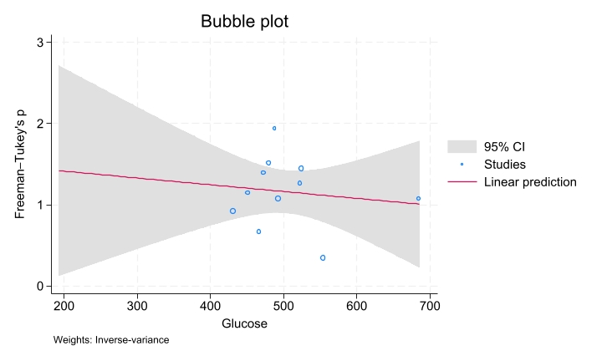
Figure S52. Bubble plot of meta-regression analysis evaluating HbA1C level as a covariate in abdominal pain
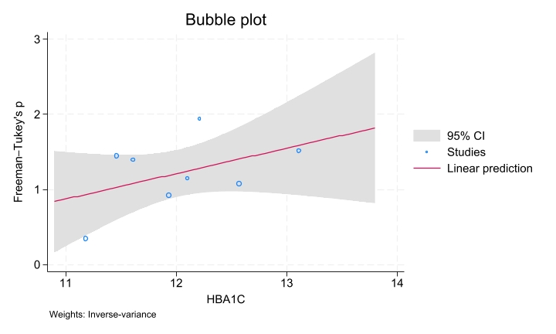
Figure S53. Bubble plot of meta-regression analysis evaluating PH level as a covariate in abdominal pain
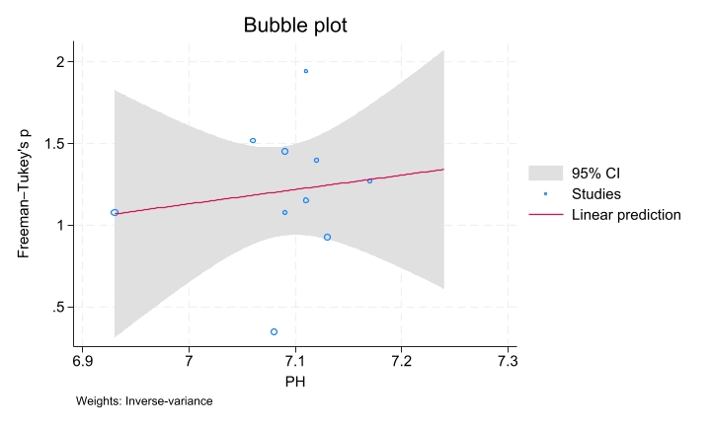
Figure S54. Bubble plot of meta-regression analysis evaluating PCO2 level as a covariate in abdominal pain
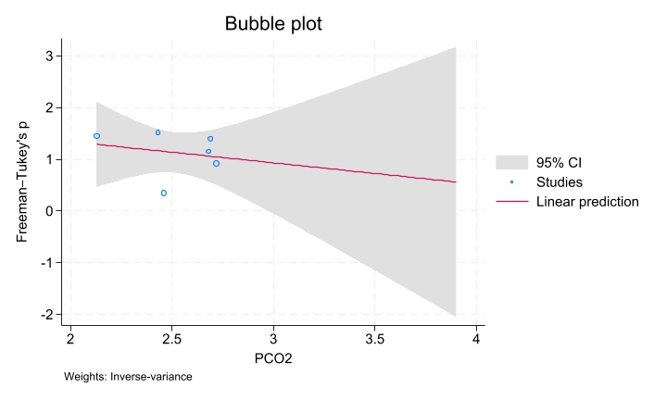
Figure S55. Bubble plot of meta-regression analysis evaluating HCO3 level as a covariate in abdominal pain
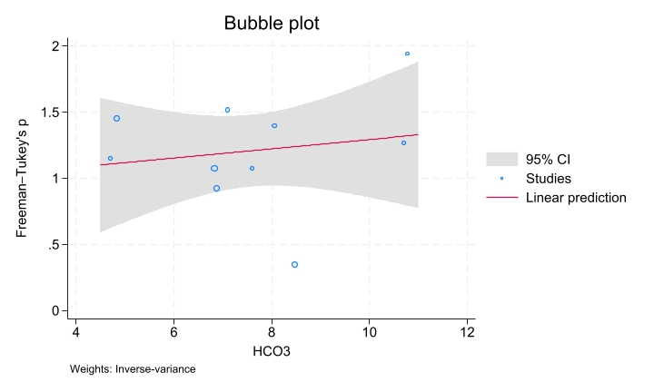
Figure S56. Bubble plot of meta-regression analysis evaluating serum glucose level as a covariate in acute kidney injury (AKI)
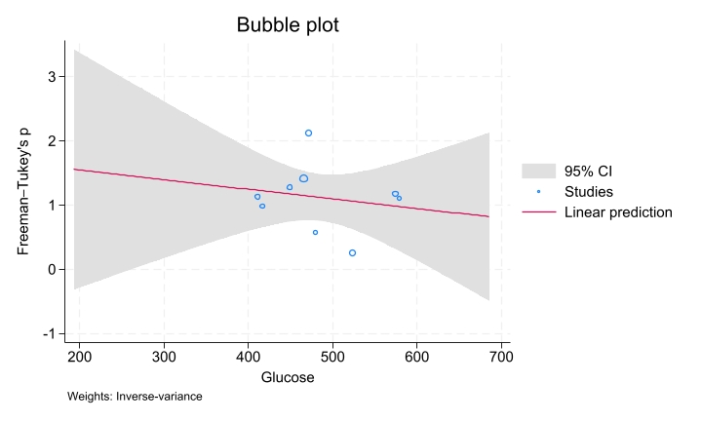
Figure S57. Bubble plot of meta-regression analysis evaluating HbA1C level as a covariate in acute kidney injury (AKI)
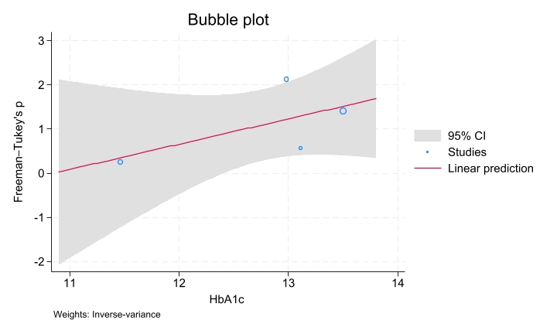
Figure S58. Bubble plot of meta-regression analysis evaluating PH level as a covariate in acute kidney injury (AKI)
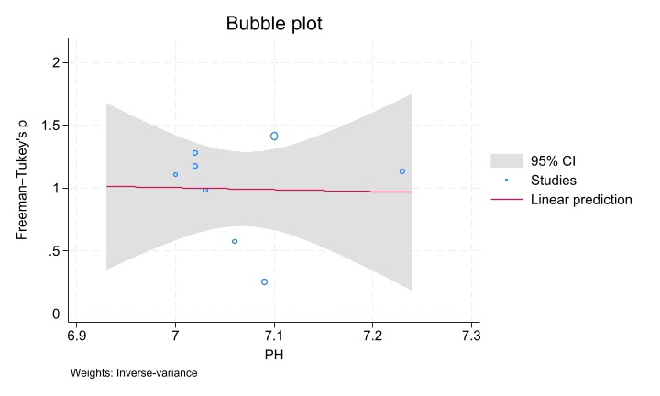
Figure S59. Bubble plot of meta-regression analysis evaluating PCO2 level as a covariate in acute kidney injury (AKI)
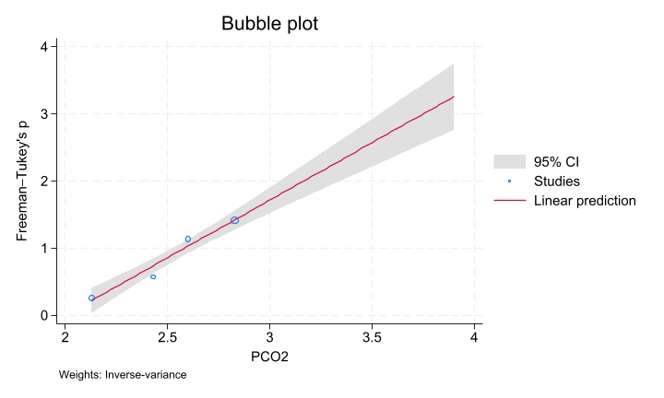
Figure S60. Bubble plot of meta-regression analysis evaluating HCO3 level as a covariate in acute kidney injury (AKI)
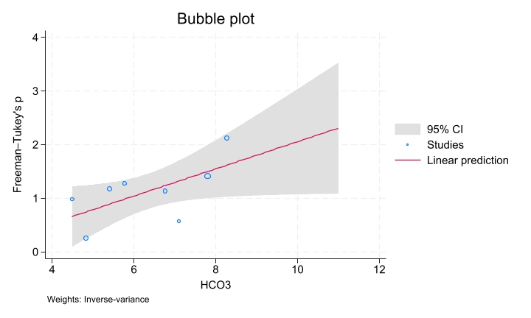
Figure S61. Bubble plot of meta-regression analysis evaluating serum glucose level as a covariate in cerebral edema (CE)
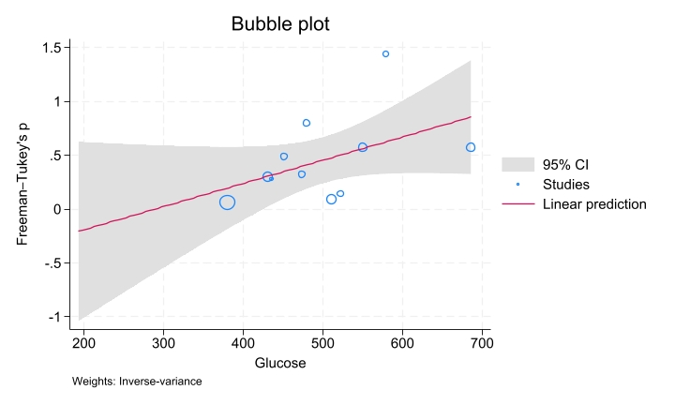
Figure S62. Bubble plot of meta-regression analysis evaluating PH level as a covariate in hypoglycemia
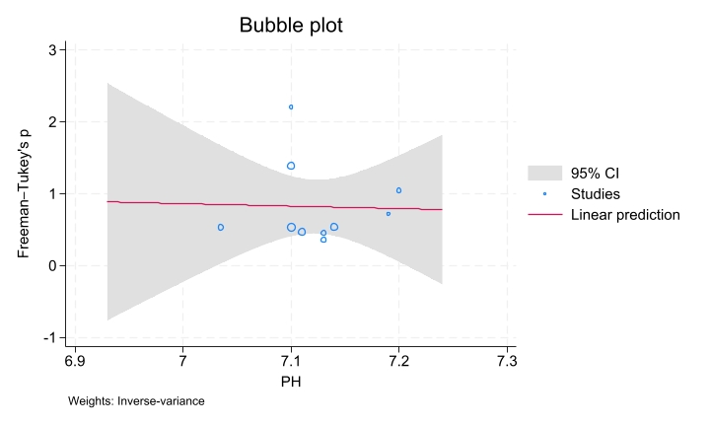
Figure S63. Bubble plot of meta-regression analysis evaluating PCO2 level as a covariate in hypoglycemia
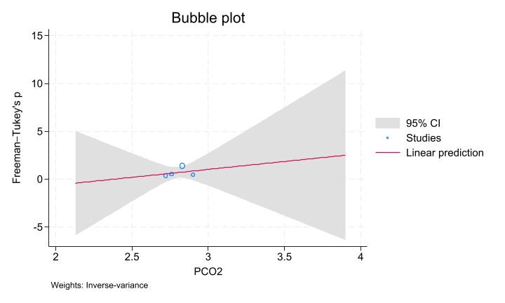
Figure S64. Bubble plot of meta-regression analysis evaluating HCO3 level as a covariate in hypoglycemia
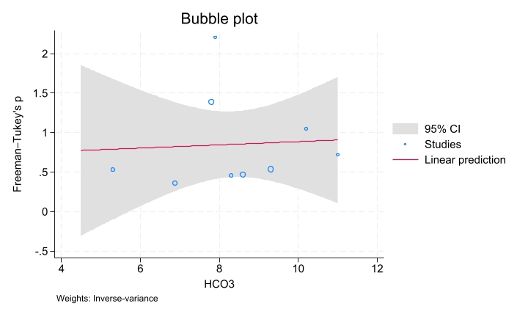
Figure S65. Bubble plot of meta-regression analysis evaluating serum glucose level as a covariate in hypokalemia
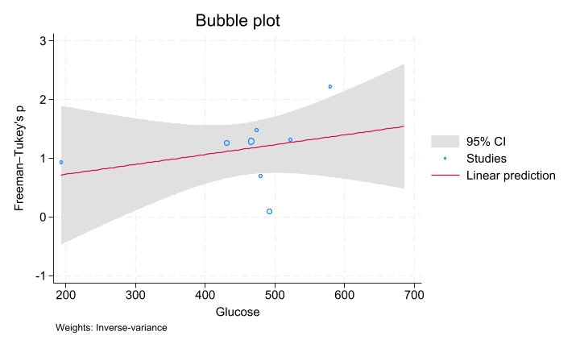
Figure S66. Bubble plot of meta-regression analysis evaluating HbA1C level as a covariate in hypokalemia
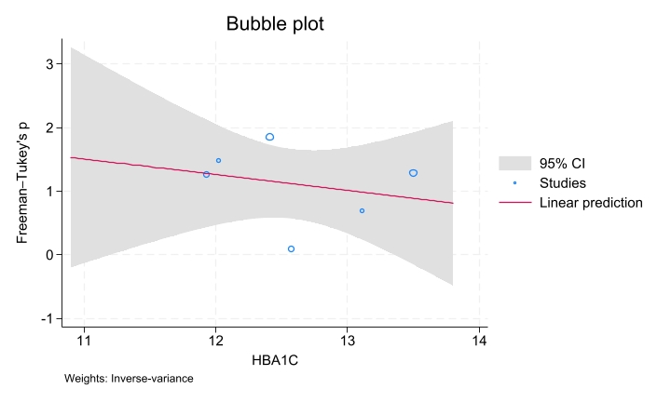
Figure S67. Bubble plot of meta-regression analysis evaluating PH level as a covariate in hypokalemia
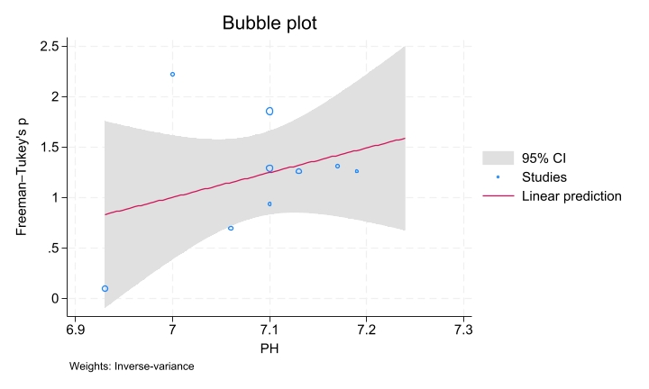
Figure S68. Bubble plot of meta-regression analysis evaluating HCO3 level as a covariate in hypokalemia
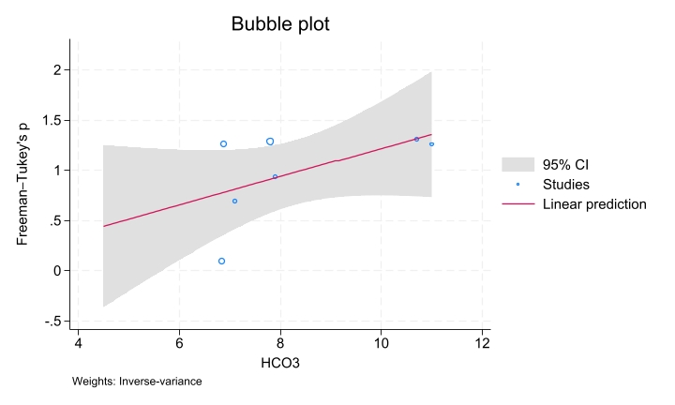
Figure S69. Bubble plot of meta-regression analysis evaluating serum glucose level as a covariate in loss of consciousness (LOC)
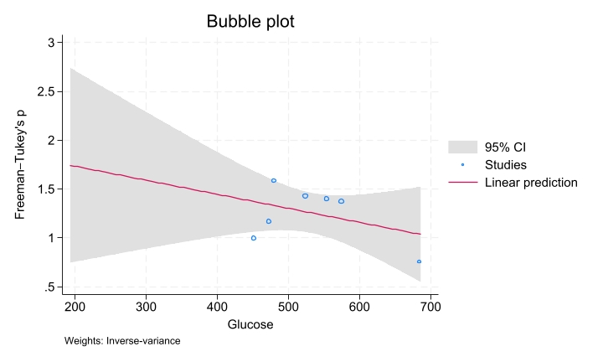
Figure S70. Bubble plot of meta-regression analysis evaluating HbA1C level as a covariate in loss of consciousness (LOC)
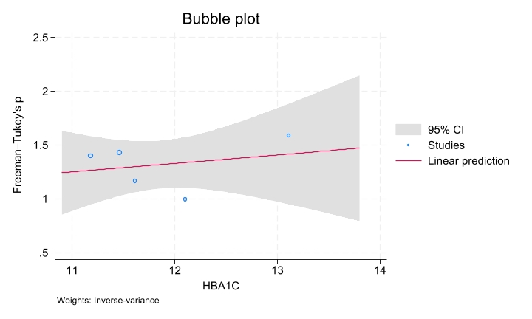
Figure S71. Bubble plot of meta-regression analysis evaluating PH level as a covariate in loss of consciousness (LOC)
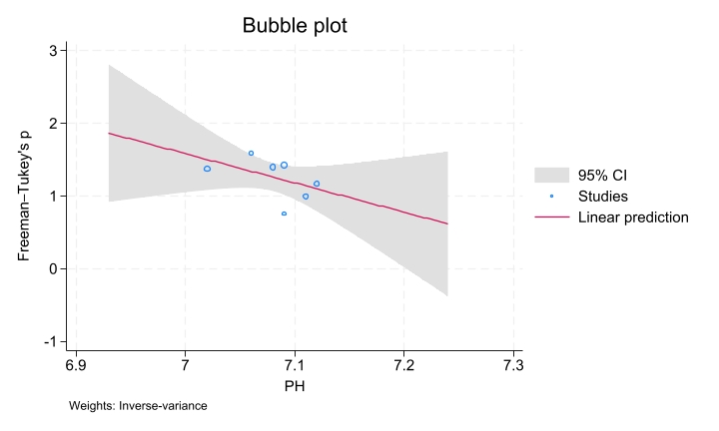
Figure S72. Bubble plot of meta-regression analysis evaluating PCO2 level as a covariate in a loss of consciousness (LOC)
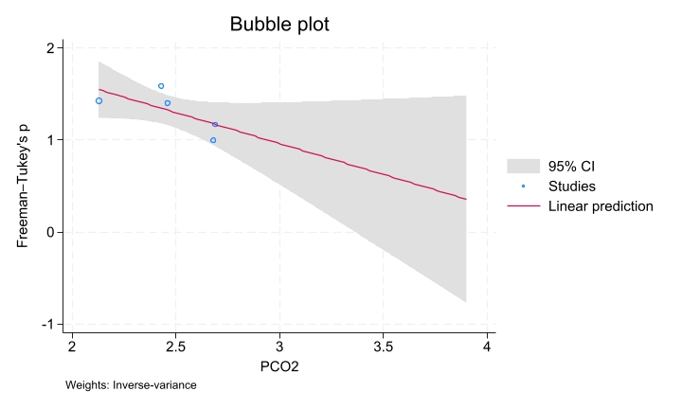
Figure S73. Bubble plot of meta-regression analysis evaluating HCO3 level as a covariate in loss of consciousness (LOC)
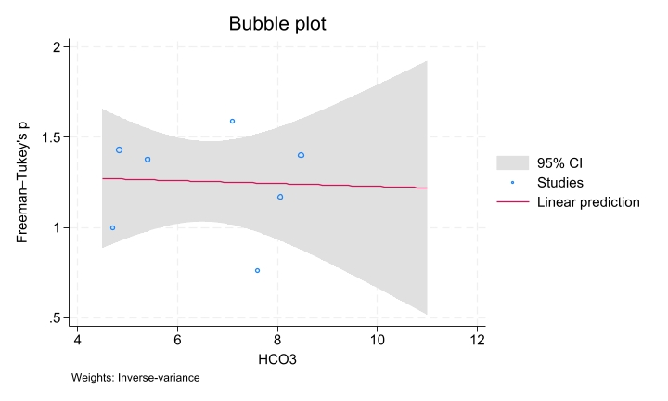
Figure S74. Bubble plot of meta-regression analysis evaluating serum glucose level as a covariate in mortality
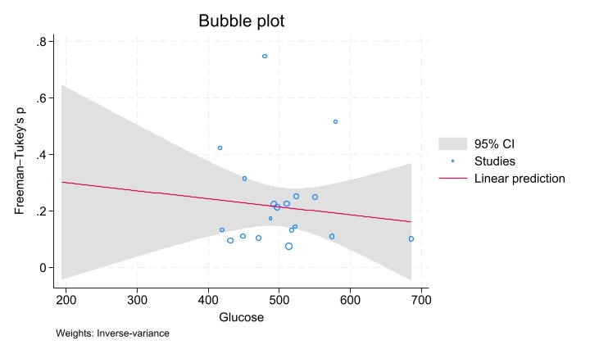
Figure S75. Bubble plot of meta-regression analysis evaluating HbA1C level as a covariate in mortality
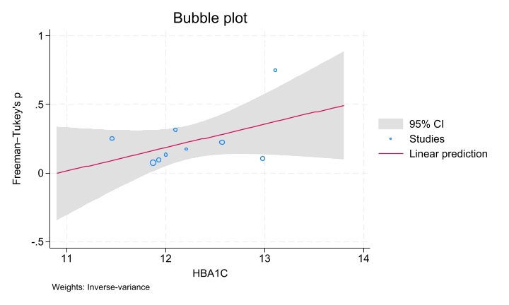
Figure S76. Bubble plot of meta-regression analysis evaluating PH level as a covariate in mortality
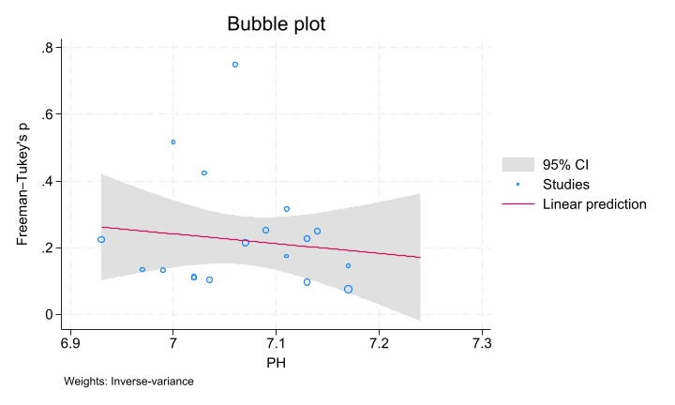
Figure S77. Bubble plot of meta-regression analysis evaluating PCO2 level as a covariate in mortality
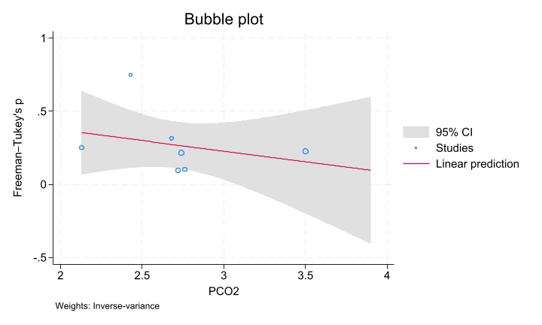
Figure S78. Bubble plot of meta-regression analysis evaluating HCO3 level as a covariate in mortality
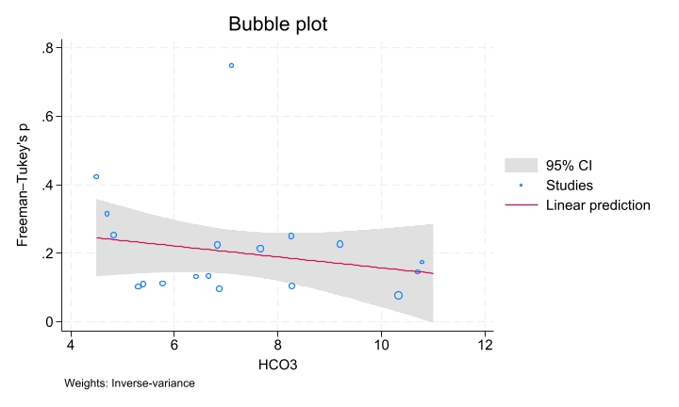
Figure S79. Bubble plot of meta-regression analysis evaluating serum glucose level as a covariate in polydipsia
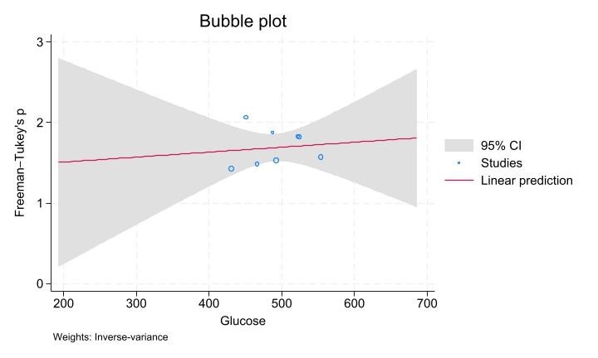
Figure S80. Bubble plot of meta-regression analysis evaluating HbA1C level as a covariate in polydipsia
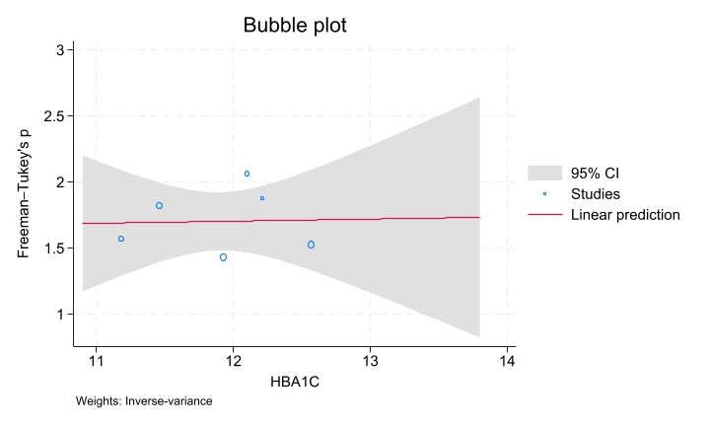
Figure S81. Bubble plot of meta-regression analysis evaluating PH level as a covariate in polydipsia
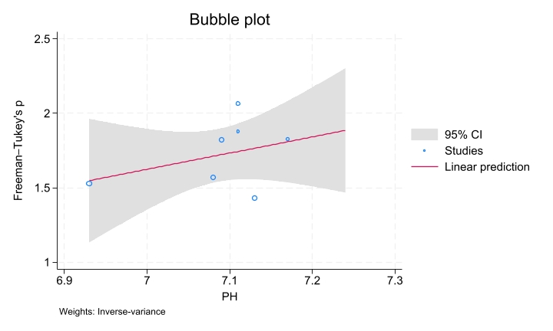
Figure S82. Bubble plot of meta-regression analysis evaluating PCO2 level as a covariate in polydipsia
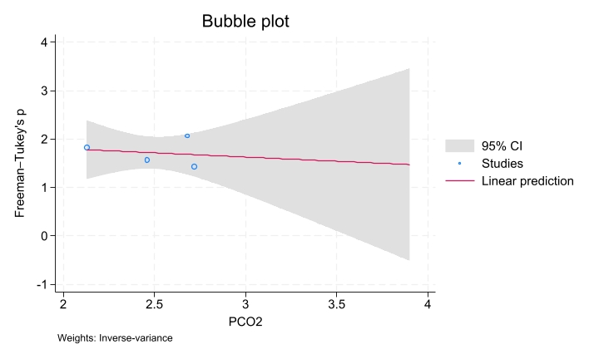
Figure S83. Bubble plot of meta-regression analysis evaluating HCO3 level as a covariate in polydipsia
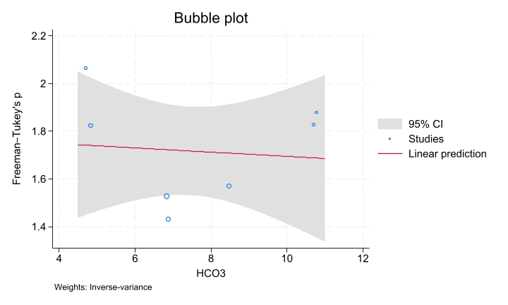
Figure S84. Bubble plot of meta-regression analysis evaluating serum glucose level as a covariate in polyuria
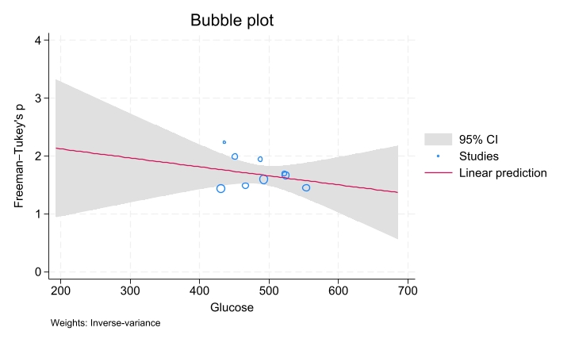
Figure S85. Bubble plot of meta-regression analysis evaluating HbA1C level as a covariate in polyuria
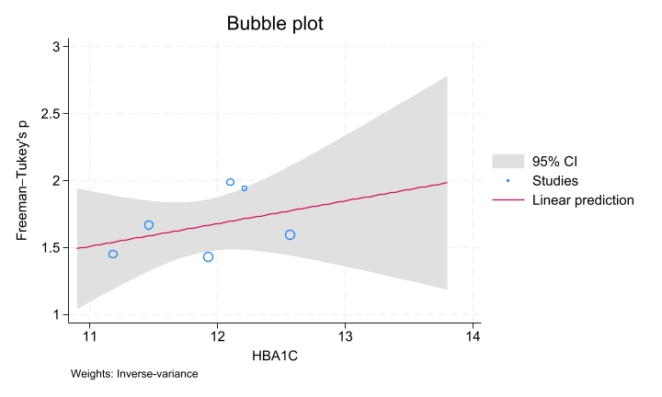
Figure S86. Bubble plot of meta-regression analysis evaluating PH level as a covariate in polyuria
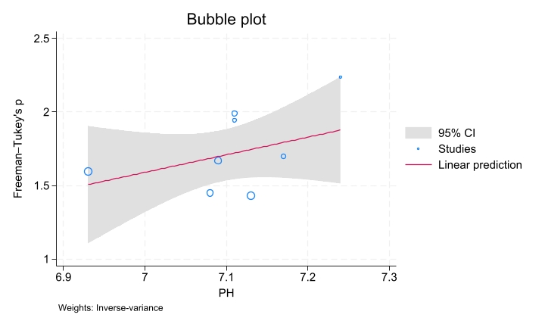
Figure S87. Bubble plot of meta-regression analysis evaluating PCO2 level as a covariate in polyuria
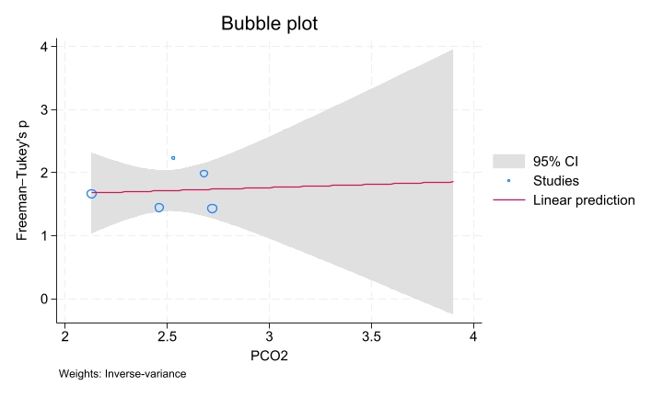
Figure S88. Bubble plot of meta-regression analysis evaluating HCO3 level as a covariate in polyuria
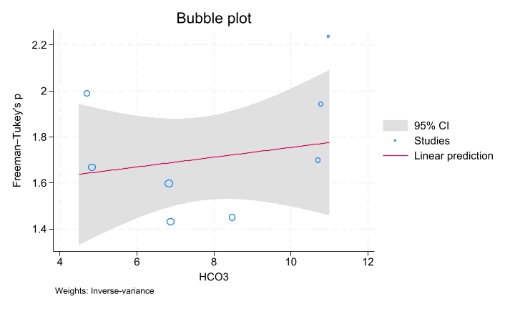
Figure S89. Bubble plot of meta-regression analysis evaluating serum glucose level as a covariate in recurrent DKA
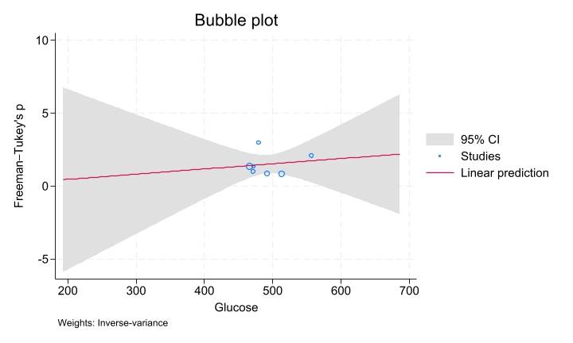
Figure S90. Bubble plot of meta-regression analysis evaluating HbA1C level as a covariate in recurrent DKA
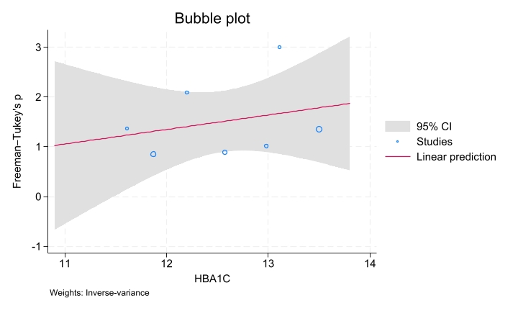
Figure S91. Bubble plot of meta-regression analysis evaluating PH level as a covariate in recurrent DKA
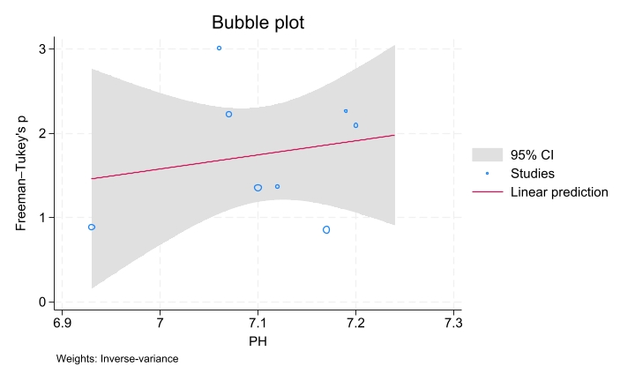
Figure S92. Bubble plot of meta-regression analysis evaluating HCO3 level as a covariate in recurrent DKA
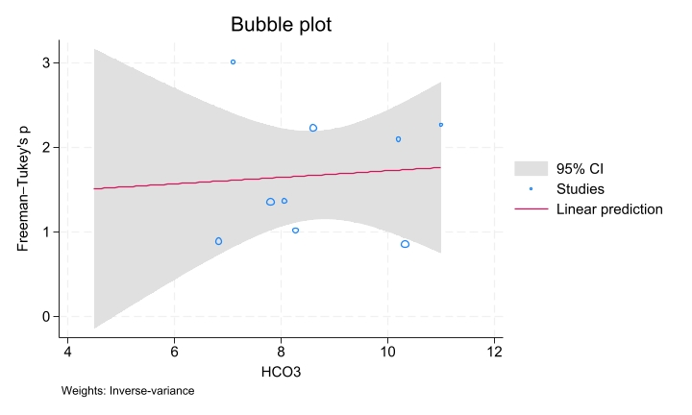
Figure S93. Bubble plot of meta-regression analysis evaluating serum glucose level as a covariate in severe DKA
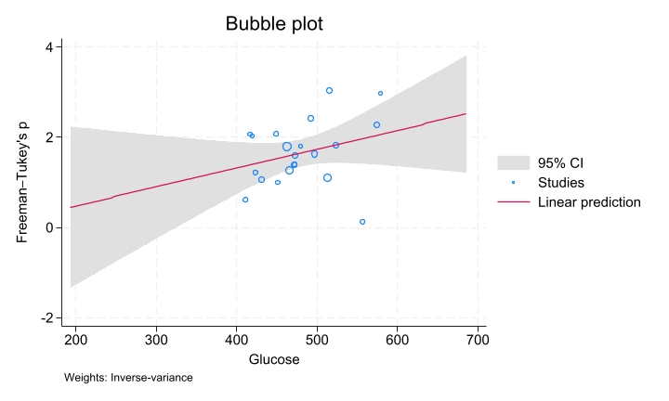
Figure S94. Bubble plot of meta-regression analysis evaluating HbA1C level as a covariate in severe DKA
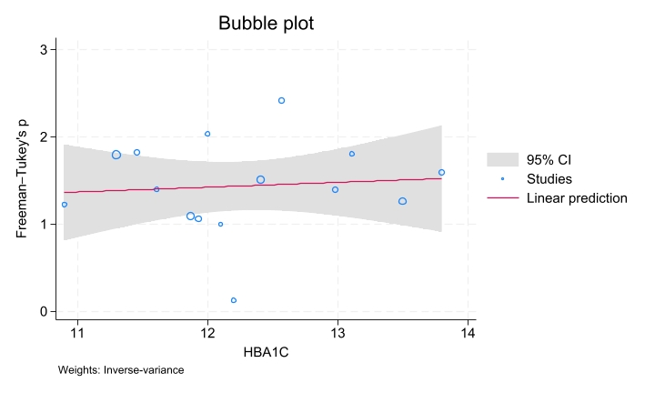
Figure S95. Bubble plot of meta-regression analysis evaluating PH level as a covariate in severe DKA
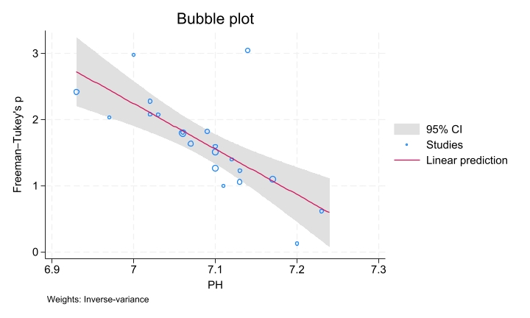
Figure S96. Bubble plot of meta-regression analysis evaluating PCO2 level as a covariate in severe DKA
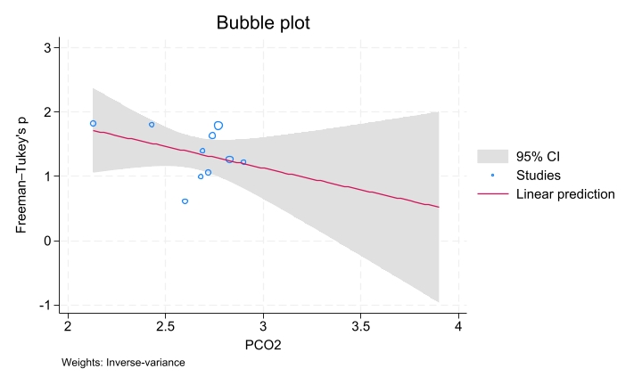
Figure S97. Bubble plot of meta-regression analysis evaluating HCO3 level as a covariate in severe DKA
