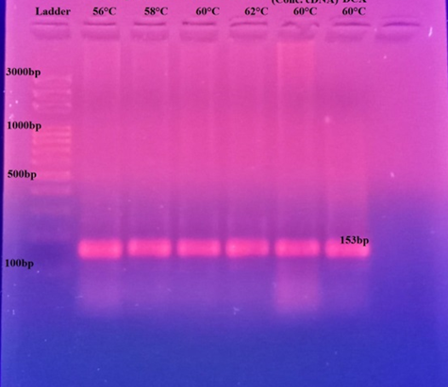
Dual Hybridization Probe Detection Method using the MIC RT-PCR

