Efficacy and Safety of Orforglipron 12 mg Versus Orforglipron 36 mg Maintenance Dose Among Patients with Obesity with or without Diabetes: A Systematic review and Comprehensive Meta-Analysis
Supplementary file

Contents
Topic | Page
Full search strategy | 3
Equations to calculate the standard deviation when not listed | 4
Figure S1 subgroup analysis of percent change in body weight (%) based on (A) diabetic status (B) treatment duration | 5
Figure S2 subgroup analysis of absolute change in body weight (kg) based on (A) diabetic status (B) treatment duration | 6
Figure S3 subgroup analysis of change in BMI(kg/m²) based on (A) diabetic status (B) treatment duration | 7
Figure S4 subgroup analysis of percent change in HbA1C (%)based on (A) diabetic status (B) diabetic status after excluding Wharton et al. 2023 (C)treatment duration | 8
Figure S5 subgroup analysis of change in waist circumference (cm) based on (A) diabetic status (B) treatment duration | 9
Figure S6 (A)forest plot for meta-analysis of percent change in serum total cholesterol (%) with (B)subgroup analysis based on diabetic status(C)subgroup analysis based on treatment duration | 10
Figure S7 (A)forest plot for meta-analysis of of percent change in LDL cholesterol (%) with (B)subgroup analysis based on diabetic status(C)subgroup analysis based on treatment duration | 11
Figure S8 (A)forest plot for meta-analysis of percent change in HDL cholesterol (%) with (B)subgroup analysis based on diabetic status(C)subgroup analysis based on treatment duration | 12
Figure S9 subgroup analysis of percent change in triglycerides (%)based on (A) diabetic status (B) treatment duration | 13
Figure S10 (A)forest plot for meta-analysis of change in fasting serum glucose (mg/dL) with (B)subgroup analysis based on diabetic status(C)subgroup analysis based on treatment duration | 14
Figure S11 subgroup analysis of change in systolic blood pressure (mmHg) based on (A) diabetic status (B) treatment duration | 15
Figure S12 (A)forest plot for meta-analysis of change in diastolic blood pressure (mmHg) with (B)subgroup analysis based on diabetic status(C)subgroup analysis based on treatment duration | 16
Figure S13 (A)forest plot for meta-analysis of percent change in pulse rate (bpm) with (B)subgroup analysis based on diabetic status(C)subgroup analysis based on treatment duration | 17
Figure S14 subgroup analysis of the risk of any TEAE based on (A) diabetic status (B) treatment duration | 18
Figure S15 subgroup analysis of the risk of serious adverse events based on (A) diabetic status (B) treatment duration | 19
Figure S16 subgroup analysis of the risk of adverse events leading to treatment discontinuation based on (A) diabetic status (B) treatment duration | 20
Figure S17 (A)forest plot for meta-analysis of the risk of nausea with (B)subgroup analysis based on diabetic status(C)subgroup analysis based on treatment duration | 21
Figure S18 (A)forest plot for meta-analysis of the risk of vomiting with (B)subgroup analysis based on diabetic status(C)subgroup analysis based on treatment duration | 22
Figure S19 (A)forest plot for meta-analysis of the risk of diarrhea with (B)subgroup analysis based on diabetic status(C)subgroup analysis based on treatment duration | 23
Figure S20 (A)forest plot for meta-analysis of the risk of constipation (B)subgroup analysis based on diabetic status(C)subgroup analysis based on treatment duration | 24
Figure S21 (A)forest plot for meta-analysis of percent change in serum lipase (%) with (B)subgroup analysis based on diabetic status(C)subgroup analysis based on treatment duration | 25
Figure S22 (A)forest plot for meta-analysis of percent change in serum amylase (%)with (B)subgroup analysis based on diabetic status(C)subgroup analysis based on treatment duration | 26
Figure S23 (A)forest plot for meta-analysis of percent change in serum calcitonin (%) with (B)subgroup analysis based on diabetic status(C)subgroup analysis based on treatment duration | 27
Figure S24 (A)forest plot for meta-analysis of percent change in ALT (%) with (B)subgroup analysis based on diabetic status(C)subgroup analysis based on treatment duration | 28
Figure S25 (A)forest plot for meta-analysis of percent change in AST (%)with (B)subgroup analysis based on diabetic status(C)subgroup analysis based on treatment duration | 29
Figure S26 (A)forest plot for meta-analysis of the risk of death | 30

Full search strategy
Database | Search terms | Fields | Records
PubMed | (Orforglipron[Title/Abstract] OR "oral GLP-1 receptor agonist"[Title/Abstract] OR LY3502970[Title/Abstract])  AND  (Obesity[Title/Abstract] OR "type 2 diabetes mellitus"[Title/Abstract] OR T2DM[Title/Abstract] OR obese[Title/Abstract] OR HbA1c[Title/Abstract] OR BMI[Title/Abstract] OR bodyweight[Title/Abstract] OR gastrointestinal[Title/Abstract] OR efficacy[Title/Abstract] OR safety[Title/Abstract] OR "adverse events"[Title/Abstract] OR "Waist circumference"[Title/Abstract] OR "systolic blood pressure"[Title/Abstract] OR cardiometabolic[Title/Abstract] OR "triglyceride levels"[Title/Abstract] OR "non-HDL cholesterol"[Title/Abstract] OR "treatment discontinuation"[Title/Abstract] OR "fasting serum glucose"[Title/Abstract] OR "total cholesterol"[Title/Abstract] OR "HDL cholesterol"[Title/Abstract] OR TEAE[Title/Abstract] OR death[Title/Abstract] OR "diastolic blood pressure"[Title/Abstract] OR "nausea"[Title/Abstract] OR "diarrhea"[Title/Abstract] OR "constipation"[Title/Abstract] OR "vomiting"[Title/Abstract]) | Title, abstract | 62
Scopus | (Orforglipron OR "oral GLP-1 receptor agonist" OR LY3502970)  AND  (Obesity OR "type 2 diabetes mellitus" OR T2DM OR obese OR HbA1c OR BMI OR bodyweight OR gastrointestinal OR efficacy OR safety OR "adverse events" OR "Waist circumference" OR "systolic blood pressure" OR cardiometabolic OR "triglyceride levels" OR "non-HDL cholesterol" OR "treatment discontinuation" OR "fasting serum glucose" OR "total cholesterol" OR "HDL cholesterol" OR TEAE OR death OR "diastolic blood pressure" OR "nausea" OR "diarrhea" OR "constipation" OR "vomiting") | Tilte,abstract ,and keywords | 126
Web of science | (Orforglipron OR "oral GLP-1 receptor agonist" OR LY3502970)  AND  (Obesity OR "type 2 diabetes mellitus" OR T2DM OR obese OR HbA1c OR BMI OR bodyweight OR gastrointestinal OR efficacy OR safety OR "adverse events" OR "Waist circumference" OR "systolic blood pressure" OR cardiometabolic OR "triglyceride levels" OR "non-HDL cholesterol" OR "treatment discontinuation" OR "fasting serum glucose" OR "total cholesterol" OR "HDL cholesterol" OR TEAE OR death OR "diastolic blood pressure" OR "nausea" OR "diarrhea" OR "constipation" OR "vomiting") | All fields | 67
Cochrane | (Orforglipron OR "oral GLP-1 receptor agonist" OR LY3502970)  AND  (Obesity OR "type 2 diabetes mellitus" OR T2DM OR obese OR HbA1c OR BMI OR bodyweight OR gastrointestinal OR efficacy OR safety OR "adverse events" OR "Waist circumference" OR "systolic blood pressure" OR cardiometabolic OR "triglyceride levels" OR "non-HDL cholesterol" OR "treatment discontinuation" OR "fasting serum glucose" OR "total cholesterol" OR "HDL cholesterol" OR TEAE OR death OR "diastolic blood pressure" OR "nausea" OR "diarrhea" OR "constipation" OR "vomiting") | Tilte,abstract ,and keywords | 71

Equations used to calculate standard deviation
- SD = √N x (upper limit–lower limit)/3.92

- SD = SE × √n

Reference
Higgins JP, Li T, Deeks JJ (editors). Chapter 6: Choosing effect measures and computing estimates of effect [last updated August 2023]. In: Higgins JP, Thomas J, Chandler J, Cumpston M, Li T, Page MJ, et al, editor(s). Cochrane Handbook for Systematic Reviews of Interventions version 6.5. Cochrane, 2024. Available from cochrane.org/handbook.

Figure S1 subgroup analysis of percent change in body weight (%) based on (A) diabetic status (B) treatment duration
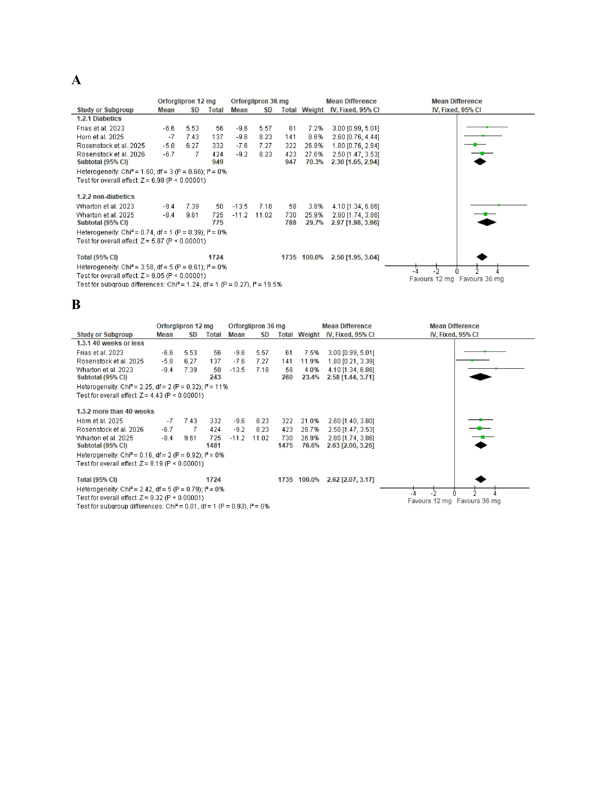
Figure S2 subgroup analysis of absolute change in body weight (kg) based on (A) diabetic status (B) treatment duration
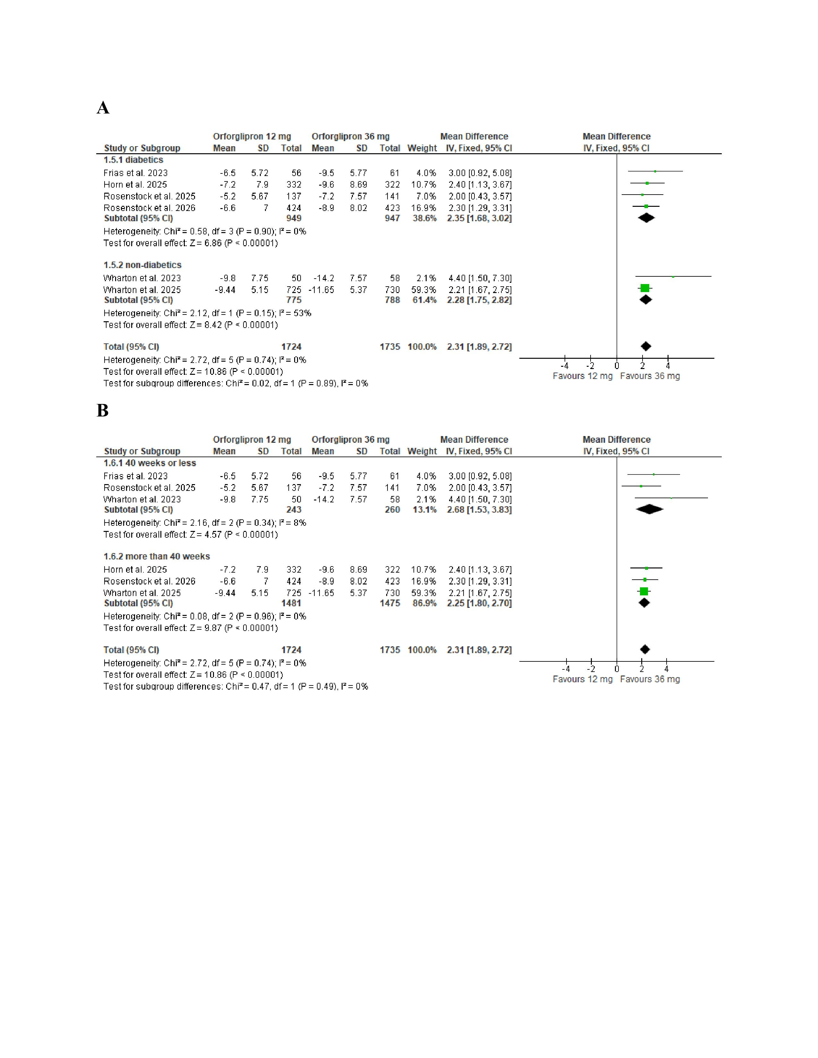
Figure S3 subgroup analysis of change in BMI(kg/m²) based on (A) diabetic status (B) treatment duration
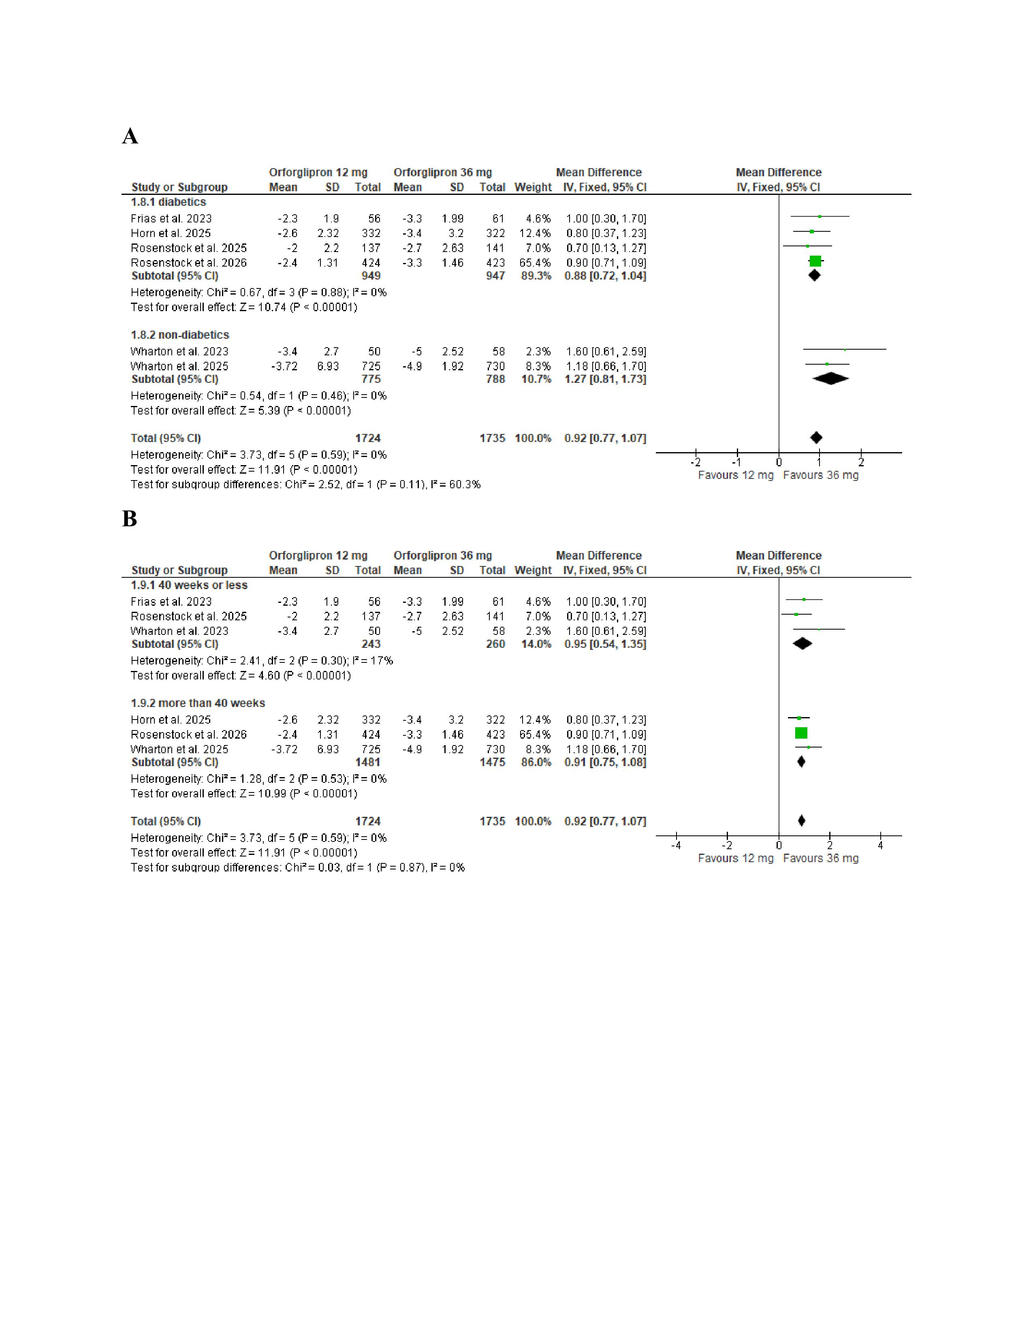
Figure S4 subgroup analysis of percent change in HbA1C (%)based on (A) diabetic status (B) diabetic status after excluding Wharton et al. 2023 (C)treatment duration
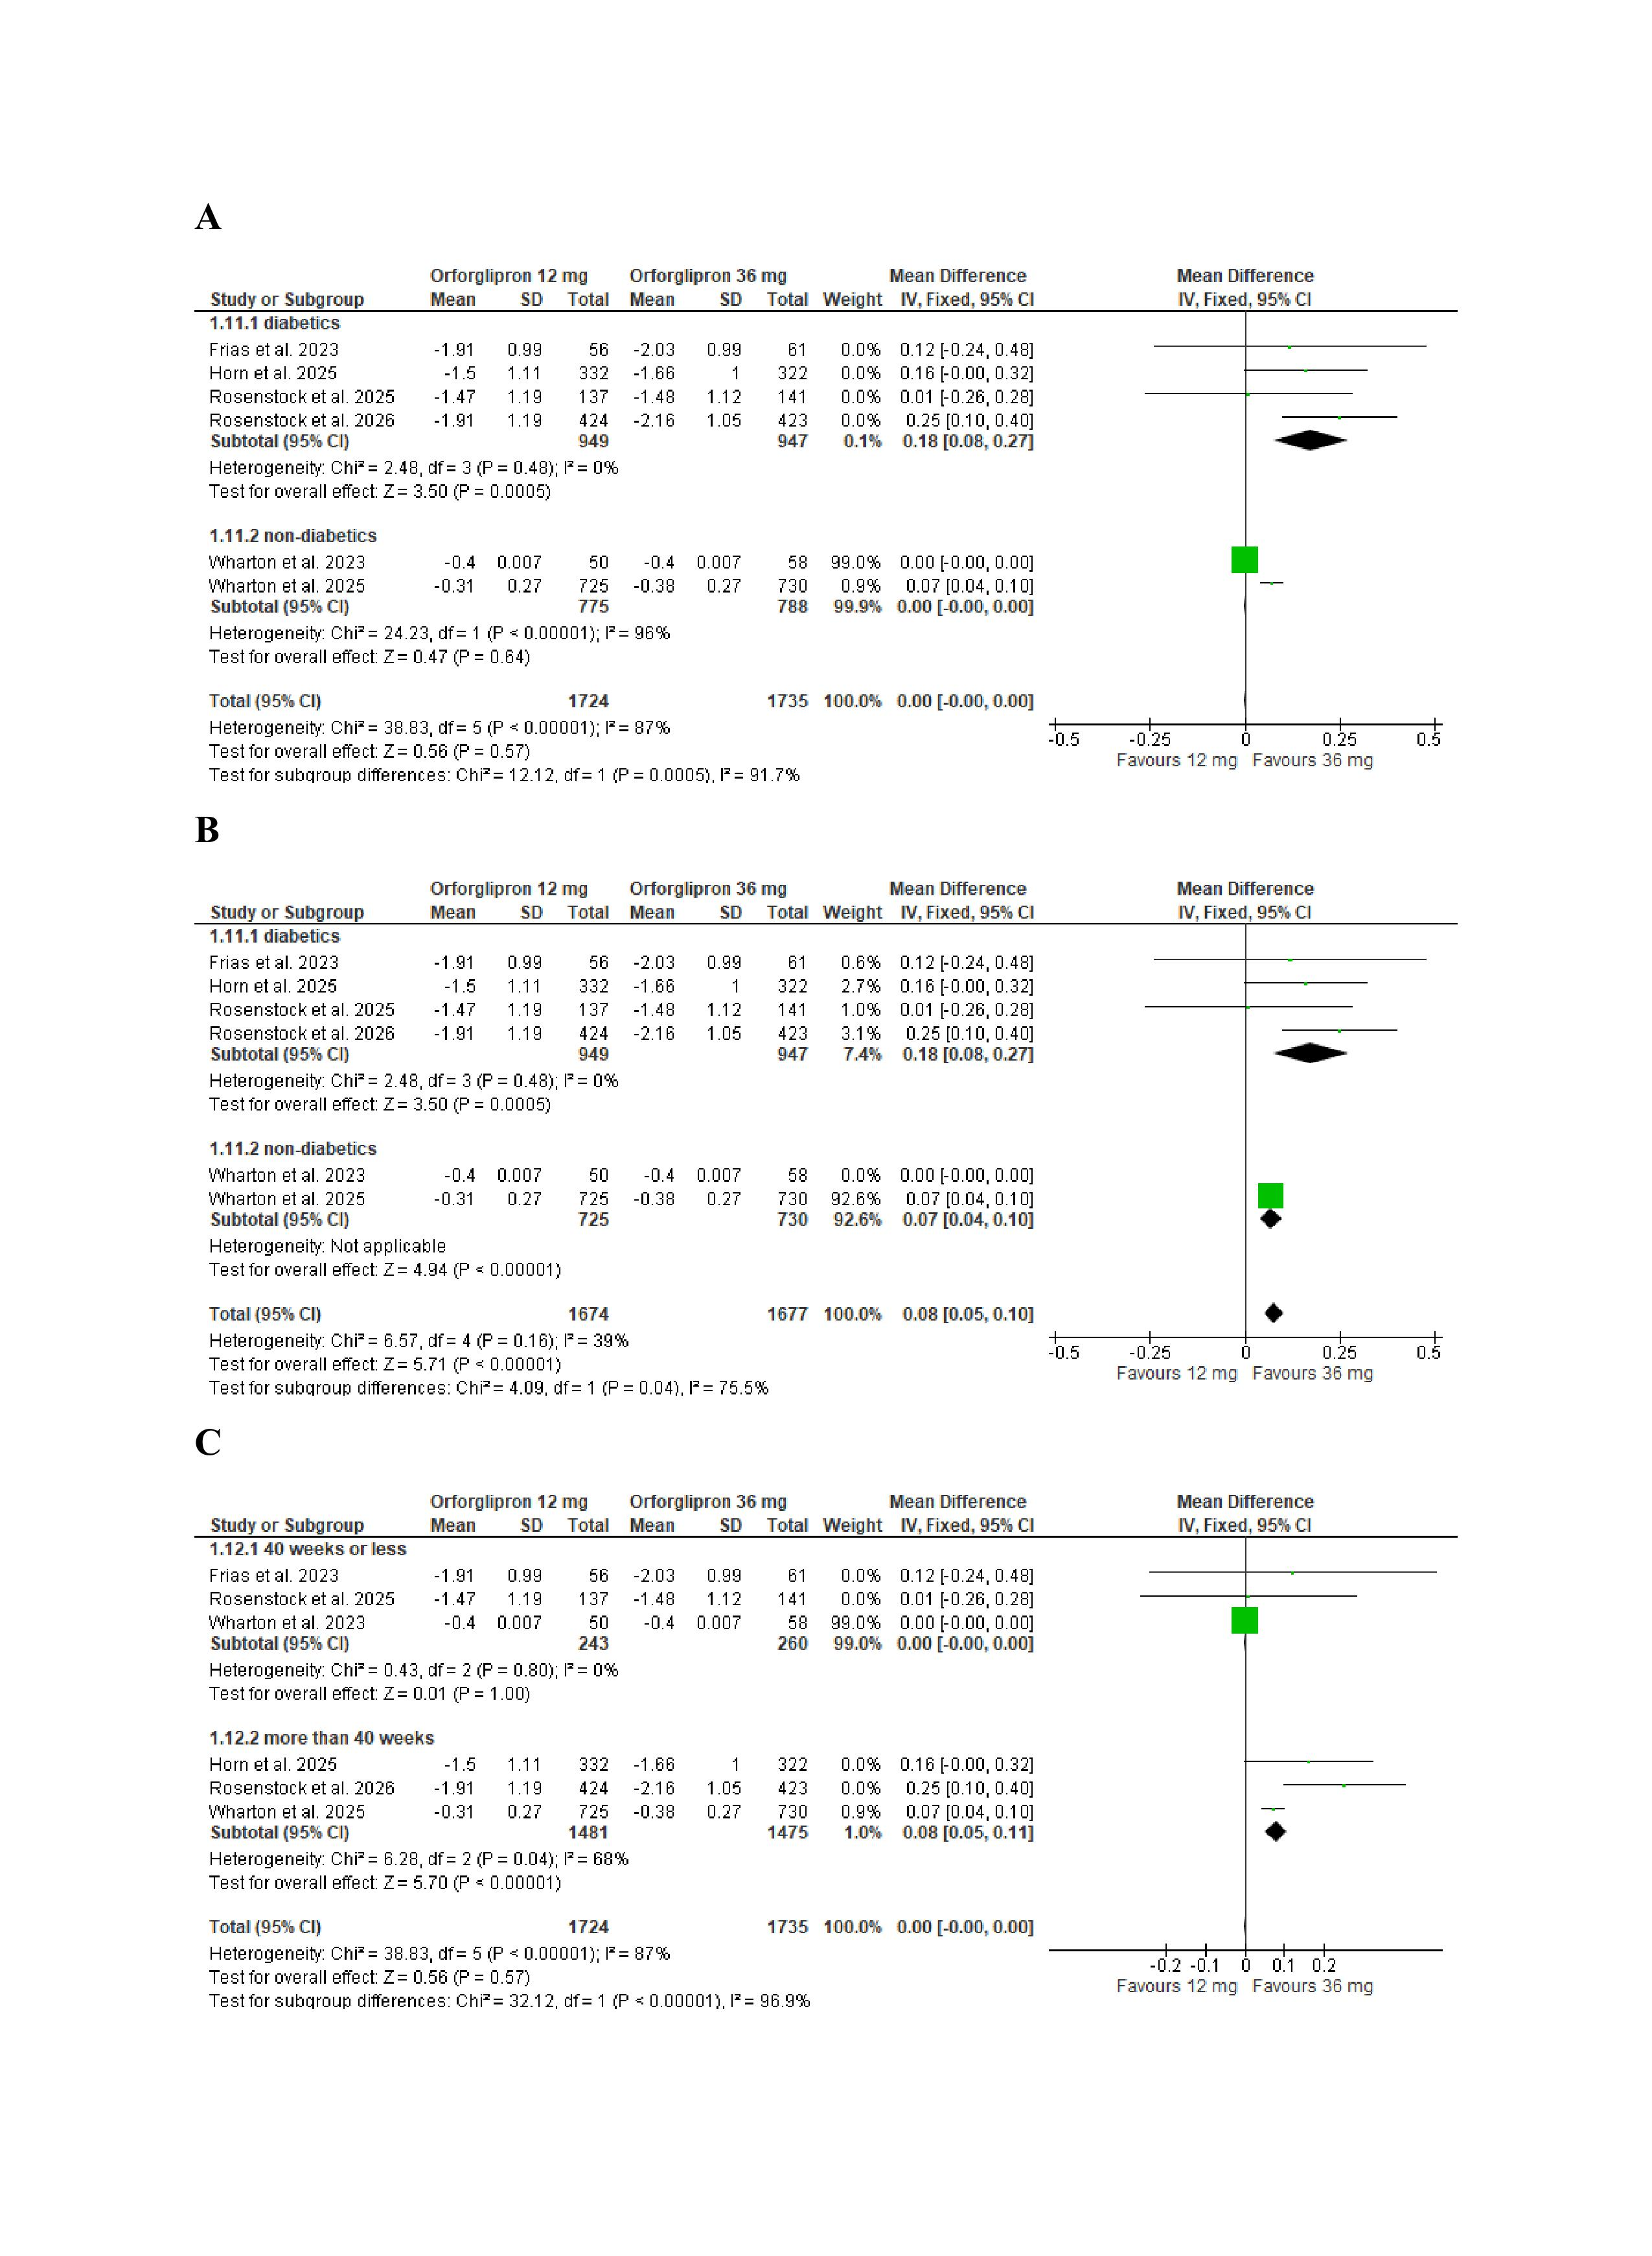
Figure S5 subgroup analysis of change in waist circumference (cm) based on (A) diabetic status (B) treatment duration
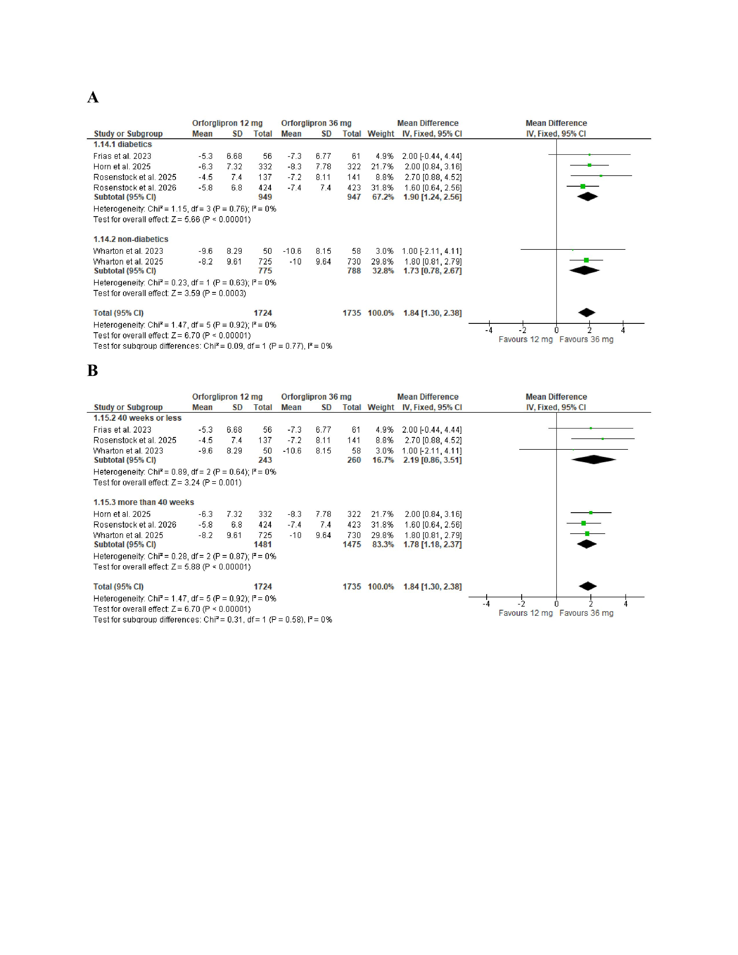
Figure S6 (A)forest plot for meta-analysis of percent change in serum total cholesterol (%) with (B)subgroup analysis based on diabetic status(C)subgroup analysis based on treatment duration
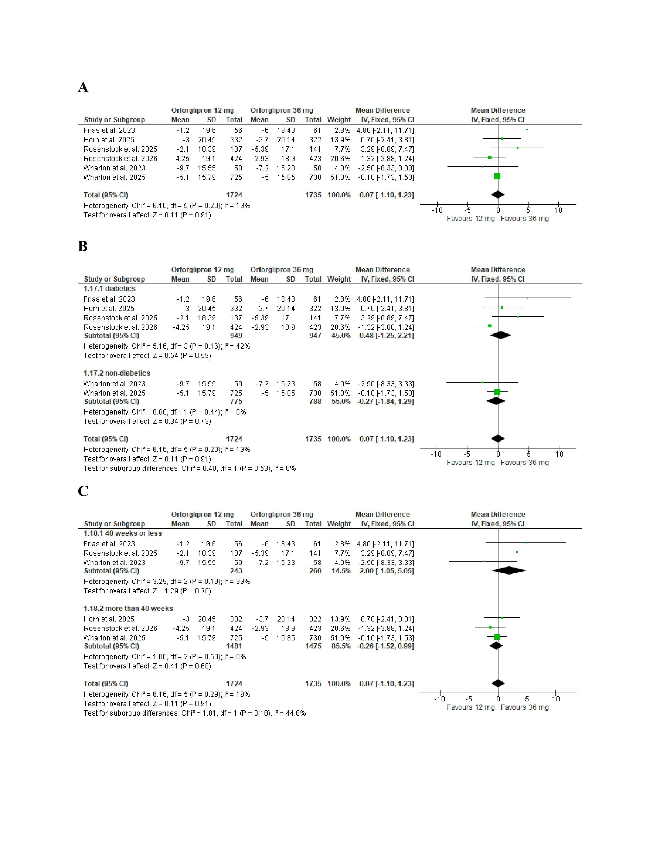
Figure S7 (A)forest plot for meta-analysis of of percent change in LDL cholesterol (%) with (B)subgroup analysis based on diabetic status(C)subgroup analysis based on treatment duration
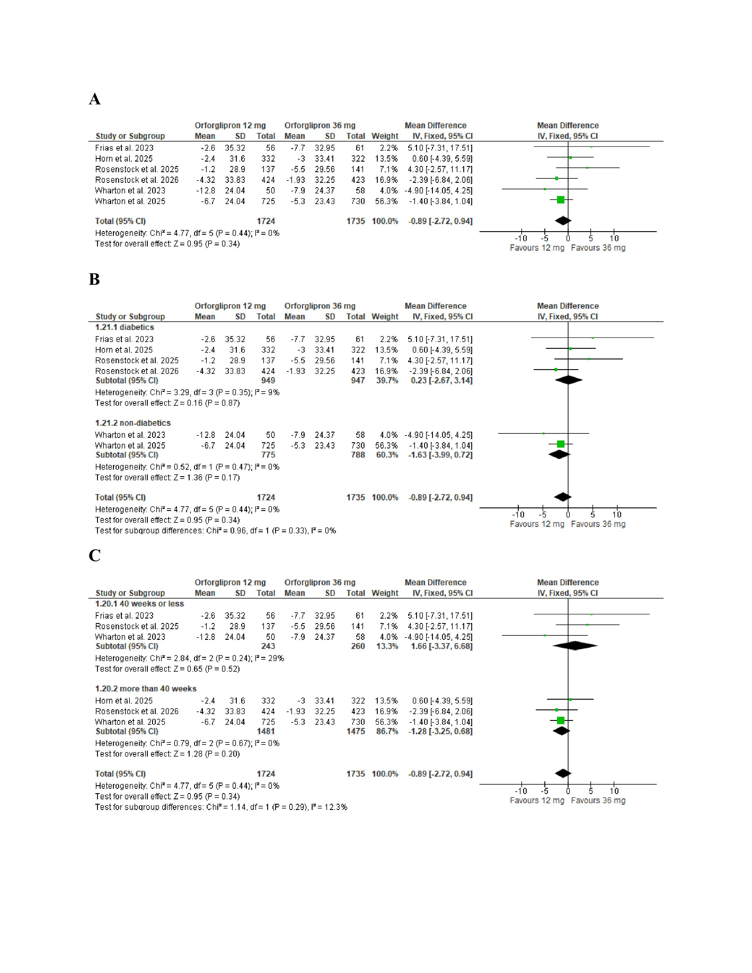
Figure S8 (A)forest plot for meta-analysis of percent change in HDL cholesterol (%) with (B)subgroup analysis based on diabetic status(C)subgroup analysis based on treatment duration
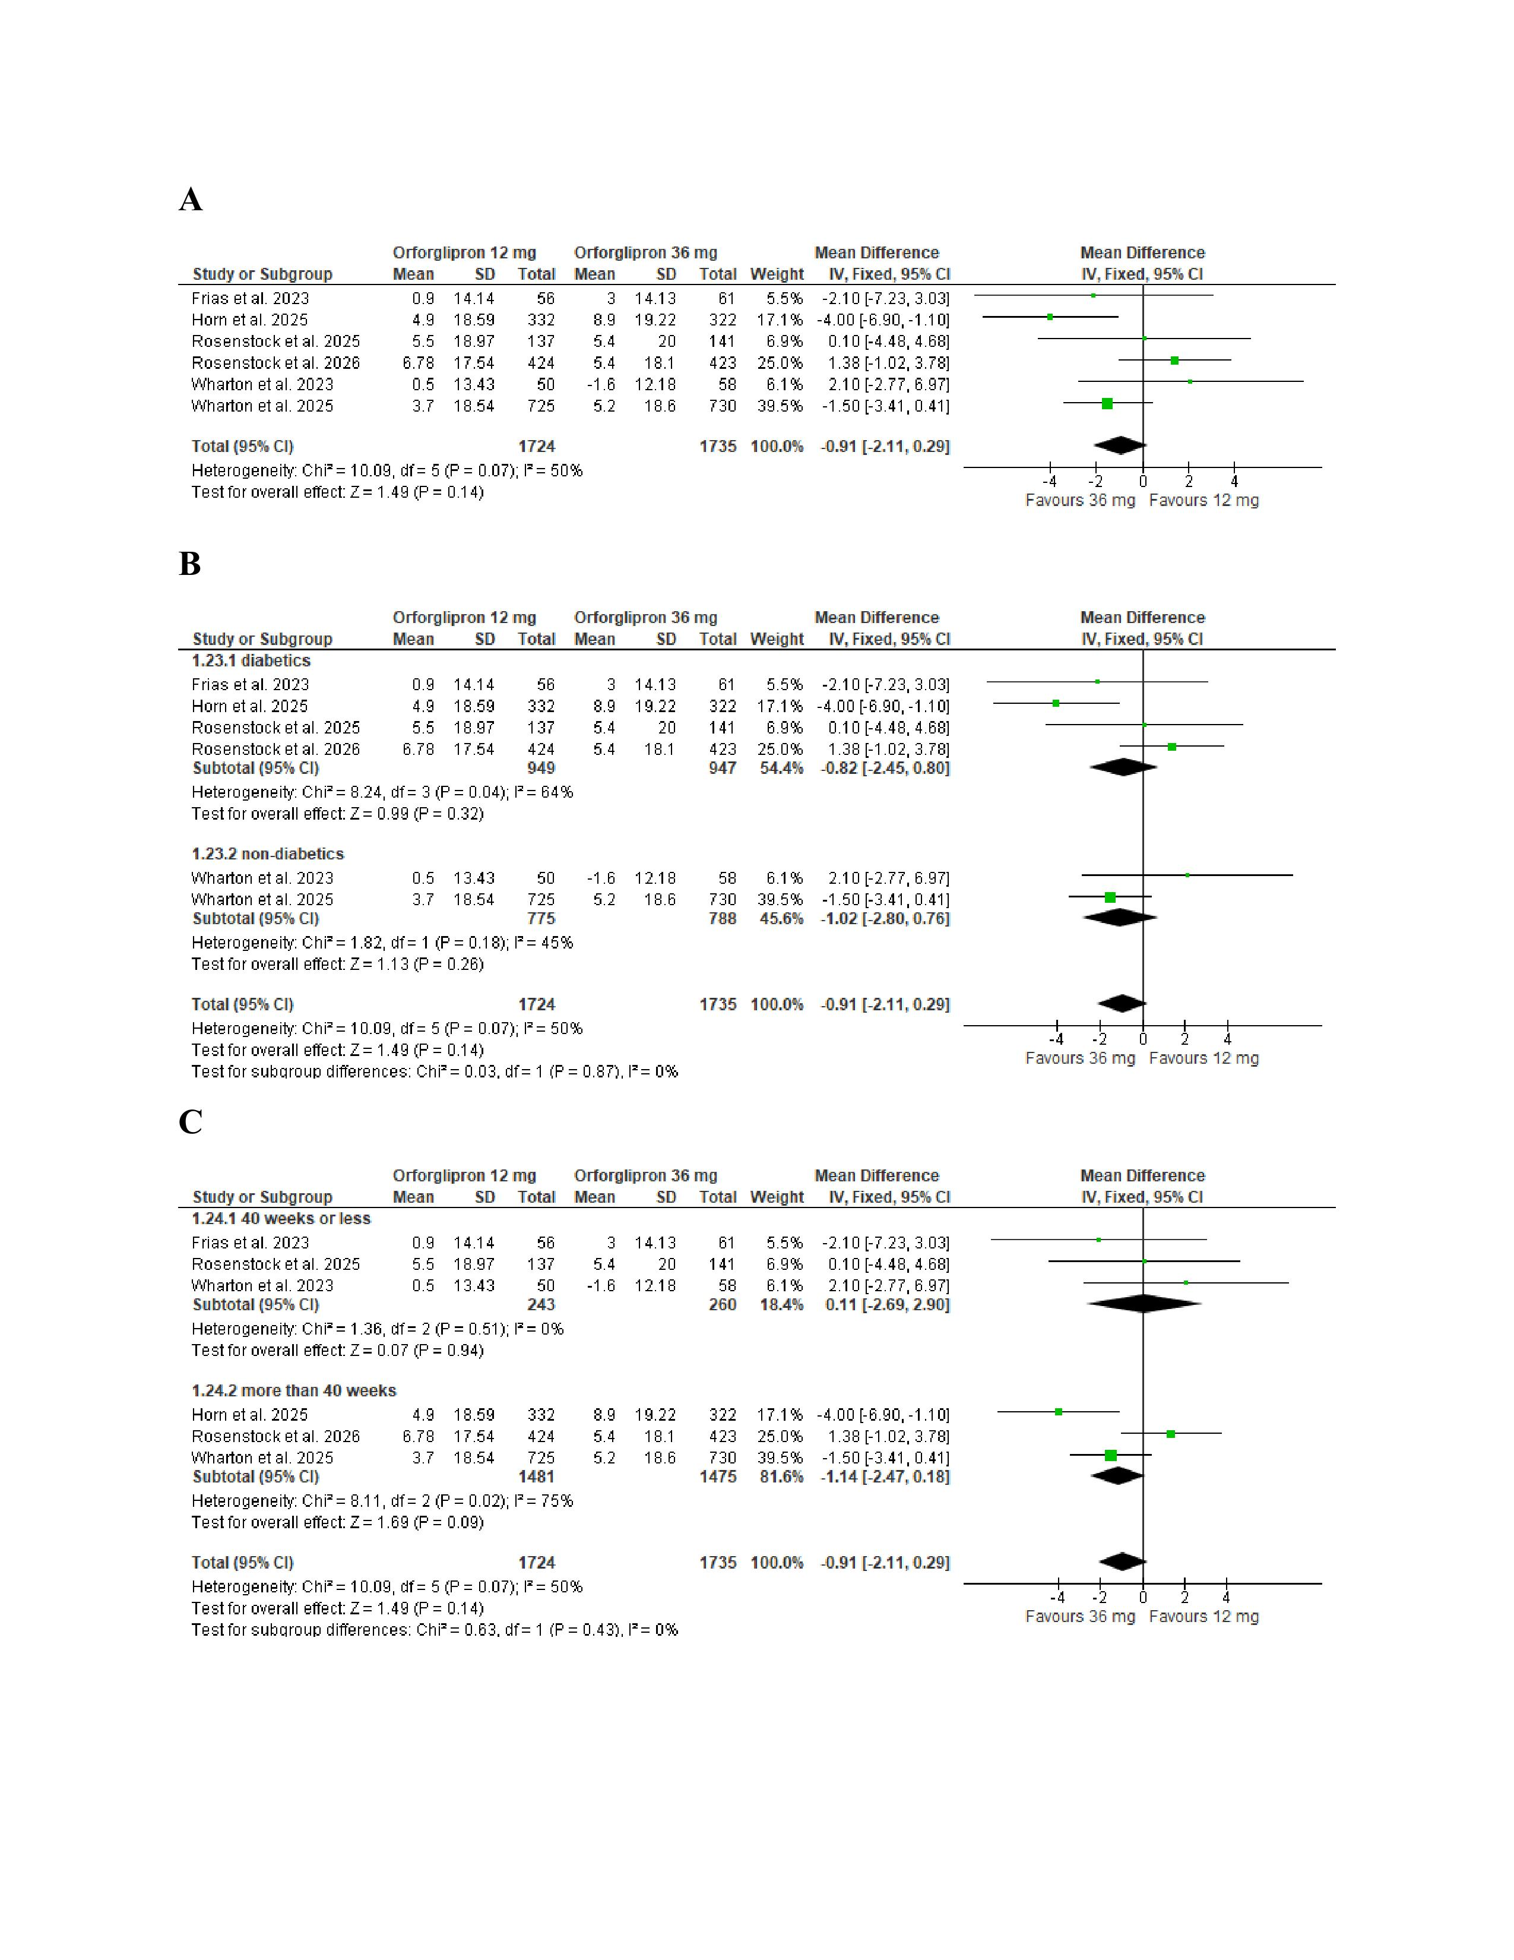
Figure S9 subgroup analysis of percent change in triglycerides (%)based on (A) diabetic status (B) treatment duration
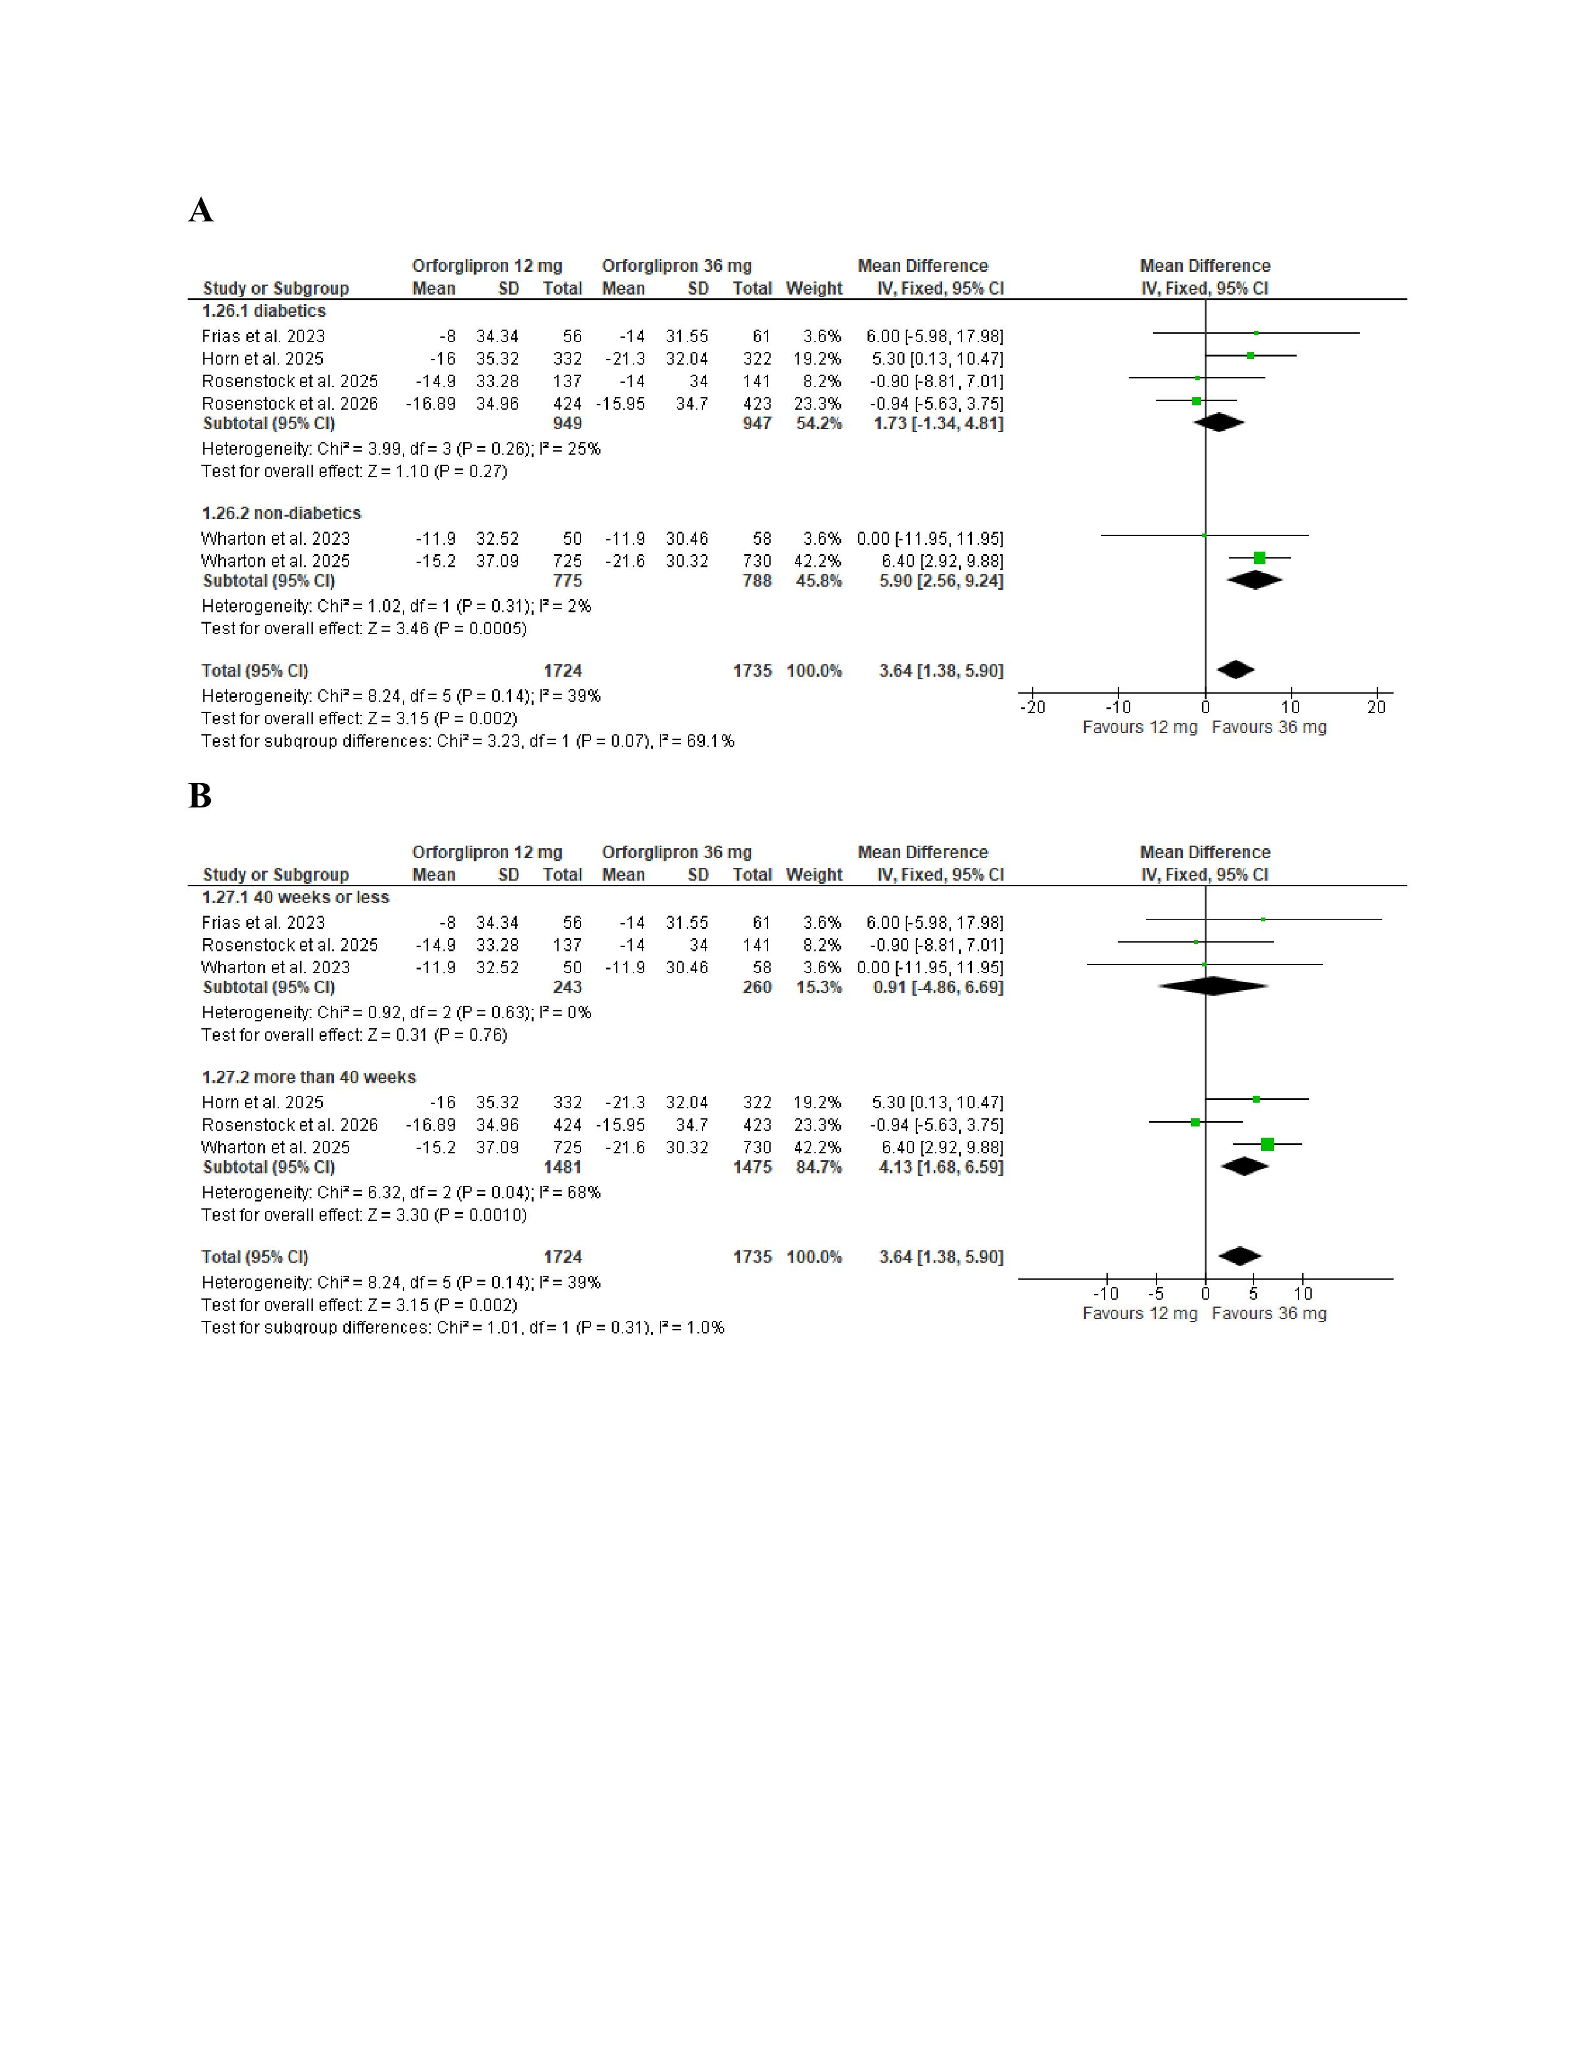
Figure S10 (A)forest plot for meta-analysis of change in fasting serum glucose (mg/dL) with (B)subgroup analysis based on diabetic status(C)subgroup analysis based on treatment duration
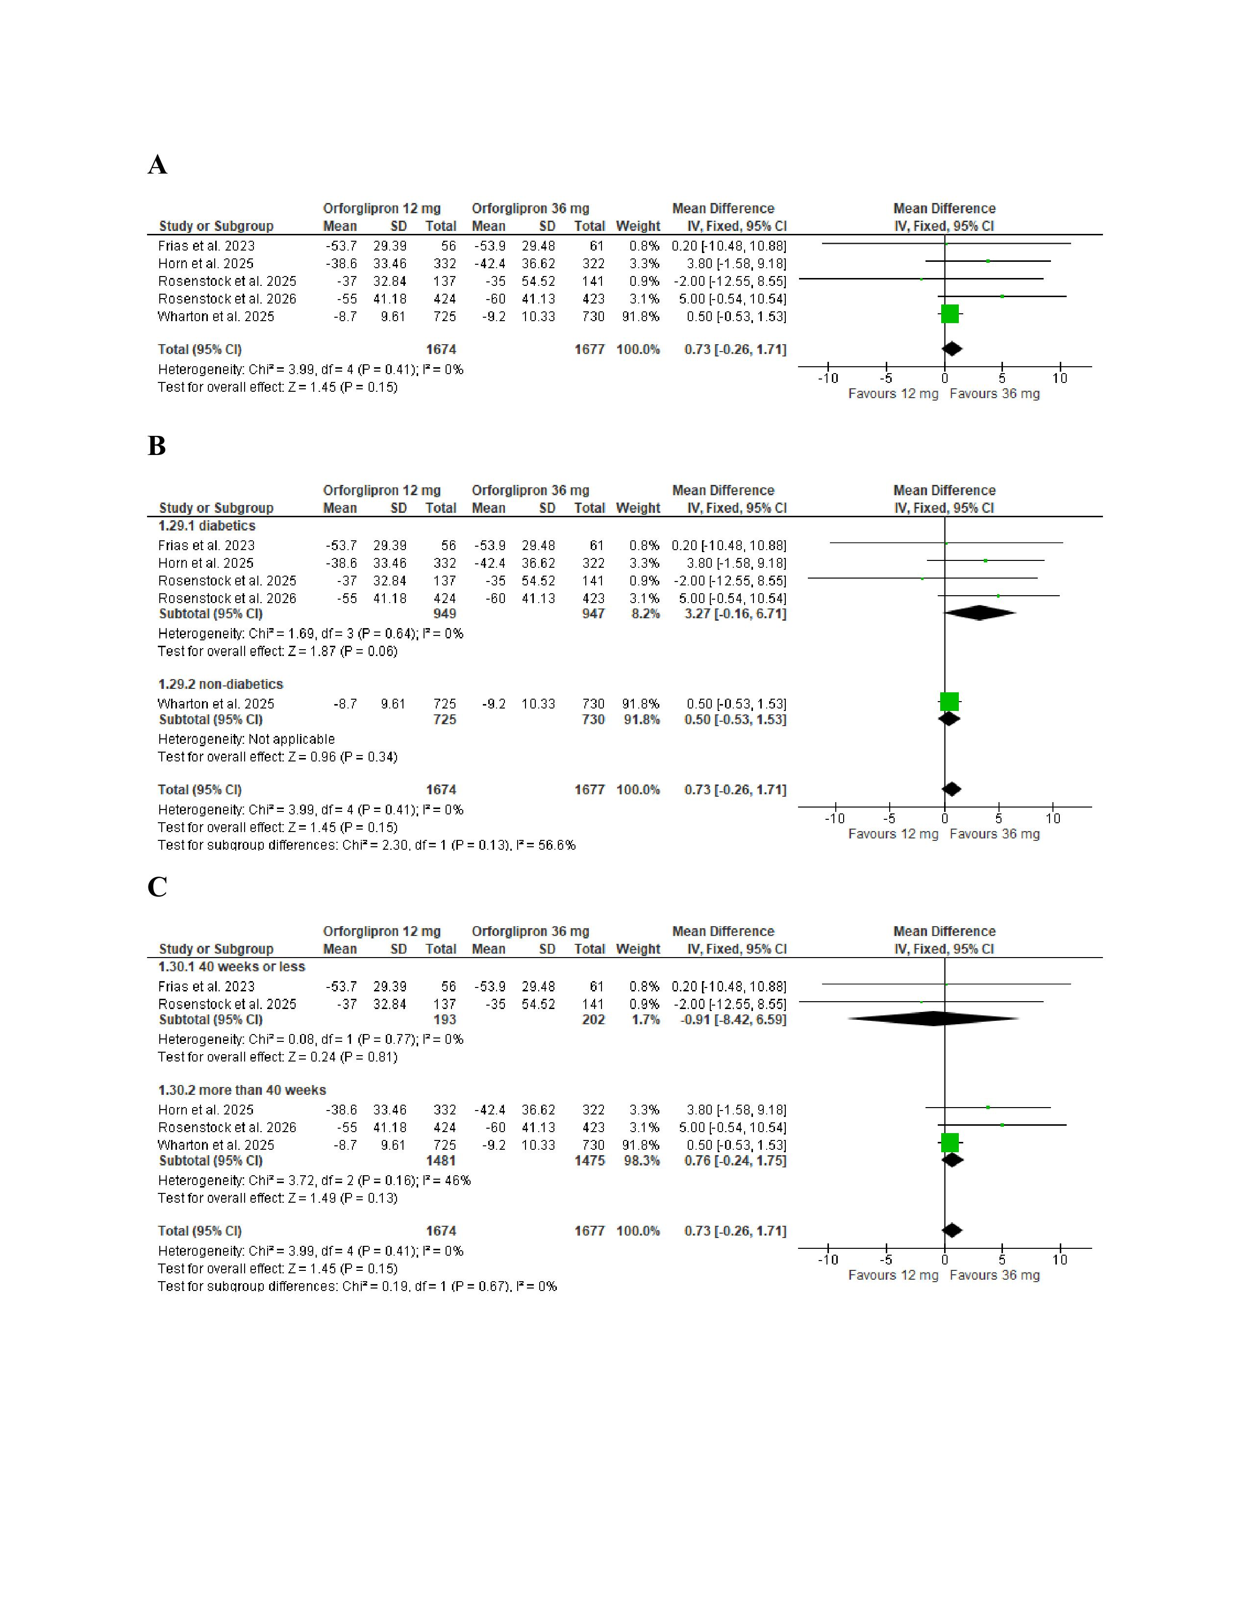
Figure S11 subgroup analysis of change in systolic blood pressure (mmHg) based on (A) diabetic status (B) treatment duration
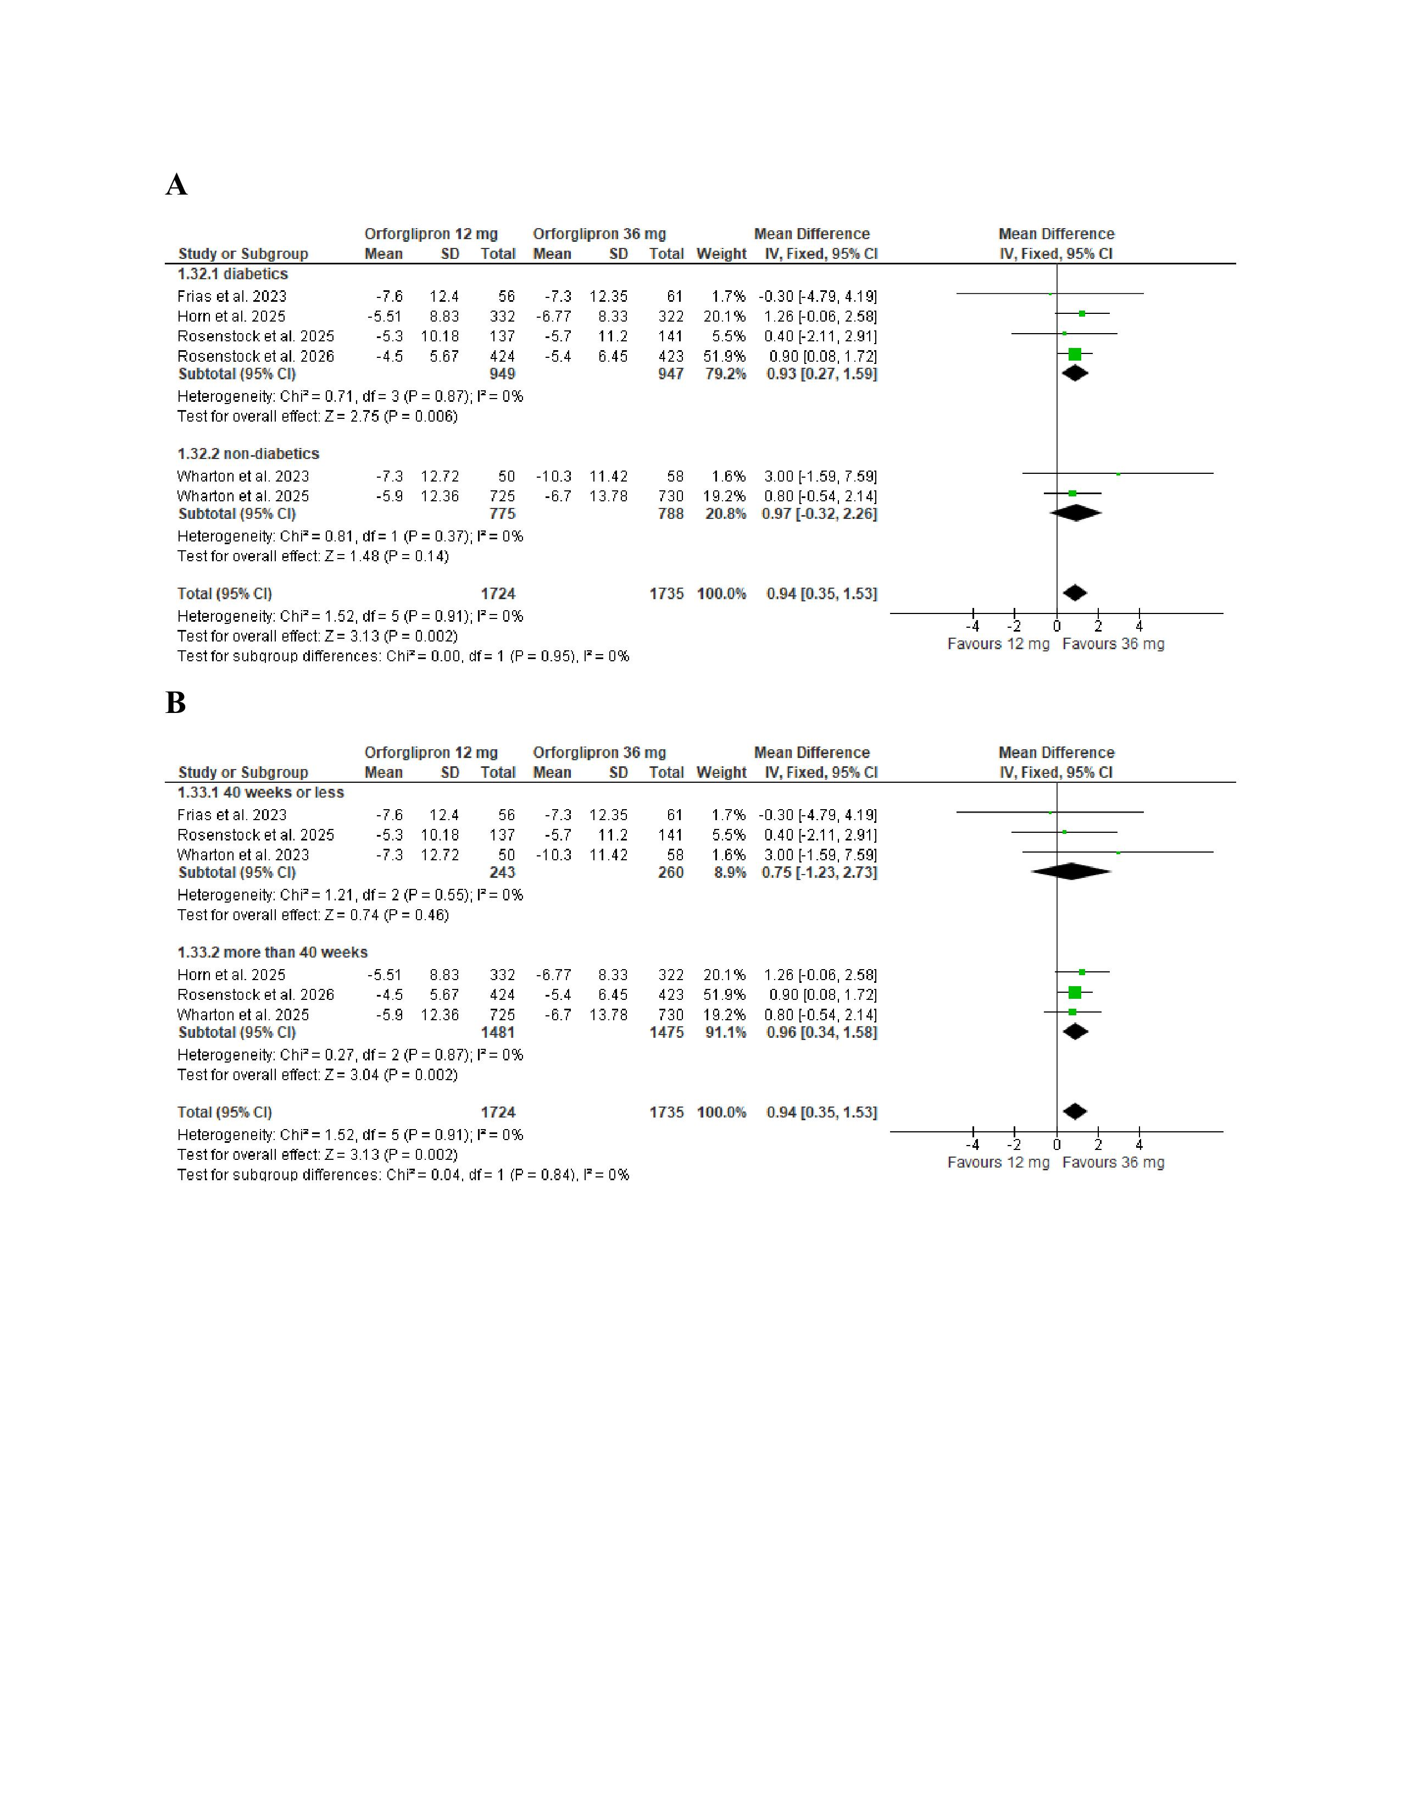
Figure S12 (A)forest plot for meta-analysis of change in diastolic blood pressure (mmHg) with (B)subgroup analysis based on diabetic status(C)subgroup analysis based on treatment duration
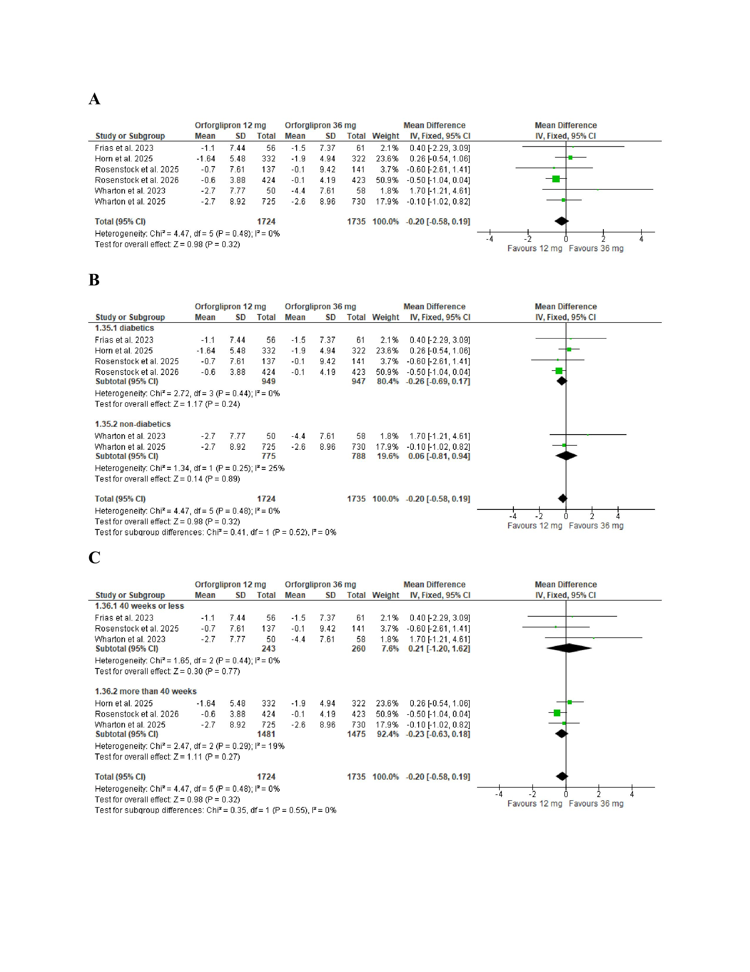
Figure S13 (A)forest plot for meta-analysis of percent change in pulse rate (bpm) with (B)subgroup analysis based on diabetic status(C)subgroup analysis based on treatment duration
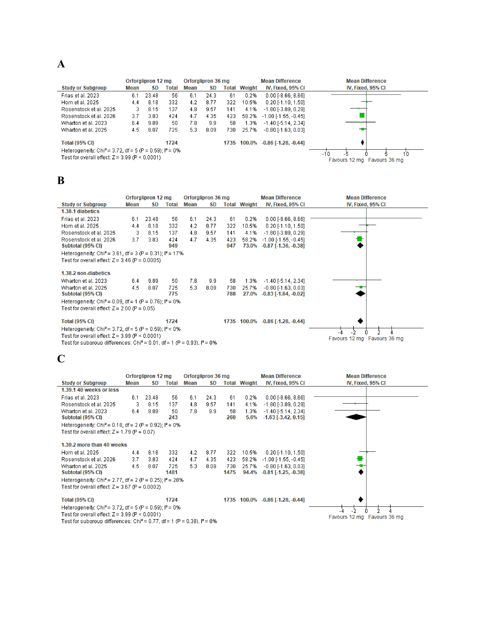
Figure S14 subgroup analysis of the risk of any TEAE based on (A) diabetic status (B) treatment duration
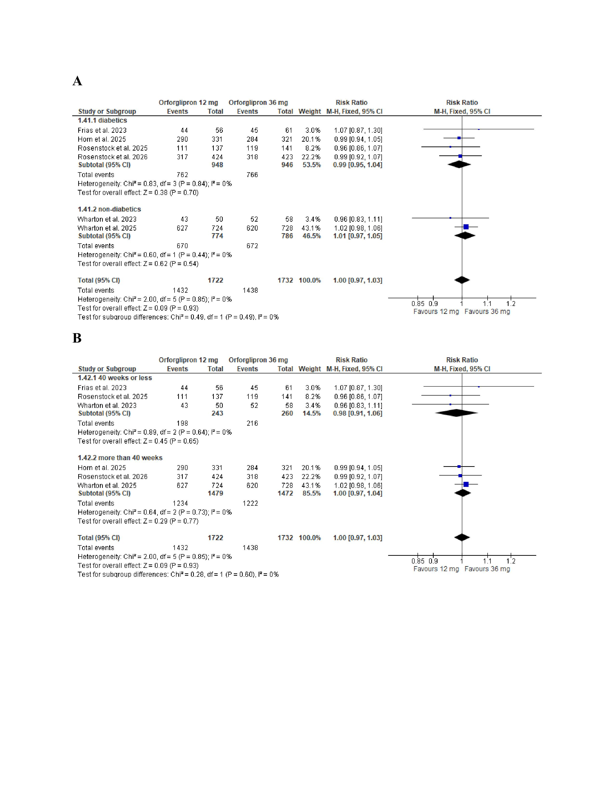
Figure S15 subgroup analysis of the risk of serious adverse events based on (A) diabetic status (B) treatment duration
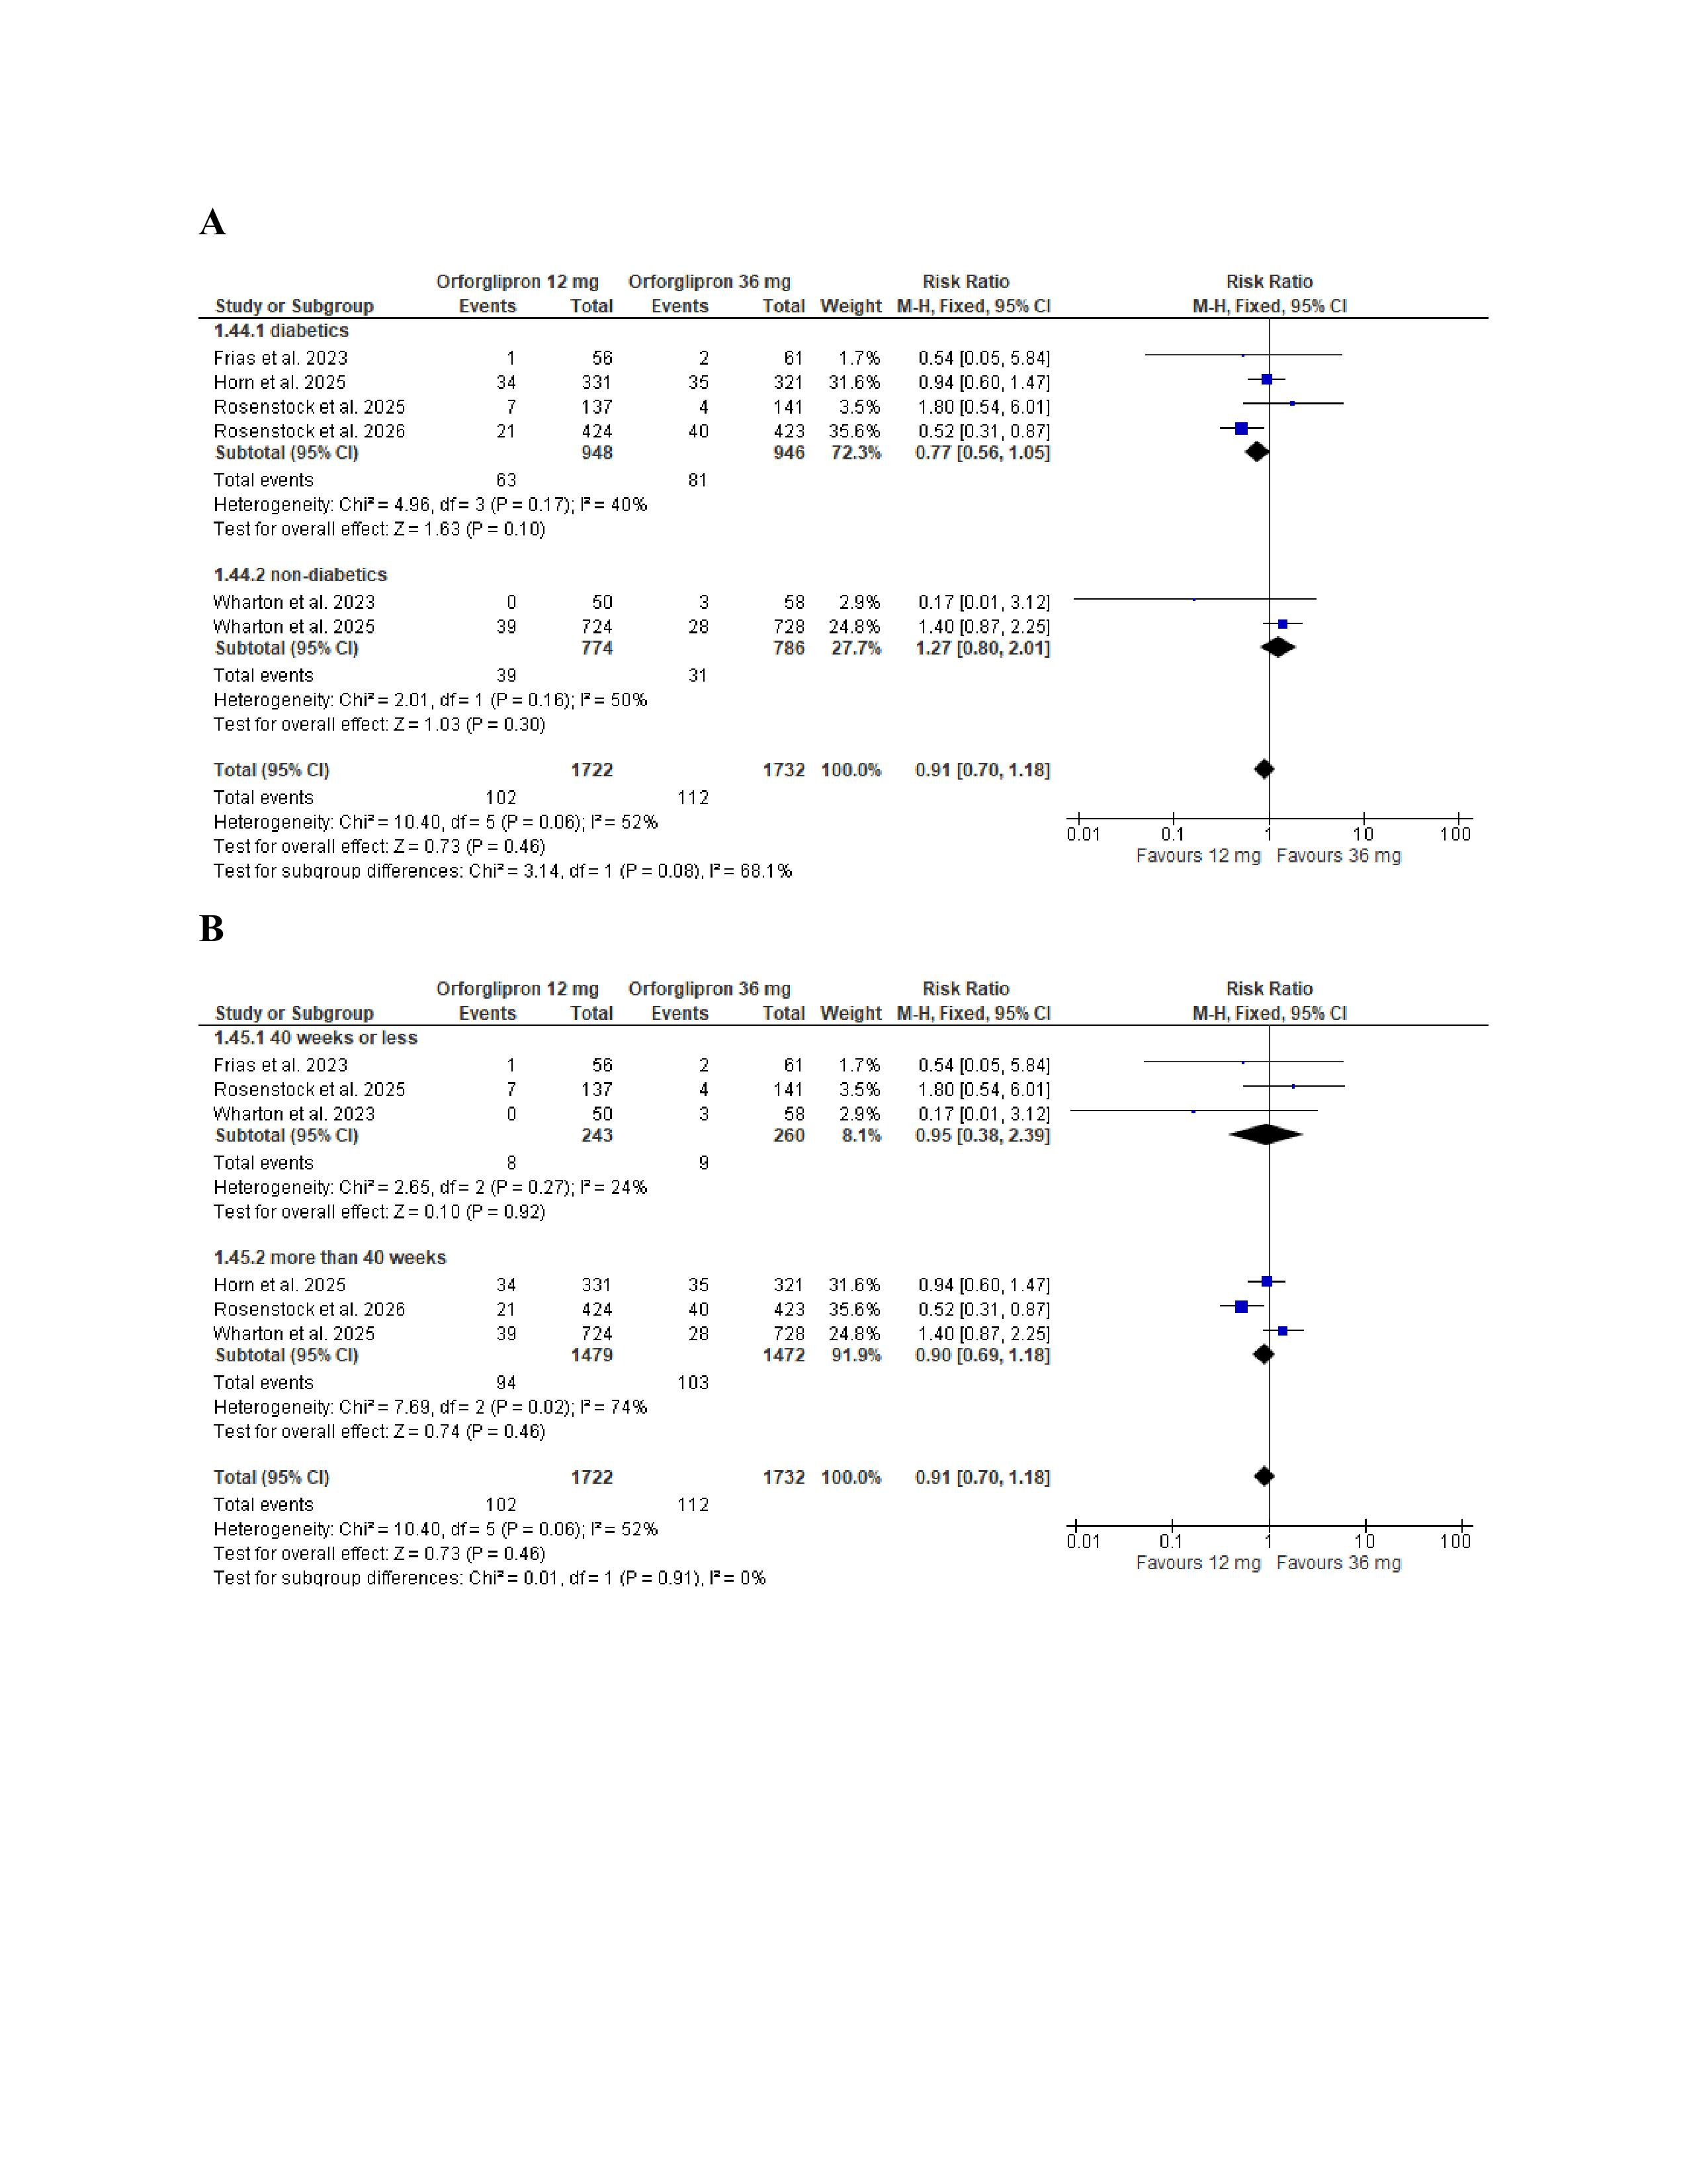
Figure S16 subgroup analysis of the risk of adverse events leading to treatment discontinuation based on (A) diabetic status (B) treatment duration
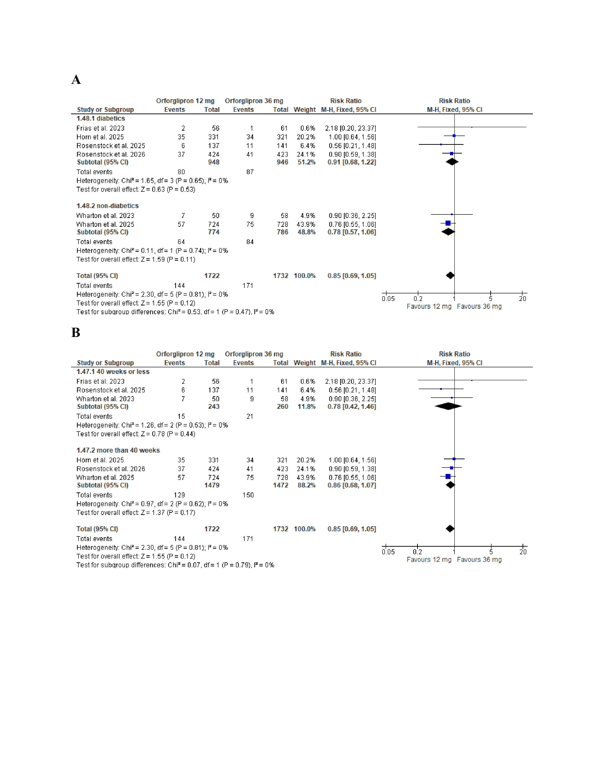
Figure S17 (A)forest plot for meta-analysis of the risk of nausea with (B)subgroup analysis based on diabetic status(C)subgroup analysis based on treatment duration
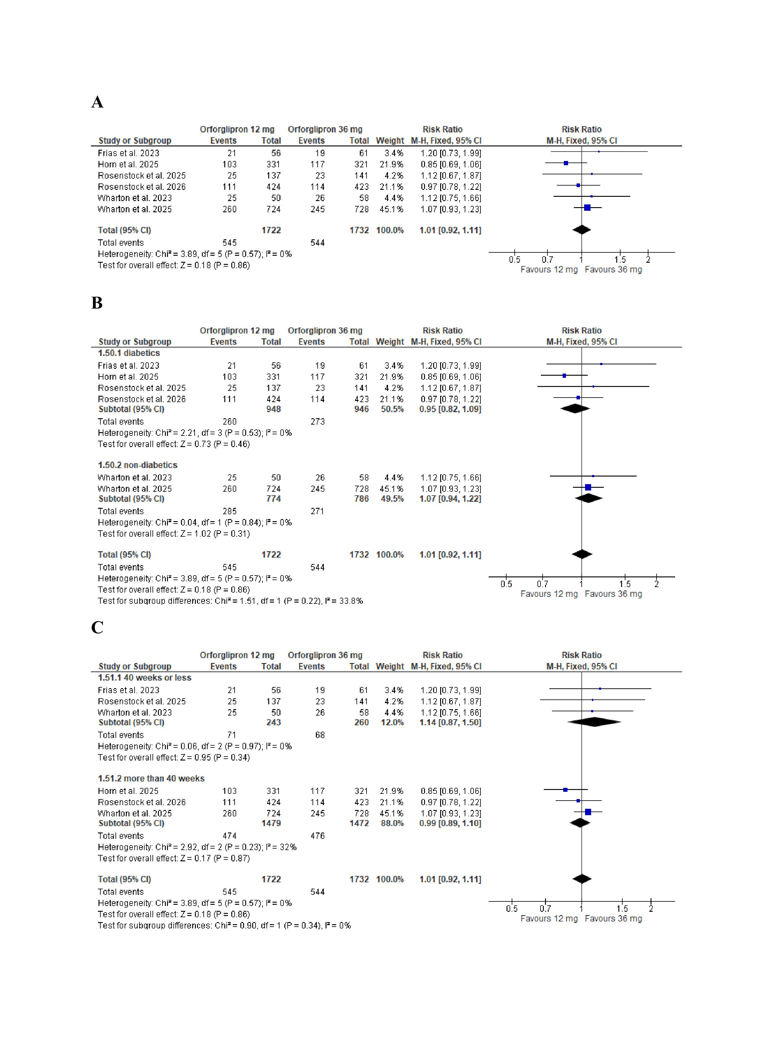
Figure S18 (A)forest plot for meta-analysis of the risk of vomiting with (B)subgroup analysis based on diabetic status(C)subgroup analysis based on treatment duration
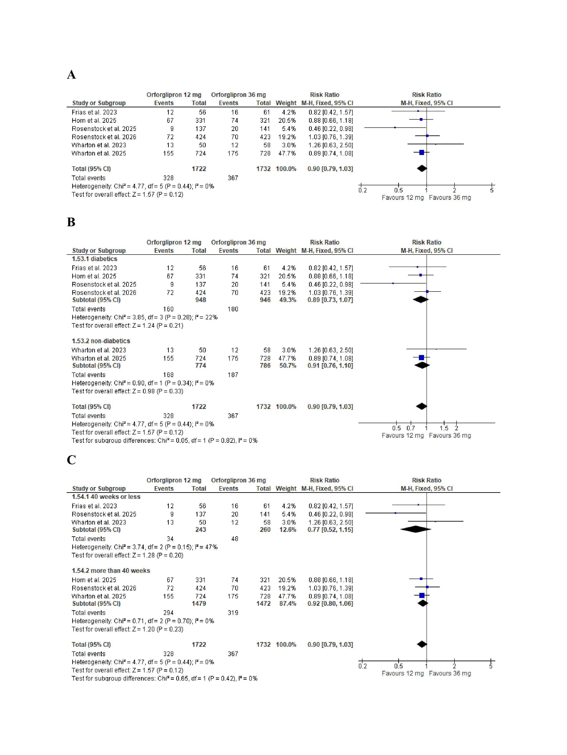
Figure S19 (A)forest plot for meta-analysis of the risk of diarrhea with (B)subgroup analysis based on diabetic status(C)subgroup analysis based on treatment duration
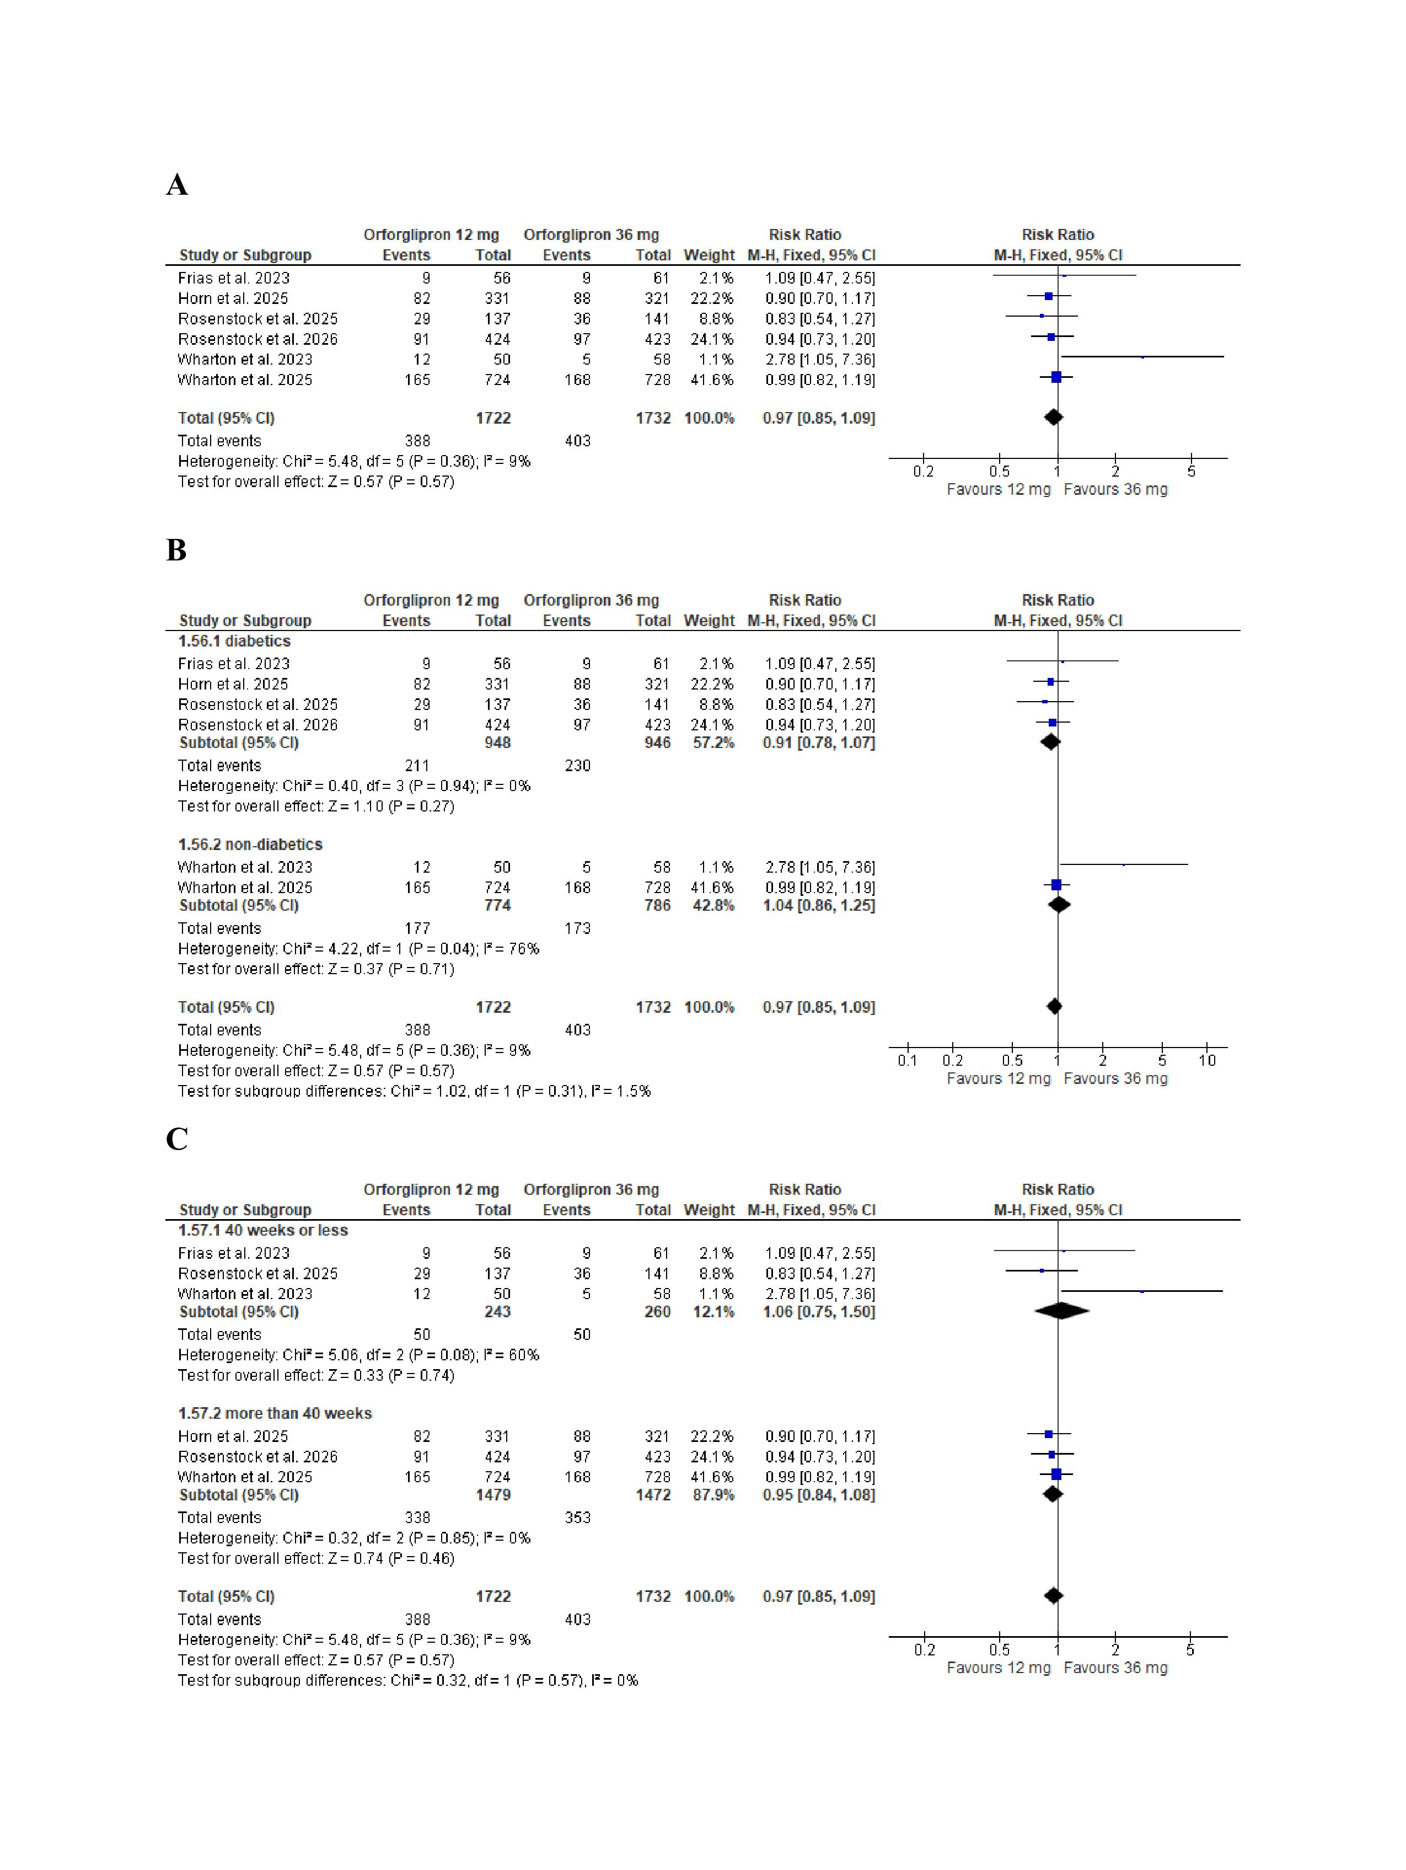
Figure S20 (A)forest plot for meta-analysis of the risk of constipation (B)subgroup analysis based on diabetic status(C)subgroup analysis based on treatment duration
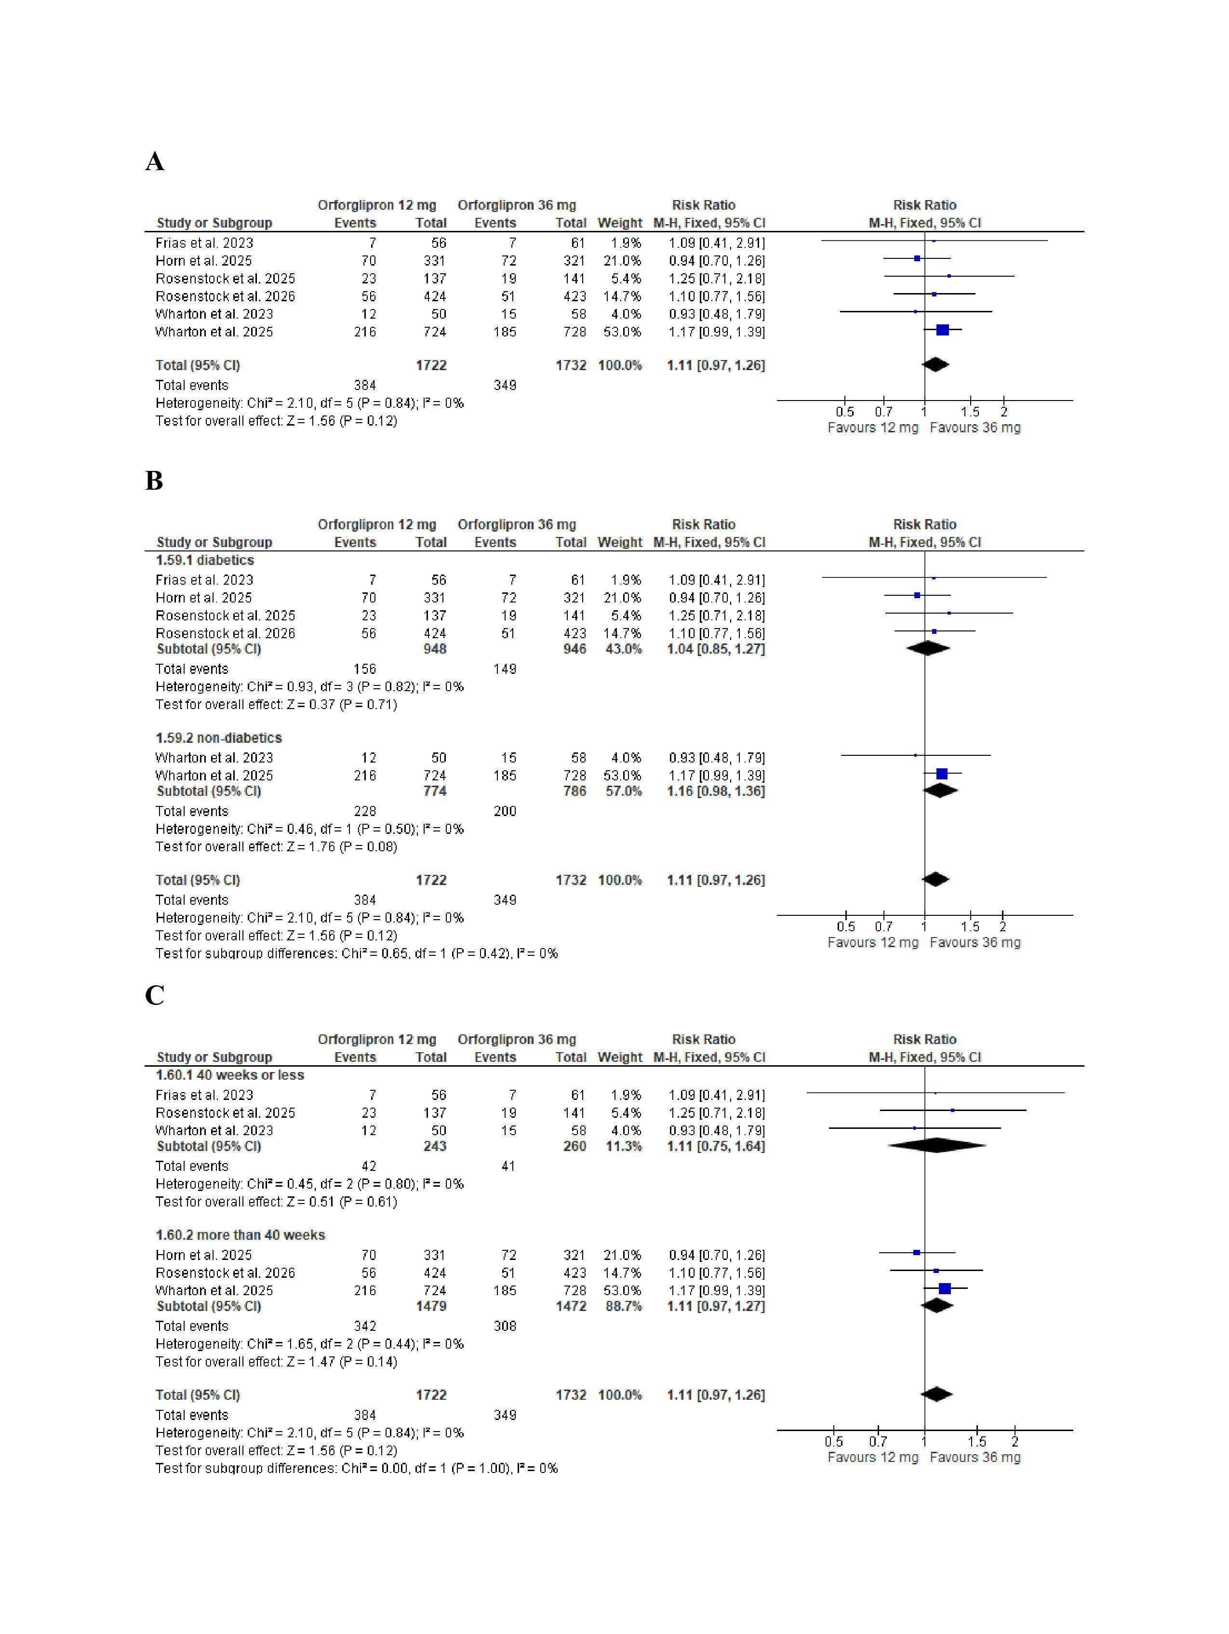
Figure S21 (A)forest plot for meta-analysis of percent change in serum lipase (%) with (B)subgroup analysis based on diabetic status(C)subgroup analysis based on treatment duration
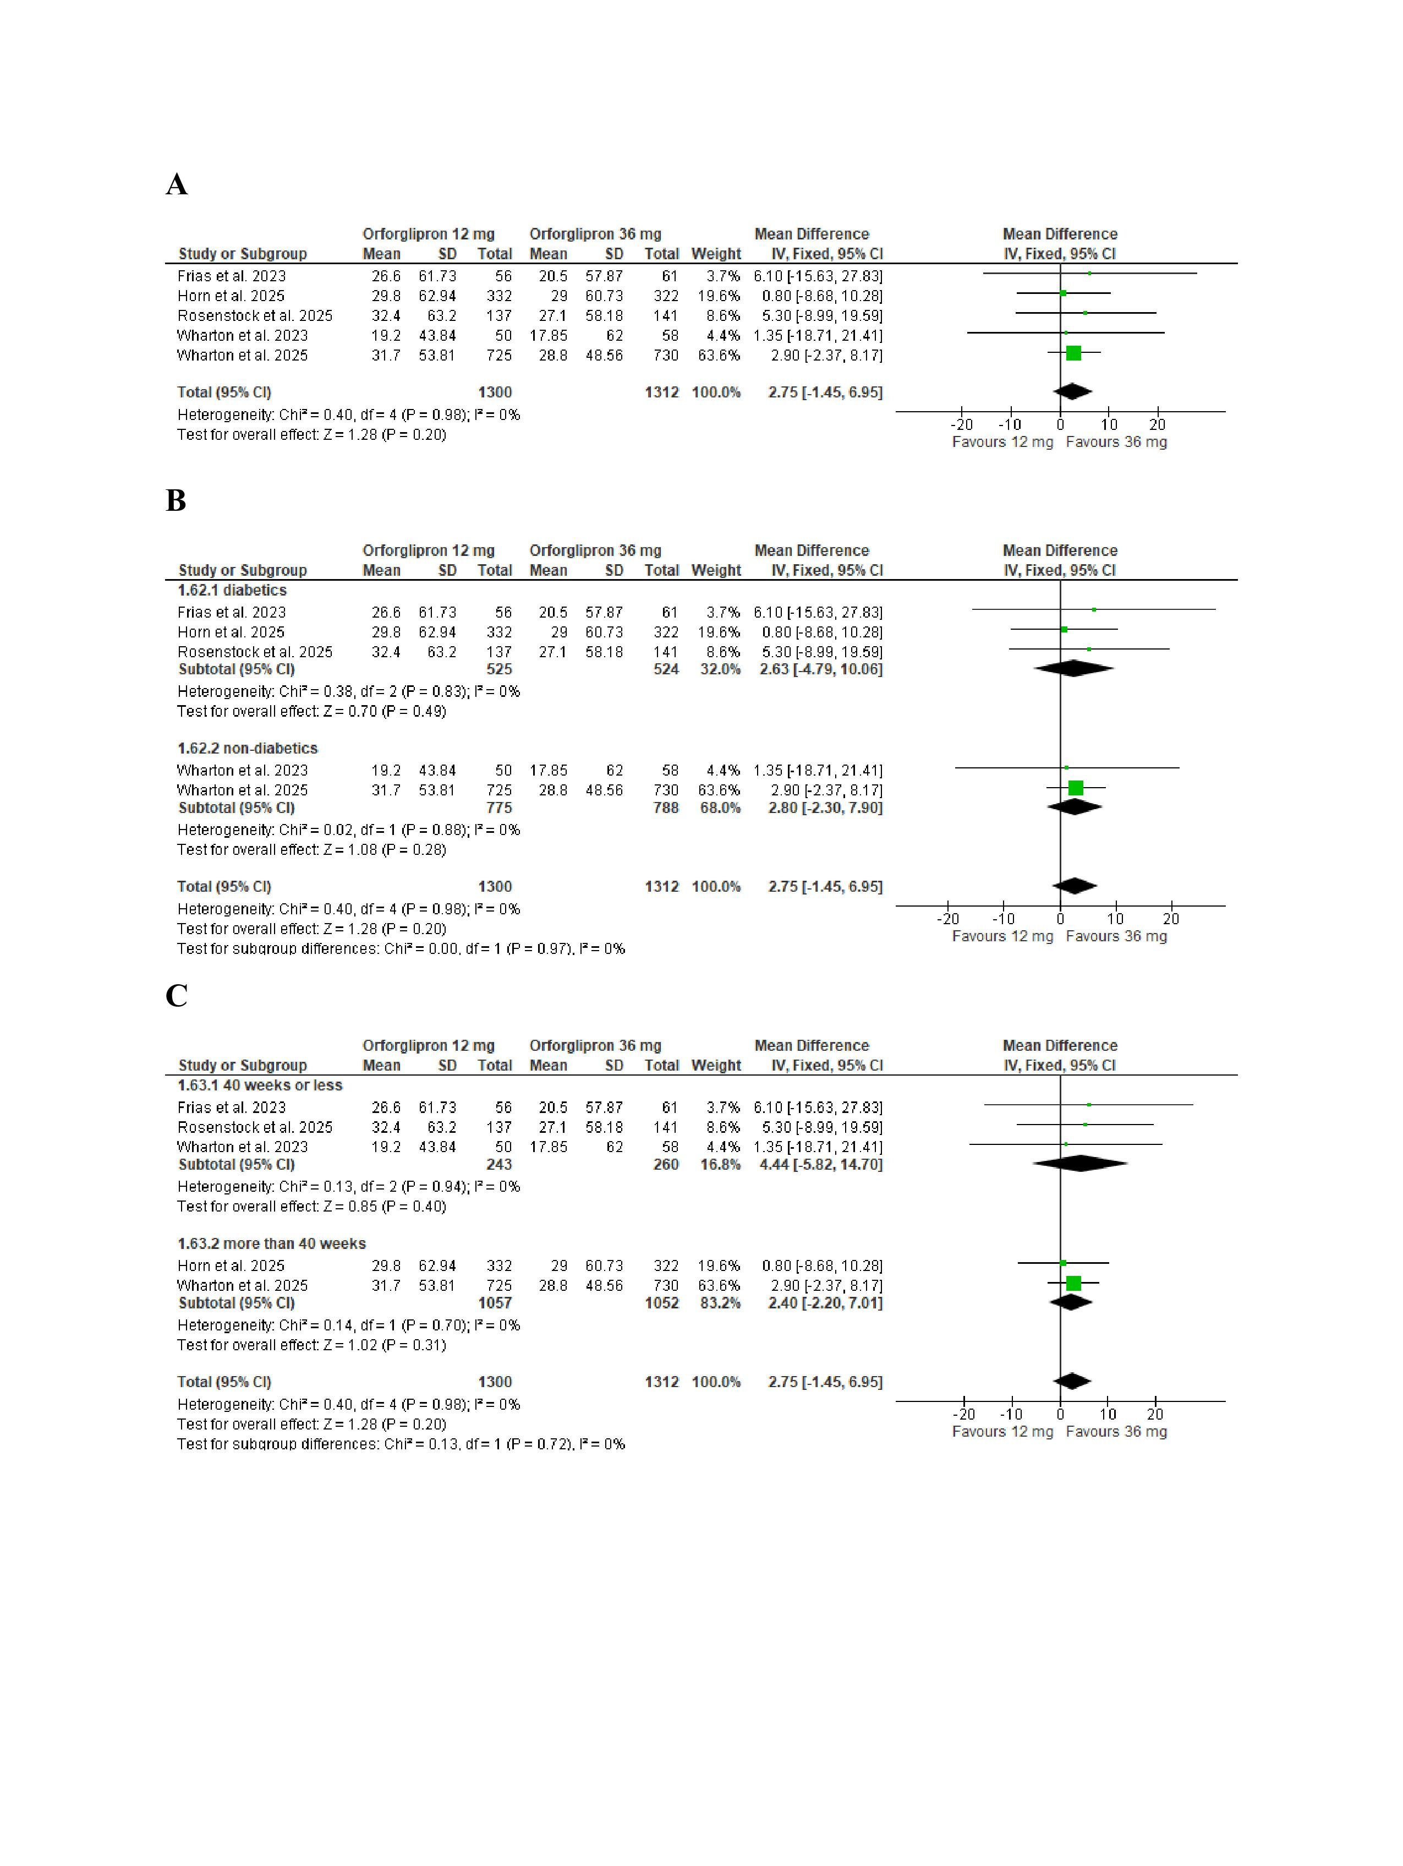
Figure S22 (A)forest plot for meta-analysis of percent change in serum amylase (%)with (B)subgroup analysis based on diabetic status(C)subgroup analysis based on treatment duration
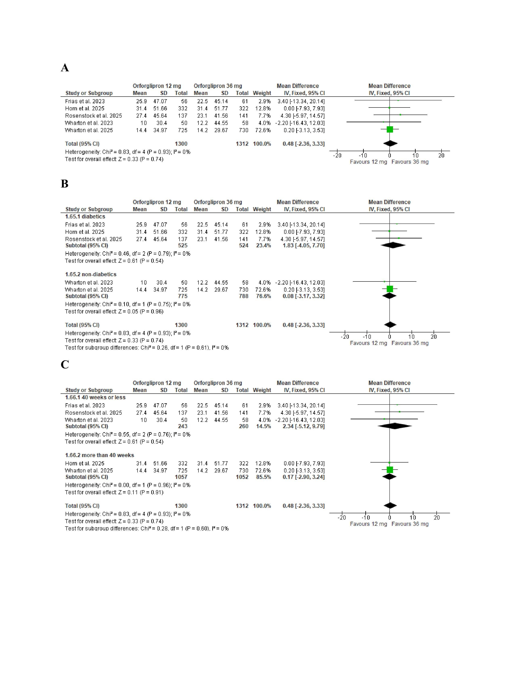
Figure S23 (A)forest plot for meta-analysis of percent change in serum calcitonin (%) with (B)subgroup analysis based on diabetic status(C)subgroup analysis based on treatment duration
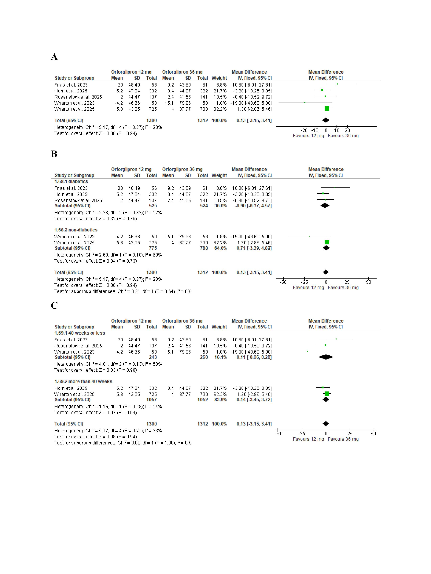
Figure S24 (A)forest plot for meta-analysis of percent change in ALT (%) with (B)subgroup analysis based on diabetic status(C)subgroup analysis based on treatment duration
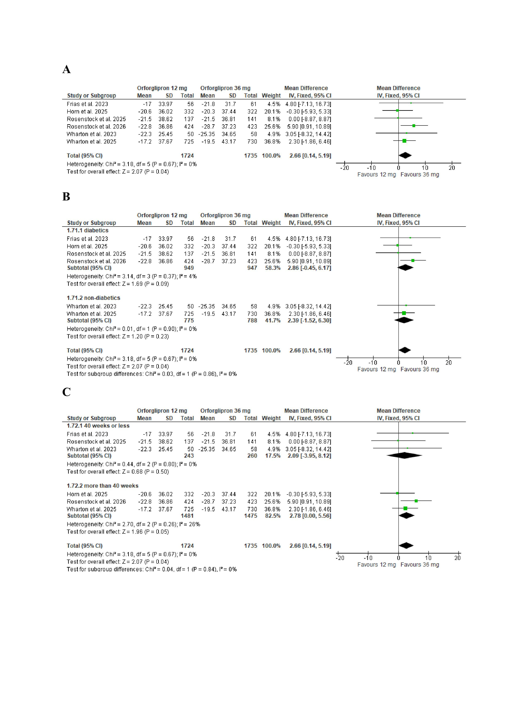
Figure S25 (A)forest plot for meta-analysis of percent change in AST (%)with (B)subgroup analysis based on diabetic status(C)subgroup analysis based on treatment duration
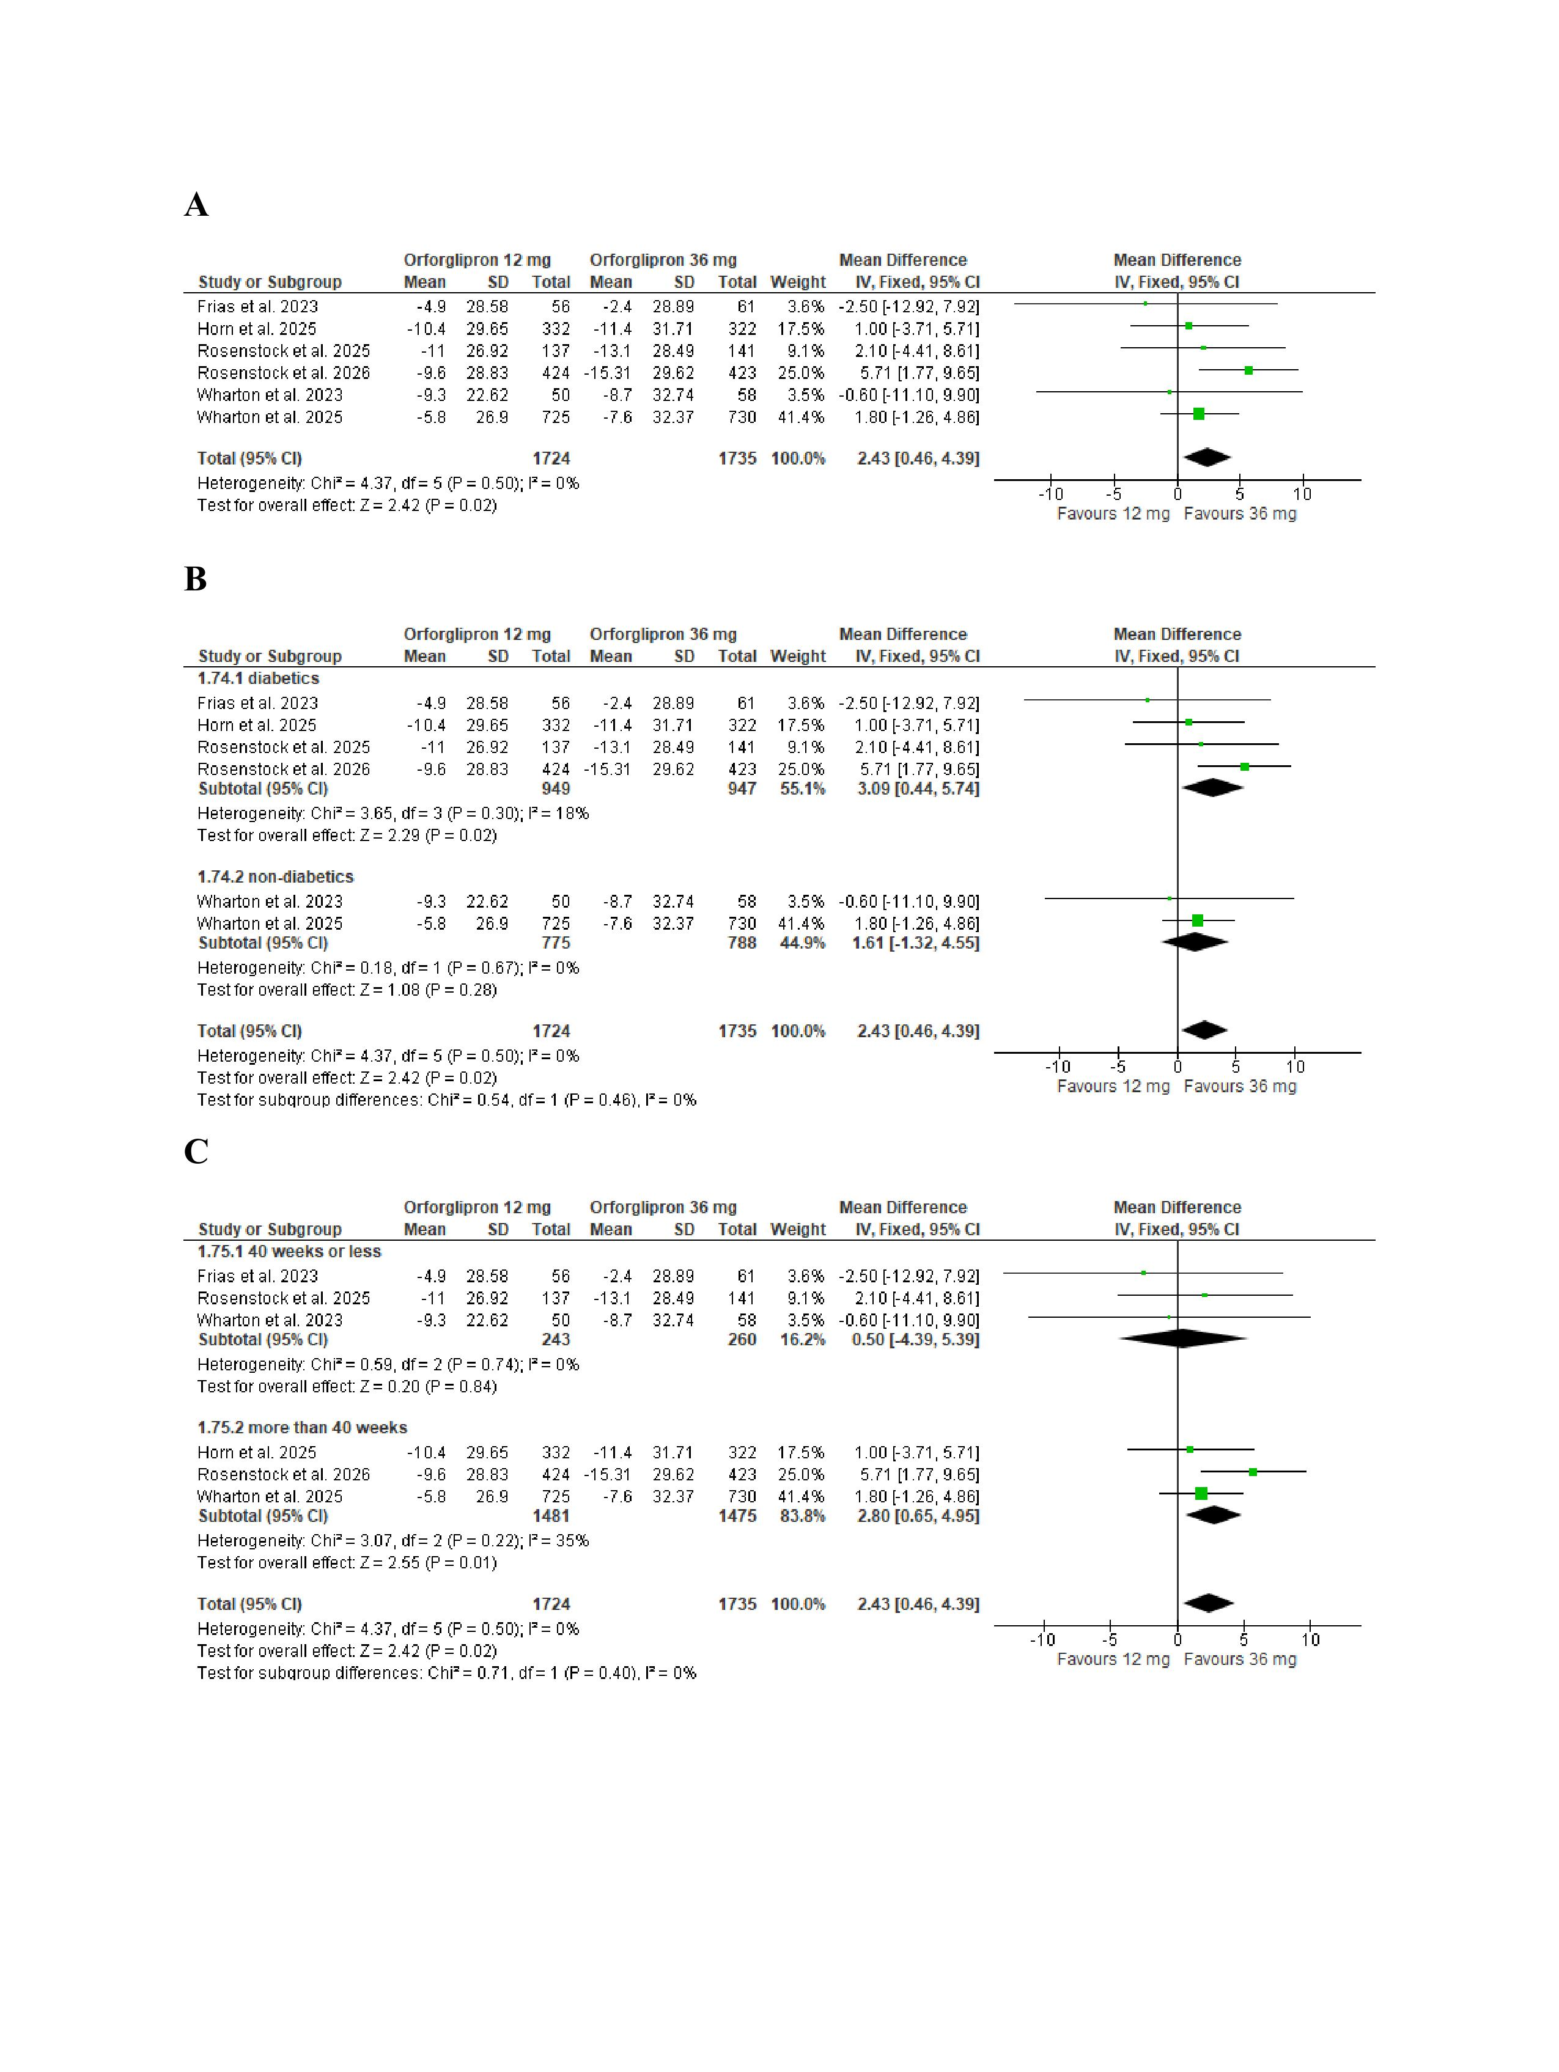
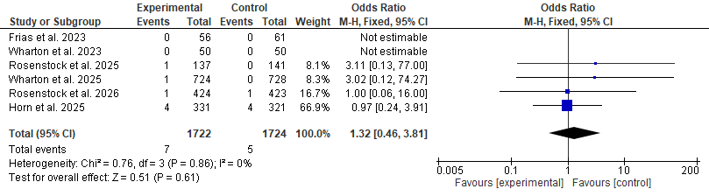
Figure S26 forest plot for meta-analysis of the risk of death

