Supplementary Content

Supplement Text 1. Details on the Meinian health check-up and its quality control process 1
Supplement Text 2. Details on the definitions of hyperthyroidism and hypothyroidism 3
Supplement Text 3. Details on the definitions and classifications of demographic characteristics and various medical conditions 4
Supplement Text 4. Details on the definitions and classifications of cluster-level covariates 7
Supplement Text 5. Supplemental methods 10
References 11
eTable 1. The proportions of missing values and the distribution before and after multiple imputation in the study population 14
eTable 2. Weighted prevalence of hyperthyroidism and hypothyroidism in the study population 15
eTable 3. Weighted prevalence of various medical conditions in the study population with hyperthyroidism and hypothyroidism compared to those with euthyroid 16
eTable 4. Associations of hyperthyroidism and hypothyroidism with various medical conditions 17
eTable 5. Sensitivity analysis: Weighted prevalence of hyperthyroidism and hypothyroidism in the study population using the first check-up health record 18
eTable 6. Sensitivity analysis: Weighted prevalence of obesity using WHO criteria and prediabetes/diabetes using ADA criteria in the study population with hyperthyroidism and hypothyroidism compared to those with euthyroid 19
eTable 7. Sensitivity analysis: Association of hyperthyroidism and hypothyroidism with various medical conditions 20
eFigure 1. Flow chart of the study population and geographical distribution of the Meinian health check-up centers included in the study 22
eFigure 2. Comparisons of characteristics and medical conditions between different population. (A) Study 24
eFigure 3. Subgroup analysis: Weighted prevalence of various medical conditions in the study population with hyperthyroidism and hypothyroidism compared to those with euthyroid by sex and age group 26
eFigure 4. Subgroup analysis: Associations of hyperthyroidism and hypothyroidism with various medical conditions by sex and age grouped 28

Supplement Text 1. Details on the Meinian health check-up and its quality control process
Regular health check-ups play an important role in early disease detection and prevention at the population level. In recent years, health check-ups have become more common in China. It is estimated that over 30% of the Chinese population underwent health check-ups in 2020.¹ Health check-up service providers in China offer a variety of package options, including physical examinations, laboratory tests, and imaging examinations. Encouraged by government policies, employers in China offer these check-up packages as part of their employee benefits. About 80% of participants receive health check-ups with the costs fully covered by their employers.¹ Therefore, for the majority of participants, the type of examinations they receive is primarily determined by employer-provided packages rather than their personal preferences or physician recommendations. This limits the influence of individual economic status and health conditions on the type of examinations received.
The Meinian Healthcare Group is the largest health check-up services provider in China, offering a wide range of services to the general population. Its check-up centers are located across all 31 provinces of the Chinese mainland. Participants in the Meinian health check-up are mainly employees from government and public sectors, public or private enterprises, and social organizations. In addition, freelancers and retirees from nearby communities also make up a subset of the participants. Each participant receives a comprehensive check-up at the centers, including physical examinations, laboratory tests, and imaging examinations. All participants are required to fast for at least eight hours before the check-up. All tests and examinations are conducted by well-trained healthcare personnel at the check-up centers.
The quality control process for the Meinian health check-up is meticulously structured to ensure high standards. First, all healthcare personnel, including physicians, technicians, and nurses, receive a unified training program. This program covers the check-up process and the operational procedures for medical instruments and equipment used during the check-up. Second, all biological samples are promptly transported to central laboratories in each province for analysis. All laboratories participate in the External Quality Assessment each year conducted by the National Center for Clinical Laboratories of the National Health Commission of China, receiving certification upon meeting quality standards. All laboratory test results meet the required standards for accuracy and reliability. Furthermore, the Department of Quality Control of the Meinian Healthcare Group conducts monthly internal reviews to monitor and improve laboratory quality. Third, the Meinian Healthcare Group has established and implemented standardized operating procedures across all centers to ensure uniformity in the check-up process. Routine unannounced inspections by the quality control team are carried out, including on-site reviews of operation procedures, document verification, and customer feedback assessment, etc., to provide a comprehensive and continuous quality oversight of the check-up process. Fourth, all check-up data are integrated into a web-based management system, with data entry performed at the center level. Data managers at the Medical Information Center of the Meinian Healthcare Group in Shanghai and statisticians at the Meinian Institute of Health in Beijing oversee the data flow and quality together through validation checks and progress reporting across all centers. Any identified data inconsistencies are promptly reported to the respective check-up centers for resolution, ensuring the accuracy, completeness, and reliability of the check-up data.

Supplement Text 2. Details on the definitions of hyperthyroidism and hypothyroidism
Hyperthyroidism and hypothyroidism were defined based on serum TSH, FT3, and FT4 levels, which are widely recommended by American^{2,3}, European⁴⁻⁶, and Chinese⁷⁻⁹ guidelines as key diagnostic indicators. Kits from 4 manufacturers were used for thyroid function testing: Mindray (Shenzhen, China), Maccura (Chengdu, China), Snibe Diagnostic (Shenzhen, China), and Autobio (Zhengzhou, China). All kits used the chemiluminescence immunoassay method. Details are shown in below table:
 | Definitions of hyperthyroidism and hypothyroidism
Overt hyperthyroidism | Subnormal TSH <0.27 mIU/L with elevated FT4 >22 pmol/L and/or FT3 >6.8 pmol/L  - Grade 1 (mild): TSH 0.1-0.27 mIU/L  - Grade 2 (severe): TSH <0.1 mIU/L
Subclinical hyperthyroidism | Subnormal TSH <0.27 mIU/L with normal FT4 12-22 pmol/L and FT3 3.1-6.8 pmol/L
Overt hypothyroidism | Elevated TSH >4.2 mIU/L with decreased FT4 <12 pmol/L  - Grade 1 (mild): TSH 4.2-10.0 mIU/L  - Grade 2 (severe): TSH >10.0 mIU/L
Subclinical hypothyroidism | Elevated TSH >4.2 mIU/L with normal FT4 12-22 pmol/L
Abbreviations: FT3, free triiodothyronine; FT4, free thyroxine; TSH, thyroid stimulating hormone; T3, Triiodothyronine; T4, Thyroxine.

Supplement Text 3. Details on the definitions and classifications of demographic characteristics and medical conditions
Study participants were classified by demographic characteristics (sex and age group). The medical conditions included three categories: cardio-renal-metabolic conditions, chronic liver conditions/abnormal liver enzymes, and other medical conditions. Their definitions and classifications are detailed in the table below:
 | Definition and classification
Demographic characteristics
Sex | According to the biological sex, participants were categorized as:  - Male  - Female
Age groups | According to the age standards of China, age groups were classified as:  - Young and middle age:<60 years  - Elderly age: ≥60 years  Age was also classified by 5-year increments to observe the age-specific change in the prevalence of hyperthyroidism and hypothyroidism:  - 18 to 24, 25 to 29, 30 to 34, 35 to 39, 40 to 44, 45 to 49, 50 to 54, 55 to 59, 60 to 64, 65 to 69, ≥70 years
Cardio-renal-metabolic conditions
Fast heart rate | Heart rate was over 100 beats/min.¹⁰
BMI categories | According to the Chinese standard, BMI was classified as:¹¹  - Underweight: BMI <18.5 kg/m²  - Normal weight: BMI 18.5 to 23.9 kg/m²  - Overweight: BMI 24.0 to 27.9 kg/m²  - Obesity: BMI ≥28.0 kg/m²
High blood pressure | According to the Chinese hypertension guideline, high blood pressure defined as SBP/DBP ranging from 130/85 mmHg, self-reported hypertension, or use of antihypertensive drugs^{12,13}
Prediabetes/diabetes | According to the Chinese Diabetes Society guideline,¹⁴ FBG was used to define prediabetes or diabetes as:  - FBG ≥6.1 mmol/L (110 mg/dL), self-reported diabetes, or use of antidiabetic drugs
Elevated TC | TC ≥6.20 mmol/L^{15,16}
Elevated TG | TG ≥2.30 mmol/L^{15,16}
Elevated LDL-C | LDL-C ≥4.20 mmol/L^{15,16}
Decreased HDL-C | HDL-C <1.0 mmol/L^{15,16}
Increased cIMT | Increased cIMT was assessed by carotid artery ultrasound and defined as ≥1.0 mm from the lumen-intima interface to the media-adventitia interface.¹⁷
Carotid plaque | Carotid plaque was assessed by carotid artery ultrasound and defined as cIMT ≥1.5 mm or a focal intimal medial thickening of ≥0.5 mm or 50% greater than the surrounding area.¹⁸
Impaired kidney function | The eGFR was calculated from serum creatinine results using the CKD Epidemiology Collaboration (CKD-EPI) formula.¹⁹ The impaired kidney function was defined as eGFR <60 ml/min/1.73 m².²⁰
Hyperuricemia | Hyperuricemia was a condition of elevated uric acid level, which was defined as uric acid >420.0 µmol/L in males and >357 µmol/L in females.²¹
Hyperhomocysteinemia | Hyperhomocysteinemia was a metabolic condition characterized by elevated blood homocysteine levels exceeding 15 µmol/L.^{22,23}
Chronic liver conditions/abnormal liver enzymes
Elevated ALT | ALT >40.0 U/L²⁴
Elevated AST | AST >40.0 U/L²⁴
AST to ALT ratio | The AST to ALT ratio higher than 1.0 was used to differentiate the abnormal liver chemistries and the diagnosis of various chronic liver conditions.²⁵  - High AST/ALT ratio >1.0  - Low AST/ALT ratio ≤1.0
Fatty liver | Fatty liver was detected by abdominal B-type ultrasound.
Other medical conditions
High platelet count | High platelet count was defined as platelet count higher than 350 10^9/L.
Low platelet count | Low platelet count was defined as platelet count less than 150 10^9/L.
Thyroid nodules | The presence of thyroid nodules was identified by thyroid ultrasound.
H. pylori infection | The non-invasive breath tests of ¹³C-urea or ¹⁴C-urea were used to detect the current infection of Helicobacter pylori.²⁶
Abbreviations: ALT, alanine aminotransferase; AST, aspartate aminotransferase; BMI, body mass index; cIMT, carotid intima-media thickness; DBP, diastolic blood pressure; eGFR, estimated glomerular filtration rate; FBG, fasting blood glucose; GDP, gross demostic product; HbA1c, hemoglobin A1c; HDL-C, high-density lipoprotein-cholesterol; H. pylori, Helicobacter pylori; LDL-C, low-density lipoprotein-cholesterol; SBP, systolic blood pressure; TC, total cholesterol; TG, triglyceride; WHO, World Health Organization.

Supplement Text 4. Details on the definitions and classifications of cluster-level variables
The definitions and classifications for cluster-level variables, including geographic regions, coastal regions, smoking prevalence, alcohol drinking prevalence, median urine iodine content, average soil selenium content, and gross domestic product (GDP) per capita are detailed in the table below:
Cluster-level covariates | Definition and classification
Geographic regions | According to the geographical location of the Chinese mainland, the 31 provinces were divided into seven geographical regions:  - Northern (5): Beijing, Tianjin, Hebei, Shanxi, Inner Mongolia  - Northeast (3): Liaoning, Jilin, Heilongjiang  - Eastern (5): Shanghai, Jiangsu, Zhejiang, Anhui, Shandong  - Central (4): Jiangxi, Henan, Hubei, Hunan  - Southern (4): Fujian, Guangdong, Guangxi, Hainan  - Southwest (5): Chongqing, Sichuan, Guizhou, Yunnan, Tibet  - Northwest (5): Shaanxi, Gansu, Ningxia, Qinghai, Xinjiang
Coastal regions | According to the China Marine Statistical Yearbook, the 31 provinces were divided into coastal and non-coastal regions:²⁷  - Coastal regions (11): Tianjin, Hebei, Liaoning, Shanghai, Jiangsu, Zhejiang, Fujian, Shandong, Guangdong, Guangxi, Hainan  - Non-coastal regions (20): Beijing, Shanxi, Inner Mongolia, Jilin, Heilongjiang, Anhui, Jiangxi, Henan, Hubei, Hunan, Chongqing, Sichuan, Guizhou, Yunnan, Tibet, Shaanxi, Gansu, Ningxia, Qinghai, Xinjiang
GDP level | City-level GDP per capita was used to reflect socioeconomic status. According to the 2020 China City Statistical Yearbook, the 254 cities included in this study were divided into three groups based on the 33rd and 67th percentiles of GDP per capita as:  - Low GDP level: <60611 CNY  - Medium GDP level: 60611 to 92175 CNY  - High GDP level: ≥92176 CNY
Smoking prevalence | According to the smoking prevalence in Chinese population aged 20 to 69 years obtained from the China Health Literacy Survey during 2018-19,²⁸ the 31 provinces were classified into three categories:  - Low smoking prevalence: <20.0% achieved the Healthy China 2030 target for tobacco control.²⁹  - Medium smoking prevalence: 20.0% to 25.0%  - High smoking prevalence: >25.0%
Alcohol drinking prevalence | According to the alcohol drinking prevalence in Chinese population aged 18 to 69 years obtained from the 2015 China Chronic Disease and Nutrition Surveillance,³⁰ the 31 provinces were classified into three categories:  - Low alcohol drinking prevalence: ≤60.4% for males and ≤18.4% for females  - Medium alcohol drinking prevalence: 60.5% to 64.4% for males and 18.5% to 21.9% for females  - High alcohol drinking prevalence: ≥65.6% for males and ≥22.0% for females
Median urine iodine content | Urine iodine concentration was a sensitive indicator of iodine intake. The median urine iodine concentration was measured in school children aged 9-11years from 31 provinces^{31,32} and was categorized into three groups based on the WHO reference of iodine level:³³  - Adequate iodine level: 100 to 199 μg/L  - More than adequate iodine level: 200 to 299 μg/L  - Excess iodine level: ≥300 μg/L
Average soil selenium content | Soil selenium was the main control of selenium concentration in food and drinking water. The selenium concentration in soil was collected from 3382 samples covering 94% of China.³⁴ According to the Geological and Mineral Industry Standards,^{35,36} the average soil selenium concentrations in 31 provinces were classified into three levels:  - Deficient or marginal selenium level: ≤0.175 mg/kg  - Sufficient selenium level: 0.175 to 0.4 mg/kg  - Rich or excess selenium level: ≥0.4 mg/kg
Abbreviations: WHO, World Health Organization.

Supplement Text 5. Supplemental methods
Continuous variables were summarized as mean (SD) for normally distributed data or median (interquartile range) for skewed data, while categorical variables were presented as counts (percentages). Given the substantially large sample size, the absolute standardized mean difference (ASMD) was used to compare differences between the two groups, with ASMD values of 0.2, 0.5, and 0.8 representing small, medium, and large differences, respectively. Several comparisons were made: (1) study population (N=10,748,391) vs. those without imputation for missing values (N=6,976,664); and (2) study population with one health check-up record (N=8,725,839) vs. those with two or more records (N=2,022,552). The differences on both continuous and categorical variables for all these comparisons were negligible with all ASMD <0.2 (eFigure 2).

Several sensitive analyses were conducted to assess the robustness of our findings:
(1) We selected the first record for analysis for the study population with multiple health check-up records to assess the weighted prevalences.
(2) We estimated the weighted prevalences of obesity in the participants with hyperthyroidism and hypothyroidism as defined by the World Health Organization criteria³⁷ (BMI ≥30.0 kg/m²). Additionally, we defined prediabetes or diabetes using the American Diabetes Association (ADA) criteria^{38,39} (FBG ≥5.6 mmol/L [100 mg/dL], HbA1c ≥5.7%, self-reported diabetes, or use of antidiabetic medications). The weighted prevalences were assessed among the 35.9% of study participants who had HbA1c data (N=3,862,780).
(3) Multivariable analyses to investigate the association of hyperthyroidism and hypothyroidism with various medical conditions were performed in Model 1 without adjustment of cluster-level data and in Model 2 with additional adjustment of smoking prevalence and alcohol drinking prevalence at province-level.

References
1. China Health Culture Association Medical and Health Credit Branch, China Chengxin International Credit Rating Company Limited, Frost & Sullivan. White Paper: Insight into Trends in China's Health Management Services Industries China, 2021.
2. Ross DS, Burch HB, Cooper DS, et al. 2016 American Thyroid Association Guidelines for Diagnosis and Management of Hyperthyroidism and Other Causes of Thyrotoxicosis. Thyroid 2016; 26(10): 1343-421.
3. Garber JR, Cobin RH, Gharib H, et al. Clinical Practice Guidelines for Hypothyroidism in Adults: Cosponsored by the American Association of Clinical Endocrinologists and the American Thyroid Association. Thyroid 2012; 22(12): 1200-35.
4. Kahaly George J, Bartalena L, Hegedüs L, Leenhardt L, Poppe K, Pearce Simon H. 2018 European Thyroid Association Guideline for the Management of Graves’ Hyperthyroidism. European Thyroid Journal 2018; 7(4): 167-86.
5. Biondi B, Bartalena L, Cooper DS, Hegedüs L, Laurberg P, Kahaly GJ. The 2015 European Thyroid Association Guidelines on Diagnosis and Treatment of Endogenous Subclinical Hyperthyroidism. European Thyroid Journal 2015; 4(3): 149-63.
6. Pearce SHS, Brabant G, Duntas LH, et al. 2013 ETA Guideline: Management of Subclinical Hypothyroidism. European Thyroid Journal 2013; 2(4): 215-28.
7. Chinese Society of Endocrinology, Chinese Endocrinologist Association, Chinese Society of Nuclear Medicine, Thyroid and Metabolism Surgery Group CSoS, Committee of Thyroid Surgeons CMA. Guidelines for Diagnosis and Management of Hyperthyroidism and Other Causes of Thyrotoxicosis. Chin J Endocrinol Metab 2022; 38(8): 700-48.
8. Chinese Medical Association, Chinese Medical Journals Publishing House, Chinese Society of General Practice, Editorial Board of Chinese Journal of General Practitioners of Chinese Medical Association, Expert Group of Guidelines for Primary Care of Endocrine System Disease. Guideline for primary care of hyperthyroidism (2019). Chinese Journal of General Practitioners 2019; 18(12): 1671-7368.
9. Chinese Medical Association, Chinese Medical Journals Publishing House, Chinese Society of General Practice, Editorial Board of Chinese Journal of General Practitioners of Chinese Medical Association, Expert Group of Guidelines for Primary Care of Endocrine System Disease. Guideline for primary care of hypothyroidism (2019). Chinese Journal of General Practitioners 2019; 18(11): 1022-8.
10. American Heart Association. Tachycardia: Fast Heart Rate. September 24, 2024. https://www.heart.org/en/health-topics/arrhythmia/about-arrhythmia/tachycardia--fast-heart-rate.
11. Chinese Nutrition Society Obesity Prevention and Control Section, Chinese Nutrition Society Clinical Nutrition Section, Chinese Preventive Medicine Association Behavioral Health Section, Chinese Preventive Medicine Association Sports and Health Section. Expert Consensus on Obesity Prevention and Treatment in China. Zhonghua Liu Xing Bing Xue Za Zhi 2022; 43(5).
12. J L. Highlights of the 2018 Chinese hypertension guidelines. Clinical hypertension 2020; 26(1).
13. M Z, Y S, B Z, et al. Prevalence, awareness, treatment, and control of hypertension in China, 2004-18: findings from six rounds of a national survey. BMJ 2023; 380.
14. Chinese Diabetes Society. Guideline for the prevention and treatment of diabetes mellitus in China (2024 edition). Chinese Journal of Diabetes Mellitus 2024; 17(00).
15. Y L, H Z, J L, et al. Prevalence of Dyslipidemia and Availability of Lipid-Lowering Medications Among Primary Health Care Settings in China. JAMA network open 2021; 4(9).
16. Joint committee issued Chinese guideline for the management of dyslipidemia in adults. 2016 Chinese guideline for the management of dyslipidemia in adults. Zhonghua Xin Xue Guan Bing Za Zhi 2016; 44(10).
17. JH S, CE K, RT H, et al. Use of carotid ultrasound to identify subclinical vascular disease and evaluate cardiovascular disease risk: a consensus statement from the American Society of Echocardiography Carotid Intima-Media Thickness Task Force. Endorsed by the Society for Vascular Medicine. Journal of the American Society of Echocardiography 2008; 21(2).
18. PJ T, MG H, S M, et al. Mannheim carotid intima-media thickness consensus (2004-2006). An update on behalf of the Advisory Board of the 3rd and 4th Watching the Risk Symposium, 13th and 15th European Stroke Conferences, Mannheim, Germany, 2004, and Brussels, Belgium, 2006 - PubMed. Cerebrovascular diseases (Basel, Switzerland) 2007; 23(1).
19. AS L, LA S, CH S, et al. A new equation to estimate glomerular filtration rate. Annals of internal medicine 2009; 150(9).
20. Wang L, Xu X, Zhang M, et al. Prevalence of Chronic Kidney Disease in China: Results From the Sixth China Chronic Disease and Risk Factor Surveillance. JAMA Internal Medicine 2023; 183(4).
21. YF H, KH Y, SH C, et al. Practice guideline for patients with hyperuricemia/gout. Zhonghua Nei Ke Za Zhi 2020; 59(7).
22. Sitdikova G, Hermann A. Homocysteine: Biochemistry, Molecular Biology, and Role in Disease 2021. Biomolecules 2023; 13(7).
23. González-Lamuño D, Arrieta-Blanco FJ, Fuentes ED, et al. Hyperhomocysteinemia in Adult Patients: A Treatable Metabolic Condition. Nutrients 2023; 16(1).
24. Kwo PY, Cohen SM, Lim JK. ACG Clinical Guideline: Evaluation of Abnormal Liver Chemistries. Official journal of the American College of Gastroenterology | ACG 2017; 112(1).
25. Domanski JP, Harrison SA, Domanski JP, Harrison SA. The AST to ALT Ratio: A Pattern Worth Considering. Current Hepatitis Reports 2013; 12(1).
26. Katelaris P, Hunt R, Bazzoli F, et al. Helicobacter pylori World Gastroenterology Organization Global Guideline. Journal of Clinical Gastroenterology 2023; 57(2).
27. Jiang X-Z, Liu T-Y, Su C-W. China׳s marine economy and regional development. Marine Policy 2014; 50.
28. Z L, YH L, ZY C, et al. Prevalence of tobacco dependence and associated factors in China: Findings from nationwide China Health Literacy Survey during 2018-19. The Lancet regional health Western Pacific 2022; 24.
29. Goodchild M, Zheng R. Tobacco control and Healthy China 2030. Tobacco Control 2018; 28(4).
30. Zhao Z, Wang L, Zhang M, et al. Geographic Distribution of Alcohol Use Among Chinese Adults — China, 2015. China CDC Weekly 2020; 2(7).
31. Y L, D T, J B, et al. Efficacy and Safety of Long-Term Universal Salt Iodization on Thyroid Disorders: Epidemiological Evidence from 31 Provinces of Mainland China. Thyroid 2020; 30(4).
32. R M, M Y, P H, et al. Deficiency and excess of groundwater iodine and their health associations. Nature communications 2022; 13(1).
33. World Health Organization. Iodine deficiency. https://www.who.int/data/nutrition/nlis/info/iodine-deficiency.
34. Liu H, Wang X, Zhang B, et al. Concentration and distribution of selenium in soils of mainland China, and implications for human health. Journal of Geochemical Exploration 2021; 220.
35. Specification of Land Quality Geochemical Assessment (DZ/T 0295-2016). Geological and Mineral Industry Standards of the People's Republic of China; 2016. p. 24.
36. Dinh QT, Cui Z, Huang J, et al. Selenium distribution in the Chinese environment and its relationship with human health: A review. Environment International 2018; 112.
37. World Health Organization. Obesity and overweight. March 1, 2024. https://www.who.int/news-room/fact-sheets/detail/obesity-and-overweight.
38. American Diabetes Association Professional Practice Committee, ElSayed NA, Aleppo G, et al. Diagnosis and Classification of Diabetes: Standards of Care in Diabetes—2024. Diabetes Care 2024; 47(Supplement_1).
39. Committee ADAPP, ElSayed NA, Aleppo G, et al. 2. Diagnosis and Classification of Diabetes: Standards of Care in Diabetes—2024. Diabetes Care 2024/01/01; 47(Supplement_1).

eTable 1. The proportions of missing values and the distribution before and after multiple imputation in the study population
 | No. of missing (%) * | Before imputation | After imputation
Age, years, mean (SD) | 0 (0.0) | 44.2 (13.0) | 44.2 (13.0)
Heart rate, beats/min, mean (SD) | 2,363,435 (22.0) | 71.8 (9.4) | 71.7 (8.3)
BMI, kg/m², mean (SD) | 712,438 (6.6) | 24.3 (3.6) | 24.3 (3.5)
SBP, mmHg, mean (SD) | 556,128 (5.2) | 123.4 (18.4) | 123.4 (17.9)
DBP, mmHg, mean (SD) | 555,836 (5.2) | 75.1 (12.0) | 75.1 (11.7)
FBG, mmol/L, median (IQR) | 292,017 (2.7) | 5.1 (4.8, 5.6) | 5.2 (4.8, 5.6)
TC, mmol/L, mean (SD) | 64,722 (0.6) | 5.0 (1.0) | 5.0 (1.0)
TG, mmol/L, mean (SD) | 107,159 (1.0) | 1.6 (1.1) | 1.6 (1.1)
LDL-C, mmol/L, mean (SD) | 599,726 (5.6) | 2.9 (0.8) | 2.9 (0.8)
HDL-C, mmol/L, mean (SD) | 585,002 (5.4) | 1.4 (0.3) | 1.4 (0.3)
cIMT, n (%) | 5,894,749 (54.8) | 711,410 (14.7) | /
Carotid plaque, n (%) | 5,894,750 (54.8) | 1,074,880 (22.1) | /
eGFR, mL/min/1.73m², mean (SD) | 277,109 (2.6) | 105.1 (15.3) | 105.1 (15.1)
Uric acid, μmol/L, mean (SD) | 154,338 (1.4) | 333.3 (96.7) | 333.4 (96.0)
Homocysteine, μmol/L, median (IQR) | 7,190,683 (66.9) | 11.5 (9.2, 14.5) | /
ALT, U/L, median (IQR) | 119,815 (1.1) | 20.0 (14.0, 30.0) | 20.0 (14.0, 30.0)
AST, U/L, median (IQR) | 265,258 (2.5) | 20.0 (17.0, 25.0) | 20.2 (17.0, 25.0)
Fatty liver, n (%) | 188,066 (1.7) | 4,266,460 (40.4) | 4,266,460 (39.7)
Platelet count, 10⁹/L, mean (SD) | 122,299 (1.1) | 225.5 (59.1) | 225.5 (58.8)
Thyroid nodules, n (%) | 473,524 (4.4) | 5,010,474 (48.7) | 5,010,474 (46.6)
H. pylori infection, n (%) | 7,017,882 (65.3) | 1,309,910 (35.1) | /
Abbreviations: ALT, alanine aminotransferase; AST, aspartate aminotransferase; BMI, body mass index; ; cIMT, carotid intima-media thickness; DBP, diastolic blood pressure; eGFR, estimated glomerular filtration rate; FBG, fasting blood glucose; HDL-C, high-density lipoprotein-cholesterol; H. pylori, Helicobacter pylori; IQR, interquartile range; LDL-C, low-density lipoprotein-cholesterol; SBP, systolic blood pressure; SD, standard deviation; TC, total cholesterol; TG, triglyceride.
* The denominator was the total number of the study population (N=10,748,391). Multiple imputation (with 5 imputations) was applied to impute continuous variables with missing rate less than 25%.

eTable 2. Weighted prevalence of hyperthyroidism and hypothyroidism in the study population
 | Weighted prevalence, % (95% CI)
 | OHyper | SHyper | OHypo | SHypo
Overall | 0.76 (0.73, 0.79) | 0.82 (0.79, 0.85) | 0.58 (0.54, 0.61) | 8.27 (8.00, 8.54)
Sex
Male | 0.57 (0.54, 0.59) *** | 0.57 (0.54, 0.59) *** | 0.34 (0.32, 0.36) *** | 5.85 (5.65, 6.05) ***
Female | 0.95 (0.92, 0.99) | 1.07 (1.03, 1.11) | 0.81 (0.76, 0.87) | 10.69 (10.35, 11.04)
Age, years
<60 | 0.84 (0.81, 0.87) *** | 0.79 (0.76, 0.82) *** | 0.46 (0.43, 0.49) *** | 7.18 (6.94, 7.42) ***
≥60 | 0.51 (0.48, 0.53) | 0.91 (0.86, 0.95) | 0.95 (0.88, 1.02) | 11.76 (11.32, 12.21)
Geographic regions
Northern | 0.67 (0.59, 0.74) *** | 0.93 (0.83, 1.02) *** | 0.60 (0.50, 0.71) *** | 8.04 (7.47, 8.61) ***
Eastern | 0.58 (0.54, 0.62) | 0.84 (0.77, 0.90) | 0.46 (0.40, 0.53) | 7.04 (6.65, 7.43)
Central | 0.91 (0.83, 1.00) | 0.81 (0.77, 0.85) | 0.73 (0.61, 0.86) | 9.34 (8.61, 10.07)
Southern | 1.05 (0.94, 1.17) | 0.90 (0.82, 0.99) | 0.47 (0.42, 0.53) | 5.60 (5.25, 5.95)
Northeast | 0.70 (0.61, 0.80) | 1.02 (0.87, 1.16) | 0.55 (0.46, 0.64) | 6.73 (5.91, 7.55)
Northwest | 0.77 (0.71, 0.83) | 0.61 (0.55, 0.67) | 0.78 (0.62, 0.94) | 13.03 (12.02, 14.03)
Southwest | 0.62 (0.58, 0.66) | 0.62 (0.56, 0.68) | 0.55 (0.47, 0.63) | 10.42 (9.90, 10.94)
Coastal regions
No | 0.75 (0.71, 0.79) | 0.77 (0.73, 0.81) *** | 0.67 (0.61, 0.73) *** | 9.89 (9.50, 10.29) ***
Yes | 0.77 (0.72, 0.82) | 0.88 (0.83, 0.93) | 0.46 (0.42, 0.49) | 6.26 (6.01, 6.52)
GDP per capita
Low Level | 0.91 (0.83, 0.98) *** | 1.00 (0.93, 1.07) *** | 0.85 (0.74, 0.96) *** | 9.30 (8.68, 9.91) ***
Medium level | 0.82 (0.74, 0.89) | 0.84 (0.78, 0.90) | 0.61 (0.54, 0.68) | 8.67 (8.00, 9.34)
High level | 0.65 (0.61, 0.68) | 0.71 (0.67, 0.74) | 0.40 (0.37, 0.43) | 7.47 (7.10, 7.84)
Abbreviations: CI, confidence interval; GDP, gross domestic product; OHyper, overt hyperthyroidism; OHypo, overt hypothyroidism; SHyper, subclinical hyperthyroidism; SHypo, subclinical hypothyroidism.
* P for difference <0.05; ** P for difference <0.01; *** P for difference <0.001.

eTable 3. Weighted prevalence of various medical conditions in the study population with hyperthyroidism and hypothyroidism compared to those with euthyroid
 | Weighted prevalence, % (95% CI)
 | OHyper | SHyper | OHypo | SHypo | Euth
Cardio-renal-metabolic conditions
Fast heart rate | 8.32 (7.68, 8.97) *** | 0.78 (0.68, 0.89) *** | 0.25 (0.17, 0.32) *** | 0.54 (0.49, 0.60) ** | 0.49 (0.44, 0.54)
Underweight | 7.48 (6.97, 7.99) *** | 3.54 (3.26, 3.82) | 1.82 (1.48, 2.16) *** | 3.48 (3.32, 3.65) *** | 3.73 (3.58, 3.88)
Obesity | 8.14 (7.73, 8.54) *** | 12.20 (11.76, 12.64) *** | 18.79 (18.11, 19.46) *** | 14.62 (14.26, 14.99) ** | 14.23 (13.88, 14.58)
Prediabetes/diabetes | 15.81 (15.05, 16.57) ** | 16.98 (16.19, 17.77) *** | 17.66 (16.86, 18.45) *** | 16.74 (16.09, 17.39) *** | 14.88 (14.27, 15.48)
High blood pressure | 41.84 (41.02, 42.65) ** | 42.23 (41.33, 43.14) *** | 49.87 (48.90, 50.84) *** | 46.53 (45.75, 47.31) *** | 40.66 (39.94, 41.39)
Elevated TC | 2.71 (2.50, 2.93) *** | 8.40 (7.98, 8.82) *** | 25.47 (24.50, 26.44) *** | 13.46 (13.09, 13.83) *** | 11.27 (10.94, 11.61)
Elevated TG | 7.72 (7.41, 8.04) *** | 12.24 (11.80, 12.67) *** | 21.11 (20.52, 21.71) *** | 17.98 (17.61, 18.35) *** | 16.24 (15.91, 16.57)
Elevated LDL-C | 1.60 (1.43, 1.77) *** | 4.82 (4.41, 5.24) *** | 14.14 (13.43, 14.85) *** | 7.20 (6.91, 7.49) *** | 6.54 (6.24, 6.83)
Decreased HDL-C | 11.72 (11.22, 12.22) *** | 7.73 (7.31, 8.15) | 7.48 (7.00, 7.95) * | 7.53 (7.22, 7.84) *** | 8.05 (7.73, 8.36)
Increased cIMT | 13.22 (12.34, 14.10) *** | 18.55 (17.38, 19.73) *** | 24.79 (23.16, 26.42) *** | 19.98 (18.84, 21.11) *** | 15.84 (15.01, 16.68)
Carotid plaque | 21.68 (20.41, 22.95) *** | 28.77 (27.30, 30.24) *** | 41.96 (40.05, 43.87) *** | 33.36 (32.12, 34.59) *** | 25.20 (24.00, 26.40)
Impaired renal function | 0.62 (0.50, 0.75) *** | 1.60 (1.26, 1.94) | 5.01 (4.37, 5.66) *** | 3.35 (3.11, 3.59) *** | 1.46 (1.35, 1.58)
Hyperuricemia | 23.91 (23.10, 24.71) | 19.46 (18.65, 20.27) *** | 20.86 (19.94, 21.77) *** | 22.58 (21.96, 23.19) *** | 23.46 (22.87, 24.04)
Hyperhomocysteinemia | 17.22 (16.01, 18.43) *** | 19.08 (17.88, 20.27) *** | 31.45 (29.46, 33.45) *** | 26.47 (25.45, 27.49) *** | 23.87 (22.90, 24.83)
Chronic liver conditions/abnormal liver chemistries
Elevated ALT | 21.83 (21.26, 22.40) *** | 11.55 (11.22, 11.88) *** | 11.40 (10.93, 11.87) *** | 11.28 (11.02, 11.54) *** | 12.92 (12.66, 13.18)
Elevated AST | 7.75 (7.38, 8.11) *** | 3.82 (3.63, 4.02) ** | 8.37 (7.96, 8.79) *** | 4.69 (4.57, 4.82) *** | 4.13 (4.05, 4.22)
AST/ALT ratio >1.0 | 33.28 (32.35, 34.22) *** | 50.72 (49.96, 51.48) | 65.75 (64.88, 66.63) *** | 58.34 (57.71, 58.96) *** | 51.16 (50.59, 51.72)
Fatty liver | 23.53 (22.68, 24.38) *** | 35.89 (34.94, 36.85) *** | 44.23 (43.10, 45.36) *** | 39.83 (39.03, 40.63) | 39.92 (39.13, 40.72)
Other medical conditions
High platelet count | 3.71 (3.42, 4.01) *** | 3.24 (2.98, 3.50) *** | 2.61 (2.34, 2.87) | 2.52 (2.35, 2.69) | 2.52 (2.37, 2.66)
Low platelet count | 7.02 (6.53, 7.50) *** | 7.65 (7.14, 8.16) *** | 13.58 (12.42, 14.73) *** | 12.01 (11.33, 12.69) *** | 8.44 (7.96, 8.92)
Thyroid nodules | 40.49 (39.51, 41.47) *** | 48.44 (47.37, 49.51) | 47.40 (46.22, 48.59) * | 52.00 (50.95, 53.06) *** | 49.08 (47.96, 50.19)
H. pylori infection | 35.10 (33.54, 36.65) | 35.05 (33.61, 36.50) | 36.60 (34.70, 38.51) | 36.52 (35.32, 37.71) *** | 35.02 (34.07, 35.96)
Abbreviations: ALT, alanine aminotransferase; AST, aspartate aminotransferase; CI, confidence interval; cIMT, carotid intima-media thickness; Euth, euthyroid; HDL-C, high-density lipoprotein-cholesterol; H. pylori, Helicobacter pylori; LDL-C, low-density lipoprotein-cholesterol; OHyper, overt hyperthyroidism; OHypo, overt hypothyroidism; SHyper, subclinical hyperthyroidism; SHypo, subclinical hypothyroidism; TC, total cholesterol; TG, triglyceride.
* P for difference <0.05; ** P for difference <0.01; *** P for difference <0.001.

eTable 4. Associations of hyperthyroidism and hypothyroidism with various medical conditions
 | Prevalence risk ratio (95% CI)
Medical condition | OHyper | SHyper | OHypo | SHypo
Cardio-renal-metabolic conditions
Fast heart rate | 16.22 (15.79, 16.66) *** | 1.86 (1.72, 2.00) *** | 0.61 (0.51, 0.72) *** | 1.09 (1.06, 1.13) ***
Underweight | 1.67 (1.63, 1.72) *** | 0.98 (0.95, 1.02) | 0.56 (0.53, 0.60) *** | 0.95 (0.94, 0.96) ***
Obesity | 0.66 (0.65, 0.68) *** | 0.96 (0.94, 0.98) *** | 1.55 (1.52, 1.58) *** | 1.15 (1.15, 1.16) ***
Prediabetes/diabetes | 1.32 (1.30, 1.35) *** | 1.10 (1.08, 1.12) *** | 0.92 (0.90, 0.95) *** | 0.97 (0.96, 0.97) ***
High blood pressure | 1.21 (1.20, 1.23) *** | 1.03 (1.02, 1.04) *** | 1.06 (1.05, 1.08) *** | 1.05 (1.05, 1.06) ***
Elevated TC | 0.25 (0.24, 0.26) *** | 0.70 (0.68, 0.71) *** | 2.07 (2.04, 2.11) *** | 1.14 (1.14, 1.15) ***
Elevated TG | 0.56 (0.55, 0.58) *** | 0.85 (0.83, 0.87) *** | 1.48 (1.45, 1.51) *** | 1.23 (1.22, 1.24) ***
Elevated LDL-C | 0.26 (0.25, 0.28) *** | 0.70 (0.68, 0.73) *** | 2.17 (2.12, 2.22) *** | 1.14 (1.13, 1.15) ***
Decreased HDL-C | 1.65 (1.62, 1.69) *** | 1.17 (1.14, 1.20) *** | 1.17 (1.13, 1.21) *** | 1.13 (1.12, 1.14) ***
Increased cIMT | 1.00 (0.96, 1.03) | 1.04 (1.01, 1.07) ** | 1.05 (1.02, 1.08) ** | 0.98 (0.97, 0.99) ***
Carotid plaque | 1.02 (0.99, 1.04) | 1.03 (1.01, 1.06) ** | 1.08 (1.05, 1.10) *** | 0.99 (0.98, 1.00) **
Impaired renal function | 0.65 (0.57, 0.73) *** | 0.95 (0.87, 1.03) | 2.43 (2.30, 2.57) *** | 1.39 (1.37, 1.42) ***
Hyperuricemia | 1.13 (1.11, 1.14) *** | 1.01 (0.99, 1.02) | 1.17 (1.15, 1.19) *** | 1.13 (1.13, 1.14) ***
Hyperhomocysteinemia | 0.87 (0.84, 0.90) *** | 0.93 (0.91, 0.96) *** | 1.42 (1.38, 1.47) *** | 1.16 (1.15, 1.17) ***
Chronic liver conditions/abnormal liver chemistries
Elevated ALT | 1.96 (1.93, 1.99) *** | 1.16 (1.14, 1.19) *** | 1.40 (1.37, 1.43) *** | 1.17 (1.16, 1.17) ***
Elevated AST | 2.12 (2.07, 2.17) *** | 1.08 (1.04, 1.12) *** | 2.53 (2.46, 2.61) *** | 1.31 (1.30, 1.33) ***
AST/ALT ratio >1.0 | 0.59 (0.58, 0.60) *** | 0.87 (0.86, 0.88) *** | 1.08 (1.07, 1.09) *** | 0.99 (0.99, 1.00) **
Fatty liver | 0.68 (0.67, 0.69) *** | 0.96 (0.95, 0.97) *** | 1.19 (1.17, 1.20) *** | 1.06 (1.06, 1.07) ***
Other medical conditions
High platelet count | 1.21 (1.17, 1.25) *** | 1.16 (1.11, 1.20) *** | 1.07 (1.02, 1.13) * | 1.02 (1.00, 1.03) *
Low platelet count | 0.97 (0.95, 1.00) | 0.95 (0.93, 0.97) *** | 1.40 (1.37, 1.44) *** | 1.22 (1.21, 1.23) ***
Thyroid nodules | 0.87 (0.86, 0.88) *** | 0.90 (0.89, 0.91) *** | 0.82 (0.81, 0.83) *** | 0.94 (0.94, 0.94) ***
H. pylori infection | 1.01 (0.98, 1.03) | 0.99 (0.97, 1.01) | 1.02 (0.99, 1.04) | 1.02 (1.01, 1.03) ***
Abbreviations: ALT, alanine aminotransferase; AST, aspartate aminotransferase; CI, confidence interval; cIMT, carotid intima-media thickness; Euth, euthyroid; HDL-C, high-density lipoprotein-cholesterol; H. pylori, Helicobacter pylori; LDL-C, low-density lipoprotein-cholesterol; OHyper, overt hyperthyroidism; OHypo, overt hypothyroidism; SHyper, subclinical hyperthyroidism; SHypo, subclinical hypothyroidism; TC, total cholesterol; TG, triglyceride.
All models were adjusted for the continuous covariate of age in years, as well as categorical covariates, including sex, coastal regions, city-level GDP per capita, province-level smoking prevalence, alcohol drinking prevalence, median urine iodine content, and average soil selenium content. Participants with normal thyroid functions (euthyroid) were considered as the reference group.
* P for difference <0.05; ** P for difference <0.01; *** P for difference <0.001.

eTable 5. Sensitivity analysis: Weighted prevalence of hyperthyroidism and hypothyroidism in the study population using the first check-up health record †
 | Weighted prevalence, % (95% CI)
 | OHyper | SHyper | OHypo | SHypo
Overall | 0.76 (0.73, 0.79) | 0.82 (0.79, 0.85) | 0.58 (0.54, 0.61) | 8.25 (7.97, 8.52)
Sex
Male | 0.57 (0.54, 0.59) *** | 0.57 (0.54, 0.59) *** | 0.34 (0.32, 0.36) *** | 5.83 (5.63, 6.04) ***
Female | 0.96 (0.92, 0.99) | 1.07 (1.03, 1.11) | 0.82 (0.77, 0.87) | 10.67 (10.32, 11.01)
Age, years
<60 | 0.84 (0.81, 0.87) *** | 0.79 (0.76, 0.82) *** | 0.46 (0.43, 0.49) *** | 7.16 (6.92, 7.41) ***
≥60 | 0.51 (0.48, 0.54) | 0.91 (0.86, 0.95) | 0.95 (0.88, 1.02) | 11.73 (11.28, 12.18)
Geographic regions
Northern | 0.67 (0.59, 0.74) *** | 0.93 (0.83, 1.02) *** | 0.60 (0.50, 0.71) *** | 8.03 (7.47, 8.60) ***
Eastern | 0.58 (0.54, 0.62) | 0.84 (0.77, 0.91) | 0.46 (0.40, 0.53) | 7.04 (6.64, 7.43)
Central | 0.92 (0.82, 1.01) | 0.82 (0.77, 0.86) | 0.74 (0.61, 0.87) | 9.30 (8.54, 10.06)
Southern | 1.05 (0.94, 1.17) | 0.89 (0.81, 0.98) | 0.48 (0.42, 0.53) | 5.59 (5.24, 5.94)
Northeast | 0.70 (0.61, 0.80) | 1.00 (0.86, 1.15) | 0.55 (0.46, 0.64) | 6.72 (5.90, 7.55)
Northwest | 0.77 (0.70, 0.83) | 0.61 (0.56, 0.67) | 0.78 (0.62, 0.94) | 13.04 (12.02, 14.05)
Southwest | 0.62 (0.58, 0.66) | 0.62 (0.55, 0.69) | 0.55 (0.47, 0.63) | 10.35 (9.83, 10.88)
Coastal regions
No | 0.75 (0.71, 0.79) | 0.77 (0.73, 0.81) *** | 0.68 (0.61, 0.74) *** | 9.86 (9.45, 10.26) ***
Yes | 0.77 (0.72, 0.82) | 0.88 (0.83, 0.92) | 0.46 (0.42, 0.49) | 6.26 (6.00, 6.52)
GDP per capita
Low Level | 0.91 (0.83, 0.98) *** | 1.00 (0.93, 1.07) *** | 0.85 (0.74, 0.96) *** | 9.29 (8.65, 9.92) ***
Medium level | 0.81 (0.73, 0.89) | 0.84 (0.78, 0.90) | 0.61 (0.54, 0.69) | 8.65 (7.99, 9.32)
High level | 0.65 (0.62, 0.68) | 0.70 (0.67, 0.74) | 0.40 (0.37, 0.43) | 7.45 (7.08, 7.81)
Abbreviations: CI, confidence interval; GDP, gross domestic product; OHyper, overt hyperthyroidism; OHypo, overt hypothyroidism; SHyper, subclinical hyperthyroidism; SHypo, subclinical hypothyroidism.
† The denominator was the total number of the study population (N=10,748,391).
* P for difference <0.05; ** P for difference <0.01; *** P for difference <0.001.

eTable 6. Sensitivity analysis: Weighted prevalence of obesity using WHO criteria† and prediabetes/diabetes using ADA criteria‡ in the study population with hyperthyroidism and hypothyroidism compared to those with euthyroid
 | Weighted prevalence, % (95% CI)
 | OHyper | SHyper | OHypo | SHypo | Euth
Overall
Obesity | 3.53 (3.27, 3.79) *** | 5.23 (4.94, 5.51) *** | 8.88 (8.42, 9.34) *** | 6.69 (6.45, 6.92) *** | 6.30 (6.11, 6.49)
Prediabetes/diabetes | 45.30 (43.63, 46.96) *** | 46.04 (44.46, 47.61) *** | 54.13 (52.35, 55.92) *** | 45.78 (44.55, 47.01) *** | 40.91 (39.72, 42.10)
Males
Obesity | 5.26 (4.80, 5.73) *** | 7.04 (6.60, 7.48) *** | 11.04 (10.26, 11.81) *** | 8.86 (8.51, 9.20) *** | 8.18 (7.95, 8.41)
Prediabetes/diabetes | 50.14 (48.13, 52.16) *** | 52.12 (49.90, 54.33) *** | 58.40 (55.85, 60.94) *** | 49.67 (48.37, 50.97) *** | 44.58 (43.33, 45.82)
Females
Obesity | 2.50 (2.24, 2.76) *** | 4.27 (3.91, 4.62) | 7.99 (7.46, 8.51) *** | 5.49 (5.26, 5.73) *** | 4.30 (4.12, 4.47)
Prediabetes/diabetes | 42.31 (40.25, 44.37) *** | 42.57 (40.74, 44.40) *** | 52.20 (50.17, 54.23) *** | 43.52 (42.22, 44.82) *** | 36.88 (35.69, 38.07)
Age <60 years
Obesity | 3.51 (3.26, 3.76) *** | 5.25 (4.97, 5.53) *** | 8.84 (8.35, 9.32) *** | 7.04 (6.80, 7.28) *** | 6.48 (6.29, 6.67)
Prediabetes/diabetes | 40.38 (38.68, 42.08) *** | 37.49 (35.87, 39.12) *** | 41.36 (39.54, 43.18) *** | 33.90 (32.74, 35.06) * | 33.24 (32.08, 34.40)
Age ≥60 years
Obesity | 3.67 (2.87, 4.47) *** | 5.16 (4.49, 5.83) | 8.96 (8.08, 9.83) *** | 5.99 (5.66, 6.32) * | 5.70 (5.46, 5.94)
Prediabetes/diabetes | 68.89 (66.31, 71.46) | 68.50 (66.26, 70.74) | 70.92 (68.58, 73.26) ** | 67.17 (66.02, 68.32) | 66.70 (65.73, 67.67)
Abbreviations: ADA, American Diabetes Association; BMI, body mass index; CI, confidence interval; Euth, euthyroid; HbA1c, hemoglobin A1c; OHyper, overt hyperthyroidism; OHypo, overt hypothyroidism; SHyper, subclinical hyperthyroidism; SHypo, subclinical hypothyroidism; WHO, World Health Organization.
† The denominator was the total number of the study population (N=10,748,391). Obesity was defined using the WHO criteria as BMI ≥30.0 kg/m².
‡ The denominator was the total number of the study population with HbA1c results (N=3,862,780). Prediabetes or diabetes was defined using the ADA criteria as FBG ≥5.6 mmol/L (100 mg/dL), HbA1c ≥5.7%, self-reported diabetes, or use of antidiabetic medications.
* P for difference <0.05; ** P for difference <0.01; *** P for difference <0.001.

eTable 7. Sensitivity analysis: Association of hyperthyroidism and hypothyroidism with various medical conditions
 | Prevalence risk ratio (95% CI)
Medical condition | OHyper | SHyper | OHypo | SHypo
Model 1
Cardio-renal-metabolic conditions
Fast heart rate | 16.21 (15.77, 16.65) *** | 1.86 (1.73, 2.01) *** | 0.60 (0.51, 0.71) *** | 1.09 (1.05, 1.13) ***
Underweight | 1.70 (1.66, 1.75) *** | 0.98 (0.94, 1.02) | 0.56 (0.53, 0.60) *** | 0.95 (0.94, 0.96) ***
Obesity | 0.65 (0.64, 0.67) *** | 0.96 (0.95, 0.98) *** | 1.55 (1.52, 1.58) *** | 1.15 (1.14, 1.16) ***
Prediabetes/diabetes | 1.32 (1.29, 1.34) *** | 1.11 (1.09, 1.13) *** | 0.92 (0.90, 0.94) *** | 0.96 (0.96, 0.97) ***
High blood pressure | 1.20 (1.19, 1.22) *** | 1.03 (1.02, 1.04) *** | 1.06 (1.04, 1.07) *** | 1.05 (1.05, 1.06) ***
Elevated TC | 0.26 (0.25, 0.27) *** | 0.70 (0.68, 0.71) *** | 2.09 (2.05, 2.12) *** | 1.14 (1.13, 1.15) ***
Elevated TG | 0.56 (0.54, 0.57) *** | 0.85 (0.83, 0.86) *** | 1.48 (1.45, 1.50) *** | 1.24 (1.23, 1.24) ***
Elevated LDL-C | 0.27 (0.25, 0.28) *** | 0.71 (0.69, 0.73) *** | 2.19 (2.14, 2.24) *** | 1.13 (1.12, 1.14) ***
Decreased HDL-C | 1.65 (1.62, 1.69) *** | 1.16 (1.13, 1.19) *** | 1.17 (1.13, 1.21) *** | 1.12 (1.11, 1.13) ***
Increased cIMT | 1.00 (0.97, 1.03) | 1.05 (1.02, 1.08) *** | 1.05 (1.02, 1.09) *** | 0.97 (0.96, 0.98) ***
Carotid plaque | 1.01 (0.99, 1.04) | 1.05 (1.03, 1.07) *** | 1.08 (1.06, 1.11) *** | 0.99 (0.98, 0.99) ***
Impaired renal function | 0.65 (0.57, 0.73) *** | 0.93 (0.85, 1.01) | 2.44 (2.31, 2.58) *** | 1.41 (1.38, 1.44) ***
Hyperuricemia | 1.14 (1.13, 1.16) *** | 1.01 (0.99, 1.02) | 1.17 (1.15, 1.20) *** | 1.14 (1.13, 1.14) ***
Hyperhomocysteinemia | 0.86 (0.83, 0.89) *** | 0.94 (0.91, 0.96) *** | 1.42 (1.38, 1.47) *** | 1.16 (1.15, 1.17) ***
Chronic liver conditions/abnormal liver chemistries
Elevated ALT | 1.95 (1.92, 1.98) *** | 1.16 (1.14, 1.18) *** | 1.40 (1.36, 1.43) *** | 1.17 (1.16, 1.18) ***
Elevated AST | 2.11 (2.06, 2.17) *** | 1.08 (1.04, 1.11) *** | 2.53 (2.45, 2.60) *** | 1.32 (1.31, 1.33) ***
AST/ALT ratio >1.0 | 0.59 (0.59, 0.60) *** | 0.87 (0.86, 0.88) *** | 1.08 (1.07, 1.09) *** | 0.99 (0.99, 1.00) ***
Fatty liver | 0.68 (0.67, 0.69) *** | 0.96 (0.95, 0.97) *** | 1.19 (1.17, 1.20) *** | 1.06 (1.06, 1.06) ***
Other medical conditions
High platelet count | 1.22 (1.18, 1.26) *** | 1.16 (1.12, 1.21) *** | 1.08 (1.02, 1.13) ** | 1.01 (0.99, 1.02)
Low platelet count | 0.95 (0.93, 0.98) *** | 0.92 (0.90, 0.95) *** | 1.38 (1.35, 1.42) *** | 1.26 (1.25, 1.27) ***
Thyroid nodules | 0.86 (0.85, 0.87) *** | 0.90 (0.89, 0.91) *** | 0.82 (0.81, 0.83) *** | 0.94 (0.94, 0.94) ***
H. pylori infection | 1.00 (0.98, 1.03) | 0.99 (0.97, 1.01) | 1.02 (0.99, 1.04) | 1.02 (1.01, 1.03) ***
Model 2
Cardio-renal-metabolic conditions
Fast heart rate | 16.22 (15.78, 16.66) *** | 1.85 (1.72, 1.99) *** | 0.60 (0.51, 0.71) *** | 1.10 (1.06, 1.13) ***
Underweight | 1.69 (1.65, 1.74) *** | 0.98 (0.95, 1.02) | 0.56 (0.52, 0.60) *** | 0.95 (0.93, 0.96) ***
Obesity | 0.65 (0.64, 0.67) *** | 0.97 (0.95, 0.98) *** | 1.55 (1.52, 1.58) *** | 1.15 (1.14, 1.16) ***
Prediabetes/diabetes | 1.32 (1.29, 1.34) *** | 1.11 (1.09, 1.13) *** | 0.92 (0.90, 0.94) *** | 0.96 (0.96, 0.97) ***
High blood pressure | 1.21 (1.19, 1.22) *** | 1.03 (1.02, 1.04) *** | 1.06 (1.05, 1.07) *** | 1.05 (1.05, 1.06) ***
Elevated TC | 0.26 (0.25, 0.27) *** | 0.70 (0.68, 0.71) *** | 2.08 (2.04, 2.11) *** | 1.14 (1.13, 1.15) ***
Elevated TG | 0.56 (0.55, 0.57) *** | 0.85 (0.83, 0.86) *** | 1.48 (1.45, 1.51) *** | 1.23 (1.23, 1.24) ***
Elevated LDL-C | 0.27 (0.25, 0.28) *** | 0.71 (0.69, 0.73) *** | 2.18 (2.13, 2.23) *** | 1.13 (1.12, 1.14) ***
Decreased HDL-C | 1.65 (1.62, 1.69) *** | 1.17 (1.14, 1.19) *** | 1.17 (1.13, 1.21) *** | 1.13 (1.12, 1.14) ***
Increased cIMT | 1.00 (0.97, 1.03) | 1.05 (1.02, 1.07) *** | 1.05 (1.02, 1.09) *** | 0.97 (0.96, 0.98) ***
Carotid plaque | 1.02 (0.99, 1.04) | 1.05 (1.03, 1.07) *** | 1.09 (1.06, 1.11) *** | 0.98 (0.98, 0.99) ***
Impaired renal function | 0.65 (0.57, 0.73) *** | 0.93 (0.86, 1.01) | 2.44 (2.31, 2.58) *** | 1.41 (1.38, 1.44) ***
Hyperuricemia | 1.14 (1.13, 1.16) *** | 1.00 (0.99, 1.02) | 1.17 (1.15, 1.19) *** | 1.13 (1.13, 1.14) ***
Hyperhomocysteinemia | 0.86 (0.83, 0.89) *** | 0.94 (0.91, 0.97) *** | 1.42 (1.38, 1.47) *** | 1.16 (1.15, 1.17) ***
Chronic liver conditions/abnormal liver chemistries
Elevated ALT | 1.95 (1.93, 1.98) *** | 1.16 (1.14, 1.19) *** | 1.40 (1.37, 1.43) *** | 1.17 (1.16, 1.17) ***
Elevated AST | 2.12 (2.06, 2.17) *** | 1.08 (1.04, 1.11) *** | 2.53 (2.46, 2.61) *** | 1.32 (1.30, 1.33) ***
AST/ALT ratio >1.0 | 0.59 (0.59, 0.60) *** | 0.87 (0.86, 0.88) *** | 1.08 (1.07, 1.09) *** | 0.99 (0.99, 1.00) ***
Fatty liver | 0.68 (0.67, 0.69) *** | 0.96 (0.95, 0.97) *** | 1.19 (1.17, 1.20) *** | 1.06 (1.06, 1.07) ***
Other medical conditions
High platelet count | 1.21 (1.17, 1.26) *** | 1.16 (1.12, 1.21) *** | 1.08 (1.02, 1.13) ** | 1.01 (1.00, 1.03)
Low platelet count | 0.96 (0.94, 0.99) ** | 0.93 (0.91, 0.96) *** | 1.39 (1.36, 1.43) *** | 1.24 (1.23, 1.24) ***
Thyroid nodules | 0.86 (0.86, 0.87) *** | 0.90 (0.89, 0.91) *** | 0.82 (0.81, 0.83) *** | 0.94 (0.94, 0.94) ***
H. pylori infection | 1.00 (0.98, 1.03) | 0.99 (0.97, 1.01) | 1.02 (0.99, 1.04) | 1.02 (1.01, 1.03) ***
Abbreviations: ALT, alanine aminotransferase; AST, aspartate aminotransferase; CI, confidence interval; cIMT, carotid intima-media thickness; Euth, euthyroid; HDL-C, high-density lipoprotein-cholesterol; H. pylori, Helicobacter pylori; LDL-C, low-density lipoprotein-cholesterol; OHyper, overt hyperthyroidism; OHypo, overt hypothyroidism; SHyper, subclinical hyperthyroidism; SHypo, subclinical hypothyroidism; TC, total cholesterol; TG, triglyceride.
All models were adjusted for the continuous covariate of age in years, as well as categorical covariates, including sex, coastal regions, and city-level GDP per capita. Model 1 was not adjusted for province-level covariates and Model 2 was additionally adjusted for province-level smoking prevalence and alcohol drinking prevalence. Participants with normal thyroid functions (euthyroid) were considered as the reference group.
* P for difference <0.05; ** P for difference <0.01; *** P for difference <0.001.

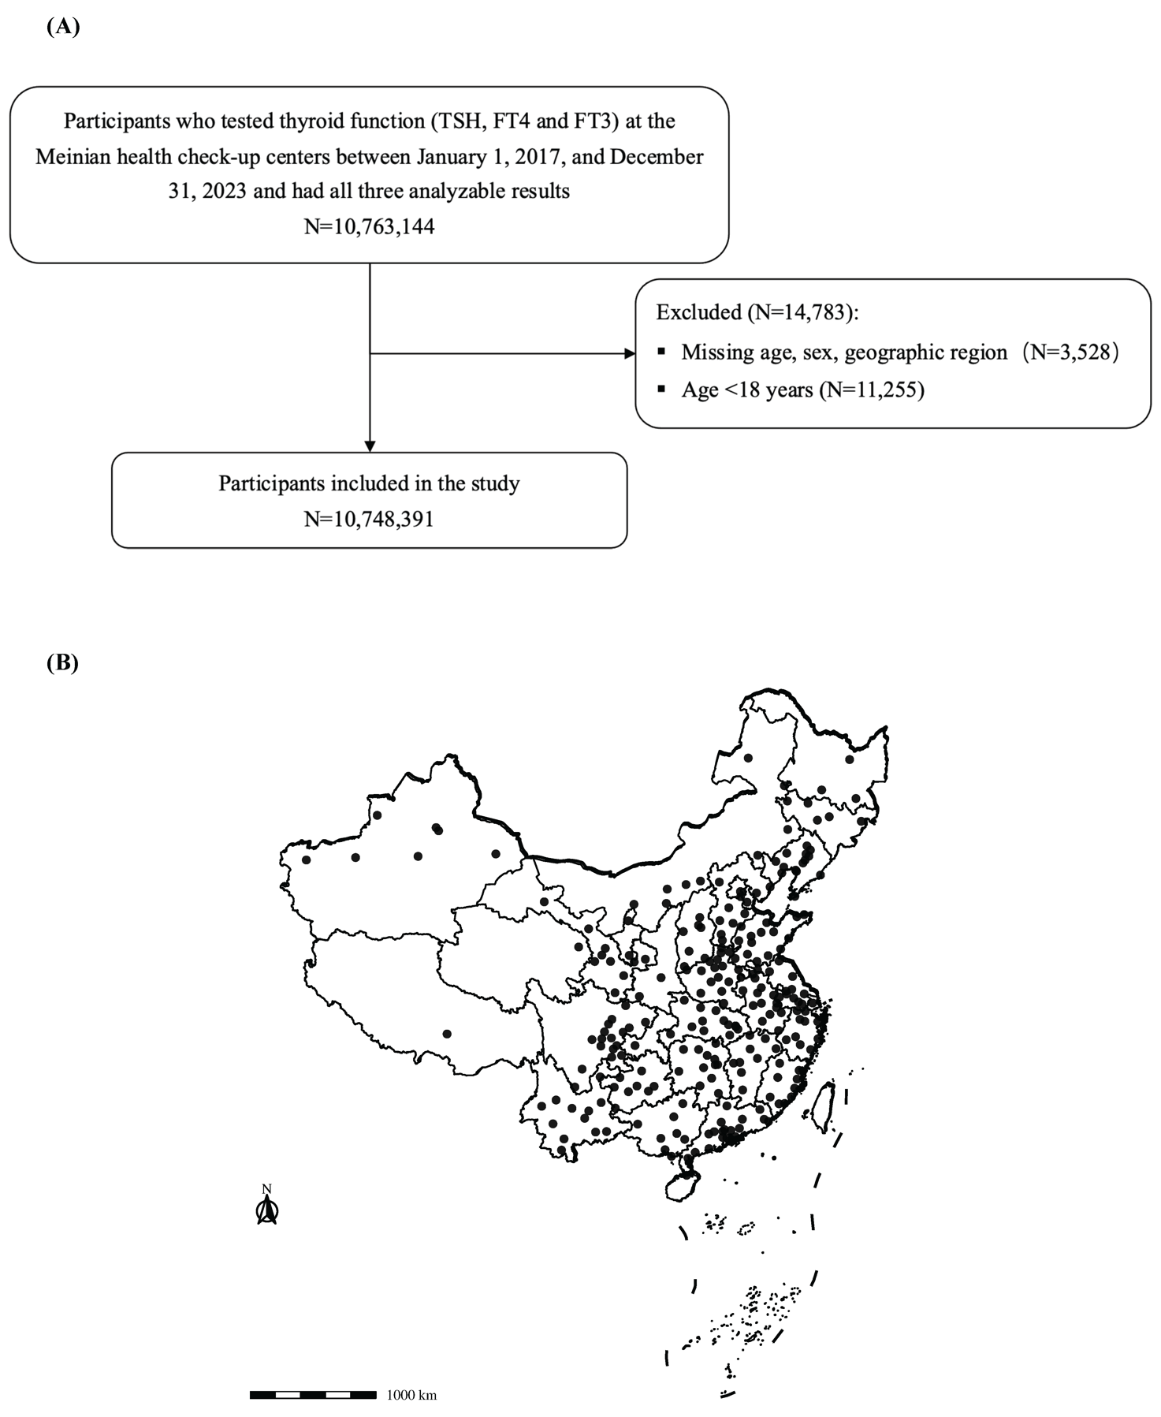

eFigure 1. Flow chart of the study population and geographical distribution of the Meinian health check-up centers included in the study. (A) Flow chart of the study population. A total of 10,748,391 participants aged 18 years or older, who underwent health check-up between January 1, 2017, to December 31, 2023, and had results of all three tests (TSH, FT4, and FT3), were included in the study. (B) Geographical distribution of the Meinian health check-up centers included in the study across 254 cities of the 31 provinces of the Chinese mainland.
Abbreviations: FT3, free triiodothyronine; FT4, free thyroxine; TSH, thyroid stimulating hormone.

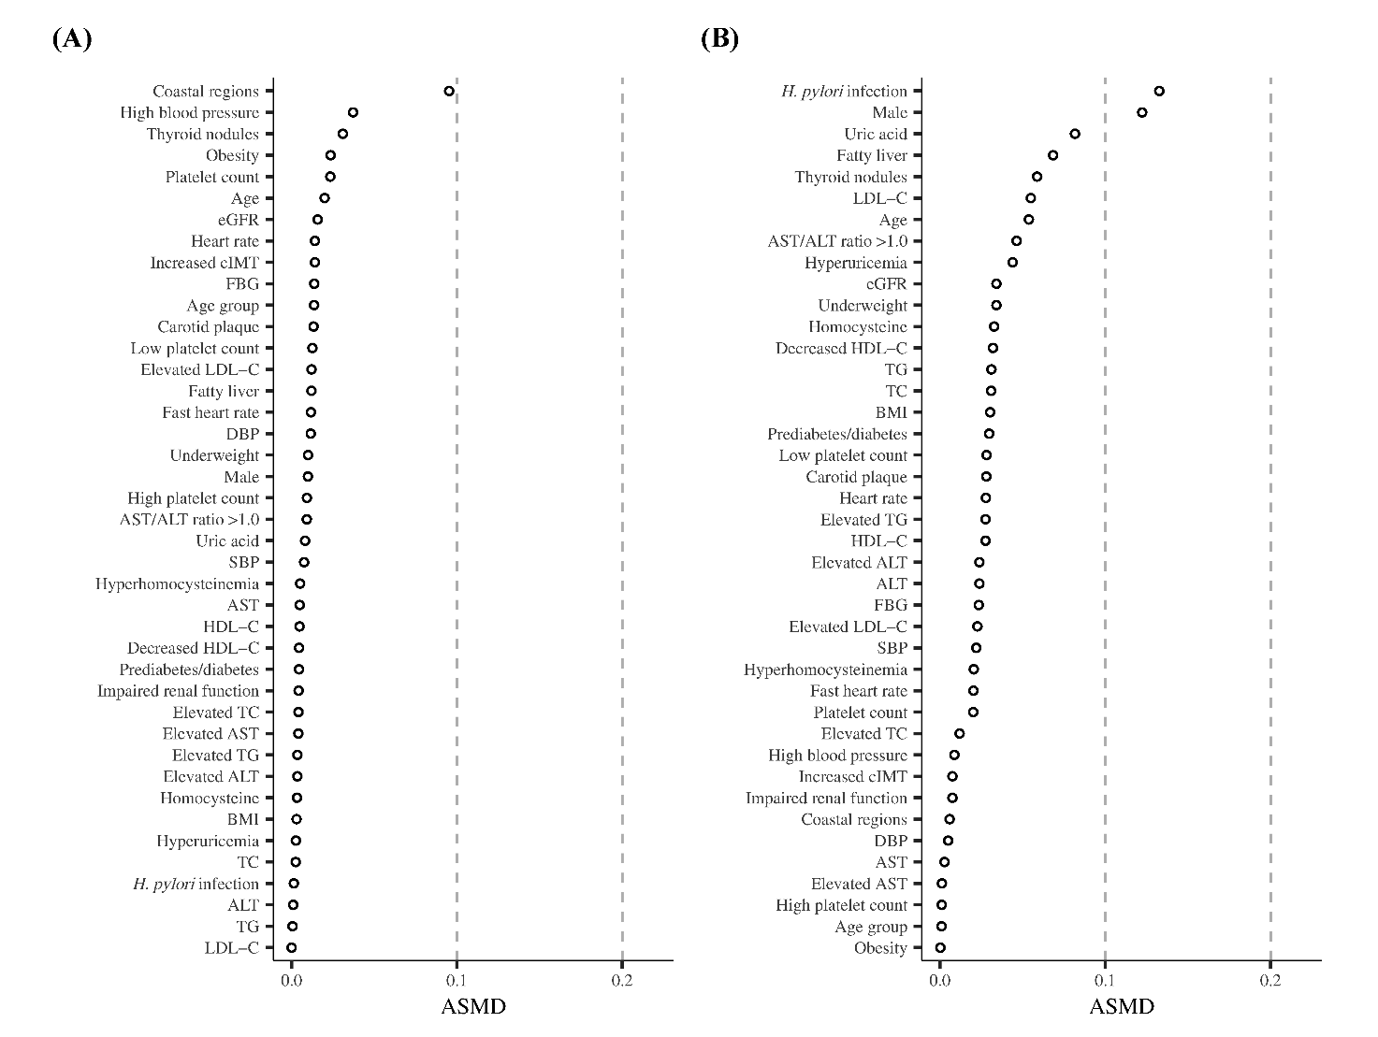

eFigure 2. Comparisons of characteristics and medical conditions between different population. (A) Study population (N=10,748,391) vs. those without imputation for missing values (N=6,976,664). (B) Study population with one health check-up record (N=8,725,839) vs. those with two or more records (N=2,022,552). Both continuous and categorical variables were included to examine the differences between different population groups. Each circle represented the difference between two population groups for each variable, with ASMD value of less than 0.2 indicating small differences.
Abbreviations: ALT, alanine aminotransferase; ASMD, absolute standardized mean difference; AST, aspartate aminotransferase; BMI, body mass index; BP, blood pressure; cIMT, carotid intima-media thickness; DBP, diastolic blood pressure; eGFR, estimated glomerular filtration rate; FBG, fasting blood glucose; HDL-C, high-density lipoprotein-cholesterol; H. pylori, Helicobacter pylori; LDL-C, low-density lipoprotein-cholesterol; SBP, systolic blood pressure; TC, total cholesterol; TG, triglyceride.

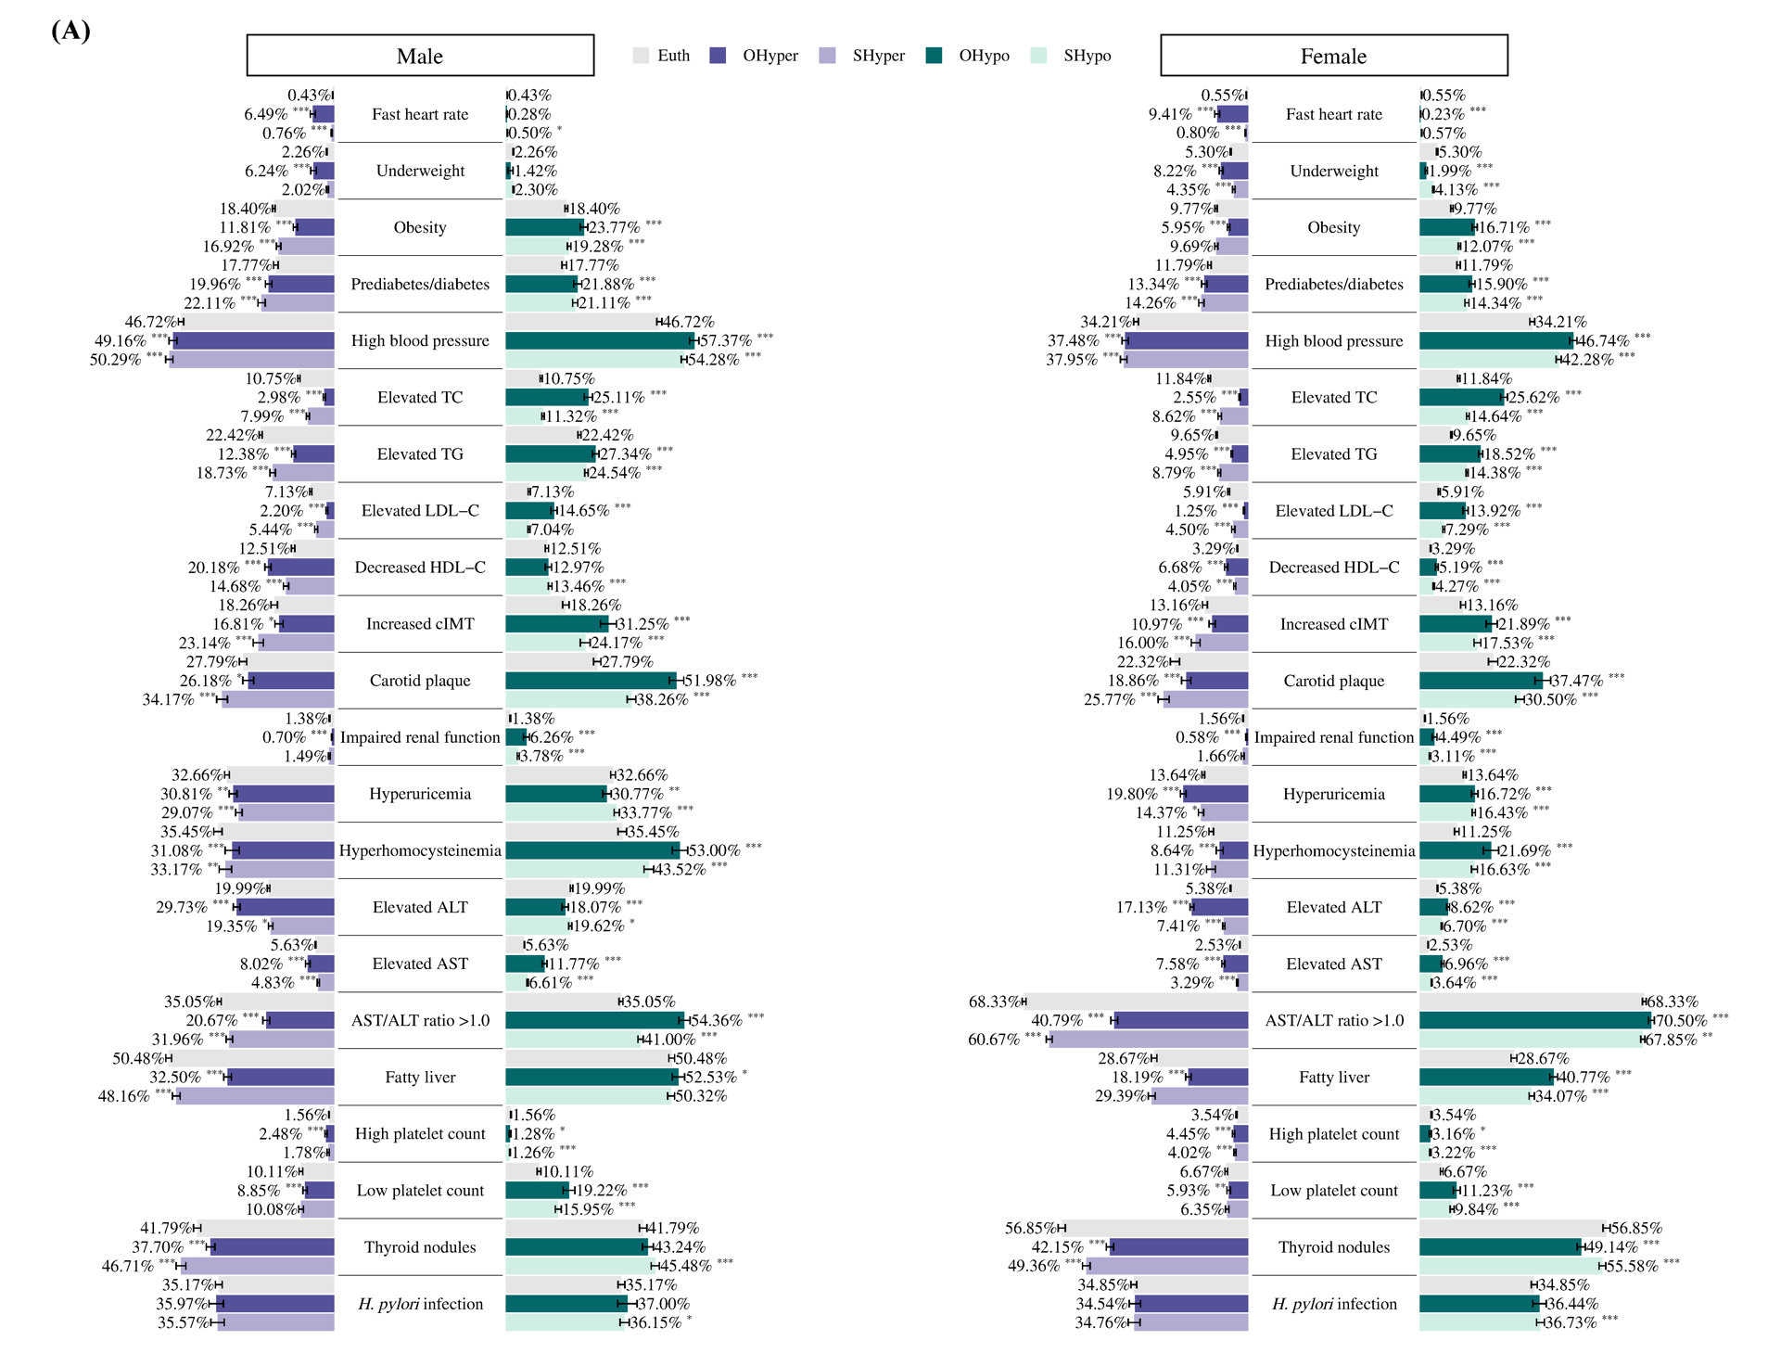

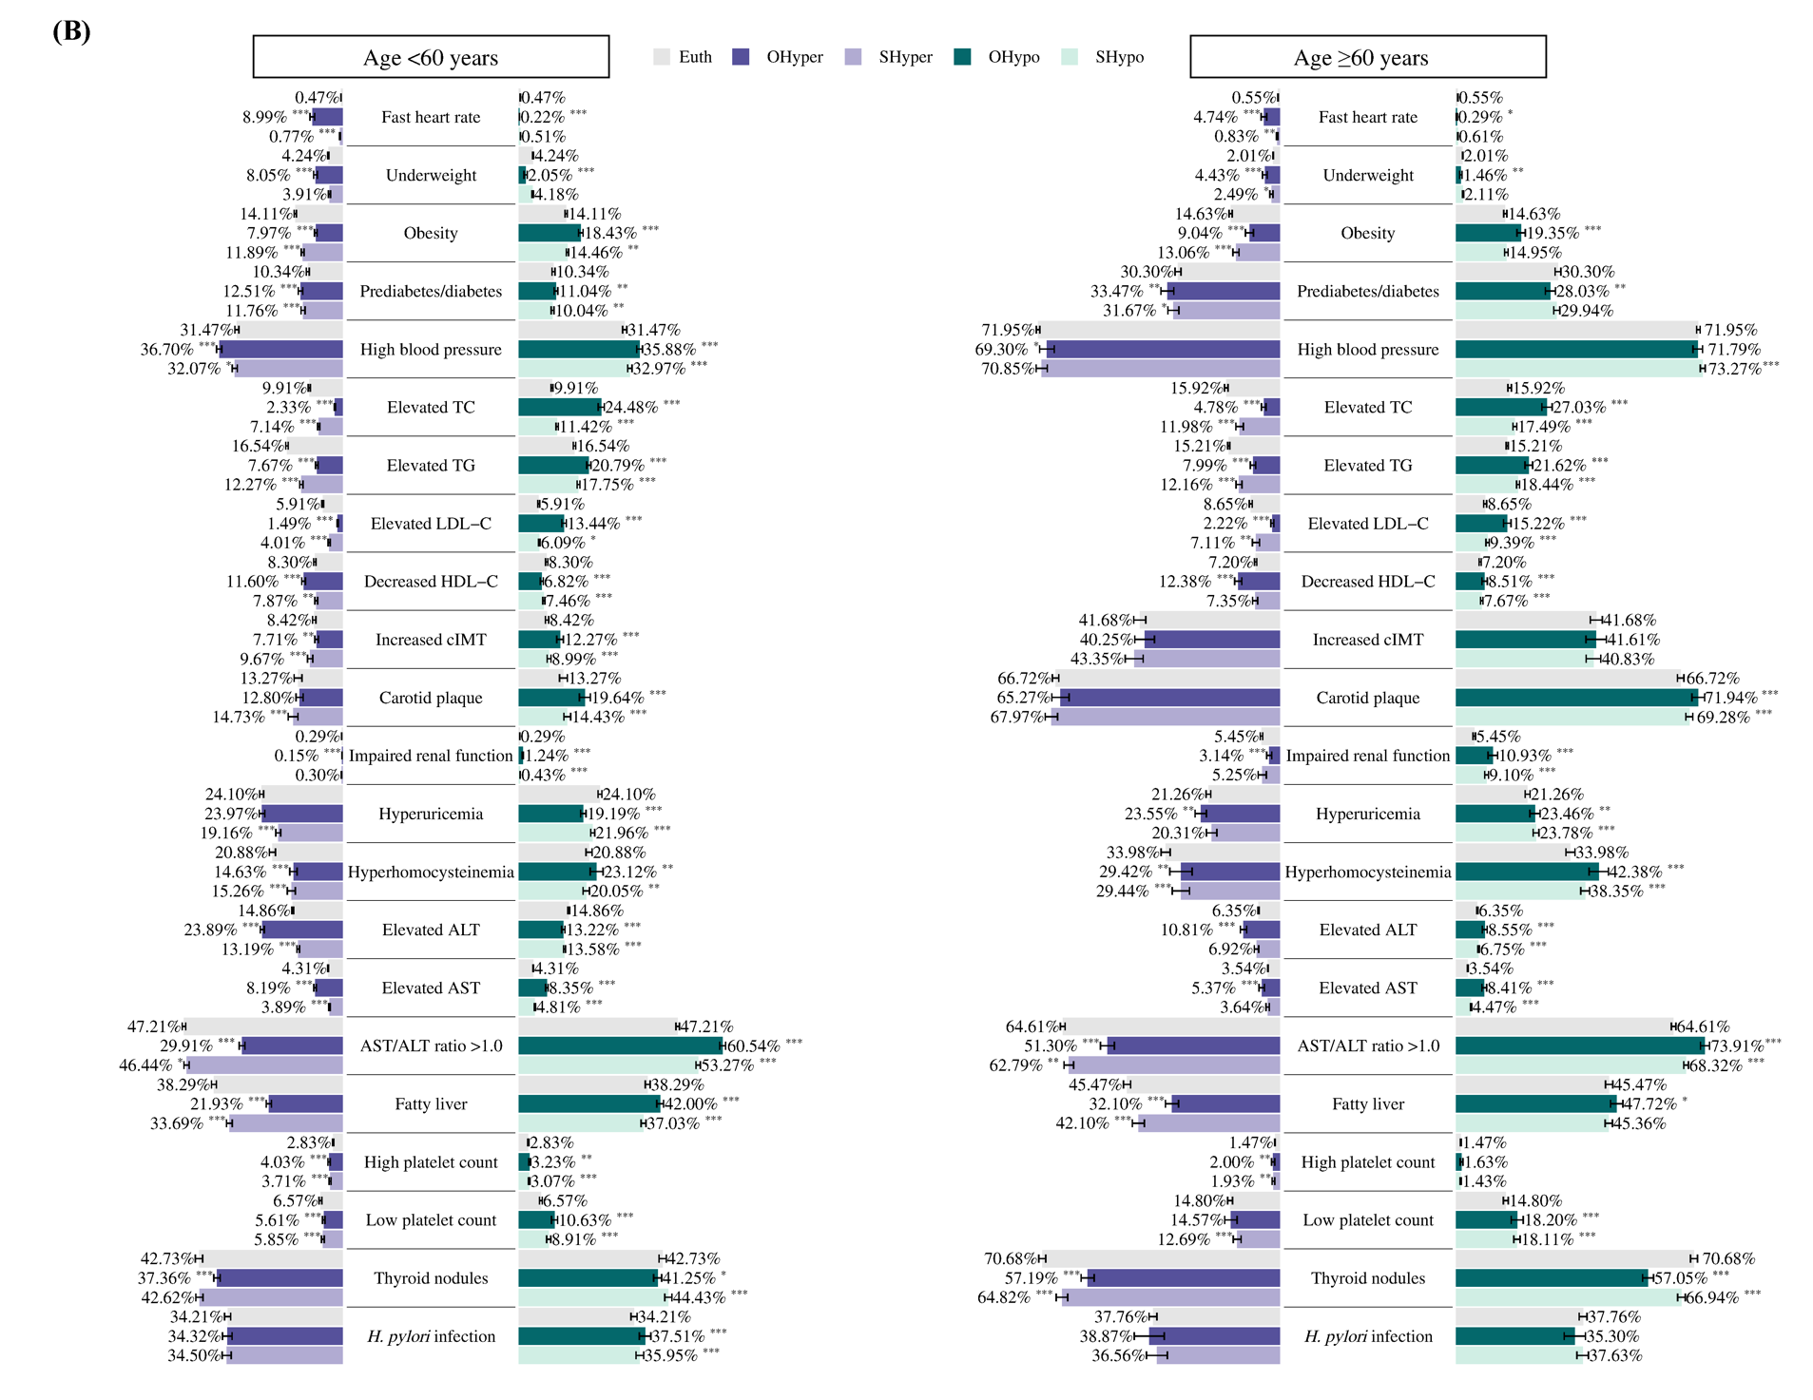

eFigure 3. Subgroup analysis: Weighted prevalence of various medical conditions in the study population with hyperthyroidism and hypothyroidism compared to those with euthyroid by sex and age group. (A) Weighted prevalence of various medical conditions in the male and female participants with OHyper, SHyper, OHypo, SHypo, and Euth. (B) Weighted prevalence of various medical conditions in the participants aged <60 and ≥60 years with OHyper, SHyper, OHypo, SHypo, and Euth. The error bars represented the 95% CIs.
Abbreviations: ALT, alanine aminotransferase; AST, aspartate aminotransferase; CI, confidence interval; cIMT, carotid intima-media thickness; Euth, euthyroid; GDP, gross domestic product; HDL-C, high-density lipoprotein-cholesterol; H. pylori, Helicobacter pylori; LDL-C, low-density lipoprotein-cholesterol; OHyper, overt hyperthyroidism; OHypo, overt hypothyroidism; SHyper, subclinical hyperthyroidism; SHypo, subclinical hypothyroidism; TC, total cholesterol; TG, triglyceride.
* P for difference <0.05; ** P for difference <0.01; *** P for difference <0.001.

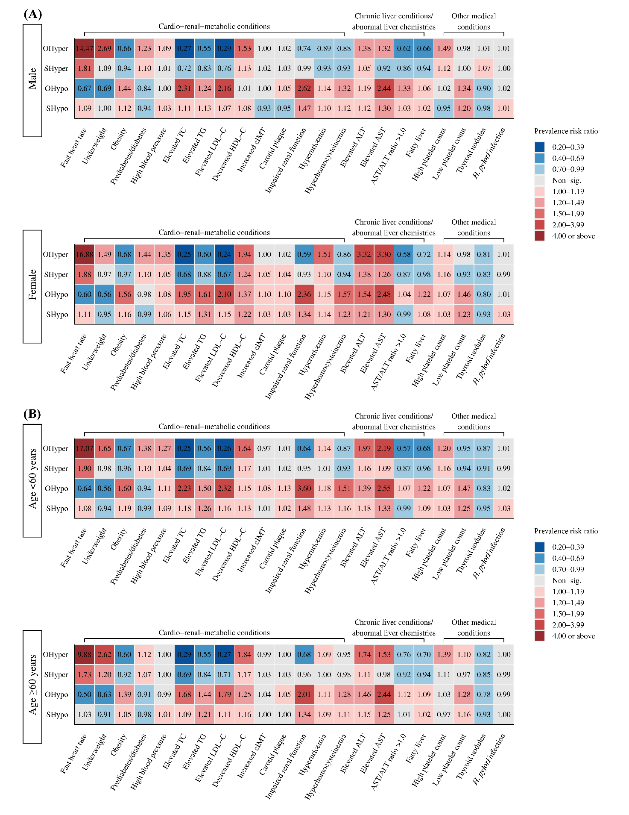

eFigure 4. Subgroup analysis: Associations of hyperthyroidism and hypothyroidism with various medical conditions by sex and age group. (A) Associations of OHyper, SHyper, OHypo, and SHypo with various medical conditions in the male and female participants. (B) Associations of OHyper, SHyper, OHypo, and SHypo with various medical conditions in the participants aged <60 and ≥60 years. All models were adjusted for the continuous covariate of age in years, as well as categorical covariates, including sex, coastal regions, city-level GDP per capita, province-level smoking prevalence, alcohol drinking prevalence, median urine iodine content, and average soil selenium content. Participants with normal thyroid functions (euthyroid) were considered as the reference group.
Abbreviations: ALT, alanine aminotransferase; AST, aspartate aminotransferase; CI, confidence interval; cIMT, carotid intima-media thickness; Euth, euthyroid; GDP, gross domestic product; HDL-C, high-density lipoprotein-cholesterol; H. pylori, Helicobacter pylori; LDL-C, low-density lipoprotein-cholesterol; Non-sig., non-significant; OHyper, overt hyperthyroidism; OHypo, overt hypothyroidism; SHyper, subclinical hyperthyroidism; SHypo, subclinical hypothyroidism; TC, total cholesterol; TG, triglyceride.

