Supplementary Table 1. Description of missing data.
Variables | Non-missing | Missing | Miss percentage (%)
Age | 57097 | 0 | 0
Gender | 57097 | 0 | 0
Height | 57097 | 0 | 0
Body weight | 57097 | 0 | 0
BMI | 57097 | 0 | 0
Baseline FPG | 57097 | 0 | 0
ALT | 56860 | 237 | 0.415
AST | 24204 | 32893 | 57.609
BUN | 55799 | 1298 | 2.273
Scr | 56301 | 796 | 1.394
SBP | 57092 | 5 | 0.009
DBP | 57092 | 5 | 0.009
HDL-C | 57097 | 0 | 0
LDL-C | 57097 | 0 | 0
TC | 57097 | 0 | 0
TG | 57097 | 0 | 0
Family history of DM | 57097 | 0 | 0
Drinking status | 15087 | 42010 | 73.577
Smoking status | 15087 | 42010 | 73.577

Supplementary Table 2. Variance inflation factors of covariates included in the multivariable-adjusted model (Model II).
Variables | VIF
Age | 1.162
Gender | 1.211
SBP | 1.48
DBP | 1.4
TC | 1.846
LDL-C | 1.848
ALT | 1.783
AST | 1.737
BUN | 1.168
Scr | 1.264
Family history of DM | 1.017
Smoking status | 1.014
Drinking status | 1.012

Supplementary Table 3. Association between TyHGB index and the risk of incident IFG, assessed using​ Cox proportional hazards regression models in​ the original dataset
Variables | Crude model |  | Model Ⅰ |  | Model Ⅱ
Variables | HR (95%CI) | P-Value | HR (95%CI) | P-Value | HR (95%CI) | P-Value
TyHGB index (per 1-unit) | 2.91 (2.80, 3.03) | < 0.001 | 2.44 (2.33, 2.55) | < 0.001 | 2.70 (2.34, 3.12) | < 0.001
TyHGB index quartiles
Q1 | 1.00 (Reference) |  | 1.00 (Reference) |  | 1.00 (Reference)
Q2 | 2.51 (2.24, 2.82) | < 0.001 | 2.27 (2.02, 2.54) | < 0.001 | 2.13 (1.42, 3.20) | < 0.001
Q3 | 4.58 (4.12, 5.09) | < 0.001 | 3.73 (3.34, 4.15) | < 0.001 | 5.58 (3.86, 8.06) | < 0.001
Q4 | 8.38 (7.58, 9.28) | < 0.001 | 6.04 (5.43, 6.71) | < 0.001 | 7.76 (5.38, 11.19) | < 0.001
P for trend |  | < 0.001 |  | < 0.001 |  | < 0.001
Crude model: we did not adjust other covariates.
Model I: adjusted for age, gender, SBP, DBP, and family history of DM at baseline.
Model II: further adjusted for ALT, AST, TC, LDL-C, BUN, Scr, smoking status, and drinking status at baseline.

Supplementary Table 4. Association between TyHGB index and incident IFG, assessed using​ logistic​ regression models in​ the original dataset.
Variables | Crude model |  | Model Ⅰ |  | Model Ⅱ
Variables | OR (95%CI) | P-Value | OR (95%CI) | P-Value | OR (95%CI) | P-Value
TyHGB index (per 1-unit) | 2.92 (2.79, 3.06) | < 0.001 | 2.30 (2.19, 2.42) | < 0.001 | 2.40 (2.03, 2.83) | < 0.001
TyHGB index quartiles
Q1 | 1.00 (Reference) |  | 1.00 (Reference) |  | 1.00 (Reference)
Q2 | 2.14 (1.91, 2.40) | < 0.001 | 1.87 (1.66, 2.10) | < 0.001 | 1.51 (1.00, 2.29) | 0.05
Q3 | 3.79 (3.40, 4.22) | < 0.001 | 2.89 (2.59, 3.23) | < 0.001 | 3.21 (2.21, 4.66) | < 0.001
Q4 | 7.02 (6.33, 7.79) | < 0.001 | 4.59 (4.12, 5.12) | < 0.001 | 4.73 (3.26, 6.85) | < 0.001
P for trend |  | < 0.001 |  | < 0.001 |  | < 0.001
Crude model: we did not adjust other covariates.
Model I: adjusted for age, gender, SBP, DBP, and family history of DM at baseline.
Model II: further adjusted for ALT, AST, TC, LDL-C, BUN, Scr, smoking status, and drinking status at baseline.

Supplementary Table 5. Association between TyHGB index and the risk of incident IFG, assessed using​ Cox proportional hazards regression models after retaining only participants with complete baseline covariate data (n= 5909).
Variables | Crude model |  | Model Ⅰ |  | Model Ⅱ
Variables | HR (95%CI) | P-Value | HR (95%CI) | P-Value | HR (95%CI) | P-Value
TyHGB index (per 1-unit) | 2.98 (2.63, 3.37) | < 0.001 | 2.73 (2.38, 3.13) | < 0.001 | 2.70 (2.34, 3.12) | < 0.001
TyHGB index quartiles
Q1 | 1.00 (Reference) |  | 1.00 (Reference) |  | 1.00 (Reference)
Q2 | 2.32 (1.64, 3.30) | < 0.001 | 2.15 (1.51, 3.06) | < 0.001 | 2.14 (1.50, 3.06) | < 0.001
Q3 | 5.23 (3.80, 7.19) | < 0.001 | 4.68 (3.37, 6.48) | < 0.001 | 4.64 (3.34, 6.45) | < 0.001
Q4 | 8.06 (5.94, 10.93) | < 0.001 | 6.66 (4.83, 9.19) | < 0.001 | 6.48 (4.66, 9.01) | < 0.001
P for trend |  | < 0.001 |  | < 0.001 |  | < 0.001
Crude model: we did not adjust other covariates.
Model I: adjusted for age, gender, SBP, DBP, and family history of DM at baseline.
Model II: further adjusted for ALT, AST, TC, LDL-C, BUN, Scr, smoking status, and drinking status at baseline.
Supplementary Table 6. Association between TyHGB index and incident IFG, assessed using​ logistic​ regression models after retaining only participants with complete baseline covariate data (n= 5909).
Variables | Crude model |  | Model Ⅰ |  | Model Ⅱ
Variables | OR (95%CI) | P-Value | OR (95%CI) | P-Value | OR (95%CI) | P-Value
TyHGB index (per 1-unit) | 2.80 (2.42, 3.25) | < 0.001 | 2.43 (2.07, 2.86) | < 0.001 | 2.4 (2.03, 2.83) | < 0.001
TyHGB index quartiles
Q1 | 1.00 (Reference) |  | 1.00 (Reference) |  | 1.00 (Reference)
Q2 | 1.72 (1.20, 2.46) | 0.003 | 1.52 (1.06, 2.18) | 0.023 | 1.51 (1.05, 2.17) | 0.026
Q3 | 3.44 (2.48, 4.77) | < 0.001 | 2.86 (2.05, 4.00) | < 0.001 | 2.85 (2.04, 3.99) | < 0.001
Q4 | 5.64 (4.12, 7.72) | < 0.001 | 4.23 (3.04, 5.89) | < 0.001 | 4.11 (2.93, 5.74) | < 0.001
P for trend |  | < 0.001 |  | < 0.001 |  | < 0.001
Crude model: we did not adjust other covariates.
Model I: adjusted for age, gender, SBP, DBP, and family history of DM at baseline.
Model II: further adjusted for ALT, AST, TC, LDL-C, BUN, Scr, smoking status, and drinking status at baseline.

Supplementary Table 7. Discriminative performance of different indicators for IFG by receiver operating characteristic (ROC) curve analysis.
Variables | AUC (95% CI) | Accuracy (95% CI) | Sensitivity (95% CI) | Specificity (95% CI)
TyG index | 0.61 (0.61 – 0.62) | 0.66 (0.65 – 0.66) | 0.68 (0.67 – 0.68) | 0.48 (0.47 – 0.50)
TyHGB index | 0.69 (0.68 – 0.70) | 0.63 (0.63 – 0.64) | 0.63 (0.63 – 0.63) | 0.65 (0.64 – 0.67)
TG/HDL ratio | 0.58 (0.57 – 0.59) | 0.50 (0.50 – 0.51) | 0.49 (0.48 – 0.49) | 0.63 (0.62 – 0.65)
TG | 0.58 (0.57 – 0.58) | 0.63 (0.63 – 0.64) | 0.65 (0.65 – 0.66) | 0.47 (0.46 – 0.48)
HDL-C | 0.55 (0.54 – 0.55) | 0.44 (0.44 – 0.45) | 0.44 (0.43 – 0.44) | 0.49 (0.48 – 0.51)
Baseline FPG | 0.68 (0.67 – 0.69) | 0.63 (0.63 – 0.63) | 0.63 (0.62 – 0.63) | 0.65 (0.64 – 0.66)
BMI | 0.63 (0.63 – 0.64) | 0.58 (0.57 – 0.58) | 0.57 (0.57 – 0.58) | 0.63 (0.62 – 0.65)
TyG-BMI | 0.65 (0.64 – 0.66) | 0.55 (0.55 – 0.56) | 0.54 (0.53 – 0.54) | 0.69 (0.68 – 0.70)

Supplementary Table 8. Association between TyHGB index and risk of incident IFG using Cox proportional hazards regression in different models based on multiply imputed data.
Variables | Crude model |  | Model Ⅲ
Variables | HR (95% CI) | P-Value | HR (95% CI) | P-Value
TyHGB index (per 1-unit) | 2.91 (2.80, 3.03) | < 0.001 | 2.43 (2.32, 2.54) | < 0.001
TyHGB index quartiles
Q1 | 1.00 (Reference) |  | 1.00 (Reference)
Q2 | 2.51 (2.24, 2.82) | < 0.001 | 2.25 (2.01, 2.53) | < 0.001
Q3 | 4.58 (4.12, 5.09) | < 0.001 | 3.69 (3.31, 4.11) | < 0.001
Q4 | 8.38 (7.58, 9.28) | < 0.001 | 5.91 (5.31, 6.58) | < 0.001
P for trend |  | < 0.001 |  | < 0.001
Crude model: we did not adjust other covariates.
Model Ⅲ: adjusted for age, gender, SBP, DBP, family history of DM, ALT, TC, LDL-C, BUN, and Scr at baseline.
Supplementary Table 9. Association between TyHGB index and risk of incident IFG within the high-normal baseline FPG subgroup (5.30 – 5.59 mmol/L) (n= 7356).
Variables | Crude model |  | Model Ⅰ |  | Model Ⅱ
Variables | HR (95%CI) | P-Value | HR (95%CI) | P-Value | HR (95%CI) | P-Value
TyHGB index (per 1-unit) | 1.53 (1.40, 1.68) | < 0.001 | 1.31 (1.19, 1.45) | < 0.001 | 1.22 (1.10, 1.36) | < 0.001
TyHGB index quartiles
Q1 | 1.00 (Reference) |  | 1.00 (Reference) |  | 1.00 (Reference)
Q2 | 1.41 (1.21, 1.65) | < 0.001 | 1.29 (1.10, 1.51) | 0.001 | 1.25 (1.07, 1.46) | 0.006
Q3 | 1.54 (1.33, 1.80) | < 0.001 | 1.34 (1.15, 1.57) | < 0.001 | 1.27 (1.08, 1.49) | 0.003
Q4 | 1.96 (1.69, 2.27) | < 0.001 | 1.58 (1.35, 1.84) | < 0.001 | 1.43 (1.22, 1.68) | < 0.001
P for trend |  | < 0.001 |  | < 0.001 |  | < 0.001
Crude model: we did not adjust other covariates.
Model I: adjusted for age, gender, SBP, DBP, and family history of DM at baseline.
Model II: further adjusted for ALT, AST, TC, LDL-C, BUN, Scr, smoking status, and drinking status at baseline.
Supplementary Table 10. Association between TyHGB index and risk of incident IFG stratified by baseline FPG categories using Cox proportional hazards regression in different models.
Baseline FPG (mmol/L) | Crude model |  | Model Ⅰ |  | Model Ⅱ
Baseline FPG (mmol/L) | HR (95% CI) | P-Value | HR (95% CI) | P-Value | HR (95% CI) | P-Value
< 5.0 | 2.71 (2.53, 2.89) | < 0.001 | 2.13 (1.97, 2.29) | < 0.001 | 2.09 (1.93, 2.25) | < 0.001
5.0 – 5.59 | 1.88 (1.77, 2.0) | < 0.001 | 1.55 (1.45, 1.66) | < 0.001 | 1.46 (1.36, 1.57) | < 0.001
Crude model: we did not adjust other covariates.
Model I: adjusted for age, gender, SBP, DBP, and family history of DM at baseline.
Model II: further adjusted for ALT, AST, TC, LDL-C, BUN, Scr, smoking status, and drinking status at baseline.

Supplementary Table 11. Pairwise comparison of the AUC between the TyHGB index and its individual components for discriminating incident IFG.​ △AUC represents the difference in AUC between TyHGB index and each comparator. SD, Z-value, and P-value are reported. A positive △AUC indicates better discriminatory performance of TyHGB index compared to the respective component.
Categories | △AUC (95% CI) | SD | Z-value | P-value
TyHGB index vs. TyG index | 0.0794 (0.0737 – 0.0851) | 0.00290 | 27.373 | < 0.0001
TyHGB index vs. TG/HDL ratio | 0.110 (0.104 – 0.117) | 0.00314 | 35.165 | < 0.0001
TyHGB index vs. TG | 0.116 (0.110 – 0.123) | 0.00342 | 34.057 | < 0.0001
TyHGB index vs. HDL-C | 0.145 (0.137 – 0.154) | 0.00434 | 33.470 | < 0.0001
TyHGB index vs. Baseline FPG | 0.00952 (0.00275 – 0.0163) | 0.00345 | 2.755 | 0.0059
TyHGB index vs. BMI | 0.0592 (0.0535 – 0.0649) | 0.00292 | 20.269 | < 0.0001
TyHGB index vs. TyG-BMI | 0.0436 (0.0393 – 0.0478) | 0.00217 | 20.060 | < 0.0001
Supplementary Figure 1. Schoenfeld residual plot for assessing the proportional hazards assumption of the Cox model (P < 0.05).
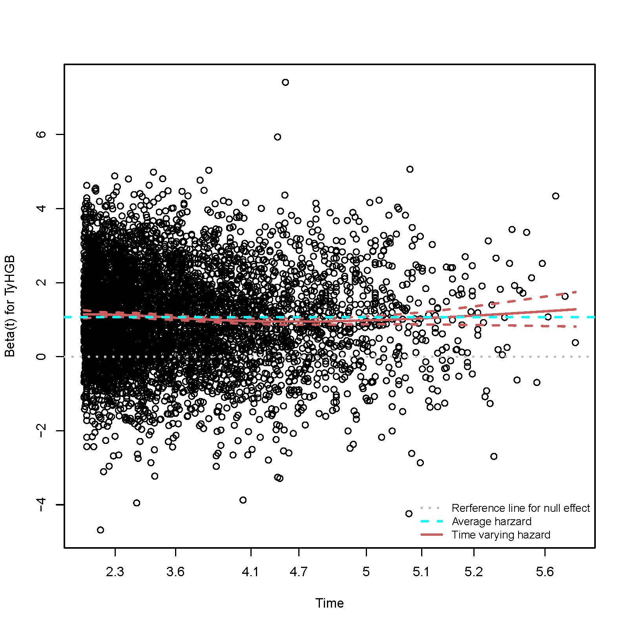

Supplementary Figure 2. K-M curves illustrate incident IFG risk by TyHGB index quartiles using the dataset excluding participants with incomplete covariate data.
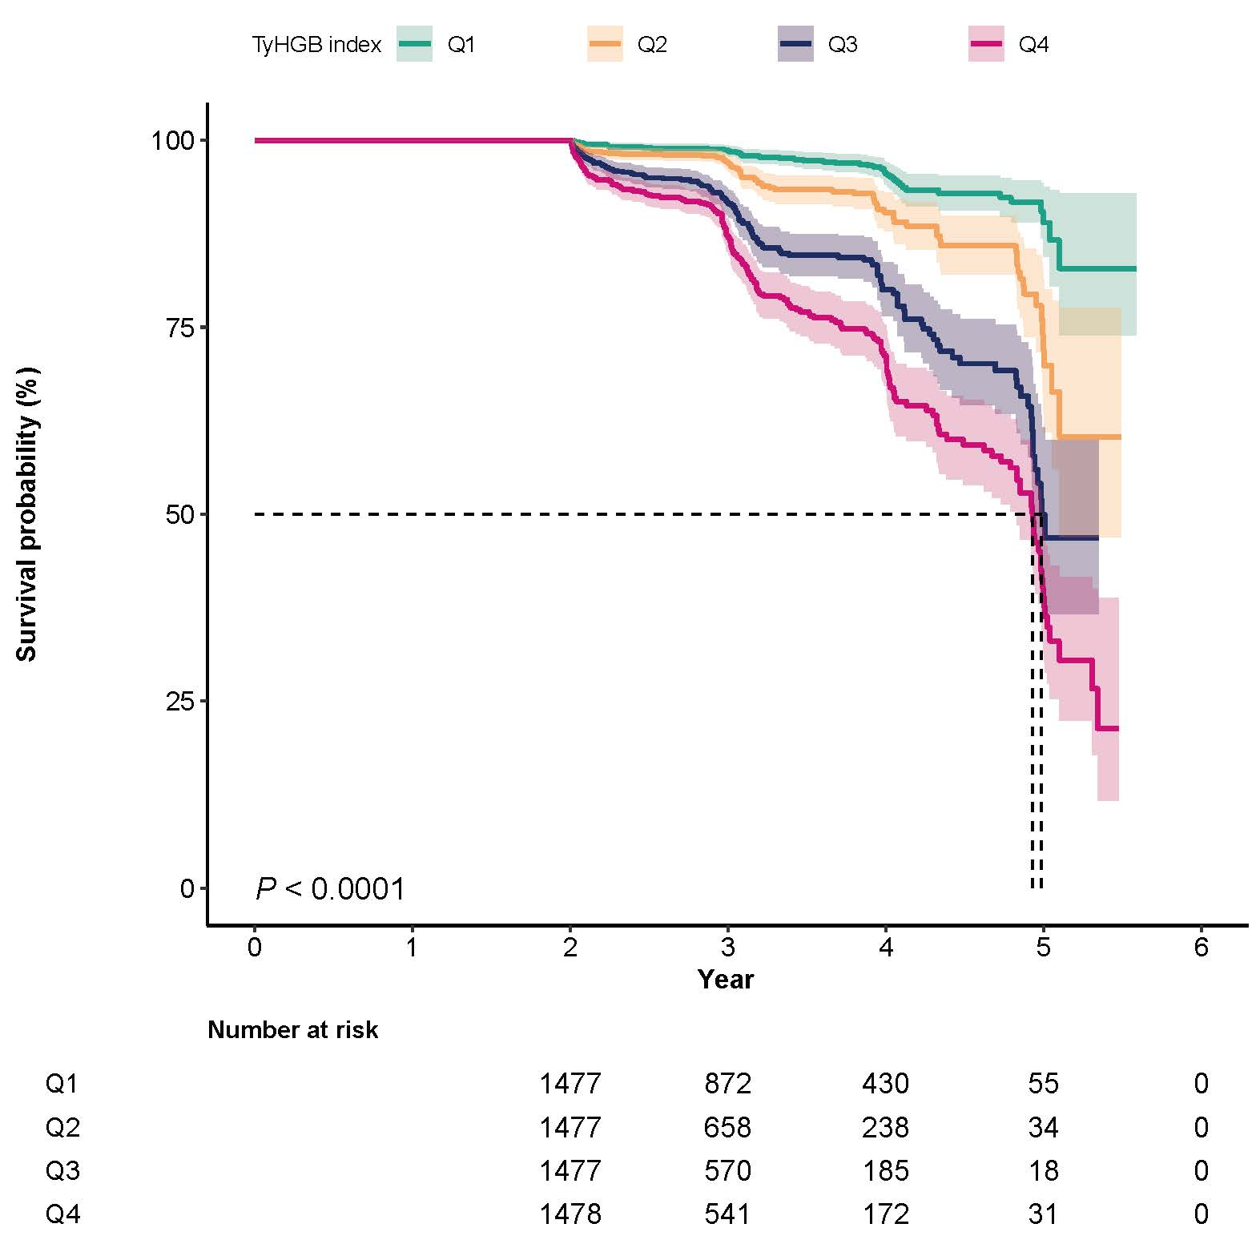

Supplementary Figure 3. The non-linear relationship between TyHGB index and risk of incident IFG using the original dataset. We adjusted for age, gender, SBP, DBP, ALT, AST, TC, LDL-C, BUN, Scr, smoking status, and family history of DM at baseline.
.
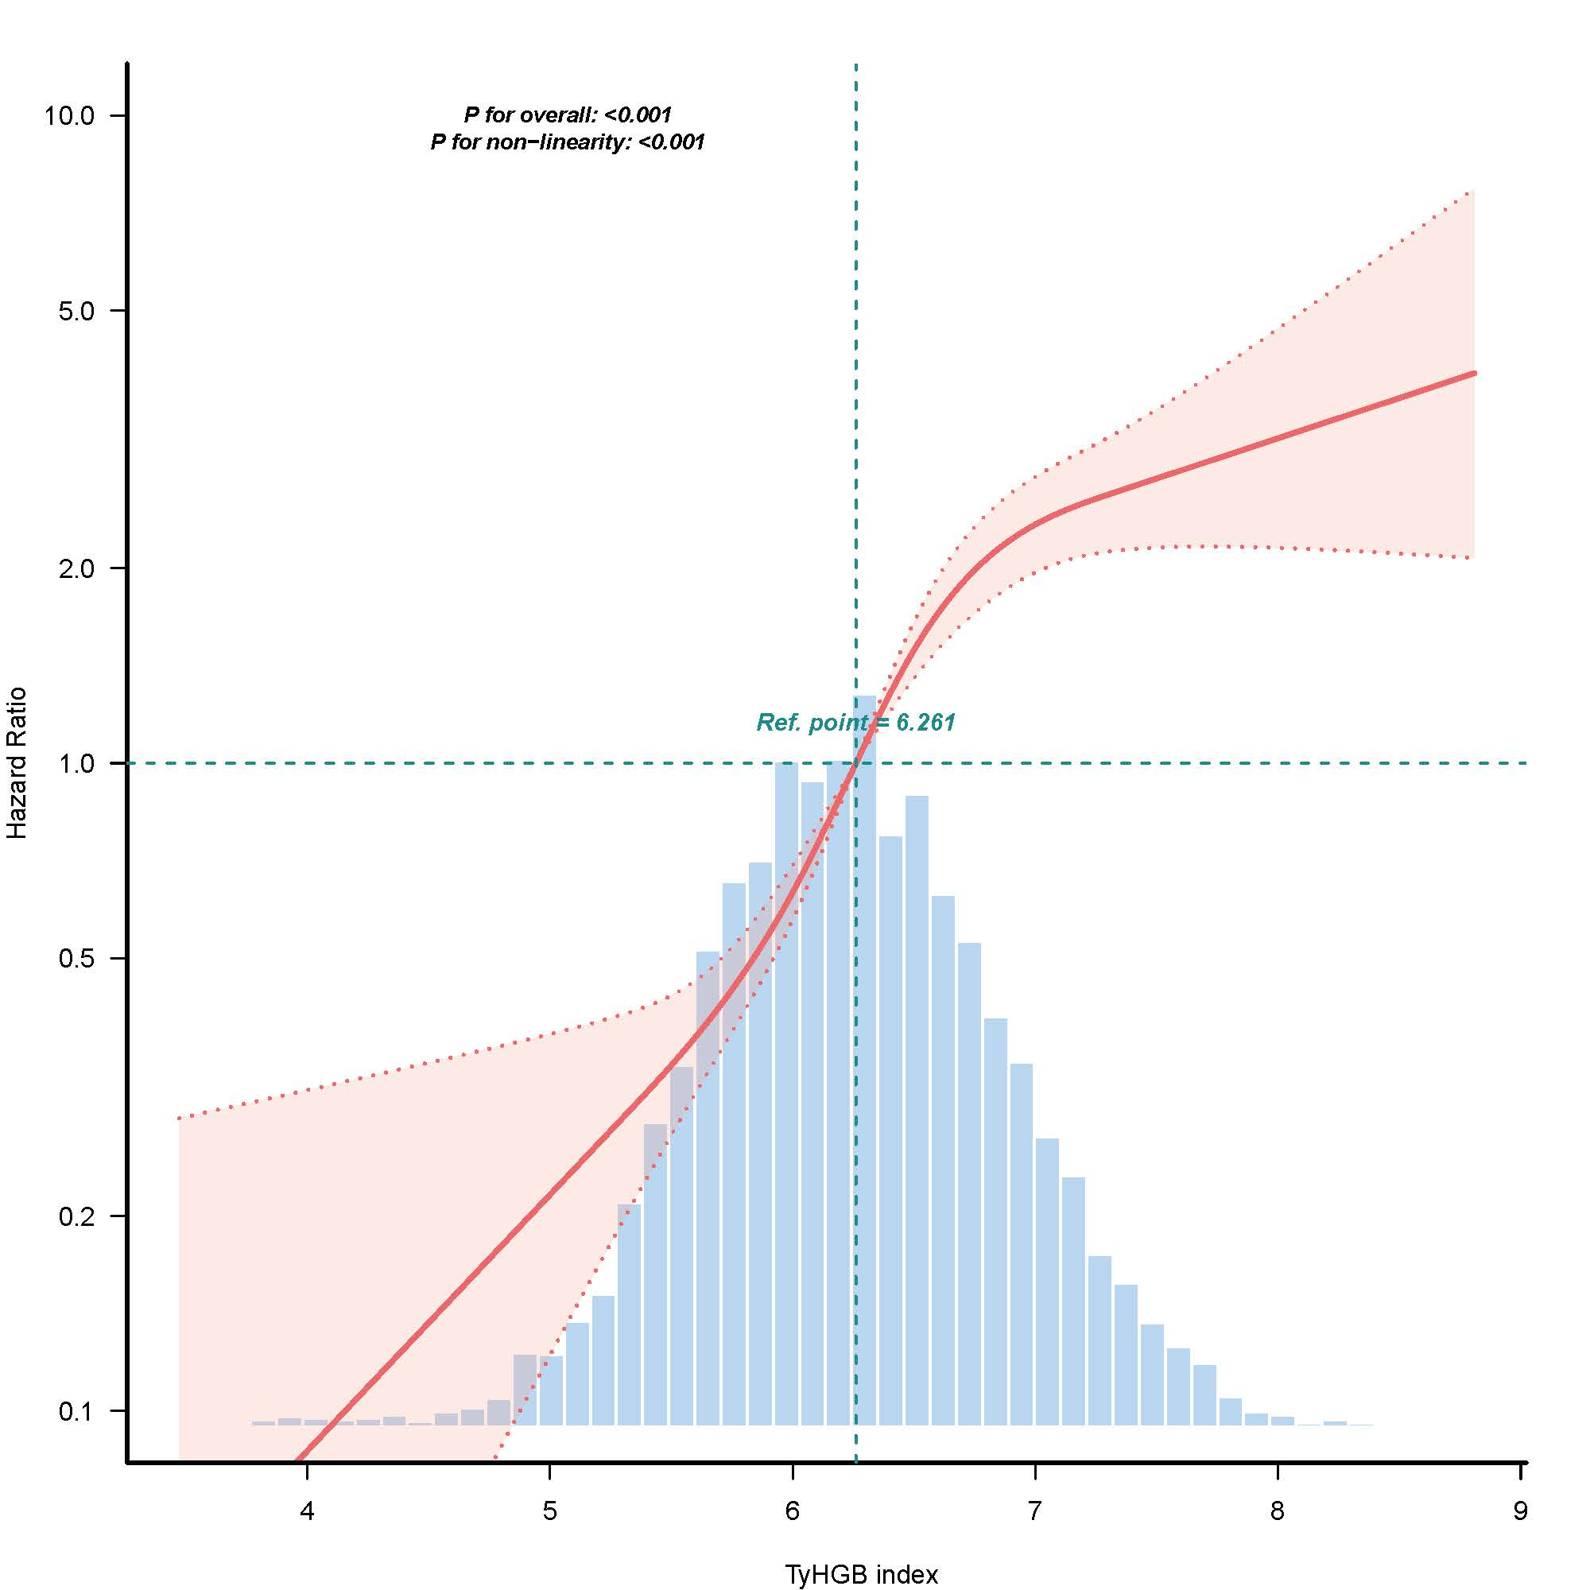
Supplementary Figure 4. The non-linear relationship between TyHGB index and risk of incident IFG using the dataset excluding participants with incomplete covariate data. We adjusted for age, gender, SBP, DBP, ALT, AST, TC, LDL-C, BUN, Scr, smoking status, and family history of DM at baseline.

Supplementary Figure 5. Receiver operating characteristic (ROC) curves comparing the predictive ability of TyG index, TyG-BMI, TyHGB index, TG/HDL-C ratio, TG, HDL-C, baseline FPG, and BMI for IFG. The diagonal dashed line represents a random classifier (AUC = 0.5).
