Supplementary material
Triglyceride–glucose index and triglyceride/HDL-cholesterol ratio versus HbA1c and HOMA-IR for identifying microvascular complications in type 2 diabetes: a cross-sectional comparative diagnostic accuracy study from western India
Supplementary figures
Figure S1. Participant flow diagram
Of 152 patients with type 2 diabetes screened, 42 were excluded and 110 formed the analytical cohort, as follows.
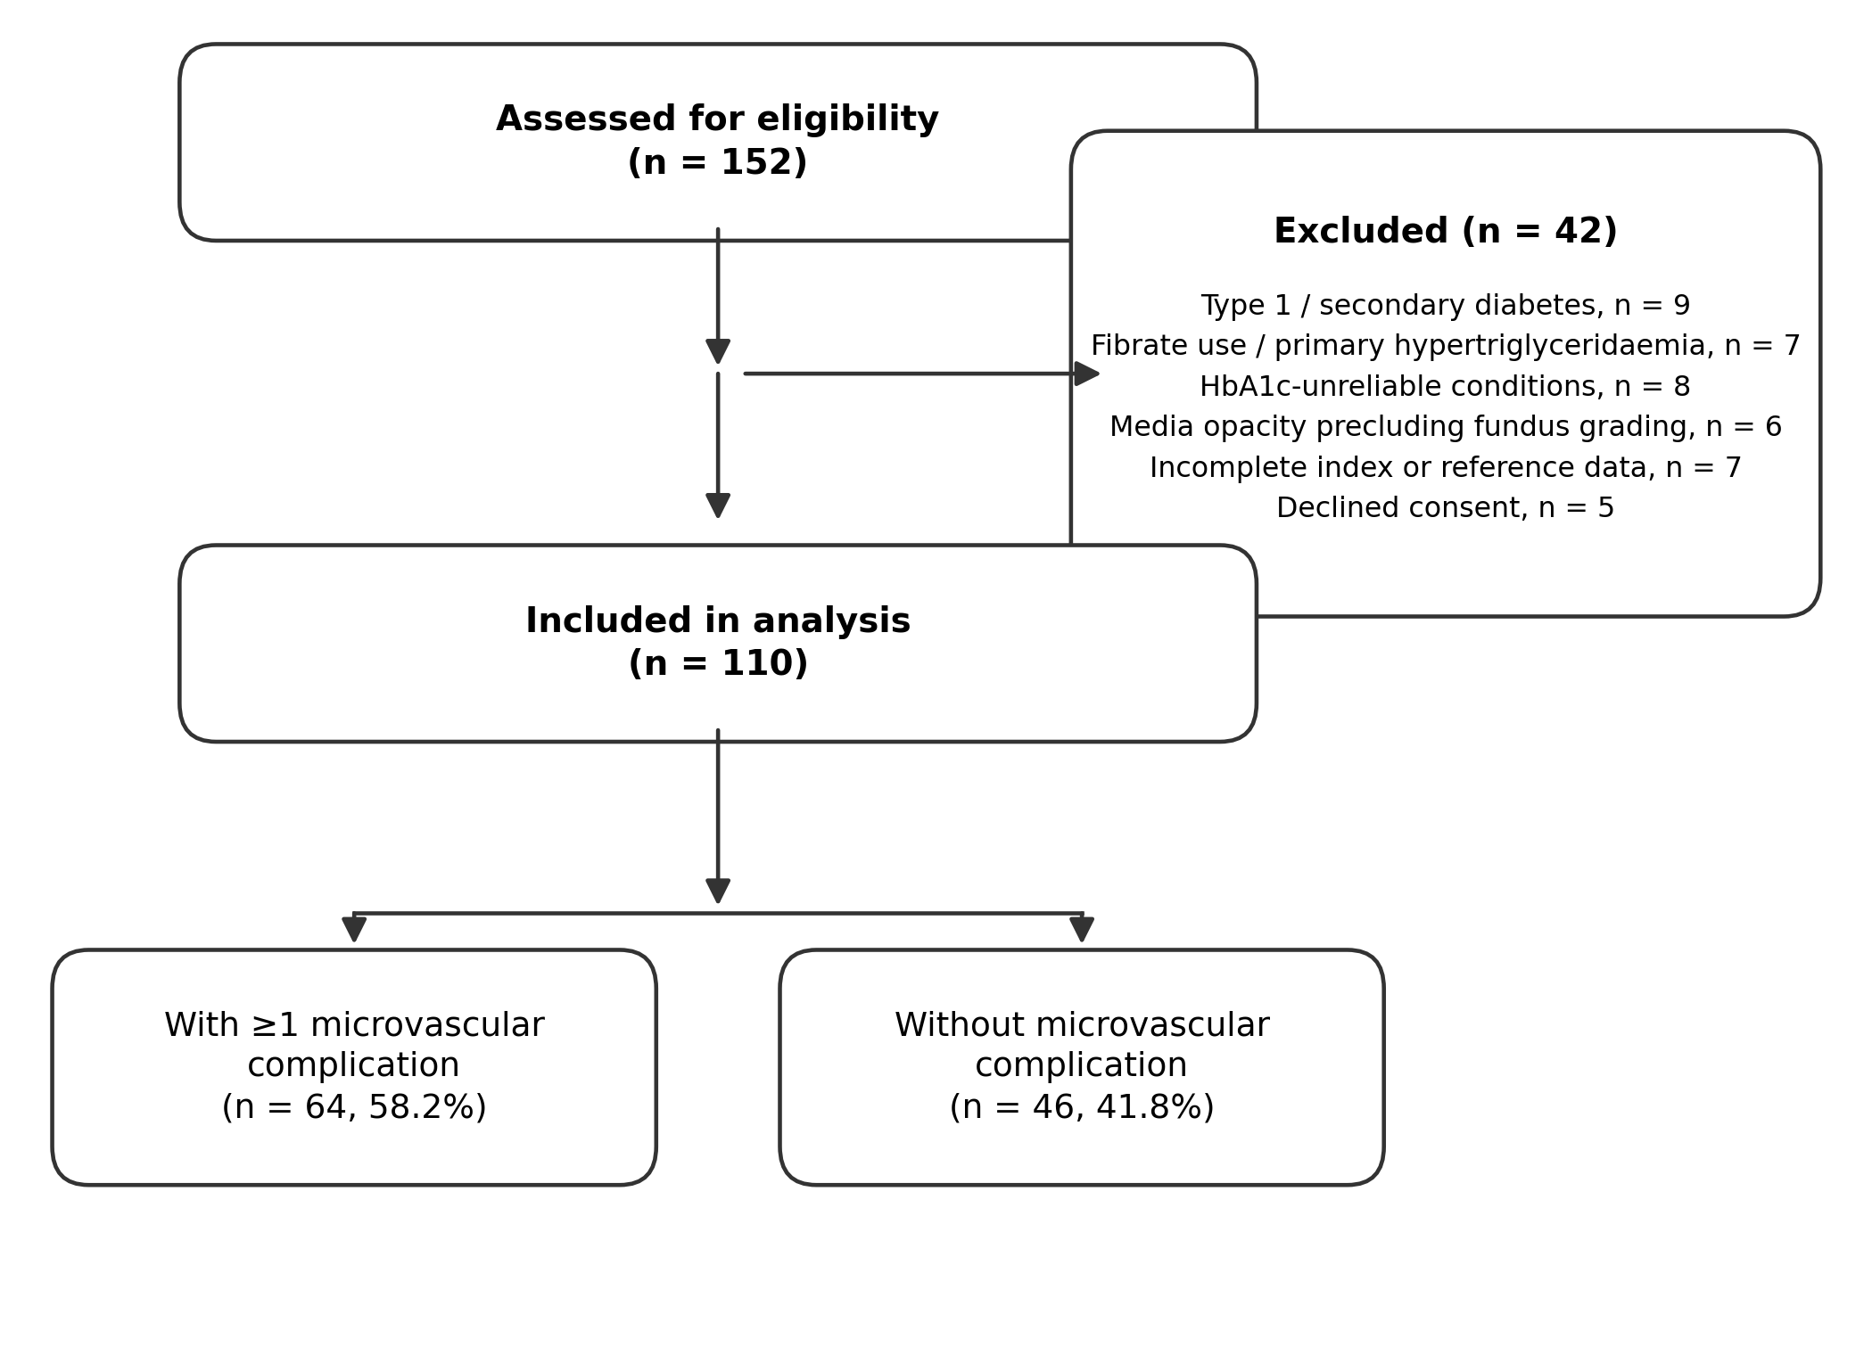

Figure S2. Complication prevalence by marker quartile

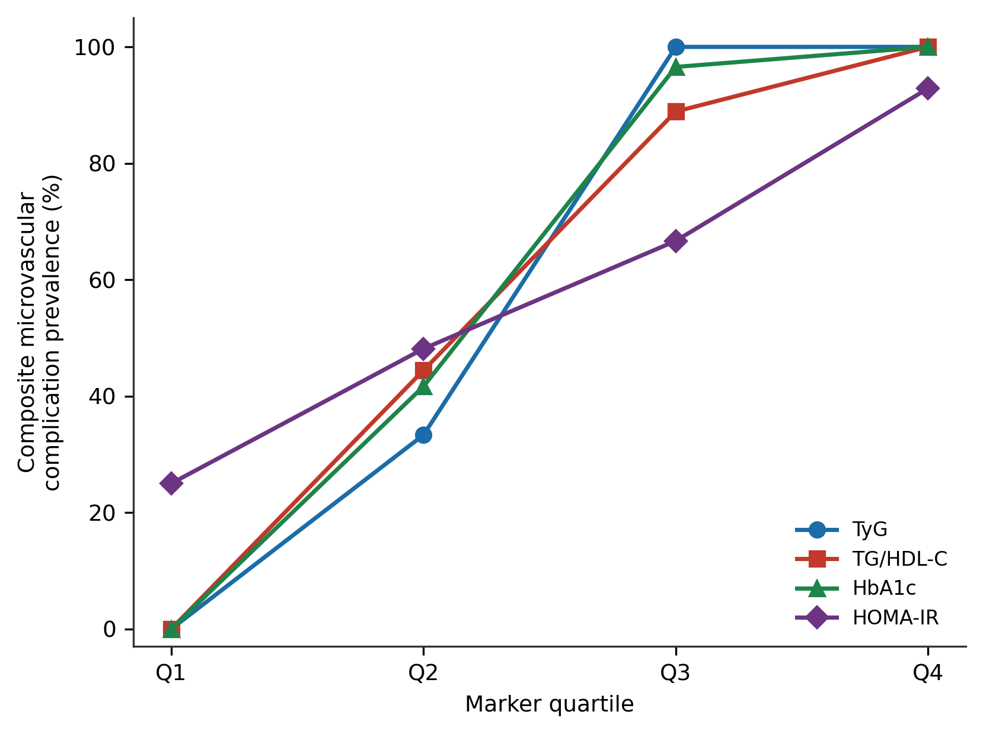
Figure S2. Composite microvascular complication prevalence across quartiles of each marker. The near-stepwise gradient for TyG (0% in Q1 to 100% in Q3–Q4) illustrates the quasi-complete separation that motivated Firth-penalised regression. HOMA-IR shows the shallowest gradient, consistent with its weaker discrimination.

Supplementary tables

Table S3. Univariable logistic regression for the composite microvascular outcome (per 1-standard-deviation rise unless stated).
Variable | Crude OR (95% CI) | P value | Note
TyG (per 1 SD) | see note | 0.001 | quasi-complete separation; OR unstable
TG/HDL-C (per 1 SD) | see note | <0.001 | near-separation; OR unstable
HbA1c (per 1 SD) | see note | <0.001 | near-separation; OR unstable
HOMA-IR (per 1 SD) | 17.8 (4.8–66.2) | <0.001 | —
Age (per 1 SD) | 2.07 (1.32–3.23) | 0.001 | per 1 SD
DM duration (per 1 SD) | 11.5 (4.5–29.2) | <0.001 | per 1 SD
HDL-C (per 1 SD) | 0.19 (0.10–0.36) | <0.001 | per 1 SD
For TyG, TG/HDL-C and HbA1c, ordinary maximum-likelihood odds ratios are not reported because of quasi-complete or near-complete separation, which inflates point estimates into the thousands with implausibly wide confidence intervals; penalised estimates are given in main-text Table 5. P values shown are from the score test, which remains valid under separation.

Table S4. Variance inflation factors for Model A predictors.
Predictor | VIF
TyG | 3.17
Age | 1.51
DM duration | 2.09
HbA1c | 2.54
HDL-C | 1.81
All variance inflation factors were below 5, indicating no problematic multicollinearity. The highest value (TyG, 3.17) reflects the expected correlation between TyG and HbA1c (ρ = 0.86) and motivated the prespecified Model A refit without HbA1c (Table S11).

Table S5. Sensitivity analysis: TyG diagnostic accuracy restricted to participants on oral-agent monotherapy.
Subgroup | n | Events | TyG AUC (95% CI) | Cut-off
Oral monotherapy | 58 | 28 | 0.991 (0.976–1.000) | ≥9.21
Overall cohort | 110 | 64 | 0.993 (0.984–1.000) | ≥9.23
Restricting to oral-agent monotherapy left TyG discrimination essentially unchanged, suggesting that the observed discrimination was not materially altered by treatment subgroup restriction.

Table S6. Sensitivity analysis: sex-stratified TyG diagnostic accuracy.
Stratum | n | TyG AUC (95% CI)
Male | 67 | 0.998 (0.992–1.000)
Female | 43 | 0.983 (0.952–1.000)
TyG discrimination was high and consistent in both sexes.

Table S7. Sensitivity analysis: TyG diagnostic accuracy stratified by diabetes duration.
Stratum | n | Events | TyG AUC (95% CI)
Duration <5 years | 41 | 2 | 0.936 (0.840–1.000)
Duration ≥5 years | 69 | 62 | 0.998 (0.993–1.000)
Discrimination was preserved in the short-duration subgroup despite few events (n = 2), though the confidence interval is correspondingly wide; the result should be interpreted with caution given sparse events in this stratum.

Table S8. Sensitivity analysis: TyG diagnostic accuracy after exclusion of biochemistry outliers (>3 SD on triglycerides or fasting glucose).
Analysis | n excluded | n analysed | TyG AUC (95% CI)
Outliers excluded | 3 | 107 | 0.992 (0.982–1.000)
Full cohort (reference) | 0 | 110 | 0.993 (0.984–1.000)
Excluding three participants with extreme triglyceride or fasting-glucose values did not materially change TyG discrimination, indicating the result is not driven by outliers.

Table S9. Incremental value of adding TyG to a base model of HbA1c and HOMA-IR.
Metric | Value | P value
Base model AUC (HbA1c + HOMA-IR) | 0.974 | —
Full model AUC (+ TyG) | 0.996 | —
ΔAUC | +0.022 | 0.048
Integrated discrimination improvement (IDI) | 0.219 | <0.001
Categorical NRI (50% threshold) | 0.181 | 0.014
IDI, integrated discrimination improvement; NRI, net reclassification improvement. IDI and NRI are exploratory measures of incremental value within this cohort and should be interpreted cautiously given the strong correlation of TyG with HbA1c and fasting glucose and the absence of external validation.

Table S10. Per-component diagnostic accuracy (AUC with 95% CI) for each marker.
Marker | Diabetic retinopathy (n=50) | Diabetic kidney disease (n=44) | Diabetic peripheral neuropathy (n=55)
TyG | 0.953 (0.913–0.993) | 0.932 (0.882–0.981) | 0.936 (0.891–0.981)
TG/HDL-C | 0.920 (0.864–0.976) | 0.914 (0.853–0.975) | 0.921 (0.868–0.975)
HbA1c | 0.906 (0.846–0.966) | 0.881 (0.811–0.952) | 0.908 (0.851–0.966)
HOMA-IR | 0.867 (0.796–0.938) | 0.853 (0.775–0.931) | 0.767 (0.679–0.856)
The component-specific AUCs showed the same overall pattern across the three complications, with HOMA-IR weakest for peripheral neuropathy.

Table S11. Prespecified refit of Model A without HbA1c (Firth-penalised).
Variable | Firth OR (95% CI) | P value
TyG (per 1 SD) | — (separation) | <0.001
Age (per 1 SD) | 0.96 (0.83–1.11) | 0.574
DM duration (per 1 SD) | 1.86 (1.11–3.11) | 0.018
HDL-C (per 1 SD) | 0.82 (0.63–1.07) | 0.142
Removing HbA1c (correlated with TyG, ρ = 0.86) left the TyG signal and the diabetes-duration association intact, supporting persistence of the TyG association after exclusion of HbA1c. The penalised odds ratio for TyG is not reported because of separation; the penalised likelihood-ratio P value is shown.

