Prevalence of severe early childhood caries and associated socioeconomic and behavioral factors in Xinjiang, China: a cross-sectional study

Yan Li¹, Jibieke Wulaerhan², Yuan Liu¹, Ayinuer Abudureyimu², Jin Zhao¹
¹Department of Endodontics, the First Affiliated Hospital of Xinjiang Medical University, Urumqi, Xinjiang 830054, China
²Stomatology Disease Institute of Xinjiang Uyghur Autonomous Region, Urumqi, Xinjiang 830054, China
Corresponding author: Jin Zhao
Department of Endodontics, the First Affiliated Hospital of Xinjiang Medical University, No. 137, Li Yu Shan South Road, Urumqi, Xinjiang Province 830054, China
E-mail: merryljin@sina.com

Additional file 1
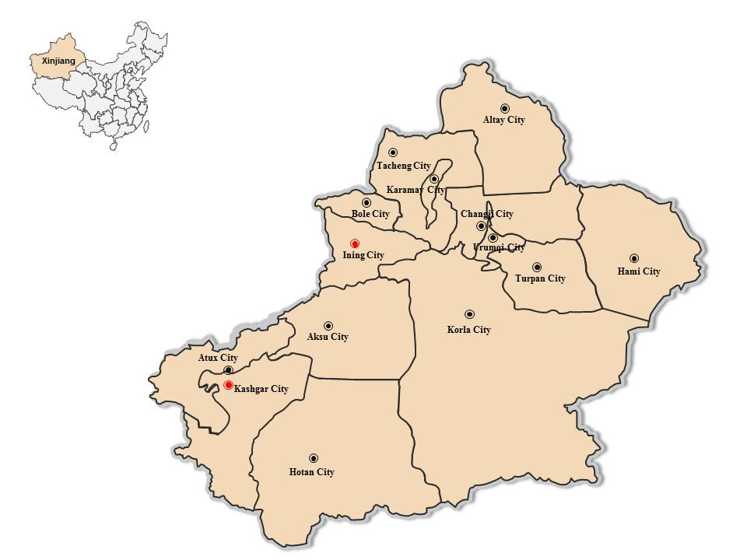
Additional file 1 Figure S1 Map of Xinjiang. Red tags indicate the geographic study areas.

