Supplementary Data

Title: Three Years of Follow-up of Otodental Syndrome in 3-year-old Chinese boy: A Rare Case Report
Authors: Ji-mei Su, Su-juan Zeng, Xiao-wei Ye, Zhi-fang Wu, Xin-wen Huang, Janak L. Pathak

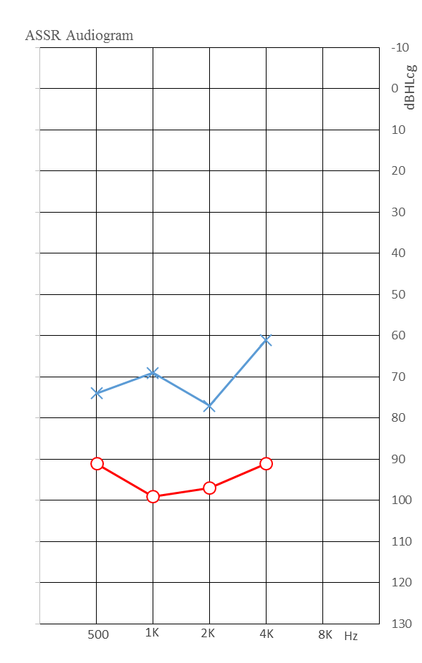
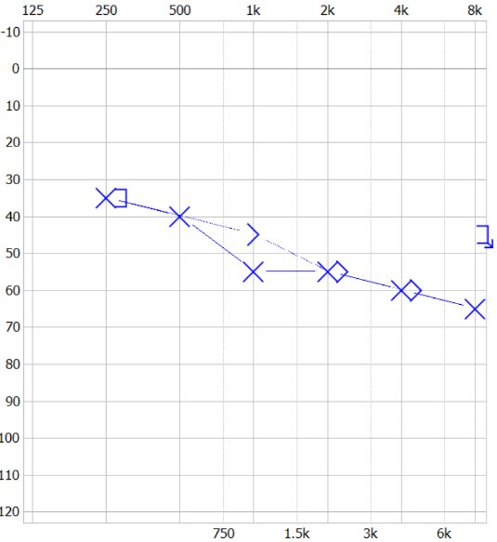
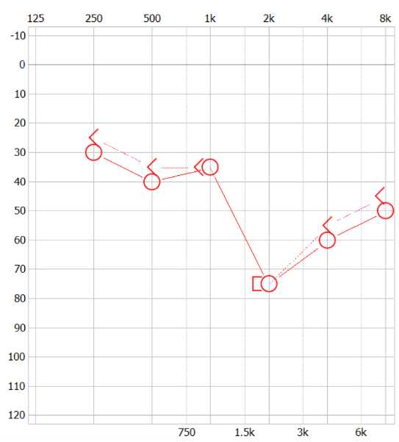
Supplementary Figure 1. Pure tone audiogram of the patient’s mother (A and B). Air conduction (X, left ear; right ear) and bone conduction (>, left ear; <, right ear) demonstrating high-frequency sensorineural hearing loss. (C) ASSR Audiogram of the patient (O, right ear; X, left ear).
C
Frequency (Hz)

Frequency (Hz)
Hearing Level (dB)
A
B
Hearing Level (dB)

