Additional file 2- Research process participant flowchart
Figure 1: Participant flowchart, as outlined by CONSORT (Eldridge et al., 2016)
Invitations per Practice (P)
P1= 22; P2 = 18; P3 = 24; P4 = 36; P5 = 26

Invitations
(n= 126)

Dropped out prior to consenting (n=11)
Reason: Unable to contact (n=4)
Changed mind about participating (n=6)
Unable to accommodate home visit (n=1)

Participants accepted
(n=47)

Consent & Baseline
(n=36)
Consented per Practice
P1= 8; P2 = 8; P3 = 5; P4 = 6; P5 = 9

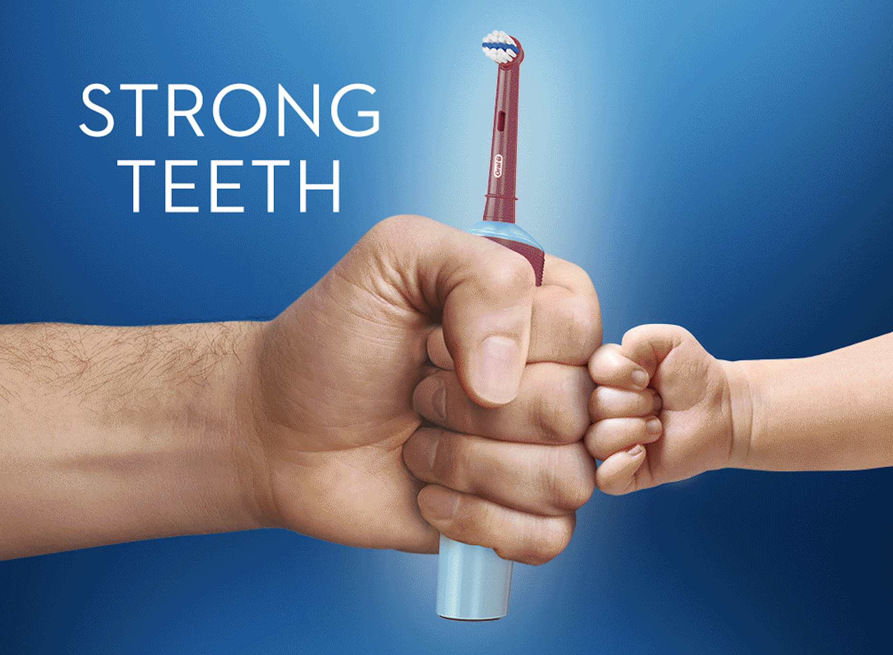
Dropped out after baseline (n=6)
Reason: Unable to contact (n=4)
Didn’t attend intervention appointment (n=2)
Strong Teeth Invention n=34

2 Week follow up
Completed: 26/30
Missed follow up (n=4)
Reason: Child Illness (n=2)
Away on holiday (n=1)
Delay in being able to contact (n=1)

Dropped out after 2 week follow up (n=3)
Reason: Unable to contact (n=3)

3 Month follow up
Completed: 27/27
Missed follow up (n=0)

Declined participation (n=6)
Qualitative interviews
Completed: 20/21
Unable to interview (n=1)
Reason: Participant work commitments (n=1)

