Adjunct effect of topical alendronate therapy for the non-surgical treatment of periodontal defects: systematic review, meta-analysis and trial sequential analysis
Claudia Arena¹, Vito Carlo Alberto Caponio¹, Khrystyna Zhurakivska¹, Lucio Lo Russo ¹, Lorenzo Lo Muzio¹, Giuseppe Troiano¹.

- Department of Clinical and Experimental Medicine, University of Foggia, Foggia, Italy.

Corresponding author:
Giuseppe Troiano, DDS, PhD
Department of Clinical and Experimental Medicine,
University of Foggia, Foggia 71122, Italy , Ph: +390881588082
email: giuseppe.troiano@unifg.it

Supplementary material legend

Appendix 1: Meta-analysis for the effects of Alendronate therapy on PD reduction by sub-groups.
Appendix 2: Meta-analysis for the effects of Alendronate therapy on CAL gain by sub-groups.
Appendix 3: Meta-analysis for the effects of Alendronate therapy on bone defect depth reduction by sub-groups.
Appendix 4: Reasons for exclusion of articles read in full-text.
Appendix 5: GRADE for the effects of Alendronate therapy on PD reduction.
Appendix 6: GRADE for the effects of Alendronate therapy on CAL gain.
Appendix 7: GRADE for the effects of Alendronate therapy on bone defect depth reduction.

Appendix 1

Appendix 2

Appendix 3

Appendix 4

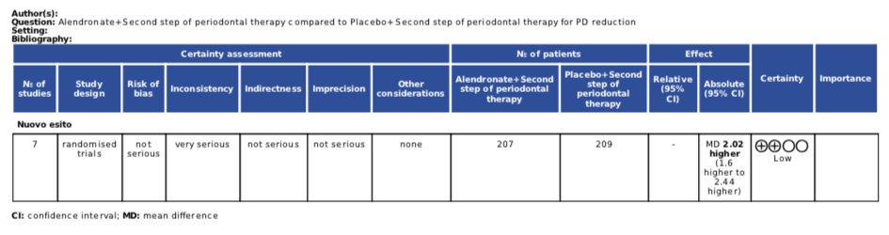

Appendix 5

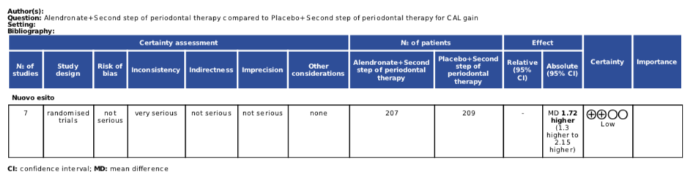

Appendix 6

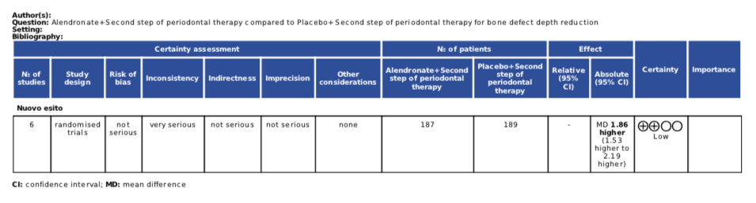

Sharma: Sharma A, Raman A, Pradeep AR (2017) Role of 1% alendronate gel as adjunct to mechanical therapy in the treatment of chronic periodontitis among smokers. J Appl Oral Sci 25 (3):243-249. doi:10.1590/1678-7757-2016-0201
Sharma’: Clinical efficacy of 1% alendronate gel as a local drug delivery system in the treatment of chronic periodontitis: a randomized, controlled clinical trial. J Periodontol 83 (1):11-18. doi:10.1902/jop.2011.110091
Sharma’’: Sharma A, Pradeep AR (2012) Clinical efficacy of 1% alendronate gel in adjunct to mechanotherapy in the treatment of aggressive periodontitis: a randomized controlled clinical trial. J Periodontol 83 (1):19-26. doi:10.1902/jop.2011.110206
Pradeep: Pradeep AR, Kanoriya D, Singhal S, Garg V, Manohar B, Chatterjee A (2017) Comparative evaluation of subgingivally delivered 1% alendronate versus 1.2% atorvastatin gel in treatment of chronic periodontitis: a randomized placebo-controlled clinical trial. J Investig Clin Dent 8 (3). doi:10.1111/jicd.12215
Pradeep’: Pradeep AR, Kumari M, Rao NS, Naik SB (2013) 1% alendronate gel as local drug delivery in the treatment of Class II furcation defects: a randomized controlled clinical trial. J Periodontol 84 (3):307-315. doi:10.1902/jop.2012.110729

