Effects of the Advanced Mandibular Spring on Mandibular Retrognathia Treatment: A Three-dimensional Finite Element Study

Supplementary Table 1. Muscle forces in maximum clenching of different vertical facial patterns (N)
Muscle | Low-angle | Normal-angle | High-angle
Masseter (superficial part) | 136.8 | 135.4 | 135
Masseter (deep part) | 199.7 | 197.6 | 197.1
Temporalis (anterior part) | 222.3 | 222 | 221.2
Temporalis (posterior part) | 185.2 | 185 | 183.2
Medial pterygoid | 203.5 | 203.5 | 203.5
Lateral pterygoid (superior head) | 37.0 | 37.0 | 37.0
Lateral pterygoid (inferior head) | 85.0 | 85.0 | 85.0

The deformation values were in millimeters (mm) and were interpreted with the color scale (The value is positive if the movement is backward and negative if the movement is forward).
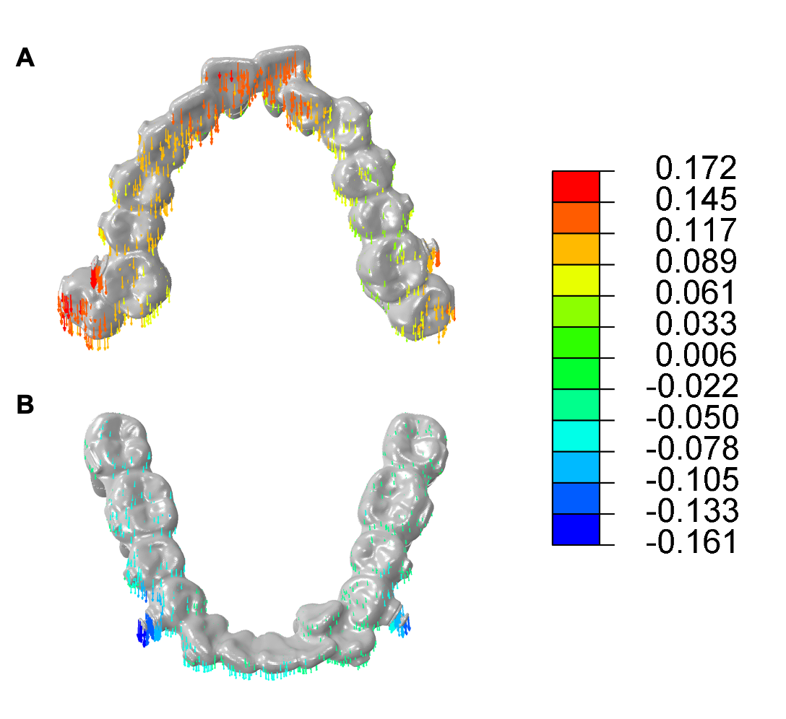
Supplementary Figure 1. Anteroposterior deformation of the dentition. The trend of teeth movement is backward in upper teeth and forward in lower teeth.

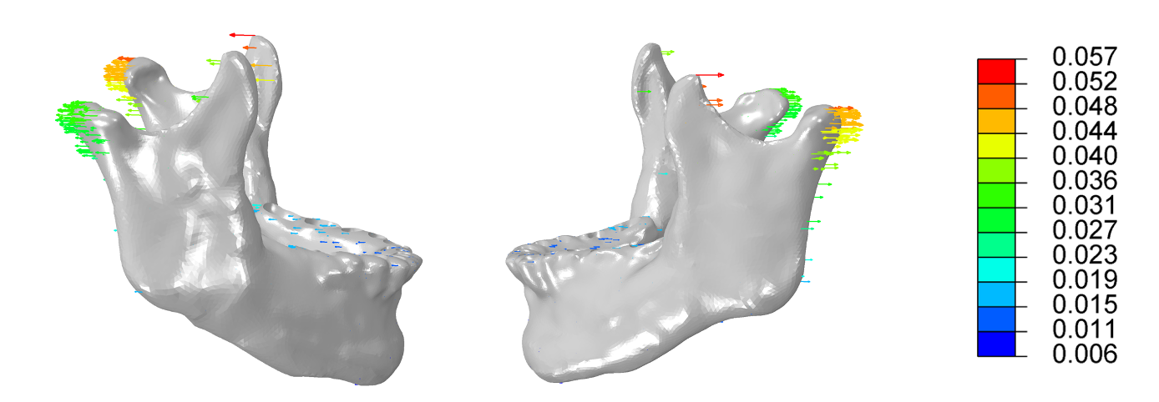
Supplementary Figure 2. Anteroposterior deformation of the mandible. The trend of condylar growth is backward in the anteroposterior direction.

