Supplementary Materials
Gene | Primers
GAPDH | F 5’ GGAGCGAGATCCCTCCAAAAT 3’
GAPDH | R 5’ GGCTGTTGTCATACTTCTCATGG 3’
RUNX2 | F 5’ CCTTTACTTACACCCCGCCA 3’
RUNX2 | R 5' GGATCCTGACGAAGTGCCAT 3’
OCN | F 5’ ATTGTGGCTCACCCTCCATC 3’
OCN | R 5’ CCAGCCTCCAGCACTGTTTA 3’
OSX | F 5’ TCTGCGGGACTCAACAACTC 3’
OSX | R 5’ TAGCATAGCCTGAGGTGGGT 3’
DSPP | F 5’ ATATTGAGGGCTGGAATGGGGA 3’
DSPP | R 5’ TTTGTGGCTCCAGCATTGTCA 3’
METTL3 | F 5’ GAGGAGTGCATGAAAGCCAG 3’
METTL3 | R 5’ GGCCTCAGAATCCATGCAAG 3’
METTL14 | F 5’ GACGGGGACTTCATTCATGC 3’
METTL14 | R 5’ CCAGCCTGGTCGAATTGTAC 3’
FTO | F 5’ AGACACCTGGTTTGGCGATA 3’
FTO | R 5’ CCAAGGTTCCTGTTGAGCAC 3’
ALKBH5 | F 5’ ACCCCATCCACATCTTCGAG 3’
ALKBH5 | R 5’ CTTGATGTCCTGAGGCCGTA 3’
GDF6 | F 5’ CGATCTCTCGCACACTCCTC 3’
GDF6 | R 5’ GCCCACCAGCTCTTCTTTGT 3’
STC1 | F 5’ AACCAGTAACGTGCTGCTCA 3’
STC1 | R 5’ TAAGTTTGGGGACCTGGGGA 3’
MAML3 | F 5’ GTTTCAAGGTTCTCCCCAGGAT 3’
MAML3 | R 5’ GGTGCTATAAGGGGCCAGTC 3’
UFL1 | F 5’ CAGTTCCTCCGCGTCTACTG 3’
UFL1 | R 5’ CGCCAACCGCCTAATCTCTT 3’
OXCT2 | F 5’ ACAAAGGACAACACCCCCAA 3’
OXCT2 | R 5’ CCTCAGCGTCAGCTCTTTCT 3’
ZNF441 | F 5’ GAGGACCCTTTACCCAGACTC 3’
ZNF441 | R 5’ GAGATGAACGACCCATGAGGA 3’
ZNF804A | F 5’ ACCAGTAGGACCGAGGCTTT 3’
ZNF804A | R 5’ CGGAAGCTGGAATGATTGGC 3’
RAB40A | F 5’ AGAAAGTGTGACGTGGGTGAA 3’
RAB40A | R 5’ CCTGTTCCCAAAAACCACAGTC 3’
ZNF547 | F 5’ TCTCTTCCCTGGCTGGACTTG 3’
ZNF547 | R 5’ ACATCACGGTACAGCAATCTCT 3’
ZNF14 | F 5’ GATTGCGTTTCACCTGCTCC 3’
ZNF14 | R 5’ CTGAGTCCATTTCCCAGCGT 3’
Supplementary Table 1. Primers used for qRT-PCR.
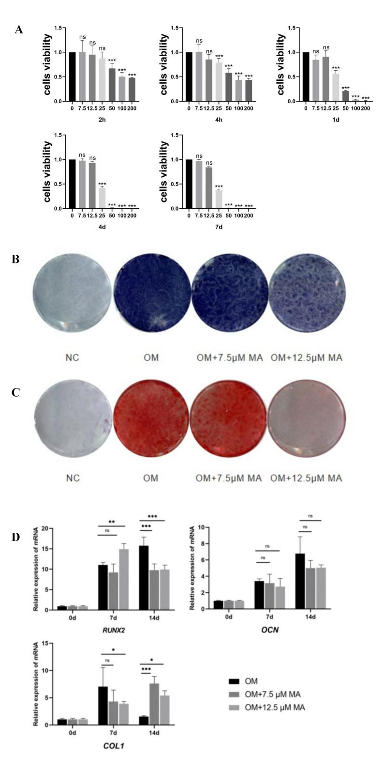
Supplementary Figure 1. FTO inhibitor reduced the odontoblast differentiation of DPSCs. A)Cell viability of DPSCs after 6 different concentrations of MA treated, and 7.5μM MA and 12.5μM MA group were selected for following experiments (n = 5). B)ALP staining on 7 d, and C)Alizarin red S staining on 14 d of DPSCs cultured in OM (n = 3). D)Expression levels of odontoblast differentiation related genes, RUNX2, OCN and COL1, were measured by real‐time RT‐PCR on 0, 7 and 14 days after mineralization induction with MA treatment (n=3). *P < 0.05, **P < 0.01, ***P < 0.001

