 | 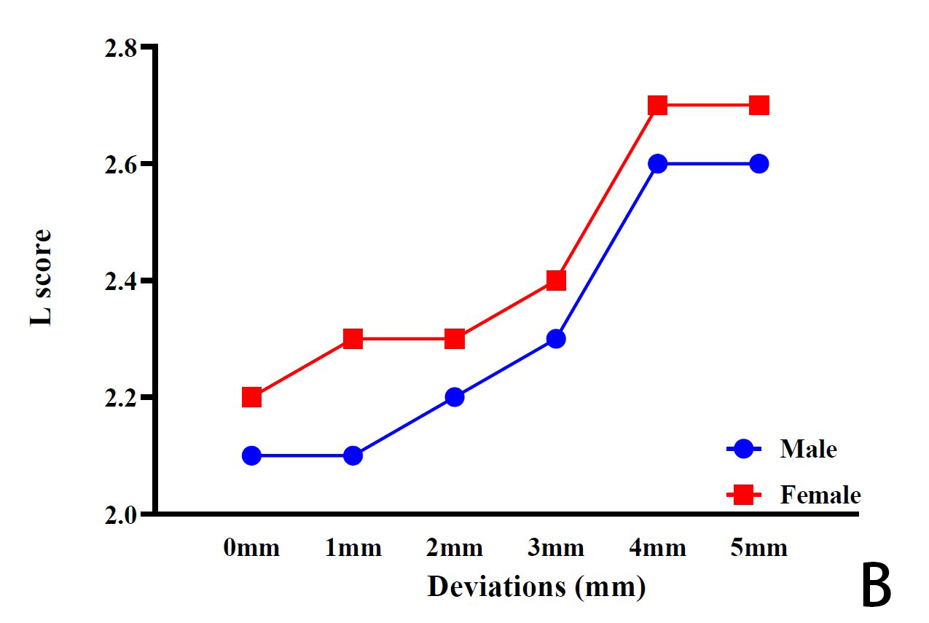
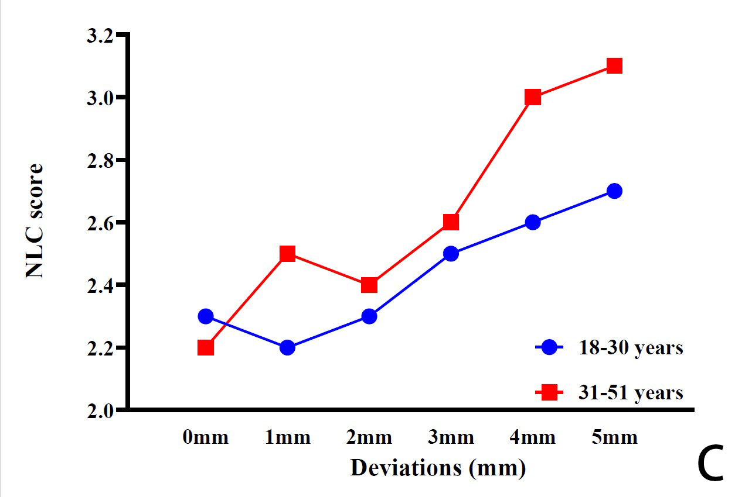 | 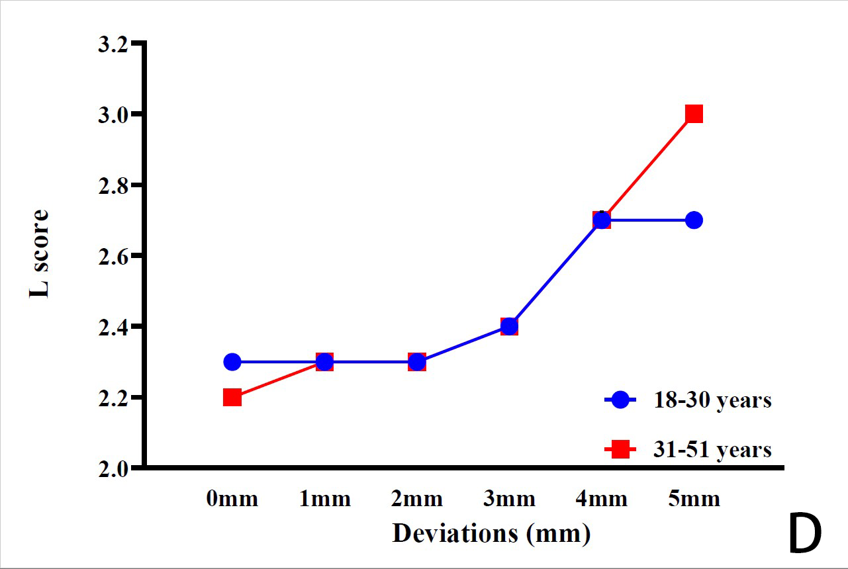
 | 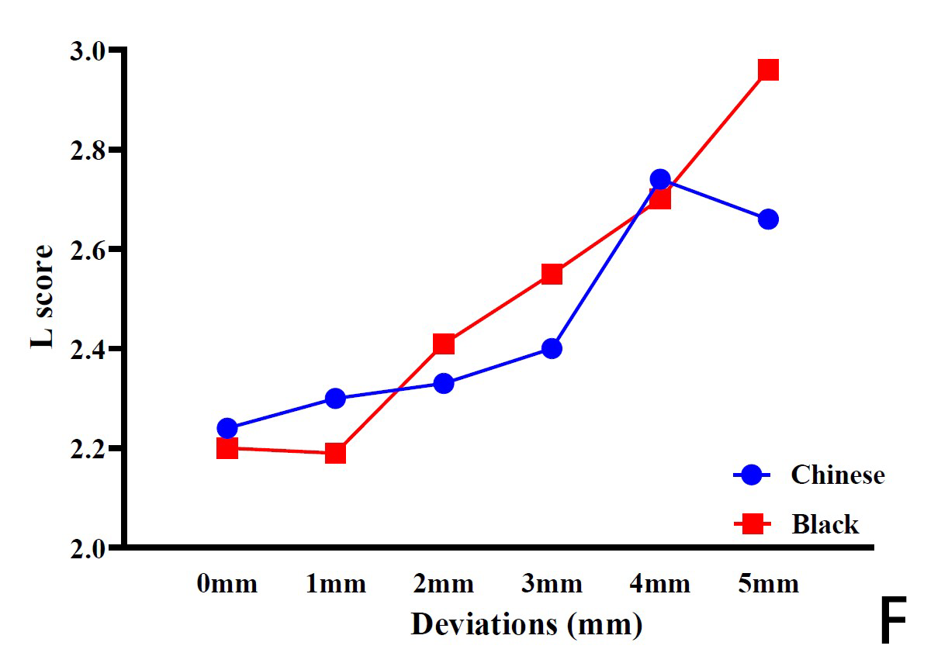
Additional file 3. Line graph showing the mean rating of attractiveness scores in NLC and L across categories of gender (A, B), age (C, D), and ethnicity (E, F) by overall raters (n=561). A higher score implies a less attractive smile

