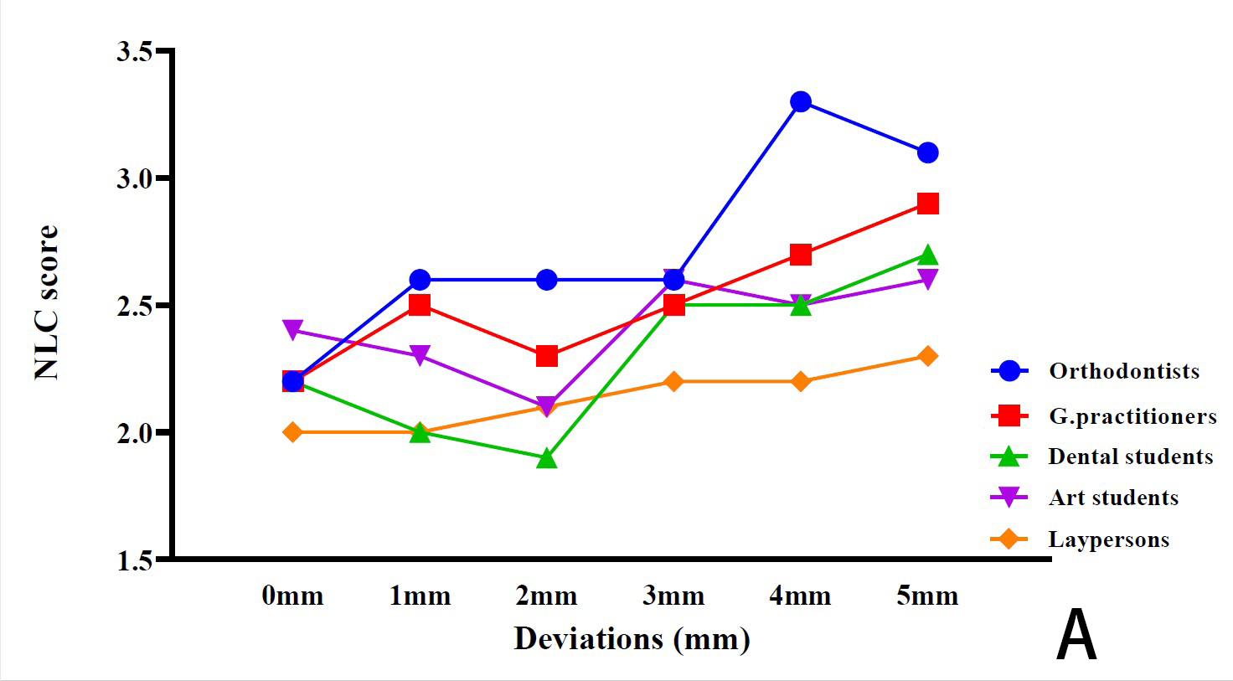 | 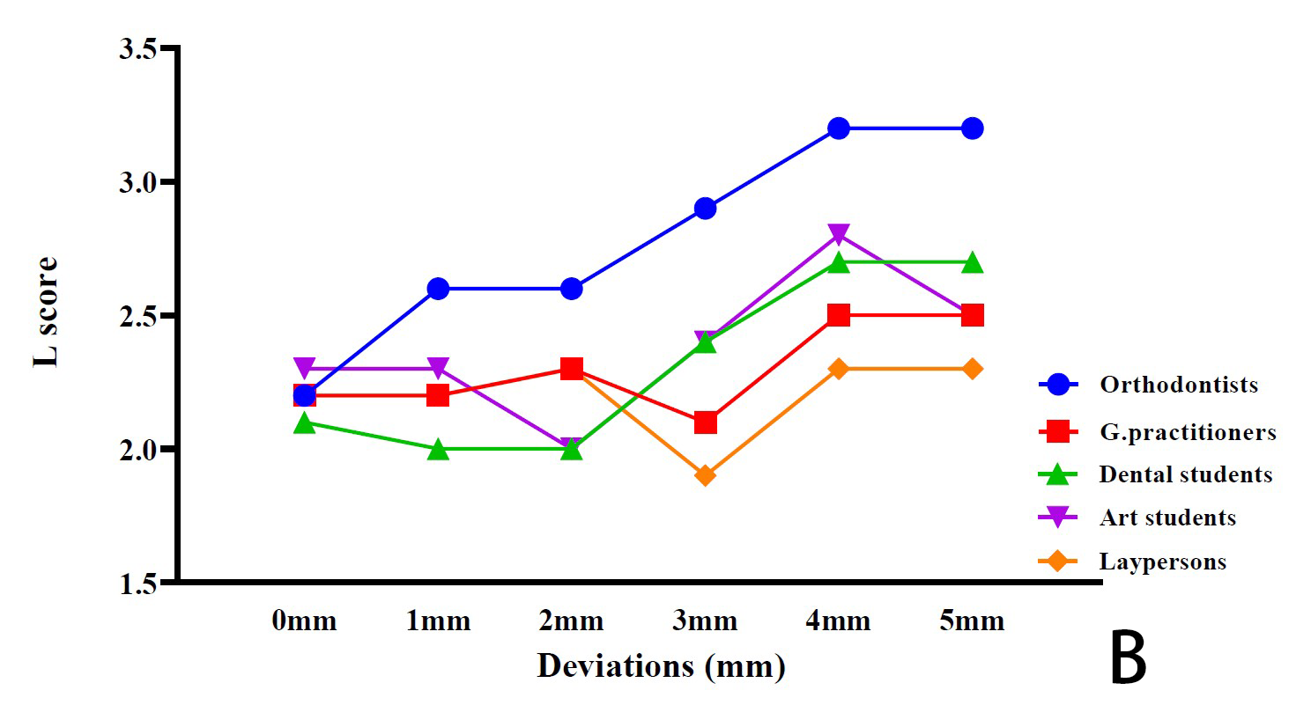
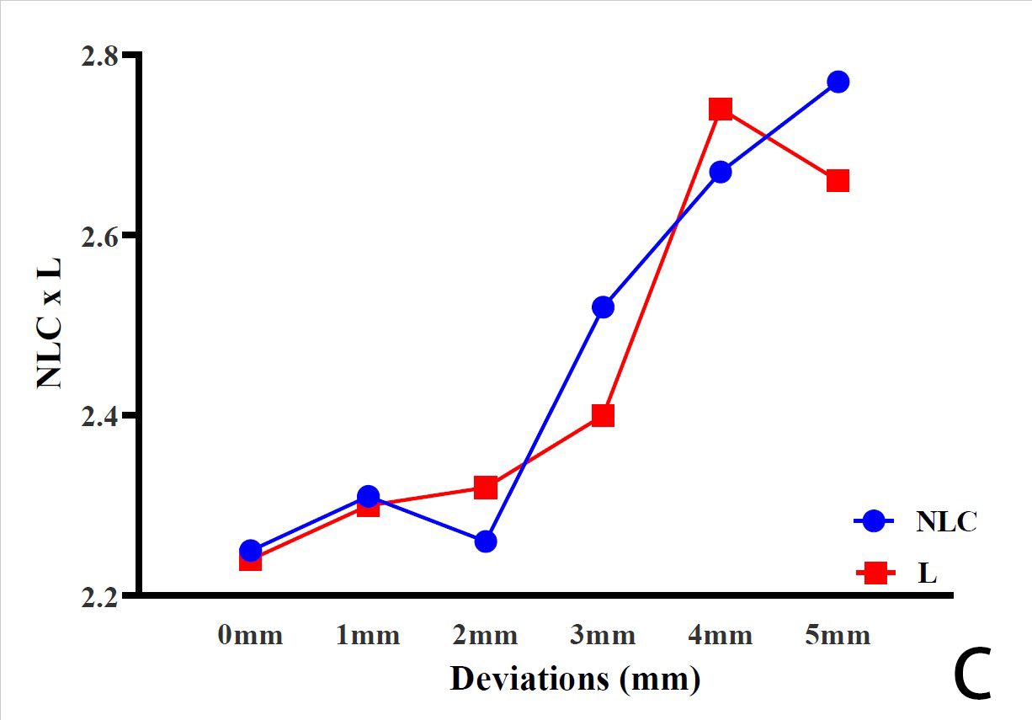 | 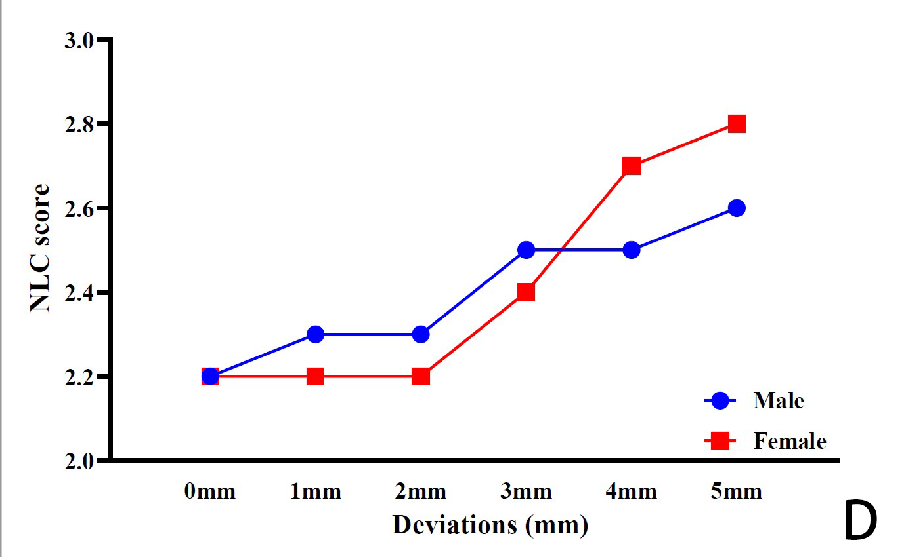
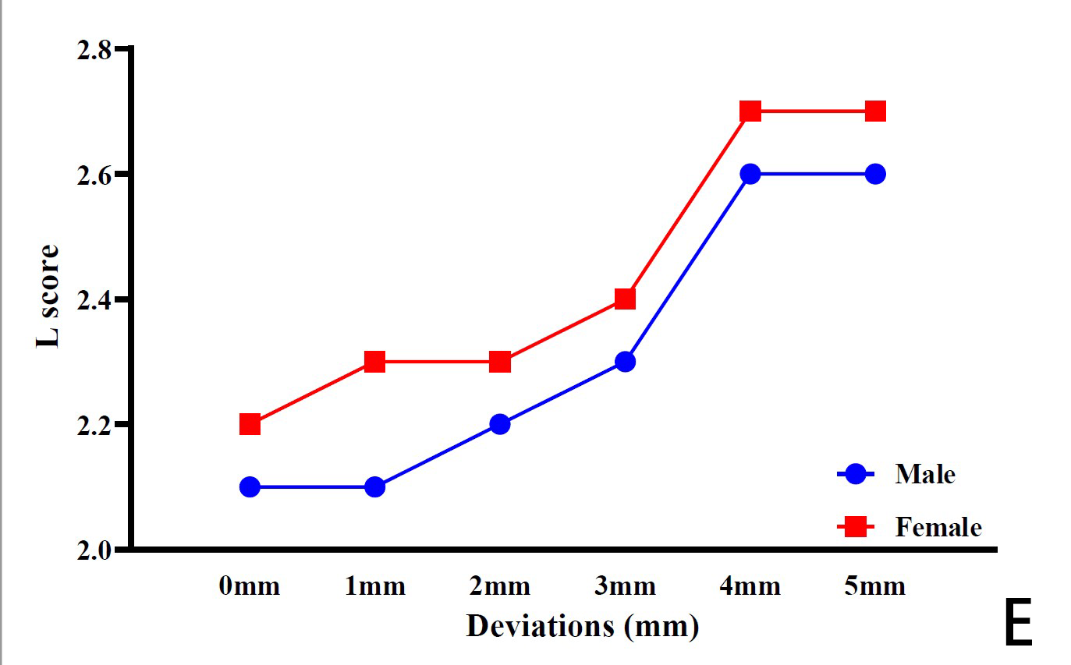 | 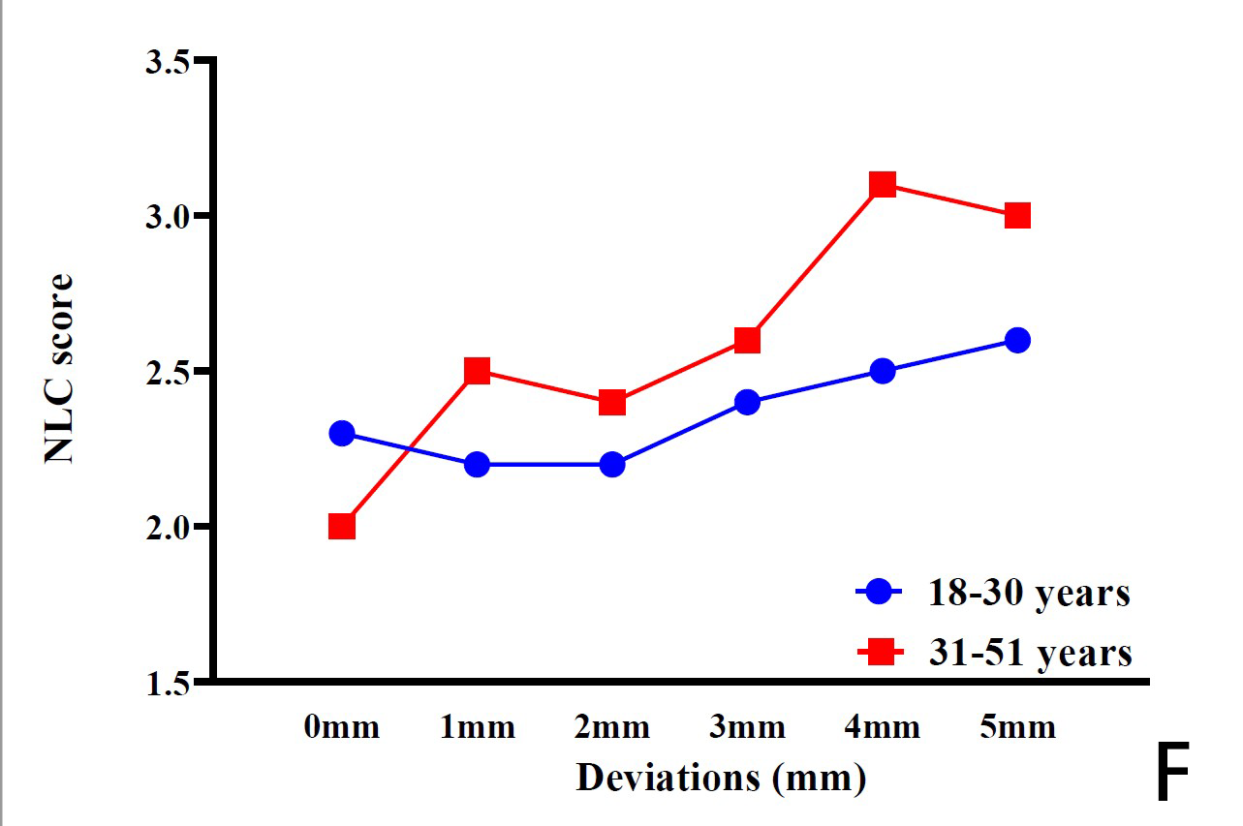
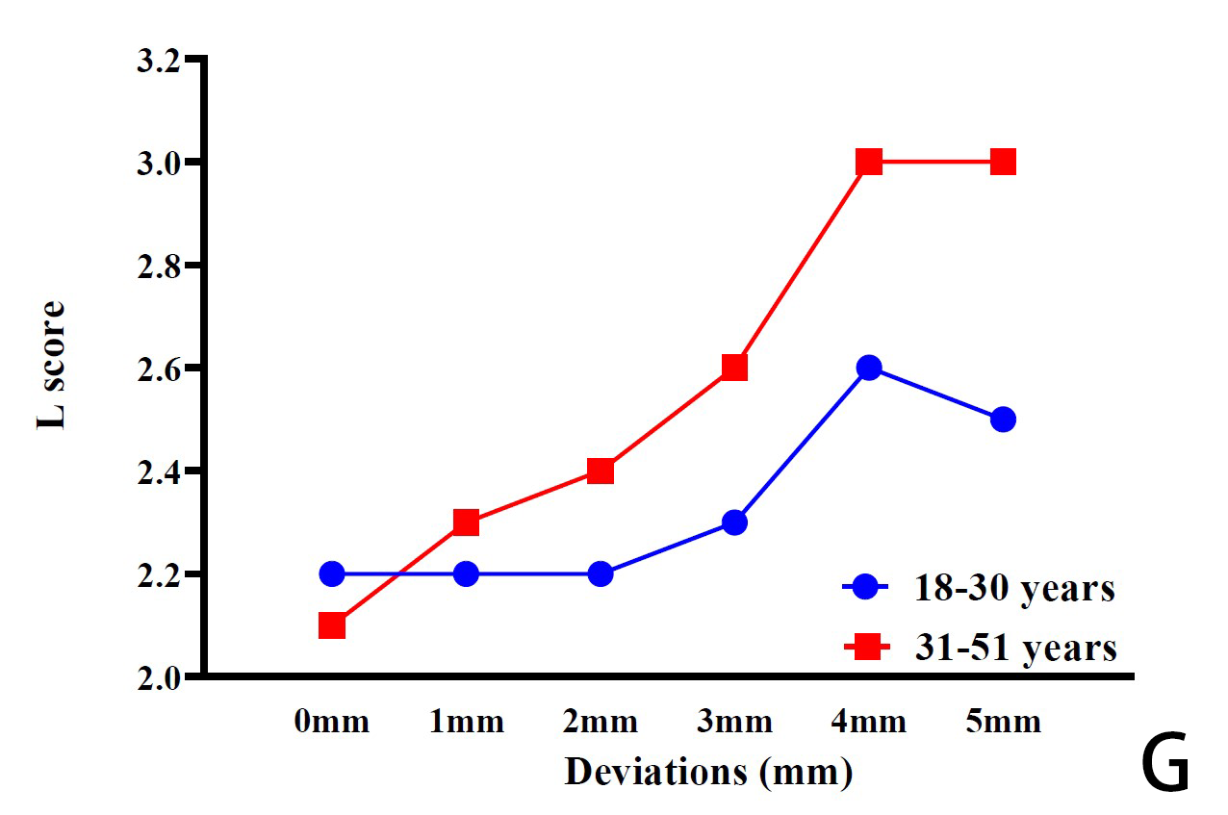
E
Additional file 4. Line graph showing the mean rating of attractiveness scores in NLC and L across categories of the profession (A, B), smile-associated structure NLC x L (C), gender (D, E), and age (F, G) by Chinese raters (n=281). A higher score implies a less attractive smile

