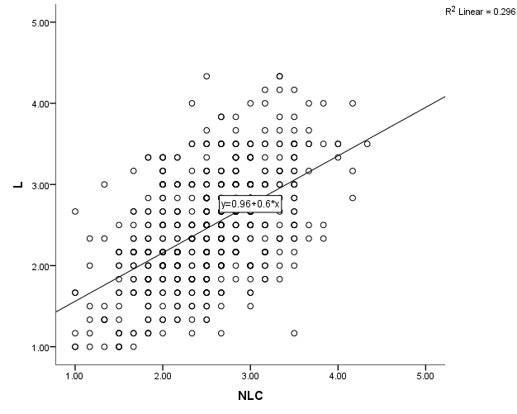
Additional file 6. A scatter plot shows the correlation between the deviations in (NLC and L) and the raters' mean values (n=561).

