Morphological changes in alveolar bone thickness and height after orthodontic proclination or labial movement combined with autogenous soft tissue grafting: a CBCT evaluation.
Tianyu Zhang^{1,+} , Lingling Zhang^{1,+}, Min Li², Fang Yi¹, Chengri Li¹, Yanqin Lu^{1,*}
¹ Department of Orthodontics, Hunan Key Laboratory of Oral Health Research & Hunan Clinical Research Center of Oral Major Diseases and Oral Health & Xiangya Stomatological Hospital & Xiangya School of Stomatology, Central South University，Changsha, 410008, Hunan, China.
² Department of Periodontics, Hunan Key Laboratory of Oral Health Research & Hunan Clinical Research Center of Oral Major Diseases and Oral Health & Xiangya Stomatological Hospital & Xiangya School of Stomatology, Central South University，Changsha, 410008, Hunan, China.
⁺ Tianyu Zhang and Lingling Zhang contributed equally to this study.
Corresponding Author: Y. Lu, Professor, PhD., Email: 213031@csu.edu.cn
⁺ Tianyu Zhang and Lingling Zhang contributed equally to this study.
Corresponding Author: Y. Lu, Professor, PhD.,
Department of Orthodontics, Hunan Key Laboratory of Oral Health Research & Hunan Clinical Research Center of Oral Major Diseases and Oral Health & Xiangya Stomatological Hospital & Xiangya School of Stomatology, Central South University，Changsha, 410008, Hunan, China.
Telephone：+86 13973102658
Email: 213031@csu.edu.cn
Author information:
Tianyu Zhang, Email: ilonew@163.com
Lingling Zhang, Email: zhanglingling@whu.edu.cn
Min Li, Email: liminlaxin@126.com
Fang Yi, Email: yifangcsu@163.com
Chengri Li, Email: lcr0928@hotmail.com
Yanqin Lu, 213031@csu.edu.cn

Supplementary Table S1. Patient basic characteristic.
Variable | N | %
Age | Mean 25.26±7.24 years
19-20 | 5 | 31.25%
20-29 | 9 | 56.25%
30-39 | 1 | 6.25%
40 and over | 1 | 6.25%
Gender
Male | 4 | 25.00%
Female | 12 | 75.00%
Tooth position
Center incisor | 11 | 18.33%
Lateral incisor | 11 | 18.33%
Canine | 19 | 31.67%
Premolar | 19 | 31.67%

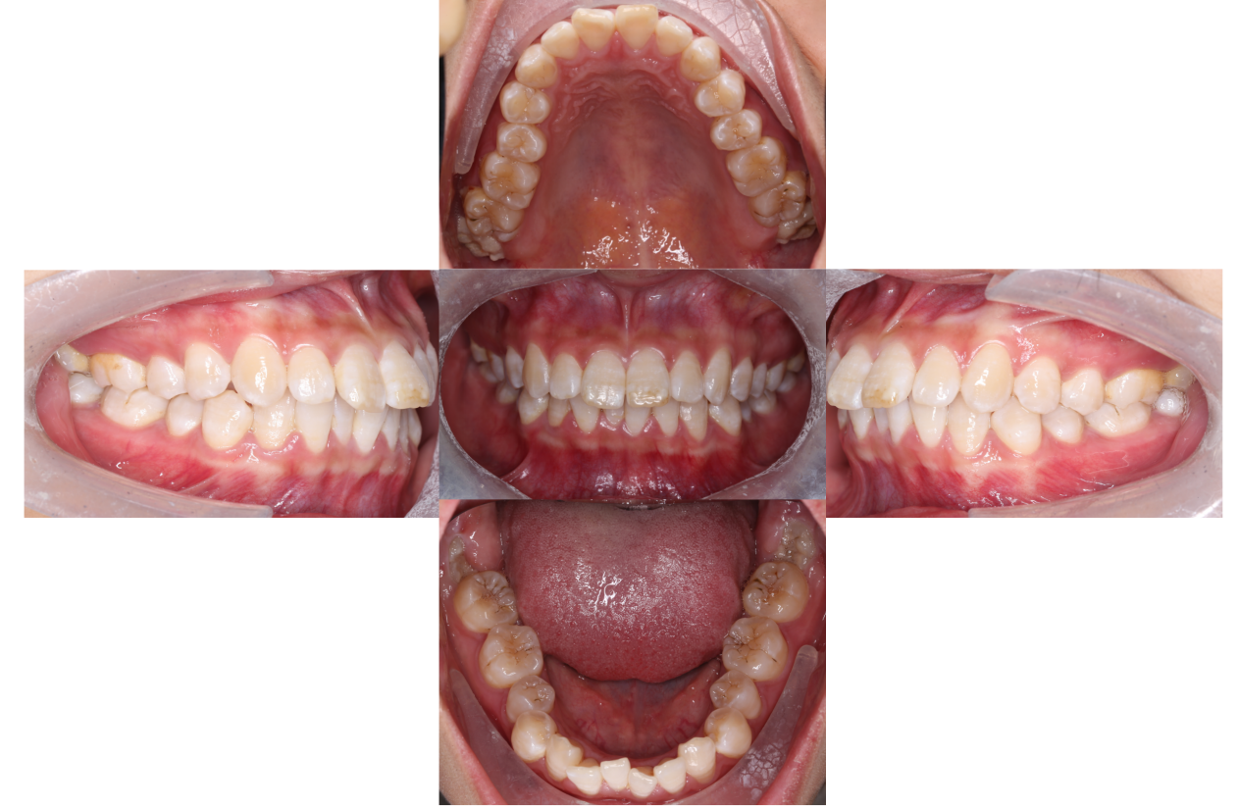
Supplementary Figure 1. Data of patient A before orthodontic treatment.

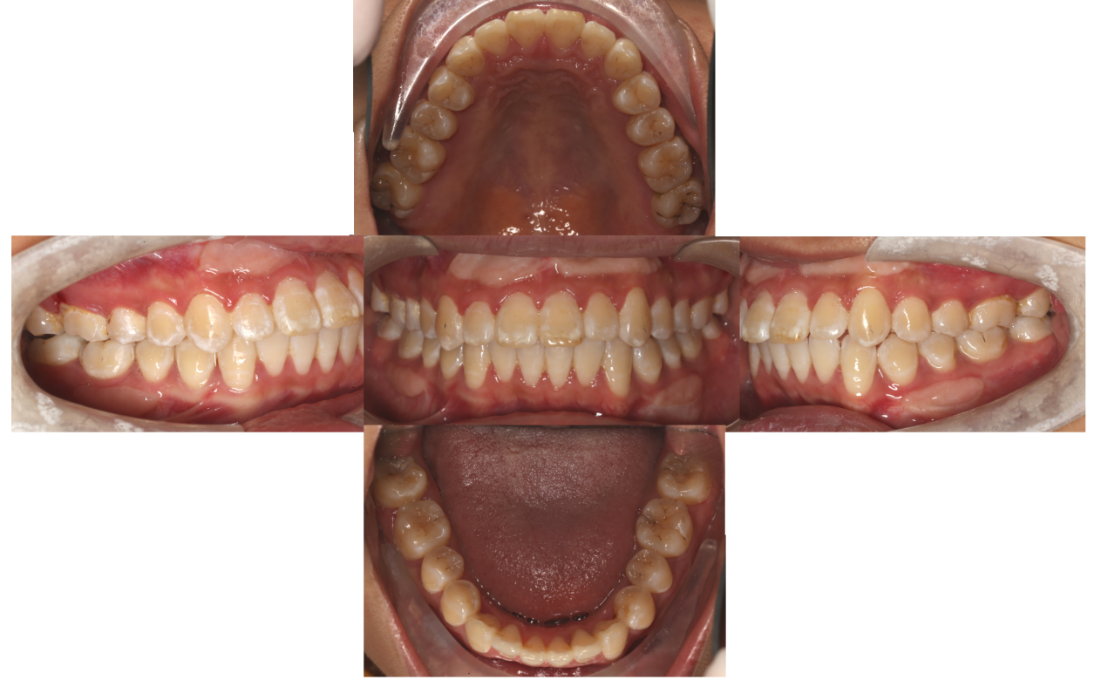
Supplementary Figure 2. Data of patient A after orthodontic treatment.

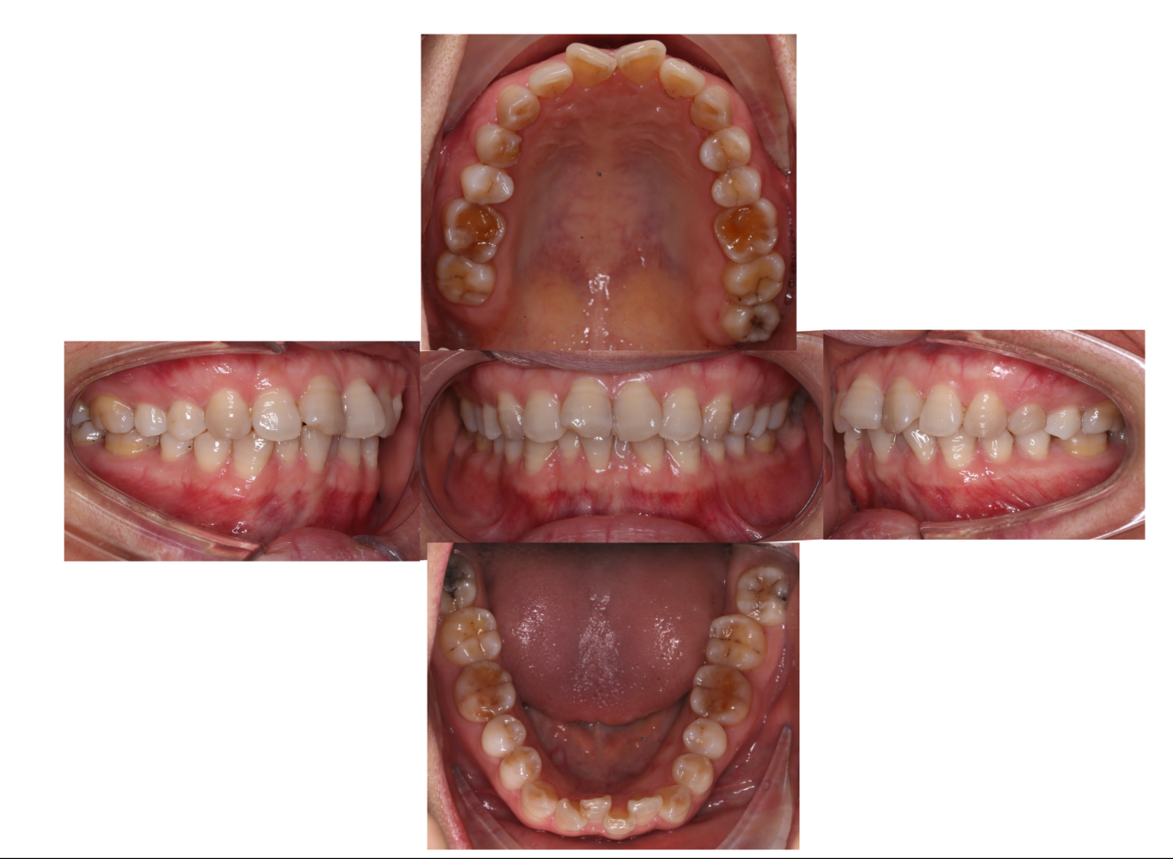
Supplementary Figure 3. Data of patient B before orthodontic treatment.

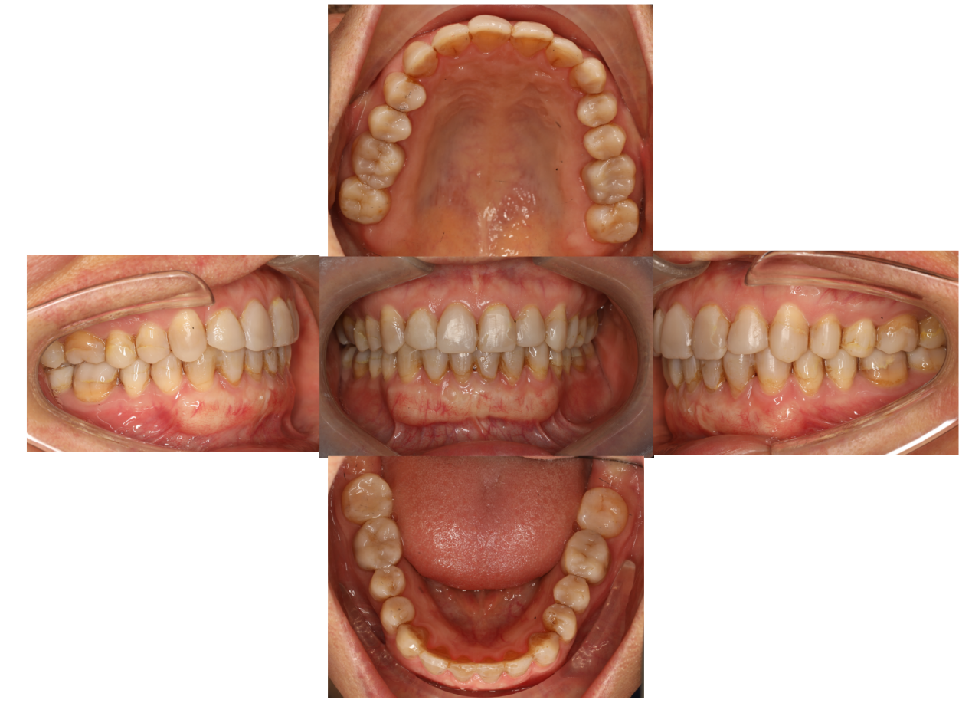
Supplementary Figure 4. Data of patient B after orthodontic treatment.

