Supplementary material
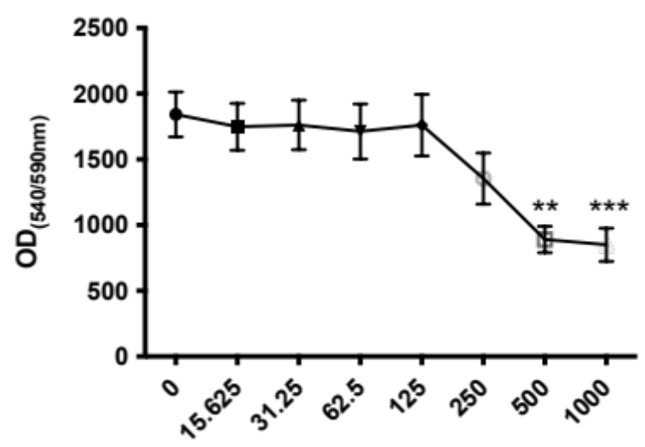
Supplementary figure 1. Cell viability assay of BMMs under various concentrations of IRAK4i (0, 15.625, 31.25, 62.5, 125, 250, 500 or 1000 nM).

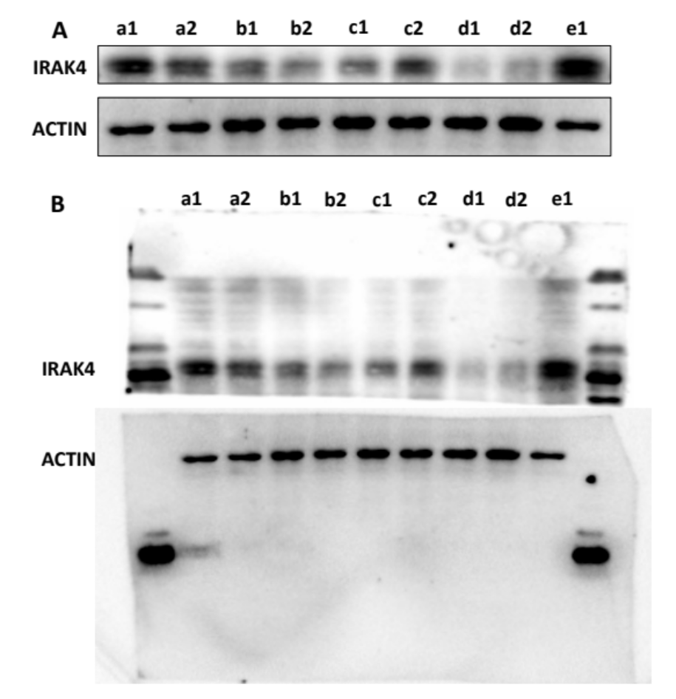
Supplementary figure 2. (A) Western blotting was used to screen out the effective IRAK4i-introducing method among various administration alternatives in vivo. Western blot was performed on bone tissues from a distance of about 5 mm around the implants.
a1: Control-SLA group, SLA implant was injected with PBS (100 μL) at the same time of implantation.
a2: Soaking-SLA group, SLA implant was soaked in IRAK4i solution before implantation.
b1: Dropping-SLA group, SLA implant was dropped with IRAKi (2500 nM, 100 μL) at the same time of implantation.
b2: Dropping-polished titanium (PT, without screw) group, PT implant was dropped with IRAK4i (2500 nM, 100 μL) at the same time of implantation.
c1: 100 μL inhibitor-SLA group, SLA implant was inserted after injecting with IRAK4i (2500 nM, 100 μL) within bone marrow at the implant sites.
c2: 100 μL inhibitor-PT group, PT implant was inserted after injecting with IRAK4i (2500 nM, 100 μL) within bone marrow at the implant sites.
d1: Subperiosteal 100 μL inhibitor-SLA group, SLA implant was inserted after injecting with IRAK4i (2500 nM, 100 μL) subperiosteally at the implant sites for 3 consecutive days.
d2: Subperiosteal 100 μL inhibitor-PT group, PT implant was inserted after injecting with IRAK4i (2500 nM, 100 μL) subperiosteally at the implant sites for 3 consecutive days.
e1: Non-implant group.
(B) The original western blot images of IRAK4 and ACTIN.

Supplementary figure 3. HLA-DR immunostaining staining on the decalcified section of the control group (PBS) and IRAK4i group. Representative images of HLA-DR after 3 (A), 7 (B), 28 days (C) of implantation. Brown cells with more than three nuclei were regarded as FBGCs.

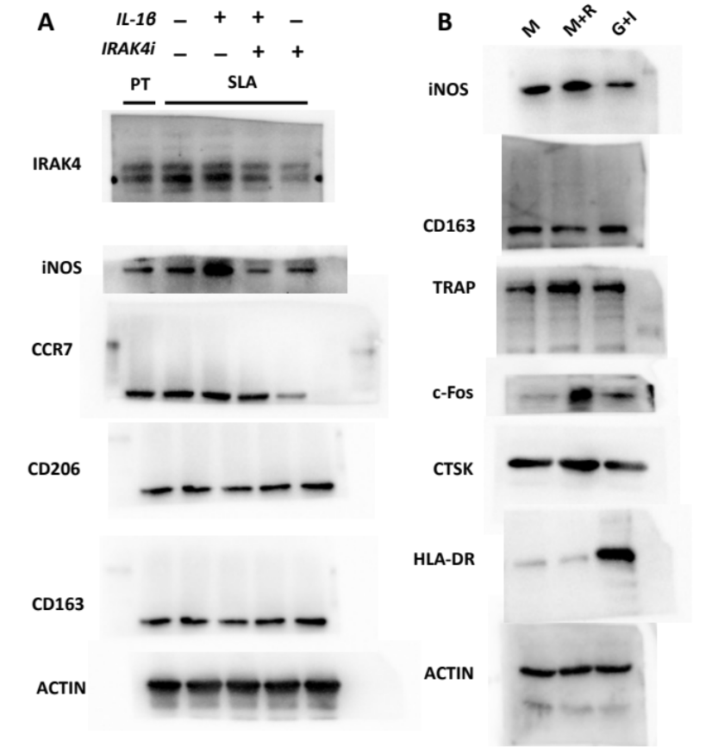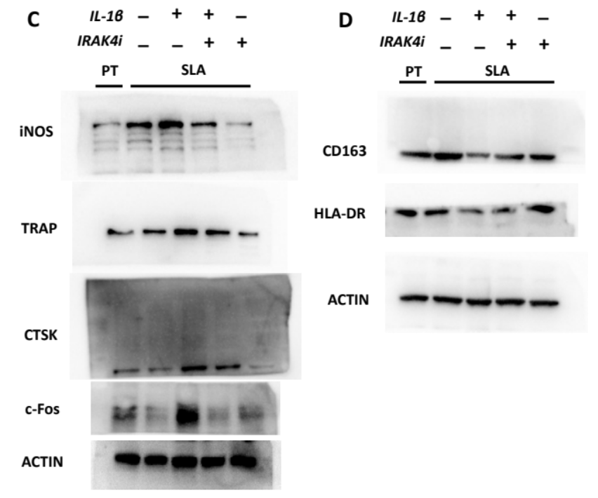
Supplementary figure 4. The original western blot images in full-length. (A) Western blotting of IRAK4, M1 Mø (iNOS, CCR7), M2 Mø (CD206, CD163) of BMMs after cultured on the SLA surfaces with the addition of Il-1β or IRAK4i. (B) Western blotting of iNOS, CD163, TRAP, CTSK, c-Fos, and HLA-DR of BMMs cultured on SLA surfaces in the presence of M-CSF (50 ng/ml) and RANKL (50 ng/ml), or GM-CSF (50 ng/ml) and IL-4 (50 ng/ml). (C) Western blotting of iNOS, TRAP, CTSK, and c-Fos in induced osteoclasts with different treatments. (D) Western blotting of CD163, and HLA-DR in induced FBGCs with different treatments of four groups.

