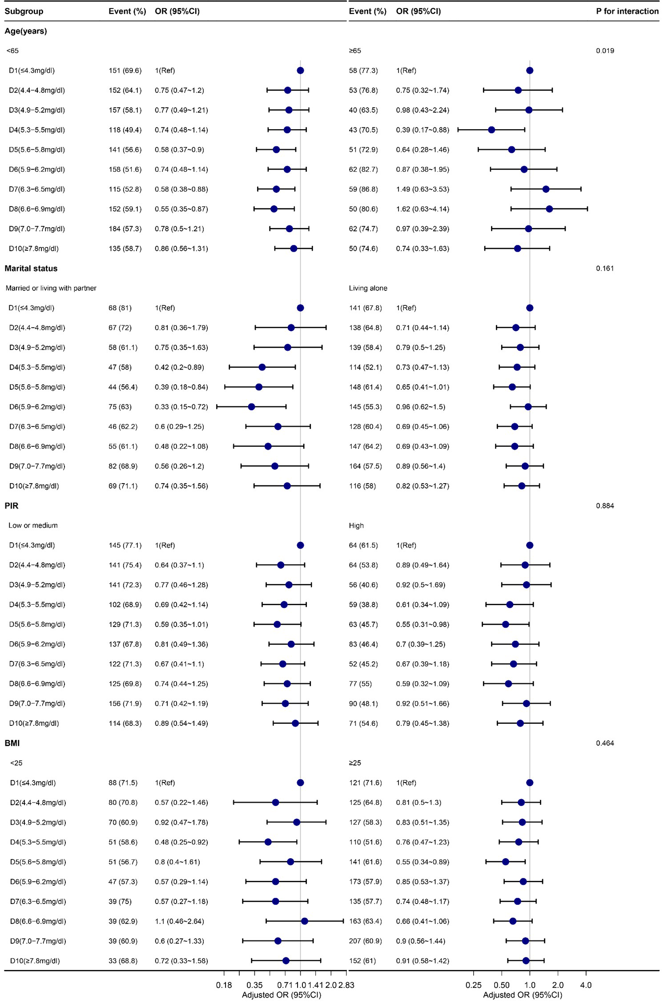
Supplementary Figure 2 Subgroup analyses of SUA and periodontitis in the male population. Except for the stratification component itself, each stratification factor was adjusted for all other variables (age, race/ethnicity, education, marital status, income-poverty ratio (PIR), alcohol status, smoking status, dietary fiber, total fat, body mass index (BMI), gout, congestive heart failure, coronary heart disease, angina, stroke, weak/failing kidneys, diabetes, hypertension and dental visit).

