Supplementary Information 1

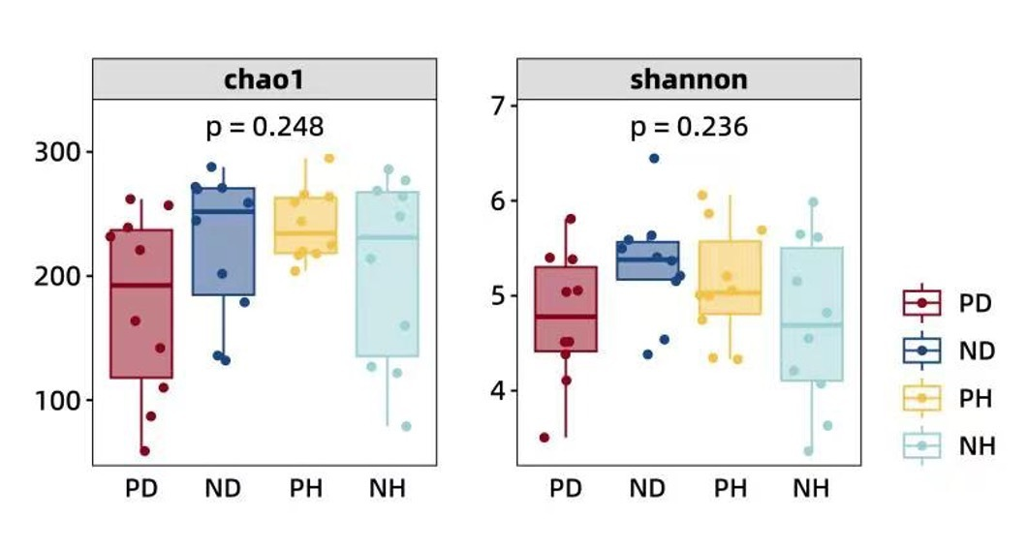
Additional Fig. 1 Alpha-diversity distributions shows lower richness and evenness in PD group comparing to ND group. p values were obtained by the Kruskal-Wallis rank sum test.

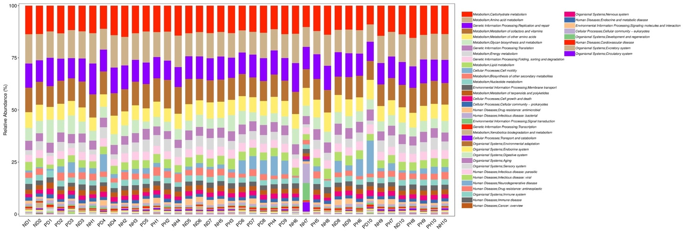
Additional Fig. 2 Overall functional composition of each subject from four study groups at KEGG level 2 shows similar predominant function units across groups.

