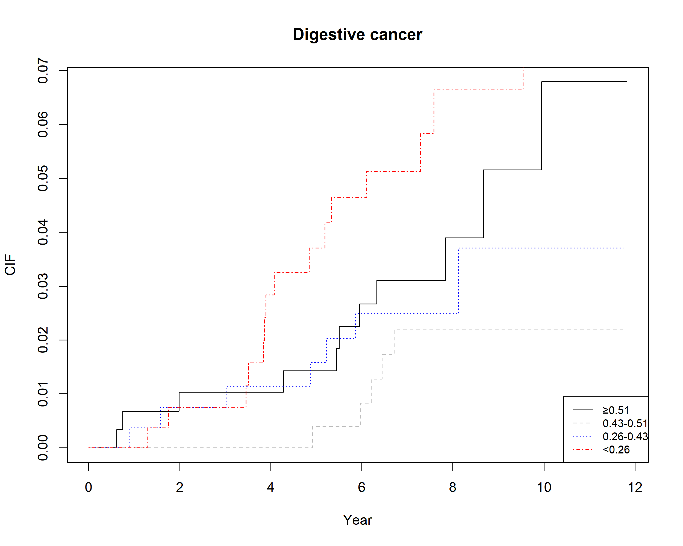
Supplementary figure 1. Increased risk of digestive cancer mortality associated with periodontal severity
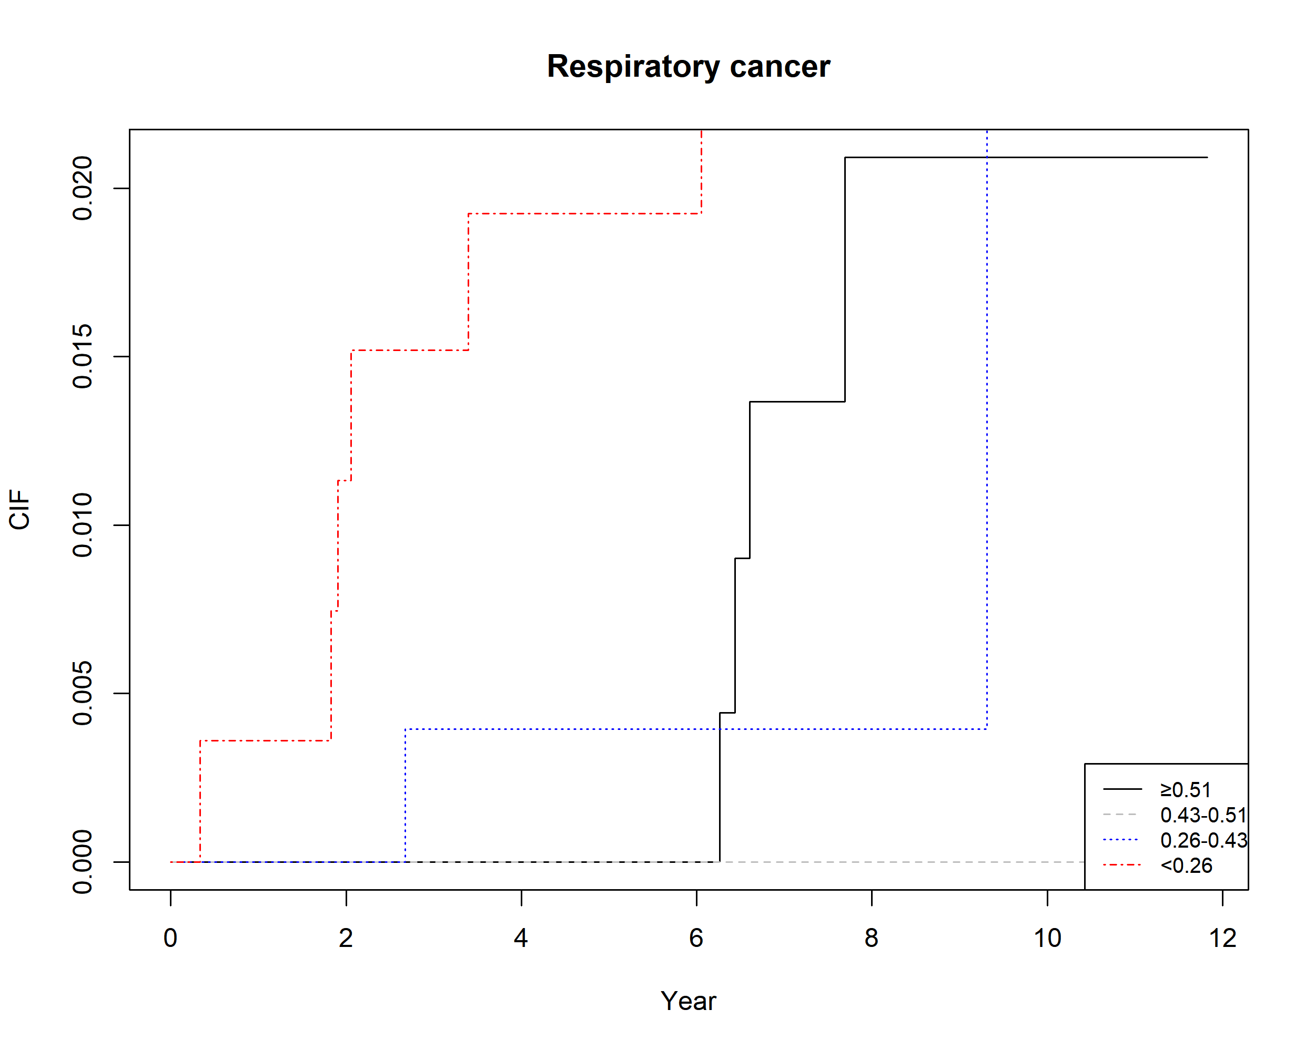
Supplementary figure 2. Increased risk of respiratory cancer mortality associated with periodontal severity

