Supplemental figure and tables
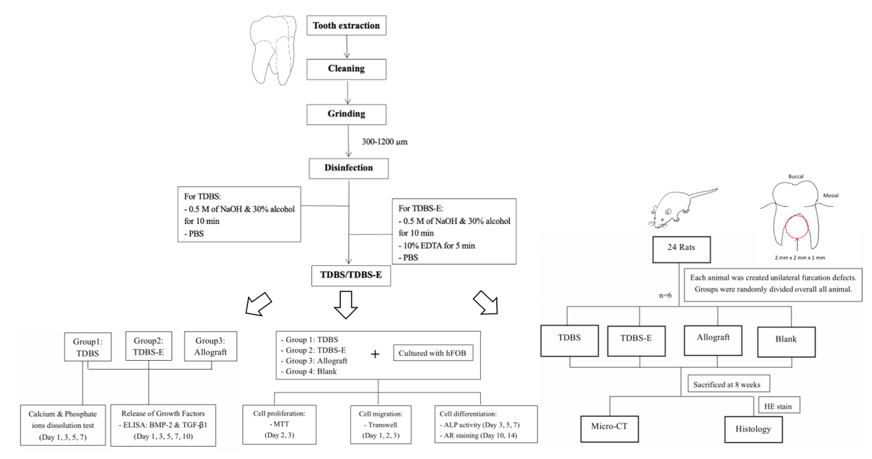

Figure S1 The design of the in vitro and in vivo experiments and the steps for teeth preparation.

Table S1 Four materials used in this study
Name | Source | Bone graft type | Composition | Size
TDBS | Teeth (Human) | Autogenous tooth particles | Enamel, dentin, and cementum | 300-1200 µm
TDBS-E | Teeth (Human) | Demineralized autogenous tooth particles | Demineralized Enamel, dentin, and cementum | 300-1200 µm
DO BONE | Bone (Human) | Allograft | Cancellous and cortical bone | 400-710 µm
BIO-GENE | Bone (Human) | Allograft | Cancellous and cortical bone | 300-1200 µm

Table S2 Inclusion and exclusion criteria of teeth collection
Inclusion criteria | - Patients aged 13-50 years  - Non-smokers  - Non-alcoholics  - Teeth extracted due to impaction or for orthodontic purposes
Exclusion criteria | - Patients with infectious diseases, such as hepatitis B, hepatitis C, or human immunodeficiency virus  - Teeth with extensive caries  - Previously undergone dental treatments: including fillings, root canal treatment, restorations, or prosthetic crowns  - Tooth malformation or congenital dental anomalies, such as fluorosis, enamel hypoplasia, amelogenesis imperfecta, dentinogenesis imperfecta, and dentin dysplasia

