Additional files 1:
Fig. S1 The growth and development of CB2^{-/-} mice. a PCR gel electrophoresis. b, c Body weight and body length of 6-week-old wild-type and CB2^{−/−} littermates. d, e There were no significant differences in body weights and length between two genotypes at 6 weeks. Values are means ± SD. NS, not significant. Full-length blots/gel is presented in Fig. S3.

The micro-CT results of mouse femur showed that (Fig. S2), compared with WT mice, CB1^{−/−} and CB2^{−/−} mice had significantly lower bone density and bone mass, and CB2^{−/−} mice had more pronounced reduction, indicating that CB2 had more prominent effect on bone mass maintenance.
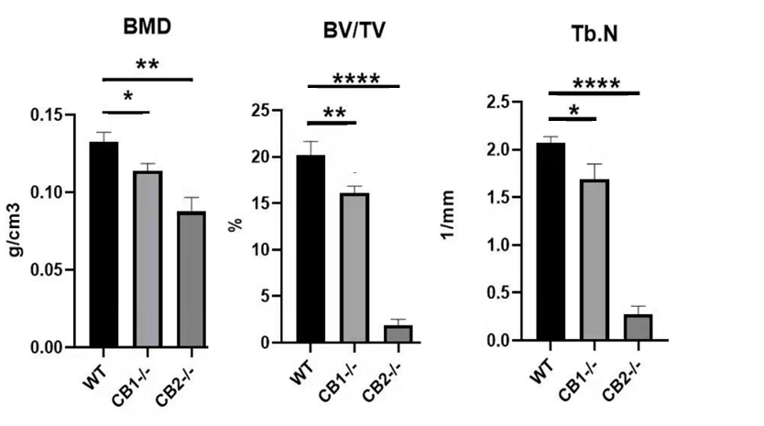
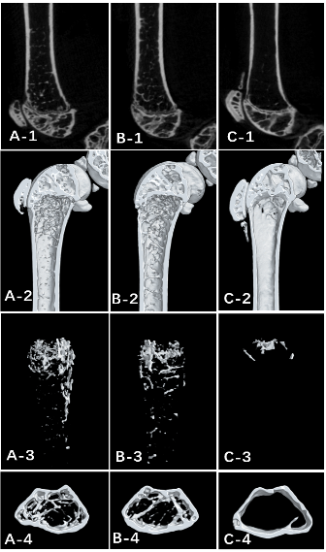
a
b

Fig. S2 Micro-CT analysis of 5-month-old mouse femur. a A WT mouse, B CB1^{−/−} mouse, C CB2^{−/−} mouse. b Statistic evaluation of Bone mineral density (BMD), Relative bone volume fraction (BV/TV) and trabecular number (Tb.N). Values are means ± SD. * P < 0.05, *** P < 0.001, and **** P < 0.0001.
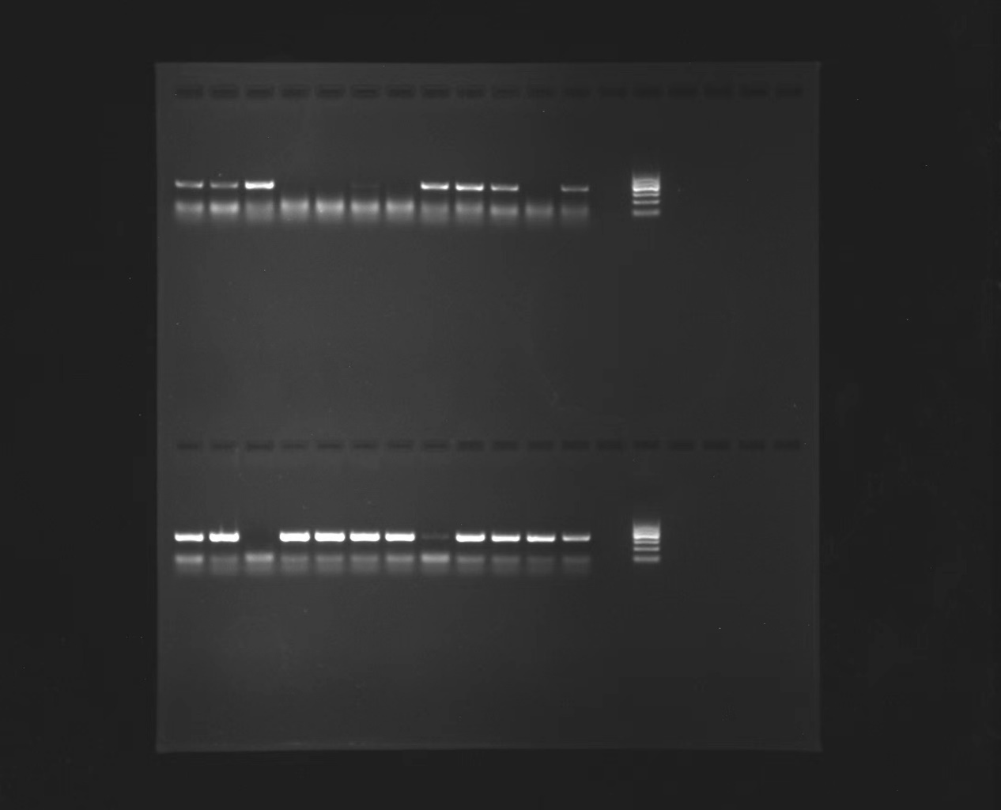
Fig. S3 Full-length PCR gel electrophoresis.

