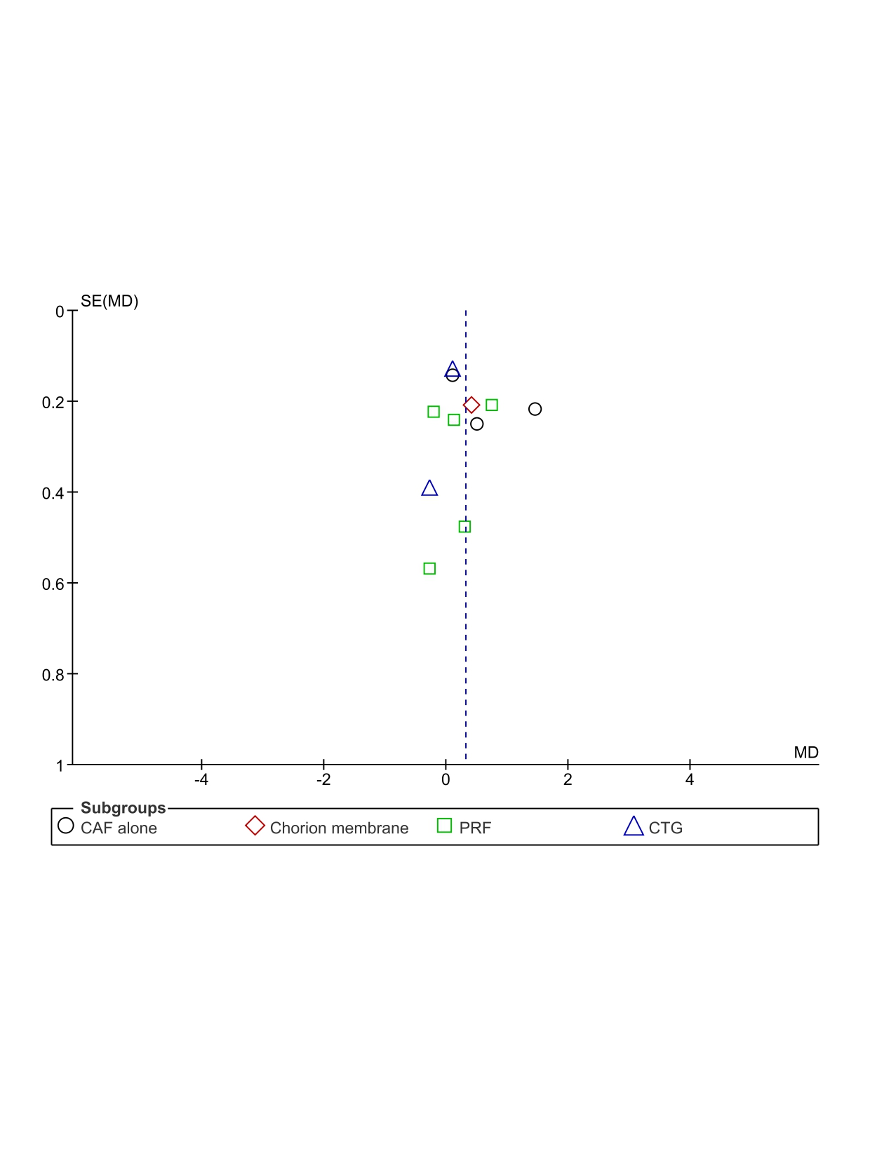
Fig.1: Funnel plot of RD reduction
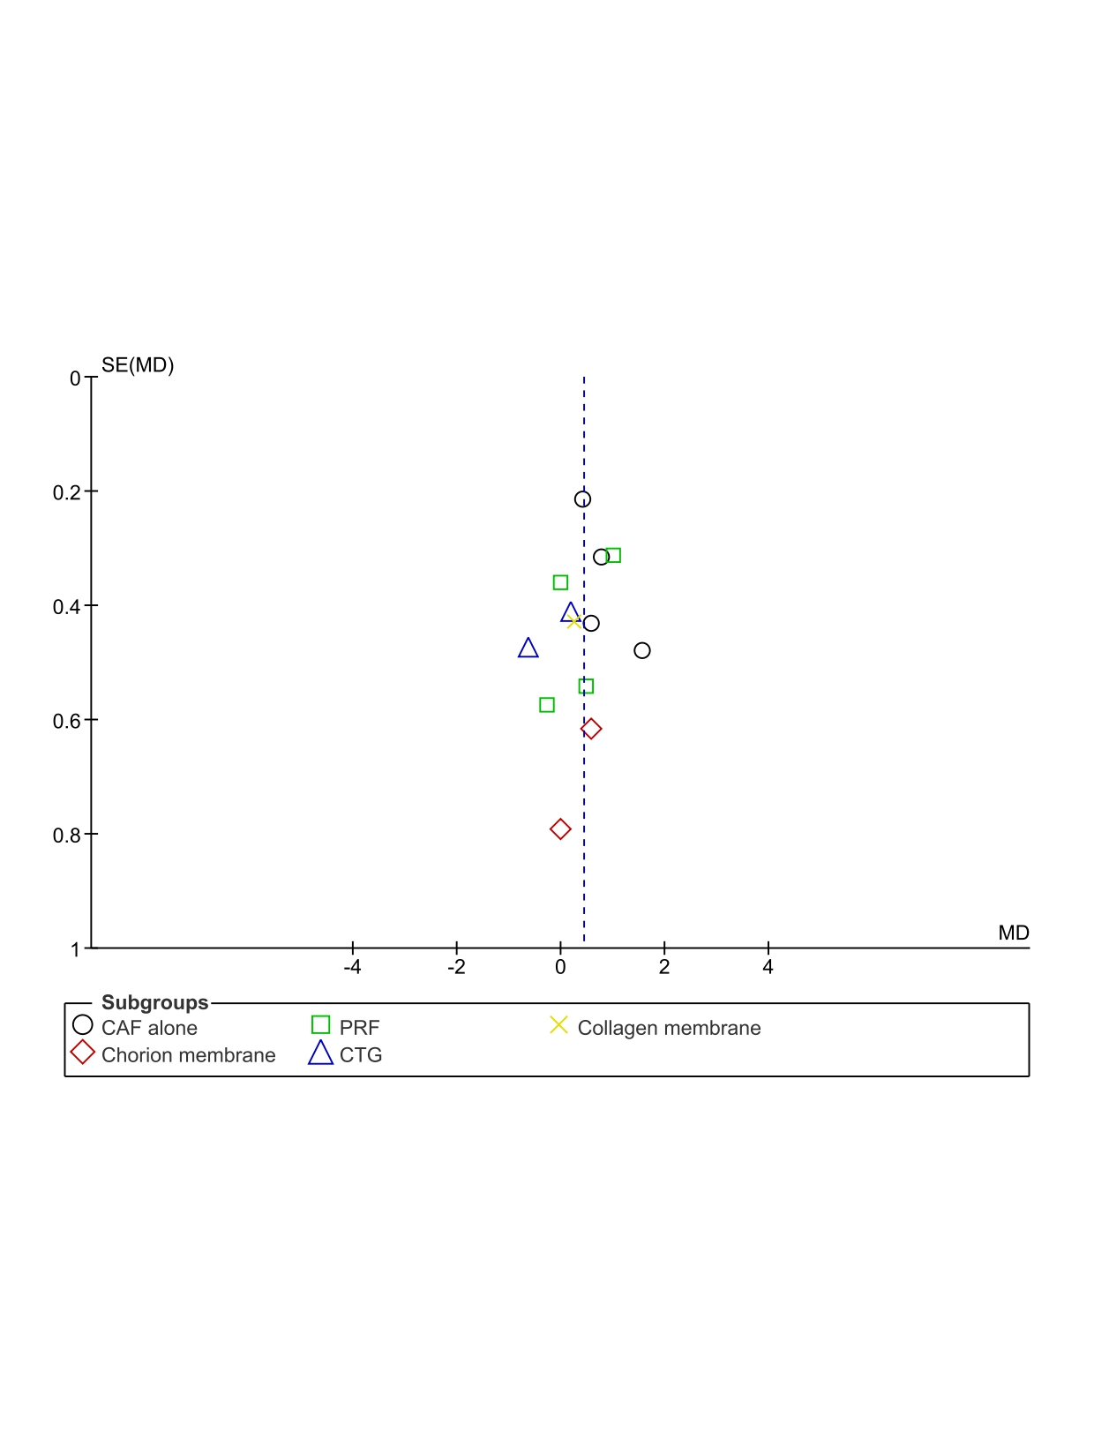
Fig.2: Funnel plot of RW reduction
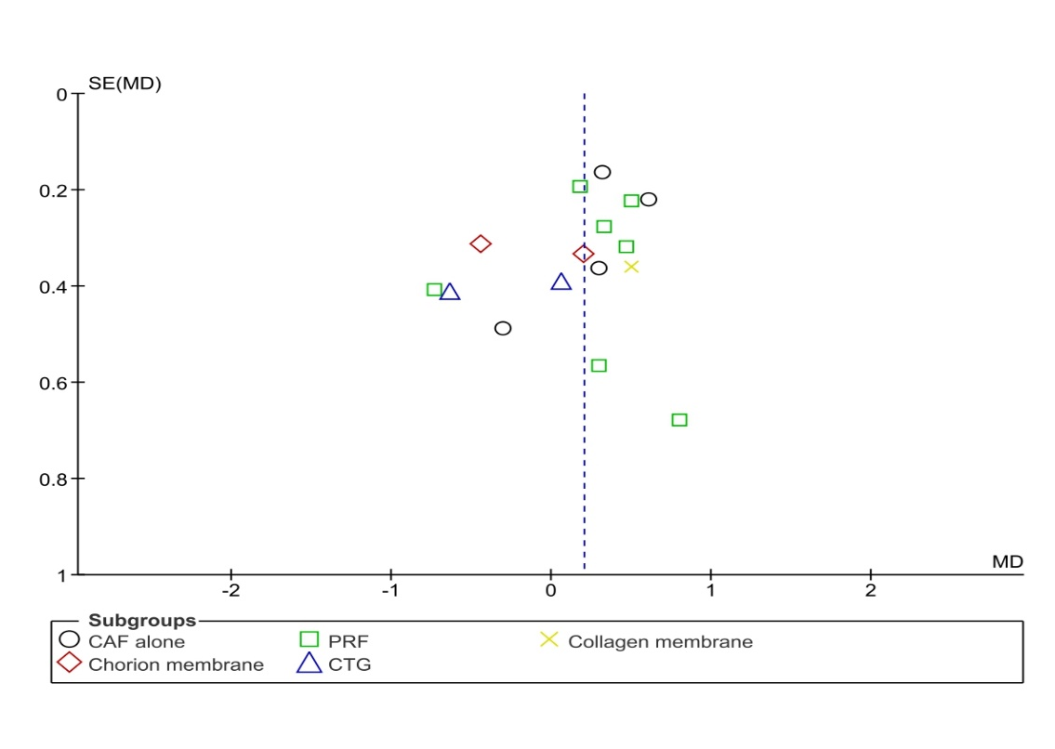
Fig.3: Funnel plot of WKG gain
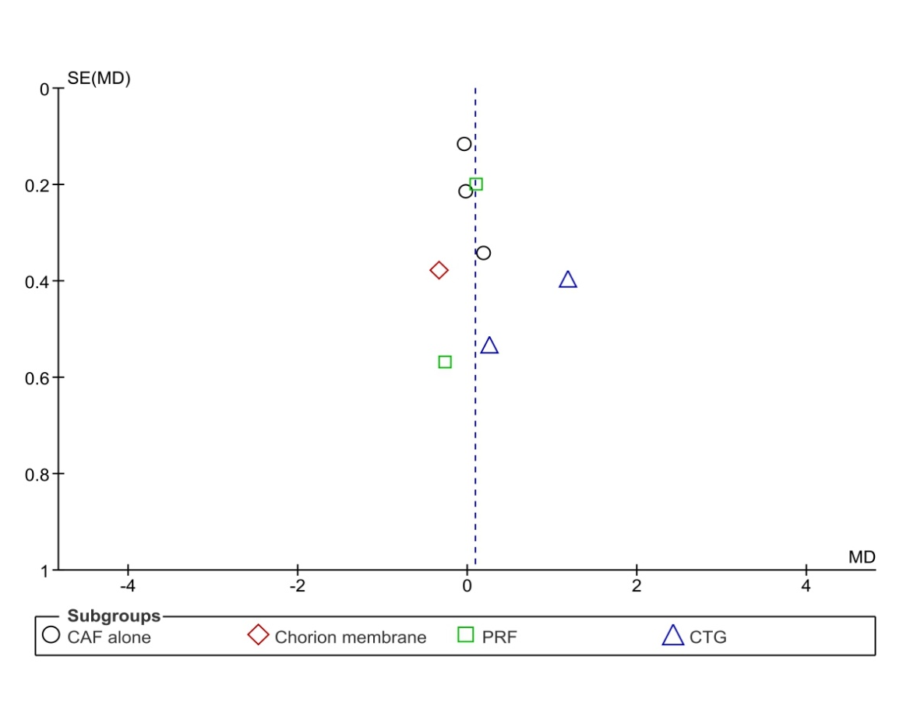
Fig.4: Funnel plot of CAL gain

