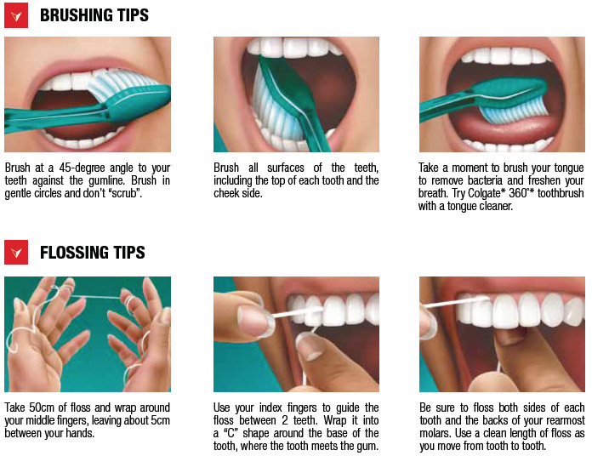

Figure: leaflet for oral hygiene instructions

