Supporting Information
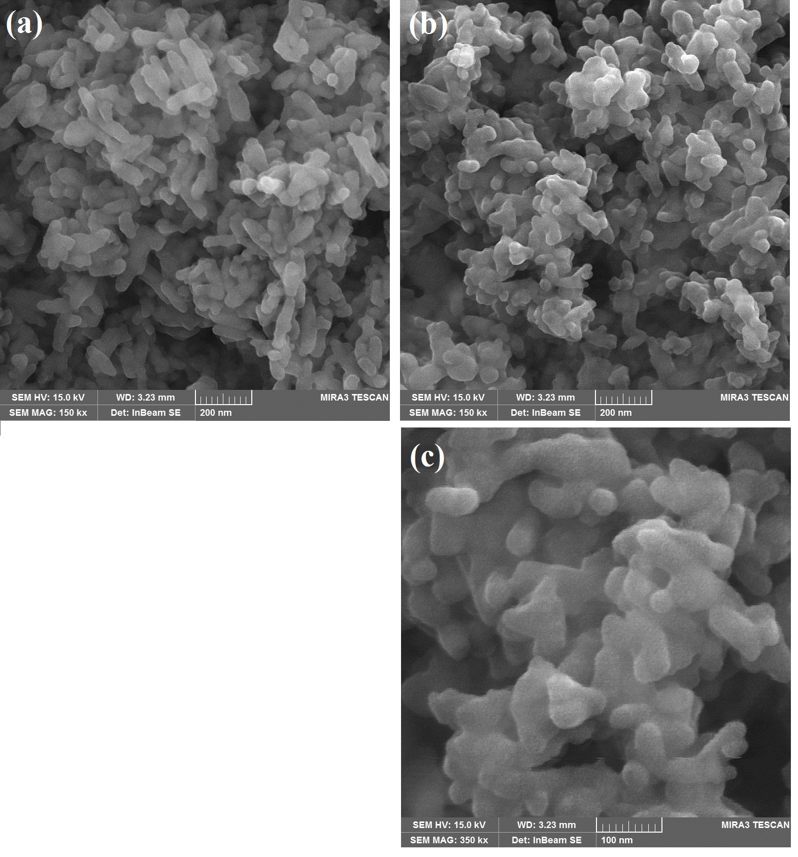
Fig. S1. FESEM image of (a) MCM-48 and (b,c) MCM-48/HA samples

