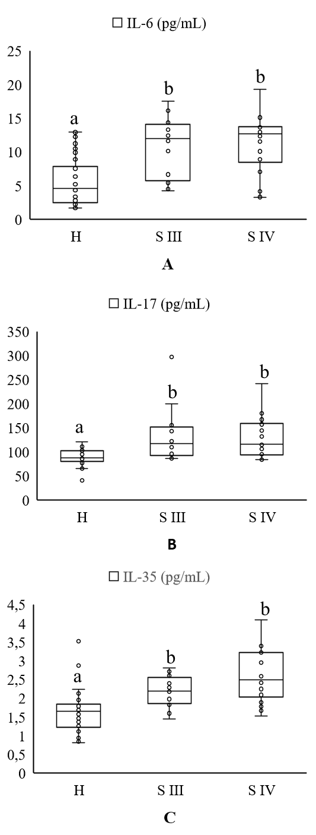
Additional Figure 1. A. Distribution of IL-6 levels in the H group and the periodontitis subgroups. B. Distribution of IL-17 levels in the H group and the periodontitis subgroups. C. Distribution of IL-35 levels in the H group and the periodontitis subgroups.
Abbreviations: H, healthy; S III, Stage III periodontitis; S IV, Stage IV periodontitis; IL, interleukin; pg, picogram; mL, milliliter.
a-b: Different letters represent significance.

