Figure 2. Odds ratios with 95% confidence intervals comparing reasons for consultations between Afghans and Syrians.
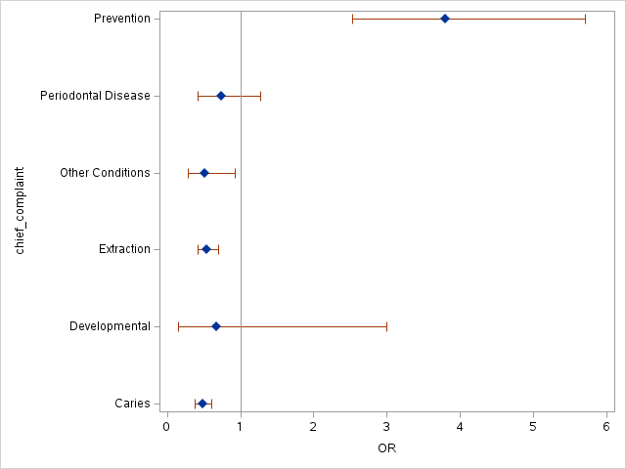
Dental Condition

