Supplemental Appendix
Evaluating and Comparing the Effects of Paracetamol and Ibuprofen on Wound Healing, MMP-9, and TGF-β1 Levels in Patients Following Upper Third Molar Tooth Extraction
S. Yuthavong, P. Chatiketu, O. Kerdto, P. Srichairatanakool, S. Srichairatanakool, and V. Chatupos

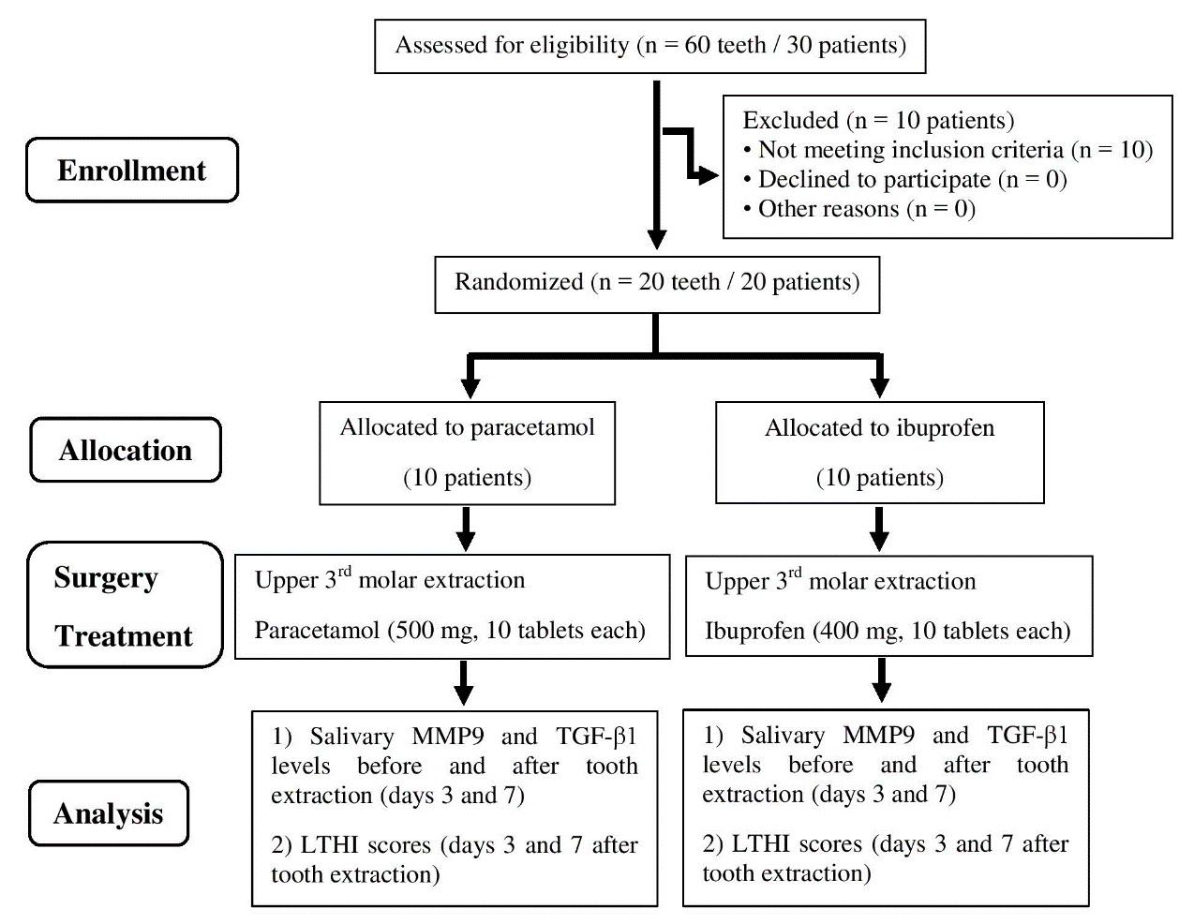
Figure S1. CONSORT flow diagram of the study design. Abbreviations: LTHI = Landry, Turnbull, Howley Index, MMP-9 = matrix metalloproteinase 9, TGF-β1 = transforming growth factor-beta 1.

Table S1. Individual information of patients enrolled in this study.
Code | Gender | Age (year) | Weight (kg) | Height (m) | BMI (kg/m²) | NSAID
1 | F | 22 | 51 | 1.55 | 21.23 | Paracetamol
5 | F | 20 | 52 | 1.58 | 20.83 | Paracetamol
6 | M | 25 | 62 | 1.70 | 21.45 | Paracetamol
8 | M | 20 | 60 | 1.72 | 20.28 | Paracetamol
9 | F | 15 | 47 | 1.60 | 18.36 | Paracetamol
11 | M | 23 | 58 | 1.68 | 20.55 | Paracetamol
15 | F | 21 | 51 | 1.60 | 19.92 | Paracetamol
16 | F | 23 | 53 | 1.60 | 20.70 | Paracetamol
18 | F | 19 | 49 | 1.56 | 20.13 | Paracetamol
20 | M | 21 | 59 | 1.70 | 20.42 | Paracetamol
2 | M | 19 | 65 | 1.75 | 21.22 | Ibuprofen
3 | F | 24 | 55 | 1.60 | 21.48 | Ibuprofen
4 | F | 20 | 48 | 1.55 | 19.98 | Ibuprofen
7 | F | 19 | 50 | 1.53 | 21.36 | Ibuprofen
10 | F | 22 | 47 | 1.55 | 19.56 | Ibuprofen
12 | M | 23 | 65 | 1.70 | 22.49 | Ibuprofen
14 | F | 21 | 52 | 1.60 | 20.31 | Ibuprofen
17 | F | 22 | 53 | 1.63 | 19.95 | Ibuprofen
19 | M | 34 | 60 | 1.72 | 20.28 | Ibuprofen
21 | M | 22 | 58 | 1.70 | 20.07 | Ibuprofen
Abbreviation: BMI = body mass index, NSAID = nonsteroidal anti-inflammatory drug.

Table S2. Absolute MMP-9 and TGF-β1 concentration and LTHI scores measured in patients who received tooth extraction and treatment of paracetamol or ibuprofen (n = 10 each) for 0, 3 and 7 days.
Code | Salivary MMP-9 (pg/mL) |  |  | Salivary TGF-β1 (pg/mL) |  |  | LTHI score
Code | Day 0 | Day 3 | Day 7 | Day 0 | Day 3 | Day 7 | Day 3 | Day 7
1 | 6.45 | 5.49 | 1.37 | 77.04 | 46.5 | 93.41 | 3 | 4
5 | 5.86 | 3.75 | 3.79 | 70.45 | 36.9 | 78.44 | 2 | 4
6 | 5.85 | 4.32 | 3.34 | 65.2 | 47.41 | 74.15 | 3 | 4
8 | 5.03 | 1.89 | 3.08 | 61.5 | 54.51 | 52.05 | 2 | 3
9 | 3.25 | 2.60 | 5.52 | 66.49 | 51.74 | 61.84 | 3 | 4
11 | 5.59 | 1.86 | 2.40 | 71.43 | 44.52 | 43.54 | 3 | 4
15 | 2.62 | 3.83 | 4.49 | 68.43 | 40.02 | 52.74 | 2 | 3
16 | 6.29 | 1.46 | 2.43 | 58.23 | 42.29 | 52.62 | 3 | 4
18 | 4.28 | 6.83 | 6.33 | 45.12 | 44.23 | 47.36 | 2 | 3
20 | 6.17 | 4.97 | 2.87 | 47.51 | 43.04 | 49.34 | 3 | 4
2 | 3.73 | 6.73 | 5.84 | 47.21 | 51.84 | 61.27 | 2 | 3
3 | 4.09 | 5.38 | 4.18 | 88.19 | 40.68 | 53.75 | 2 | 4
4 | 6.29 | 5.84 | 4.56 | 80.89 | 53.01 | 56.9 | 3 | 4
7 | 5.21 | 6.28 | 1.96 | 66.37 | 55.59 | 72.17 | 2 | 3
10 | 3.69 | 3.80 | 2.33 | 54.72 | 95.79 | 83.38 | 2 | 3
12 | 4.62 | 6.81 | 3.31 | 82.2 | 60.93 | 95.09 | 3 | 4
14 | 5.41 | 6.48 | 1.75 | 40.96 | 39.76 | 72.2 | 2 | 4
17 | 4.77 | 7.43 | 3.62 | 38.17 | 59.57 | 48.16 | 2 | 3
19 | 2.26 | 6.66 | 5.04 | 56.24 | 39.83 | 49.85 | 3 | 4
21 | 6.36 | 6.88 | 5.14 | 55.12 | 49.85 | 59.04 | 2 | 3
Abbreviation: LTHI = Landry, Turnbull, Howley Index, MMP-9 = matrix metalloproteinase 9, TGF-β1 = transforming growth factor-beta1.

Table S3. Median ± IQR values of salivary MMP-9 and TGF-β1 concentration and the significant differences among patients who received tooth extraction and treatment of paracetamol or ibuprofen (n = 10 each) for 0, 3 and 7 days.
Treatment | Time | Salivary MMP-9 (pg/mL) |  |  | Salivary TGF-β1 (pg/mL)
Treatment | Time | Absolute value | Difference | P-value | Absolute value | Difference | P-value
Paracetamol | Day 0 | 5.72 ± 1.89 | - | - | 65.85 ± 12.22 | - | -
Paracetamol | Day 3 | 3.79 ± 3.08 | z = 1.965 | 0.049 | 44.38 ± 5.12 | z = 3.326 | 0.001
Paracetamol | Day 7 | 3.21 ± 2.06 | z = 0.151 | 0.880 | 52.68 ± 24.81 | z = -1.626 | 0.545
Ibuprofen | Day 0 | 4.70 ± 1.68 | - | - | 55.68 ± 33.68 | - | -
Ibuprofen | Day 3 | 6.57 ± 0.97 | z = -2.721 | 0.007 | 52.43 ± 18.89 | z = 0.832 | 0.406
Ibuprofen | Day 7 | 3.90 ± 2.71 | z = 3.290 | 0.001 | 60.16 ± 18.45 | z = -0.756 | 0.450
Abbreviation: IQR = interquartile range, MMP-9 = matrix metalloproteinase 9, TGF-β1 = transforming growth factor-beta1.

