Audit of Oral Neoplasms in Children and Young Adults in Nigeria
Adetayo Oluwole Aborisade¹, Efetobo Victor Orikpete^{2*}, Adeola Temitope Williams³, Yewande Isabella Adeyemo⁴, Abdul-Warith Olaitan Akinshipo⁵, Mofoluwaso Olajide⁶, Chukwubuzor Udokwu Okwuosa⁷, Mark Chukwuemeka Nwoga⁸, Taoheed Olaide Mudasiru⁹, Mujtaba Bala¹⁰, Mohammed A.S Abdullahi¹¹, Akinyele Olumuyiwa Adisa¹²

¹Department of Oral Diagnostic Sciences, Bayero University, Kano

²Department of Oral Pathology, Oral Medicine and Oral Radiology, Faculty of Dentistry University of Port Harcourt, Nigeria.

³Department of Child Oral Health, Faculty of Dentistry, University of Ibadan, Ibadan, Nigeria and University College Hospital, Ibadan, Nigeria.

⁴Department of Child Dental Health, Faculty of Dentistry, Bayero University, Kano and Aminu Kano Teaching Hospital, Kano.

⁵Department of Oral and Maxillofacial Pathology/Biology, Faculty of Dental Sciences, University of Lagos, Lagos, Nigeria

⁶Department of Oral Pathology and Oral Medicine, Faculty of Dentistry, Lagos State University College of Medicine, Ikeja, Lagos

⁷Department of Oral Medicine and Oral Pathology University of Nigeria, Enugu campus and University of Nigeria Teaching Hospital, Ituku-Ozalla Enugu Nigeria

⁸Department of Oral Medicine and Oral Pathology University of Nigeria Teaching Hospital, Ituku-Ozalla Enugu Nigeria

⁹Department of Oral and Maxillofacial Surgery, Ahmadu Bello University Teaching Hospital, Zaria
¹⁰Department of Dental & Maxillofacial Surgery, Usmanu Danfodiyo University Teaching Hospital, Sokoto, Nigeria.

¹¹Department of Oral and Maxillofacial Surgery, University of Maiduguri Teaching Hospital, Borno

¹²Department of Oral Pathology, Faculty of Dentistry, University of Ibadan, Ibadan, Nigeria and University College Hospital, Ibadan, Nigeria

Correspondence:
E.V. Orikpete
Department of Oral Pathology, Oral Medicine and Oral Radiology,
Faculty of Dentistry
University of Port Harcourt,
Nigeria.
efezi2000@yahoo.com,

Abstract
Background
Orofacial neoplasms in children and young adults may differ significantly from those observed in adults. Our aim was to describe the epidemiological characteristics of histologically diagnosed orofacial neoplasms among children and young adults in Nigeria.
Methods
This was a multicenter cross-sectional study across geopolitical zones in Nigeria. Annual reports of clinical information and surgical biopsies submitted at the Oral Pathology Laboratory, clinic day registries, surgical day case registries and operative theatre registries were retrieved from January 2008 to March 2024. The relevant demographic data were obtained for each patient. The study subjects were categorized by age into children, adolescents and young adults. Tissue involvement was classified as soft tissue involvement, bony involvement or both soft tissue and bony involvement. The site and behaviour of the lesions were subdivided according to the ICD-10 codes. Statistical analysis was performed via the R programming language.
Results
A total of 1889 cases were observed during the period under review, with a mean age of 15 years. Cases were more common in females (52%) and in young adults (47%). Most cases were benign neoplasms (85%), and bony affectation (54%) was slightly predominant. Odontogenic tumours (38%) and fibro-osseous lesions (20%) were the most common category of lesions observed, whereas salivary gland tumours (2.2%) and neoplasms of epithelial origin (2.5%) were the least common. Neoplasms in children involve mostly soft tissues, whereas those in adolescents and young adults have a preference for bone (p< 0.001). In all age groups, benign lesions were mostly observed in the mouth and pharynx. For malignant lesions, in children, the bones of the skull and face were mostly involved, whereas in adolescents, the mandible was the predominant site (p< 0.001). In children, mesenchymal neoplasms were the most prevalent category of lesions, whereas in both adolescents and young adults, odontogenic tumours were more common. The proportion of malignant neoplasms in males was significantly greater than that in females (p < 0.001).
Conclusion
This study revealed that although most biopsied orofacial lesions were more often benign, the proportion of malignant neoplasms in this population was greater than that previously reported.

Keywords: Neoplasm, Orofacial, Children, Young adults, Tumour, Nigeria

Audit of Oral Neoplasms in Children and Young Adults in Nigeria
Introduction
Orofacial neoplasms are abnormal, uncontrolled growths that occur in oral, perioral and facial structures(1). They may be derived from epithelial, mesenchymal, lymphoid or neuroendocrine sources and can be categorized into benign and malignant neoplasms. (1,2) Benign neoplasms grow slowly, have a lower propensity to invade surrounding tissues, and do not spread to distant sites. Malignant neoplasms, on the other hand, grow more rapidly, invade surrounding tissues and often spread to distant sites.(2) Children and young adults constitute a unique population with different physical, mental, emotional and social developments (3), and the epidemiological and clinical characteristics of orofacial neoplasms in this population may differ significantly from those of adults. (3,4)
Several authors have reported on oral/orofacial conditions in children and adolescents. However, many of these studies have focused on dental caries, periodontal diseases, trauma and malocclusion. (5,6) Reports on orofacial lesions requiring biopsy are much rare, and even fewer reports are specific to orofacial neoplasms in this population. Most studies on biopsied orofacial lesions in children and adolescents have reported that nonneoplastic or tumour-like lesions are more common in this age group, (3,7,8) although some studies have reported more cases of neoplastic lesions. (9,10) Orofacial neoplasms in this age group are highly important and impact not only the individual but also the household and the entire community. (11) Establishing evidence-based epidemiological characteristics of orofacial neoplasms in this subset of the population will help improve clinical diagnosis, support the planning of oral health intervention programs and inform policy formulation. (9,11)
The prevalence of disease varies with geographical location; thus, it is important to establish the epidemiological characteristics of diseases in specific locations. (12) Several Nigerian studies have described the prevalence and distribution of biopsied orofacial lesions among children and adolescents. (9,10,13–16) However, these studies have been limited to single institutions or regions, (9,10,13–15) whereas others have focused on subsets of orofacial tumours. (13,16) The aim of this study was to describe the epidemiological characteristics of histologically diagnosed orofacial neoplasms among children and young adults in Nigeria. This study provides a comprehensive multicentre representation of the occurrence and distribution of orofacial neoplasms among children and young adults in Nigeria.

Methods
Study Design
This was a multicentre cross-sectional study conducted across five (5) of six geopolitical zones in Nigeria. Nigeria is the most populous country in Africa, with six (6) geopolitical zones. The South‒West Zone is represented by three tertiary institutions. The North‒West Zone has two representative tertiary centres, whereas the other zones each have one representative centre. These centres are the foremost tertiary institutions in their respective regions, offering services to their host states and the nearby towns and cities. Annual reports of clinical information and all surgical biopsies submitted at the Oral Pathology Laboratory, clinic day registries, surgical day case registries and operative theatre registries were retrieved from January 2008 to March 2024 and imputed into a Microsoft Excel spreadsheet via a uniform proforma and code book. The demographic data obtained for each patient included the identification number, age, sex, involved structures, lesion site, geopolitical zone of each centre, histological diagnosis of the lesion, and clinical presentation of the lesion. Data entry was completed by a single researcher for each centre, and the final data entry, synthesis, cleaning and analysis were performed by one designated researcher. All the data were deidentified before the initial and final data collation. The exclusion criteria included duplicated cases, reports lacking adequate information, and those with ambiguous histologic diagnoses.
Ages were classified via a modified UNAIDS categorization(17) into three subcategories. i) 0–9 years (children). ii) 10–16 years (adolescents) and iii) 17–24 years (young adults). Tissue involvement was classified as i) peripheral or soft tissue involvement, ii) bony involvement, or iii) both peripheral and bony involvement.
The site and behaviour of the lesion were subdivided according to the following ICD-10 codes(18):
- Benign neoplasms of bones of the skull and face (D16.4) (BNSF)
- Benign neoplasms of the lower jawbone (D16.5) (BNM)
- Benign neoplasms of the mouth and pharynx (D10) (BNMP)
- Malignant neoplasms of bones of the skull and face (C41.0) (MNSF)
- Malignant neoplasms of the mandible (C41.1) (MNM)
- Malignant neoplasms of the lip, oral cavity and pharynx (C00--C14) (MNMPs)
Lesions were grouped into categories by using a modified version of Akinyamoju's diagnostic criteria for the classification of oral lesions. (19) Neoplasms are categorized into
- Cystic lesions (CLs)
- Benign fibro-osseous lesions (including other bone-related lesions) (FOLs)
- Odontogenic tumours (OTs)
- Nonodontogenic epithelial tumours (ETs)
- Nonodontogenic mesenchymal tumours (MTs)
- Salivary gland tumours (SGTs)
- Haematolymphoid tumours (HLTs)
Statistical analysis
Descriptive statistics were conducted for sociodemographic variables such as age, age, sex and tumor location. The categorical variables are expressed as frequencies, tables and proportions, whereas the continuous variables are expressed as the means with standard deviations and medians with IQRs. Student’s t test and ANOVA were used to compare mean differences in the variables; Shapiro‒Wilk and Levene tests were subsequently used to confirm the normality of the data and homogeneity of variance, respectively. Suitable nonparametric alternatives were utilized when the normality of distribution and homogeneity of variance were breached. The chi-square test with Fisher’s approximation was also used to compare the proportions of the different categories across the age categories, locations of the tumours, and types of lesions where necessary. All tests of significance were set at p<0.05.
Multivariate analysis of characteristics was performed via factor analysis of mixed data (FAMD) to visualize the distinct separation of orofacial neoplasms into benign and malignant types. The most significant predictors of the type of neoplasm were selected based on their contribution to the FAMD. All the statistical analyses were performed via the R programming language (version 4.3.3).

Results
General characteristics
A total of 1899 cases were observed between the years 2008 and the first quarter of 2024 across the five geopolitical zones represented by government tertiary centres in each zone. The lowest number of cases were observed in 2008 (n=44, 2.32%), whereas the highest number of cases of orofacial neoplasms was recorded in 2022 (n=324,17.1%). A sharp decline in cases was observed after 2022 (Figure 1). The distributions of the reviewed cases of orofacial neoplasms across geopolitical zones are shown in Table 1.

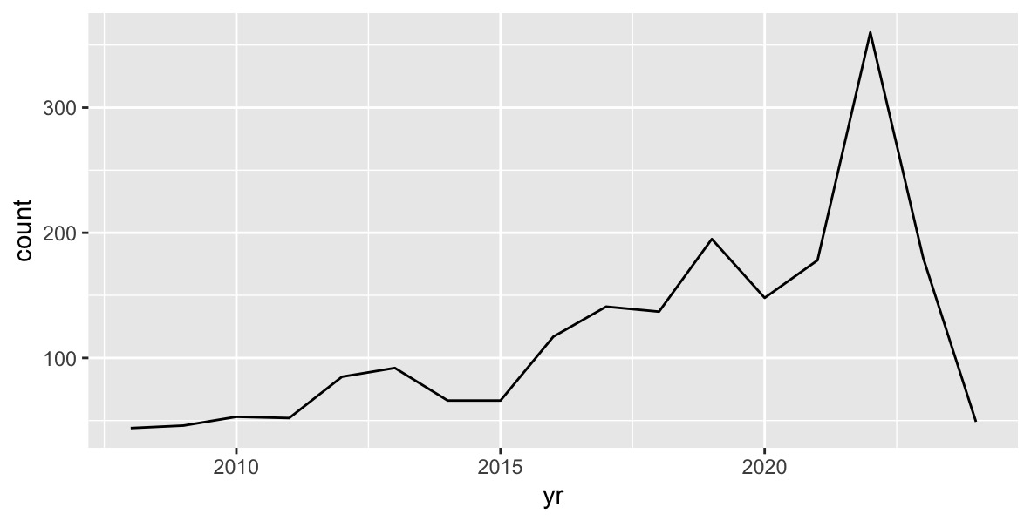
Figure I: Line plot showing the distribution of cases across the years
Table 1. Sources of the reviewed cases.
Institutions | Geopolitical Zone | Years | Neoplastic Cases | Proportion
UCH | Southwest | 2009 - 2024 | 529 | 27.9
LASUTH | Southwest | 2013 - 2024 | 522 | 27.5
LUTH | Southwest | 2009 - 2024 | 121 | 6.4
UNTH | Southeast | 2007 - 2024 | 306 | 16.1
UPTH | Southsouth | 2008 - 2024 | 146 | 7.7
AKTH | Northwest | 2015 - 2024 | 145 | 7.6
UDUTH | Northwest | 2014 - 2024 | 90 | 4.7
UMTH | Northeast | 2018 - 2024 | 40 | 2.1
 | Total reviewed cases. |  | 1899 | 100

The mean age of the individuals observed in this study was 15 years ± 6 years. Females accounted for 52% (n=989) of the total cases, whereas young adults accounted for 48% (n=910) of all cases. The male to female ratio of participants in our study was 1:1.09, whereas the ratio of the age groups was 1:1.29:2.84 for children: adolescents: young adults.
Benign neoplasms comprised 85.4% of all cases (n=1,622), and bony involvement by neoplasms was observed in 51% of all cases. Odontogenic tumours were the most common category of lesions observed (n=730, 38.4%), followed by neoplasms of mesenchymal origin (n=357, 18.8%), whereas salivary gland tumours (n=41, 2.2%) and neoplasms of epithelial origin (n=47, 2.5%) were the least commonly reported neoplasms in this age group. Table 2 shows the general characteristics and site involvement of orofacial neoplasms in our study.

Table 2: General characteristics of orofacial neoplasms across types of neoplasms.
Characteristic | Overall, N = 1,899¹ | Benign, N = 1,622¹ | Malignant, N = 277¹ | p value²
Age | 15 (6) | 16 (6) | 14 (6) | <0.001
Age groups |  |  |  | <0.001
Children | 337 (18%) | 263 (16%) | 74 (27%)
Adolescents | 658 (35%) | 551 (34%) | 107 (39%)
Young Adults | 904 (48%) | 808 (50%) | 96 (35%)
Sex |  |  |  | <0.001
Female | 989 (52%) | 873 (54%) | 116 (42%)
Male | 910 (48%) | 749 (46%) | 161 (58%)
Tissue involvement |  |  |  | <0.001
Soft | 746 (39%) | 614 (38%) | 132 (48%)
Bony | 1,034 (54%) | 945 (58%) | 89 (32%)
Both | 119 (7%) | 63 (4%) | 56 (20%)
Categories |  |  |  | <0.001
FOLs | 388 (20.4%) | 381 (23.5%) | 7 (2.5%)
Cysts | 178 (9.4%) | 178 (11%) | 0 (0%)
ETs | 47 (2.5%) | 27 (1.7%) | 20 (7.2%)
HLTs | 158 (8.3%) | 89 (5.5%) | 69 (25%)
MTs | 357 (18.8%) | 223 (13.7%) | 134 (48%)
OTs | 730 (38.4%) | 709 (43.7%) | 21 (7.6%)
SGTs | 41 (2.2%) | 15 (0.79%) | 26 (9.4%)
¹Mean (SD); n (%)
²Wilcoxon rank sum test; Pearson's Chi-squared test

Age groups
The median age of the participants across each age category was 6 years for children, 13 years for adolescents and 20 years for young adults. Fifty-four percent (n= 485) of young adults were females, whereas the female prevalence in children was 49% (n=166); this difference was not statistically significant (p=0.3). With respect to tissue involvement in neoplasms, 58% (n=196) of all child neoplasms involved soft tissues, whereas in adolescents and young adults, a preference for bony involvement was observed at 56.5% (372), and 61% (551) respectively. This difference was statistically significant at p< 0.001. Table 3
Both benign and malignant lesions had a predilection for the mandible and were present in 47% (438) and 3.5% (33) of young adults, respectively. Among the adolescents, benign lesions (n=298; 41%) were predominant in the mouth and pharynx, whereas malignant lesions (n=29; 4.0%) were predominant in the mandible. In children, a predilection for the mouth and pharynx was observed for benign neoplasms (n=168; 50%), and the bones of the skull and face were observed for malignant neoplasms (n= 30; 8.9%). The difference in the site of the neoplasm was statistically significant across the age categories (p< 0.001)
Odontogenic tumours were the most common neoplastic category in both the adolescent group (n=271; 41.2%) and the young adult group (n=409; 45.2%), followed by benign and fibro-osseous lesions in both age categories at 142 (21.6%) and 203 (22.5%) respectively. Table 3 Among the children’ age group, mesenchymal neoplasms (n=122; 36.2%) and neoplasms of haemato-lymphoid origin (n=66; 19.6%) were the most common conditions. Salivary gland tumours are the least common neoplasms in children, whereas neoplasms of epithelial origin are the least common tumours in both adolescents and young adults. The proportion of malignant neoplasms varied significantly from 11% (n=96) of all cases in the young adult group to 22% (n=74) of all orofacial neoplasms in the children’s category (p< 0.001).

Table 3: Characteristics of orofacial neoplasms across age groups.
Characteristic | Children, N = 337¹ | Adolescent, N = 658¹ | Young Adult, N = 904¹ | p value²
Age | 6 (3, 8) | 13 (12, 15) | 20 (19, 22) | <0.001
Sex |  |  |  | 0.3
Female | 166 (49%) | 338 (51.4%) | 485 (54%)
Male | 171 (51%) | 320 (48.6%) | 419 (46%)
Tissue involvement |  |  |  | <0.001
Soft | 196 (58%) | 240 (36.5%) | 310 (34.3%)
Bony | 111 (33%) | 372 (56.5%) | 551 (61%)
Both | 30 (8.9%) | 46 (7%) | 43 (4.8%)
Site |  |  |  | <0.001
BNM | 58 (17%) | 240 (36.5%) | 438 (48.5%)
BNMP | 168 (50%) | 225 (34.2%) | 230 (25.4%)
BNSF | 48 (14%) | 119 (18.1%) | 155 (17.1%)
MNM | 19 (5.6%) | 29 (4.4%) | 33 (3.7%)
MNMP | 14 (4.2%) | 25 (3.7%) | 30 (3.3%)
MNSF | 30 (8.9%) | 20 (3%) | 18 (2%)
Categories |  |  |  | <0.001
FOLs | 43 (12.8%) | 142 (21.6%) | 203 (22.5%)
Cysts | 46 (13.6%) | 65 (9.9%) | 67 (7.4%)
ETs | 10 (2.9%) | 17 (2.6%) | 20 (2.2%)
HLTs | 66 (19.6%) | 56 (8.5%) | 36 (3.9%)
MTs | 122 (36.2%) | 107 (16.3%) | 128 (14.2%)
OTs | 50 (14.8%) | 271 (41.2%) | 409 (45.2%)
SGTs | 0 (0%) | 0 (0%) | 41 (4.5%)
Type |  |  |  | <0.001
Benign | 263 (78%) | 551 (84%) | 808 (89%)
Malignant | 74 (22%) | 107 (16%) | 96 (11%)
¹Median (IQR); n (%)
²Kruskal-Wallis rank sum test; Pearson's Chi-squared test
Gender
In our study, the mean age of the female participants was significantly greater at 16 years ± 6 years (p=0.02) (Table 4). The proportion of malignant neoplasms in males was significantly greater (17.7%, n=161) than in females (n=116), accounting for 11.7% of all orofacial neoplasms. (p < 0.001). The site predilection in females varied from malignant orofacial neoplasms affecting the mouth and pharynx (2.4% (n=24) of all cases) to benign neoplasms involving the mandible (40% (n= 395)). This finding was significantly different from the predilection in males, which varied from 4.5% (n=41) of malignant neoplasms having a predilection for the skull and face to benign neoplasms involving the mandible at 37.5% (n= 341). Table 4
Table 4: Characteristics of orofacial neoplasms across gender.
Characteristic | Female, N = 989¹ | Male, N = 910¹ | p value²
Age | 16 (6) | 15 (6) | 0.02
Age groups |  |  | 0.3
Children | 166 (16.8%) | 171 (18.8%)
Adolescent | 338 (34.2%) | 320 (35.2%)
Young Adult | 485 (49%) | 419 (46%)
Tissue Involvement |  |  | 0.076
Soft | 381 (38.5%) | 365 (40%)
Bony | 556 (56.2%) | 478 (52.5%)
Both | 52 (5.2%) | 67 (7.4%)
Site |  |  | <0.001
BNM | 395 (40%) | 341 (37.5%)
BNMP | 339 (34.3%) | 284 (31.2%)
BNSF | 175 (17.7%) | 147 (16.2%)
MNM | 29 (2.9%) | 52 (5.7%)
MNMP | 24 (2.4%) | 45 (4.9%)
MNSF | 27 (2.7%) | 41 (4.5%)
Type |  |  | <0.001
Benign | 873 (88.3%) | 749 (82.3%)
Malignant | 116 (11.7%) | 161 (17.7%)
¹Mean (SD); n (%)
²Wilcoxon rank sum test; Pearson's Chi-squared test

Types of neoplasms
The mean age of the participants with benign orofacial neoplasms was 16 years ± 6 years, whereas the mean age of the participants with malignant orofacial neoplasms was 14 years ± 6 years (p value < 0.001). Participants in the adolescent age group accounted for 39% (n=107) of all malignant neoplasms, whereas young adults accounted for 50% (n=808) of all benign orofacial neoplasms. This difference was statistically significant at a p value < 0.001. Table 2
Across genders, females were found to have a predilection for benign neoplasms (n=873, 54%), whereas male individuals had a predilection for malignant neoplasms (n= 161, 58%). p value < 0.001. Benign neoplasms had a predilection for bony tissues (n=945, 58%) compared with the soft tissue predilection recorded in malignant neoplasms (p <0.001)). Table 2
Odontogenic tumours accounted for 43.7% (n=709) of benign neoplasms, followed by fibro-osseous lesions (n=381; 23.5%), whereas other epithelial tumours accounted for the least common benign orofacial neoplasms (n=27; 1.7%). For malignant neoplasms, tumours of mesenchymal origin accounted for 48% (n=134) of all cases (Figure 2). In our study, 7 cases of malignant transformation of FOLs were observed, accounting for 1.84% of all FOLs.
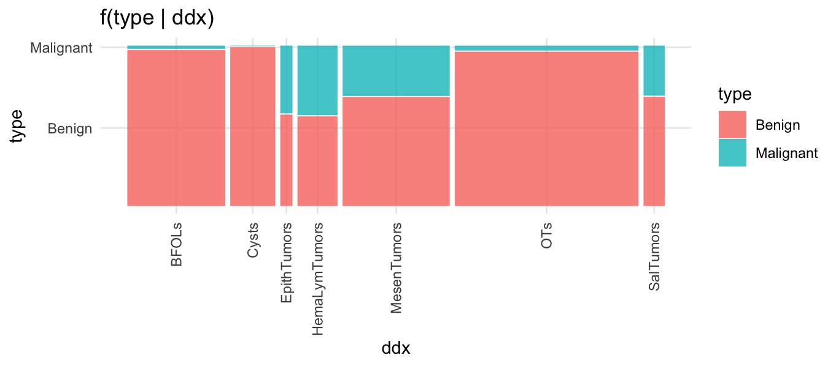
Figure 2. Mosaic plot showing categories of orofacial neoplasms.
Despite an overall preponderance of benign lesions across all geopolitical zones, varying proportions of benign to malignant lesion (B:M) ratios were observed across all zones. The lowest B:M ratio was observed in the Northwest region, with a 3.6:1 ratio, whereas the Northeast region had the highest 12.3:1 B:M ratio. Overall, the southern regions had a 6.3 B:M ratio, whereas the northern regions had a 4.1:1 B:M ratio. This disparity was statistically significant at p = 0.03 (Table 5).
Categories of orofacial neoplasms
Ameloblastoma was the most common type of odontogenic tumour, followed by adenomatoid odontogenic tumours. Both accounted for 74.4% (n=543) of all odontogenic tumour categories. Other conditions in this category include benign OTs such as odontogenic myxomas (n=38; 5.2%), ameloblastic fibroma (n=37; 5.1%), calcifying epithelial odontogenic tumours (n=15; 2.1%), squamous odontogenic tumours (n=3; 0.41%), and cementoblastoma (n=3; 0.41%); odontomas composed only 7.81% (n=57) of all OTs. Malignant OTs, such as ameloblastic carcinoma (n=25; 3.42%) and primary intraosseous odontogenic carcinoma (n=3, 0.41%), were also observed. OTs presented no sex predilection but were most found within the young adult age group.
Table 5: Types of neoplasms across geopolitical zones
Zones |  | Type of Neoplasms
Zones |  | Benign | Malignant | Total
NE | Count | 37 (2.3%) | 3 (1.1%) | 40 (2.1%)
NE | Mar. pct ⁽¹⁾ | 92.5% | 7.5% | *12.3: 1
NW | Count | 184 (11.3%) | 51 (18.4%) | 235 (12.4%)
NW | Mar. pct | 78.3% | 21.7% | *3.6: 1
SE | Count | 258 (15.9%) | 48 (17.3%) | 306 (16.1%)
SE | Mar. pct | 84.3% | 15.7% | *5.4: 1
SS | Count | 125 (7.7%) | 21 (7.6%) | 146 (7.7%)
SS | Mar. pct | 85.6% | 14.4% | *6.0:1
SW | Count | 1,018 (62.8%) | 154 (55.5%) | 1,172 (61.7%)
SW | Mar. pct | 87.3% | 12.7% | *6.6:1
Total | Count | 1,622 (85.4%) | 277 (14.6%) | 1899 (100.0%)
 | X-squared = 10.582, df = 4, p value = 0.03
⁽¹⁾ Row percentages
*Benign: Malignant Tumour Ratio
Fibromyxomas (n=40; 11.2%) and neurofibromas (n=32; 8.9%) constitute the most common benign mesenchymal tumours observed in this study. Rhabdomyosarcomas (n=64; 17.9%), osteosarcomas (n=52; 14.6%) and fibrosarcomas (n=28; 7.8%) were the most frequently observed malignant mesenchymal orofacial neoplasms. Lipomas (n=20; 5.6%), granular cell tumours (n=18; 5.04%) and schwannomas (n=12; 3.4%) were also observed in the benign category, whereas chondrosarcomas (n=13; 3.6%) and Ewing’s sarcomas (n=3; 0.8%) were the least common malignant sarcomas. Mesenchymal tumours were mostly observed in children and presented with no gender predilection; mesenchymal tumours were also mostly of the malignant variety. (S1)
Ossifying fibroma (n=140; 36.1%) and fibrous dysplasia (n=105; 27.1%) were the most common fibro-osseous lesions in this study; both types of lesions accounted for 63.2% of all fibro-osseous lesions. These lesions were followed in frequency by juvenile ossifying fibromas (n=38; 9.8%) and central giant cell granulomas (n=25; 6.44%), and cherubism had the lowest frequency in this category (n=4; 1.03%). Other reported FOLs include osseous dysplasia and osteomas, with frequencies of 20 (5.2%) each. FOLs presented a slight female preponderance, and like OTs, they were also more common within the young adult age category. A total of 7 FOLs were reported to have undergone malignant transformation following late intervention.
Cystic lesions and haematolymphoid lesions comprised the fourth and fifth most common orofacial neoplasms in this cohort. Odontogenic cysts were the most common subtype, with dentigerous cysts (n=28; 15.7%), odontogenic keratocysts (n=26; 14.6%), and radicular cysts (n=25; 14%) being the most common lesions within this category. Common nonodontogenic cysts observed in this study included epidermoid cysts (n=12; 6.7%), nasopalatine cysts (n=12; 6.7%), dermoid cysts (n=7; 3.9%), cervical and oral lymphoepithelial cysts (n=5; 2.8%), aneurysmal bone cysts (n=5; 2.8%) and nasolabial cysts (n=4; 2.2%). Haemangiomas were the most common haematolymphoid orofacial neoplasms (n=78; 49.4%), whereas non-Hodgkin’s lymphoma (NHL) (n=52; 32.9%) was the most common malignant haematolymphoid neoplasm observed. Among the NHLs, diffuse lymphocytic lymphomas (n=26; 16.5%) and Burkitt’s lymphomas (n=22; 13.9%) were the most common. HCNs presented a slight male predilection, with a three-- to fourfold preponderance in children, and were mostly benign. (S1)
Salivary gland tumours and epithelial tumours comprised the least observed orofacial neoplasms in this study. Oral squamous cell carcinomas comprised the most common epithelial malignancies (n=16; 34%), whereas squamous papillomas (n=17; 36.2%) were the most common benign neoplasms. Pleomorphic adenomas (n=28; 68.3%) were the most common salivary gland lesions observed in our study. Other epithelial tumours observed included nasopharyngeal carcinomas (n=2, 4.3%) and metastatic carcinomas (n=3, 6.4%) from other regions of the body. Mucoepidermoid carcinomas (n=9, 21.9%) were the most common salivary adenocarcinomas, whereas adenoid cystic carcinomas, myoepitheliomas and acinic cell carcinomas were also observed within these age groups, each with one presentation (n=1, 2.4%). A slight male predilection was observed in both salivary gland tumours and epithelial tumours. Salivary gland tumours are most common in young adults, whereas epithelial tumours are predominant in children. (S1)
Multivariate analysis
Multivariate analysis of the characteristics of orofacial neoplasms in these age groups was conducted via factor analysis of mixed data (FAMD). These unsupervised algorithms are designed to identify and predict groups or clusters in data. FAMD revealed that the variables utilized in this study predict the types of orofacial neoplasms based on the orofacial characteristics selected for this study. Benign and malignant neoplasms are well placed in two distinct clusters despite overlap in the middle areas of both clusters. (Figure 3). FAMD also revealed that the site of a neoplasm (30%) and the category of neoplasm (25%) were the most prevalent characteristics for predicting whether a neoplasm was benign or malignant.
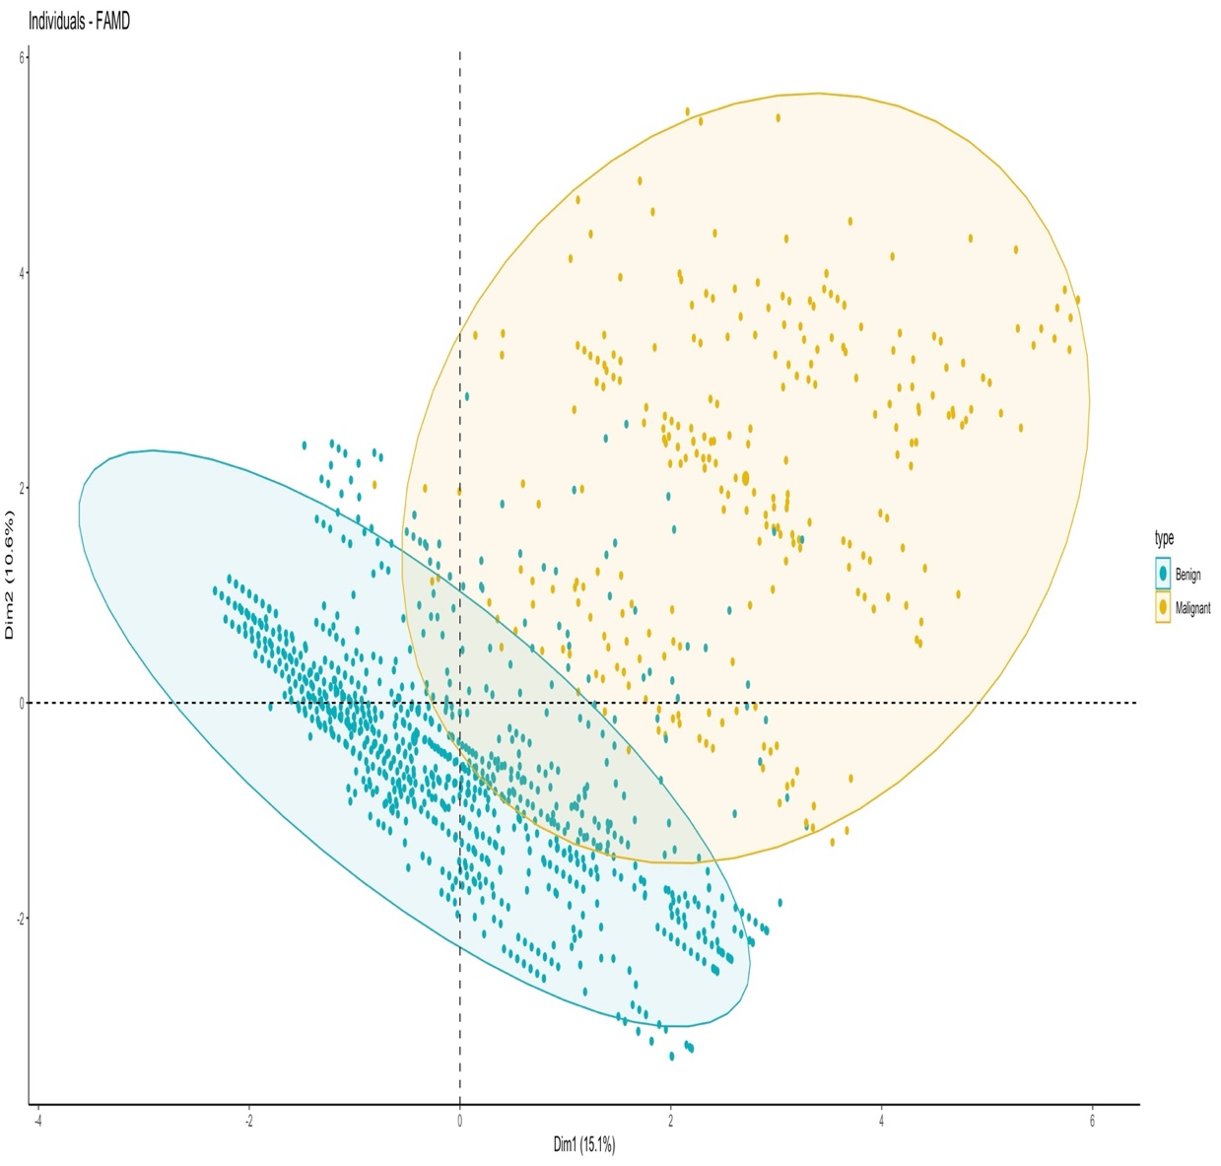
Figure 3: FAMD plot showing two distinct clusters of orofacial neoplasms.

Discussion
This was a multicenter study that recorded over 1800 cases of orofacial neoplasms in children and young adults over a 17-year period. The study foremost includes tertiary centres from each geo-political zone of Nigeria, thus providing a comprehensive representation of the occurrence and distribution of orofacial neoplasms among children and young adults in Nigeria.
The neoplasms were evenly distributed between both genders and were most common among young adults. In addition, most of these neoplasms were bony, benign and of odontogenic origin. The strength of this study lies in it being a national study, having included 8 tertiary health care centres that address cases from five of the six geo-political zones in Nigeria. Thus, it is a comprehensive documentation of the occurrence and distribution of all biopsied orofacial neoplasms among children and young adults in Nigeria, the country with the largest black population on earth (20). This clinical audit also covers a long period of time and has reviewed all categories of neoplasms seen in the identified population, adopting a standardized diagnostic criterion. This review revealed a fluctuating increase in the number of neoplasms from 2008, reaching a peak in 2022, followed by a decline (Figure 1). This trend may be attributed to the surge of patients seeking routine clinical dental services immediately after the COVID-19 lockdown period, which gradually normalized over time.
The number of biopsied orofacial neoplasms in children and adolescents recorded over the 17-year review period was greater than that reported in previous studies both within Nigeria (6,13,15,21) and outside Nigeria.(22–25) This difference is expected, as these prior studies reviewed records from shorter durations, fewer centers, or focused on specific types of neoplasms. Additionally, the highest upper age limit in previous studies was 19 years, while this study extended the upper age limit to 24 years, reviewed biopsy records over 17 years, and included data from eight different teaching hospitals, encompassing all neoplasm categories within these age groups. The extended age limit likely contributed to the higher mean age reported in this study than in other studies.(6,15,21,22,26)
Despite the inclusion of young adults in this study, an increase in the proportion of biopsied orofacial neoplasms with age was observed, which was consistent with previous reports.(8, 22,23,25–27) This observation has been attributed to the preference for conservative management in children, with delays in biopsy and other invasive procedures until adolescence or early adulthood. Therefore, this finding should be interpreted with caution, as it may reflect the timing of management rather than the actual onset of neoplasms. (28) In addition, the present study revealed that almost half of the neoplasms were young adults, which partly agrees with the findings of the modal age of the 3rd decade reported by Ibikunle et al(9). The proportion of children with orofacial neoplasms in this study was slightly greater than that in a previous Nigerian study (13.7%)(29), which may be due to their study’s restriction to intrabony neoplasms only. Further specific comparisons of proportions or occurrence rates within age groups with those in previous studies were also difficult because of variation in age stratification among studies.(26)
This study revealed no significant differences in sex distribution across the different age groups; however, soft tissue neoplasms were more common in children, whereas bony neoplasms were more common in young adults (Table 3). Using the ICD-10 classification, a similar pattern was observed, as half of the neoplasms in children were benign neoplasms of the mouth and pharynx, whereas a similar proportion of neoplasms in young adults were benign neoplasms of the mandible. Although the majority of all the neoplasms in all the age groups were benign, a greater proportion of malignant neoplasms were detected in children than in adolescents and young adults (Table 3).
In terms of sex, a slightly greater prevalence was recorded among females (Table 4), which is similar to findings from some previous studies (22,26,30) and contrary to other findings.(8,21,25,26) Females were also found to have a significantly greater mean age than males; however, females had a greater proportion of benign neoplasms, whereas males had a greater proportion of malignant neoplasms. (Table 4) This finding is in accordance with previous reports (6,23,31), whereas Ladeji et al.(16) reported no sex difference in the presentation of malignant neoplasms.
In this study, for the purpose of standardization of reporting, neoplasms were classified based on their site and behaviour via ICD-10 codes. The most frequent neoplasms were those belonging to the BNM group, closely followed by those in the BNMP group (Table 3). Similarly, approximately nine of every ten biopsied neoplasms in this study were benign, and more than half of these benign lesions were intraosseous. These findings agree with previous findings that benign neoplasms are the most common neoplasms (15,22,23,26,30) and that the mandible is the most reported site of involvement in children and adolescents.(6,15,22) However, Iatrou et al(26) reported greater soft tissue involvement (52.1%).
Furthermore, the prevalence of malignant neoplasms observed in the present study falls within the range of 19.3% and 30.3% reported in previous African studies (6,23) but is higher than that reported in other continents (8,22,26,30) This may be attributed to the greater endemicity of Burkitt lymphoma in Africa. A study by Soyele et al(32) among Nigerian children reported a similar frequency to that reported by other continents and did not include maxillofacial Burkitt lymphoma in their review. These malignant neoplasms were more common in children than in older children, which is comparable to the findings of Okumu et al.(31) Bony structures such as the orbit, maxilla (31), mandible and maxilla (6,16) have been reported as the most commonly affected sites, which is contrary to our finding that soft tissue is the most common site for malignant neoplasms. This variation in site of involvement is determined by the most frequent neoplasms observed in each study.
Odontogenic tumours were the most frequent neoplasms in this study (S1), constituting more than a third of all the neoplasms. This is similar to the findings of previous African studies (13,33), and this prevalence is greater than that of other non-African studies (8,22,24) Similarly, the finding of equal sex distribution of odontogenic tumours in this study is similar to that of Butt et al. (34) but contrary to that of Lawal et al. (13), who reported a greater male predominance. Among the age groups, however, OTs were found to be the most common among adolescents and young adults (Table 3), which is also in line with the findings of a Kenyan study. (33)Among all the odontogenic tumours reported in the present study, ameloblastoma was the most common, which is similar to previous findings. (10,13,32,33) Odontomas were found to be the least common odontogenic tumor, contrary to other studies (22,24–26)where it was the most common OT, although the documented prevalence rates are similar to those of the present study. Fewer than one tenth of the participants in the present study had malignant odontogenic tumours, which is consistent with findings that lesions are rare in children and adolescents. (21,23,24,26)
Salivary gland tumours and other epithelial tumours were the least common orofacial neoplasms observed in this study (Figure 2), whereas other studies reported that salivary gland tumours were the most common neoplasms. (8,22,24)A slight male predilection was also observed for salivary gland tumours in this study, and these tumours were more common in young adults than in young adults, which is contrary to previous findings. (24). In the present study, a few malignant salivary gland neoplasms were recorded, whereas Yu et al. (8) reported none.
Cysts can be odontogenic or nonodontogenic. This study revealed that odontogenic cysts were the most common, with dentigerous cysts being the most common (S1). This finding is consistent with those of several previous studies. (6,8,25,27) However, other studies have reported that radicular cysts are the most common. (30) Radicular cysts are usually a complication of caries; hence, their occurrence in different locations may vary with caries prevalence. Additionally, they may often be managed without biopsy in some parts of the world. (35)
Mesenchymal neoplasms had the greatest number of malignant neoplasms, followed by the haematolymphoid category, and both categories were more common in children than in other age groups. Among HLTs, haemangiomas are the most common benign haematolymphoid orofacial neoplasms, while non-Hodgkin’s lymphomas are the most common malignant haematolymphoid neoplasms observed in this study, which is similar to the findings of Abdulai et al.(23) Some previous Nigerian studies reported lymphoma, especially Burkitt lymphoma, as the most common malignant tumour in this age group (6,10,21,36) Okumu et al. (31) reported Burkitt lymphoma to be second only to retinoblastoma; however, the present study revealed rhabdomyosarcoma as the most common malignancy, similar to the findings of a recent Nigerian study. (16) This may be attributed to the possible shift in the management of Burkitt lymphomas at maxillofacial clinics to haematology-oncology clinics in some centres, as documented by Soyele et al.(32)
Factor analysis of mixed data (FAMD) is an exploratory algorithm that utilizes several dimensions, which are linear combinations of the selected variables to best identify and determine the variance in the dataset.(37) In this study, visualizing the distinct individuals in the two-dimensional space created by the first two dimensions revealed that the first two dimensions explained approximately 26% of the variability in these data (Figure 3). Despite this low variance of the first two components, there are two distinct clusters of the neoplastic type, with regions of overlap observed. This small overlap shows that the selected variables in this dataset are sufficient to predict a paediatric neoplasm as either a benign or malignant subtype, with the location of the neoplasm and the category of the neoplasm being the most important predictors.
In our study, there was an overall predilection of benign neoplasms in the mandible, whereas most malignant lesions involved the soft tissues of the oral cavity, mouth and pharynx. As previously stated, the soft tissue predilection for malignant neoplasms contrasts with other documented reports. Despite an overall preponderance of benign neoplasms in all categories of lesions, the benign-to-malignant ratio varies across categories, with epithelial tumours and haematolymphoid tumours having almost equal proportions of benign and malignant neoplasms. The associations between the type of neoplasm and both the category of lesion and the site of the neoplasm were highly significant at p < 2.2 × 10-¹⁶ (S2).
In conclusion, this study revealed that the proportion of biopsied orofacial neoplasms increased with age. Benign neoplasms were the most commonly biopsied lesions, as previously documented; however, the occurrence of malignant neoplasms in this population was greater than that previously documented. This calls for a high index of suspicion among paediatric dentists. Ameloblastoma, fibrous dysplasia and ossifying fibroma were the most common benign neoplasms while rhabdomyosarcomas and osteosarcomas were the most common malignant neoplasms in these age groups.
Recommendations
Whilst the findings of this study do not entirely represent the prevalence of these neoplasms, they can be reflected in a national survey and can be generalized to a similar African population. We recommend that other national surveys from other African and non-African countries be performed via standardized age stratification and diagnostic criteria to allow for better comparisons among different nations.

List of abbreviations
BNSF - Benign neoplasms of bones of the skull and face
BNM - Benign neoplasms of the lower jawbone BNM
BNMP - Benign neoplasms of the mouth and pharynx
MNSF - Malignant neoplasms of bones of the skull and face
MNM - Malignant neoplasms of the mandible
MNMP - Malignant neoplasms of the lip, oral cavity and pharynx
CLs - Cystic lesions
FOLs - Benign fibro-osseous lesions (including other bone-related lesions)
OTs - Odontogenic tumours
ETs - Nonodontogenic epithelial tumours
MTs - Nonodontogenic mesenchymal tumors
SGTs - Salivary gland tumours
HLTs - Haematolymphoid tumours

Limitations
Since we collected and analysed retrospective data, some information, such as socioeconomic strata and ethnicity, was incomplete and had to be excluded from the analysis.
Declarations
The authors declare that the study was conducted in accordance with Helsinki Declaration as revised in 2013.
Ethics approval and consent to participate
Not applicable. Our study is not deemed to require an ethical approval because there was no interface with human subjects. The Helsinki declaration (article 32) states that ethical approval is required when working with identifiable human data, but our study only utilized de-identified records from the archives.
Consent for publication
Not applicable since there was no direct human contact.
Availability of data and materials
The datasets used and/or analysed during the current study are available from the corresponding author on reasonable request.
Competing interests
The authors declare that they have no competing interests
Funding
The authors received no specific grant from any funding agency in the public, commercial or not-for-profit sectors for the conduct of this study.
Authors' contributions
Adetayo Oluwole Aborisade: Conceptualization, Data curation, Formal Analysis, Project administration, Resources, Validation, Visualization, Writing – original draft, Writing –review & editing.
Efetobo Victor Orikpete: Conceptualization, Data curation, Project administration, Resources, Validation, Writing – original draft, Writing –review & editing.
Adeola Temitope Williams: Conceptualization, Formal Analysis, Methodology, Resources, Validation, Writing – original draft, Writing –review & editing.
Yewande Isabella Adeyemo: Validation, Writing – original draft, Writing – review & editing.
Abdul-Warith Olaitan Akinshipo: Data curation, Validation, Writing – original draft, Writing– review & editing.
Mofoluwaso Olajide: Data curation, Validation, Writing – review & editing.
Chukwubuzor Udokwu Okwuosa: Data curation, Validation, Writing – review & editing.
Mark Chukwuemeka Nwoga: Data curation, Validation, Writing – review & editing.
Taoheed Olaide Mudasiru: Data curation, Validation, Writing – review & editing.
Mujtaba Bala: Data curation, Validation, Writing – review & editing.
Mohammed A.S Abdullahi: Data curation, Validation, Writing – review & editing.
Akinyele Adisa: Conceptualization, Methodology, Project administration, Resources, Supervision, Validation, Writing – original draft, Writing – review & editing.

References
1. Keyur BRS, Joshi S, AK JGD. Introduction to neoplasm: a review article. International Journal of Advanced Research in Pharmaceutical & Bio Sciences. 2012;1(3):65–72.
2. Patel A. Benign vs malignant tumors. JAMA Oncol. 2020;6(9):1488.
3. da Silva Barros CC, da Silva LP, Gonzaga AKG, de Medeiros AMC, de Souza LB, da Silveira ÉJD. Neoplasms and nonneoplastic pathologies in the oral and maxillofacial regions in children and adolescents of a Brazilian population. Clin Oral Investig. 2019;23:1587–93.
4. Vale EB, Ramos-Perez FMM, Rodrigues GLC, Carvalho EJA, Castro JFL, Perez DEC. A review of oral biopsies in children and adolescents: a clinicopathological study of a case series. J Clin Exp Dent. 2013;5(3):e144.
5. Mahmoudi P, Razavi SM, Tahani B. Orofacial pathological lesions in children and adolescents: A 25-year survey in Iran. J Dent. 2018;19(4):265.
6. Orikpete EV, Iyogun CA, Omitola OG. Clinicopathologic analysis of biopsied orofacial lesions seen in children in a tertiary health centre in port harcourt: an 11-year review. J Biosci Med (Irvine). 2020;8(3):1–8.
7. Saravani S, Kadeh H, Amirabadi F, Keramati N. Clinical and histopathological profiles of pediatric and adolescent oral and maxillofacial biopsies in a Persian population. Int J Pediatr. 2015;3(1.1):381–90.
8. Yu Z, Seo B, Hussaini HM, Meldrum AM, Rich AM. The relative frequency of paediatric oral and maxillofacial pathology in New Zealand: A 10‐year review of a national specialist centre. Int J Paediatr Dent. 2020;30(2):209–15.
9. Ibikunle AA, Taiwo AO, Braimah RO, Umar MS. A review of oral and maxillofacial biopsies from a new academic health facility in remote Northwestern Nigeria. International Journal of Oral Health Sciences. 2018;8(2):86–91.
10. Aregbesola SB, Ugboko VI, Akinwande JA, Arole GF, Fagade OO. Orofacial tumours in suburban Nigerian children and adolescents. British Journal of Oral and Maxillofacial Surgery. 2005;43(3):226–31.
11. Blankson PK, Amoah G, Thadani M, Newman-Nartey M, Amarquaye G, Hewlett S, et al. Prevalence of oral conditions and associated factors among schoolchildren in Accra, Ghana: a cross-sectional study. Int Dent J. 2022;72(1):93–9.
12. Sohal KS, Moshy JR. Oral and maxillofacial tumors;: An audit in paediatric patients attended in MNH, Tanzania: A 6 year retrospective study. The Professional Medical Journal. 2017;24(03):433–40.
13. Lawal AO, Adisa AO, Popoola BO. Odontogenic tumours in children and adilescents: a review od forty-eight cases. Ann Ib Postgrad Med. 2013;11(1):7–11.
14. Taiwo AO, Braimah RO, Ibikunle AA, Obileye MF, Jiya NM, Sahabi SM, et al. Oral and maxillofacial tumours in children and adolescents: Clinicopathologic audit of 75 cases in an academic medical centre, Sokoto, Northwest Nigeria. African Journal of Paediatric Surgery. 2017;14(3):37–42.
15. Anyanechi CE. Paediatric and adolescent intrabony oro-facial tumours and allied lesions in a Nigeria tertiary health facility: An 18-year retrospective analysis. J Oral Maxillofac Surg Med Pathol. 2015;27(3):412–7.
16. Ladeji A, Aborisade A, Olajide M, Oyedele T, Adebiyi K, Kuye O, et al. Paediatric orofacial malignancies in an African population. Journal of Paediatric Dental Research and Practice. 2023;4(1–2):10–9.
17. UNAIDS report on the global AIDS epidemic 2013. Geneva: Joint United Nations Programme on HIV/AIDS; 2013. Geneva; 2014 Jul.
18. Steindel SJ. International classification of diseases, 10th edition, clinical modification and procedure coding system: Descriptive overview of the next generation HIPAA code sets. Vol. 17, Journal of the American Medical Informatics Association. 2010. p. 274–82.
19. Akinyamoju AO, Adeyemi BF, Adisa AO, Okoli CN. Audit of Oral Histopathology Service at a Nigerian Tertiary Institution over a 24-Year Period. Ethiop J Health Sci. 2017 Jul 1;27(4):383–92.
20. Mileno P. The largest black nation outside frica and its racist politics. Ufahamu: A Journal of African Studies. 2018;41(1).
21. Omoregie FO, Akpata O. Paediatric orofacial tumours: new oral health concern in paediatric patients. Ghana Med J. 2014;48(1):14–9.
22. Patil SS, Kontham UR, Kontham RK, Chowdhery A. Retrospective evaluation of paediatric oral biopsies over a 10-year period in Western India. European Archives of Paediatric Dentistry. 2017;18:171–8.
23. Abdulai AE, Nuamah IK, Gyasi R. Head and neck tumours in Ghanaian children. A 20 year review. Int J Oral Maxillofac Surg. 2012;41(11):1378–82.
24. Martins-Filho PRS, de Santana Santos T, Piva MR, da Silva HF, da Silva LCF, Mascarenhas-Oliveira AC, et al. A multicenter retrospective cohort study on pediatric oral lesions. J Dent Child. 2015;82(2):84–90.
25. Puangwan Lapthanasupkul D, Juengsomjit R, Sopee Poomsawat D. Oral and maxillofacial lesions in a Thai pediatric population: a retrospective review from two dental schools. J Med Assoc Thai. 2015;98(3):291–7.
26. Iatrou I, Theologie-Lygidakis N, Tzerbos F, Schoinohoriti OK. Oro-facial tumours and tumour-like lesions in Greek children and adolescents: an 11-year retrospective study. Journal of Cranio-Maxillofacial Surgery. 2013;41(5):437–43.
27. Prosdócimo ML, Agostini M, Romañach MJ. A retrospective analysis of oral and maxillofacial pathology in a pediatric population from Rio de Janeiro–Brazil over a 75-year period. Med Oral Patol Oral Cir Bucal. 2018;23(5):e511.
28. Ha WN, Kelloway E, Dost F, Farah CS. A retrospective analysis of oral and maxillofacial pathology in an Australian paediatric population. Aust Dent J. 2014;59(2):221–5.
29. Anyanechi CE. Paediatric and adolescent intrabony oro-facial tumours and allied lesions in a Nigeria tertiary health facility: An 18-year retrospective analysis. J Oral Maxillofac Surg Med Pathol. 2015;27(3):412–7.
30. Gültelkin SE, Türkseven MR. A review of paediatric oral biopsies in Turkey. Int Dent J. 2003;53(1):26–32.
31. Okumu SB, Chindia ML, Gathece LW, Dimba EAO, Odhiambo W. Clinical features and types of paediatric orofacial malignant neoplasms at two hospitals in Nairobi, Kenya. Journal of Cranio-Maxillofacial Surgery. 2012;40(1):e8–14.
32. Soyele OO, Aborisade A, Adesina OM, Olatunji A, Adedigba M, Ladej AM, et al. Concordance between clinical and histopathologic diagnosis and an audit of oral histopathology service at a Nigerian tertiary hospital. Pan African Medical Journal. 2019;34(1).
33. Butt FM, Ogeng’o JA, Bahra J, Chindia ML, Dimba EAO, Wagaiyu E. 19-year Audit of BenignJaw Tumours and Tumour-like Lesions in a Teaching Hospital in Nairobi, Kenya. 2012;
34. Butt FMA, Guthua SW, Awange DA, Dimba EAO, MacIgo FG. The pattern and occurrence of ameloblastoma in adolescents treated at a university teaching hospital, in Kenya: A 13-year study. Journal of Cranio-Maxillofacial Surgery. 2012 Feb;40(2).
35. Jones A V, Franklin CD. An analysis of oral and maxillofacial pathology found in children over a 30‐year period. Int J Paediatr Dent. 2006;16(1):19–30.
36. Ajayi OF, Adeyemo WL, Ladeinde AL, Ogunlewe MO, Omitola OG, Effiom OA, et al. Malignant orofacial neoplasms in children and adolescents: a clinicopathologic review of cases in a Nigerian tertiary hospital. Int J Pediatr Otorhinolaryngol. 2007;71(6):959–63.
37. Lefeuvre C, Roux M, Blanchard S, Le Guillou-Guillemette H, Boursier J, Lunel-Fabiani F, et al. Analysis of hepatic fibrosis markers in the serum of chronic hepatitis B patients according to basal core promoter/precore mutants. Sci Rep. 2022;12(1):10261.

