
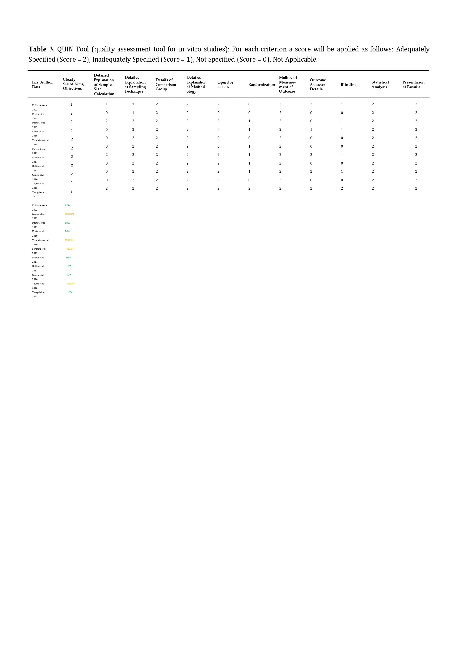
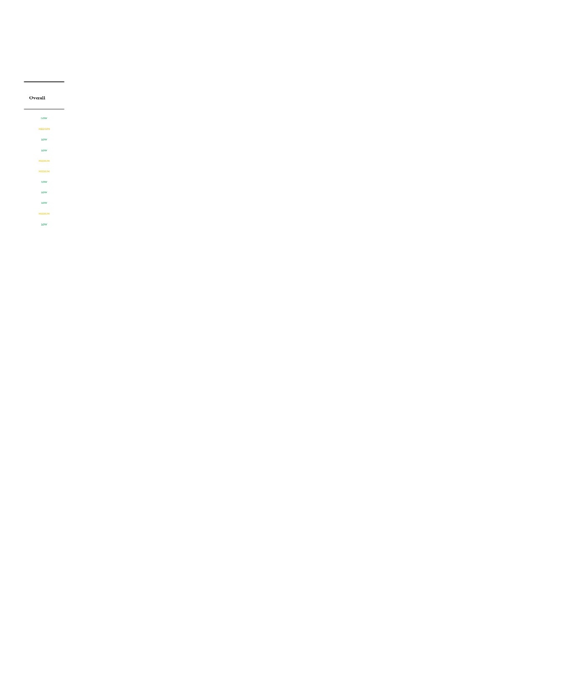
The scoring results obtained from the QUIN tool indicated that four in vitro studies have a medium risk of bias, while seven studies have a low risk of bias. Among the studies with a medium risk of bias, the most common criteria that were not specified included “detailed explanation of the sample size calculation” and “operator details”. Interestingly, some studies did not provide any information regarding randomization, blinding, and outcome assessor details. The assessment details of the QUIN tool can be found in Table ... Moving on to the ROB.2 assessments, six clinical studies were evaluated, and three of them were deemed to have a low risk of bias. One study had a medium risk of bias, while two studies were classified as high risk. The studies with a high risk of bias was found to have significant concerns in four domains, namely the randomization process, deviation from intended interventions, missing outcomes, and measurement of the outcome. Additionally, the study that raised concerns in the randomization process was judged as ‘some concerns’. The results of the ROB.2 tool are presented in Figure ...

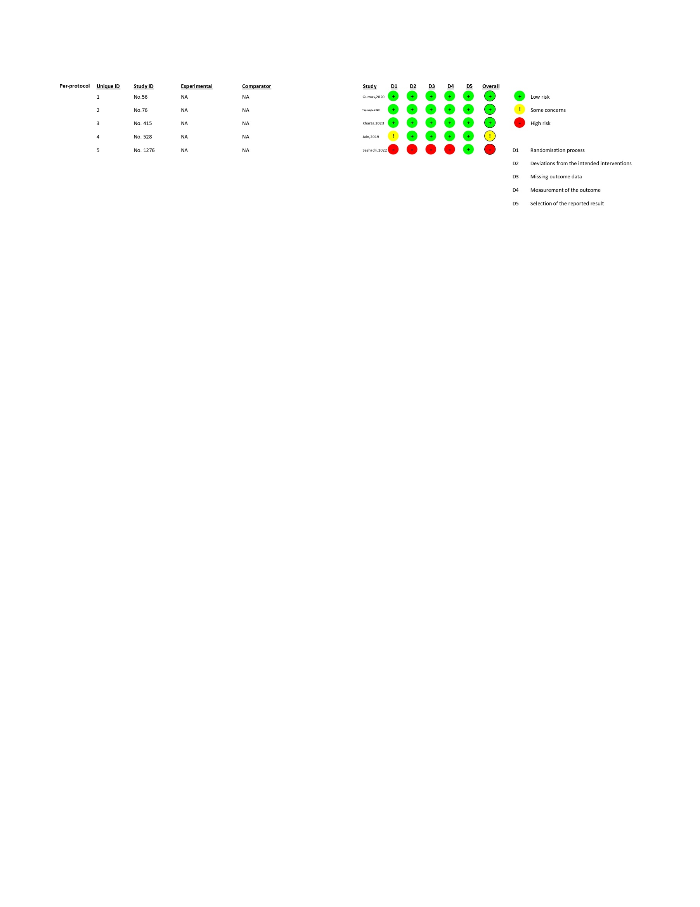




Ahmadi et al,2023

