Additional File

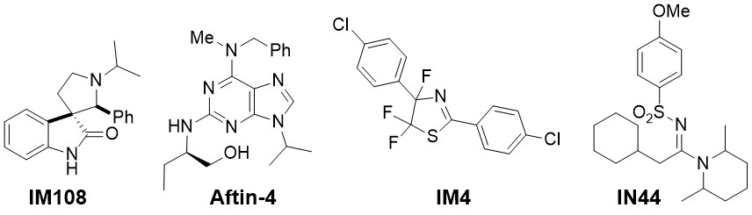
Additional Figure S1: Structure of the PHB ligands examined for their effects on P. gingivalis induced inflammation.

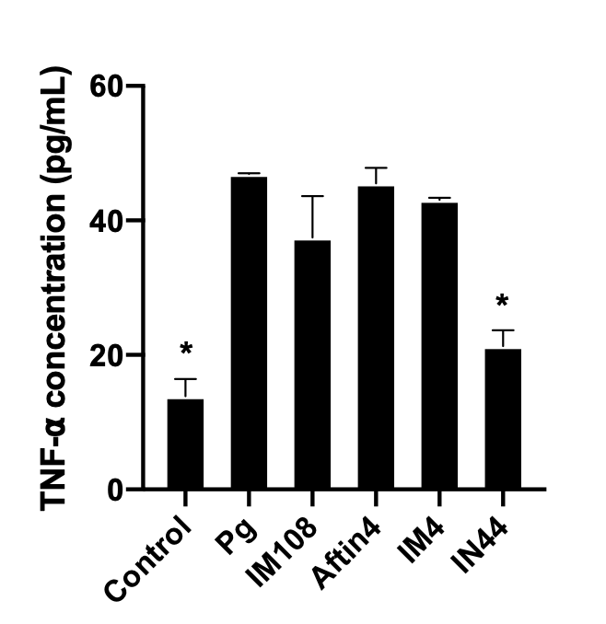
Additional Figure S2 : an ELISA assay was conducted to evaluate TNF-α concentrations following infection with P. gingivalis (MOI = 100) and subsequent PHB treatment. IN44 was found to reduce TNF-α levels by 50% after infection with P. gingivalis. * p<0.001. (Kruskall-Wallis test and Dunn post hoc).

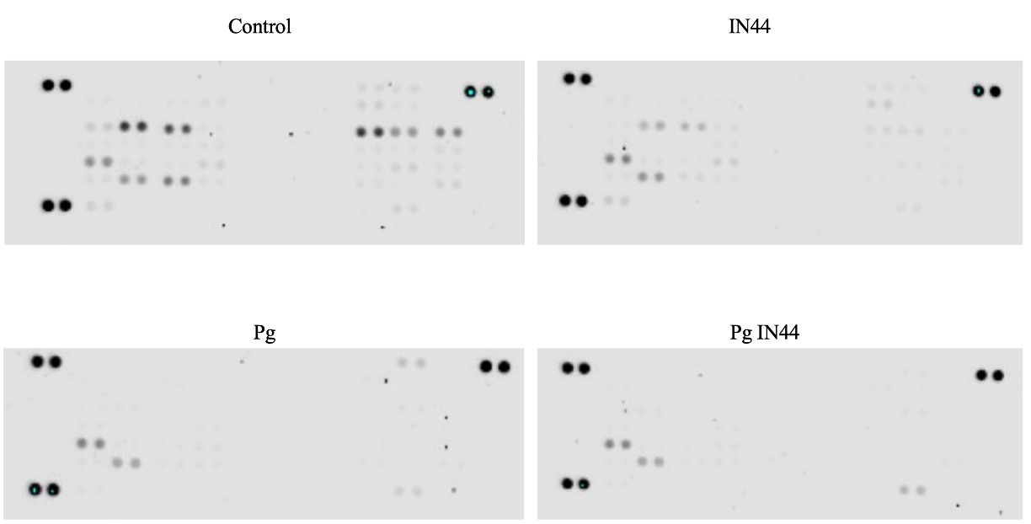
Additional Figure S3 : original phosphoprotein array blot.

