Figure S1. Flowchart of disulfidptosis-related immune patterns predict prognosis and characterizes the tumor microenvironment in oral squamous cell carcinoma.
Figure S2. Validation of the prognostic model in the testing set. (A)The risk score distributions, (B) survival times and (C) overall survival of OSCCs. (D) Time-dependent ROC curve in the testing set.
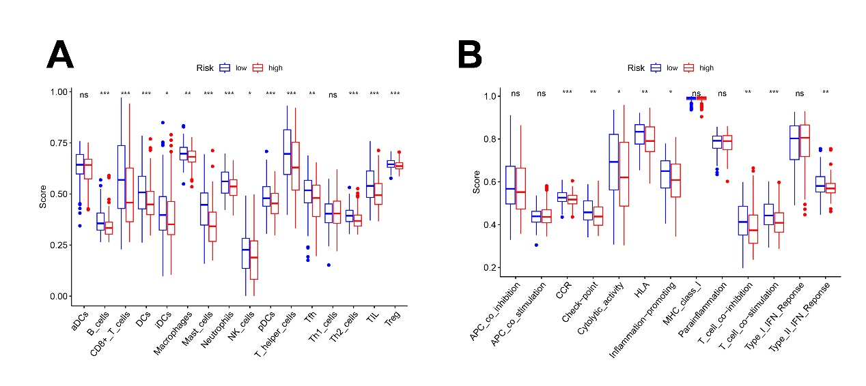Figure S3. Comparation of immune infiltration cells(A) and immune-related pathways (B) between the two risk groups in OSCC TCGA cohort.
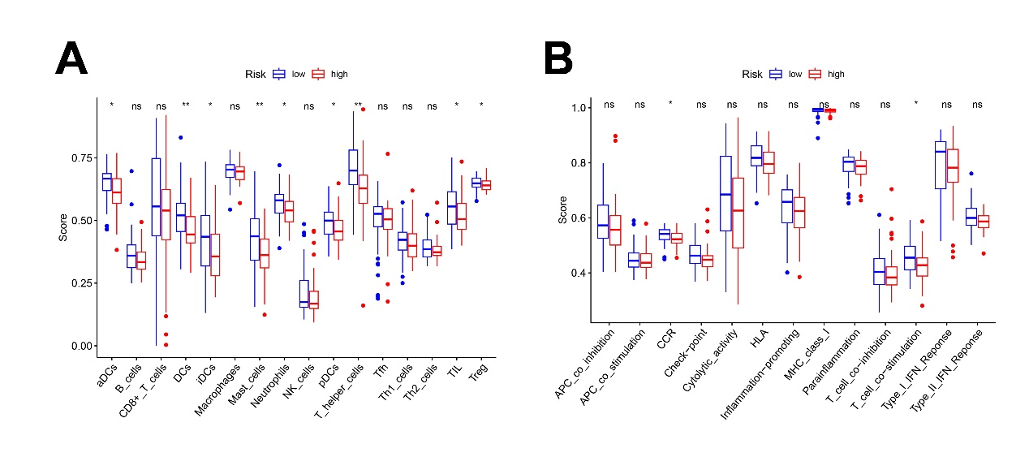Figure S4. Comparation of immune infiltration cells (A) and immune-related pathways (B) in the two risk groups in GEO set.
Figure S5. Clinical significance and immune landscape of risk score in OSCC TCGA cohort. Correlations between the risk score and (A) immune score, (B)stromal score, (C)ESTIMATE score in the TCGA set. (D) Proportions of immune infiltration in the high and low risk score subgroups in OSCCs using CIBERSORT databases. (E) Violin plot illustrating the proportions of 22 immune cells in different risk score subtypes. (F) TCGA cohort heatmap based on the 22 immune cell signatures. The risk ratings were used to arrange the samples along the row. The magnitude is represented by the different color scale, with red denoting high and green denoting low.
Figure S6. The association between the risk score and the (A)chemokines, (B) immune checkpoints (C) tumor receptor and (D) HLA family genes in the TME of TCGA OSCC patients.

Figure S7. Expression of nine DIRGs and its relationship to immune cells (A) Nine DIRGs are expressed in both normal and OSCC tissues (B) Correlation of the immune cell infiltration with the prognostic genes.

Figure S8. Substantial association between these immunological genes and the disulfidptosis genes. (A)PLAU, (B) BECN1, (C) GPI, (D)AIMP1.

Figure S9. Functional analysis of nine DIRGs expression using (A) GO terms and (B) KEGG pathway.

Figure S10. In order to investigate putative biological functions in the high- and low-risk groups, GSVA analysis was combined with annotations of (A)GO (B) KEGG and (C)HALLMARK gene sets.
Table S1. Primers used in this study.
Primers | Sequences
GAPDH-F | 5’-GTCTCCTCTGACTTCAACAGCG-3’
GAPDH-R | 5’-ACCACCCTGTTGCTGTAGCCAA-3’
ACTN4-F | 5’-TGGAGGTCATATCAGGGGAGC-3’
ACTN4-R | 5’-GAGACCAGCTTGACGCCTTT-3’
ACTB-F | 5’-CATGTACGTTGCTATCCAGGC-3’
ACTB-R | 5’-CTCCTTAATGTCACGCACGAT-3’
CD2AP-F | 5’-TGTGAAACTTCGGACAAGAACA-3’
CD2AP-R | 5’-AGTGACTGTAGGATTAAGGGCT-3’
CAPZB-F | 5’-TTTGACCAGTATCGAGACCTGT-3’
CAPZB-R | 5’-GCAAAGCCATGATCCAGATCC-3’
DSTN-F | 5’-ATTTTGTGGGAATGCTTCCTGA-3’
DSTN-R | 5’-GCATCCTTGGAGCTTGCATAG-3’
FLNA-F | 5’-CTTATCGCGCTGTTGGAGGT-3’
FLNA-R | 5’-GCCACCGACACGTTCTCAA-3’
FLNB-F | 5’-AACTGGCAAGACGGCAAAG-3’
FLNB-R | 5’-CGTGCATTATCCACAGGCTTC-3’
INF2-F | 5’-GCGTTGCACGTATCTCCGA-3’
INF2-R | 5’-CACCATCACGTTGGATGTGTC-3’
IQGAP1-F | 5’-TTTGTACCTGTTCAAGCTAGGC-3’
IQGAP1-R | 5’-CCACTGACAGTTCATTAGCCAAG-3’
MYH10-F | 5’-GTAACTGGCTATATCGTTGGGG-3’
MYH10-R | 5’-CTTTTGCTTGACGAACAGCAC-3’
MYL6-F | 5’-GAAGACCAGACCGCAGAGTTC-3’
MYL6-R | 5’-TCCAGCACCTTCACATTCATC-3’
MYH9-F | 5’-CAGCAAGCTGCCGATAAGTAT-3’
MYH9-R | 5’-CTTGTCGGAAGGCACCCAT-3’
PDLIM1-F | 5’-GCTGGCCTCTACTCTTCTGAA-3’
PDLIM1-R | 5’-GCTGAGCATGGTCTAAGGGT-3’
TLN1-F | 5’-GACGATGCAGTTTGAGCCG-3’
TLN1-R | 5’-GGGTCATCATCTGACAGAAAGAG-3’

