Supplementary Figure

a) Oral frailty index-8
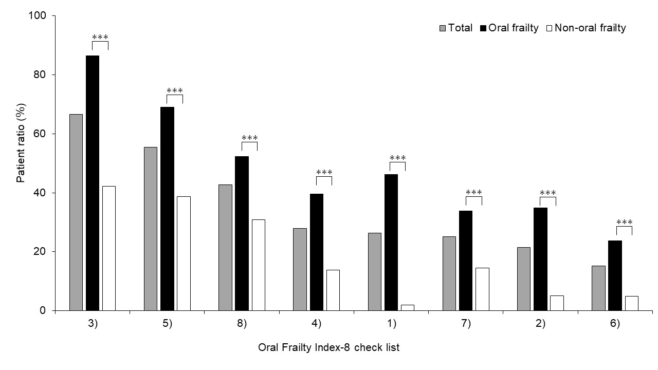

b) Frailty Screening Index
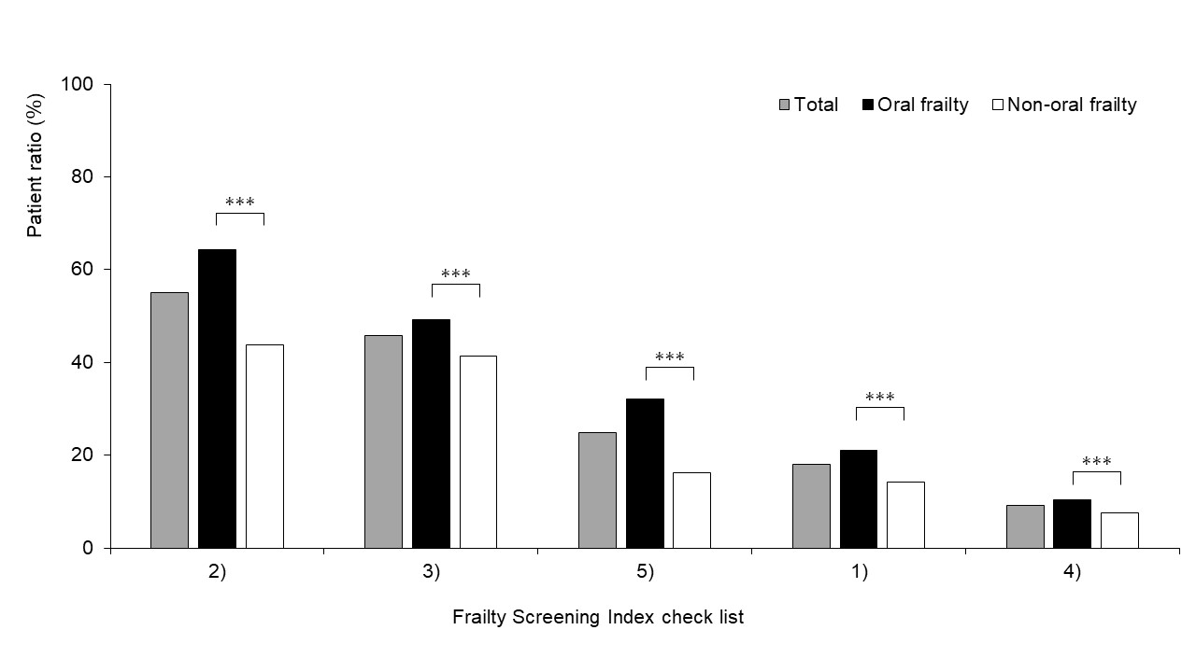

Supplementary Figure Association between oral frailty and items of Oral frailty index-8 and Frailty Screening Index

a) Oral frailty index-8
(1) Do you have any difficulties eating tough foods compared to 6 months ago? (Yes: 2 points, No: 0 points).
(2) Have you choked on your tea or soup recently? (Yes: 2 points, No: 0 points).
(3) Denture use (Yes: 2 points, No: 0 points).
(4) Do you often experience a dry mouth? (Yes: 1 point, No: 0 point).
(5) Do you go out less frequently than you did last year? (Yes: 1 point, No: 0 point).
(6) Can you eat hard foods like squid jerky or pickled radish? (Yes: 0 points, No: 1 point).
(7) How many times do you brush your teeth per day? (<3 times/day) (Yes: 0 points, No: 1 point).
(8) Have you visited a dental clinic at least annually? (Yes: 0 points, No: 1 point).

b) Frailty Screening Index
(1) Have you lost 2 kg or more in the past 6 months? (Yes: 1 point, No: 0 point).
(2) Do you think you walk slower than before? (Yes: 1 point, No: 0 point).
(3) Do you go for a walk for your health at least once a week? (Yes: 0 points, No: 1 point).
(4) Can you recall what happened 5 min ago? (Yes: 0 points, No: 1 point).
(5) In the last 2 weeks, have you felt tired without a reason? (Yes: 1 point, No: 0 point).

***p<0.001

