Supplementary Information for
Microscale bone interlocking enhances osseointegration strength on the rough surface of 3D-printed titanium implants: experimental and finite element analysis
Tianyu Shu^{1,2†}, Haoyu Shi^{1†}, Meng Li¹, Yu-Chia Lin¹, Ang Li^{1*}, and Dandan Pei^{1*}
¹Key Laboratory of Shaanxi Province for Craniofacial Precision Medicine Research, College of Stomatology, Xi’an Jiaotong University, Xi’an 710049, China.
²State Key Laboratory for Manufacturing System Engineering, School of Mechanical Engineering, Xi'an Jiaotong University, Xi'an 710054, China.

† Tianyu Shu and Haoyu Shi contributed equally to this work and share first authorship.

*Correspondence:
Ang Li
drliang@xjtu.edu.cn
Dandan Pei
peidandan@xjtu.edu.cn

Supplementary Fig. 1 Shape of experimental implants.

Supplementary Table 1 Surface element composition (weight percentage).
 | Ti | O | Al | V | C
SLM | 76.64% | 11.16% | 5.72% | 3.94% | 2.53%
CNC-SLA | 80.83% | 4.92% | 6.84% | 4.27% | 3.13%

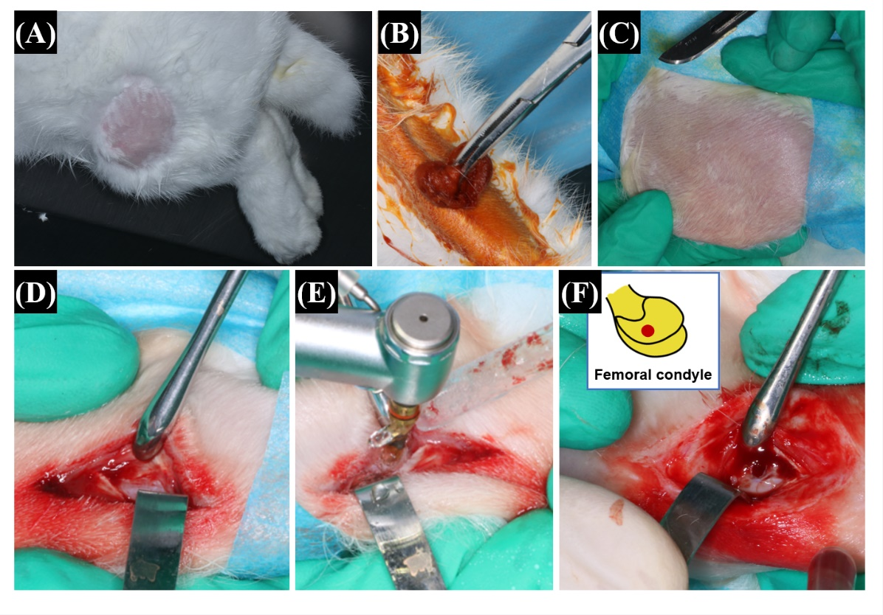

Supplementary Fig. 2 Implant installation at the femoral condyle of New Zealand rabbit. (A) Skin preparation. (B) Skin disinfection. (C) Surgical field. (D) Incision at skin and joint capsule. (E) Cavity preparation. (F) The implant position.

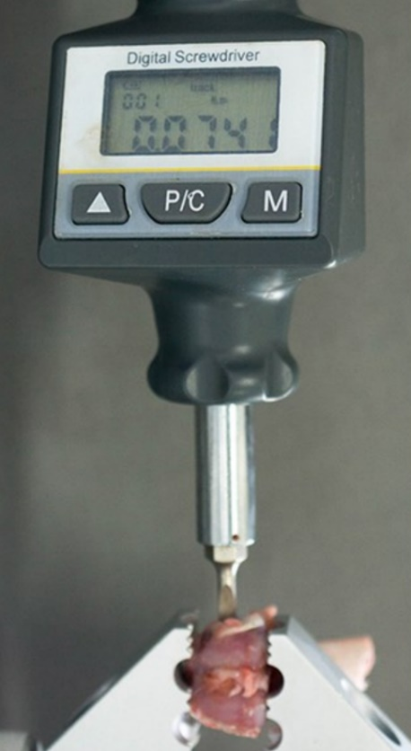

Supplementary Fig. 3 The removal torque analysis.

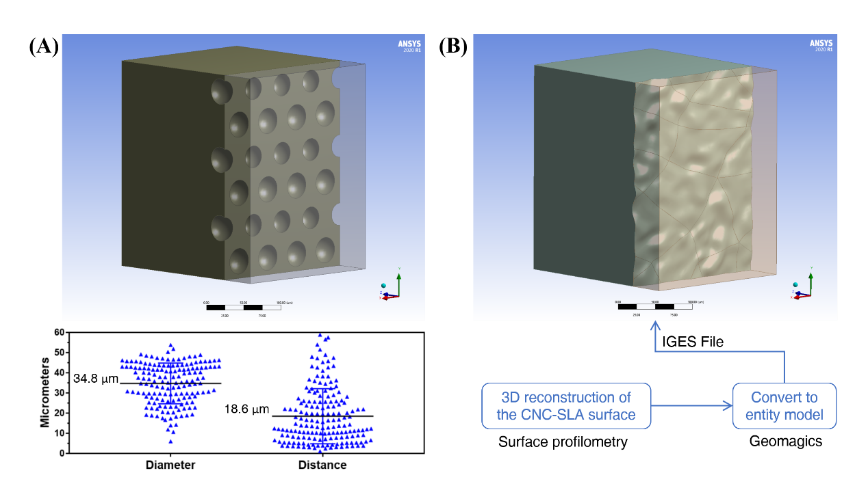

Supplementary Fig. 4 The microscale finite element model of the bone-implant interface. (A) The SLM group. (B) The CNC-SLA group.

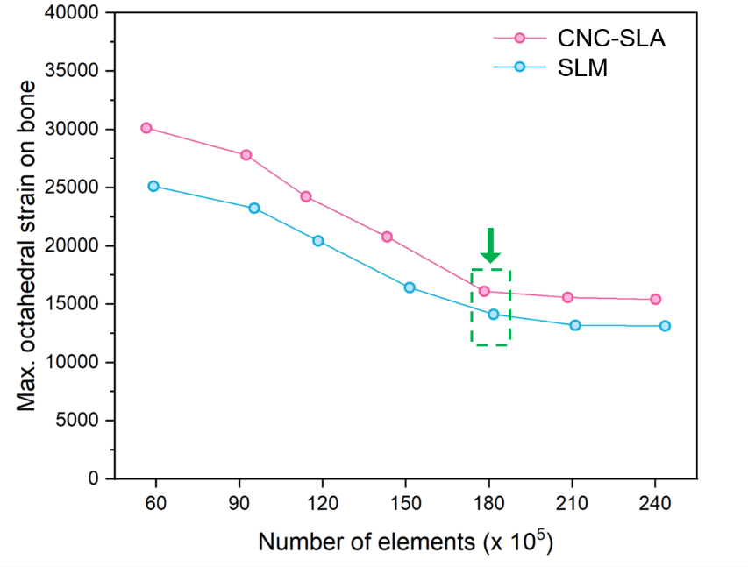

Supplementary Fig. 5 Mesh sensitivity analysis. The green arrow indicates the selected element number.

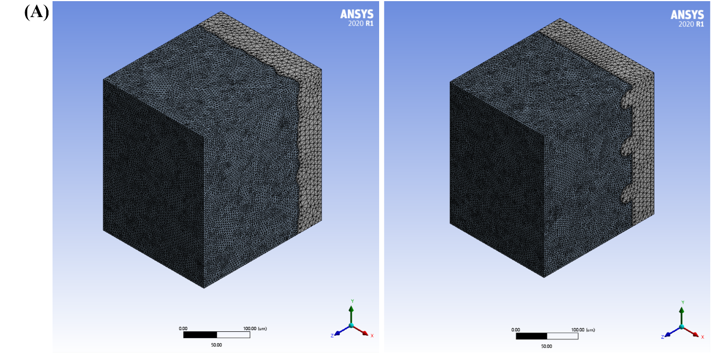
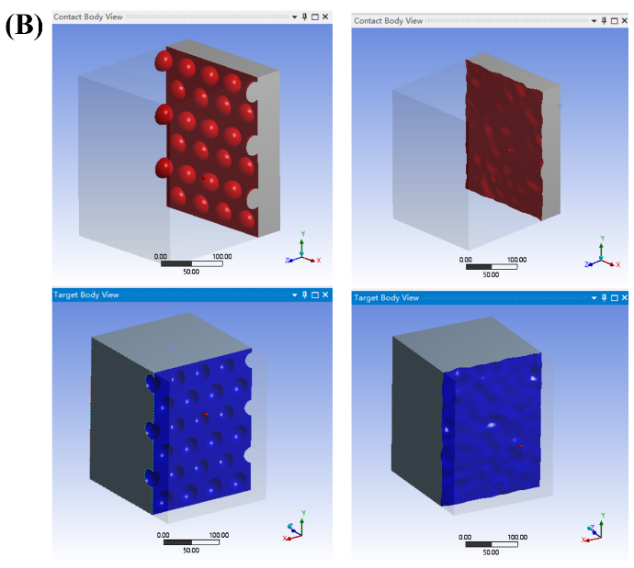
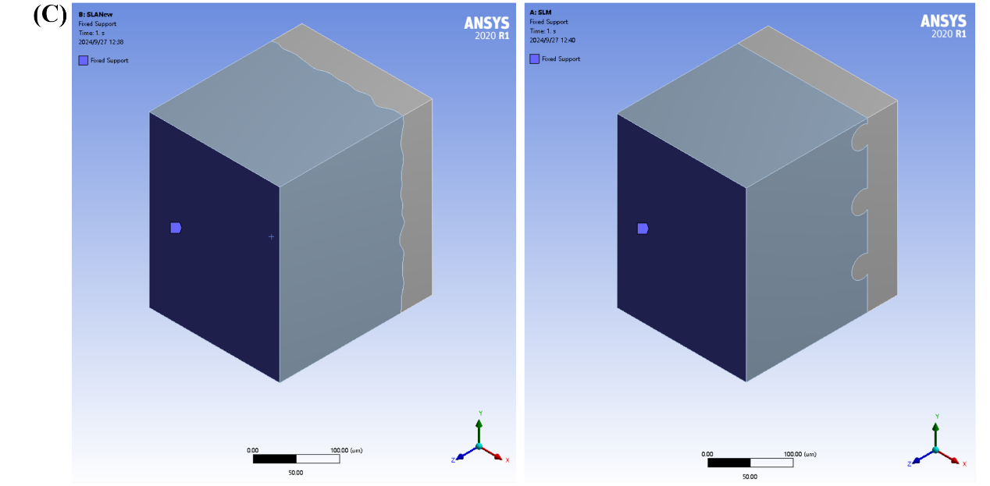

Supplementary Fig. 6 Boundary conditions in the finite element model. (A) Meshed model. (B) Contact region. (C) Fixed support.

