Supplementary Information

Influence of Alloplastic Materials, Biologics, and Their Combinations, Along with Defect Characteristics, on Short-Term Intrabony Defect Surgical Treatment Outcomes: A Systematic Review and Network Meta-Analysis
Khanti Rattanpornsompong¹, Kantapon Rattanaprukskul², Sikharate Prachanukoon^{1,2}, Kanokrat Sriwangyang¹, Mawika Rinkrathok¹, Junji Tagami^{3,*}, Thantrira Porntaveetus^{1,4*}

¹Center of Excellence in Genomics and Precision Dentistry, Department of Physiology, Faculty of Dentistry, Chulalongkorn University, Bangkok, Thailand
²Department of Periodontology, Faculty of Dentistry, Chulalongkorn University, Bangkok, Thailand
³Research Affairs, Faculty of Dentistry, Chulalongkorn University, Bangkok, Thailand
⁴Graduate Program in Geriatric and Special Patients Care, Clinical Research Center, Faculty of Dentistry, Chulalongkorn University, Bangkok, Thailand

*Correspondence to:
Thantrira Porntaveetus
E-mail: thantrira.p@chula.ac.th
Lists of Supplementary Tables | Pages
Table S1 PubMed search strategy. | 5
Table S2 Scopus search strategy. | 7
Table S3 CENTRAL search strategy. | 8
Table S4 Total number of included RCTs for each outcome at different follow-up intervals post-surgery. | 9
Table S5 Summary of the number of included RCTs evaluating each treatment across different defect morphologies. | 9
Table S6 Risk of bias (RoB2) assessment for the included studies. | 10
Table S7 Heterogeneity testing of clinical attachment level (CAL), probing depth (PD), and radiographic linear bone (RLB) at baseline across studies. | 12
Table S8 Heterogeneity testing of clinical attachment level (CAL) gain and probing depth (PD) reduction at 3 months across studies. | 13
Table S9 Heterogeneity testing of clinical attachment level (CAL) gain, probing depth (PD) reduction and radiographic linear bone (RLB) at 6 months across studies. | 14
Table S10 Heterogeneity testing of clinical attachment level (CAL) gain and probing depth (PD) reduction at 9 months across studies. | 15
Table S11 Heterogeneity testing of clinical attachment level (CAL) gain, probing depth (PD) reduction and radiographic linear bone (RLB) at 12 months across studies. | 16
Table S12 Heterogeneity exploration through covariate adjustment in meta-regression for clinical attachment level (CAL) gain, probing depth (PD) reduction, and radiographic linear bone (RLB) gain at baseline, 6 months, and 12 months post-surgery. | 17
Table S13 Assessment of inconsistency in network meta-analyses using design-by-treatment inconsistency. | 25
Table S14 Assessment of inconsistency in network meta-analyses using a design-by-treatment interaction model and a loop-specific approach. | 26
Table S15 Comparative treatment efficacy in clinical attachment (CAL) gain at 3-month post-surgery. | 27
Table S16 Comparative treatment efficacy in clinical attachment (CAL) gain at 6-month post-surgery. | 27
Table S17 Comparative treatment efficacy in clinical attachment (CAL) gain at 9-month post-surgery. | 28
Table S18 Comparative treatment efficacy in clinical attachment (CAL) gain at 12-month post-surgery. | 28
Table S19 Comparative treatment efficacy in probing depth (PD) reduction at 3-month post-surgery. | 29
Table S20 Comparative treatment efficacy in probing depth (PD) reduction at 6-month post-surgery. | 29
Table S21 Comparative treatment efficacy in probing depth (PD) reduction at 9-month post-surgery. | 30
Table S22 Comparative treatment efficacy in probing depth (PD) reduction at 9-month post-surgery. | 30
Table S23 Comparative treatment efficacy in radiographic linear bone (RLB) gain at 6-month post-surgery. | 31
Table S24 Comparative treatment efficacy in radiographic linear bone (RLB) gain at 12-month post-surgery. | 31
Table S25 SUCRA percentage rankings for clinical attachment level (CAL) gain, probing depth (PD) reduction, and radiographic linear bone (RLB) gain across various treatments at different time points. | 32
Table S26 Confidence in network meta-analysis of clinical attachment level (CAL) gain at 3 months. | 42
Table S27 Confidence in network meta-analysis of clinical attachment level (CAL) gain at 6 months. | 44
Table S28 Confidence in network meta-analysis of clinical attachment level (CAL) gain at 9 months. | 47
Table S29 Confidence in network meta-analysis of clinical attachment level (CAL) gain at 12 months. | 48
Table S30 Confidence in network meta-analysis of probing depth (PD) reduction at 3 months. | 51
Table S31 Confidence in network meta-analysis of probing depth (PD) reduction at 6 months. | 53
Table S32 Confidence in network meta-analysis of probing depth (PD) reduction at 9 months. | 57
Table S33 Confidence in network meta-analysis of probing depth (PD) reduction at 12 months. | 58
Table S34 Confidence in network meta-analysis of radiographic linear bone (RLB) gain at 6 months. | 61
Table S35 Confidence in network meta-analysis of radiographic linear bone (RLB) gain at 12 months. | 66

Lists of Supplementary Figures | Pages
Figure S1 Subgroup analysis of clinical attachment level (CAL) gain at 6 months post-surgery stratified by radiographic defect depth. | 19
Figure S2 Subgroup analysis of clinical attachment level (CAL) gain at 12 months post-surgery stratified by radiographic defect depth. | 20
Figure S3 Subgroup analysis of radiographic linear bone (RLB) gain at 6 months post-surgery stratified by defect morphology. | 21
Figure S4 Subgroup analysis of radiographic linear bone (RLB) gain at 6 months post-surgery stratified by inclusion of smoker. | 22
Figure S5 Subgroup analysis of radiographic linear bone (RLB) gain at 6 months post-surgery stratified by inclusion of radiographic defect depth at baseline. | 23
Figure S6 Network geometry plots for clinical and radiographic outcomes at 3-, and 9-month post-surgery. | 24
Figure S7 Ranking plots for clinical attachment level (CAL) gain at 3-, 6-, 9-, and 12-months post-surgery. | 33
Figure S8 Ranking plots for probing depth (PD) reduction at 3-, 6-, 9-, and 12-months post-surgery. | 34
Figure S9 Ranking plots for radiographic linear bone (RLB) gain at 6- and 12-months post-surgery. | 35
Figure S10 Predictive interval plots of unstandardized mean difference for clinical attachment level (CAL) gain at 3-, 6-, 9- and 12-month post-surgery. | 36
Figure S11 Predictive interval plots of unstandardized mean difference for probing depth (PD) reduction at 3-, 6-, 9- and 12-month post-surgery. | 37
Figure S12 Predictive interval plots of unstandardized mean difference for radiographic linear bone (RLB) gain at 6- and 12-month post-surgery. | 38
Figure S13 Comparison-adjusted funnel plots for NMAs of clinical attachment level (CAL) gain at 3, 6, 9, 12 months after surgery. | 39
Figure S14 Comparison-adjusted funnel plots for NMAs of probing depth (PD) reduction at 3, 6, 9 and 12 months after surgery. | 40
Figure S15 Comparison-adjusted funnel plots for NMAs of radiographic linear bone (RLB) gain at 6 and 12 months after surgery. | 41
Supplementary Table S1. PubMed search strategy.

Domain | Search | Query | Result
Population (P) domain
Periodontitis and intrabony defect
MeSH term | #1 | periodontitis[MeSH] | 37,117
Intrabony defect | #2 | "intrabony defect"[All Fields] | 396
Intrabony defect | #3 | "infrabony defect"[All Fields] | 129
Intrabony defect | #4 | "angular bony defect"[All Fields] | 10
Intrabony defect | #5 | "vertical bone loss"[All Fields] | 297
Intrabony defect | #6 | "periodontal defect"[All Fields] | 324
Intrabony defect | #7 | "intraosseous defect"[All Fields] | 41
P in summary | #8 | #1 OR #2 OR #3 OR #4 OR #5 OR #6 OR #7 | 37,978
Intervention/Comparator (I/C) domain
Bone graft (I/C1)
MeSH term | #9 | "bone transplantation"[MeSH] | 35,171
Bone graft | #10 | "bone graft*"[All Fields] | 34,593
Bone graft | #11 | "bone transplant*"[All Fields] | 34,939
Bone graft | #12 | ("bone"[All Fields] AND "transplant*"[All Fields]) | 175,768
Bone graft | #13 | ("bone"[All Fields] AND "graft*"[All Fields]) | 89,309
 | #14 | "bone graft material"[All Fields] | 685
I/C1 in summary | #15 | #9 OR #10 OR #11 OR #12 OR #13 OR #14 | 206,628
Alloplast (I/C2)
MeSH term | #16 | "durapatite"[MeSH] | 18,211
MeSH term | #17 | "hydroxyapatites"[MeSH] | 23,575
Alloplast | #18 | "alloplast*"[All Fields] | 4,410
Alloplastic material | #19 | "durapatite"[All Fields] | 18,222
Alloplastic material | #20 | "hydroxyapatite"[All Fields] | 32,672
Alloplastic material | #21 | "nano-hydroxyapatite"[All Fields] | 1,668
Alloplastic material | #22 | "tricalcium phosphate"[All Fields] | 8,265
Alloplastic material | #23 | ("tricalcium"[All Fields] AND "phosphate"[All Fields]) | 8,480
Alloplastic material | #24 | "biphasic calcium phosphate"[All Fields] | 1,071
Alloplastic material | #25 | ("biphasic"[All Fields] AND "calcium"[All Fields] AND "phosphate"[All Fields]) | 1,546
Alloplastic material | #26 | "calcium sulfate"[All Fields] | 4,798
Alloplastic material | #27 | ("calcium"[All Fields] AND "sulfate"[All Fields]) | 13,118
Alloplastic material | #28 | "calcium phosphate"[All Fields] | 22,262
Alloplastic material | #29 | ("calcium"[All Fields] AND "phosphate"[All Fields]) | 52,922
Alloplastic material | #30 | "bioglass"[All Fields] | 1,772
I/C2 in summary | #31 | #16 OR #17 OR #18 OR #19 OR #20 OR #21 #22 OR #23 OR #24 OR #25 OR #26 OR #27 OR #28 OR #29 OR #30 | 67,683
Platelet concentrate (I/C3)
MeSH term | #32 | "blood platelets"[MeSH] | 84,326
MeSH term | #33 | "platelet rich plasma"[MeSH] | 7,727
MeSH term | #34 | "platelet rich fibrin"[MeSH] | 1,204
Platelet concentrate | #35 | ("blood"[All Fields] AND "platelet*"[All Fields]) | 200,128
Platelet concentrate | #36 | ("platelet*"[All Fields] AND "concentrat*"[All Fields]) | 45,683
Platelet-rich plasma | #37 | ("platelet"[All Fields] AND "rich"[All Fields] AND "plasma"[All Fields]) | 16,832
Platelet-rich plasma | #38 | "platelet rich plasma"[All Fields] | 15,698
Platelet-rich fibrin | #39 | ("platelet"[All Fields] AND "rich"[All Fields] AND "fibrin"[All Fields]) | 3,823
Platelet-rich fibrin | #40 | "platelet rich fibrin"[All Fields] | 2,768
I/C3 in summary | #41 | #32 OR #33 OR #34 OR #35 OR #36 OR #37 OR #38 OR #39 OR #40 | 221,395
Enamel matrix derivative (I/C4)
MeSH term | #42 | "dental enamel proteins"[MeSH] | 3,129
Enamel matrix derivative | #43 | "enamel matrix protein*"[All Fields] | 1,236
Enamel matrix derivative | #44 | "enamel matrix derivative"[All Fields] | 789
Enamel matrix derivative | #45 | "enamel matrix proteins"[Supplementary Concept] | 812
Enamel matrix derivative | #46 | "emdogain"[All Fields] | 303
I/C4 in summary | #47 | #42 OR #43 OR #44 OR #45 OR #46 | 3,527
Recombinant human growth factor (I/C5)
MeSH term | #48 | "platelet derived growth factor"[MeSH] | 14,551
MeSH term | #49 | "proto oncogene proteins c sis"[MeSH] | 4,343
MeSH term | #50 | "becaplermin"[MeSH] | 3,360
MeSH term | #51 | "fibroblast growth factors"[MeSH] | 36,120
Platelet-derived growth factor | #52 | "platelet derived growth factor"[All Fields] | 29,058
Platelet-derived growth factor | #53 | ("platelet"[All Fields] AND "deriv*"[All Fields] AND "growth"[All Fields] AND "factor*"[All Fields]) | 32,384
Platelet-derived growth factor | #54 | "PDGF"[All Fields] | 18,480
Platelet-derived growth factor | #55 | ("proto oncogene"[All Fields] AND "proteins"[All Fields] AND "c sis"[All Fields]) | 3,788
Platelet-derived growth factor | #56 | "proto oncogene proteins c sis"[All Fields] | 3,745
Platelet-derived growth factor | #57 | "becaplermin"[All Fields] | 3,398
Fibroblast growth factor | #58 | "fibroblast growth factor"[All Fields] | 54,984
Fibroblast growth factor | #59 | ("fibroblast"[All Fields] AND "growth"[All Fields] AND "factor"[All Fields]) | 68,363
Fibroblast growth factor | #60 | "FGF"[All Fields] | 21,661
I/C5 in summary | #61 | #48 OR #49 #50 OR #51 OR #52 OR #53 OR #54 OR #55 OR #56 OR #57 OR #58 OR #59 OR #60 | 104,216
I/C in summary | #62 | #15 OR #31 OR #41 OR #47 OR #61 | 575,972
P+I/C | #63 | #8 AND #62 | 2,023
 | #64 | #107 Filters: Clinical Trial, Randomized Controlled Trial | 507

Supplementary Table S2. Scopus search strategy.
Domain | Search | Query | Result
P | #1 | periodontitis | 59,802
P | #2 | "intrabony defect" | 1,193
P | #3 | "infrabony defect" | 385
P | #4 | "vertical bone loss" | 341
P | #5 | "angular bony defect" | 46
P | #6 | "periodontal defect" | 1,506
P in summary | #7 | #1 OR #2 OR #3 OR #4 OR #5 OR #6 | 61,702
I/C1 | #8 | "dental enamel protein" | 2,269
I/C1 | #9 | "enamel matrix protein" | 1,260
I/C1 | #10 | "enamel matrix derivative" | 946
I/C1 | #11 | emdogain | 407
I/C1 in summary | #12 | #8 OR #9 OR #10 OR #11 | 2,946
I/C2 | #13 | "platelet concentrate" | 5,549
I/C2 | #14 | "platelet derivative​" | 86
I/C2 | #15 | "platelet rich plasma​" | 19,390
I/C2 | #16 | "platelet rich fibrin" | 3,529
I/C2 in summary | #17 | #13 OR #14 OR #15 OR #16 | 26,486
I/C3 | #18 | "bone graft" | 50,261
I/C3 | #19 | "bone graft material" | 1,739
I/C3 | #20 | alloplast | 301
I/C3 | #21 | hydroxyapatite | 81,168
I/C3 | #22 | "nano-hydroxyapatite" | 4,289
I/C3 | #23 | "tricalcium phosphate" | 12,582
I/C3 | #24 | "biphasic calcium phosphate" | 1,900
I/C3 | #25 | "calcium sulfate" | 15,297
I/C3 | #26 | "calcium phosphate" | 54,527
I/C3 | #27 | "bioglass" | 3,702
I/C3 in summary | #28 | #18 OR #19 OR #20 OR #21 OR #22 OR #23 OR #24 OR #25 OR #26 OR #27 | 183,966
I/C4 | #29 | "platelet derived growth factor" | 54,533
I/C4 | #30 | "fibroblast growth factor" | 101,566
I/C4 in summary | #31 | #29 OR #30 | 144,293
I/C in summary | #32 | #12 OR #17 OR #28 OR #31 | 352,179
S | #33 | randomi* AND control* AND trial | 1,164,277
S | #34 | clinical AND trial | 2,328,589
S in summary | #35 | #33 OR #34 | 2,572,169
P+I/C+S | #36 | #7 AND #32 AND #35 | 745

Supplementary table S3. CENTRAL search strategy.

Domain | Search | Query
P | #1 | periodontitis
P | #2 | "intrabony defect"
P | #3 | "intraosseous defect"
P | #4 | "vertical bone loss"
P in summary | #5 | #1 OR #2 OR #3 OR #4
I/C1 | #6 | dental enamel proteins
I/C1 | #7 | "enamel matrix derivative"
I/C1 | #8 | emdogain
I/C1 in summary | #9 | #6 OR #7 OR #8
 | #10 | "platelet rich plasma"
 | #11 | "platelet rich fibrin"
I/C2 in summary | #12 | #10 OR #11
I/C3 | #13 | "bone graft"
I/C3 | #14 | "bone graft material"
I/C3 | #15 | alloplast
I/C3 | #16 | hydroxyapatite
I/C3 | #17 | "nano-hydroxyapatite"
I/C3 | #18 | "tricalcium phosphate"
I/C3 | #19 | "biphasic calcium phosphate"
I/C3 | #20 | "calcium sulfate"
I/C3 | #21 | "calcium phosphate"
I/C3 | #22 | "bioglass"
I/C3 in summary | #23 | #13 OR #14 OR #15 OR #16 OR #17 OR #18 OR #19 OR #22 OR #21 OR #22
I/C4 | #24 | "platelet derived growth factor"
I/C4 | #25 | "fibroblast growth factor"
I/C4 in summary | #26 | #24 OR #25
I/C in summary | #27 | #9 OR #12 OR #23 OR #26
P+I/C (S) | #28 | #5 AND #27
Total Result | 889

Supplementary Table S4. Total number of included RCTs for each outcome at different follow-up intervals post-surgery. Outcomes with sufficient data for direct meta-analysis or network meta-analysis at each follow-up month are highlighted in blue.
Outcome | Baseline | Outcome | Follow-up month
Outcome | Baseline | Outcome | 3 | 5 | 6 | 8 | 9 | 12 | 16 | 18 | 24 | 36 | 48 | 60 | 120
Clinical attachment level (CAL) |  | Clinical attachment level (CAL) gain
Total number | 44 | Total number | 16 | 1 | 45 | 2 | 18 | 32 | 1 | 1 | 4 | 2 | 1 | 1 | 1
Probing depth (PD) |  | Probing depth (PD) reduction
Total number | 68 | Total number | 15 | 1 | 44 | 2 | 17 | 32 | 1 | 1 | 4 | 2 | 1 | 1 | 1
Radiographic linear bone (RLB) |  | Radiographic linear bone (RLB) gain
Total number | 41 | Total number | 3 | 0 | 24 | 2 | 12 | 18 | 1 | 0 | 2 | 2 | 0 | 1 | 1

Supplementary Table S5. Summary of the number of included RCTs evaluating each treatment across different defect morphologies.
Defect Type | BCP  +EMD | Bioglass  +EMD | Bioglass  +PRF | Bioglass  +PRP | nHA  +PRF | BCP | Bioglass | nHA | EMD | PRF | PRP | OFD
6 months after surgery
Containable defect | 0 | - | 2 | 0 | 1 | 0 | 4 | 1 | 1 | 5 | 0 | 6
Non-containable defect | 4 | - | 0 | 0 | 0 | 0 | 0 | 1 | 4 | 0 | 0 | 0
Mixed defect | 0 | - | 0 | 0 | 0 | 0 | 0 | 2 | 0 | 0 | 0 | 2
No information | 0 | - | 0 | 1 | 1 | 2 | 1 | 1 | 3 | 1 | 2 | 6
12 months after surgery
Containable defect | 2 | 0 | - | - | - | 1 | 1 | 0 | 1 | 2 | 1 | 4
Non-containable defect | 4 | 0 | - | - | - | 0 | 0 | 1 | 6 | 1 | 0 | 3
Mixed defect | 0 | 2 | - | - | - | 1 | 1 | 1 | 8 | 1 | 0 | 8
No information | 0 | 0 | - | - | - | 0 | 1 | 0 | 7 | 0 | 0 | 8

Supplementary Table S6. Risk of bias (RoB2) assessment for the included studies.

Study ID | Author Year | Experimental | Comparator | D1 | D2 | D3 | D4 | D5 | Overall
1 | Aimetti et al., 2024 | EMD | OFD
2 | Pal et al., 2022 | BCP+EMD | BCP
3 | Gupta et al., 2022 | BCP | OFD
4 | Bhatnagar et al., 2022 | BCP | OFD
5 | Abdulrahman et al., 2022 | PRF | OFD
6 | Walia et al., 2022 | PRF | OFD
7 | Mallappa et al., 2022 | nHA+PRF | nHA
8 | Cortellini et al., 2022 | EMD | OFD
9 | Cimões et al., 2022 | EMD | PRF
10 | Anoixiadou et al., 2022 | EMD | OFD
11 | Pham et al., 2021 | PRF | OFD
12 | Csifó et al., 2021 | PRF | EMD
13 | Ashraf et al., 2021 | nHA | OFD
14 | Apatzidou et al., 2021 | PRF | OFD
15 | Bahammam et al., 2021 | nHA+PRF, nHA, PRF | OFD
16 | Graziani et al., 2020 | EMD | OFD
17 | Xu et al., 2019 | PRF | OFD
18 | Bodhare et al., 2019 | Bioglass+PRF | Bioglass
19 | Ahmad et al., 2019 | PRF | OFD
20 | Jalaluddin et al., 2018 | BCP | PRP
21 | Pradeep et al., 2017 | PRF | OFD
22 | Patel et al., 2017 | PRF | OFD
23 | Naqvi et al., 2017 | Bioglass+PRF | Bioglass
24 | Losada et al., 2017 | BCP+EMD | EMD
25 | Jalaluddin et al., 2017 | PRP | OFD
26 | Chatterjee et al., 2017 | PRF | OFD
27 | Pradeep et al., 2016 | PRF | OFD
28 | Martande et al., 2016 | PRF | OFD
29 | Kanoriya et al., 2016 | PRF | OFD
30 | Hoffmann et al., 2016 | BCP+EMD | EMD
31 | Chandradas et al., 2016 | PRF | OFD
32 | Agarwal et al., 2016A | PRP | OFD
33 | Kitamura et al., 2016 | EMD | OFD
34 | Agrali et al., 2016 | EMD | OFD
35 | Pradeep et al., 2015 | PRF | OFD
36 | Elgendy et al., 2015 | nHA+PRF | nHA
37 | Ajwani et al., 2015 | PRF | OFD
38 | Gupta et al., 2014 | EMD | PRF
39 | Al Machot et al., 2014 | nHA | EMD
40 | De Leonardis & Paolantonio, 2013 | BCP+EMD, EMD | OFD
41 | Bhutda & Deo, 2013 | EMD | OFD
42 | Pradeep et al., 2012 | PRF | OFD
43 | Pietruska et al., 2012A | nHA | OFD
44 | Pietruska et al., 2012B | BCP+EMD | EMD
45 | Thorat et al., 2011 | PRF | OFD
46 | Subbaiah et al., 2011 | Bioglass | OFD
47 | Sharma et al., 2011 | PRF | OFD
48 | Ribeiro et al., 2011 | EMD | OFD
49 | Meyle et al., 2011 | BCP+EMD | EMD
50 | Kaushick et al., 2011 | BCP+PRP | BCP
51 | Cortellini & Tonetti, 2011 | EMD | OFD
52 | Kaur et al., 2010 | Bioglass+PRP | Bioglass
53 | Heinz et al., 2010 | nHA | OFD
54 | Chambrone et al., 2010 | EMD | OFD
55 | Stein et al., 2009 | BCP | OFD
56 | Leknes et al., 2009 | Bioglass | EMD
57 | Fickl et al., 2009 | EMD | OFD
58 | Kasaj et al., 2008 | nHA | OFD
59 | Jepsen et al., 2008 | BCP+EMD | EMD
60 | Dybvik et al., 2007 | Bioglass | OFD
61 | Chambrone et al., 2007 | EMD | OFD
62 | Demir et al., 2007 | Bioglass+PRP | Bioglass
63 | Sculean et al., 2007 | Bioglass+EMD | EMD
64 | Karu et al., 2006 | Bioglass+EMD | EMD
65 | Bokan et al., 2006 | EMD | OFD
66 | Sculean et al., 2005 | Bioglass+EMD | OFD
67 | Rösing et al., 2005 | EMD | Alloplast+EMD
68 | Francetti et al., 2004 | EMD | EMD
69 | Wachtel et al., 2003 | EMD | EMD
70 | Tonetti et al.,2002 | EMD | OFD
71 | Park et al., 2001 | Bioglass | OFD
72 | Okuda et al., 2000 | EMD | OFD
73 | Zamet et al., 1997 | Bioglass | OFD
74 | Heijl et al., 1997 | EMD | OFD

 |  |  | Domain
 | Low risk |  | Domain 1 (D1); Randomization process
 | Some concerns |  | Domain2 (D2); Deviations from intended interventions
 | High risk |  | Domain 3 (D3); Missing outcome data
 |  |  | Domain 4 (D4); Measurement of the outcome
 |  |  | Domain 5 (D5); Selection of the reported result

Supplementary Table S7. Heterogeneity testing of clinical attachment level (CAL), probing depth (PD), and radiographic linear bone (RLB) at baseline across studies. A p-value from the Q test below 0.1 or I² value of > 25% indicates the presence of heterogeneity. The value in the N column represents the total number of studies included in the analysis. The outcome is the pooled unstandardized mean (in mm) along with the 95% confidence interval at baseline. The bold text indicates presence of heterogeneity.
Outcome | N | CAL  (mm) | Q test  (p value) | I²(%) | N | PD  (mm) | Q test  (p value) | I²(%) | N | RLB  (mm) | Q test  (p value) | I²(%)
Overall | 44 | 8.04  (7.79,  8.28) | 0.45 | 1.25 | 68 | 7.52  (7.36,  7.68) | 1.00 | 0.00 | 41 | 4.87  (4.66,  5.07) | 0.04 | 22.03
BCP  +EMD | 4 | 9.82  (8.21,  11.55) | 0.76 | 0.00 | 6 | 8.06  (6.84,  9.28) | 0.88 | 0.00 | 6 | 4.53  (3.68,  5.38) | 0.55 | 0.00
Bioglass  +EMD | 2 | 10.35  (8.21,  12.50) | 0.96 | 0.00 | 3 | 8.98  (7.81,  10.15) | 0.62 | 0.00 | 1 | 6.24  (4.71,  7.77) | - | -
Bioglass  +PRF | 2 | 8.28  (5.91,  10.65) | 0.13 | 55.45 | 2 | 6.82  (5.28,  8.36) | 0.11 | 60.90 | 1 | 5.85  (2.64,  9.06) | - | -
Bioglass  +PRP | 2 | 8.64  (7.86,  9.42) | 0.39 | 0.00 | 2 | 7.81  (7.27,  8.35) | 0.83 | 0.00 | 1 | 5.27  (4.45,  6.09) | - | -
nHA  +PRF | 2 | 6.95  (5.75,  8.15) | 0.40 | 0.00 | 3 | 6.82  (5.51,  8.14) | 0.97 | 0.00 | 2 | 3.54  (1.98,  5.10) | 0.44 | 0.00
BCP | 1 | 8.10  (6.34,  9.86) | - | - | 3 | 7.23  (6.46,  8.00) | 0.81 | 0.00 | 3 | 3.88  (3.09,  4.68) | 0.43 | 0.00
Bioglass | 6 | 8.63  (7.71,  9.54) | 0.27 | 22.37 | 8 | 7.70  (7.21,  8.19) | 0.68 | 0.00 | 2 | 6.18  (5.27,  7.08) | 0.77 | 0.00
nHA | 5 | 7.56  (6.71,  8.42) | 0.91 | 0.00 | 8 | 7.20  (6.46,  7.93) | 0.95 | 0.00 | 5 | 4.21  (3.20,  5.23) | 0.66 | 0.00
EMD | 20 | 8.94  (8.32,  9.56) | 0.81 | 0.00 | 31 | 7.69  (7.28,  8.09) | 0.96 | 0.00 | 17 | 5.30  (4.79,  5.81) | 0.95 | 0.00
PRF | 14 | 7.52  (6.99,  8.05) | 0.63 | 0.00 | 20 | 7.66  (7.26,  8.06) | 0.99 | 0.00 | 15 | 4.96  (4.47,  5.45) | 0.04 | 43.92
PRP | 1 | 6.16  (3.16,  9.16) | - | - | 3 | 7.62  (6.09,  9.14) | 0.84 | 0.00 | 4 | 3.99  (2.54,  5.45) | 0.48 | 0.00
OFD | 33 | 7.65  (7.17,  8.13) | 0.89 | 0.00 | 48 | 7.26  (6.98,7.54) | 0.91 | 0.00 | 29 | 4.76  (4.23,  5.09) | 0.13 | 23.51

Supplementary Table S8. Heterogeneity testing of clinical attachment level (CAL) gain and probing depth (PD) reduction at 3 months across studies. A p-value from the Q test below 0.1 or I² value of > 25% indicates the presence of heterogeneity. The value in the N column represents the total number of studies included in the analysis. The outcome is the pooled unstandardized mean difference (in mm) along with the 95% confidence interval at between 3 months and baseline.
Outcome | N | CAL gain  (mm) | Q test  (p value) | I²  (%) | N | PD  reduction  (mm) | Q test  (p value) | I²  (%) | N | RLB gain  (mm) | Q test  (p value) | I²  (%)
Overall | 16 | 2.03  (1.72,  2.34) | 0.59 | 0.00 | 15 | 2.45  (2.12,  2.77) | 0.77 | 0.00
BCP
+EMD
Bioglass
+EMD
Bioglass  +PRF | 2 | 3.78  (2.15,  5.42) | 0.22 | 34.74 | 2 | 3.95  (0.55,  7.34) | 0.15 | 52.11
Bioglass  +PRP | 1 | 3.90  (1.16,  6.64) | - | - | 1 | 3.70  (0.96,  6.44) | - | -
nHA
+PRF
BCP | 3 | 2.08  (0.74,  3.42) | 0.96 | 0.00 | 3 | 2.39  (1.17,  3.61) | 1.00 | 0.00
Bioglass | 4 | 2.66  (1.45,  3.86) | 0.64 | 0.00 | 4 | 2.79  (1.67,  3.91) | 0.49 | 0.00
nHA | 1 | 2.08  (0.34,  3.82) | - | - | 1 | 2.34  (0.18,  4.50) | - | -
EMD | 2 | 1.98  (-0.37,  4.34) | 0.98 | 0.00 | 1 | 2.70  (1.01,  4.39) | - | -
PRF | 5 | 2.31  (1.68,  2.94) | 0.16 | 39.92 | 5 | 2.86  (2.19,  3.54) | 0.75 | 0.00
PRP | 2 | 1.90  (0.15,  3.65) | 1.00 | 0.00 | 2 | 2.70  (1.58,  3.82) | 1.00 | 0.00
OFD | 12 | 1.64  (1.20,  2.08) | 0.75 | 0.00 | 11 | 1.95  (1.47,  2.44) | 0.83 | 0.00

Supplementary Table S9. Heterogeneity testing of clinical attachment level (CAL) gain, probing depth (PD) reduction and radiographic linear bone (RLB) at 6 months across studies. A p-value from the Q test below 0.1 or I² value of > 25% indicates the presence of heterogeneity. The value in the N column represents the total number of studies included in the analysis. The outcome is the pooled unstandardized mean difference (in mm) along with the 95% confidence interval at between 6 months and baseline. The bold text indicates presence of heterogeneity. The bold text indicates presence of heterogeneity.
Outcome | N | CAL gain  (mm) | Q test  (p value) | I²  (%) | N | PD  reduction  (mm) | Q test  (p value) | I²  (%) | N | RLB gain  (mm) | Q test  (p value) | I²  (%)
Overall | 45 | 2.59  (2.34,  2.84) | 0.03 | 23.80 | 44 | 3.12  (2.90,  3.34) | 0.16 | 12.83 | 24 | 1.73  (1.40,  2.05) | 0.00 | 77.68
BCP  +EMD | 4 | 1.65  (-0.11,  3.41) | 0.98 | 0.00 | 4 | 2.46  (0.66,  4.26) | 0.95 | 0.00 | 3 | 2.29  (0.49,  4.09) | 0.99 | 0.00
Bioglass
+EMD
Bioglass  +PRF | 2 | 4.55  (2.79,  6.31) | 0.42 | 0.00 | 2 | 4.85  (2.07,  7.64) | 0.23 | 29.83 | 2 | 4.08  (2.36,  5.79) | 0.47 | 0.00
Bioglass  +PRP | 1 | 4.30  (1.75,  6.85) | - | - | 1 | 3.40  (0.66,  6.14) | . | . | 1 | 3.50  (1.54,  5.46) | . | .
nHA  +PRF | 3 | 3.30  (2.49,  4.10) | 0.45 | 0.00 | 3 | 3.3  (2.36,  4.23) | 0.93 | 0.00 | 2 | 3.03  (1.76,  4.31) | 0.59 | 0.00
BCP | 4 | 4.07  (2.52,  5.61) | 0.10 | 51.89 | 4 | 4.03  (2.84,  5.22) | 0.30 | 18.69 | 2 | 2.2  (0.71,  3.69) | 0.41 | 0.00
Bioglass | 6 | 2.51  (1.54,  3.48) | 0.67 | 0.00 | 7 | 3.15  (2.21,  4.10) | 0.65 | 0.00 | 5 | 2.86  (1.72,  4.00) | 0.97 | 0.00
nHA | 7 | 3.16  (2.50,  3.82) | 0.70 | 0.00 | 8 | 3.08  (2.38,  3.79) | 0.86 | 0.00 | 5 | 2.08  (1.27,  2.89) | 0.47 | 0.00
EMD | 19 | 2.50  (2.10,  2.91) | 0.98 | 0.00 | 18 | 3.36  (3.04,  3.69) | 0.72 | 0.00 | 8 | 1.85  (1.25,  2.44) | 0.01 | 63.15
PRF | 11 | 2.99  (2.37,  3.61) | 0.49 | 0.00 | 11 | 3.27  (2.69,  3.85) | 0.43 | 0.74 | 6 | 1.74  (1.12,  2.37) | 0.04 | 57.53
PRP | 2 | 3.70  (1.17,  6.23) | 1.00 | 0.00 | 2 | 4.3  (3.22,  5.38) | 1.00 | 0.00 | 2 | 0.8  (-0.35,  1.95) | 1.00 | 0.00
OFD | 29 | 2.04  (1.66,  2.42) | 0.17 | 20.19 | 29 | 2.73  (2.38,  3.08) | 0.26 | 13.74 | 14 | 0.77  (0.59,  0.94) | 0.98 | 0.00

Outcome | N | CAL gain  (mm) | Q test  (p value) | I²  (%) | N | PD  reduction  (mm) | Q test  (p value) | I²  (%) | N | RLB gain  (mm) | Q test  (p value) | I²  (%)
Overall | 18 | 3.14  (2.86,  3.43) | 0.04 | 31.61 | 17 | 3.38  (3.09,  3.68) | 0.02 | 37.28
BCP
+EMD
Bioglass
+EMD
Bioglass  +PRF | 1 | 4.10  (0.71,  7.49) | - | - | 1 | 3.20  (-1.31,  7.71) | - | -
Bioglass  +PRP | 1 | 3.13  (2.23,  4.03) | - | - | 1 | 3.60  (2.60,  4.60) | - | -
nHA
+PRF
BCP
Bioglass | 3 | 2.90  (2.15,  3.66) | 0.97 | 0.00 | 3 | 3.61  (2.76,  4.45) | 0.79 | 0.00
nHA
EMD | 1 | 2.30  (-0.66,  5.26) | - | -
PRF | 14 | 3.86  (3.57,  4.15) | 0.55 | 0.00 | 14 | 3.95  (3.72,  4.18) | 0.61 | 0.00
PRP | 1 | 2.93  (0.81,  5.05) | - | - | 1 | 3.77  (1.44,  6.10) | - | -
OFD | 16 | 2.92  (2.69,  3.14) | 0.65 | 0.00 | 15 | 2.95  (2.69,  3.21) | 0.72 | 0.00
Supplementary Table S10. Heterogeneity testing of clinical attachment level (CAL) gain and probing depth (PD) reduction at 9 months across studies. A p-value from the Q test below 0.1 or I² value of > 25% indicates the presence of heterogeneity. The value in the N column represents the total number of studies included in the analysis. The outcome is the pooled unstandardized mean difference (in mm) along with the 95% confidence interval at between 9 months and baseline. The bold text indicates presence of heterogeneity.

Outcome | N | CAL gain  (mm) | Q test  (p value) | I²(%) | N | PD reduction  (mm) | Q test  (p value) | I²(%) | N | RLB  gain (mm) | Q test  (p value) | I²(%)
Overall | 32 | 2.77  (2.40,  3.13) | 0.00 | 51.34 | 32 | 3.47  (3.16,  3.78) | 0.00 | 42.97 | 18 | 2.05  (1.62,  2.48) | 0.00 | 81.27
BCP  +EMD | 6 | 3.67  (2.77,  4.57) | 0.47 | 0.00 | 6 | 4.09  (3.42,  4.75) | 0.91 | 0 | 5 | 2.83  (2.03,  3.64) | 0.96 | 0
Bioglass  +EMD | 2 | 3.41  (1.09,  5.72) | 0.87 | 0.00 | 2 | 4.47  (3.63,  5.31) | 0.84 | 0 | - | -
Bioglass
+PRF
Bioglass
+PRP
nHA
+PRF
BCP | 2 | 2.01  (1.78,  3.72) | 0.69 | 0.00 | 2 | 3.30  (2.25,  4.35) | 0.50 | 0 | 1 | 1.4  (0.40,  2.40) | - | -
Bioglass | 3 | 0.24  (-1.27,  1.75) | 0.68 | 0.00 | 3 | 2.74  (1.04,  4.44) | 0.79 | 0 | 1 | 1.3  (-6.21,  8.81) | - | -
nHA | 2 | 1.59  (-1.35,  4.52) | 0.85 | 0.00 | 2 | 2.7  (-0.16,  5.57) | 0.92 | 0 | 2 | 1.72  (-0.12,  3.55) | 0.88 | 0
EMD | 22 | 2.50  (1.18,  3.81) | 0.00 | 1.13 | 22 | 4.07  (3.70,  4.45) | 1.00 | 0 | 12 | 2.44  (1.99,  2.89) | 0.99 | 0
PRF | 4 | 4.20  (3.21,  5.18) | 0.22 | 0.32 | 4 | 3.72  (2.29,  5.15) | 0.16 | 42.25 | 2 | 3.60  (1.49,  5.71) | 0.23 | 31.57
PRP | 1 | - | - | - | 1 | 4.86  (0.71,  9.02) | - | - | 1 | 1.83  (0.93,  2.73) | - | -
OFD | 23 | 1.97  (1.51,  2.44) | 0.90 | 0.00 | 23 | 2.41  (2.18,  2.64) | 0.77 | 0 | 13 | 1.26  (0.74,  1.79) | 0.00 | 80.39
Supplementary Table S11. Heterogeneity testing of clinical attachment level (CAL) gain, probing depth (PD) reduction and radiographic linear bone (RLB) at 12 months across studies. A p-value from the Q test below 0.1 or I² value of > 25% indicates the presence of heterogeneity. The value in the N column represents the total number of studies included in the analysis. The outcome is the pooled unstandardized mean difference (in mm) along with the 95% confidence interval at between 9 months and baseline. The bold text indicates presence of heterogeneity.

Supplementary Table S12. Heterogeneity exploration through covariate adjustment in meta-regression for clinical attachment level (CAL) gain, probing depth (PD) reduction, and radiographic linear bone (RLB) gain at 6 months, 9 months or 12 months post-surgery. A p-value from the Q test below 0.1 or I² value of 25% higher indicated the presence of heterogeneity. Bold text indicates that the covariate factors contributed to the heterogeneity for each outcome. A reduction in tau² > 50% following the inclusion of covariates in the regression model was considered evidence of an association trend. The regression coefficient is reported as the unstandardized mean with a 95% confidence interval and p-value.
Outcomes | Parameter | None | Risk bias | Surgical type | Smoker | Systemic disease | %3wall defect | %2- or -1 wall defect | Radiographic defect depth  (categorical subgroup) | Radiographic defect depth  (continuous)
Clinical attachment level (CAL) gain
At 6 months after surgery | N study | 45 | 45 | 45 | 40 | 34 | 22 | 22 | 19 | 19
At 6 months after surgery | Q test  (p value) | 0.03 | 0.03 | 0.02 | 0.06 | 0.01 | 0.23 | 0.24 | 0.94 | 0.94
At 6 months after surgery | I²(%) | 23.80 | 23.55 | 25.66 | 20.30 | 30.61 | 13.52 | 13.13 | 0.00 | 0.00
At 6 months after surgery | tau² | 0.27 | 0.28 | 0.31 | 0.27 | 0.48 | 0.17 | 0.16 | 0.00 | 0.00
At 6 months after surgery | Regression  coefficient | 2.59 (2.34, 2.84) | 0.20  (-0.09, 0.48) | -0.14  (-0.70, 0.42) | -0.85  (-1.57,  -0.13) | -0.21  (-1.96, 1.55) | 0.00  (-0.01, 0.01) | 0.00 (-0.09, 0.07) | -0.18  (-0.79, 0.43) | -0.11 (-0.39, 0.18)
At 6 months after surgery | p-value | 0.00 | 0.17 | 0.62 | 0.02 | 0.82 | 0.58 | 0.77 | 0.57 | 0.47
At 9 months after surgery | N study | 18 | 18 | 18 | 16 | - | 14 | 14 | 6 | 6
At 9 months after surgery | Q test  (p value) | 0.04 | 0.05 | 0.03 | 0.02 | - | 0.03 | 0.02 | 0.09 | 0.01
At 9 months after surgery | I²(%) | 31.61 | 30.97 | 33.60 | 36.48 | - | 37.15 | 37.65 | 27.92 | 28.19
At 9 months after surgery | tau² | 0.14 | 0.17 | 0.15 | 0.17 | - | 0.17 | 0.17 | 0.10 | 0.10
At 9 months after surgery | Regression  coefficient | 3.14 (2.86, 3.42) | -0.01  (-0.31,  0.30) | -0.07  (-3.10, 2.96) | -0.16  (-1.03,  0.71) | - | 0.01 (0.00, 0.02) | -0.01 (-0.02, 0.00) | -0.05  (-0.74, 0.65) | -0.01 (-0.49, 0.47)
At 9 months after surgery | p-value | 0.00 | 0.97 | 0.97 | 0.71 | - | 0.22 | 0.27 | 0.89 | 0.97
At 12 months after surgery | N study | 32 | 32 | 32 | 29 | - | 19 | 19 | 17 | 17
At 12 months after surgery | Q test  (p value) | 0.00 | 0.00 | 0.00 | 0.00 | - | 0.00 | 0.01 | 0.22 | 0.21
At 12 months after surgery | I²(%) | 51.34 | 47.59 | 51.95 | 39.09 | - | 47.98 | 38.97 | 15.40 | 16.05
At 12 months after surgery | tau² | 0.90 | 0.79 | 0.95 | 0.65 | - | 0.85 | 0.63 | 0.19 | 0.19
At 12 months after surgery | Regression  coefficient | 2.76 (2.40, 3.13) | 0.21 (-0.19, 0.60) | 0.28  (-0,47, 1.02) | -0.71  (-1.49,  0.06) | - | 0.001 (-0.012, 0.015) | 0.01 (-0.01, 0.02) | -0.77  (-1.91, 0.37) | 0.26 (-0.30, 0.83)
At 12 months after surgery | p-value | 0.00 | 0.30 | 0.47 | 0.07 | - | 0.81 | 0.26 | 0.19 | 0.36
Probing depth (PD) reduction
At 6 months after surgery | N study | 44 | 44 | 44 | 44 | 44 | 22 | 22 | 19 | 19
At 6 months after surgery | Q test  (p value) | 0.16 | 0.21 | 0.16 | 0.76 | 0.90 | 0.57 | 0.56 | 0.56 | 0.57
At 6 months after surgery | I²(%) | 12.83 | 10.68 | 12.95 | 0.00 | 0.00 | 0.00 | 0.00 | 0.00 | 0.00
At 6 months after surgery | tau² | 0.11 | 0.09 | 0.12 | 0.00 | 0.00 | 0.00 | 0.00 | 0.00 | 0.00
At 6 months after surgery | Regression  coefficient | 3.12 (2.90, 3.34) | 0.16 (-0.08, 0.40) | -0.21  (-0.67, 0.25) | -0.06  (-0.64, 0.52) | 0.47  (-1.04, 1.99) | -0.003 (-0.01, 0.004) | 0.003 (-0.05, 0.01 | -0.33 (-0.87, 0.20) | -0.17 (-0.42, 0.09)
At 6 months after surgery | p-value | 0.00 | 0.19 | 0.37 | 0.84 | 0.54 | 0.44 | 0.49 | 0.23 | 0.20
At 9 months after surgery | N study | 17 | 17 | 17 | 16 | - | 13 | 13 | 13 | 13
At 9 months after surgery | Q test  (p value) | 0.02 | 0.05 | 0.01 | 0.01 | - | 0.41 | 0.41 | 0.01 | 0.05
At 9 months after surgery | I²(%) | 37.28 | 31.14 | 39.12 | 42.39 | - | 3.40 | 3.40 | 46.63 | 33.05
At 9 months after surgery | tau² | 0.17 | 0.13 | 0.18 | 0.21 | - | 0.01 | 0.01 | 0.25 | 0.13
At 9 months after surgery | Regression  coefficient | 3.38 (3.09, 3.68) | -0.25  (-0.55, 0.06) | 0.14  (-2.77, 3.06) | 0.25  (-0.71, 1.21) | - | 0.00 (-0.01, 0.01) | 0.00 (-0.01, 0.01) | 0.28  (-0.36, 0.91) | 0.43 (0.04, 0.83)
At 9 months after surgery | p-value | 0.00 | 0.11 | 0.92 | 0.61 | - | 0.94 | 0.94 | 0.39 | 0.03
At 12 months after surgery | N study | 32 | 32 | 32 | 29 | - | 19 | 19 | 17 | 17
At 12 months after surgery | Q test  (p value) | 0.00 | 0.00 | 0.00 | 0.01 | - | 0.00 | 0.00 | 0.03 | 0.75
At 12 months after surgery | I²(%) | 42.97 | 34.58 | 34.32 | 33.89 | - | 43.35 | 44.62 | 34.20 | 0.00
At 12 months after surgery | tau² | 0.46 | 0.38 | 0.35 | 0.38 | - | 0.49 | 0.49 | 0.34 | 0.00
At 12 months after surgery | Regression  coefficient | 3.47 (3.16,  3.78) | 0.03 (-0.30, 0.36) | -0.11 (-0.70, 0.48) | 0.06  (-0.66, 0.79) | - | 0.00 (-0.02, 0.01) | 0.00 (-0.01, 0.02) | -0.27  (-1.69, 1.15) | 1.04 (0.62, 1.45)
At 12 months after surgery | p-value | 0.00 | 0.87 | 0.71 | 0.86 | - | 0.95 | 0.59 | 0.71 | 0.00
Radiographic linear bone (RLB) gain
At 6 months after surgery | N study | 24 | 24 | 24 | 23 | - | 11 | 10 | 13 | 13
At 6 months after surgery | Q test  (p value) | 0.00 | 0.00 | 0.04 | 0.01 | - | 0.50 | 0.23 | 0.41 | 0.17
At 6 months after surgery | I²(%) | 77.68 | 63.53 | 28.24 | 34.54 | - | 0.00 | 17.70 | 3.73 | 20.89
At 6 months after surgery | tau² | 0.53 | 0.34 | 0.08 | 0.13 | - | 0.00 | 0.10 | 0.02 | 0.10
At 6 months after surgery | Regression  coefficient | 1.73  (1.40, 2.05) | -0.02  (-0.37, 0.32) | -0.79 (-1.20, -0.38) | 0.05 (-0.73, 0.84) | - | -0.009 (-0.013, -0.005) | 0.01 (-0.002, 0.02) | 0.53  (0.15, 0.91) | 0.15 (-0.07, 0.38)
At 6 months after surgery | p-value | 0.00 | 0.89 | 0.00 | 0.89 | - | 0.00 | 0.11 | 0.01 | 0.19
At 12 months after surgery | N study | 18 | 18 | 18 | 16 | - | 8 | 8 | 12 | 12
At 12 months after surgery | Q test  (p value) | 0.00 | 0.00 | 0.00 | 0.00 | - | 0.01 | 0.01 | 0.00 | 0.00
At 12 months after surgery | I²(%) | 81.27 | 73.88 | 77.89 | 77.52 | - | 51.28 | 53.66 | 74.49 | 71.52
At 12 months after surgery | tau² | 0.80 | 1.13 | 1.32 | 1.51 | - | 0.65 | 0.72 | 1.16 | 1.17
At 12 months after surgery | Regression  coefficient | 2.05 (1.62, 2.48) | -0.02 (-0.56, 0.52) | 0.25  (-0.75, 1.26) | 0.08  (-1.11, 1.27) | - | -0.01 (-0.02, 0.01) | 0.01 (-0.01, 0.02) | -0.25  (-1.71, 1.21) | 0.13 (-0.64, 0.90)
At 12 months after surgery | p-value | 0.00 | 0.95 | 0.62 | 0.90 | - | 0.22 | 0.32 | 0.73 | 0.74

Supplementary Figure S1. Subgroup analysis of clinical attachment level (CAL) gain at 6 months post-surgery stratified by radiographic defect depth. The radiographic defect depth is subcategorized into < 4 mm, 4-6 mm, and > 6 mm. A p-value from the Q test below 0.1 or I² value of 25% higher indicated the presence of heterogeneity. The I² value for CAL gain at 6 months decreased from 23.80% to 0.00%, indicating no heterogeneity after subgroup. The p-value from the Q-test for CAL gain at 6 months increased from 0.03 to 0.95, and the p-value for group differences was 0.83, suggesting that heterogeneity was resolved after subgroup analysis.
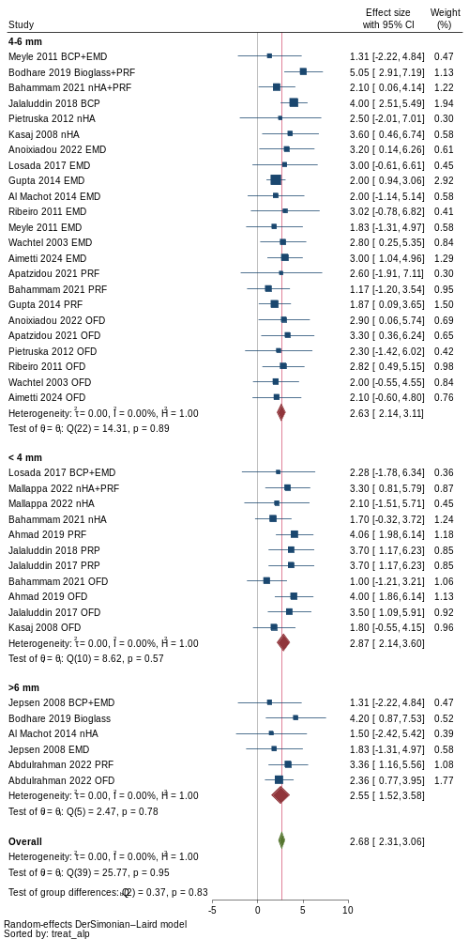
Supplementary Figure S2. Subgroup analysis of clinical attachment level (CAL) gain at 12 months post-surgery stratified by radiographic defect depth. The radiographic defect depth is subcategorized into < 4 mm, 4-6 mm, and > 6 mm. A p-value from the Q test below 0.1 or I² value of 25% higher indicated the presence of heterogeneity. The I² value for CAL gain at 12 months decreased from 51.34% to 16.28%. The p-value from the Q-test for CAL gain at 12 months increased from 0.00 to 0.20, and the p-value for group differences was 0.83, suggesting that heterogeneity was resolved after subgroup analysis.
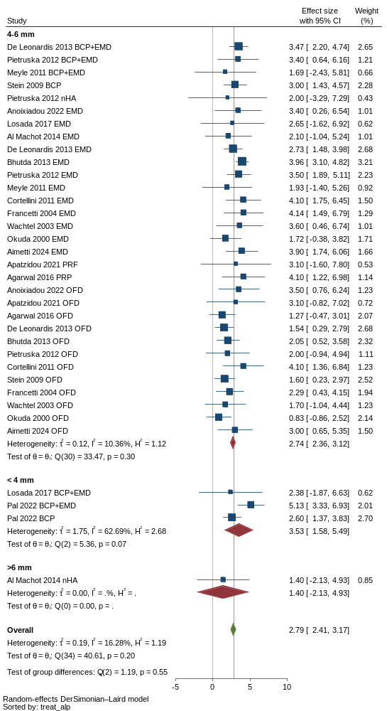
Supplementary Figure S3. Subgroup analysis of radiographic linear bone (RLB) gain at 6 months post-surgery stratified by defect morphology. The defect morphology is subcategorized into contained, non-contained and mixed defect. A p-value from the Q test below 0.1 or I² value of 25% higher indicated the presence of heterogeneity. The I² value for RLB gain at 6 months decreased from 77.68% to 35.03%. The p-value from the Q-test for RLB gain at 6 months increased from 0.00 to 0.03, and the p-value for group differences was 0.09, suggesting that there was residual heterogeneity after subgroup analysis.
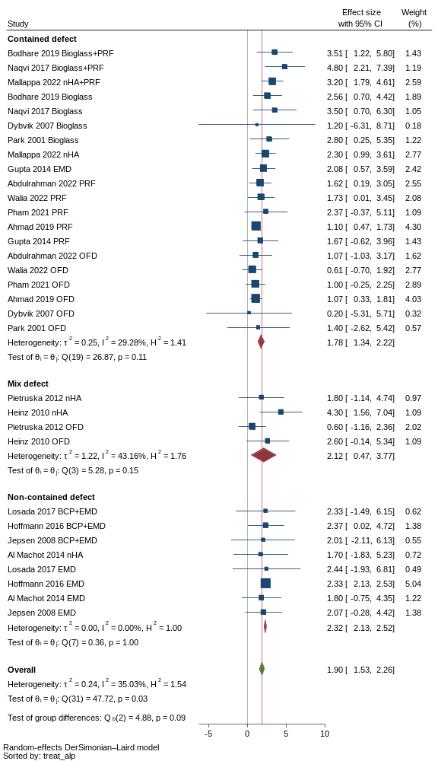
Supplementary Figure S4. Subgroup analysis of radiographic linear bone (RLB) gain at 6 months post-surgery stratified by inclusion of smoker. A p-value from the Q test below 0.1 or I² value of 25% higher indicated the presence of heterogeneity. The I² value for RLB gain at 6 months decreased from 77.68% to 33.85%. The p-value from the Q-test for RLB gain at 6 months increased from 0.00 to 0.01, and the p-value for group differences was 0.95, suggesting that there was residual heterogeneity after subgroup analysis.
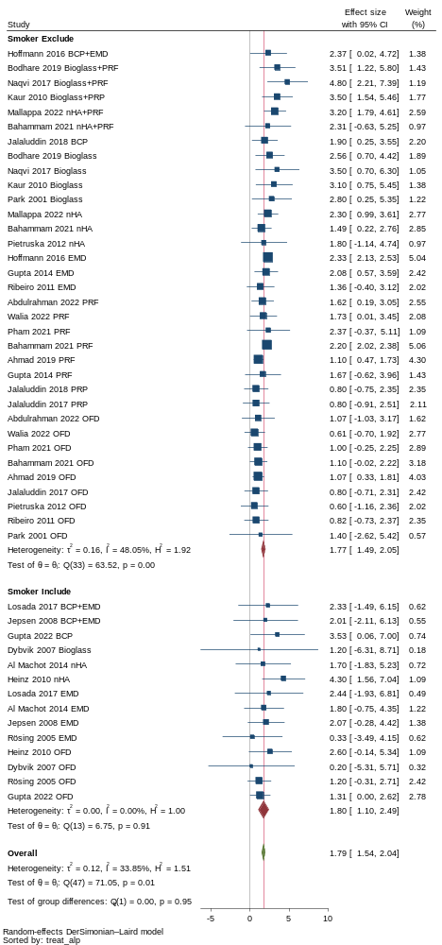
Supplementary Figure S5. Subgroup analysis of radiographic linear bone (RLB) gain at 6 months post-surgery stratified by inclusion of radiographic defect depth at baseline. The radiographic defect depth is subcategorized into < 4 mm, 4-6 mm, and > 6 mm. A p-value from the Q test below 0.1 or I² value of 25% higher indicated the presence of heterogeneity. The I² value for RLB gain at 6 months decreased from 77.68% to 32.56%. The p-value from the Q-test for RLB gain at 6 months increased from 0.00 to 0.05, and the p-value for group differences was 0.00, suggesting that there was residual heterogeneity after subgroup analysis, but RLB gain from among subgroup was significantly different.
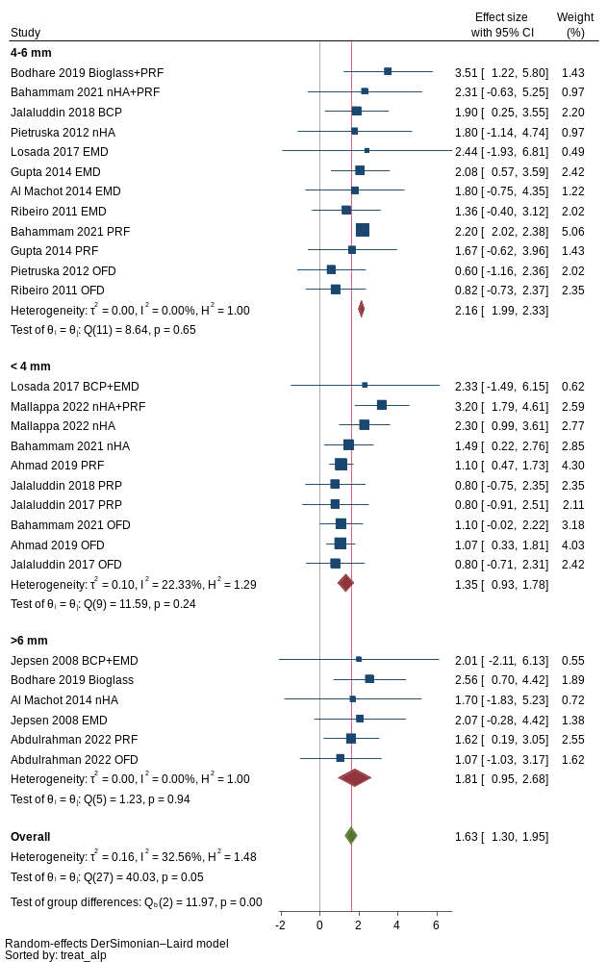
Supplementary Figure S6. Network geometry plots for clinical and radiographic outcomes at 3-, and 9-month post-surgery. Network comparisons of RCTs included in the analyses of (a-b) clinical attachment level (CAL) gain, (c-d) probing depth (PD) reduction and (e) radiographic linear bone (RLB) gain.
- CAL gain at 3 months | - CAL gain at 9 months
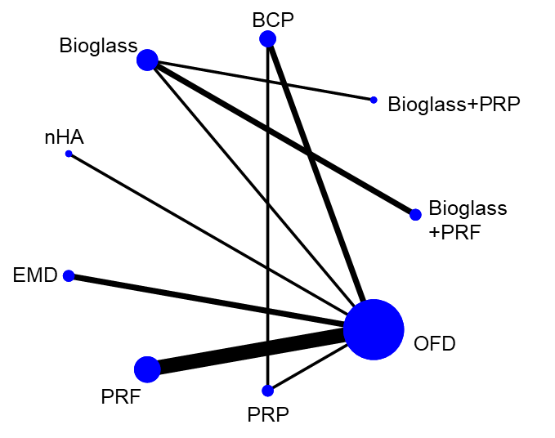 | 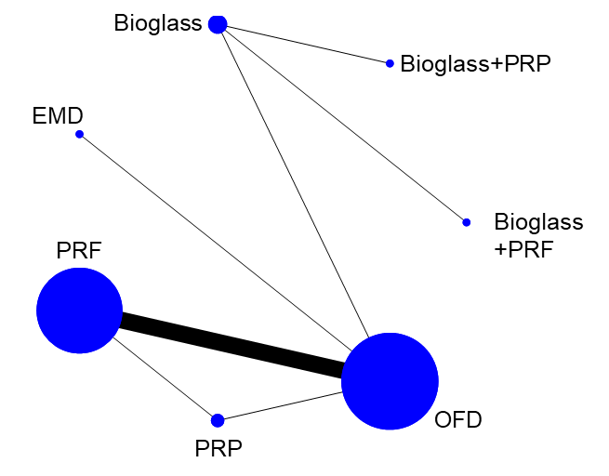
- PD reduction at 3 months | - PD reduction at 9 months
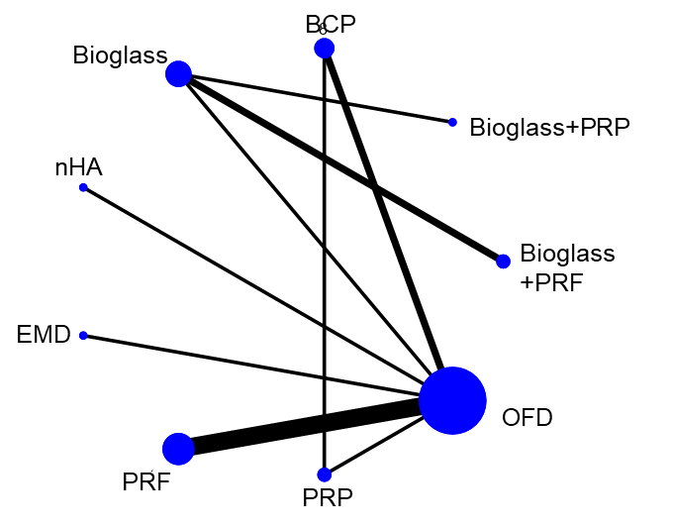 | 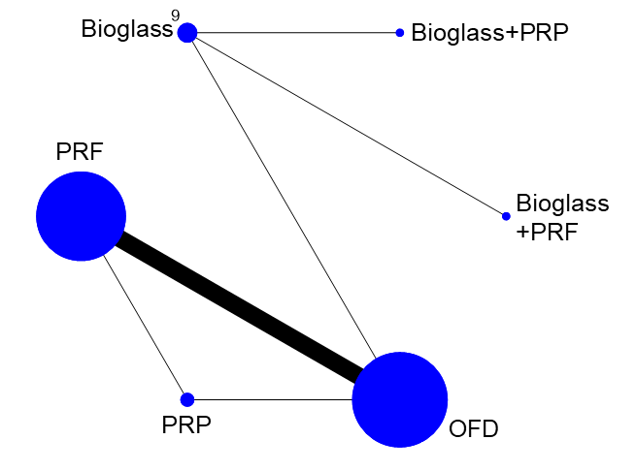
 | - RLB gain at 9 months

Supplementary Table S13. Assessment of inconsistency in network meta-analyses using design-by-treatment inconsistency. A p-value for the test of global inconsistency > 0.05 indicates no evidence of inconsistency in the network.

Outcome | Number of studies | Chi² | p-value for test of global inconsistency
Clinical attachment level (CAL) gain  at 3 months after surgery | 16 | 0.48 | 0.49
Clinical attachment level (CAL) gain  at 6 months after surgery | 44 | 5.83 | 0.56
Clinical attachment level (CAL) gain  at 9 months after surgery | 18 | 0.23 | 0.63
Clinical attachment level (CAL) gain  at 12 months after surgery | 32 | 10.38 | 0.07
Probing depth (PD) reduction  at 3 months after surgery | 15 | 0.82 | 0.37
Probing depth (PD) reduction  at 6 months after surgery | 44 | 4.61 | 0.71
Probing depth (PD) reduction  at 9 months after surgery | 17 | 0.03 | 0.85
Probing depth (PD) reduction  at 12 months after surgery | 32 | 5.87 | 0.32
Radiographic linear bone (RLB) gain  at 6 months after surgery | 24 | 7.23 | 0.30
Radiographic linear bone (RLB) gain  at 12 months after surgery | 18 | 6.59 | 0.09

Supplementary Table S14. Assessment of inconsistency in network meta-analyses using a design-by-treatment interaction model and a loop-specific approach. An inconsistency factor (IF) close to zero, with the lower bound of the 95% confidence interval equal to zero, indicates the absence of inconsistency within triangular and quadratic loops in the network. A p-value > 0.05 for the loop-specific approach suggests no evidence of inconsistency within the loop. The bold text indicates the presence of inconsistency.
Loop | Clinical attachment level (CAL) gain |  | Probing depth (PD) reduction |  | Radiographic linear bone (RLB) gain
Loop | IF  (95% CI) | p-value | IF  (95% CI) | p-value | IF  (95% CI) | p-value
3 months after surgery
BCP-PRP-OFD | 0.87  (0.00, 2.49) | 0.292 | 0.93  (0.00,2.22) | 0.160 | - | -
6 months after surgery
BCP-PRP-OFD | 1.80  (0.00,3.86) | 0.09 | 1.85  (0.00,3.80) | 0.06 | 1.12  (0.00,2.67) | 0.16
nHA+PRF-PRF-OFD | 0.96  (0.00,2.20) | 0.13 | 0.71  (0.00,1.84) | 0.22 | 0.35  (0.00,1.69) | 0.61
nHA-EMD-PRF | 0.88  (0.00,2.34) | 0.24 | 0.22  (0.00,1.58) | 0.76 | 1.02  (0.00,2.22) | 0.10
nHA-PRF-OFD | 0.79  (0.00,1.92) | 0.17 | 0.15  (0.00,1.24) | 0.23 | 0.95  (0.00,2.11) | 0.11
nHA-EMD-OFD | 0.59  (0.00,1.93) | 0.39 | 0.80  (0.00,2.15) | 0.25 | 0.79  (0.00,2.24) | 0.29
EMD-PRF-OFD | 0.40  (0.00,1.16) | 0.31 | 0.52  (0.00,1.35) | 0.23 | 0.93  (0.00,2.01) | 0.10
Bioglass-EMD-OFD | 0.35  (0.00,2.11) | 0.70 | 0.28  (0.00,1.76) | 0.72 | - | -
nHA+PRF-nHA-OFD | 0.18  (0.00,1.48) | 0.78 | 0.70  (0.00,1.97) | 0.28 | 1.08  (0.00,2.22 | 0.06
nHA+PRF-nHA-PRF | 0.08  (0.00,1.66) | 0.92 | 0.05  (0.00,1.64) | 0.96 | 0.08  (0.00,1.06) | 0.87
9 months after surgery
PRF-PRP-OFD | 0.60  (0.00,1.44) | 0.169 | 0.14  (0.00,0.97) | 0.75 | - | -
12 months after surgery
BCP+EMD-BCP-OFD | 2.00  (1.21,2.79) | 0.00 | 1.51  (0.61,2.41) | 0.00 | 1.87  (1.07,2.67) | 0.00
BCP+EMD-EMD-OFD | 0.89  (0.07,1.71) | 0.03 | 0.39  (0.00,1.03) | 0.24 | - | -
Bioglass-EMD-OFD | 0.87  (0.00,2.28) | 0.23 | 0.89  (0.00,2.43) | 0.26 | - | -
nHA-EMD-OFD | 0.25  (0.00,2.20) | 0.80 | 0.02  (0.00,1.95) | 0.98 | 0.18  (0.00,1.54) | 0.80

Supplementary Table S15. Comparative treatment efficacy in clinical attachment (CAL) gain at 3-month post-surgery. The value was unstandardized mean differences (USMD) along with 95% confidence interval (95% CI) for CAL gain between various treatment pairs. Comparisons are read from lower right to upper left of diagonal line. For instance, the USMD (95% CI) of CAL gain between bioglass and OFD was 1.25 (-1.17,3.66). Statistically significant differences between treatment options are showed in bold (p < 0.05).

OFD | 0.56  (-0.59,1.71) | 0.93  (0.40,1.46) | 0.22  (-0.73,1.17) | 0.83  (-0.45,2.11) | 1.25  (-1.17,3.66) | 0.92  (-0.03,1.87) | 1.65  (-1.22,4.51) | 1.90  (-0.70,4.50)
 | PRP | 0.37  (-0.89,1.63) | -0.34  (-1.82,1.14) | 0.27  (-1.44,1.99) | 0.69  (-1.98,3.36) | 0.36  (-0.75,1.47) | 1.09  (-2.00,4.17) | 1.35  (-1.50,4.19)
 |  | PRF | -0.71  (-1.80,0.38) | -0.10  (-1.48,1.28) | 0.32  (-2.15,2.79) | -0.01  (-1.09,1.08) | 0.72  (-2.19,3.63) | 0.98  (-1.68,3.63)
 |  |  | EMD | 0.61  (-0.98,2.20) | 1.03  (-1.56,3.62) | 0.70  (-0.64,2.04) | 1.43  (-1.59,4.44) | 1.69  (-1.08,4.45)
 |  |  |  | nHA | 0.42  (-2.31,3.14) | 0.09  (-1.50,1.68) | 0.82  (-2.32,3.95) | 1.07  (-1.82,3.97)
 |  |  |  |  | Bioglass | -0.33  (-2.92,2.26) | 0.40  (-1.14,1.94) | 0.66  (-0.32,1.63)
 |  |  |  |  |  | BCP | 0.73  (-2.29,3.74) | 0.99  (-1.78,3.75)
 |  |  |  |  |  |  | Bioglass+PRP | 0.26  (-1.56,2.08)
 |  |  |  |  |  |  |  | Bioglass+PRF

Supplementary Table S16. Comparative treatment efficacy in clinical attachment (CAL) gain at 6-month post-surgery. The value was unstandardized mean differences (USMD) along with 95% confidence interval (95% CI) for CAL gain between various treatment pairs. Comparisons are read from lower right to upper left of diagonal line. For instance, the USMD (95% CI) of CAL gain between bioglass and OFD was 1.13 (0.30, 1.96). Statistically significant differences between treatment options are showed in bold (p < 0.05).

OFD | 1.01  (-0.14,2.16) | 0.98  (0.59,1.36) | 0.86  (0.49,1.24) | 0.91  (0.30,1.52) | 1.13  (0.30,1.96) | 1.99  (1.03,2.94) | 1.37  (0.55,2.19) | 2.13  (0.38,3.88) | 1.98  (0.67,3.29) | 0.33  (-0.45,1.11)
 | PRP | -0.03  (-1.24,1.18) | -0.14  (-1.35,1.07) | -0.10  (-1.40,1.20) | 0.13  (-1.29,1.54) | 0.98  (-0.13,2.10) | 0.36  (-1.05,1.78) | 1.13  (-0.97,3.22) | 0.98  (-0.77,2.72) | -0.68  (-2.06,0.71)
 |  | PRF | -0.11  (-0.59,0.37) | -0.06  (-0.74,0.61) | 0.16  (-0.74,1.06) | 1.01  (-0.02,2.04) | 0.39  (-0.46,1.25) | 1.16  (-0.63,2.94) | 1.01  (-0.35,2.37) | -0.64  (-1.48,0.19)
 |  |  | EMD | 0.05  (-0.63,0.72) | 0.27  (-0.58,1.12) | 1.12  (0.10,2.15) | 0.51  (-0.37,1.38) | 1.27  (-0.49,3.03) | 1.12  (-0.20,2.44) | -0.53  (-1.22,0.15)
 |  |  |  | nHA | 0.22  (-0.80,1.24) | 1.08  (-0.06,2.21) | 0.46  (-0.24,1.16) | 1.22  (-0.62,3.07) | 1.07  (-0.36,2.51) | -0.58  (-1.54,0.38)
 |  |  |  |  | Bioglass | 0.85  (-0.41,2.12) | 0.24  (-0.92,1.39) | 1.00  (-0.54,2.54) | 0.85  (-0.16,1.86) | -0.80  (-1.89,0.29)
 |  |  |  |  |  | BCP | -0.62  (-1.88,0.64) | 0.15  (-1.85,2.14) | -0.00  (-1.62,1.62) | -1.66  (-2.89,-0.42)
 |  |  |  |  |  |  | nHA  +PRF | 0.76  (-1.16,2.69) | 0.61  (-0.93,2.15) | -1.04  (-2.15,0.07)
 |  |  |  |  |  |  |  | Bioglass  +PRP | -0.15  (-1.99,1.69) | -1.80  (-3.69,0.09)
 |  |  |  |  |  |  |  |  | Bioglass  +PRF | -1.65  (-3.14,-0.16)
BCP
+EMD

Supplementary Table S17. Comparative treatment efficacy in clinical attachment (CAL) gain at 9-month post-surgery. The value was unstandardized mean differences (USMD) along with 95% confidence interval (95% CI) for CAL gain between various treatment pairs. Comparisons are read from lower right to upper left of diagonal line. For instance, the USMD (95% CI) of CAL gain between bioglass and OFD was 2.22 (-0.68, 5.12). Statistically significant differences between treatment options are showed in bold (p < 0.05).

OFD | 0.32  (-1.28,1.91) | 0.79  (0.28,1.30) | 0.60  (-1.20,2.40) | 2.22  (-0.68,5.12) | 2.49  (-0.91,5.88) | 3.17  (-0.44,6.78)
 | PRP | 0.47  (-1.12,2.07) | 0.28  (-2.13,2.69) | 1.90  (-1.41,5.21) | 2.17  (-1.58,5.91) | 2.85  (-1.09,6.79)
 |  | PRF | -0.19  (-2.07,1.68) | 1.43  (-1.52,4.38) | 1.69  (-1.73,5.12) | 2.38  (-1.26,6.02)
 |  |  | EMD | 1.62  (-1.80,5.04) | 1.89  (-1.96,5.73) | 2.57  (-1.46,6.60)
 |  |  |  | Bioglass | 0.27  (-1.50,2.03) | 0.95  (-1.19,3.09)
 |  |  |  |  | Bioglass+PRP | 0.68  (-2.09,3.46)
 |  |  |  |  |  | Bioglass+PRF

Supplementary Table S18. Comparative treatment efficacy in clinical attachment (CAL) gain at 12-month post-surgery. The value was unstandardized mean differences (USMD) along with 95% confidence interval (95% CI) for CAL gain between various treatment pairs. Comparisons are read from lower right to upper left of diagonal line. For instance, the USMD (95% CI) of CAL gain between bioglass and OFD was 0.69 (-0.45, 1.82). Statistically significant differences between treatment options are showed in bold (p < 0.05).
OFD | 2.83  (1.06,4.60) | 1.18  (0.36,2.00) | 1.03  (0.62,1.45) | 0.19  (-1.19,1.57) | 0.69  (-0.45,1.82) | 0.16  (-0.97,1.28) | 0.65  (-0.71,2.01) | 1.47  (0.72,2.22)
 | PRP | -1.65  (-3.60,0.30) | -1.80  (-3.61,0.02) | -2.64  (-4.88,-0.39) | -2.14  (-4.24,-0.04) | -2.67  (-4.77,-0.58) | -2.18  (-4.41,0.05) | -1.36  (-3.28,0.56)
 |  | PRF | -0.14  (-1.06,0.77) | -0.98  (-2.59,0.62) | -0.49  (-1.89,0.90) | -1.02  (-2.41,0.37) | -0.53  (-2.11,1.06) | 0.30  (-0.81,1.40)
 |  |  | EMD | -0.84  (-2.21,0.53) | -0.35  (-1.47,0.78) | -0.88  (-2.02,0.27) | -0.38  (-1.68,0.91) | 0.44  (-0.25,1.13)
 |  |  |  | nHA | 0.49  (-1.26,2.25) | -0.04  (-1.80,1.72) | 0.46  (-1.43,2.34) | 1.28  (-0.24,2.80)
 |  |  |  |  | Bioglass | -0.53  (-2.10,1.04) | -0.04  (-1.75,1.68) | 0.79  (-0.51,2.09)
 |  |  |  |  |  | BCP | 0.49  (-1.23,2.22) | 1.32  (0.19,2.44)
 |  |  |  |  |  |  | Bioglass+EMD | 0.82  (-0.64,2.29)
 |  |  |  |  |  |  |  | BCP+EMD

Supplementary Table S19. Comparative treatment efficacy in probing depth (PD) reduction at 3-month post-surgery. The value was unstandardized mean differences (USMD) along with 95% confidence interval (95% CI) for PD reduction between various treatment pairs. Comparisons are read from lower right to upper left of diagonal line. For instance, the USMD (95% CI) of PD reduction between bioglass and OFD was 1.00 (-0.66, 2.65). Statistically significant differences between treatment options are showed in bold (p < 0.05).
OFD | 0.95  (-0.01,1.92) | 1.04  (0.54,1.55) | -0.58  (-1.73,0.57) | 0.26  (-1.04,1.56) | 1.00  (-0.66,2.65) | 0.98  (0.10,1.86) | 1.70  (-0.54,3.94) | 1.03  (-0.94,3.00)
 | PRP | 0.09  (-1.00,1.18) | -1.53  (-3.03,-0.03) | -0.69  (-2.31,0.93) | 0.05  (-1.87,1.96) | 0.03  (-0.92,0.98) | 0.75  (-1.69,3.19) | 0.08  (-2.11,2.27)
 |  | PRF | -1.62  (-2.88,-0.37) | -0.78  (-2.18,0.61) | -0.05  (-1.78,1.68) | -0.06  (-1.08,0.95) | 0.65  (-1.64,2.95) | -0.02  (-2.05,2.01)
 |  |  | EMD | 0.84  (-0.90,2.58) | 1.58  (-0.44,3.60) | 1.56  (0.11,3.01) | 2.28  (-0.24,4.80) | 1.61  (-0.67,3.89)
 |  |  |  | nHA | 0.74  (-1.37,2.85) | 0.72  (-0.85,2.29) | 1.44  (-1.15,4.03) | 0.77  (-1.59,3.13)
 |  |  |  |  | Bioglass | -0.02  (-1.89,1.86) | 0.70  (-0.81,2.21) | 0.03  (-1.03,1.09)
 |  |  |  |  |  | BCP | 0.72  (-1.69,3.12) | 0.05  (-2.11,2.20)
 |  |  |  |  |  |  | Bioglass+PRP | -0.67  (-2.51,1.17)
 |  |  |  |  |  |  |  | Bioglass+PRF

Supplementary Table S20. Comparative treatment efficacy in probing depth (PD) reduction at 6-month post-surgery. The value was unstandardized mean differences (USMD) along with 95% confidence interval (95% CI) for PD reduction between various treatment pairs. Comparisons are read from lower right to upper left of diagonal line. For instance, the USMD (95% CI) of PD reduction between bioglass and OFD was 0.76 (-0.10, 1.62). Statistically significant differences between treatment options are showed in bold (p < 0.05).
OFD | 1.09  (0.01,2.16) | 1.09  (0.67,1.51) | 0.78  (0.37,1.18) | 0.81  (0.24,1.39) | 0.76  (-0.10,1.62) | 1.69  (0.72,2.65) | 1.52  (0.70,2.33) | 1.56  (-0.26,3.38) | 0.80  (-0.65,2.26) | 0.14  (-0.70,0.99)
 | PRP | 0.01  (-1.15,1.16) | -0.31  (-1.46,0.84) | -0.27  (-1.49,0.95) | -0.33  (-1.71,1.05) | 0.60  (-0.48,1.68) | 0.43  (-0.92,1.78) | 0.47  (-1.64,2.59) | -0.28  (-2.09,1.52) | -0.94  (-2.31,0.43)
 |  | PRF | -0.32  (-0.84,0.21) | -0.28  (-0.94,0.39) | -0.33  (-1.28,0.62) | 0.59  (-0.46,1.65) | 0.42  (-0.44,1.29) | 0.47  (-1.40,2.33) | -0.29  (-1.79,1.22) | -0.95  (-1.85,-0.04)
 |  |  | EMD | 0.04  (-0.63,0.70) | -0.02  (-0.92,0.89) | 0.91  (-0.14,1.96) | 0.74  (-0.15,1.63) | 0.78  (-1.06,2.62) | 0.03  (-1.45,1.51) | -0.63  (-1.37,0.11)
 |  |  |  | nHA | -0.06  (-1.09,0.98) | 0.87  (-0.25,2.00) | 0.70  (-0.01,1.42) | 0.74  (-1.16,2.65) | -0.01  (-1.57,1.55) | -0.67  (-1.66,0.33)
 |  |  |  |  | Bioglass | 0.93  (-0.37,2.22) | 0.76  (-0.43,1.94) | 0.80  (-0.80,2.40) | 0.05  (-1.12,1.21) | -0.61  (-1.78,0.55)
 |  |  |  |  |  | BCP | -0.17  (-1.44,1.09) | -0.13  (-2.19,1.93) | -0.88  (-2.62,0.86) | -1.54  (-2.82,-0.26)
 |  |  |  |  |  |  | nHA+PRF | 0.04  (-1.95,2.03) | -0.71  (-2.37,0.95) | -1.37  (-2.53,-0.22)
 |  |  |  |  |  |  |  | Bioglass  +PRP | -0.75  (-2.74,1.23) | -1.41  (-3.40,0.57)
 |  |  |  |  |  |  |  |  | Bioglass  +PRF | -0.66  (-2.31,0.99)
BCP
+EMD

Supplementary Table S21. Comparative treatment efficacy in probing depth (PD) reduction at 9-month post-surgery. The value was unstandardized mean differences (USMD) along with 95% confidence interval (95% CI) for PD reduction between various treatment pairs. Comparisons are read from lower right to upper left of diagonal line. For instance, the USMD (95% CI) of PD reduction between bioglass and OFD was 1.12 (-0.37, 2.62). Statistically significant differences between treatment options are showed in bold (p < 0.05).
OFD | 0.85  (-0.09,1.79) | 0.91  (0.61,1.21) | 1.12  (-0.37,2.62) | 1.12  (-0.66,2.91) | 1.17  (-1.18,3.52)
 | PRP | 0.06  (-0.89,1.00) | 0.27  (-1.49,2.04) | 0.27  (-1.75,2.29) | 0.32  (-2.21,2.85)
 |  | PRF | 0.21  (-1.31,1.74) | 0.21  (-1.60,2.02) | 0.26  (-2.10,2.63)
 |  |  | Bioglass | -0.00  (-0.98,0.98) | 0.05  (-1.76,1.86)
 |  |  |  | Bioglass+PRP | 0.05  (-2.01,2.11)
 |  |  |  |  | Bioglass+PRF

Supplementary Table S22. Comparative treatment efficacy in probing depth (PD) reduction at 12-month post-surgery. The value was unstandardized mean differences (USMD) along with 95% confidence interval (95% CI) for PD reduction between various treatment pairs. Comparisons are read from lower right to upper left of diagonal line. For instance, the USMD (95% CI) of PD reduction between bioglass and OFD was 0.45 (-0.54, 1.44). Statistically significant differences between treatment options are showed in bold (p < 0.05).

OFD | 2.17  (0.25,4.09) | 1.12  (0.41,1.82) | 0.98  (0.64,1.33) | 0.35  (-0.88,1.58) | 0.45  (-0.54,1.44) | -0.01  (-0.95,0.94) | 0.75  (-0.31,1.80) | 1.23  (0.61,1.84)
 | PRP | -1.05  (-3.10,1.00) | -1.19  (-3.14,0.77) | -1.82  (-4.11,0.46) | -1.72  (-3.88,0.45) | -2.18  (-4.32,-0.03) | -1.42  (-3.62,0.77) | -0.94  (-2.96,1.08)
 |  | PRF | -0.13  (-0.92,0.65) | -0.77  (-2.19,0.65) | -0.66  (-1.88,0.55) | -1.12  (-2.30,0.06) | -0.37  (-1.64,0.90) | 0.11  (-0.82,1.04)
 |  |  | EMD | -0.64  (-1.86,0.59) | -0.53  (-1.54,0.48) | -0.99  (-1.96,-0.03) | -0.24  (-1.23,0.76) | 0.24  (-0.32,0.81)
 |  |  |  | nHA | 0.11  (-1.46,1.67) | -0.35  (-1.89,1.18) | 0.40  (-1.18,1.98) | 0.88  (-0.46,2.22)
 |  |  |  |  | Bioglass | -0.46  (-1.82,0.90) | 0.29  (-1.12,1.71) | 0.77  (-0.36,1.91)
 |  |  |  |  |  | BCP | 0.75  (-0.63,2.14) | 1.23  (0.28,2.19)
 |  |  |  |  |  |  | Bioglass+EMD | 0.48  (-0.66,1.62)
 |  |  |  |  |  |  |  | BCP+EMD

Supplementary Table S23. Comparative treatment efficacy in radiographic linear bone (RLB) gain at 6-month post-surgery. The value was unstandardized mean differences (USMD) along with 95% confidence interval (95% CI) for RLB gain between various treatment pairs. Comparisons are read from lower right to upper left of diagonal line. For instance, the USMD (95% CI) of RLB gain between bioglass and OFD was 1.33 (0.01, 2.65). Statistically significant differences between treatment options are showed in bold (p < 0.05).
OFD | 0.31  (-0.69,1.31) | 0.79  (0.36,1.22) | 0.57  (0.05,1.10) | 0.68  (0.10,1.27) | 1.33  (0.01,2.65) | 1.72  (0.61,2.83) | 1.39  (0.53,2.25) | 1.73  (-0.15,3.61) | 2.40  (0.80,4.01) | 0.54  (-0.35,1.44)
 | PRP | 0.48  (-0.61,1.56) | 0.26  (-0.87,1.39) | 0.37  (-0.78,1.53) | 1.02  (-0.64,2.67) | 1.41  (0.41,2.40) | 1.08  (-0.24,2.39) | 1.42  (-0.71,3.55) | 2.09  (0.21,3.98) | 0.23  (-1.11,1.57)
 |  | PRF | -0.21  (-0.82,0.39) | -0.10  (-0.75,0.54) | 0.54  (-0.85,1.93) | 0.93  (-0.26,2.12) | 0.60  (-0.28,1.48) | 0.94  (-0.99,2.87) | 1.62  (-0.04,3.28) | -0.24  (-1.18,0.70)
 |  |  | EMD | 0.11  (-0.60,0.83) | 0.76  (-0.67,2.18) | 1.14  (-0.09,2.38) | 0.81  (-0.15,1.78) | 1.15  (-0.80,3.11) | 1.83  (0.14,3.52) | -0.03  (-0.75,0.69)
 |  |  |  | nHA | 0.64  (-0.80,2.09) | 1.03  (-0.22,2.29) | 0.70  (-0.08,1.48) | 1.04  (-0.93,3.01) | 1.72  (0.01,3.43) | -0.14  (-1.16,0.88)
 |  |  |  |  | Bioglass | 0.39  (-1.34,2.11) | 0.06  (-1.52,1.63) | 0.40  (-0.94,1.74) | 1.08  (0.16,1.99) | -0.78  (-2.38,0.81)
 |  |  |  |  |  | BCP | -0.33  (-1.73,1.07) | 0.01  (-2.17,2.19) | 0.69  (-1.26,2.64) | -1.17  (-2.60,0.25)
 |  |  |  |  |  |  | nHA+PRF | 0.34  (-1.73,2.41) | 1.02  (-0.80,2.84) | -0.84  (-2.04,0.36)
 |  |  |  |  |  |  |  | Bioglass+PRP | 0.68  (-0.94,2.29) | -1.18  (-3.26,0.90)
 |  |  |  |  |  |  |  |  | Bioglass+PRF | -1.86  (-3.69,-0.03)
 |  |  |  |  |  |  |  |  |  | BCP+EMD

Supplementary Table S24. Comparative treatment efficacy in radiographic linear bone (RLB) gain at 12-month post-surgery. The value was unstandardized mean differences (USMD) along with 95% confidence interval (95% CI) for RLB gain between various treatment pairs. Comparisons are read from lower right to upper left of diagonal line. For instance, the USMD (95% CI) of RLB gain between bioglass and OFD was 0.40 (-3.00, 3.80). Statistically significant differences between treatment options are showed in bold (p < 0.05).

OFD | 1.50  (-0.20,3.20) | 1.08  (-0.34,2.51) | 0.89  (0.27,1.50) | 0.94  (-0.43,2.31) | 0.40  (-3.00,3.80) | 0.26  (-1.73,2.25) | 1.59  (0.58,2.60)
 | PRP | -0.42  (-2.63,1.80) | -0.61  (-2.42,1.19) | -0.56  (-2.74,1.62) | -1.10  (-4.90,2.70) | -1.24  (-3.86,1.37) | 0.09  (-1.89,2.06)
 |  | PRF | -0.20  (-1.74,1.35) | -0.14  (-2.12,1.83) | -0.68  (-4.38,3.01) | -0.83  (-3.27,1.61) | 0.50  (-1.23,2.24)
 |  |  | EMD | 0.05  (-1.31,1.42) | -0.49  (-3.94,2.97) | -0.63  (-2.55,1.30) | 0.70  (-0.18,1.58)
 |  |  |  | nHA | -0.54  (-4.21,3.13) | -0.68  (-3.03,1.67) | 0.65  (-0.96,2.25)
 |  |  |  |  | Bioglass | -0.14  (-4.08,3.80) | 1.19  (-2.36,4.74)
 |  |  |  |  |  | BCP | 1.33  (-0.38,3.04)
 |  |  |  |  |  |  | BCP+EMD

Supplementary Table S25. SUCRA percentage rankings for clinical attachment level (CAL) gain, probing depth (PD) reduction, and radiographic linear bone (RLB) gain across various treatments at different time points.

Rank | SUCRA percentage for CAL gain |  |  |  | SUCRA percentage for PD reduction |  |  |  | SUCRA percentage for RLB gain
Rank | at 3  month | at 6  month | at 9  month | at 12  month | at 3  month | at 6  month | at 9  month | at 12  month | at 6  month | at 12  month
1 | Bioglass  +PRP  (80.3) | Bioglass  (86) | Bioglass  +PRP  (86.4) | OFD  (97.4) | BCP  (81.5) | Bioglass  (85.7) | Bioglass  +PRP  (63.7) | OFD  (91.2) | Bioglass  +PRP  (92.8) | BCP  (81.2)
2 | BCP  (70.5) | nHA  +PRF  (83.5) | Bioglass  (73) | Bioglass  +EMD  (79.6) | PRP  (67.5) | BCP  (79.8) | PRF  (61.5) | Bioglass  +EMD  (76.8) | Bioglass  (79.3) | OFD  (71.1)
3 | PRP  (59.5) | Bioglass  +PRP  (83.4) | EMD  (68.5) | PRP  (66.7) | Bioglass  (62.4) | nHA  +PRF  (73.7) | Bioglass  (59.8) | PRP  (70.9) | nHA  +PRF  (73.2) | PRP  (59.4)
4 | Bioglass  (57.1) | BCP  (64.6) | PRP  (45.7) | PRF  (59.7) | OFD  (60.5) | PRP  (62) | PRP  (54.8) | PRF  (63.3) | BCP  (70) | EMD  (53.5)
5 | nHA  (56.2) | nHA  (51.2) | PRF  (35.9) | BCP  (43.9) | Bioglass  +PRP  (60.2) | OFD  (57.7) | OFD  (52.9) | BCP  (51.5) | nHA  (62.3) | PRF  (50.4)
6 | EMD  (50.9) | PRP  (44.6) | OFD  (28) | nHA  (43.6) | nHA  (59.3) | Bioglass  +PRP  (45.5) | Bioglass  +PRF  (7.3) | nHA  (35.7) | PRP  (45.1) | nHA  (40.3)
7 | OFD  (38.4) | OFD  (44.4) | Bioglass  +PRF  (12.5) | EMD  (24.4) | EMD  (32.4) | EMD  (42.9) |  | EMD  (31.5) | EMD  (37.7) | Bioglass  (29)
8 | PRF  (24.9) | EMD  (39.2) |  | Bioglass  (21.5) | Bioglass  +PRF  (19.4) | PRF  (41.6) |  | Bioglass  (15.5) | PRF  (32.1) | BCP  +EMD  (15)
9 | Bioglass  +PRF  (12.4) | PRF  (36.7) |  | BCP+EMD  (13.2) | PRF  (6.8) | nHA  (41) |  | BCP  +EMD (13.6) | Bioglass  +PRF  (31.9)
10 |  | Bioglass  +PRF  (13.9) |  |  |  | Bioglass  +PRF  (13.6) |  |  | OFD  (21)
11 |  | BCP  +EMD  (2.6) |  |  |  | BCP  +EMD  (6.5) |  |  | BCP  +EMD  (4.7)

Supplementary Figure S7. Ranking plots for clinical attachment level (CAL) gain at 3-, 6-, 9-, and 12-months post-surgery. Treatments are ranked based on the surface under the cumulative ranking curves (SUCRA) percentage for CAL gain at (a) 3 months, (b) 6 months, (c) 9 months, and (d) 12 months. Treatments with higher SUCRA rankings than open flap debridement (OFD) are shown in red, while those with lower rankings are shown in blue. OFD is set as the control treatment and is labeled in black.
- CAL gain at 3 months | - CAL gain at 6 months
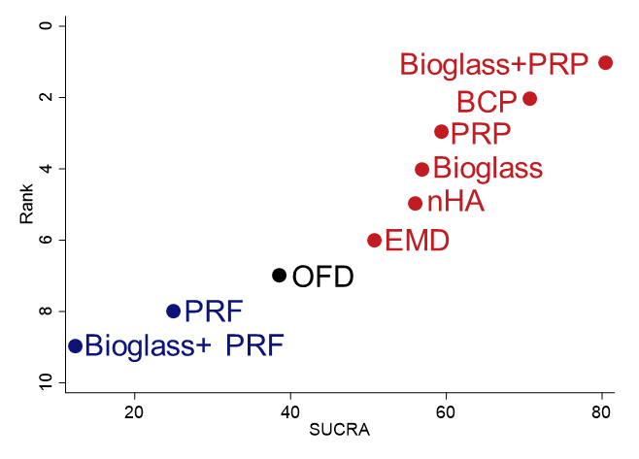 | 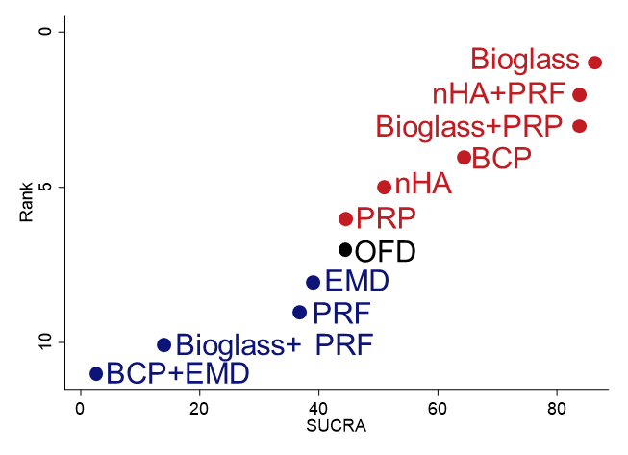
- CAL gain at 9 months | - CAL gain at 12 months
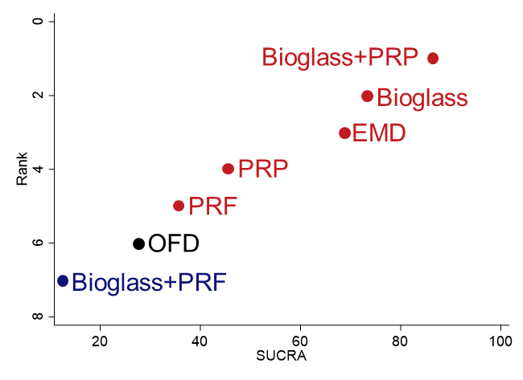 | 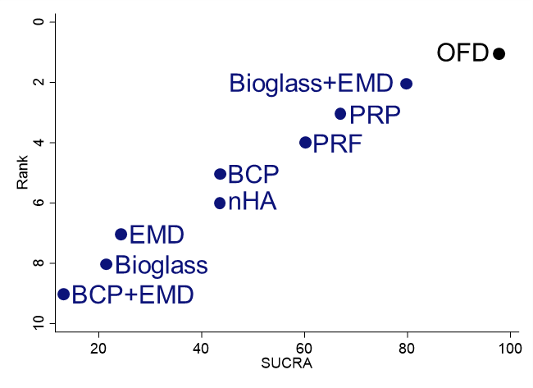
Supplementary Figure S8. Ranking plots for probing depth (PD) reduction at 3-, 6-, 9-, and 12-months post-surgery. Treatments are ranked based on the surface under the cumulative ranking curves (SUCRA) percentage for PD reduction at (a) 3 months, (b) 6 months, (c) 9 months, and (d) 12 months. Treatments with higher SUCRA rankings than open flap debridement (OFD) are shown in red, while those with lower rankings are shown in blue. OFD is set as the control treatment and is labeled in black.

- PD reduction at 3 months | - PD reduction at 6 months
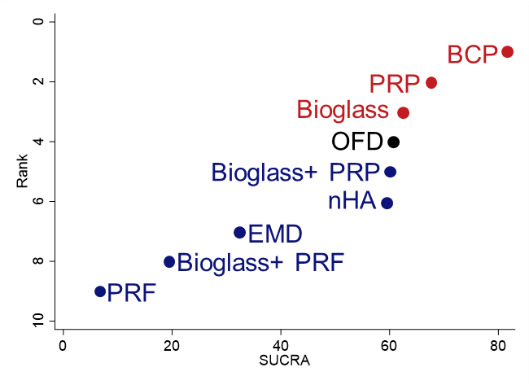 | 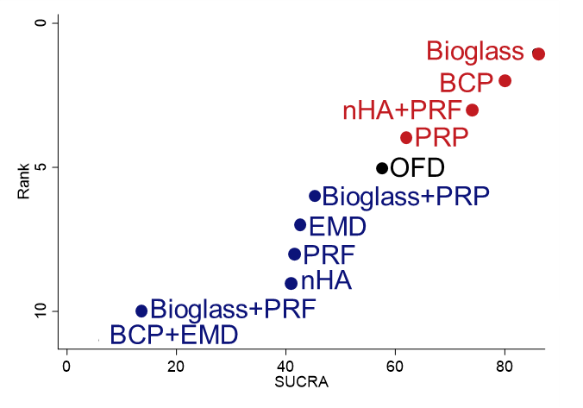
- PD reduction at 9 months | - PD reduction at 12 months
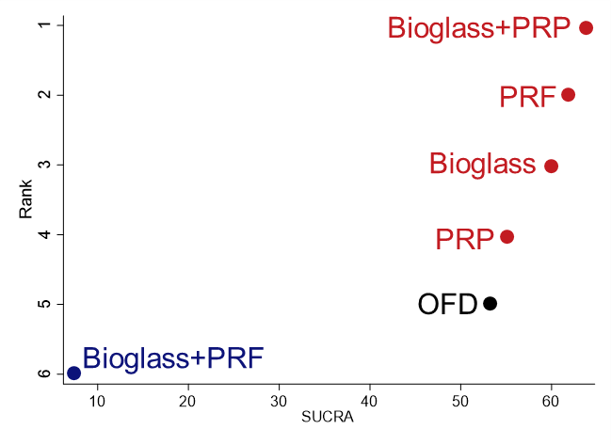 | 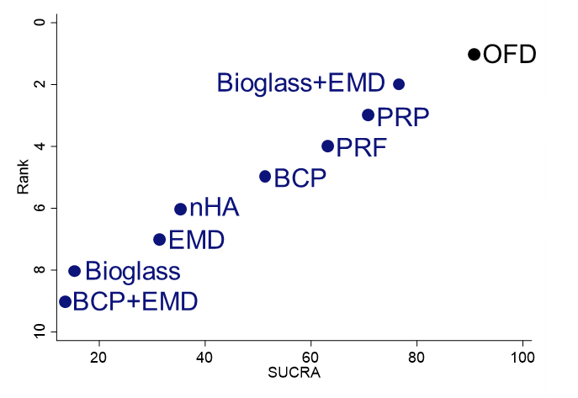

Supplementary Figure S9. Ranking plots for radiographic linear bone (RLB) gain at 6- and 12-months post-surgery. Treatments are ranked based on the surface under the cumulative ranking curves (SUCRA) percentage for RLB gain at (a) 6 months and (b) 12 months. Treatments with higher SUCRA rankings than open flap debridement (OFD) are shown in red, while those with lower rankings are shown in blue. OFD is set as the control treatment and is labeled in black.

- RLB gain at 6 months | - RLB gain at 12 months
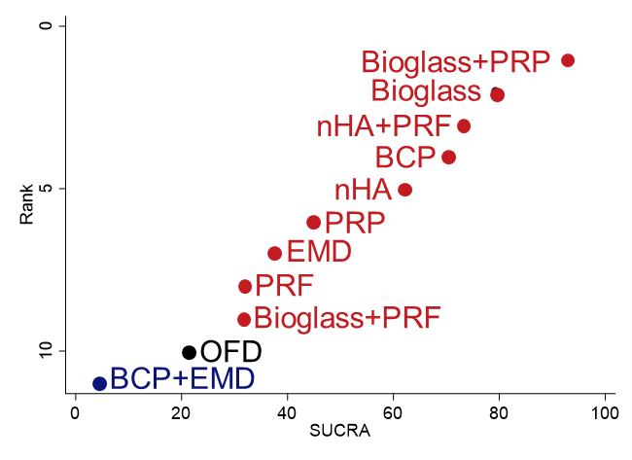 | 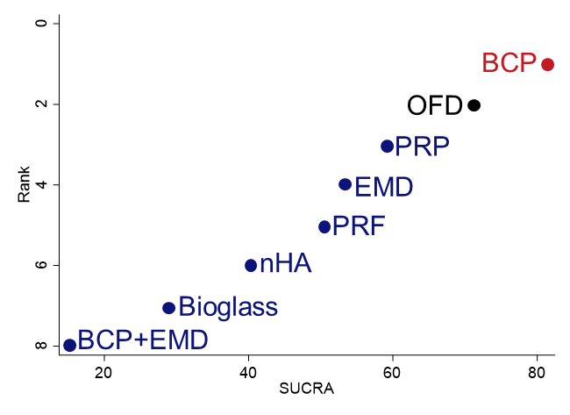

Supplementary Figure S10. Predictive interval plots of unstandardized mean difference for clinical attachment level (CAL) gain at 3-, 6-, 9- and 12-month post-surgery. The efficacy of each treatment was compared to OFD. The values in the right column showed the unstandardized mean difference with 95% confident interval (CI) and 95% prediction interval (PrI).

- CAL gain at 3 months | - CAL gain at 6 months
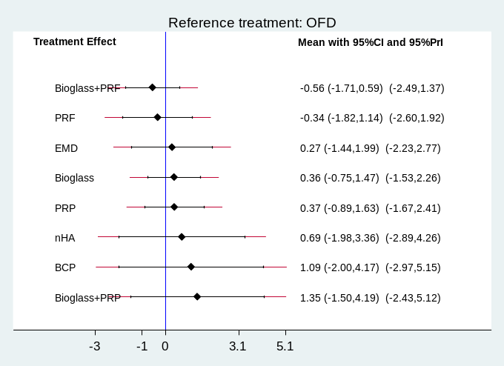 | 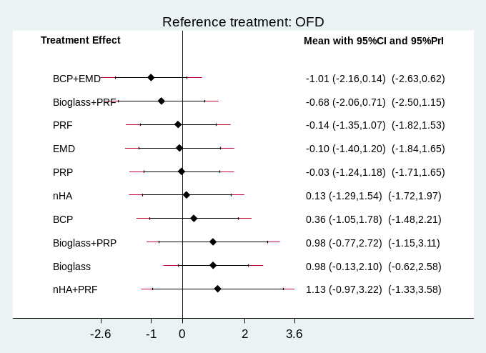
- CAL gain at 9 months | - CAL gain at 12 months
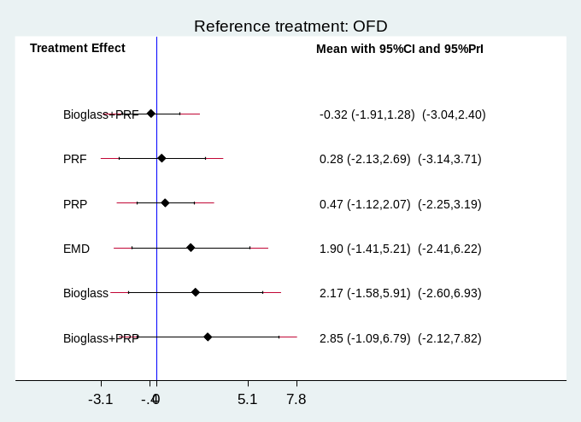 | 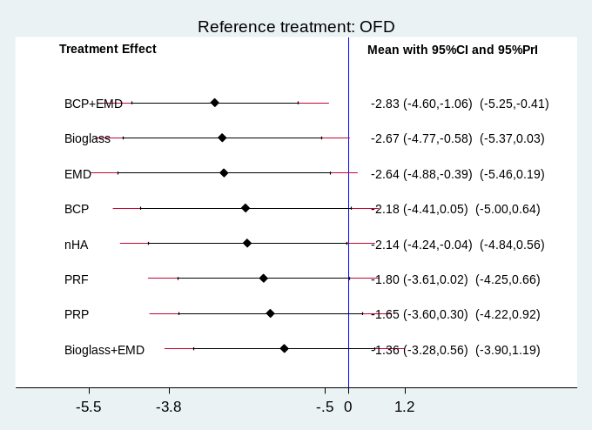

Supplementary Figure S11. Predictive interval plots of unstandardized mean difference for probing depth (PD) reduction at 3-, 6-, 9- and 12-month post-surgery. The efficacy of each treatment was compared to OFD. The values in the right column showed the unstandardized mean difference with 95% confident interval (CI) and 95% prediction interval (PrI).
- PD reduction at 3 months | - PD reduction at 6 months
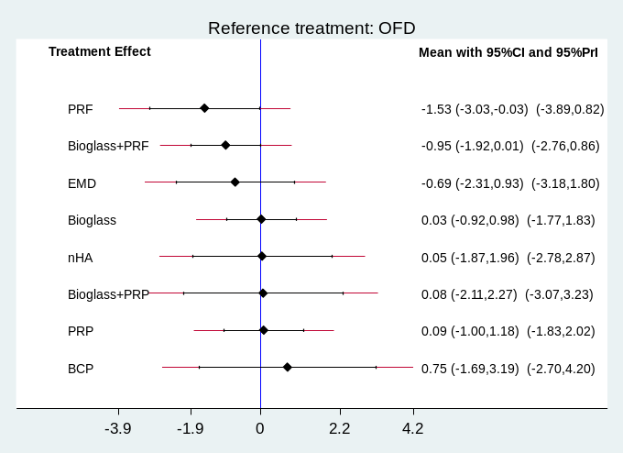 | 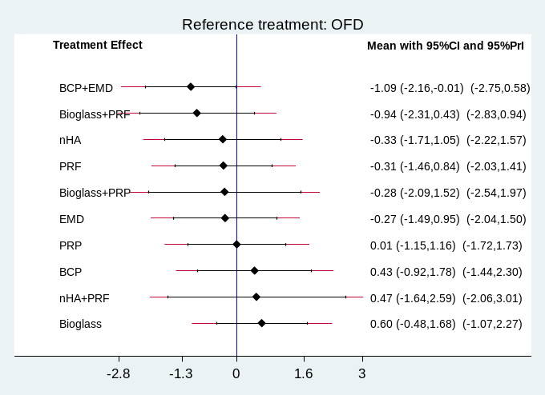
- PD reduction at 9 months | - PD reduction at 12 months
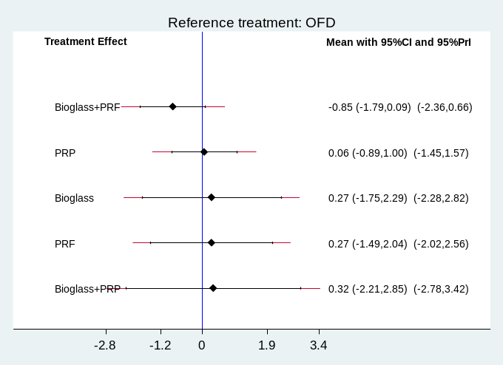 | 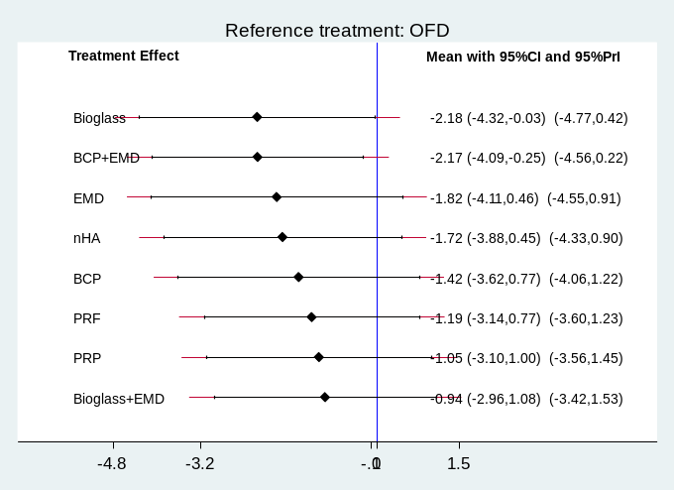

- RLB gain at 6 months | - RLB gain at 12 months
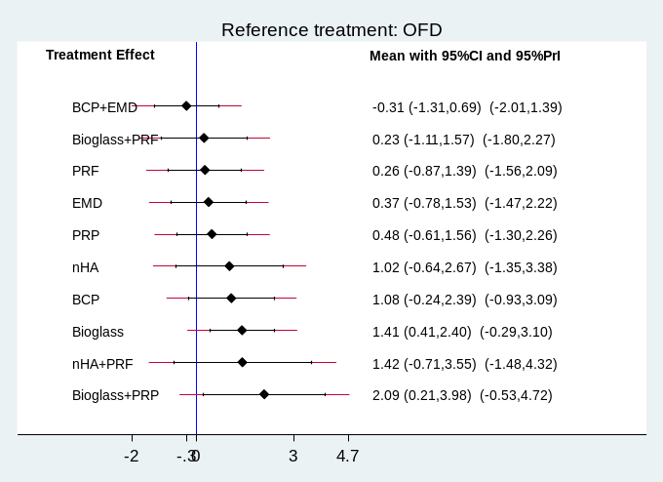 | 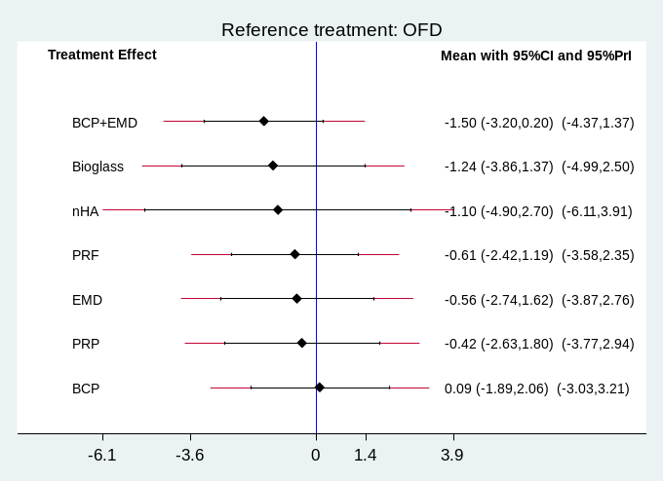
Supplementary Figure S12. Predictive interval plots of unstandardized mean difference for radiographic linear bone (RLB) gain at 6- and 12-month post-surgery. The efficacy of each treatment was compared to OFD. The values in the right column showed the unstandardized mean difference with 95% confident interval (CI) and 95% prediction interval (PrI).

Supplementary Figure S13. Comparison-adjusted funnel plots for NMAs of clinical attachment level (CAL) gain at 3, 6, 9, 12 months after surgery. The publication bias was assessed using comparison-adjusted funnel plots and Egger’s test. A p-value less than 0.05 indicates that studies with favorable results are more likely to be published.
- CAL gain at 3 months, Egger’s test p-value=0.985 |  |  |  | - CAL gain at 6 months, Egger’s test p-value=0.113
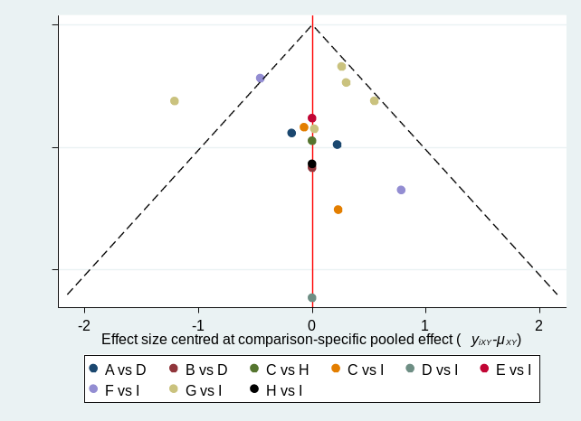 |  |  |  | 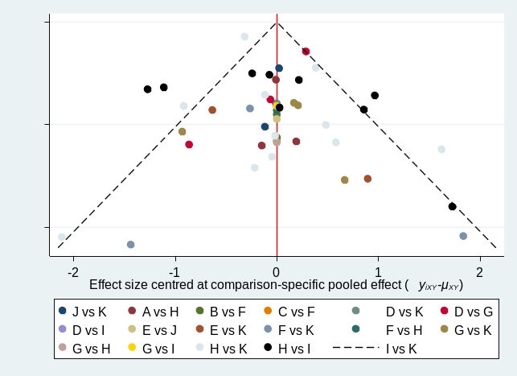
A=Bioglass+PRF  B=Bioglass+PRP  C=BCP | D=Bioglass  E=nHA  F=EMD | G=PRF  H=PRP  I=OFD |  | A=BCP+EMD  B=Bioglass+PRF  C=Bioglass+PRP  D=nHA+PRF | E=BCP  F=Bioglass  G=nHA  H=EMD |  |  | I=PRF  J=PRP  K=OFD
- CAL gain at 9 months, Egger’s test p-value= 0.217 |  |  |  | - CAL gain at 12 months, Egger’s test p-value= 0.000
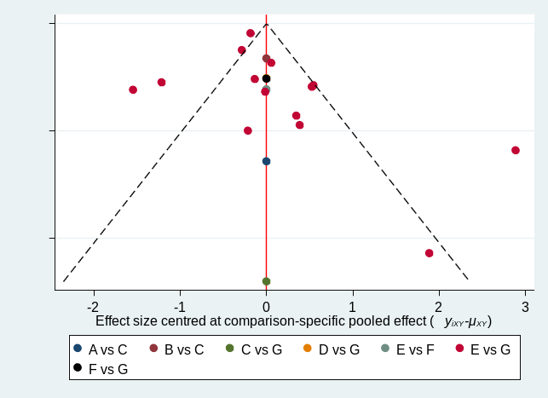 |  |  |  | 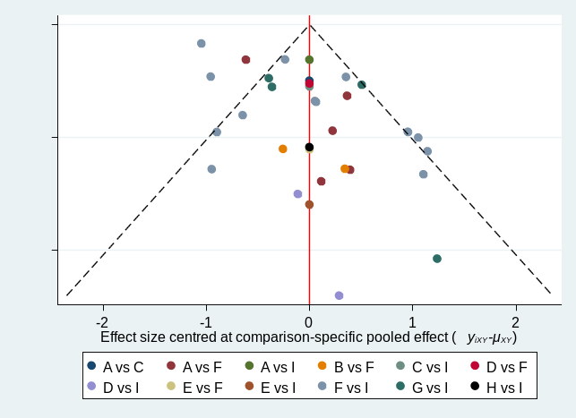
A=Bioglass+PRF  B=Bioglass+PRP  C=Bioglass | D=EMD  E=PRF |  | F=PRP  G=OFD | A=BCP+EMD  B=Bioglass+EMD C=BCP |  | D=Bioglass  E=nHA  F=EMD | G=PRF  H=PRP  I=OFD

Supplementary Figure S14. Comparison-adjusted funnel plots for NMAs of probing depth (PD) reduction at 3, 6, 9 and 12 months after surgery. The publication bias was assessed using comparison-adjusted funnel plots and Egger’s test. A p-value less than 0.05 indicates that studies with favorable results are more likely to be published.
- PD reduction at 3 months, Egger’s test p-value= 0.442 | - PD reduction at 6 months, Egger’s test p-value= 0.000
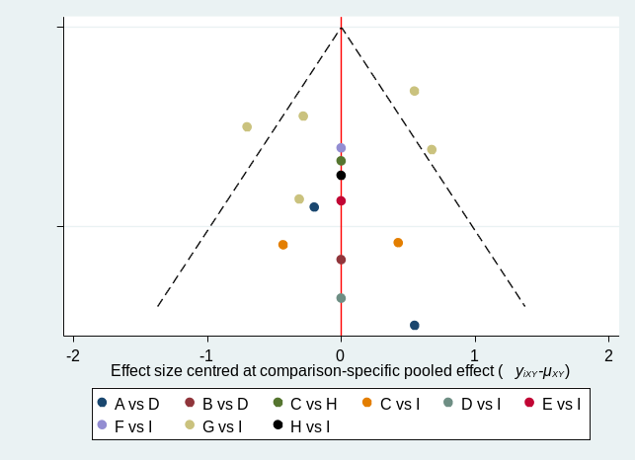 | 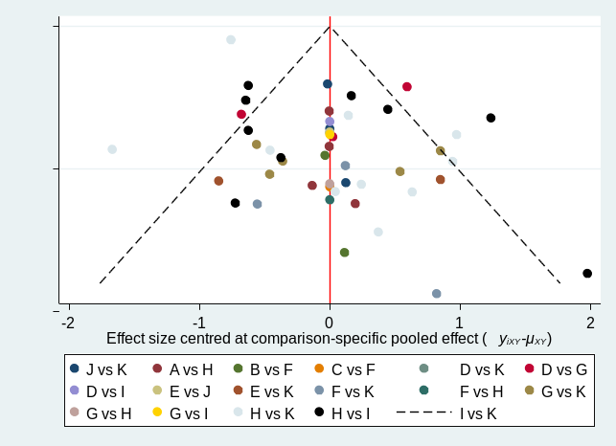
  A=Bioglass+PRF | D=Bioglass | G=PRF
  B=Bioglass+PRP | E=nHA, | H=PRP
  C=BCP | F=EMD | I=OFD
  A=BCP+EMD | E=BCP | I=PRF
  B=Bioglass+PRF | F=Bioglass | J=PRP,
  C=Bioglass+PRP | G=nHA | K=OFD
  D=nHA+PRF | H=EMD
- PD reduction at 9 months, Egger’s test p-value= 0.533 | - PD reduction at 12 months, Egger’s test p-value= 0.000
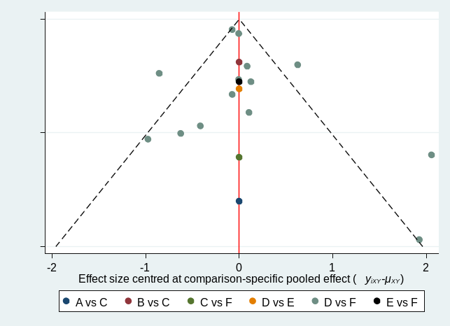 | 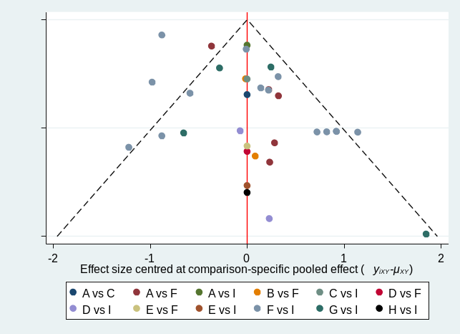
  A=Bioglass+PRF | D=PRF
  B=Bioglass+PRP | E=PRP
  C=Bioglass | F=OFD
  A=BCP+EMD | D=Bioglass | G=PRF
  B=Bioglass+EM | E=nHA | H=PRP
  C=BCP | F=EMD | I=OFD

Supplementary Figure S15. Comparison-adjusted funnel plots for NMAs of radiographic linear bone (RLB) gain at 6 and 12 months after surgery. The publication bias was assessed using comparison-adjusted funnel plots and Egger’s test. A p-value less than 0.05 indicates that studies with favorable results are more likely to be published.
- RLB gain at 6 months, Egger’s test p-value=0.025 | - RLB gain at 12 months, Egger’s test p-value=0.014
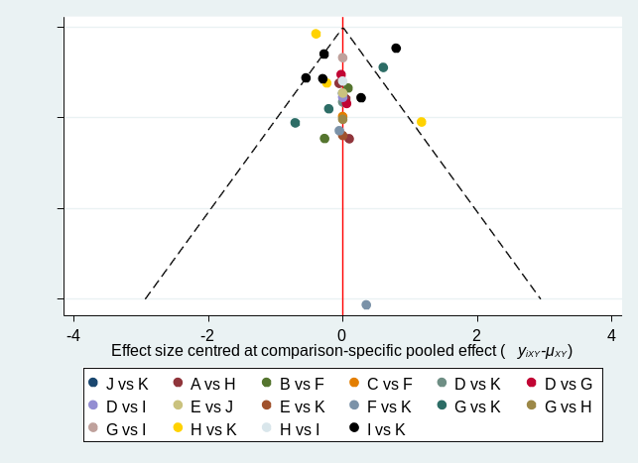 | 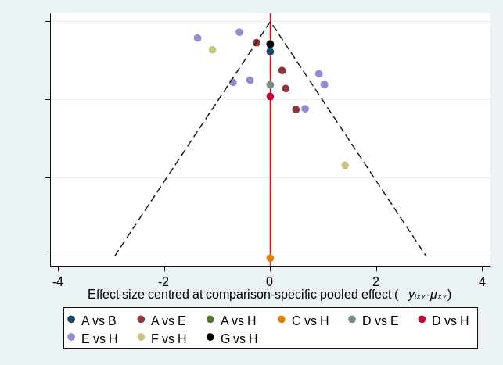
  A=BCP+EMD | E=BCP | I=PRF
  B=Bioglass+PRF | F=Bioglass | J=PRP
  C=Bioglass+PRP | G=nHA | K=OFD
  D=nHA+PRF | H=EMD
  A=BCP+EMD | D=nHA | G=PRP
  B=BCP | E=EMD | H=OFD
  C=Bioglass | F=PRF

Supplementary Table S26. Confidence in network meta-analysis of clinical attachment level (CAL) gain at 3 months.
Comparison | Number of studies | Within-study bias | Reporting bias | Indirectness | Imprecision | Hetero-geneity | Incoherence | Confidence rating | Reason(s) for downgrading
BCP:OFD | 2 | Major concerns | Low risk | No concerns | Some concerns | No concerns | No concerns | Very Low | ["Within-study bias",  "Imprecision"]
BCP:PRP | 1 | Major concerns | Low risk | No concerns | Some concerns | Some concerns | No concerns | Very Low | ["Within-study bias",  "Imprecision",  "Heterogeneity"]
Bioglass:  Bioglass+PRF | 2 | No concerns | Low risk | No concerns | Some concerns | No concerns | No concerns | Moderate | ["Imprecision"]
Bioglass:  Bioglass+PRP | 1 | Major concerns | Low risk | No concerns | Major concerns | No concerns | No concerns | Very Low | ["Within-study bias",  "Imprecision"]
Bioglass:OFD | 1 | Major concerns | Low risk | Some concerns | Major concerns | No concerns | No concerns | Very Low | ["Within-study bias",  "Indirectness",  "Imprecision"]
EMD:OFD | 2 | No concerns | Low risk | Some concerns | Some concerns | Some concerns | No concerns | Low | ["Indirectness",  "Imprecision",  "Heterogeneity"]
OFD:PRF | 5 | Major concerns | Low risk | No concerns | No concerns | Some concerns | No concerns | Very Low | ["Within-study bias",  "Heterogeneity"]
OFD:PRP | 1 | Major concerns | Low risk | No concerns | Some concerns | Some concerns | No concerns | Very Low | ["Within-study bias",  "Imprecision",  "Heterogeneity"]
nHA:OFD | 1 | No concerns | Low risk | Some concerns | Some concerns | Some concerns | No concerns | Low | ["Indirectness",  "Imprecision",  "Heterogeneity"]
BCP:Bioglass | 0 | Major concerns | Low risk | Some concerns | Major concerns | No concerns | No concerns | Very Low | ["Within-study bias",  "Indirectness",  "Imprecision"]
BCP:  Bioglass+PRF | 0 | Major concerns | Low risk | No concerns | Major concerns | No concerns | No concerns | Very Low | ["Within-study bias",  "Imprecision"]
BCP:  Bioglass+PRP | 0 | Major concerns | Low risk | No concerns | Major concerns | No concerns | No concerns | Very Low | ["Within-study bias",  "Imprecision"]
BCP:EMD | 0 | Major concerns | Low risk | No concerns | Some concerns | Some concerns | No concerns | Very Low | ["Within-study bias",  "Imprecision",  "Heterogeneity"]
BCP:PRF | 0 | Major concerns | Low risk | No concerns | Major concerns | No concerns | No concerns | Very Low | ["Within-study bias",  "Imprecision"]
BCP:nHA | 0 | Major concerns | Low risk | Some concerns | Major concerns | No concerns | No concerns | Very Low | ["Within-study bias",  "Indirectness",  "Imprecision"]
Bioglass:EMD | 0 | No concerns | Low risk | Some concerns | Major concerns | No concerns | No concerns | Very Low | ["Indirectness",  "Imprecision"]
Bioglass:PRF | 0 | Major concerns | Low risk | Some concerns | Major concerns | No concerns | No concerns | Very Low | ["Within-study bias",  "Indirectness",  "Imprecision"]
Bioglass:PRP | 0 | Major concerns | Low risk | No concerns | Major concerns | No concerns | No concerns | Very Low | ["Within-study bias",  "Imprecision"]
Bioglass:nHA | 0 | No concerns | Low risk | Some concerns | Major concerns | No concerns | No concerns | Very Low | ["Indirectness",  "Imprecision"]
Bioglass+PRF:  Bioglass+PRP | 0 | Major concerns | Low risk | No concerns | Major concerns | No concerns | No concerns | Very Low | ["Within-study bias",  "Imprecision"]
Bioglass+PRF:  EMD | 0 | No concerns | Low risk | Some concerns | Major concerns | No concerns | No concerns | Very Low | ["Indirectness",  "Imprecision"]
Bioglass+PRF:  OFD | 0 | Major concerns | Low risk | No concerns | Some concerns | Some concerns | No concerns | Very Low | ["Within-study bias",  "Imprecision",  "Heterogeneity"]
Bioglass+PRF:  PRF | 0 | Major concerns | Low risk | No concerns | Major concerns | No concerns | No concerns | Very Low | ["Within-study bias",  "Imprecision"]
Bioglass+PRF:  PRP | 0 | Major concerns | Low risk | No concerns | Major concerns | No concerns | No concerns | Very Low | ["Within-study bias",  "Imprecision"]
Bioglass+PRF:  nHA | 0 | No concerns | Low risk | Some concerns | Major concerns | No concerns | No concerns | Very Low | ["Indirectness",  "Imprecision"]
Bioglass+PRP:  EMD | 0 | Major concerns | Low risk | Some concerns | Major concerns | No concerns | No concerns | Very Low | ["Within-study bias",  "Indirectness",  "Imprecision"]
Bioglass+PRP:  OFD | 0 | Major concerns | Low risk | No concerns | Major concerns | No concerns | No concerns | Very Low | ["Within-study bias",  "Imprecision"]
Bioglass+PRP:  PRF | 0 | Major concerns | Low risk | No concerns | Major concerns | No concerns | No concerns | Very Low | ["Within-study bias",  "Imprecision"]
Bioglass+PRP:  PRP | 0 | Major concerns | Low risk | No concerns | Major concerns | No concerns | No concerns | Very Low | ["Within-study bias",  "Imprecision"]
Bioglass+PRP:  nHA | 0 | Major concerns | Low risk | Some concerns | Major concerns | No concerns | No concerns | Very Low | ["Within-study bias",  "Indirectness",  "Imprecision"]
EMD:PRF | 0 | No concerns | Low risk | No concerns | Some concerns | Some concerns | No concerns | Moderate | ["Imprecision",  "Heterogeneity"]
EMD:PRP | 0 | Major concerns | Low risk | No concerns | Major concerns | No concerns | No concerns | Very Low | ["Within-study bias",  "Imprecision"]
EMD:nHA | 0 | No concerns | Low risk | Some concerns | Some concerns | Some concerns | No concerns | Low | ["Indirectness",  "Imprecision",  "Heterogeneity"]
PRF:PRP | 0 | Major concerns | Low risk | No concerns | Some concerns | Some concerns | No concerns | Very Low | ["Within-study bias",  "Imprecision",  "Heterogeneity"]
nHA:PRF | 0 | No concerns | Low risk | Some concerns | Major concerns | No concerns | No concerns | Very Low | ["Indirectness",  "Imprecision"]
nHA:PRP | 0 | Major concerns | Low risk | No concerns | Major concerns | No concerns | No concerns | Very Low | ["Within-study bias",  "Imprecision"]

Supplementary Table S27. Confidence in network meta-analysis of clinical attachment level (CAL) gain at 6 months.
Comparison | Number of studies | Within-study bias | Reporting bias | Indirectness | Imprecision | Hetero-  geneity | Incoherence | Confidence rating | Reason(s) for downgrading
BCP:OFD | 2 | Major concerns | Low risk | Major concerns | No concerns | No concerns | Major concerns | Very Low | ["Within-study bias",  "Indirectness",  "Incoherence"]
BCP:PRP | 1 | Major concerns | Low risk | Major concerns | Some concerns | No concerns | Some concerns | Very Low | ["Within-study bias",  "Indirectness",  "Imprecision",  "Incoherence"]
Bioglass:  Bioglass+PRF | 2 | No concerns | Low risk | Major concerns | Some concerns | No concerns | No concerns | Very Low | ["Indirectness",  "Imprecision"]
Bioglass:  Bioglass+PRP | 1 | Major concerns | Low risk | Major concerns | Some concerns | No concerns | No concerns | Very Low | ["Within-study bias",  "Indirectness",  "Imprecision"]
Bioglass:EMD | 1 | No concerns | Low risk | Some concerns | Some concerns | Some concerns | No concerns | Low | ["Indirectness",  "Imprecision",  "Heterogeneity"]
Bioglass:OFD | 3 | Some concerns | Low risk | Some concerns | No concerns | Some concerns | No concerns | Very Low | ["Within-study bias",  "Indirectness",  "Heterogeneity"]
Bioglass+EMD:EMD | 4 | No concerns | Low risk | Some concerns | Some concerns | No concerns | No concerns | Low | ["Indirectness",  "Imprecision"]
EMD:OFD | 11 | No concerns | Low risk | Major concerns | No concerns | Some concerns | No concerns | Very Low | ["Indirectness",  "Heterogeneity"]
EMD:PRF | 2 | Major concerns | Low risk | Major concerns | No concerns | Some concerns | No concerns | Very Low | ["Within-study bias",  "Indirectness",  "Heterogeneity"]
EMD:nHA | 1 | No concerns | Low risk | Major concerns | No concerns | Major concerns | No concerns | Very Low | ["Indirectness",  "Heterogeneity"]
OFD:PRF | 9 | Major concerns | Low risk | Major concerns | No concerns | Some concerns | No concerns | Very Low | ["Within-study bias",  "Indirectness",  "Heterogeneity"]
OFD:PRP | 1 | Major concerns | Low risk | Major concerns | Some concerns | No concerns | Some concerns | Very Low | ["Within-study bias",  "Indirectness",  "Imprecision",  "Incoherence"]
nHA:OFD | 4 | Some concerns | Low risk | Major concerns | No concerns | Some concerns | No concerns | Very Low | ["Within-study bias",  "Indirectness",  "Heterogeneity"]
nHA+PRF:OFD | 1 | Some concerns | Low risk | Major concerns | No concerns | No concerns | No concerns | Very Low | ["Within-study bias",  "Indirectness"]
nHA:PRF | 1 | Some concerns | Low risk | Major concerns | No concerns | Major concerns | No concerns | Very Low | ["Within-study bias",  "Indirectness",  "Heterogeneity"]
nHA+PRF:PRF | 1 | Some concerns | Low risk | Major concerns | Some concerns | No concerns | No concerns | Very Low | ["Within-study bias",  "Indirectness",  "Imprecision"]
nHA:nHA+PRF | 3 | Some concerns | Low risk | Major concerns | Some concerns | No concerns | No concerns | Very Low | ["Within-study bias",  "Indirectness",  "Imprecision"]
BCP:Bioglass | 0 | Major concerns | Low risk | Major concerns | Some concerns | No concerns | No concerns | Very Low | ["Within-study bias",  "Indirectness",  "Imprecision"]
BCP:  Bioglass+EMD | 0 | Major concerns | Low risk | Some concerns | No concerns | No concerns | No concerns | Very Low | ["Within-study bias",  "Indirectness"]
BCP:  Bioglass+PRF | 0 | Major concerns | Low risk | Major concerns | Major concerns | No concerns | No concerns | Very Low | ["Within-study bias",  "Indirectness",  "Imprecision"]
BCP:  Bioglass+PRP | 0 | Major concerns | Low risk | Major concerns | Major concerns | No concerns | No concerns | Very Low | ["Within-study bias",  "Indirectness",  "Imprecision"]
BCP:EMD | 0 | Major concerns | Low risk | Major concerns | No concerns | Some concerns | No concerns | Very Low | ["Within-study bias",  "Indirectness",  "Heterogeneity"]
BCP:PRF | 0 | Major concerns | Low risk | Major concerns | No concerns | Some concerns | No concerns | Very Low | ["Within-study bias",  "Indirectness",  "Heterogeneity"]
BCP:nHA | 0 | Major concerns | Low risk | Major concerns | Some concerns | No concerns | No concerns | Very Low | ["Within-study bias",  "Indirectness",  "Imprecision"]
BCP:nHA+PRF | 0 | Major concerns | Low risk | Major concerns | Some concerns | No concerns | No concerns | Very Low | ["Within-study bias",  "Indirectness",  "Imprecision"]
Bioglass:  Bioglass+EMD | 0 | No concerns | Low risk | Some concerns | Some concerns | No concerns | No concerns | Low | ["Indirectness",  "Imprecision"]
Bioglass:PRF | 0 | Major concerns | Low risk | Major concerns | Some concerns | Some concerns | No concerns | Very Low | ["Within-study bias",  "Indirectness",  "Imprecision",  "Heterogeneity"]
Bioglass:PRP | 0 | Major concerns | Low risk | Major concerns | Major concerns | No concerns | No concerns | Very Low | ["Within-study bias",  "Indirectness",  "Imprecision"]
Bioglass:nHA | 0 | Some concerns | Low risk | Major concerns | Some concerns | Some concerns | No concerns | Very Low | ["Within-study bias",  "Indirectness",  "Imprecision",  "Heterogeneity"]
Bioglass:  nHA+PRF | 0 | Some concerns | Low risk | Major concerns | Some concerns | Some concerns | No concerns | Very Low | ["Within-study bias",  "Indirectness",  "Imprecision",  "Heterogeneity"]
Bioglass+EMD:Bioglass+PRF | 0 | No concerns | Low risk | Some concerns | No concerns | Some concerns | No concerns | Low | ["Indirectness",  "Heterogeneity"]
Bioglass+EMD:Bioglass+PRP | 0 | Major concerns | Low risk | Some concerns | Some concerns | No concerns | No concerns | Very Low | ["Within-study bias",  "Indirectness",  "Imprecision"]
Bioglass+EMD:OFD | 0 | No concerns | Low risk | Some concerns | Some concerns | No concerns | No concerns | Low | ["Indirectness",  "Imprecision"]
Bioglass+EMD:PRF | 0 | No concerns | Low risk | Some concerns | Some concerns | No concerns | No concerns | Low | ["Indirectness",  "Imprecision"]
Bioglass+EMD:PRP | 0 | Major concerns | Low risk | Major concerns | Some concerns | Some concerns | No concerns | Very Low | ["Within-study bias",  "Indirectness",  "Imprecision",  "Heterogeneity"]
Bioglass+EMD:nHA | 0 | No concerns | Low risk | Some concerns | Some concerns | No concerns | No concerns | Low | ["Indirectness",  "Imprecision"]
Bioglass+EMD:nHA+PRF | 0 | No concerns | Low risk | Major concerns | Some concerns | No concerns | No concerns | Very Low | ["Indirectness",  "Imprecision"]
Bioglass+PRF:  Bioglass+PRP | 0 | Major concerns | Low risk | Major concerns | Major concerns | No concerns | No concerns | Very Low | ["Within-study bias",  "Indirectness",  "Imprecision"]
Bioglass+PRF:  EMD | 0 | No concerns | Low risk | Major concerns | Some concerns | No concerns | No concerns | Very Low | ["Indirectness",  "Imprecision"]
Bioglass+PRF:  OFD | 0 | No concerns | Low risk | Major concerns | No concerns | No concerns | No concerns | Low | ["Indirectness"]
Bioglass+PRF:  PRF | 0 | Some concerns | Low risk | Major concerns | Some concerns | No concerns | No concerns | Very Low | ["Within-study bias",  "Indirectness",  "Imprecision"]
Bioglass+PRF:  PRP | 0 | Major concerns | Low risk | Major concerns | Some concerns | Some concerns | No concerns | Very Low | ["Within-study bias",  "Indirectness",  "Imprecision",  "Heterogeneity"]
Bioglass+PRF:  nHA | 0 | No concerns | Low risk | Major concerns | Some concerns | No concerns | No concerns | Very Low | ["Indirectness",  "Imprecision"]
Bioglass+PRF:  nHA+PRF | 0 | Some concerns | Low risk | Major concerns | Some concerns | Some concerns | No concerns | Very Low | ["Within-study bias",  "Indirectness",  "Imprecision",  "Heterogeneity"]
Bioglass+PRP:  EMD | 0 | Major concerns | Low risk | Major concerns | Some concerns | No concerns | No concerns | Very Low | ["Within-study bias",  "Indirectness",  "Imprecision"]
Bioglass+PRP:  OFD | 0 | Major concerns | Low risk | Major concerns | No concerns | No concerns | No concerns | Very Low | ["Within-study bias",  "Indirectness"]
Bioglass+PRP:  PRF | 0 | Major concerns | Low risk | Major concerns | Some concerns | No concerns | No concerns | Very Low | ["Within-study bias",  "Indirectness",  "Imprecision"]
Bioglass+PRP:  PRP | 0 | Major concerns | Low risk | Major concerns | Some concerns | Some concerns | No concerns | Very Low | ["Within-study bias",  "Indirectness",  "Imprecision",  "Heterogeneity"]
Bioglass+PRP:  nHA | 0 | Major concerns | Low risk | Major concerns | Some concerns | No concerns | No concerns | Very Low | ["Within-study bias",  "Indirectness",  "Imprecision"]
Bioglass+PRP:  nHA+PRF | 0 | Major concerns | Low risk | Major concerns | Major concerns | No concerns | No concerns | Very Low | ["Within-study bias",  "Indirectness",  "Imprecision"]
EMD:PRP | 0 | Major concerns | Low risk | Major concerns | Major concerns | No concerns | No concerns | Very Low | ["Within-study bias",  "Indirectness",  "Imprecision"]
EMD:nHA+PRF | 0 | Some concerns | Low risk | Major concerns | Some concerns | No concerns | No concerns | Very Low | ["Within-study bias",  "Indirectness",  "Imprecision"]
PRF:PRP | 0 | Major concerns | Low risk | Major concerns | Major concerns | No concerns | No concerns | Very Low | ["Within-study bias",  "Indirectness",  "Imprecision"]
nHA:PRP | 0 | Major concerns | Low risk | Major concerns | Major concerns | No concerns | No concerns | Very Low | ["Within-study bias",  "Indirectness",  "Imprecision"]
nHA+PRF:PRP | 0 | Major concerns | Low risk | Major concerns | Major concerns | No concerns | No concerns | Very Low | ["Within-study bias",  "Indirectness",  "Imprecision"]

Supplementary Table S28. Confidence in network meta-analysis of clinical attachment level (CAL) gain at 9 months.
Comparison | Number of studies | Within-study bias | Reporting bias | Indirectness | Imprecision | Hetero-geneity | Incoherence | Confidence rating | Reason(s) for downgrading
Bioglass:  Bioglass+PRF | 1 | Some concerns | Low risk | No concerns | Some concerns | Some concerns | No concerns | Low | ["Within-study bias",  "Imprecision",  "Heterogeneity"]
Bioglass:  Bioglass+PRP | 1 | No concerns | Low risk | Some concerns | Some concerns | Some concerns | No concerns | Low | ["Indirectness",  "Imprecision",  "Heterogeneity"]
Bioglass:OFD | 1 | Major concerns | Low risk | Some concerns | Some concerns | No concerns | No concerns | Very Low | ["Within-study bias",  "Indirectness",  "Imprecision"]
EMD:OFD | 1 | No concerns | Low risk | Some concerns | Some concerns | No concerns | No concerns | Low | ["Indirectness",  "Imprecision"]
OFD:PRF | 14 | Major concerns | Low risk | No concerns | No concerns | Some concerns | No concerns | Very Low | ["Within-study bias",  "Heterogeneity"]
OFD:PRP | 1 | No concerns | Low risk | No concerns | Some concerns | Some concerns | No concerns | Moderate | ["Imprecision",  "Heterogeneity"]
PRF:PRP | 1 | No concerns | Low risk | No concerns | Some concerns | No concerns | No concerns | Moderate | ["Imprecision"]
Bioglass:EMD | 0 | No concerns | Low risk | Some concerns | Major concerns | No concerns | No concerns | Very Low | ["Indirectness",  "Imprecision"]
Bioglass:PRF | 0 | Major concerns | Low risk | Some concerns | Major concerns | No concerns | No concerns | Very Low | ["Within-study bias",  "Indirectness",  "Imprecision"]
Bioglass:PRP | 0 | Major concerns | Low risk | No concerns | Some concerns | Some concerns | No concerns | Very Low | ["Within-study bias",  "Imprecision",  "Heterogeneity"]
Bioglass+PRF:  Bioglass+PRP | 0 | No concerns | Low risk | No concerns | Major concerns | No concerns | No concerns | Low | ["Imprecision"]
Bioglass+PRF:  EMD | 0 | No concerns | Low risk | Some concerns | Some concerns | Some concerns | No concerns | Low | ["Indirectness",  "Imprecision",  "Heterogeneity"]
Bioglass+PRF:  OFD | 0 | Some concerns | Low risk | No concerns | No concerns | Some concerns | No concerns | Low | ["Within-study bias",  "Heterogeneity"]
Bioglass+PRF:  PRF | 0 | Major concerns | Low risk | No concerns | Some concerns | Some concerns | No concerns | Very Low | ["Within-study bias",  "Imprecision",  "Heterogeneity"]
Bioglass+PRF:  PRP | 0 | Major concerns | Low risk | No concerns | Some concerns | No concerns | No concerns | Very Low | ["Within-study bias",  "Imprecision",]
Bioglass+PRP:  EMD | 0 | No concerns | Low risk | Some concerns | Some concerns | Some concerns | No concerns | Low | ["Indirectness",  "Imprecision",  "Heterogeneity"]
Bioglass+PRP:  OFD | 0 | No concerns | Low risk | Some concerns | Some concerns | No concerns | No concerns | Low | ["Indirectness",  "Imprecision"]
Bioglass+PRP:  PRF | 0 | Major concerns | Low risk | Some concerns | Major concerns | No concerns | No concerns | Very Low | ["Within-study bias",  "Indirectness",  "Imprecision"]
Bioglass+PRP:  PRP | 0 | No concerns | Low risk | Some concerns | Some concerns | Some concerns | No concerns | Low | ["Indirectness",  "Imprecision",  "Heterogeneity"]
EMD:PRF | 0 | No concerns | Low risk | Some concerns | Some concerns | Some concerns | No concerns | Low | ["Indirectness",  "Imprecision",  "Heterogeneity"]
EMD:PRP | 0 | No concerns | Low risk | No concerns | Major concerns | No concerns | No concerns | Low | ["Imprecision"]

Supplementary Table S29. Confidence in network meta-analysis of clinical attachment level (CAL) gain at 12 months.
Comparison | Number of studies | Within-study bias | Reporting bias | Indirectness | Imprecision | Hetero- geneity | Incoherence | Confidence rating | Reason(s) for downgrading
BCP:  BCP+EMD | 1 | No concerns | High risk | Major concerns | No concerns | Some concerns | Major concerns | Very Low | ["Reporting bias",  "Indirectness",  "Heterogeneity",  "Incoherence"]
BCP:OFD | 1 | No concerns | High risk | Major concerns | Some concerns | Some concerns | Major concerns | Very Low | ["Reporting bias",  "Indirectness",  "Imprecision",  "Heterogeneity",  "Incoherence"]
BCP+EMD:  EMD | 5 | No concerns | High risk | Major concerns | Some concerns | Some concerns | Some concerns | Very Low | ["Reporting bias",  "Indirectness",  "Imprecision",  "Heterogeneity",  "Incoherence"]
BCP+EMD:  OFD | 1 | No concerns | High risk | Major concerns | No concerns | Some concerns | No concerns | Very Low | ["Reporting bias",  "Indirectness",  "Heterogeneity"]
Bioglass:EMD | 1 | No concerns | High risk | Some concerns | Some concerns | Some concerns | No concerns | Very Low | ["Reporting bias",  "Indirectness",  "Imprecision",  "Heterogeneity"]
Bioglass:OFD | 2 | Major concerns | High risk | Some concerns | Some concerns | Some concerns | No concerns | Very Low | ["Within-study bias",  "Reporting bias",  "Indirectness",  "Imprecision",  "Heterogeneity"]
Bioglass+EMD:EMD | 2 | Major concerns | High risk | Major concerns | Some concerns | Some concerns | No concerns | Very Low | ["Within-study bias",  "Reporting bias",  "Indirectness",  "Imprecision",  "Heterogeneity"]
EMD:OFD | 14 | No concerns | High risk | Major concerns | No concerns | Some concerns | No concerns | Very Low | ["Reporting bias",  "Indirectness",  "Heterogeneity"]
EMD:nHA | 1 | No concerns | High risk | Major concerns | Some concerns | Some concerns | No concerns | Very Low | ["Reporting bias",  "Indirectness",  "Imprecision",  "Heterogeneity"]
OFD:PRF | 4 | Some concerns | High risk | Major concerns | No concerns | Some concerns | No concerns | Very Low | ["Within-study bias",  "Reporting bias",  "Indirectness",  "Heterogeneity"]
OFD:PRP | 1 | Major concerns | High risk | Some concerns | No concerns | No concerns | No concerns | Very Low | ["Within-study bias",  "Reporting bias",  "Indirectness"]
nHA:OFD | 1 | No concerns | High risk | Major concerns | Major concerns | No concerns | No concerns | Very Low | ["Reporting bias",  "Indirectness",  "Imprecision"]
BCP:Bioglass | 0 | No concerns | High risk | Major concerns | Major concerns | No concerns | No concerns | Very Low | ["Reporting bias",  "Indirectness",  "Imprecision"]
BCP:  Bioglass+EMD | 0 | No concerns | High risk | Major concerns | Major concerns | No concerns | No concerns | Very Low | ["Reporting bias",  "Indirectness",  "Imprecision"]
BCP:EMD | 0 | No concerns | High risk | Major concerns | Some concerns | No concerns | No concerns | Very Low | ["Reporting bias",  "Indirectness",  "Imprecision"]
BCP:PRF | 0 | No concerns | High risk | Major concerns | Some concerns | Some concerns | No concerns | Very Low | ["Reporting bias",  "Indirectness",  "Imprecision",  "Heterogeneity"]
BCP:PRP | 0 | No concerns | High risk | Major concerns | No concerns | No concerns | No concerns | Very Low | ["Reporting bias",  "Indirectness"]
BCP:nHA | 0 | No concerns | High risk | Major concerns | Major concerns | No concerns | No concerns | Very Low | ["Reporting bias",  "Indirectness",  "Imprecision"]
BCP+EMD:  Bioglass | 0 | No concerns | High risk | Some concerns | Some concerns | Some concerns | No concerns | Very Low | ["Reporting bias",  "Indirectness",  "Imprecision",  "Heterogeneity"]
BCP+EMD:  Bioglass+EMD | 0 | Major concerns | High risk | Major concerns | Some concerns | Some concerns | No concerns | Very Low | ["Within-study bias",  "Reporting bias",  "Indirectness",  "Imprecision",  "Heterogeneity"]
BCP+EMD:PRF | 0 | No concerns | High risk | Major concerns | Some concerns | Some concerns | No concerns | Very Low | ["Reporting bias",  "Indirectness",  "Imprecision",  "Heterogeneity"]
BCP+EMD:PRP | 0 | Major concerns | High risk | Some concerns | Some concerns | Some concerns | No concerns | Very Low | ["Within-study bias",  "Reporting bias",  "Indirectness",  "Imprecision",  "Heterogeneity"]
BCP+EMD:  nHA | 0 | No concerns | High risk | Major concerns | Some concerns | No concerns | No concerns | Very Low | ["Reporting bias",  "Indirectness",  "Imprecision"]
Bioglass:  Bioglass+EMD | 0 | Major concerns | High risk | Major concerns | Major concerns | No concerns | No concerns | Very Low | ["Within-study bias",  "Reporting bias",  "Indirectness",  "Imprecision"]
Bioglass:PRF | 0 | Major concerns | High risk | Major concerns | Some concerns | Some concerns | No concerns | Very Low | ["Within-study bias",  "Reporting bias",  "Indirectness",  "Imprecision",  "Heterogeneity"]
Bioglass:PRP | 0 | Major concerns | High risk | Some concerns | No concerns | Some concerns | No concerns | Very Low | ["Within-study bias",  "Reporting bias",  "Indirectness",  "Heterogeneity"]
Bioglass:nHA | 0 | No concerns | High risk | Major concerns | Major concerns | No concerns | No concerns | Very Low | ["Reporting bias",  "Indirectness",  "Imprecision"]
Bioglass+EMD:OFD | 0 | Major concerns | High risk | Major concerns | Some concerns | Some concerns | No concerns | Very Low | ["Within-study bias",  "Reporting bias",  "Indirectness",  "Imprecision",  "Heterogeneity"]
Bioglass+EMD:PRF | 0 | Major concerns | High risk | Major concerns | Major concerns | No concerns | No concerns | Very Low | ["Within-study bias",  "Reporting bias",  "Indirectness",  "Imprecision"]
Bioglass+EMD:PRP | 0 | Major concerns | High risk | Major concerns | Some concerns | No concerns | No concerns | Very Low | ["Within-study bias",  "Reporting bias",  "Indirectness",  "Imprecision"]
Bioglass+EMD:nHA | 0 | Major concerns | High risk | Major concerns | Major concerns | No concerns | No concerns | Very Low | ["Within-study bias",  "Reporting bias",  "Indirectness",  "Imprecision"]
EMD:PRF | 0 | No concerns | High risk | Major concerns | Some concerns | Some concerns | No concerns | Very Low | ["Reporting bias",  "Indirectness",  "Imprecision",  "Heterogeneity"]
EMD:PRP | 0 | Major concerns | High risk | Some concerns | No concerns | Some concerns | No concerns | Very Low | ["Within-study bias",  "Reporting bias",  "Indirectness",  "Heterogeneity"]
PRF:PRP | 0 | Major concerns | High risk | Some concerns | Some concerns | No concerns | No concerns | Very Low | ["Within-study bias",  "Reporting bias",  "Indirectness",  "Imprecision"]
nHA:PRF | 0 | Some concerns | High risk | Major concerns | Some concerns | Some concerns | No concerns | Very Low | ["Within-study bias",  "Reporting bias",  "Indirectness",  "Imprecision",  "Heterogeneity"]
nHA:PRP | 0 | Major concerns | High risk | Major concerns | No concerns | Some concerns | No concerns | Very Low | ["Within-study bias",  "Reporting bias",  "Indirectness",  "Heterogeneity"]

Supplementary Table S30. Confidence in network meta-analysis of probing depth (PD) reduction at 3 months.
Comparison | Number of studies | Within-study bias | Reporting bias | Indirectness | Imprecision | Hetero-geneity | Incoherence | Confidence rating | Reason(s) for downgrading
BCP:OFD | 2 | Major concerns | Low risk | No concerns | No concerns | Some concerns | No concerns | Very Low | ["Within-study bias",  "Heterogeneity"]
BCP:PRP | 1 | Major concerns | Low risk | No concerns | Some concerns | Some concerns | No concerns | Very Low | ["Within-study bias",  "Imprecision",  "Heterogeneity"]
Bioglass:  Bioglass+PRF | 2 | No concerns | Low risk | No concerns | Major concerns | No concerns | No concerns | Low | ["Imprecision"]
Bioglass:  Bioglass+PRP | 1 | Major concerns | Low risk | Some concerns | Some concerns | Some concerns | No concerns | Very Low | ["Within-study bias",  "Indirectness",  "Imprecision",  "Heterogeneity"]
Bioglass:OFD | 1 | Major concerns | Low risk | Some concerns | Some concerns | Some concerns | No concerns | Very Low | ["Within-study bias",  "Indirectness",  "Imprecision",  "Heterogeneity"]
EMD:OFD | 1 | No concerns | Low risk | No concerns | Some concerns | Some concerns | No concerns | Moderate | ["Imprecision",  "Heterogeneity"]
OFD:PRF | 5 | Major concerns | Low risk | No concerns | No concerns | Some concerns | No concerns | Very Low | ["Within-study bias",  "Heterogeneity"]
OFD:PRP | 1 | Major concerns | Low risk | No concerns | Some concerns | No concerns | No concerns | Very Low | ["Within-study bias",  "Imprecision"]
nHA:OFD | 1 | No concerns | Low risk | Some concerns | Major concerns | No concerns | No concerns | Very Low | ["Indirectness",  "Imprecision"]
BCP:Bioglass | 0 | Major concerns | Low risk | Some concerns | Major concerns | No concerns | No concerns | Very Low | ["Within-study bias",  "Indirectness",  "Imprecision"]
BCP:  Bioglass+PRF | 0 | Major concerns | Low risk | No concerns | Major concerns | No concerns | No concerns | Very Low | ["Within-study bias",  "Imprecision"]
BCP:  Bioglass+PRP | 0 | Major concerns | Low risk | Some concerns | Major concerns | No concerns | No concerns | Very Low | ["Within-study bias",  "Indirectness",  "Imprecision"]
BCP:EMD | 0 | Major concerns | Low risk | No concerns | No concerns | Some concerns | No concerns | Very Low | ["Within-study bias",  "Heterogeneity"]
BCP:PRF | 0 | Major concerns | Low risk | No concerns | Some concerns | Some concerns | No concerns | Very Low | ["Within-study bias",  "Imprecision",  "Heterogeneity"]
BCP:nHA | 0 | Major concerns | Low risk | Some concerns | Some concerns | Some concerns | No concerns | Very Low | ["Within-study bias",  "Indirectness",  "Imprecision",  "Heterogeneity"]
Bioglass:EMD | 0 | No concerns | Low risk | No concerns | Some concerns | Some concerns | No concerns | Moderate | ["Imprecision",  "Heterogeneity"]
Bioglass:PRF | 0 | Major concerns | Low risk | Some concerns | Major concerns | No concerns | No concerns | Very Low | ["Within-study bias",  "Indirectness",  "Imprecision"]
Bioglass:PRP | 0 | Major concerns | Low risk | Some concerns | Major concerns | No concerns | No concerns | Very Low | ["Within-study bias",  "Indirectness",  "Imprecision"]
Bioglass:nHA | 0 | No concerns | Low risk | Some concerns | Major concerns | No concerns | No concerns | Very Low | ["Indirectness",  "Imprecision"]
Bioglass+PRF:  Bioglass+PRP | 0 | Major concerns | Low risk | No concerns | Major concerns | No concerns | No concerns | Very Low | ["Within-study bias",  "Imprecision"]
Bioglass+PRF:  EMD | 0 | No concerns | Low risk | No concerns | Some concerns | Some concerns | No concerns | Moderate | ["Imprecision",  "Heterogeneity"]
Bioglass+PRF:  OFD | 0 | Major concerns | Low risk | No concerns | Some concerns | Some concerns | No concerns | Very Low | ["Within-study bias",  "Imprecision",  "Heterogeneity"]
Bioglass+PRF:  PRF | 0 | Major concerns | Low risk | No concerns | Major concerns | No concerns | No concerns | Very Low | ["Within-study bias",  "Imprecision"]
Bioglass+PRF:  PRP | 0 | Major concerns | Low risk | No concerns | Major concerns | No concerns | No concerns | Very Low | ["Within-study bias",  "Imprecision"]
Bioglass+PRF:  nHA | 0 | No concerns | Low risk | Some concerns | Major concerns | No concerns | No concerns | Very Low | ["Indirectness",  "Imprecision"]
Bioglass+PRP:  EMD | 0 | Major concerns | Low risk | Some concerns | Some concerns | Some concerns | No concerns | Very Low | ["Within-study bias",  "Indirectness",  "Imprecision",  "Heterogeneity"]
Bioglass+PRP:  OFD | 0 | Major concerns | Low risk | Some concerns | Some concerns | Some concerns | No concerns | Very Low | ["Within-study bias",  "Indirectness",  "Imprecision",  "Heterogeneity"]
Bioglass+PRP:  PRF | 0 | Major concerns | Low risk | Some concerns | Major concerns | No concerns | No concerns | Very Low | ["Within-study bias",  "Indirectness",  "Imprecision"]
Bioglass+PRP:  PRP | 0 | Major concerns | Low risk | Some concerns | Major concerns | No concerns | No concerns | Very Low | ["Within-study bias",  "Indirectness",  "Imprecision"]
Bioglass+PRP:  nHA | 0 | Major concerns | Low risk | Some concerns | Major concerns | No concerns | No concerns | Very Low | ["Within-study bias",  "Indirectness",  "Imprecision"]
EMD:PRF | 0 | No concerns | Low risk | No concerns | No concerns | Some concerns | No concerns | Moderate | ["Heterogeneity"]
EMD:PRP | 0 | Major concerns | Low risk | No concerns | Some concerns | No concerns | No concerns | Very Low | ["Within-study bias",  "Imprecision"]
EMD:nHA | 0 | No concerns | Low risk | No concerns | Some concerns | Some concerns | No concerns | Moderate | ["Imprecision",  "Heterogeneity"]
PRF:PRP | 0 | Major concerns | Low risk | No concerns | Major concerns | No concerns | No concerns | Very Low | ["Within-study bias",  "Imprecision"]
nHA:PRF | 0 | No concerns | Low risk | Some concerns | Some concerns | Some concerns | No concerns | Low | ["Indirectness",  "Imprecision",  "Heterogeneity"]
nHA:PRP | 0 | Major concerns | Low risk | Some concerns | Some concerns | Some concerns | No concerns | Very Low | ["Within-study bias",  "Indirectness",  "Imprecision",  "Heterogeneity"]

Supplementary Table S31. Confidence in network meta-analysis of probing depth (PD) reduction at 6 months.
Comparison | Number of studies | Within-study bias | Reporting bias | Indirectness | Imprecision | Hetero-geneity | Incoherence | Confidence rating | Reason(s) for downgrading
BCP:OFD | 2 | Major concerns | High risk | Major concerns | No concerns | No concerns | No concerns | Very Low | ["Within-study bias",  "Reporting bias",  "Indirectness"]
BCP:PRP | 1 | Major concerns | High risk | Major concerns | Some concerns | Some concerns | No concerns | Very Low | ["Within-study bias",  "Reporting bias",  "Indirectness",  "Imprecision",  "Heterogeneity"]
Bioglass:  Bioglass+PRF | 2 | No concerns | High risk | Major concerns | Major concerns | No concerns | No concerns | Very Low | ["Reporting bias",  "Indirectness",  "Imprecision"]
Bioglass:  Bioglass+PRP | 1 | Major concerns | High risk | Major concerns | Some concerns | Some concerns | No concerns | Very Low | ["Within-study bias",  "Reporting bias",  "Indirectness",  "Imprecision",  "Heterogeneity"]
Bioglass:EMD | 1 | No concerns | High risk | Some concerns | No concerns | Major concerns | No concerns | Very Low | ["Reporting bias",  "Indirectness",  "Heterogeneity"]
Bioglass:OFD | 3 | Major concerns | High risk | Some concerns | Some concerns | No concerns | No concerns | Very Low | ["Within-study bias",  "Reporting bias",  "Indirectness",  "Imprecision"]
Bioglass+EMD:EMD | 4 | No concerns | High risk | Some concerns | Some concerns | No concerns | No concerns | Very Low | ["Reporting bias",  "Indirectness",  "Imprecision"]
EMD:OFD | 10 | No concerns | High risk | Major concerns | No concerns | Some concerns | No concerns | Very Low | ["Reporting bias",  "Indirectness",  "Heterogeneity"]
EMD:PRF | 2 | Major concerns | High risk | Major concerns | No concerns | Major concerns | No concerns | Very Low | ["Within-study bias",  "Reporting bias",  "Indirectness",  "Heterogeneity"]
EMD:nHA | 1 | No concerns | High risk | Major concerns | No concerns | Major concerns | No concerns | Very Low | ["Reporting bias",  "Indirectness",  "Heterogeneity"]
OFD:PRF | 8 | Major concerns | High risk | Major concerns | No concerns | Some concerns | No concerns | Very Low | ["Within-study bias",  "Reporting bias",  "Indirectness",  "Heterogeneity"]
OFD:PRP | 2 | Major concerns | High risk | Major concerns | No concerns | Some concerns | No concerns | Very Low | ["Within-study bias",  "Reporting bias",  "Indirectness",  "Heterogeneity"]
nHA:OFD | 5 | No concerns | High risk | Major concerns | No concerns | Some concerns | No concerns | Very Low | ["Reporting bias",  "Indirectness",  "Heterogeneity"]
nHA+PRF:OFD | 1 | Some concerns | High risk | Major concerns | No concerns | No concerns | No concerns | Very Low | ["Within-study bias",  "Reporting bias",  "Indirectness"]
nHA:PRF | 1 | Some concerns | High risk | Major concerns | No concerns | Major concerns | No concerns | Very Low | ["Within-study bias",  "Reporting bias",  "Indirectness",  "Heterogeneity"]
nHA+PRF:PRF | 1 | Some concerns | High risk | Major concerns | Some concerns | Some concerns | No concerns | Very Low | ["Within-study bias",  "Reporting bias",  "Indirectness",  "Imprecision",  "Heterogeneity"]
nHA:nHA+PRF | 3 | Some concerns | High risk | Major concerns | Some concerns | No concerns | No concerns | Very Low | ["Within-study bias",  "Reporting bias",  "Indirectness",  "Imprecision"]
BCP:Bioglass | 0 | Major concerns | High risk | Major concerns | Some concerns | No concerns | No concerns | Very Low | ["Within-study bias",  "Reporting bias",  "Indirectness",  "Imprecision"]
BCP:  Bioglass+EMD | 0 | Major concerns | High risk | Some concerns | No concerns | Some concerns | No concerns | Very Low | ["Within-study bias",  "Reporting bias",  "Indirectness",  "Heterogeneity"]
BCP:  Bioglass+PRF | 0 | Major concerns | High risk | Major concerns | Some concerns | Some concerns | No concerns | Very Low | ["Within-study bias",  "Reporting bias",  "Indirectness",  "Imprecision",  "Heterogeneity"]
BCP:  Bioglass+PRP | 0 | Major concerns | High risk | Major concerns | Major concerns | No concerns | No concerns | Very Low | ["Within-study bias",  "Reporting bias",  "Indirectness",  "Imprecision"]
BCP:EMD | 0 | Major concerns | High risk | Major concerns | Some concerns | No concerns | No concerns | Very Low | ["Within-study bias",  "Reporting bias",  "Indirectness",  "Imprecision"]
BCP:PRF | 0 | Major concerns | High risk | Major concerns | Some concerns | No concerns | No concerns | Very Low | ["Within-study bias",  "Reporting bias",  "Indirectness",  "Imprecision"]
BCP:nHA | 0 | Major concerns | High risk | Major concerns | Some concerns | No concerns | No concerns | Very Low | ["Within-study bias",  "Reporting bias",  "Indirectness",  "Imprecision"]
BCP:nHA+PRF | 0 | Major concerns | High risk | Major concerns | Some concerns | Some concerns | No concerns | Very Low | ["Within-study bias",  "Reporting bias",  "Indirectness",  "Imprecision",  "Heterogeneity"]
Bioglass:  Bioglass+EMD | 0 | No concerns | High risk | Some concerns | Some concerns | Some concerns | No concerns | Very Low | ["Reporting bias",  "Indirectness",  "Imprecision",  "Heterogeneity"]
Bioglass:PRF | 0 | Major concerns | High risk | Major concerns | Some concerns | Some concerns | No concerns | Very Low | ["Within-study bias",  "Reporting bias",  "Indirectness",  "Imprecision",  "Heterogeneity"]
Bioglass:PRP | 0 | Major concerns | High risk | Major concerns | Some concerns | Some concerns | No concerns | Very Low | ["Within-study bias",  "Reporting bias",  "Indirectness",  "Imprecision",  "Heterogeneity"]
Bioglass:nHA | 0 | Some concerns | High risk | Major concerns | Some concerns | Some concerns | No concerns | Very Low | ["Within-study bias",  "Reporting bias",  "Indirectness",  "Imprecision",  "Heterogeneity"]
Bioglass:  nHA+PRF | 0 | Some concerns | High risk | Major concerns | Some concerns | No concerns | No concerns | Very Low | ["Within-study bias",  "Reporting bias",  "Indirectness",  "Imprecision"]
Bioglass+EMD:Bioglass+PRF | 0 | No concerns | High risk | Major concerns | Some concerns | Some concerns | No concerns | Very Low | ["Reporting bias",  "Indirectness",  "Imprecision",  "Heterogeneity"]
Bioglass+EMD:Bioglass+PRP | 0 | Major concerns | High risk | Major concerns | Some concerns | No concerns | No concerns | Very Low | ["Within-study bias",  "Reporting bias",  "Indirectness",  "Imprecision"]
Bioglass+EMD:OFD | 0 | No concerns | High risk | Some concerns | No concerns | Major concerns | No concerns | Very Low | ["Reporting bias",  "Indirectness",  "Heterogeneity"]
Bioglass+EMD:PRF | 0 | No concerns | High risk | Some concerns | No concerns | Some concerns | No concerns | Very Low | ["Reporting bias",  "Indirectness",  "Heterogeneity"]
Bioglass+EMD:PRP | 0 | No concerns | High risk | Major concerns | Some concerns | No concerns | No concerns | Very Low | ["Reporting bias",  "Indirectness",  "Imprecision"]
Bioglass+EMD:nHA | 0 | No concerns | High risk | Major concerns | Some concerns | No concerns | No concerns | Very Low | ["Reporting bias",  "Indirectness",  "Imprecision"]
Bioglass+EMD:nHA+PRF | 0 | No concerns | High risk | Major concerns | No concerns | Some concerns | No concerns | Very Low | ["Reporting bias",  "Indirectness",  "Heterogeneity"]
Bioglass+PRF:  Bioglass+PRP | 0 | Major concerns | High risk | Major concerns | Major concerns | No concerns | No concerns | Very Low | ["Within-study bias",  "Reporting bias",  "Indirectness",  "Imprecision"]
Bioglass+PRF:  EMD | 0 | No concerns | High risk | Major concerns | Major concerns | No concerns | No concerns | Very Low | ["Reporting bias",  "Indirectness",  "Imprecision"]
Bioglass+PRF:  OFD | 0 | No concerns | High risk | Major concerns | Some concerns | Some concerns | No concerns | Very Low | ["Reporting bias",  "Indirectness",  "Imprecision",  "Heterogeneity"]
Bioglass+PRF:  PRF | 0 | Some concerns | High risk | Major concerns | Major concerns | No concerns | No concerns | Very Low | ["Within-study bias",  "Reporting bias",  "Indirectness",  "Imprecision"]
Bioglass+PRF:  PRP | 0 | Major concerns | High risk | Major concerns | Major concerns | No concerns | No concerns | Very Low | ["Within-study bias",  "Reporting bias",  "Indirectness",  "Imprecision"]
Bioglass+PRF:  nHA | 0 | No concerns | High risk | Major concerns | Major concerns | No concerns | No concerns | Very Low | ["Reporting bias",  "Indirectness",  "Imprecision"]
Bioglass+PRF:  nHA+PRF | 0 | Some concerns | High risk | Major concerns | Some concerns | Some concerns | No concerns | Very Low | ["Within-study bias",  "Reporting bias",  "Indirectness",  "Imprecision",  "Heterogeneity"]
Bioglass+PRP:  EMD | 0 | Major concerns | High risk | Major concerns | Major concerns | No concerns | No concerns | Very Low | ["Within-study bias",  "Reporting bias",  "Indirectness",  "Imprecision"]
Bioglass+PRP:  OFD | 0 | Major concerns | High risk | Major concerns | Some concerns | No concerns | No concerns | Very Low | ["Within-study bias",  "Reporting bias",  "Indirectness",  "Imprecision"]
Bioglass+PRP:  PRF | 0 | Major concerns | High risk | Major concerns | Major concerns | No concerns | No concerns | Very Low | ["Within-study bias",  "Reporting bias",  "Indirectness",  "Imprecision"]
Bioglass+PRP:  PRP | 0 | Major concerns | High risk | Major concerns | Major concerns | No concerns | No concerns | Very Low | ["Within-study bias",  "Reporting bias",  "Indirectness",  "Imprecision"]
Bioglass+PRP:  nHA | 0 | Major concerns | High risk | Major concerns | Major concerns | No concerns | No concerns | Very Low | ["Within-study bias",  "Reporting bias",  "Indirectness",  "Imprecision"]
Bioglass+PRP:  nHA+PRF | 0 | Major concerns | High risk | Major concerns | Major concerns | No concerns | No concerns | Very Low | ["Within-study bias",  "Reporting bias",  "Indirectness",  "Imprecision"]
EMD:PRP | 0 | Major concerns | High risk | Major concerns | Some concerns | Some concerns | No concerns | Very Low | ["Within-study bias",  "Reporting bias",  "Indirectness",  "Imprecision",  "Heterogeneity"]
EMD:nHA+PRF | 0 | Some concerns | High risk | Major concerns | Some concerns | No concerns | No concerns | Very Low | ["Within-study bias",  "Reporting bias",  "Indirectness",  "Imprecision"]
PRF:PRP | 0 | Major concerns | High risk | Major concerns | Some concerns | Some concerns | No concerns | Very Low | ["Within-study bias",  "Reporting bias",  "Indirectness",  "Imprecision",  "Heterogeneity"]
nHA:PRP | 0 | No concerns | High risk | Major concerns | Some concerns | Some concerns | No concerns | Very Low | ["Reporting bias",  "Indirectness",  "Imprecision",  "Heterogeneity"]
nHA+PRF:PRP | 0 | Major concerns | High risk | Major concerns | Some concerns | Some concerns | No concerns | Very Low | ["Within-study bias",  "Reporting bias",  "Indirectness",  "Imprecision",  "Heterogeneity"]

Supplementary Table S32. Confidence in network meta-analysis of probing depth (PD) reduction at 9 months.
Comparison | Number of studies | Within-study bias | Reporting bias | Indirectness | Imprecision | Hetero-geneity | Incoherence | Confidence rating | Reason(s) for downgrading
Bioglass:  Bioglass+PRF | 1 | Some concerns | Low risk | No concerns | Major concerns | No concerns | No concerns | Very Low | ["Within-study bias",  "Imprecision"]
Bioglass:  Bioglass+PRP | 1 | No concerns | Low risk | No concerns | No concerns | No concerns | No concerns | High | []
Bioglass:OFD | 1 | Major concerns | Low risk | Major concerns | Some concerns | No concerns | No concerns | Very Low | ["Within-study bias",  "Indirectness",  "Imprecision"]
OFD:PRF | 14 | No concerns | Low risk | No concerns | No concerns | No concerns | No concerns | High | []
OFD:PRP | 1 | No concerns | Low risk | No concerns | No concerns | Some concerns | No concerns | Moderate | ["Heterogeneity"]
PRF:PRP | 1 | No concerns | Low risk | No concerns | No concerns | Some concerns | No concerns | Moderate | ["Heterogeneity"]
Bioglass:PRF | 0 | Major concerns | Low risk | Major concerns | Major concerns | No concerns | No concerns | Very Low | ["Within-study bias",  "Indirectness",  "Imprecision"]
Bioglass:PRP | 0 | Major concerns | Low risk | No concerns | Major concerns | No concerns | No concerns | Very Low | ["Within-study bias",  "Imprecision"]
Bioglass+PRF:  Bioglass+PRP | 0 | No concerns | Low risk | No concerns | Major concerns | No concerns | No concerns | Low | ["Imprecision"]
Bioglass+PRF:  OFD | 0 | Some concerns | Low risk | No concerns | Some concerns | Some concerns | No concerns | Low | ["Within-study bias",  "Imprecision",  "Heterogeneity"]
Bioglass+PRF:  PRF | 0 | Major concerns | Low risk | No concerns | Major concerns | No concerns | No concerns | Very Low | ["Within-study bias",  "Imprecision"]
Bioglass+PRF:  PRP | 0 | Major concerns | Low risk | No concerns | Major concerns | No concerns | No concerns | Very Low | ["Within-study bias",  "Imprecision"]
Bioglass+PRP:  OFD | 0 | No concerns | Low risk | No concerns | Some concerns | No concerns | No concerns | Moderate | ["Imprecision"]
Bioglass+PRP:  PRF | 0 | No concerns | Low risk | No concerns | Major concerns | No concerns | No concerns | Low | ["Imprecision"]
Bioglass+PRP:  PRP | 0 | No concerns | Low risk | No concerns | Major concerns | No concerns | No concerns | Low | ["Imprecision"]

Supplementary Table S33. Confidence in network meta-analysis of probing depth (PD) reduction at 12 months.
Comparison | Number of studies | Within-study bias | Reporting bias | Indirectness | Imprecision | Hetero-geneity | Incoherence | Confidence rating | Reason(s) for downgrading
BCP:  BCP+EMD | 1 | No concerns | High risk | Major concerns | No concerns | Some concerns | Some concerns | Very Low | ["Reporting bias",  "Indirectness",  "Heterogeneity",  "Incoherence"]
BCP:OFD | 1 | No concerns | High risk | Major concerns | No concerns | Major concerns | Major concerns | Very Low | ["Reporting bias",  "Indirectness",  "Heterogeneity",  "Incoherence"]
BCP+EMD:  EMD | 5 | No concerns | High risk | Major concerns | No concerns | Major concerns | Some concerns | Very Low | ["Reporting bias",  "Indirectness",  "Heterogeneity",  "Incoherence"]
BCP+EMD:  OFD | 1 | No concerns | High risk | Major concerns | No concerns | Some concerns | No concerns | Very Low | ["Reporting bias",  "Indirectness",  "Heterogeneity"]
Bioglass:EMD | 1 | No concerns | High risk | Some concerns | Some concerns | Some concerns | No concerns | Very Low | ["Reporting bias",  "Indirectness",  "Imprecision",  "Heterogeneity"]
Bioglass:OFD | 2 | Major concerns | High risk | Major concerns | Some concerns | Some concerns | No concerns | Very Low | ["Within-study bias",  "Reporting bias",  "Indirectness",  "Imprecision",  "Heterogeneity"]
Bioglass+EMD:EMD | 2 | Major concerns | High risk | Major concerns | Some concerns | Some concerns | No concerns | Very Low | ["Within-study bias",  "Reporting bias",  "Indirectness",  "Imprecision",  "Heterogeneity"]
EMD:OFD | 14 | No concerns | High risk | Major concerns | No concerns | Some concerns | No concerns | Very Low | ["Reporting bias",  "Indirectness",  "Heterogeneity"]
EMD:nHA | 1 | No concerns | High risk | Major concerns | Some concerns | Some concerns | No concerns | Very Low | ["Reporting bias",  "Indirectness",  "Imprecision",  "Heterogeneity"]
OFD:PRF | 4 | Some concerns | High risk | Major concerns | No concerns | Some concerns | No concerns | Very Low | ["Within-study bias",  "Reporting bias",  "Indirectness",  "Heterogeneity"]
OFD:PRP | 1 | Major concerns | High risk | Some concerns | No concerns | Some concerns | No concerns | Very Low | ["Within-study bias",  "Reporting bias",  "Indirectness",  "Heterogeneity"]
nHA:OFD | 1 | No concerns | High risk | Major concerns | Some concerns | Some concerns | No concerns | Very Low | ["Reporting bias",  "Indirectness",  "Imprecision",  "Heterogeneity"]
BCP:Bioglass | 0 | No concerns | High risk | Major concerns | Some concerns | Some concerns | No concerns | Very Low | ["Reporting bias",  "Indirectness",  "Imprecision",  "Heterogeneity"]
BCP:  Bioglass+EMD | 0 | No concerns | High risk | Major concerns | Some concerns | Some concerns | No concerns | Very Low | ["Reporting bias",  "Indirectness",  "Imprecision",  "Heterogeneity"]
BCP:EMD | 0 | No concerns | High risk | Major concerns | No concerns | Some concerns | No concerns | Very Low | ["Reporting bias",  "Indirectness",  "Heterogeneity"]
BCP:PRF | 0 | No concerns | High risk | Major concerns | Some concerns | No concerns | No concerns | Very Low | ["Reporting bias",  "Indirectness",  "Imprecision"]
BCP:PRP | 0 | No concerns | High risk | Major concerns | No concerns | Some concerns | No concerns | Very Low | ["Reporting bias",  "Indirectness",  "Heterogeneity"]
BCP:nHA | 0 | No concerns | High risk | Major concerns | Major concerns | No concerns | No concerns | Very Low | ["Reporting bias",  "Indirectness",  "Imprecision"]
BCP+EMD:  Bioglass | 0 | No concerns | High risk | Major concerns | Some concerns | No concerns | No concerns | Very Low | ["Reporting bias",  "Indirectness",  "Imprecision"]
BCP+EMD:  Bioglass+EMD | 0 | Major concerns | High risk | Major concerns | Some concerns | Some concerns | No concerns | Very Low | ["Within-study bias",  "Reporting bias",  "Indirectness",  "Imprecision",  "Heterogeneity"]
BCP+EMD:PRF | 0 | No concerns | High risk | Major concerns | Some concerns | Some concerns | No concerns | Very Low | ["Reporting bias",  "Indirectness",  "Imprecision",  "Heterogeneity"]
BCP+EMD:PRP | 0 | Major concerns | High risk | Some concerns | Major concerns | No concerns | No concerns | Very Low | ["Within-study bias",  "Reporting bias",  "Indirectness",  "Imprecision"]
BCP+EMD:  nHA | 0 | No concerns | High risk | Major concerns | Some concerns | No concerns | No concerns | Very Low | ["Reporting bias",  "Indirectness",  "Imprecision"]
Bioglass:  Bioglass+EMD | 0 | Major concerns | High risk | Major concerns | Major concerns | No concerns | No concerns | Very Low | ["Within-study bias",  "Reporting bias",  "Indirectness",  "Imprecision"]
Bioglass:PRF | 0 | Major concerns | High risk | Major concerns | Some concerns | Some concerns | No concerns | Very Low | ["Within-study bias",  "Reporting bias",  "Indirectness",  "Imprecision",  "Heterogeneity"]
Bioglass:PRP | 0 | Major concerns | High risk | Some concerns | Some concerns | No concerns | No concerns | Very Low | ["Within-study bias",  "Reporting bias",  "Indirectness",  "Imprecision"]
Bioglass:nHA | 0 | No concerns | High risk | Major concerns | Major concerns | No concerns | No concerns | Very Low | ["Reporting bias",  "Indirectness",  "Imprecision"]
Bioglass+EMD:OFD | 0 | Major concerns | High risk | Major concerns | Some concerns | No concerns | No concerns | Very Low | ["Within-study bias",  "Reporting bias",  "Indirectness",  "Imprecision"]
Bioglass+EMD:PRF | 0 | Major concerns | High risk | Major concerns | Some concerns | Some concerns | No concerns | Very Low | ["Within-study bias",  "Reporting bias",  "Indirectness",  "Imprecision",  "Heterogeneity"]
Bioglass+EMD:PRP | 0 | Major concerns | High risk | Major concerns | Some concerns | Some concerns | No concerns | Very Low | ["Within-study bias",  "Reporting bias",  "Indirectness",  "Imprecision",  "Heterogeneity"]
Bioglass+EMD:nHA | 0 | Major concerns | High risk | Major concerns | Major concerns | No concerns | No concerns | Very Low | ["Within-study bias",  "Reporting bias",  "Indirectness",  "Imprecision"]
EMD:PRF | 0 | No concerns | High risk | Major concerns | No concerns | Major concerns | No concerns | Very Low | ["Reporting bias",  "Indirectness",  "Heterogeneity"]
EMD:PRP | 0 | Major concerns | High risk | Some concerns | Some concerns | Some concerns | No concerns | Very Low | ["Within-study bias",  "Reporting bias",  "Indirectness",  "Imprecision",  "Heterogeneity"]
PRF:PRP | 0 | Major concerns | High risk | Some concerns | Major concerns | No concerns | No concerns | Very Low | ["Within-study bias",  "Reporting bias",  "Indirectness",  "Imprecision"]
nHA:PRF | 0 | Some concerns | High risk | Major concerns | Some concerns | Some concerns | No concerns | Very Low | ["Within-study bias",  "Reporting bias",  "Indirectness",  "Imprecision",  "Heterogeneity"]
nHA:PRP | 0 | Major concerns | High risk | Major concerns | Some concerns | No concerns | No concerns | Very Low | ["Within-study bias",  "Reporting bias",  "Indirectness",  "Imprecision"]

Supplementary Table S34. Confidence in network meta-analysis of radiographic linear bone (RLB) gain at 6 months.
Comparison | Number of studies | Within-study bias | Reporting bias | Indirectness | Imprecision | Hetero-geneity | Incoherence | Confidence rating | Reason(s) for downgrading
BCP:OFD | 1 | Major concerns | High risk | Some concerns | No concerns | Some concerns | No concerns | Very Low | ["Within-study bias",  "Reporting bias",  "Indirectness",  "Heterogeneity"]
BCP:PRP | 1 | Major concerns | High risk | Major concerns | No concerns | Some concerns | No concerns | Very Low | ["Within-study bias",  "Reporting bias",  "Indirectness",  "Heterogeneity"]
Bioglass:  Bioglass+PRF | 2 | No concerns | High risk | Major concerns | No concerns | Some concerns | No concerns | Very Low | ["Reporting bias",  "Indirectness",  "Heterogeneity"]
Bioglass:  Bioglass+PRP | 1 | Major concerns | High risk | Major concerns | Major concerns | No concerns | No concerns | Very Low | ["Within-study bias",  "Reporting bias",  "Indirectness",  "Imprecision"]
Bioglass:OFD | 2 | Some concerns | High risk | Major concerns | Some concerns | No concerns | No concerns | Very Low | ["Within-study bias",  "Reporting bias",  "Indirectness",  "Imprecision"]
Bioglass+EMD:EMD | 3 | Major concerns | High risk | Some concerns | No concerns | Major concerns | No concerns | Very Low | ["Within-study bias",  "Reporting bias",  "Indirectness",  "Heterogeneity"]
EMD:OFD | 3 | No concerns | High risk | Major concerns | Some concerns | No concerns | No concerns | Very Low | ["Reporting bias",  "Indirectness",  "Imprecision"]
EMD:PRF | 1 | Major concerns | High risk | Major concerns | No concerns | Major concerns | No concerns | Very Low | ["Within-study bias",  "Reporting bias",  "Indirectness",  "Heterogeneity"]
EMD:nHA | 1 | No concerns | High risk | Major concerns | No concerns | Major concerns | No concerns | Very Low | ["Reporting bias",  "Indirectness",  "Heterogeneity"]
OFD:PRF | 5 | Some concerns | High risk | Major concerns | No concerns | Some concerns | No concerns | Very Low | ["Within-study bias",  "Reporting bias",  "Indirectness",  "Heterogeneity"]
OFD:PRP | 1 | Major concerns | High risk | Major concerns | Some concerns | Some concerns | No concerns | Very Low | ["Within-study bias",  "Reporting bias",  "Indirectness",  "Imprecision",  "Heterogeneity"]
nHA:OFD | 3 | Some concerns | High risk | Major concerns | No concerns | Some concerns | No concerns | Very Low | ["Within-study bias",  "Reporting bias",  "Indirectness",  "Heterogeneity"]
nHA+PRF:OFD | 1 | Some concerns | High risk | Major concerns | No concerns | Some concerns | No concerns | Very Low | ["Within-study bias",  "Reporting bias",  "Indirectness",  "Heterogeneity"]
nHA:PRF | 1 | Some concerns | High risk | Major concerns | No concerns | Major concerns | No concerns | Very Low | ["Within-study bias",  "Reporting bias",  "Indirectness",  "Heterogeneity"]
nHA+PRF:PRF | 1 | Some concerns | High risk | Major concerns | Some concerns | No concerns | No concerns | Very Low | ["Within-study bias",  "Reporting bias",  "Indirectness",  "Imprecision"]
nHA:nHA+PRF | 2 | Some concerns | High risk | Major concerns | Some concerns | No concerns | No concerns | Very Low | ["Within-study bias",  "Reporting bias",  "Indirectness",  "Imprecision"]
BCP:Bioglass | 0 | Major concerns | High risk | Major concerns | Major concerns | No concerns | No concerns | Very Low | ["Within-study bias",  "Reporting bias",  "Indirectness",  "Imprecision"]
BCP:  Bioglass+EMD | 0 | Major concerns | High risk | Some concerns | Some concerns | No concerns | No concerns | Very Low | ["Within-study bias",  "Reporting bias",  "Indirectness",  "Imprecision"]
BCP:  Bioglass+PRF | 0 | Major concerns | High risk | Major concerns | Major concerns | No concerns | No concerns | Very Low | ["Within-study bias",  "Reporting bias",  "Indirectness",  "Imprecision"]
BCP:  Bioglass+PRP | 0 | Major concerns | High risk | Major concerns | Major concerns | No concerns | No concerns | Very Low | ["Within-study bias",  "Reporting bias",  "Indirectness",  "Imprecision"]
BCP:EMD | 0 | Major concerns | High risk | Major concerns | Some concerns | No concerns | No concerns | Very Low | ["Within-study bias",  "Reporting bias",  "Indirectness",  "Imprecision"]
BCP:PRF | 0 | Major concerns | High risk | Major concerns | Some concerns | No concerns | No concerns | Very Low | ["Within-study bias",  "Reporting bias",  "Indirectness",  "Imprecision"]
BCP:nHA | 0 | Major concerns | High risk | Major concerns | Some concerns | No concerns | No concerns | Very Low | ["Within-study bias",  "Reporting bias",  "Indirectness",  "Imprecision"]
BCP:nHA+PRF | 0 | Major concerns | High risk | Major concerns | Major concerns | No concerns | No concerns | Very Low | ["Within-study bias",  "Reporting bias",  "Indirectness",  "Imprecision"]
Bioglass:  Bioglass+EMD | 0 | Major concerns | High risk | Major concerns | Some concerns | Some concerns | No concerns | Very Low | ["Within-study bias",  "Reporting bias",  "Indirectness",  "Imprecision",  "Heterogeneity"]
Bioglass:EMD | 0 | Some concerns | High risk | Major concerns | Some concerns | Some concerns | No concerns | Very Low | ["Within-study bias",  "Reporting bias",  "Indirectness",  "Imprecision",  "Heterogeneity"]
Bioglass:PRF | 0 | Some concerns | High risk | Major concerns | Some concerns | Some concerns | No concerns | Very Low | ["Within-study bias",  "Reporting bias",  "Indirectness",  "Imprecision",  "Heterogeneity"]
Bioglass:PRP | 0 | Major concerns | High risk | Major concerns | Some concerns | Some concerns | No concerns | Very Low | ["Within-study bias",  "Reporting bias",  "Indirectness",  "Imprecision",  "Heterogeneity"]
Bioglass:nHA | 0 | Some concerns | High risk | Major concerns | Some concerns | Some concerns | No concerns | Very Low | ["Within-study bias",  "Reporting bias",  "Indirectness",  "Imprecision",  "Heterogeneity"]
Bioglass:  nHA+PRF | 0 | Some concerns | High risk | Major concerns | Major concerns | No concerns | No concerns | Very Low | ["Within-study bias",  "Reporting bias",  "Indirectness",  "Imprecision"]
Bioglass+EMD:Bioglass+PRF | 0 | No concerns | High risk | Major concerns | Some concerns | No concerns | No concerns | Very Low | ["Reporting bias",  "Indirectness",  "Imprecision"]
Bioglass+EMD:Bioglass+PRP | 0 | Major concerns | High risk | Major concerns | Major concerns | No concerns | No concerns | Very Low | ["Within-study bias",  "Reporting bias",  "Indirectness",  "Imprecision"]
Bioglass+EMD:OFD | 0 | No concerns | High risk | Some concerns | Some concerns | Some concerns | No concerns | Very Low | ["Reporting bias",  "Indirectness",  "Imprecision",  "Heterogeneity"]
Bioglass+EMD:PRF | 0 | Major concerns | High risk | Some concerns | Some concerns | Some concerns | No concerns | Very Low | ["Within-study bias",  "Reporting bias",  "Indirectness",  "Imprecision",  "Heterogeneity"]
Bioglass+EMD:PRP | 0 | Major concerns | High risk | Major concerns | Major concerns | No concerns | No concerns | Very Low | ["Within-study bias",  "Reporting bias",  "Indirectness",  "Imprecision"]
Bioglass+EMD:nHA | 0 | No concerns | High risk | Some concerns | Some concerns | Some concerns | No concerns | Very Low | ["Reporting bias",  "Indirectness",  "Imprecision",  "Heterogeneity"]
Bioglass+EMD:nHA+PRF | 0 | Some concerns | High risk | Major concerns | Some concerns | No concerns | No concerns | Very Low | ["Within-study bias",  "Reporting bias",  "Indirectness",  "Imprecision"]
Bioglass+PRF:  Bioglass+PRP | 0 | Major concerns | High risk | Major concerns | Major concerns | No concerns | No concerns | Very Low | ["Within-study bias",  "Reporting bias",  "Indirectness",  "Imprecision"]
Bioglass+PRF:  EMD | 0 | No concerns | High risk | Major concerns | No concerns | Some concerns | No concerns | Very Low | ["Reporting bias",  "Indirectness",  "Heterogeneity"]
Bioglass+PRF:  OFD | 0 | Some concerns | High risk | Major concerns | No concerns | No concerns | No concerns | Very Low | ["Within-study bias",  "Reporting bias",  "Indirectness"]
Bioglass+PRF:  PRF | 0 | Some concerns | High risk | Major concerns | Some concerns | No concerns | No concerns | Very Low | ["Within-study bias",  "Reporting bias",  "Indirectness",  "Imprecision"]
Bioglass+PRF:  PRP | 0 | Major concerns | High risk | Major concerns | No concerns | Some concerns | No concerns | Very Low | ["Within-study bias",  "Reporting bias",  "Indirectness",  "Heterogeneity"]
Bioglass+PRF:  nHA | 0 | Some concerns | High risk | Major concerns | Some concerns | No concerns | No concerns | Very Low | ["Within-study bias",  "Reporting bias",  "Indirectness",  "Imprecision"]
Bioglass+PRF:  nHA+PRF | 0 | Some concerns | High risk | Major concerns | Some concerns | Some concerns | No concerns | Very Low | ["Within-study bias",  "Reporting bias",  "Indirectness",  "Imprecision",  "Heterogeneity"]
Bioglass+PRP:  EMD | 0 | Major concerns | High risk | Major concerns | Some concerns | Some concerns | No concerns | Very Low | ["Within-study bias",  "Reporting bias",  "Indirectness",  "Imprecision",  "Heterogeneity"]
Bioglass+PRP:  OFD | 0 | Major concerns | High risk | Major concerns | Some concerns | No concerns | No concerns | Very Low | ["Within-study bias",  "Reporting bias",  "Indirectness",  "Imprecision"]
Bioglass+PRP:  PRF | 0 | Major concerns | High risk | Major concerns | Major concerns | No concerns | No concerns | Very Low | ["Within-study bias",  "Reporting bias",  "Indirectness",  "Imprecision"]
Bioglass+PRP:  PRP | 0 | Major concerns | High risk | Major concerns | Some concerns | Some concerns | No concerns | Very Low | ["Within-study bias",  "Reporting bias",  "Indirectness",  "Imprecision",  "Heterogeneity"]
Bioglass+PRP:  nHA | 0 | Some concerns | High risk | Major concerns | Major concerns | No concerns | No concerns | Very Low | ["Within-study bias",  "Reporting bias",  "Indirectness",  "Imprecision"]
Bioglass+PRP:  nHA+PRF | 0 | Some concerns | High risk | Major concerns | Major concerns | No concerns | No concerns | Very Low | ["Within-study bias",  "Reporting bias",  "Indirectness",  "Imprecision"]
EMD:PRP | 0 | Major concerns | High risk | Major concerns | Some concerns | Some concerns | No concerns | Very Low | ["Within-study bias",  "Reporting bias",  "Indirectness",  "Imprecision",  "Heterogeneity"]
EMD:nHA+PRF | 0 | Some concerns | High risk | Major concerns | Some concerns | No concerns | No concerns | Very Low | ["Within-study bias",  "Reporting bias",  "Indirectness",  "Imprecision"]
PRF:PRP | 0 | Major concerns | High risk | Major concerns | Some concerns | Some concerns | No concerns | Very Low | ["Within-study bias",  "Reporting bias",  "Indirectness",  "Imprecision",  "Heterogeneity"]
nHA:PRP | 0 | Major concerns | High risk | Major concerns | Some concerns | Some concerns | No concerns | Very Low | ["Within-study bias",  "Reporting bias",  "Indirectness",  "Imprecision",  "Heterogeneity"]
nHA+PRF:PRP | 0 | Some concerns | High risk | Major concerns | Some concerns | No concerns | No concerns | Very Low | ["Within-study bias",  "Reporting bias",  "Indirectness",  "Imprecision"]
Supplementary Table S35. Confidence in network meta-analysis of radiographic linear bone (RLB) gain at 12 months.
Comparison | Number of studies | Within-study bias | Reporting bias | Indirectness | Imprecision | Hetero-geneity | Incoherence | Confidence rating | Reason(s) for downgrading
BCP:  BCP+EMD | 1 | No concerns | High risk | Major concerns | Some concerns | No concerns | No concerns | Very Low | ["Reporting bias",  "Indirectness",  "Imprecision"]
BCP+EMD:  EMD | 4 | No concerns | High risk | Major concerns | Some concerns | Some concerns | Some concerns | Very Low | ["Reporting bias",  "Indirectness",  "Imprecision",  "Heterogeneity",  "Incoherence"]
BCP+EMD:  OFD | 1 | No concerns | High risk | Major concerns | No concerns | Some concerns | Some concerns | Very Low | ["Reporting bias",  "Indirectness",  "Heterogeneity",  "Incoherence"]
Bioglass:OFD | 1 | Major concerns | High risk | Some concerns | Major concerns | No concerns | No concerns | Very Low | ["Within-study bias",  "Reporting bias",  "Indirectness",  "Imprecision"]
EMD:OFD | 8 | No concerns | High risk | Major concerns | No concerns | Some concerns | No concerns | Very Low | ["Reporting bias",  "Indirectness",  "Heterogeneity"]
EMD:nHA | 1 | No concerns | High risk | Some concerns | Major concerns | No concerns | No concerns | Very Low | ["Reporting bias",  "Indirectness",  "Imprecision"]
OFD:PRF | 2 | Some concerns | High risk | Major concerns | Some concerns | No concerns | No concerns | Very Low | ["Within-study bias",  "Reporting bias",  "Indirectness",  "Imprecision"]
OFD:PRP | 1 | Major concerns | High risk | Some concerns | No concerns | Some concerns | No concerns | Very Low | ["Within-study bias",  "Reporting bias",  "Indirectness",  "Heterogeneity"]
nHA:OFD | 1 | Some concerns | High risk | Major concerns | Some concerns | Some concerns | No concerns | Very Low | ["Within-study bias",  "Reporting bias",  "Indirectness",  "Imprecision",  "Heterogeneity"]
BCP:Bioglass | 0 | No concerns | High risk | Major concerns | Major concerns | No concerns | No concerns | Very Low | ["Reporting bias",  "Indirectness",  "Imprecision"]
BCP:EMD | 0 | No concerns | High risk | Major concerns | Major concerns | No concerns | No concerns | Very Low | ["Reporting bias",  "Indirectness",  "Imprecision"]
BCP:OFD | 0 | No concerns | High risk | Major concerns | Major concerns | No concerns | No concerns | Very Low | ["Reporting bias",  "Indirectness",  "Imprecision"]
BCP:PRF | 0 | No concerns | High risk | Major concerns | Major concerns | No concerns | No concerns | Very Low | ["Reporting bias",  "Indirectness",  "Imprecision"]
BCP:PRP | 0 | No concerns | High risk | Major concerns | Major concerns | No concerns | No concerns | Very Low | ["Reporting bias",  "Indirectness",  "Imprecision"]
BCP:nHA | 0 | No concerns | High risk | Major concerns | Major concerns | No concerns | No concerns | Very Low | ["Reporting bias",  "Indirectness",  "Imprecision"]
BCP+EMD:  Bioglass | 0 | Major concerns | High risk | Some concerns | Major concerns | No concerns | No concerns | Very Low | ["Within-study bias",  "Reporting bias",  "Indirectness",  "Imprecision"]
BCP+EMD:PRF | 0 | No concerns | High risk | Major concerns | Major concerns | No concerns | No concerns | Very Low | ["Reporting bias",  "Indirectness",  "Imprecision"]
BCP+EMD:PRP | 0 | Major concerns | High risk | Some concerns | Major concerns | No concerns | No concerns | Very Low | ["Within-study bias",  "Reporting bias",  "Indirectness",  "Imprecision"]
BCP+EMD:  nHA | 0 | No concerns | High risk | Major concerns | Some concerns | Some concerns | No concerns | Very Low | ["Reporting bias",  "Indirectness",  "Imprecision",  "Heterogeneity"]
Bioglass:EMD | 0 | Major concerns | High risk | Some concerns | Major concerns | No concerns | No concerns | Very Low | ["Within-study bias",  "Reporting bias",  "Indirectness",  "Imprecision"]
Bioglass:PRF | 0 | Major concerns | High risk | Some concerns | Major concerns | No concerns | No concerns | Very Low | ["Within-study bias",  "Reporting bias",  "Indirectness",  "Imprecision"]
Bioglass:PRP | 0 | Major concerns | High risk | Some concerns | Major concerns | No concerns | No concerns | Very Low | ["Within-study bias",  "Reporting bias",  "Indirectness",  "Imprecision"]
Bioglass:nHA | 0 | Major concerns | High risk | Some concerns | Major concerns | No concerns | No concerns | Very Low | ["Within-study bias",  "Reporting bias",  "Indirectness",  "Imprecision"]
EMD:PRF | 0 | Some concerns | High risk | Major concerns | Major concerns | No concerns | No concerns | Very Low | ["Within-study bias",  "Reporting bias",  "Indirectness",  "Imprecision"]
EMD:PRP | 0 | Major concerns | High risk | Some concerns | Some concerns | Some concerns | No concerns | Very Low | ["Within-study bias",  "Reporting bias",  "Indirectness",  "Imprecision",  "Heterogeneity"]
PRF:PRP | 0 | Major concerns | High risk | Some concerns | Major concerns | No concerns | No concerns | Very Low | ["Within-study bias",  "Reporting bias",  "Indirectness",  "Imprecision"]
nHA:PRF | 0 | Some concerns | High risk | Major concerns | Major concerns | No concerns | No concerns | Very Low | ["Within-study bias",  "Reporting bias",  "Indirectness",  "Imprecision"]
nHA:PRP | 0 | Major concerns | High risk | Some concerns | Major concerns | No concerns | No concerns | Very Low | ["Within-study bias",  "Reporting bias",  "Indirectness",  "Imprecision"]

