Table S 1. Search strategies of the systematic review (up to November 2022).
MEDLINE via Ovid
#1 Dentin Sensitivity/
#2 dentin$ hypersensitivity.mp.
#3 dentin$ sensitivity.mp.
#4 (sensitive teeth or sensitive tooth).mp.
#5 1 OR 2 OR 3 OR 4
Embase via Ovid
#1 Dentin Sensitivity/
#2 dentin$ hypersensitivity.mp.
#3 dentin$ sensitivity.mp.
#4 (sensitive teeth or sensitive tooth).mp.
#5 1 OR 2 OR 3 OR 4
ProQuest
#1 (dentin OR dentinal) AND (sensitivity OR hypersensitivity)
CNKI
SU=”牙本质敏感”
ClinicalTrials.gov
#1 (dentine Hypersensitivity) OR (dentine sensitivity)

Table S 2. Characteristics of included studies.
Author | Year | Country | Location | Age | F/M | Funding | Rate | Total number
Verzak¹ | 1998 | Croatia | Dental school | NS | NS | No | 0.525 | 40
Rees² | 2000 | UK | general dental practice | 11-89 | NS | No | 0.03813 | 3593
Taani³ | 2001 | Jordan | periodontology clinic | NS | NS | No | 0.52649 | 302
Rees⁴ | 2002 | UK | general dental practice | 11-89 | NS | No | 0.04152 | 4841
Rees⁵ | 2003 | Hongkong | periodontology clinic | 12-82 | 134/92 | No | 0.676991 | 226
Tan⁶ | 2007 | China | community | 18-35 | 382/359 | No | 0.17274 | 741
Ye⁷ | 2009 | China | community | 20-69 | 660/660 | No | 0.325758 | 1320
Que⁸ | 2010 | China | community | 20-69 | 1320/1320 | Yes | 0.254545 | 2640
Rong⁹ | 2010 | China | community | 20-69 | NS | No | 0.296511 | 7939
Chrysanthakopoulos¹⁰ | 2011 | Greece | general dental practice | 18-69 | 760/690 | No | 0.182069 | 1450
Lin¹¹ | 2011 | China | community | 20-69 | 228/342 | No | 0.279365 | 630
Que¹² | 2011 | China | community | 20-70 | NS | No | 0.27859 | 1163
Ye¹³ | 2011 | China | community | 20-69 | 1060/1060 | No | 0.341038 | 2120
Dhaliwal¹⁴ | 2012 | India | community | 20-69 | 380/270 | No | 0.250769 | 650
Tengrungsun¹⁵ | 2012 | Thailand | general dental practice | >=20 | 288/132 | No | 0.307143 | 420
Wang¹⁶ | 2012 | China | community | 20-69 | 1.3:1 | No | 0.199036 | 6843
Al-Khafaji¹⁷ | 2013 | UAE | general dental practice | 20-59 | 76/128 | No | 0.269608 | 204
Cunha-Cruz¹⁸ | 2013 | USA | general dental practice | >18 | 455/332 | No | 0.123253 | 787
Hegde¹⁹ | 2013 | India | specialty dental practice | >14 | 780/1220 | No | 0.182 | 2000
Rane²⁰ | 2013 | India | specialty dental practice | 20-50 | 432/528 | No | 0.575 | 960
Vijiaya²¹ | 2013 | India | specialty dental practice | NS | NS | No | 0.549618 | 655
West²² | 2013 | Europeª | general dental practice | 18-35 | 1767/1420 | No | 0.418575 | 3187
Costa²³ | 2014 | Brazil | community | >34 | 827/398 | No | 0.342131 | 1023
Dodhiya²⁴ | 2014 | India | general dental practice | NS | NS | No | 0.2245 | 2000
Naidu²⁵ | 2014 | India | general dental practice | 18-65 | 118/94 | No | 0.320755 | 212
Scaramucci²⁶ | 2014 | Brazil | general dental practice | 18-77 | 179/121 | No | 0.463333 | 300
Kong²⁷ | 2015 | China | School | 17-23 | 1315/1912 | Yes | 0.112798 | 3227
Al-Saidy²⁸ | 2016 | Iraq | periodontology clinic | 10-69 | 100/100 | No | 0.46 | 200
Sood²⁹ | 2016 | India | periodontology clinic | 20-69 | NS | Yes | 0.478 | 1000
Awad³⁰ | 2019 | Arab^{b} | general dental practice | 18-35 | 1524/1400 | Yes | 0.624 | 2924
Barroso³¹ | 2019 | Brazil | School | 18-61 | 255/125 | Yes | 0.88421 | 380
Chowdhary³² | 2019 | India | specialty dental practice | 20-69 | 600/800 | No | 0.274995 | 5091
Hamasha³³ | 2019 | Saudi Arab | general dental practice | >18 | 211/336 | No | 0.3327 | 547
Savage³⁴ | 2019 | Nigeria | general dental practice | 18-35 | 737/592^{c} | Yes | 0.328 | 1349
Silva³⁵ | 2019 | Brazil | School | 12-20 | 228/156 | No | 0.191042 | 384
Rafeek³⁶ | 2020 | Trinidad and Tobago | general dental practice | 18-81 | 203/92 | No | 0.518644 | 295
Soares³⁷ | 2021 | Brazil | community | 30-49 | 140/57 | Yes | 0,370558 | 197
Mustafa³⁸ | 2022 | Turkey | periodontology clinic | 18-70 | NS | No | 0.102 | 1210
Paul³⁹ | 2022 | Nigeria | periodontology clinic | 18-74 | 165/263 | No | 0.311 | 428
ª Estonia, Finland, Latvia, France, Italy, Spain and UK
^{b} United Arab Emirates, Oman, Jordan, Egypt, Saudi Arabia and Kuwait.
^{c} The gender information of 20 participants was lost.

Table S 3. Excluded studies with reasons.
Study | Exclusion reason
Alcântara 2018⁴⁰ | The prevalence was estimated by the ratio of DH teeth in all the examined teeth, which was not accorded to the definition of prevalence
Amarasena 2011⁴¹ | The diagnosis was made according to results of questionnaires without confirmation by clinical examinations
Azodo 2011⁴² | The diagnosis was made according to results of questionnaires without confirmation by clinical examinations
Babu 2016⁴³ | The study did not investigate DH but sensitive teeth
Bamise 2010⁴⁴ | The prevalence was estimated by the ratio of DH teeth in all the examined teeth, which was not accorded to the definition of prevalence.
Bartlett 2011⁴⁵ | The study did not investigate DH but tooth wear
Bashi 2012⁴⁶ | The study only investigated severe DH. The study only included the patients with at least two different quadrants which have sensitive teeth
Blaizot 2020⁴⁷ | The study did not investigate DH but sensitive teeth
Chabanski 1996⁴⁸ | 1. The diagnosis was made according to results of questionnaires without confirmation by clinical examinations  2. The study did not investigate DH but CDH
Chabanski 1997⁴⁹ | The study did not investigate DH but CDH
Chi 2008⁵⁰ | The study did not investigate DH but oral health
Clayton 2002⁵¹ | The diagnosis was made according to results of questionnaires without confirmation by clinical examinations
Colak 2012 a⁵² | The study only investigated severe DH. The study only included the patients with at least two different quadrants which have sensitive teeth.
Colak 2012 b⁵³ | The study only investigated severe DH. The study only included the patients with at least two different quadrants which have sensitive teeth.
Dantas-Nate 2014⁵⁴ | The study did not investigate DH but bruxism, in which the proportion of CDH was analyzed
Deogade 2017⁵⁵ | The diagnosis was made according to results of questionnaires without confirmation by clinical examinations
Fisher 1992⁵⁶ | The study did not investigate DH but buccal CDH
Flynn 1985⁵⁷ | The study did not investigate DH but hypersensitive teeth
Fukumoto 2013⁵⁸ | The study only investigated the ratio of DH in the teeth with gingival recession
Gillam 2001⁵⁹ | The diagnosis was made according to results of questionnaires without confirmation by clinical examinations
Graf 1977⁶⁰ | The study did not investigate DH but hypersensitive teeth
Guerra 2017⁶¹ | The study was to evaluate a diagnosis system of DH, which was not a cross-sectional epidemiological study
Haneet 2015⁶² | The prevalence was estimated by the ratio of DH teeth in all the examined teeth, which was not accorded to the definition of prevalence.
Irwin 1997⁶³ | The diagnosis was made according to results of questionnaires without confirmation by clinical examinations
Jensen 1964⁶⁴ | The study was a trial assessing the treatment effect, which was not a cross-sectional epidemiological study
Kehua 2009⁶⁵ | Duplicate publication of Que 2009
Liang 2017⁶⁶ | Duplicate publication of Que 2009
Liu 1998⁶⁷ | The study did not investigate DH but buccal CDH
Locker 1987⁶⁸ | The study did not investigate DH but oral and facial pain
Lutskaya 2015⁶⁹ | The study did not investigate DH but hypersensitive teeth
Lan Ma⁷⁰ | The study did not investigate DH but tooth wear
Medeiros 2020⁷¹ | The study did not investigate DH but NCCLs
Murray 1994⁷² | The study did not investigate DH but hypersensitive teeth, which was not confirmed by clinical examinations
Oderinu 2011⁷³ | The study did not investigate DH but hypersensitive teeth, which was not confirmed by clinical examinations
Olley 2015⁷⁴ | The study did not investigate DH but occlussal and incisal sensitivity
Ommerborn 2007⁷⁵ | The study did not investigate DH but NCCLs
Porter 2015⁷⁶ | The study did not investigate DH but oral health
Que 2013⁷⁷ | The study did not investigate DH but NCCLs and CDH
Rahiotis 2012⁷⁸ | The study did not investigate DH but buccal CDH
Raposo 2019⁷⁹ | The study did not investigate DH but sensitive teeth, whereas the hypersensitivity was associated with molar-incisor hypomineralization and sequential caries.
Rees 2004⁸⁰ | The study did not investigate DH but buccal CDH
Ribeiro teixeira 2018⁸¹ | The study did not investigate DH but CDH and NCCLs
Rocha 2020⁸² | The prevalence was estimated by the ratio of DH teeth in all the examined teeth, which was not accorded to the definition of prevalence.
Sreenath 2017⁸³ | The study declared that it investigated DH but in fact it only addressed hypersensitive teeth
Taani 2002⁸⁴ | The study did not investigate DH but CDH
O’Toole 2017⁸⁵ | The diagnosis was made according to results of questionnaires without confirmation by clinical examinations
Udoye 2006⁸⁶ | The study did not investigate DH but buccal CDH
Wagner 2016⁸⁷ | The study did not investigate DH but gingival recession
Xu 2017⁸⁸ | The study only investigated carbonated-drinks-related DH
Yoshizaki 2017⁸⁹ | The prevalence was estimated by the ratio of DH teeth in all the examined teeth, which was not accorded to the definition of prevalence.
Kong 2015⁹⁰ | Duplicate publication of Kong 2015. | China

Table S 4. The differences in epidemiological investigation methods
Author | Sampling setting | Sampling method | Sample size estimation | Participant inclusion | Clinical examination | Questionnaire | Stimuli | Examiner consistency | Survey duration
Verzak¹ | 0 | 0 | 0 | 1 | 1 | 1 | 1 | 0 | 0
Rees² | 0 | 1 | 0 | 1 | 0 | 1 | 0 | 0 | 1
Taani³ | 0 | 0 | 0 | 1 | 0 | 1 | 1 | 0 | 0
Rees⁴ | 0 | 1 | 0 | 1 | 0 | 1 | 0 | 0 | 1
Rees⁵ | 0 | 1 | 0 | 0 | 1 | 1 | 0 | 0 | 1
Tan⁶ | 1 | 1 | 1 | 1 | 0 | 1 | 0 | 0 | 1
Ye⁷ | 1 | 1 | 1 | 1 | 1 | 0 | 0 | 1 | 0
Que⁸ | 1 | 1 | 1 | 1 | 0 | 1 | 0 | 1 | 0
Rong⁹ | 1 | 1 | 1 | 1 | 0 | 1 | 0 | 1 | 0
Chrysanthakopoulos¹⁰ | 0 | 0 | 0 | 1 | 0 | 1 | 0 | 0 | 1
Lin¹¹ | 1 | 1 | 1 | 1 | 1 | 1 | 0 | 1 | 0
Que¹² | 1 | 1 | 1 | 0 | 1 | 1 | 0 | 1 | 1
Ye¹³ | 1 | 1 | 1 | 1 | 0 | 1 | 1 | 0 | 1
Dhaliwal¹⁴ | 1 | 0 | 0 | 0 | 0 | 1 | 0 | 1 | 0
Tengrungsun¹⁵ | 0 | 0 | 0 | 1 | 0 | 1 | 0 | 1 | 1
Wang¹⁶ | 1 | 1 | 1 | 1 | 1 | 0 | 0 | 1 | 1
Al-Khafaji¹⁷ | 0 | 1 | 0 | 0 | 0 | 1 | 0 | 0 | 1
Cunha-Cruz¹⁸ | 0 | 1 | 1 | 1 | 0 | 1 | 0 | 1 | 1
Hegde¹⁹ | 0 | 0 | 0 | 0 | 0 | 1 | 0 | 0 | 1
Rane²⁰ | 0 | 1 | 0 | 0 | 1 | 1 | 1 | 0 | 1
Vijiaya²¹ | 0 | 1 | 0 | 0 | 1 | 0 | 1 | 0 | 1
West²² | 0 | 1 | 1 | 1 | 1 | 1 | 0 | 1 | 0
Costa²³ | 1 | 1 | 1 | 1 | 0 | 1 | 1 | 0 | 1
Dodhiya²⁴ | 0 | 0 | 0 | 1 | 0 | 1 | 0 | 0 | 1
Naidu²⁵ | 0 | 0 | 0 | 0 | 1 | 1 | 1 | 0 | 1
Scaramucci²⁶ | 0 | 1 | 1 | 1 | 1 | 1 | 1 | 1 | 0
Kong²⁷ | 1 | 1 | 1 | 1 | 0 | 1 | 0 | 0 | 0
Al-Saidy²⁸ | 0 | 0 | 0 | 1 | 1 | 1 | 1 | 0 | 0
Sood²⁹ | 0 | 1 | 0 | 1 | 1 | 1 | 0 | 0 | 1
Awad³⁰ | 0 | 0 | 0 | 1 | 0 | 1 | 1 | 0 | 1
Barroso³¹ | 0 | 0 | 1 | 1 | 1 | 0 | 1 | 0 | 1
Chowdhary³² | 0 | 1 | 1 | 1 | 1 | 1 | 1 | 1 | 1
Hamasha³³ | 0 | 1 | 1 | 0 | 1 | 1 | 0 | 1 | 0
Savage³⁴ | 1 | 1 | 1 | 1 | 1 | 1 | 1 | 1 | 0
Silva³⁵ | 0 | 1 | 0 | 1 | 1 | 1 | 0 | 1 | 1
Rafeek³⁶ | 0 | 1 | 0 | 1 | 1 | 1 | 0 | 0 | 1
Soares³⁷ | 1 | 1 | 1 | 1 | 1 | 1 | 0 | 1 | 0
Mustafa³⁸ | 0 | 0 | 1 | 0 | 0 | 1 | 1 | 1 | 1
Paul³⁹ | 0 | 0 | 1 | 0 | 1 | 0 | 1 | 1 | 1

1: superior
0: inferior

Table S 5. Subgroup analysis of different populations by demographic factors.
Subgroup | n | ES | LCI | UCI
Continent
Asia | 25 | 0.321 | 0.280 | 0.363
Europe | 5 | 0.222 | 0.116 | 0.328
North America | 1 | 0.123 | 0.100 | 0.146
South America | 6 | 0.458 | 0.221 | 0.695
Africa | 2 | 0.236 | 0.091 | 0.381
Age
Younger (<35) | 6 | 0.224 | 0.116 | 0.331
Older (>35) | 1 | 0.342 | 0.313 | 0.371
All | 32 | 0.340 | 0.285 | 0.395
Survey site
Community | 11 | 0.281 | 0.245 | 0.317
School | 4 | 0.422 | 0.012 | 0.832
General dental practice | 14 | 0.263 | 0.193 | 0.333
specialty dental practice | 4 | 0.395 | 0.241 | 0.549
periodontology clinic | 6 | 0.425 | 0.226 | 0.624
Publication date
≤ 2000 | 2 | 0.287 | -0.201 | 0.755
2001-2010 | 7 | 0.332 | 0.173 | 0.488
≥ 2011 | 30 | 0.322 | 0.275 | 0.382
Funding status
Yes | 9 | 0.365 | 0.213 | 0.507
No | 30 | 0.311 | 0.273 | 0.357
ES: Effect Size
LCI: Low Confidence Interval
UCI: Up Confidence Interval
Table S6 The methodological quality of 39 studies
Author | Year | Section |  |  |  | Comparability | Outcome |  |  | Tortal score
Author | Year | Representativeness of the exposed cohort | Selection of the non-exposed cohort | Ascertainment of exposure | Demonstration that outcome of interest was not present at start of study | Comparability of cohorts on the basis of the design or analysis controlled for confounders | Assessment of outcome | Was follow-up long enough for outcomes to occur | Adequacy of follow-up of cohorts | Tortal score
Verzak | 1998 | 1 | 1 | 1 | 0 | 0 | 1 | 0 | 0 | 4
Rees | 2000 | 1 | 1 | 1 | 1 | 1 | 1 | 0 | 0 | 7
Taani | 2001 | 1 | 1 | 1 | 1 | 0 | 0 | 0 | 0 | 4
Rees | 2002 | 1 | 1 | 1 | 1 | 0 | 1 | 0 | 0 | 5
Rees | 2003 | 1 | 1 | 1 | 1 | 0 | 1 | 0 | 0 | 5
Tan | 2007 | 1 | 1 | 1 | 1 | 1 | 1 | 0 | 0 | 7
Ye | 2009 | 1 | 1 | 1 | 1 | 0 | 1 | 0 | 0 | 5
Que | 2010 | 1 | 1 | 1 | 1 | 0 | 1 | 0 | 0 | 5
Rong | 2010 | 1 | 1 | 1 | 1 | 1 | 1 | 0 | 0 | 7
Chrysanthakopoulos | 2011 | 1 | 1 | 1 | 1 | 1 | 1 | 0 | 0 | 7
Lin | 2011 | 1 | 1 | 1 | 1 | 1 | 1 | 0 | 0 | 7
Que | 2011 | 1 | 1 | 1 | 1 | 1 | 1 | 0 | 0 | 7
Ye | 2011 | 1 | 1 | 1 | 1 | 1 | 1 | 0 | 0 | 7
Dhaliwal | 2012 | 0 | 0 | 1 | 1 | 0 | 1 | 0 | 0 | 3
Tengrungsun | 2012 | 0 | 0 | 1 | 1 | 0 | 1 | 0 | 0 | 3
Wang | 2012 | 1 | 1 | 1 | 1 | 1 | 1 | 0 | 0 | 7
Al-Khafaji | 2013 | 0 | 0 | 1 | 1 | 1 | 1 | 0 | 0 | 5
Cunha-Cruz | 2013 | 1 | 1 | 1 | 1 | 1 | 1 | 0 | 0 | 7
Hegde | 2013 | 0 | 0 | 1 | 1 | 0 | 1 | 0 | 0 | 3
Rane | 2013 | 0 | 0 | 1 | 1 | 1 | 1 | 0 | 0 | 5
Vijiaya | 2013 | 0 | 0 | 1 | 1 | 1 | 1 | 0 | 0 | 5
West | 2013 | 1 | 1 | 1 | 1 | 1 | 1 | 0 | 0 | 7
Costa | 2014 | 1 | 1 | 1 | 1 | 1 | 1 | 0 | 1 | 8
Dodhiya | 2014 | 0 | 0 | 1 | 1 | 0 | 1 | 0 | 0 | 3
Naidu | 2014 | 0 | 0 | 1 | 1 | 0 | 1 | 1 | 1 | 5
Scaramucci | 2014 | 1 | 1 | 1 | 1 | 0 | 1 | 0 | 0 | 5
Kong | 2015 | 1 | 1 | 1 | 1 | 0 | 1 | 0 | 0 | 5
Al-Saidy | 2016 | 0 | 0 | 1 | 1 | 0 | 1 | 0 | 0 | 3
Sood | 2016 | 0 | 0 | 1 | 1 | 0 | 1 | 0 | 0 | 3
Awad | 2019 | 1 | 1 | 1 | 1 | 1 | 1 | 0 | 0 | 7
Barroso | 2019 | 1 | 1 | 1 | 1 | 0 | 1 | 0 | 0 | 5
Chowdary | 2019 | 0 | 0 | 1 | 1 | 1 | 1 | 0 | 0 | 5
Hamasha | 2019 | 1 | 1 | 1 | 1 | 1 | 1 | 0 | 0 | 7
Savage | 2019 | 1 | 1 | 1 | 1 | 1 | 1 | 0 | 0 | 7
Silva | 2020 | 1 | 1 | 1 | 1 | 1 | 1 | 0 | 0 | 7
Rafeek | 2020 | 0 | 0 | 1 | 1 | 1 | 1 | 0 | 0 | 5
Soares | 2021 | 0 | 0 | 1 | 1 | 0 | 1 | 0 | 0 | 3
Mustafa | 2022 | 1 | 1 | 1 | 1 | 1 | 1 | 0 | 0 | 7
Paul | 2022 | 1 | 1 | 1 | 1 | 1 | 1 | 0 | 0 | 7

Figure S 1. Sensitivity analysis of pooling of DH prevalence
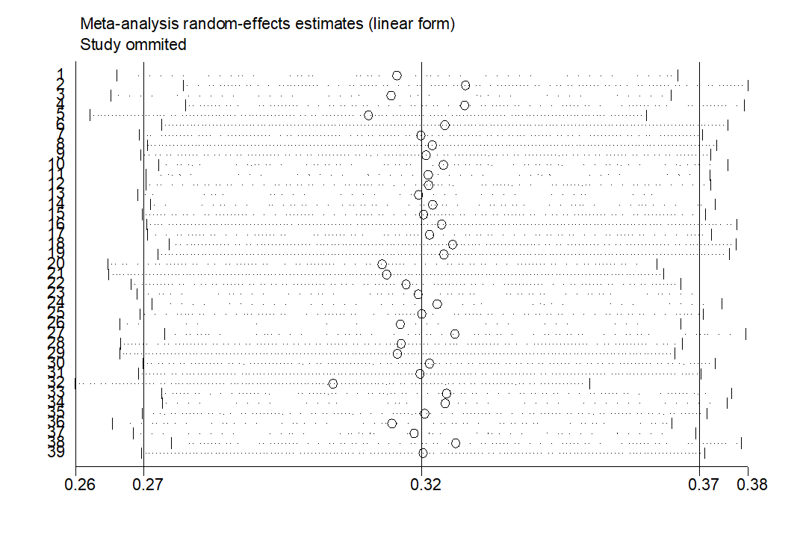

Figure S 2. Egger rest of the meta-analysis.
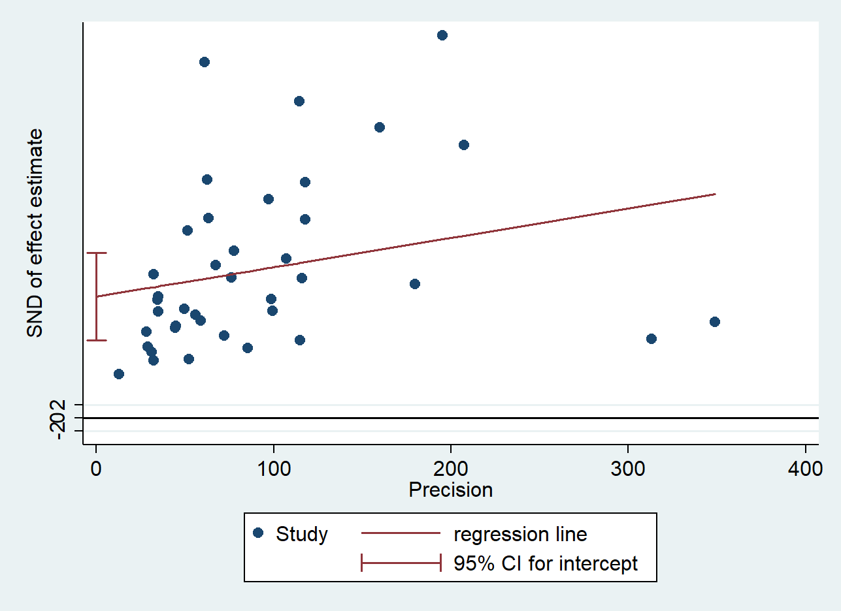

Figure S 3. Funnel plot of the meta-analysis.
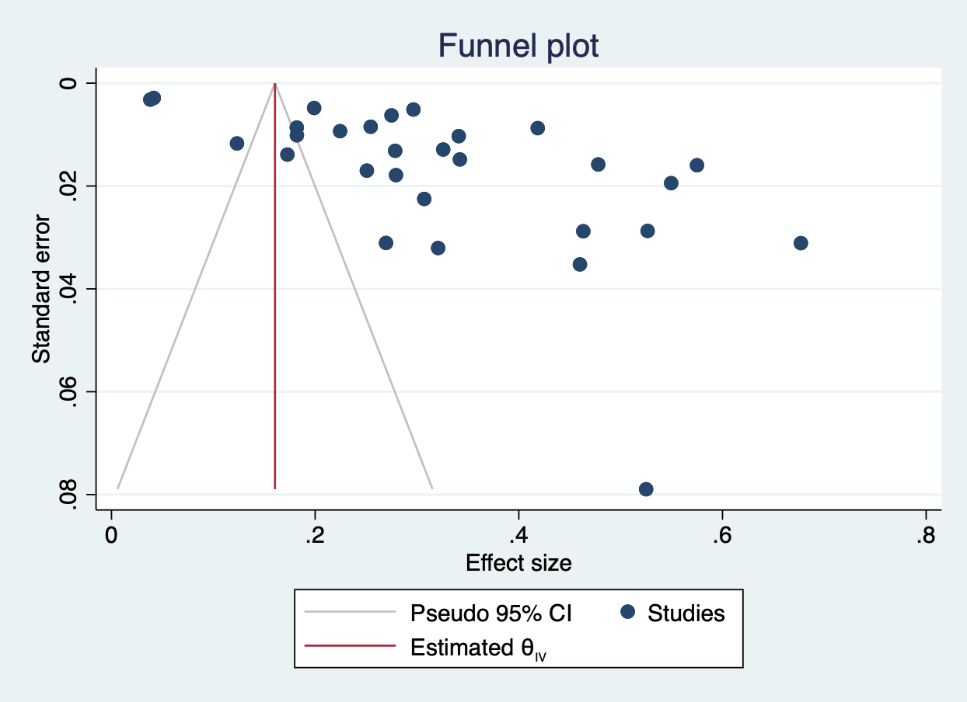

Appendix references
1. Verzak Z, Bukovic D, Bagic I. Prevalention and intraoral distribution of dentin hypersensitivity among students. Collegium antropologicum. 1998;22:259-265.
2. Rees JS. The prevalence of dentine hypersensitivity in general dental practice in the UK. Journal of clinical periodontology. 2000;27(11):860-865.
3. Taani DQ, Awartani F. Prevalence and distribution of dentin hypersensitivity and plaque in a dental hospital population. Quintessence international (Berlin, Germany : 1985). 2001;32(5):372-376.
4. Rees JS, Addy M. A cross-sectional study of dentine hypersensitivity. Journal of clinical periodontology. 2002;29(11):997-1003.
5. Rees JS, Jin LJ, Lam S, Kudanowska I, Vowles R. The prevalence of dentine hypersensitivity in a hospital clinic population in Hong Kong. Journal of dentistry. 2003;31(7):453-461.
6. Tan C-s, Hu D-y, Fan X, Li X, Que K-h. Epidemiological survey of dentine hypersensitivity of young people in Chengdu City. Hua xi kou qiang yi xue za zhi = Huaxi kouqiang yixue zazhi = West China journal of stomatology. 2009;27(4):394-396.
7. Ye W, Wang G-y, Lv J, Feng X-p. The epidemiology of dentine hypersensitivity among adults in Shanghai municipality. Shanghai kou qiang yi xue = Shanghai journal of stomatology. 2009;18(3):247-250.
8. Que K, Ruan J, Fan X, Liang X, Hu D. A multi-centre and cross-sectional study of dentine hypersensitivity in China. Journal of clinical periodontology. 2010;37(7):631-637.
9. Rong W-S, Hu D-Y, Feng X-P, Tai B-J, Zhang J-C, Ruan J-P. A national survey on dentin hypersensitivity in Chinese urban adults. Zhonghua kou qiang yi xue za zhi = Zhonghua kouqiang yixue zazhi = Chinese journal of stomatology. 2010;45(3):141-145.
10. Chrysanthakopoulos NA. Prevalence of Dentine Hypersensitivity in a General Dental Practice in Greece. Journal of clinical and experimental dentistry. 2011;3(5):e445-451.
11. Lin L, Que KH, Li X, Hu DY, Fu YY, Wang MH. Epidemiological survey of dentine hypersensitivity of 630 adults in rural of Sichuan province. [Chinese]. Hua xi kou qiang yi xue za zhi = Huaxi kouqiang yixue zazhi = West China journal of stomatology. 2011;29(2):157-160.
12. Que K-h, Li X, Yin W, Fu Y-y, Hu D-y, Yang J. Cross-sectional study of dentine hypersensitivity in smaller cities and rural area in Sichuan province. Zhonghua kou qiang yi xue za zhi = Zhonghua kouqiang yixue zazhi = Chinese journal of stomatology. 2011;46(9):537-540.
13. Ye W, Feng XP, Li R. The prevalence of dentine hypersensitivity in Chinese adults. Journal of oral rehabilitation. 2012;39(3):182-187.
14. Dhaliwal JS, Palwankar P, Khinda PK, Sodhi SK. Prevalence of dentine hypersensitivity: A cross-sectional study in rural Punjabi Indians. Journal of Indian Society of Periodontology. 2012;16(3):426-429.
15. Tengrungsun T, Jamornnium Y, Tengrungsun S. Prevalence of dentine hypersensitivity among Thai dental patients at the Faculty of Dentistry, Mahidol University. The Southeast Asian journal of tropical medicine and public health. 2012;43(4):1059-1064.
16. Wang Y, Que K, Lin L, Hu D, Li X. The prevalence of dentine hypersensitivity in the general population in China. Journal of oral rehabilitation. 2012;39(11):812-820.
17. Al-Khafaji H. Observations on dentine hypersensitivity in general dental practices in the United Arab Emirates. European journal of dentistry. 2013;7(4):389-394.
18. Cunha-Cruz J, Wataha JC, Heaton LJ, et al. The prevalence of dentin hypersensitivity in general dental practices in the northwest United States. J Am Dent Assoc. 2013;144(3):288-296.
19. M. N. Hedge CJ, P. Hedge. Prevalence of Dentinal Hypersensitivity in South Canara Population - An Epidemiological Survey. International Journal of Medicine and Pharmaceutical Research. 2013;1(4):334-336.
20. Rane P, Pujari S, Patel P, Gandhewar M, Madria K, Dhume S. Epidemiological Study to Evaluate the Prevalence of Dentine Hypersensitivity among Patients. Journal of international oral health : JIOH. 2013;5(5):15-19.
21. V. Vijaya VS, R. K. Varghese, R. Ravuri, A. Agarwal. Association of Dentine Hypersensitivity with Different Risk Factors – A Cross Sectional Study. Journal of International Oral Health. 2013;5(6):88-92.
22. West NX, Sanz M, Lussi A, Bartlett D, Bouchard P, Bourgeois D. Prevalence of dentine hypersensitivity and study of associated factors: a European population-based cross-sectional study. Journal of dentistry. 2013;41(10):841-851.
23. Costa RSA, Rios FS, Moura MS, Jardim JJ, Maltz M, Haas AN. Prevalence and Risk Indicators of Dentin Hypersensitivity in Adult and Elderly Populations From Porto Alegre, Brazil. Journal of periodontology. 2014;85(9):1247-1258.
24. S. S. Dodhiya GB, M. N. Hedge. A Cross-Sectional Study of Dentin Hypersensitivity in South Kanara Population. Indian Journal of Applied Research. 2014;4(6):1-2.
25. Naidu GM, Ram K C, Sirisha NR, et al. Prevalence of dentin hypersensitivity and related factors among adult patients visiting a dental school in andhra pradesh, southern India. Journal of clinical and diagnostic research : JCDR. 2014;8(9):ZC48-51.
26. Scaramucci T, de Almeida Anfe TE, da Silva Ferreira S, Frias AC, Sobral MA. Investigation of the prevalence, clinical features, and risk factors of dentin hypersensitivity in a selected Brazilian population. Clinical oral investigations. 2014;18(2):651-657.
27. Kong L, Meng X, Xu Y, et al. Popular features and related risk factors analysis of dentine hypersensitivity among undergraduate students in hefei. Anhui Med Pharm J. 2015;19(8):1478-1482.
28. Al-Saidy A. Prevalence and distribution of dentine hypersensitivity in a sample of population in Sulaimani city - Kurdistan region - Iraq. International Journal of Current Research. 2016;8(9):38105-38109.
29. Sood S, Nagpal M, Gupta S, Jain A. Evaluation of dentine hypersensitivity in adult population with chronic periodontitis visiting dental hospital in Chandigarh. Indian journal of dental research : official publication of Indian Society for Dental Research. 2016;27(3):249-255.
30. Awad MA, El Kassas D, Al Harthi L, et al. Dentine hypersensitivity and dentine exposure in Arab patient populations. J Oral Rehabil. 2020;47(4):473-479.
31. Barroso NFF, Alcantara PM, Botelho AM, Douglas-de-Oliveira DW, Goncalves PF, Flecha OD. Prevalence of self-reported versus diagnosed dentinal hypersensitivity: a cross-sectional study and ROC curve analysis. Acta Odontol Scand. 2019;77(3):219-223.
32. Chowdhary Z, Gupta P, Kaur J, Garg Y, Swarup N. Multifaceted assessment of dentine hypersensitivity, evaluation of demographic prevalence along with associated factors: A cross-sectional study. Journal of Indian Society of Periodontology. 2019;23(1):64-68.
33. Hamasha AA-H, Alkhamis F, Alotaibi M, et al. Prevalence and Risk Indicators of Dentine Hypersensitivity among Adults Living in Riyadh City, Saudi Arabia. Int J Med Res Health Sci. 2019;8(10):8-13.
34. Savage KO, Oderinu OH, Oginni AO, Uti OG, Adegbulugbe IC, Dosumu OO. Dentine hypersensitivity and associated factors: A Nigerian cross-sectional study. Pan African Medical Journal. 2019;33 (no pagination)(272).
35. Silva MS, Lima A, Pereira MMA, Ferraz Mendes R, Prado Junior RR. Prevalence and predictive factors of dentin hypersensitivity in Brazilian adolescents. J Clin Periodontol. 2019;46(4):448-456.
36. Rafeek R, Naidu R, Peters T, Paul G, Tripathi V. Prevalence and Factors Associated with Dentin Hypersensitivity among Adult Patients Attending a University Dental Clinic in Trinidad, West Indies. A Cross-Sectional Study. Oral health prev. 2020;18(1):1077-1085.
37. Soares A, Chalub L, Barbosa RS, Campos DEP, Moreira AN, Ferreira RC. Prevalence and severity of non-carious cervical lesions and dentin hypersensitivity: association with oral-health related quality of life among Brazilian adults. Heliyon. 2021;7(3):e06492.
38.Demirci M, Karabay F, Berkman M, Özcan İ, Tuncer S, Tekçe N, Baydemir C. The prevalence, clinical features, and related factors of dentin hypersensitivity in the Turkish population. Clin Oral Investig. 2022 Mar;26(3):2719-2732.
39.Idon PI, Ikusika OF, Sotunde OA, Ogundare TO. Are there associations between the occurrence of dental fluorosis and the experience of dentine hypersensitivity? A cross-sectional study. Niger Postgrad Med J. 2022 Apr-Jun;29(2):161-166.
40. Alcantara PM, Figueiredo Barroso NF, Botelho AM, Douglas-de-Oliveira DW, Goncalves PF, Flecha OD. Associated factors to cervical dentin hypersensitivity in adults: a transversal study. BMC oral health. 2018;18.
41. Amarasena N, Spencer J, Ou Y, Brennan D. Dentine hypersensitivity in a private practice patient population in Australia. Journal of oral rehabilitation. 2011;38(1):52-60.
42. Azodo CC, Amayo AC. Dentinal sensitivity among a selected group of young adults in Nigeria. Nigerian medical journal : journal of the Nigeria Medical Association. 2011;52(3):189-192.
43. B. Babu MNH, A. Shetty, M. Yelapure. Prevalence of Dentinal Hypersensitivity in Southwest Coastal Population of India. Research & Reviews: Journal of Dental Sciences. 2016;4(2):106-109.
44. Bamise CT, Kolawole KA, Oloyede EO, Esan TA. Tooth sensitivity experience among residential university students. International journal of dental hygiene. 2010;8(2):95-100.
45. Bartlett DW, Fares J, Shirodaria S, Chiu K, Ahmad N, Sherriff M. The association of tooth wear, diet and dietary habits in adults aged 18-30 years old. Journal of dentistry. 2011;39(12):811-816.
46. E. Bashi MD, R. Uzgur, M. Turkal, M. M. Hamidi, H. Colak. An analysis of the aetiology, prevalence and clinical features of dentine hypersensitivity in a general dental population. European review for medical and pharmacological sciences. 2012;16:1107-1116.
47. Blaizot A, Offner D, Trohel G, et al. Prevalence of sensitive teeth and associated factors: a multicentre, cross-sectional questionnaire survey in France. BMC Oral Health. 2020;20(1):234.
48. Chabanski MB, Gillam DG, Bulman JS, Newman HN. Prevalence of cervical dentine sensitivity in a population of patients referred to a specialist Periodontology Department. Journal of clinical periodontology. 1996;23(11):989-992.
49. Chabanski MB, Gillam DG, Bulman JS, Newman HN. Clinical evaluation of cervical dentine sensitivity in a population of patients referred to a specialist periodontology department: a pilot study. Journal of oral rehabilitation. 1997;24(9):666-672.
50. Chi D, Milgrom P. The oral health of homeless adolescents and young adults and determinants of oral health: preliminary findings. Special care in dentistry : official publication of the American Association of Hospital Dentists, the Academy of Dentistry for the Handicapped, and the American Society for Geriatric Dentistry. 2008;28(6):237-242.
51. Clayton DR, McCarthy D, Gillam DG. A study of the prevalence and distribution of dentine sensitivity in a population of 17-58-year-old serving personnel on an RAF base in the Midlands. Journal of oral rehabilitation. 2002;29(1):14-23.
52. Colak H, Demirer S, Hamidi M, Uzgur R, Koseoglu S. Prevalence of dentine hypersensitivity among adult patients attending a dental hospital clinic in Turkey. The West Indian medical journal. 2012;61(2):174-179.
53. Colak H, Aylikci BU, Hamidi MM, Uzgur R. Prevalence of dentine hypersensitivity among university students in Turkey. Nigerian journal of clinical practice. 2012;15(4):415-419.
54. Dantas-Neta NB, Laurentino JB, Souza CHdCe, Nunes-Dos-Santos DL, Mendes RF, Prado-JÚNior RR. Prevalence and potential factors associated with probable sleep or awake bruxism and dentin hypersensitivity in undergraduate students. Revista de Odontologia da UNESP. 2014;43(4):245-251.
55. Deogade SC, Suresan V, Rathod JR, Naitam D. Prevalence and Impact of Dentine Hypersensitivity among Undergraduates in a University Campus of Central India. Annals of Medical and Health Sciences Research. 2017;7(3):137-143.
56. Fisher MA, Gilbert GH, Shelton BJ. A cohort study found racial differences in dental insurance, utilization, and the effect of care on quality of life. Journal of clinical epidemiology. 2004;57(8):853-857.
57. Flynn J, Galloway R, Orchardson R. The incidence of 'hypersensitive' teeth in the West of Scotland. Journal of dentistry. 1985;13(3):230-236.
58. Fukumoto Y, Horibe M, Inagaki Y, et al. Association of gingival recession and other factors with the presence of dentin hypersensitivity. Odontology. 2014;102(1):42-49.
59. Gillam DG, Seo HS, Newman HN, Bulman JS. Comparison of dentine hypersensitivity in selected occidental and oriental populations. Journal of oral rehabilitation. 2001;28(1):20-25.
60. Graf H, Galasse R. MORBIDITY, PREVALENCE AND INTRAORAL DISTRIBUTION OF HYPERSENSITIVE TEETH. Journal of dental research. 1977;56:A162-A162.
61. Guerra F, Corridore D, Cocco F, et al. Oral health sentinel-based surveillance: a pilot study on dentinal hypersensitivity pain. La Clinica terapeutica. 2017;168(5):e333-e337.
62. Haneet RK, Vandana LK. Prevalence of dentinal hypersensitivity and study of associated factors: a cross-sectional study based on the general dental population of Davangere, Karnataka, India. International dental journal. 2016;66(1):49-57.
63. Irwin CR, McCusker P. Prevalence of dentine hypersensitivity in a general dental population. Journal of the Irish Dental Association. 1997;43(1):7-9.
64. Jensen R. Pathophysiological mechanisms of tension-type headache: a review of epidemiological and experimental studies. Cephalalgia. 1999;19(6):602-621.
65. Kehua Q, Yingying F, Hong S, Menghong W, Deyu H, Xu F. A cross-sectional study of dentine hypersensitivity in China. International dental journal. 2009;59(6):376-380.
66. Liang X, Wei Z, Hu D, Ruan J. Prevalence of dentin hypersensitivity among the residents of Xi'an city, China. Acta odontologica Scandinavica. 2017;75(6):387-393.
67. Liu HC, Lan WH, Hsieh CC. Prevalence and distribution of cervical dentin hypersensitivity in a population in Taipei, Taiwan. Journal of endodontics. 1998;24(1):45-47.
68. Locker D, Grushka M. Prevalence of oral and facial pain and discomfort: preliminary results of a mail survey. Community dentistry and oral epidemiology. 1987;15(3):169-172.
69. Lutskaya IK, Zinovenko OG, Kovalenko IP. [Epidemiology of teeth hypersensitivity]. Stomatologiia. 2015;94(3):12-15.
70. Ma L. Tooth wear and its complications epidemiological investigation and prevention treatment: Shanxi Medical University2015.
71. Medeiros TLM, Mutran S, Espinosa DG, do Carmo Freitas Faial K, Pinheiro HHC, D'Almeida Couto RS. Prevalence and risk indicators of non-carious cervical lesions in male footballers. BMC Oral Health. 2020;20(1):215.
72. L.E. Murray AJR. The prevalence of self-reported hypersensitive teeth. Archieves of Oral Biology. 1994;Suppl:129S.
73. Oderinu OH, Savage KO, Uti OG, Adegbulugbe IC. Prevalence of self-reported hypersensitive teeth among a group of Nigerian undergraduate students. The Nigerian postgraduate medical journal. 2011;18(3):205-209.
74. Olley RC, Moazzez R, Bartlett D. The relationship between incisal/occlusal wear, dentine hypersensitivity and time after the last acid exposure in vivo. Journal of dentistry. 2015;43(2):248-252.
75. Ommerborn MA, Schneider C, Giraki M, et al. In vivo evaluation of noncarious cervical lesions in sleep bruxism subjects. The Journal of prosthetic dentistry. 2007;98(2):150-158.
76. Porter J, Ntouva A, Read A, Murdoch M, Ola D, Tsakos G. The impact of oral health on the quality of life of nursing home residents. Health and quality of life outcomes. 2015;13:102.
77. Que K, Guo B, Jia Z, Chen Z, Yang J, Gao P. A cross-sectional study: non-carious cervical lesions, cervical dentine hypersensitivity and related risk factors. Journal of oral rehabilitation. 2013;40(1):24-32.
78. Rahiotis C, Polychronopoulou A, Tsiklakis K, Kakaboura A. Cervical dentin hypersensitivity: a cross-sectional investigation in Athens, Greece. Journal of oral rehabilitation. 2013;40(12):948-957.
79. Raposo F, de Carvalho Rodrigues AC, Lia EN, Leal SC. Prevalence of Hypersensitivity in Teeth Affected by Molar-Incisor Hypomineralization (MIH). Caries Res. 2019;53(4):424-430.
80. Rees JS, Addy M. A cross-sectional study of buccal cervical sensitivity in UK general dental practice and a summary review of prevalence studies. International journal of dental hygiene. 2004;2(2):64-69.
81. Ribeiro Teixeira DN, Zeola LF, Machado AC, et al. Relationship between noncarious cervical lesions, cervical dentin hypersensitivity, gingival recession, and associated risk factors: A cross-sectional study. Journal of dentistry. 2018;76:93-97.
82. Rocha MOC, Cruz AACF, Santos DO, Douglas DEODW, Flecha OD, Goncalves PF. Sensitivity and specificity of assessment scales of dentin hypersensitivity - an accuracy study. Brazilian oral research. 2020;34:e043.
83. N. Sreenath MNH, M. Yelapure. Prevalence of dentinal hypersensitivity in Dakshina Kannada population. International Journal of Advanced Research. 2017;5:182-186.
84. Taani SD, Awartani F. Clinical evaluation of cervical dentin sensitivity (CDS) in patients attending general dental clinics (GDC) and periodontal specialty clinics (PSC). Journal of clinical periodontology. 2002;29(2):118-122.
85. O'Toole S, Bartlett D. The relationship between dentine hypersensitivity, dietary acid intake and erosive tooth wear. Journal of dentistry. 2017;67:84-87.
86. Udoye CI. Pattern and distribution of cervical dentine hypersensitivity in a Nigerian tertiary hospital. Odonto-stomatologie tropicale = Tropical dental journal. 2006;29(116):19-22.
87. Wagner TP, Costa RS, Rios FS, et al. Gingival recession and oral health-related quality of life: a population-based cross-sectional study in Brazil. Community dentistry and oral epidemiology. 2016;44(4):390-399.
88. Xu Y. Epidemiological survey of dentin sensitivity and carbonated drinks among undergraduate athletes: Anhui Medical University2017.
89. Yoshizaki KT, Francisconi-dos-Rios LF, Sobral MAP, Aranha ACC, Mendes FM, Scaramucci T. Clinical features and factors associated with non-carious cervical lesions and dentin hypersensitivity. Journal of oral rehabilitation. 2017;44(2):112-118.
90. Kong L. Epidemiological survey of dentine hypersensitivity among undergraduate students in Hefei City: Anhui Medical University2015.

