Supplementary material
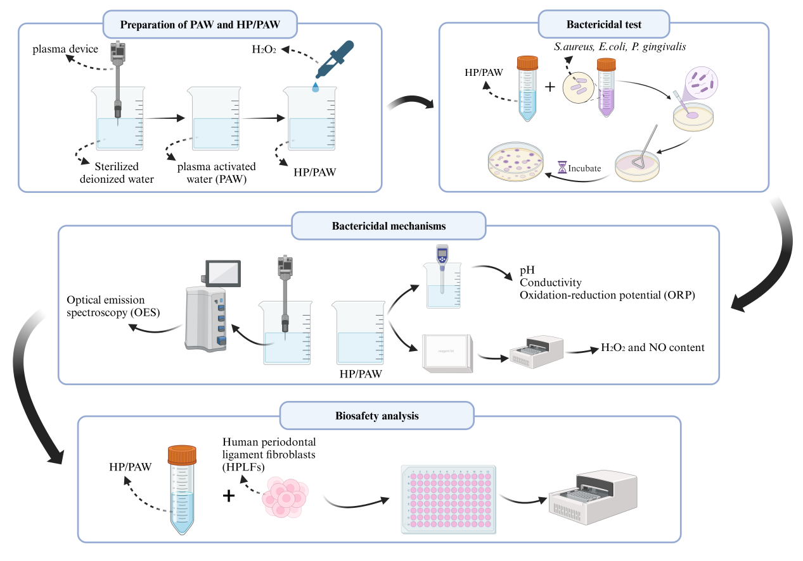
Fig. S1. A scheme illustrating of this study. This figure was created with Biorender.com.

