Machine learning models for ECC prediction
In this study, various supervised machine learning models were applied to assess the effectiveness of Early Childhood Caries (ECC) prediction using salivary biomarkers, clinical data, and demographic factors. The following machine learning models were utilized: Logistic Regression, Support Vector Machine (SVM), Neural Networks, and Ensemble Learning Methods including XGBoost, Random Forest, AdaBoost, and CatBoost. Additionally, performance metrics including Accuracy and Area under the ROC Curve (AUC) were used to evaluate the model performance.

Data Preprocessing
Standardization of features was performed as part of the data preprocessing, especially for models sensitive to feature scaling (e.g., neural networks). This step was crucial for optimizing the performance of the machine learning models.
The formula for standardizing a feature x_{i} ​ is:
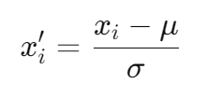
Where:
- x′_{i} is the standardized value of the feature.
- x_{i} ​ is the original value of the feature.
- μ is the mean of the feature.
- σ is the standard deviation of the feature.

Models and Algorithms

1. Logistic regression
Logistic regression was used to model the probability of a binary outcome (ECC vs. non-ECC (CF)). The model uses the logistic function to predict the probability that a given instance belongs to the positive class. The formula for logistic regression is:
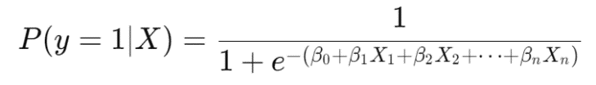
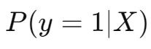
Where:
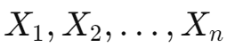
- is the probability of the positive class (ECC).
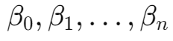
- ​ are the input features (e.g., salivary biomarkers, clinical data).
- ​ are the coefficients learned during model training.

2. Support Vector Machine (SVM)
The SVM model was applied for classification, aiming to find a hyperplane that best separates the two classes (ECC and non-ECC). For a linear SVM, the decision function is defined as:
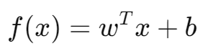
Where:
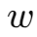
- is the weight vector.
- x is the input feature vector.
- b is the bias term.
The classifier assigns a label based on the sign of the decision function f(x).

3. Neural Network
For binary classification, a neural network with a sigmoid activation function in the output layer was used to model the probability of ECC. The sigmoid function squashes the output between 0 and 1. The formula for the sigmoid activation is:
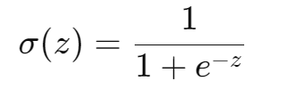
Where:
- σ(z) is the sigmoid function that produces a probability value between 0 and 1.
- z is the weighted sum of the inputs to the output layer.
The neural network was trained using backpropagation and optimization algorithms such as Adam to minimize the binary cross-entropy loss function:
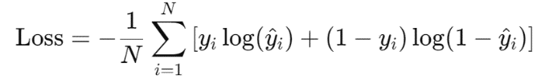
Where:
- N is the number of samples.
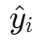
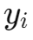
- ​ is the actual label.
- is the predicted probability for the positive class.

4. Ensemble Learning Models
Several ensemble learning methods were applied to improve prediction accuracy by combining multiple weak learners (usually decision trees):
- XGBoost: An optimized gradient boosting algorithm that implements boosting in a parallelized and efficient manner.
- Random Forest: A bagging-based ensemble method that constructs multiple decision trees and averages their predictions to reduce variance and prevent overfitting.
- AdaBoost: A boosting algorithm that combines the predictions of several weak learners (typically decision trees) by sequentially adjusting the weights of misclassified instances.
- CatBoost: A gradient boosting algorithm specifically designed to handle categorical features efficiently.

AdaBoost Weight Update Formula:
The weight update rule in AdaBoost is given by:
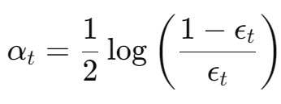
Where:
- ϵ_{t} is the weighted error of the weak learner at iteration t.
- α_{t} ​is the weight assigned to the learner.
The final prediction is a weighted combination of all individual models.

Evaluation Metrics

1. Accuracy
Accuracy is a fundamental metric to evaluate the overall performance of the model. It measures the proportion of correct predictions out of the total number of predictions:
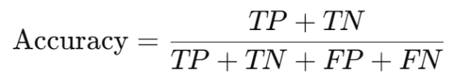
Where:
- TP (True Positives): Correctly predicted positive cases (children with ECC).
- TN (True Negatives): Correctly predicted negative cases (children without ECC).
- FP (False Positives): Incorrectly predicted positive cases.
- FN (False Negatives): Incorrectly predicted negative cases.

2. Area under the ROC curve (AUC)
The receiver operating characteristic (ROC) curve is used to assess the trade-off between the true positive rate (TPR) and the false positive rate (FPR). The Area under the curve (AUC) provides an aggregate measure of the model's ability to distinguish between the positive and negative classes.
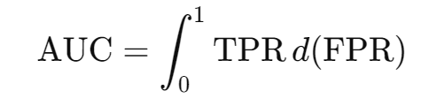
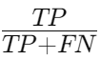
Where:
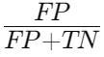
- True positive rate (TPR) = Sensitivity =
- False positive rate (FPR) =
AUC values range from 0 to 1, with a value of 1 indicating perfect classification and a value of 0.5 representing random guessing.

