- Subgroup Analysis of the Effect of Interventions on Plaque Index
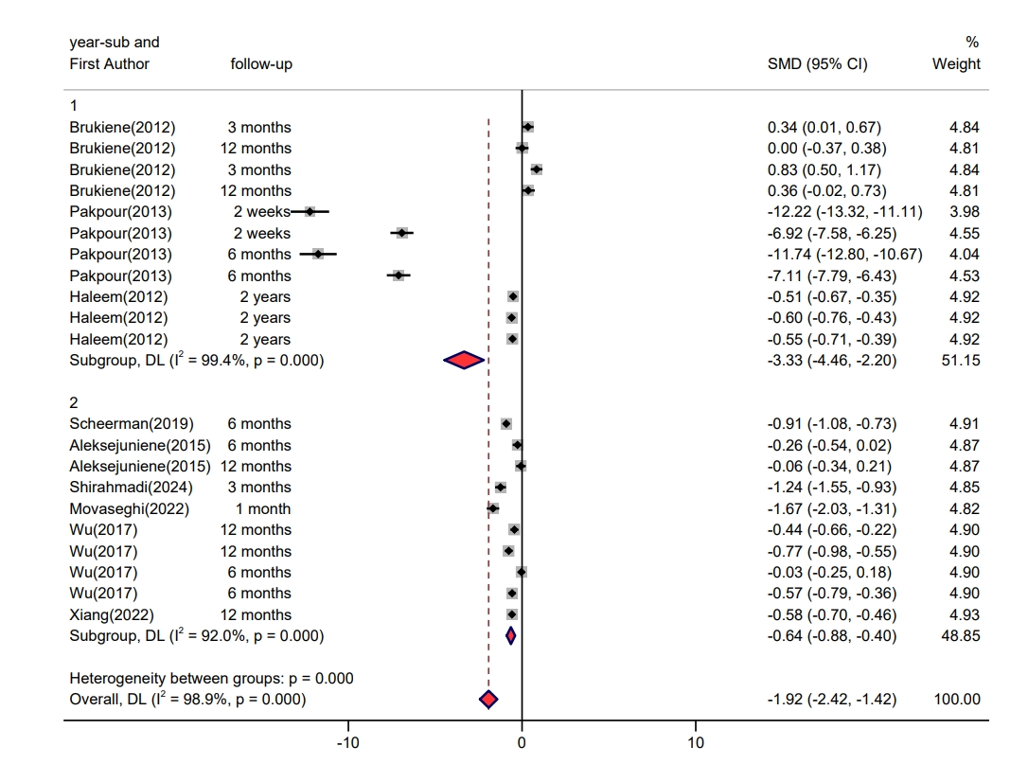
Figure 1-1: Subgroup Analysis of the Effect of Interventions on Plaque Index by Year of Study

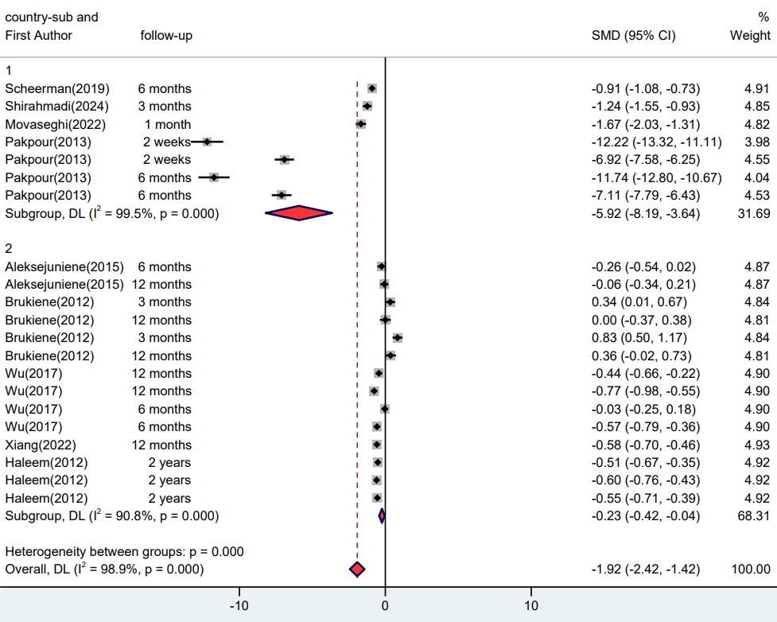
Figure 1-2: Subgroup Analysis of the Effect of Interventions on Plaque Index by Counrty

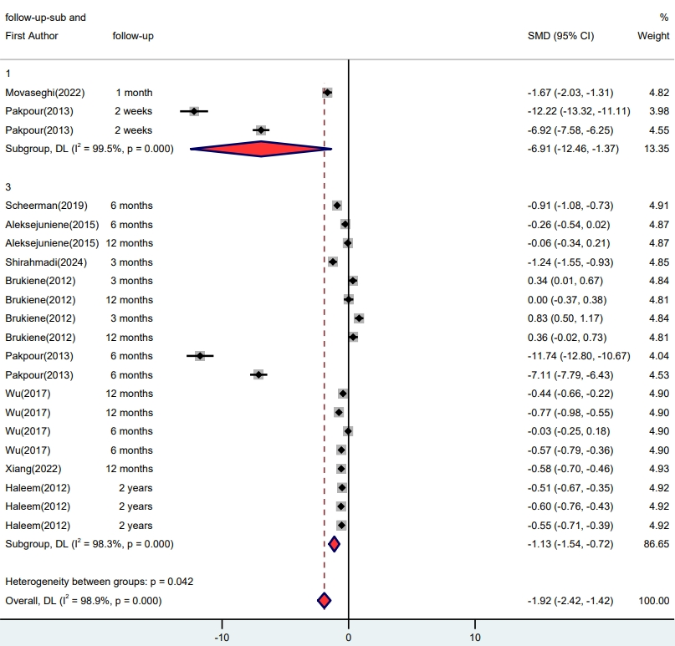
Figure 1-3: Subgroup Analysis of the Effect of Interventions on Plaque Index by Follow-up Duration

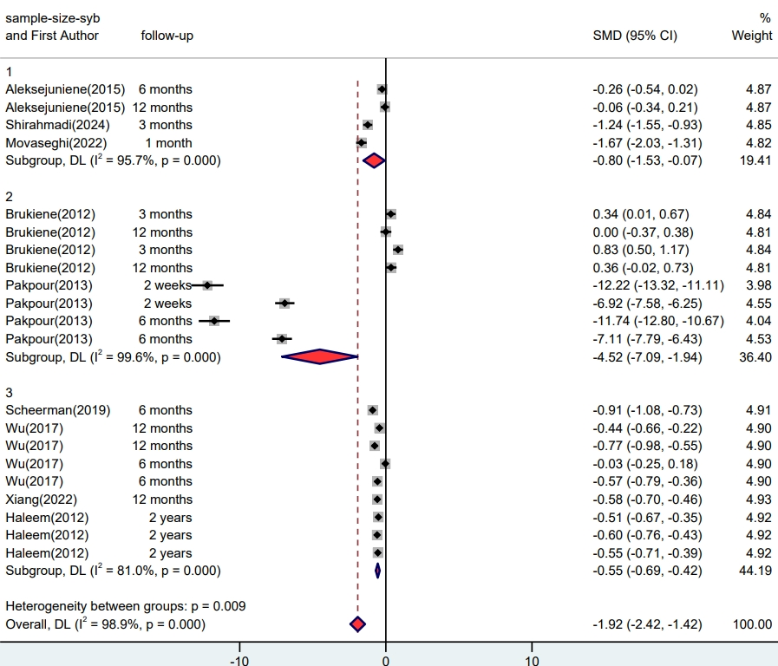
Figure 1-4: Subgroup Analysis of the Effect of Interventions on Plaque Index by Sample Size

- Subgroup Analysis of the Effect of Interventions on Periodontal Health
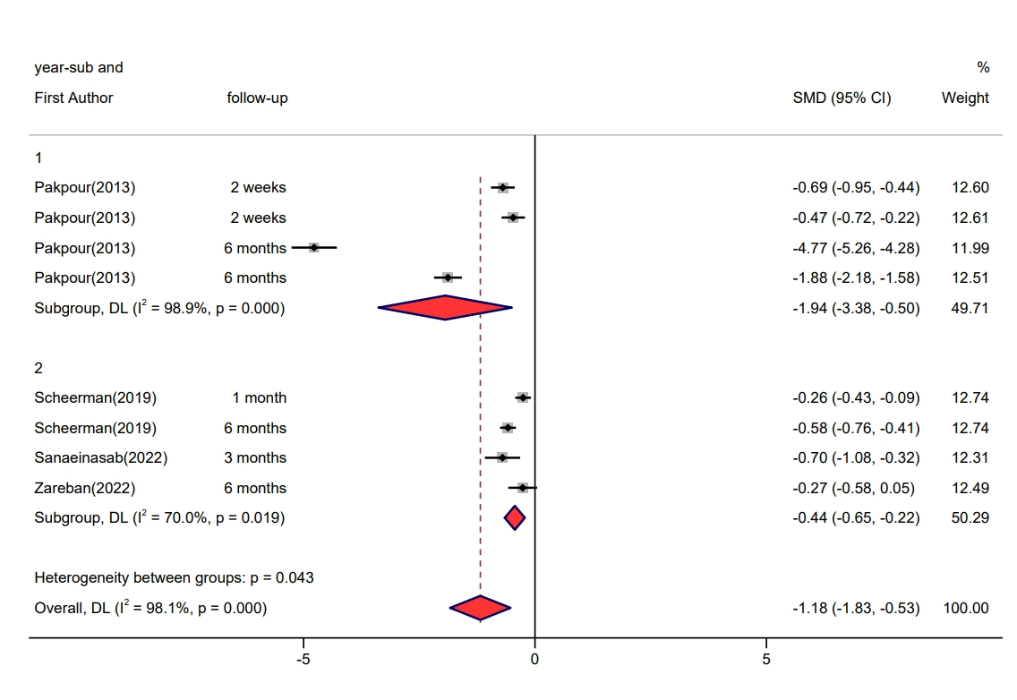
Figure2- 1: Subgroup Analysis of the Effect of Interventions on Periodontal Health by Year of the Study

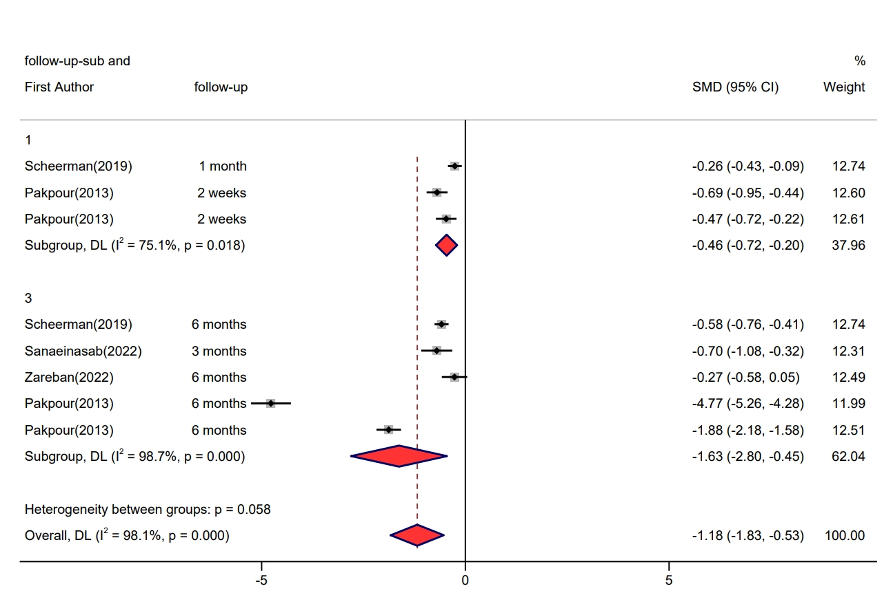
Figure 2-2: Subgroup Analysis of the Effect of Interventions on Periodontal Health by follow-up Duration

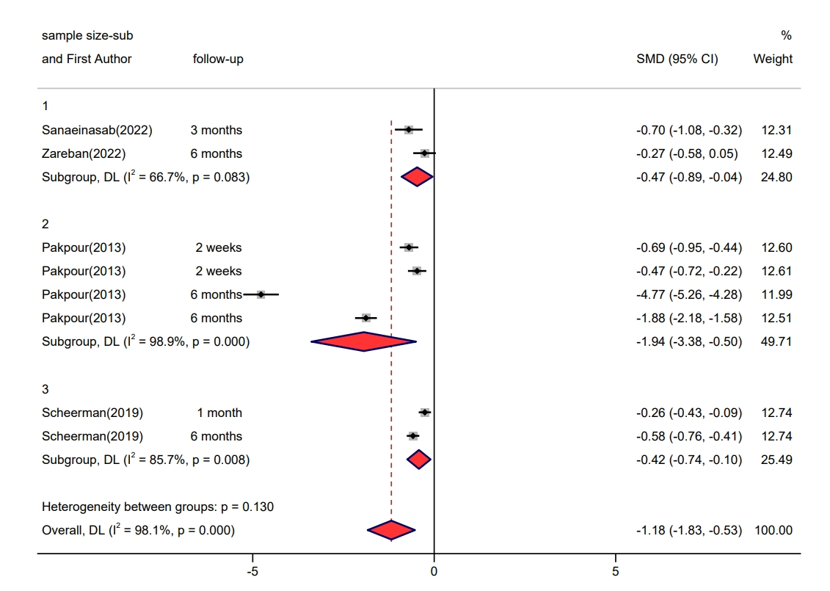
Figure 2-3: Subgroup Analysis of the Effect of Interventions on Periodontal Health by Sample Size

- Subgroup Analysis of the Effect of Interventions on DMFT
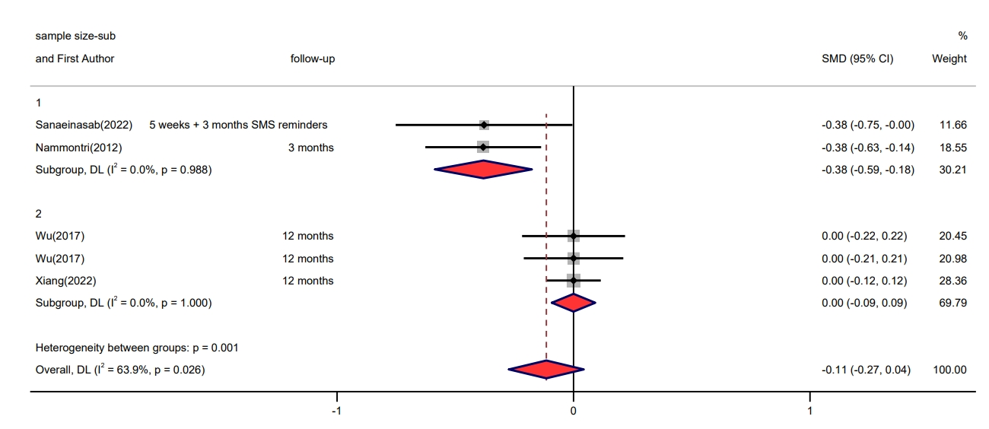
Figure 3-1: Subgroup Analysis of the Effect of Interventions on DMFT by Sample Size

- Subgroup Analysis of the Effect of Interventions on Self-efficacy related to oral
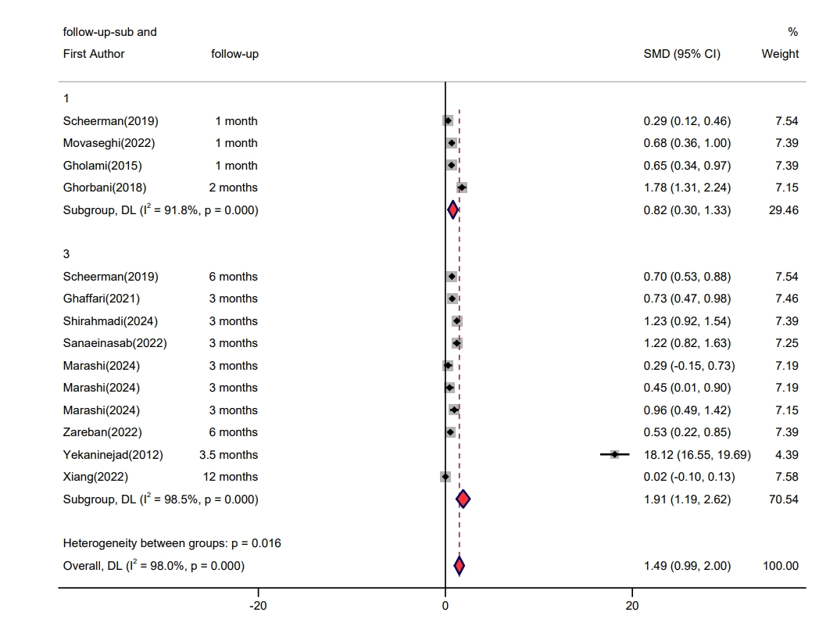
Figure 4-1: Subgroup Analysis of the Effect of Interventions on Self-efficacy related to oral by Follow-up Duration

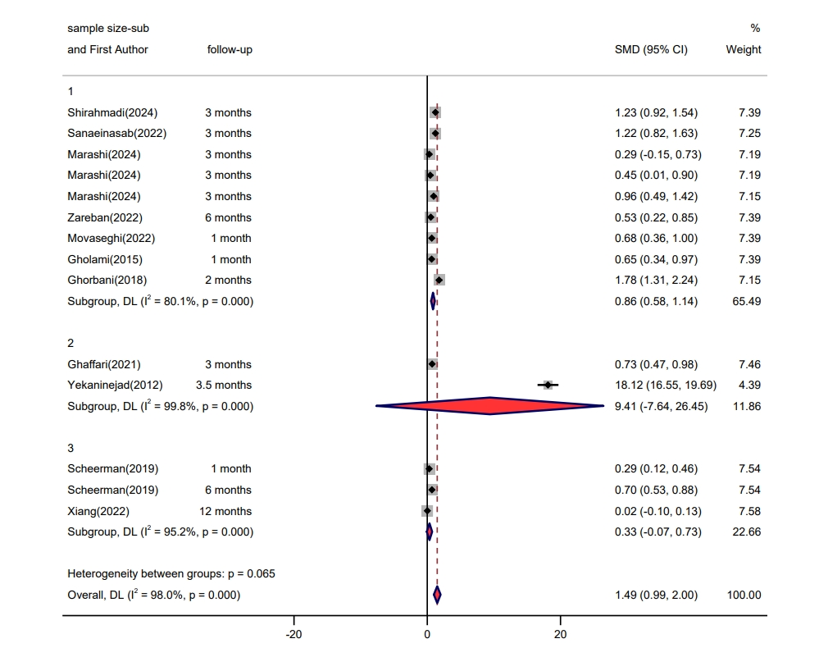
Figure 4-2: Subgroup Analysis of the Effect of Interventions on Self-efficacy related to oral by Sample Size

- Subgroup Analysis of the Effect of Interventions on OHRQoL
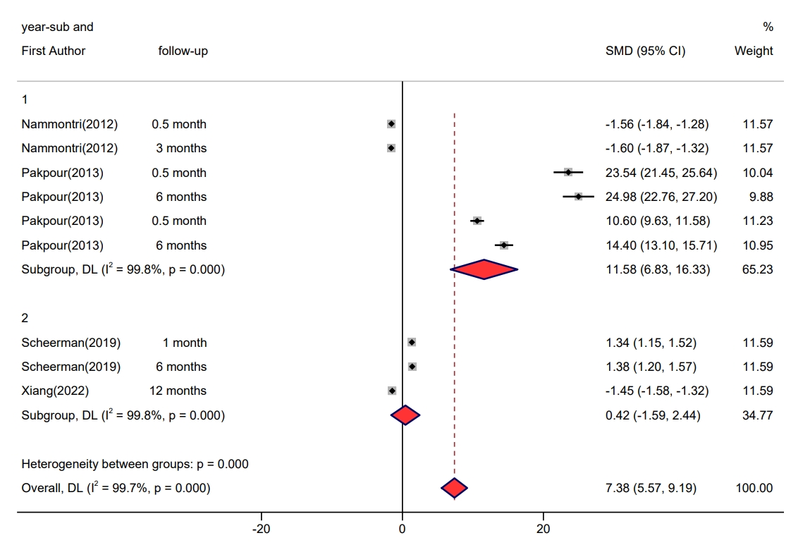
Figure 5-1: Subgroup Analysis of the Effect of Interventions on OHRQoL by year

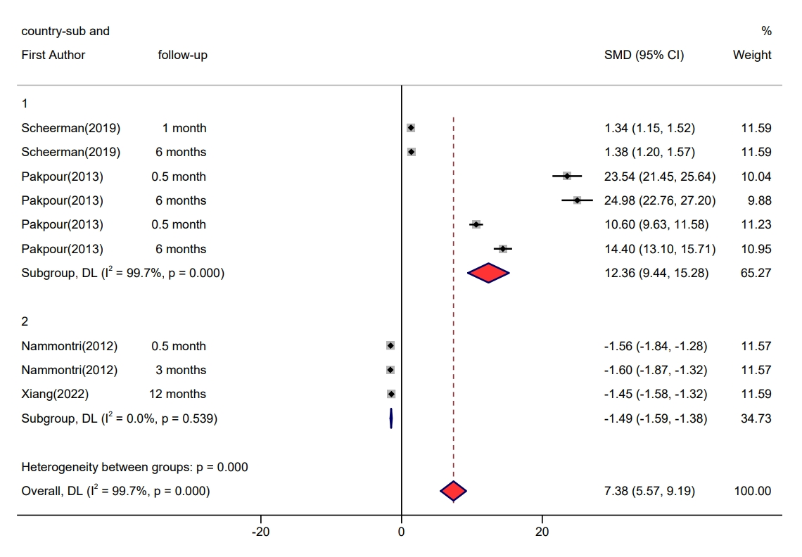
Figure 5-2: Subgroup Analysis of the Effect of Interventions on OHRQoL by country

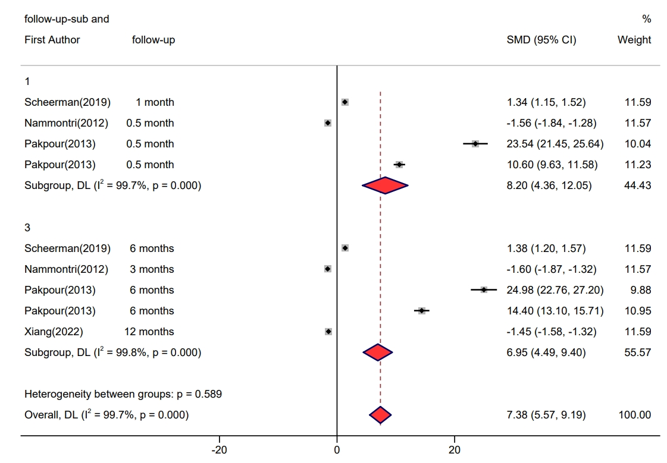
Figure 5-3: Subgroup Analysis of the Effect of Interventions on OHRQoL by Follow-up Duration

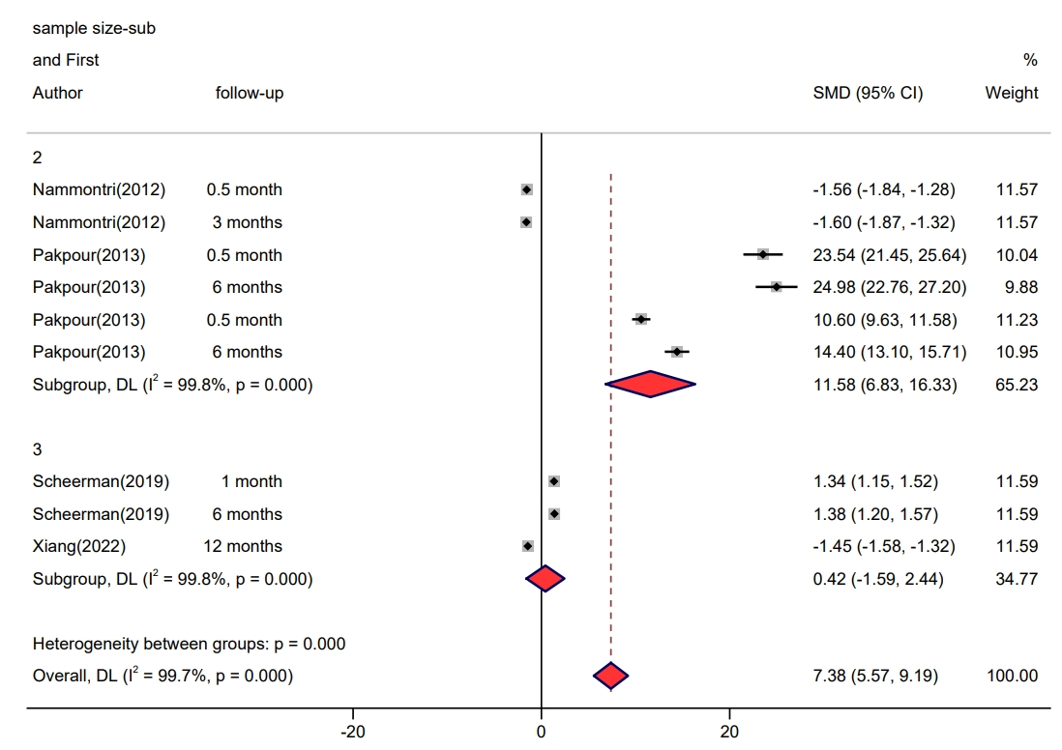
Figure 5-4: Subgroup Analysis of the Effect of Interventions on OHRQoL by Sample Size

- Subgroup Analysis of the Effect of Interventions on Oral Health knowledge

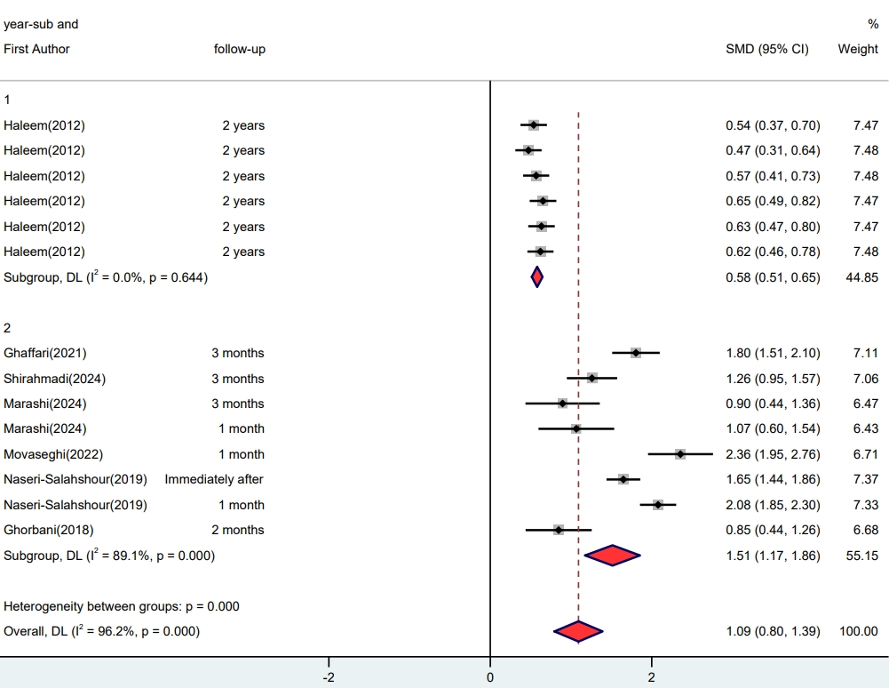
Figure 6-1: Subgroup Analysis of the Effect of Interventions on Oral Health knowledge by year

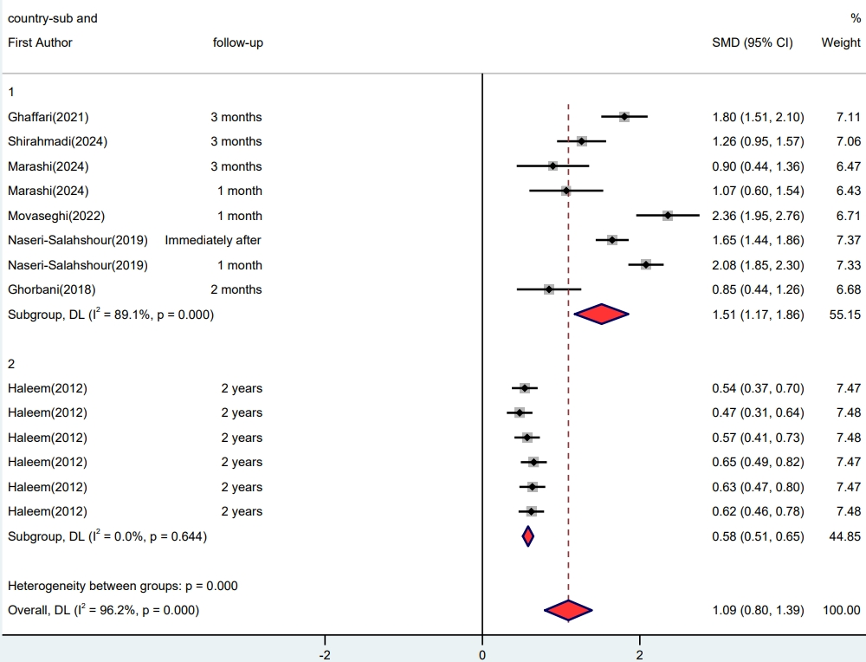
Figure 6-2: Subgroup Analysis of the Effect of Interventions on Oral Health knowledge by country

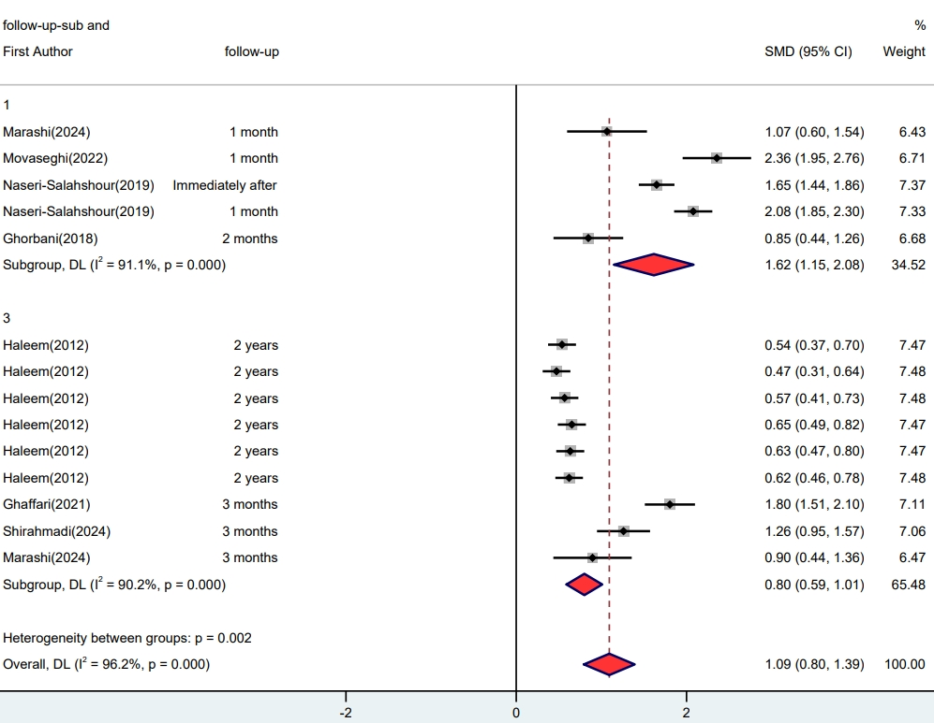
Figure 6-3: Subgroup Analysis of the Effect of Interventions on Oral Health knowledge by Follow-up Duration

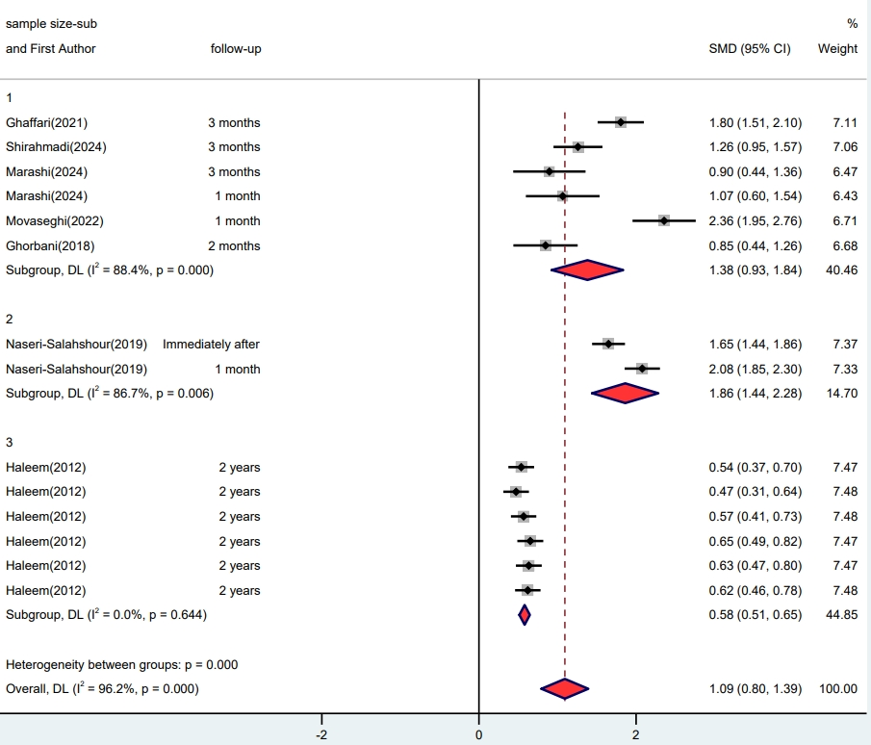
Figure 6-4: Subgroup Analysis of the Effect of Interventions on Oral Health knowledge by Sample Size

- Subgroup Analysis of the Effect of Interventions on Oral Health knowledge

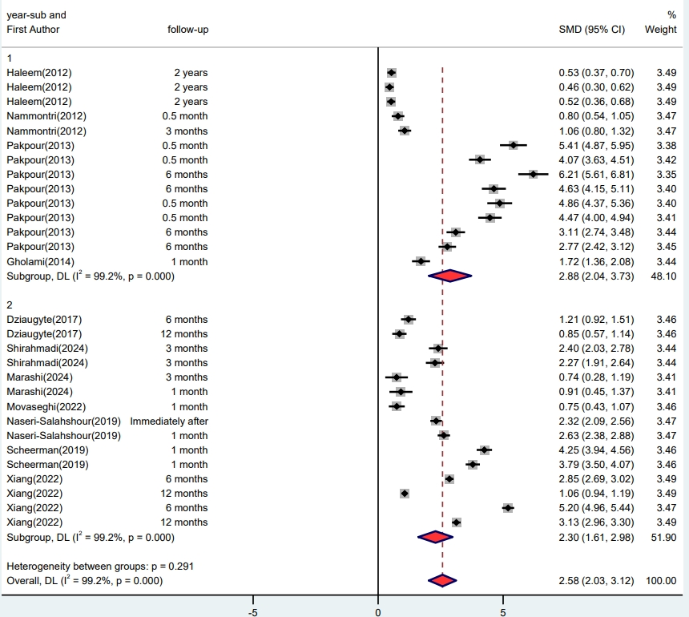
Figure 7-1: Subgroup Analysis of the Effect of Interventions on Oral Health Behavior by Year

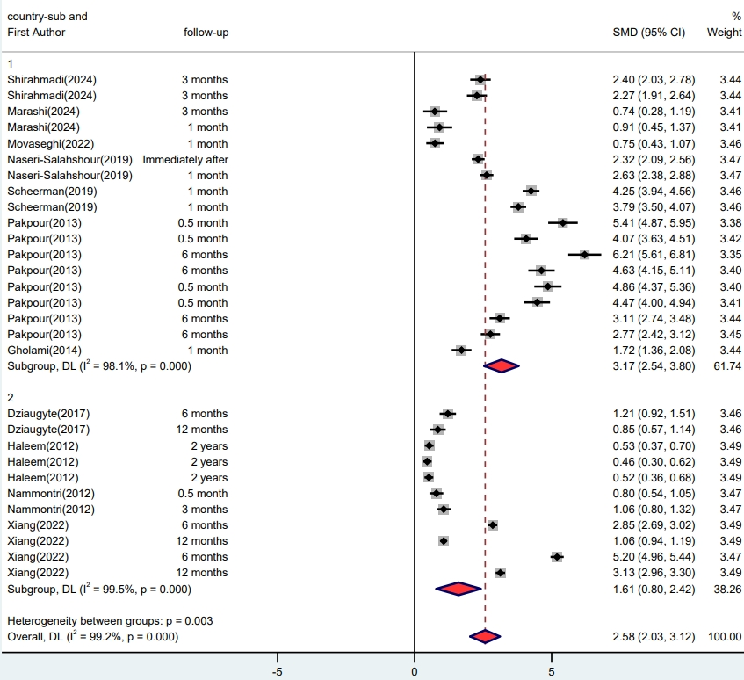
Figure 7-2: Subgroup Analysis of the Effect of Interventions on Oral Health Behavior by Country

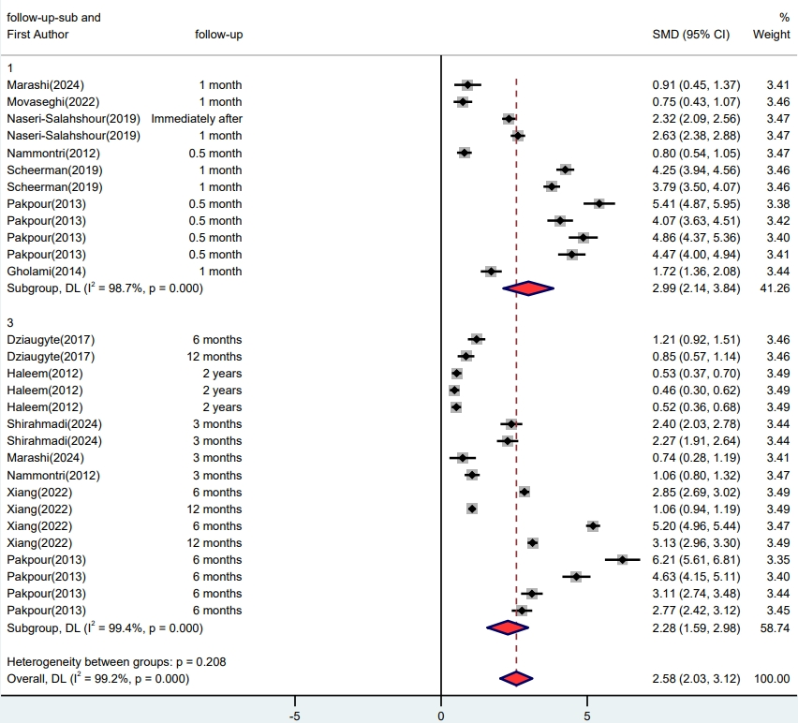
Figure 7-3: Subgroup Analysis of the Effect of Interventions on Oral Health Behavior by Follow-up Duration

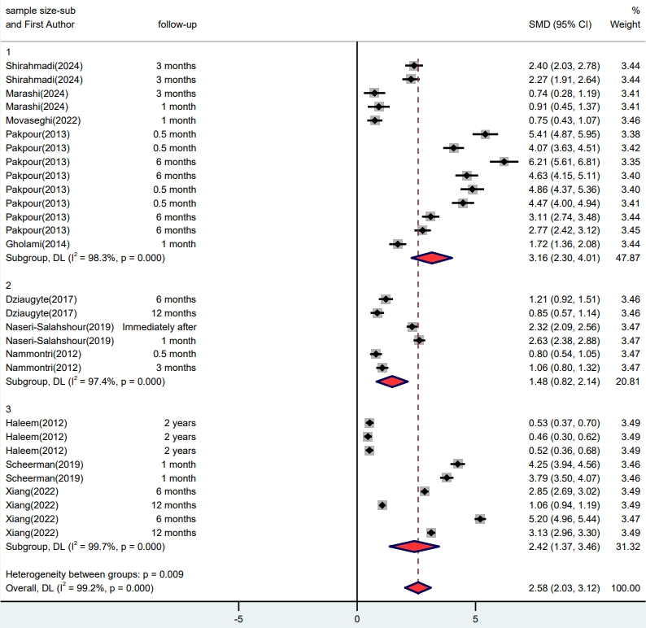
Figure 7-4: Subgroup Analysis of the Effect of Interventions on Oral Health Behavior by Sample Size

- Subgroup Analysis of the Effect of Interventions on Oral Health Attitude

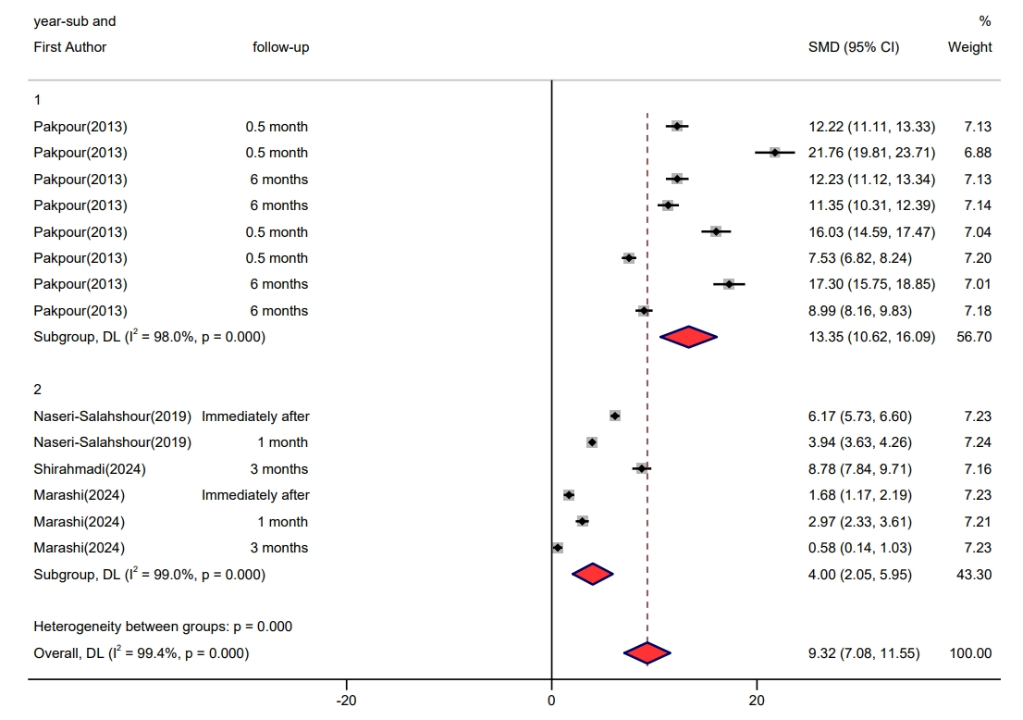
Figure 8-1: Subgroup Analysis of the Effect of Interventions on Oral Health Attitude by Year

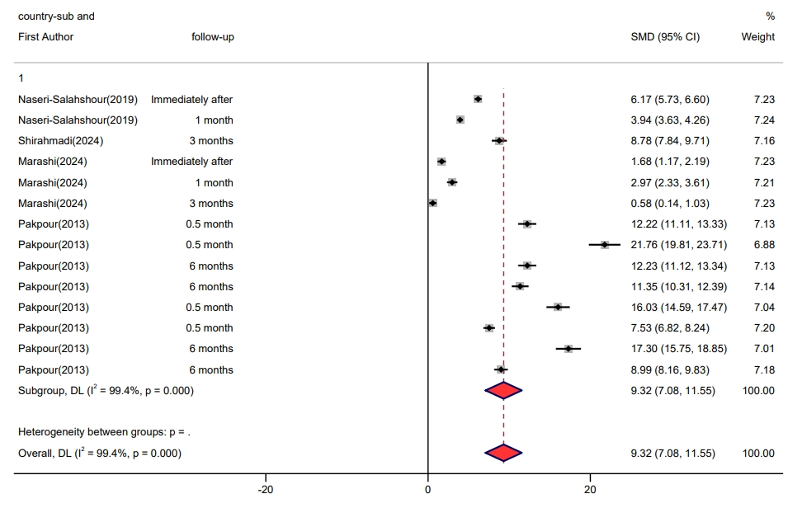
Figure 8-2: Subgroup Analysis of the Effect of Interventions on Oral Health Attitude by Country

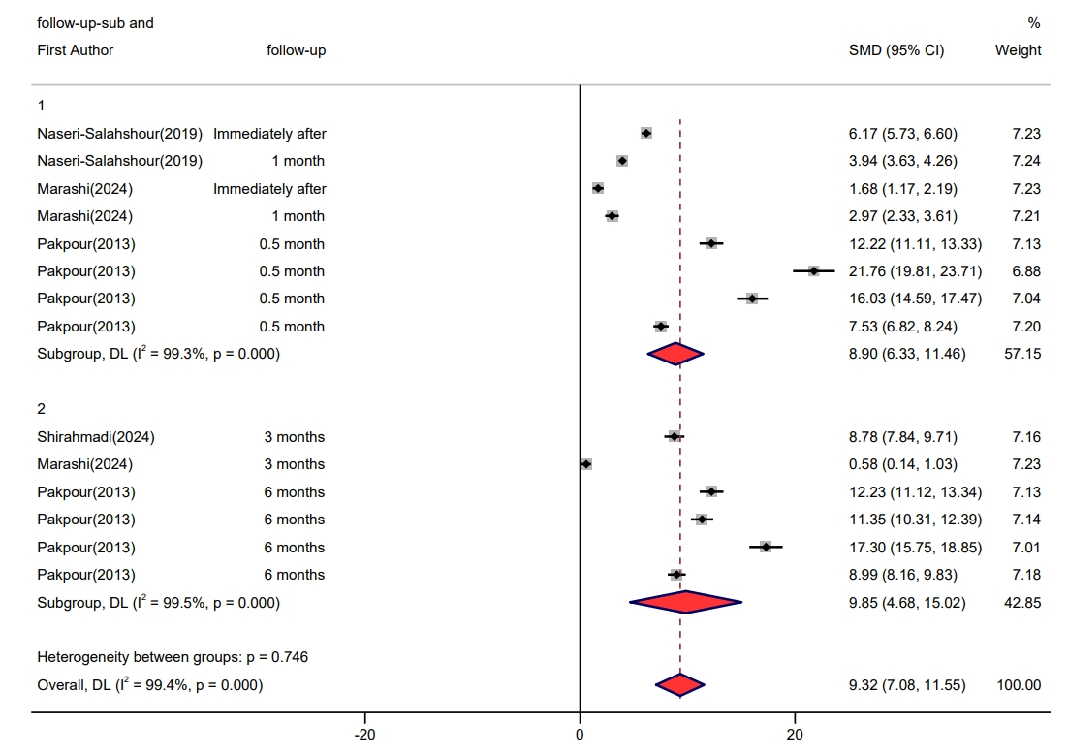
Figure 8-3: Subgroup Analysis of the Effect of Interventions on Oral Health Attitude by Follow-up Duration

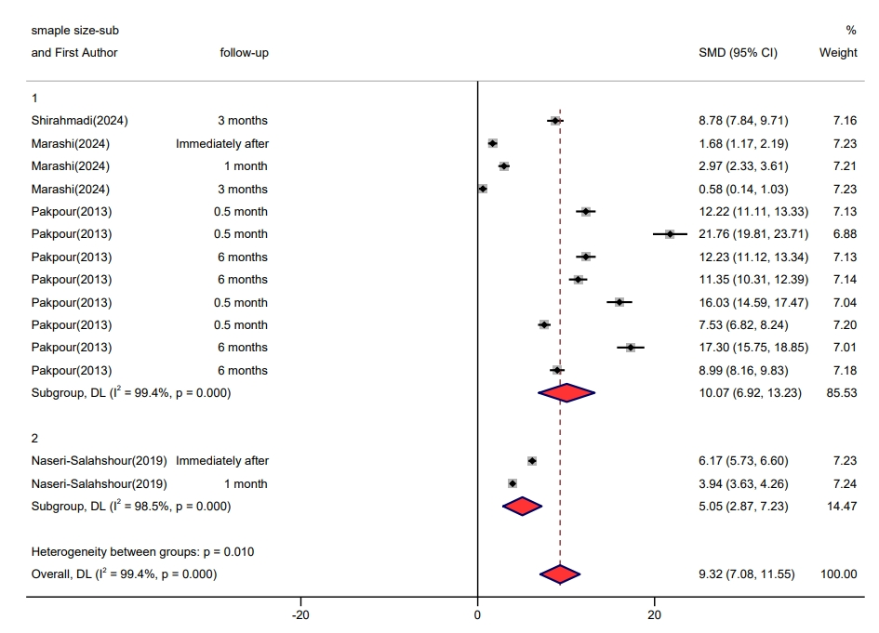
Figure 8-2: Subgroup Analysis of the Effect of Interventions on Oral Health Attitude by Sample Size

